Juries Act
R.R.O. 1990, REGULATION 680
GENERAL
Historical version for the period June 30, 2010 to March 30, 2011.
Last amendment: O. Reg. 231/10.
This is the English version of a bilingual regulation.
1. The jury service notice and return to the jury service notice referred to in subsection 6 (1) of the Act shall be in Form 1. R.R.O. 1990, Reg. 680, s. 1.
2. The jury roll referred to in section 7 of the Act shall be in Form 2. R.R.O. 1990, Reg. 680, s. 2.
3. The precept referred to in section 12 of the Act shall be in Form 3. R.R.O. 1990, Reg. 680, s. 3.
4. The summons referred to in subsection 19 (1) of the Act shall be in Form 4. R.R.O. 1990, Reg. 680, s. 4.
5. The notice that the attendance of jurors is not required referred to in subsection 21 (1) of the Act shall be in Form 5. R.R.O. 1990, Reg. 680, s. 5.
6. The notice referred to in subsection 21 (2) of the Act shall be in Form 6. R.R.O. 1990, Reg. 680, s. 6.
7. The notice to a juror that his or her attendance is not required referred to in subsection 21 (3) of the Act shall be in Form 7. R.R.O. 1990, Reg. 680, s. 7.
8. The notice to a juror that his or her attendance is not required until a day specified referred to in subsection 21 (3) of the Act shall be in Form 8. R.R.O. 1990, Reg. 680, s. 8.
9. The jury panel lists referred to in section 18 of the Act shall be in Form 9. R.R.O. 1990, Reg. 680, s. 9.
9.1 For the purposes of subsection 18.2 (4) of the Act, the sheriff may enter into an agreement with the Ontario Provincial Police. O. Reg. 231/10, s. 1.
10. The following areas are established as jury areas:
1. The Timmins Jury Area, consisting of that part of Dundonald Township that is within the municipal boundary of the City of Timmins, those parts of Walker Township and Benoit Township that are within the Municipality of Black River-Matheson, as well as all of the following townships: Adams; Beatty; Black; Blackstock; Bond; Bowman; Bristol; Byers, Cote; Carman; Carr; Carscallen; Cody; Cook; Cowan; Currie; Deloro; Denton; Egan; Eldorado; Evelyn; Flayfair; German; Godfrey; Hislop; Hoyle; Jamieson; Jessop; Keefer; Kidd; Langmuir; Loveland; MacDiarmid; Macklem; Massey; Matheson; McCann; McEvay; Melba; Mountjoy; Murphy; Ogden; Price; Robb; Shaw; Sheraton; Stock; Taylor; Thomas; Thorneloe; Timmins; Tisdale; Tolstoi; Turnbull; Wark; Whitesides; Whitney.
2. The Cochrane Jury Area, consisting of all territory in the District of Cochrane other than the territory described in paragraph 1. O. Reg. 334/96, s. 1.
FORM 1
QUESTIONNAIRE About QUALIFICATIONS FOR JURY SERVICE
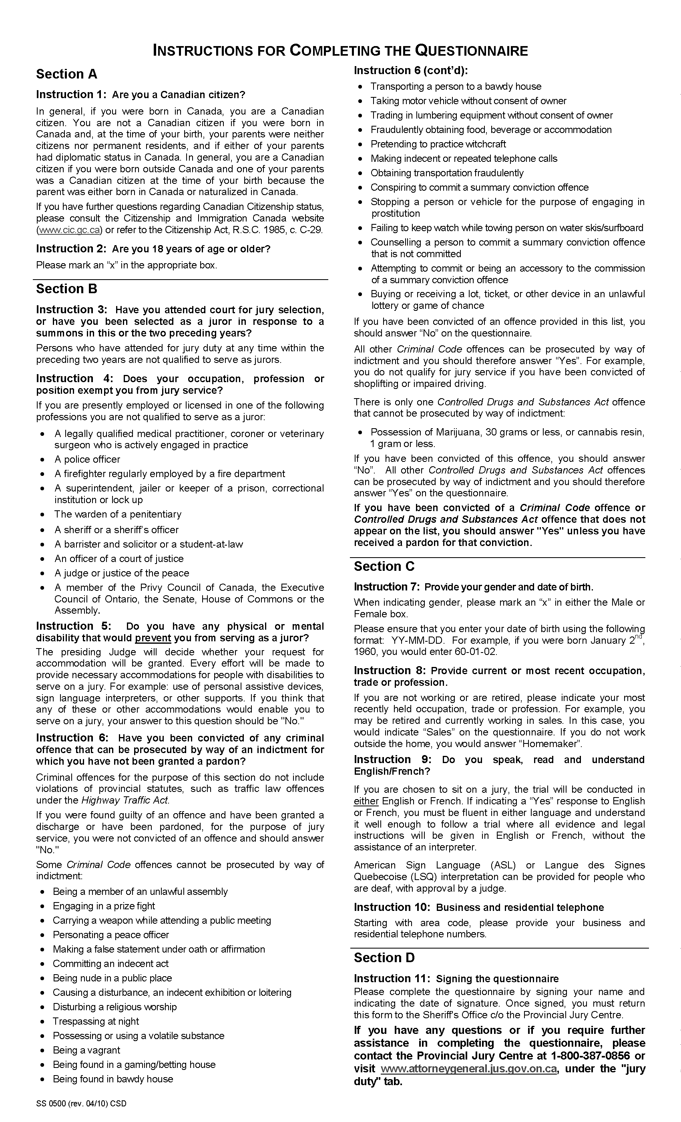
O. Reg. 231/10, s. 2.
Form 2 / Formule 2
Jury Roll / Liste Des JurÉS
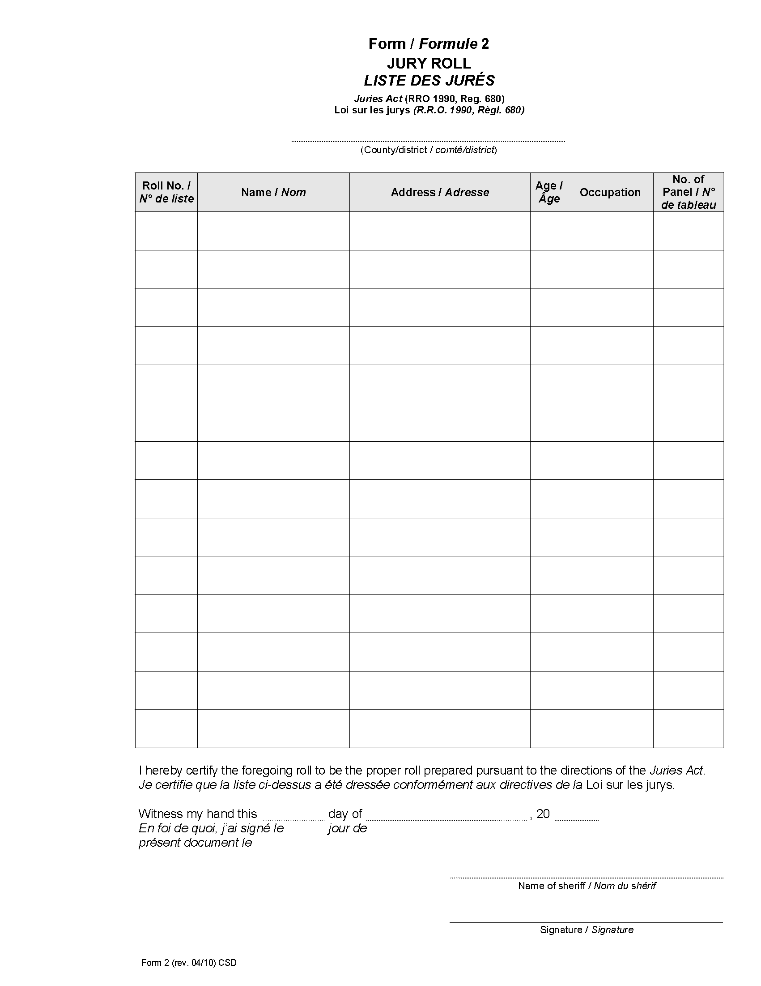
O. Reg. 231/10, s. 2.
Form 3 / Formule 3
Precept from Judge to Sheriff / Citation dÉlivrÉE par un juge À un shÉrif
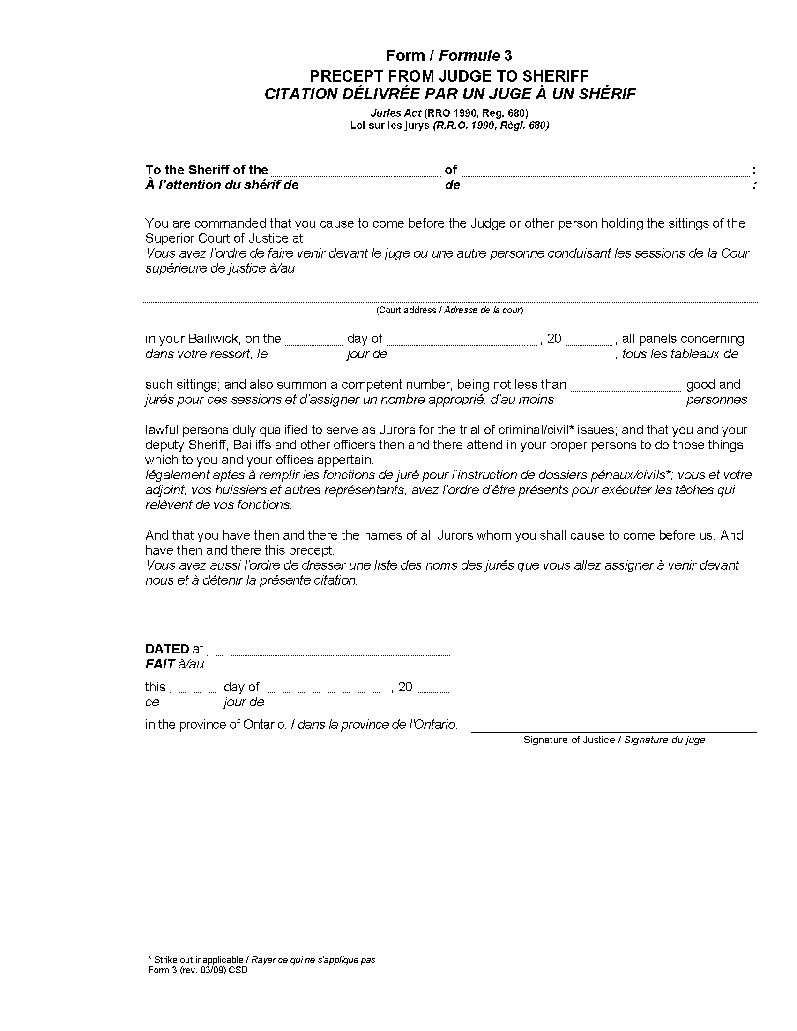
O. Reg. 231/10, s. 2.
Form 4 / Formule 4
Summons / Assignation
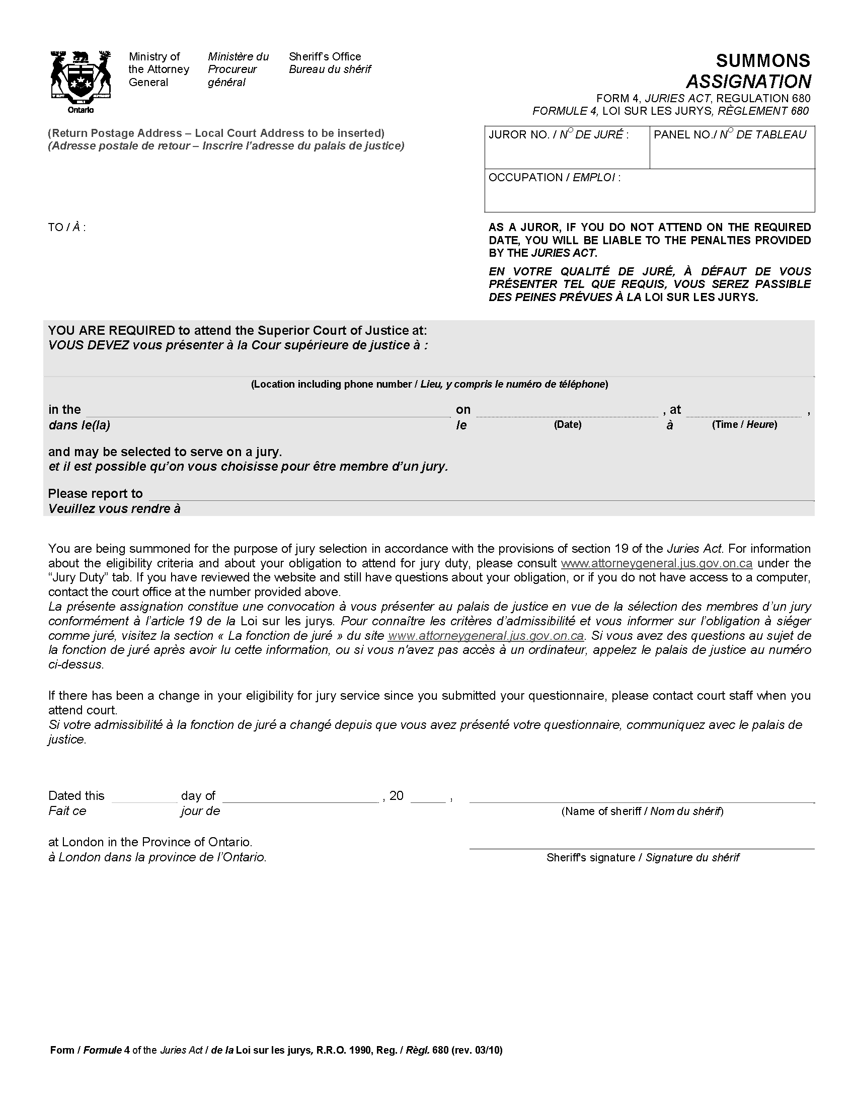
O. Reg. 231/10, s. 2.
Form 5 / Formule 5
Notice to Sheriff regarding number of jurors required / Avis au shÉrif sur le nombre de jurÉs requis
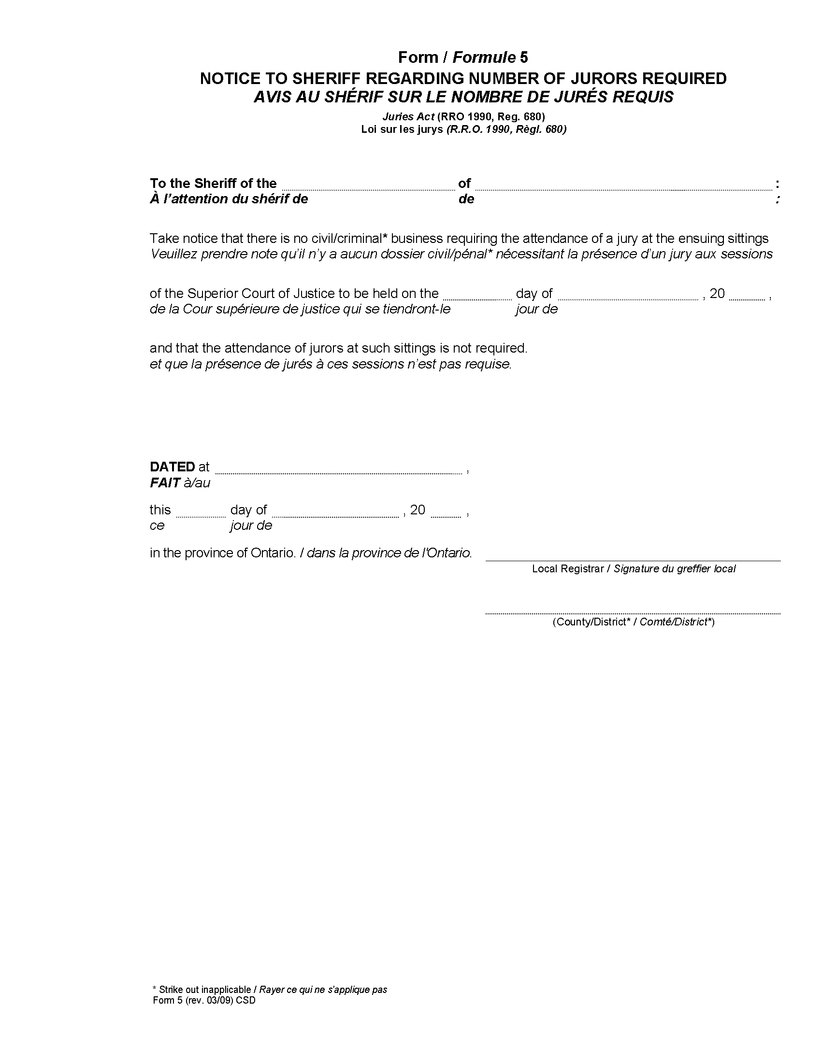
O. Reg. 231/10, s. 2.
Form 6 / Formule 6
Notice to sheriff regarding number of jurors required on opening day / avis au shÉrif concernant le nombre de jurÉs requis À l’Ouverture de la session
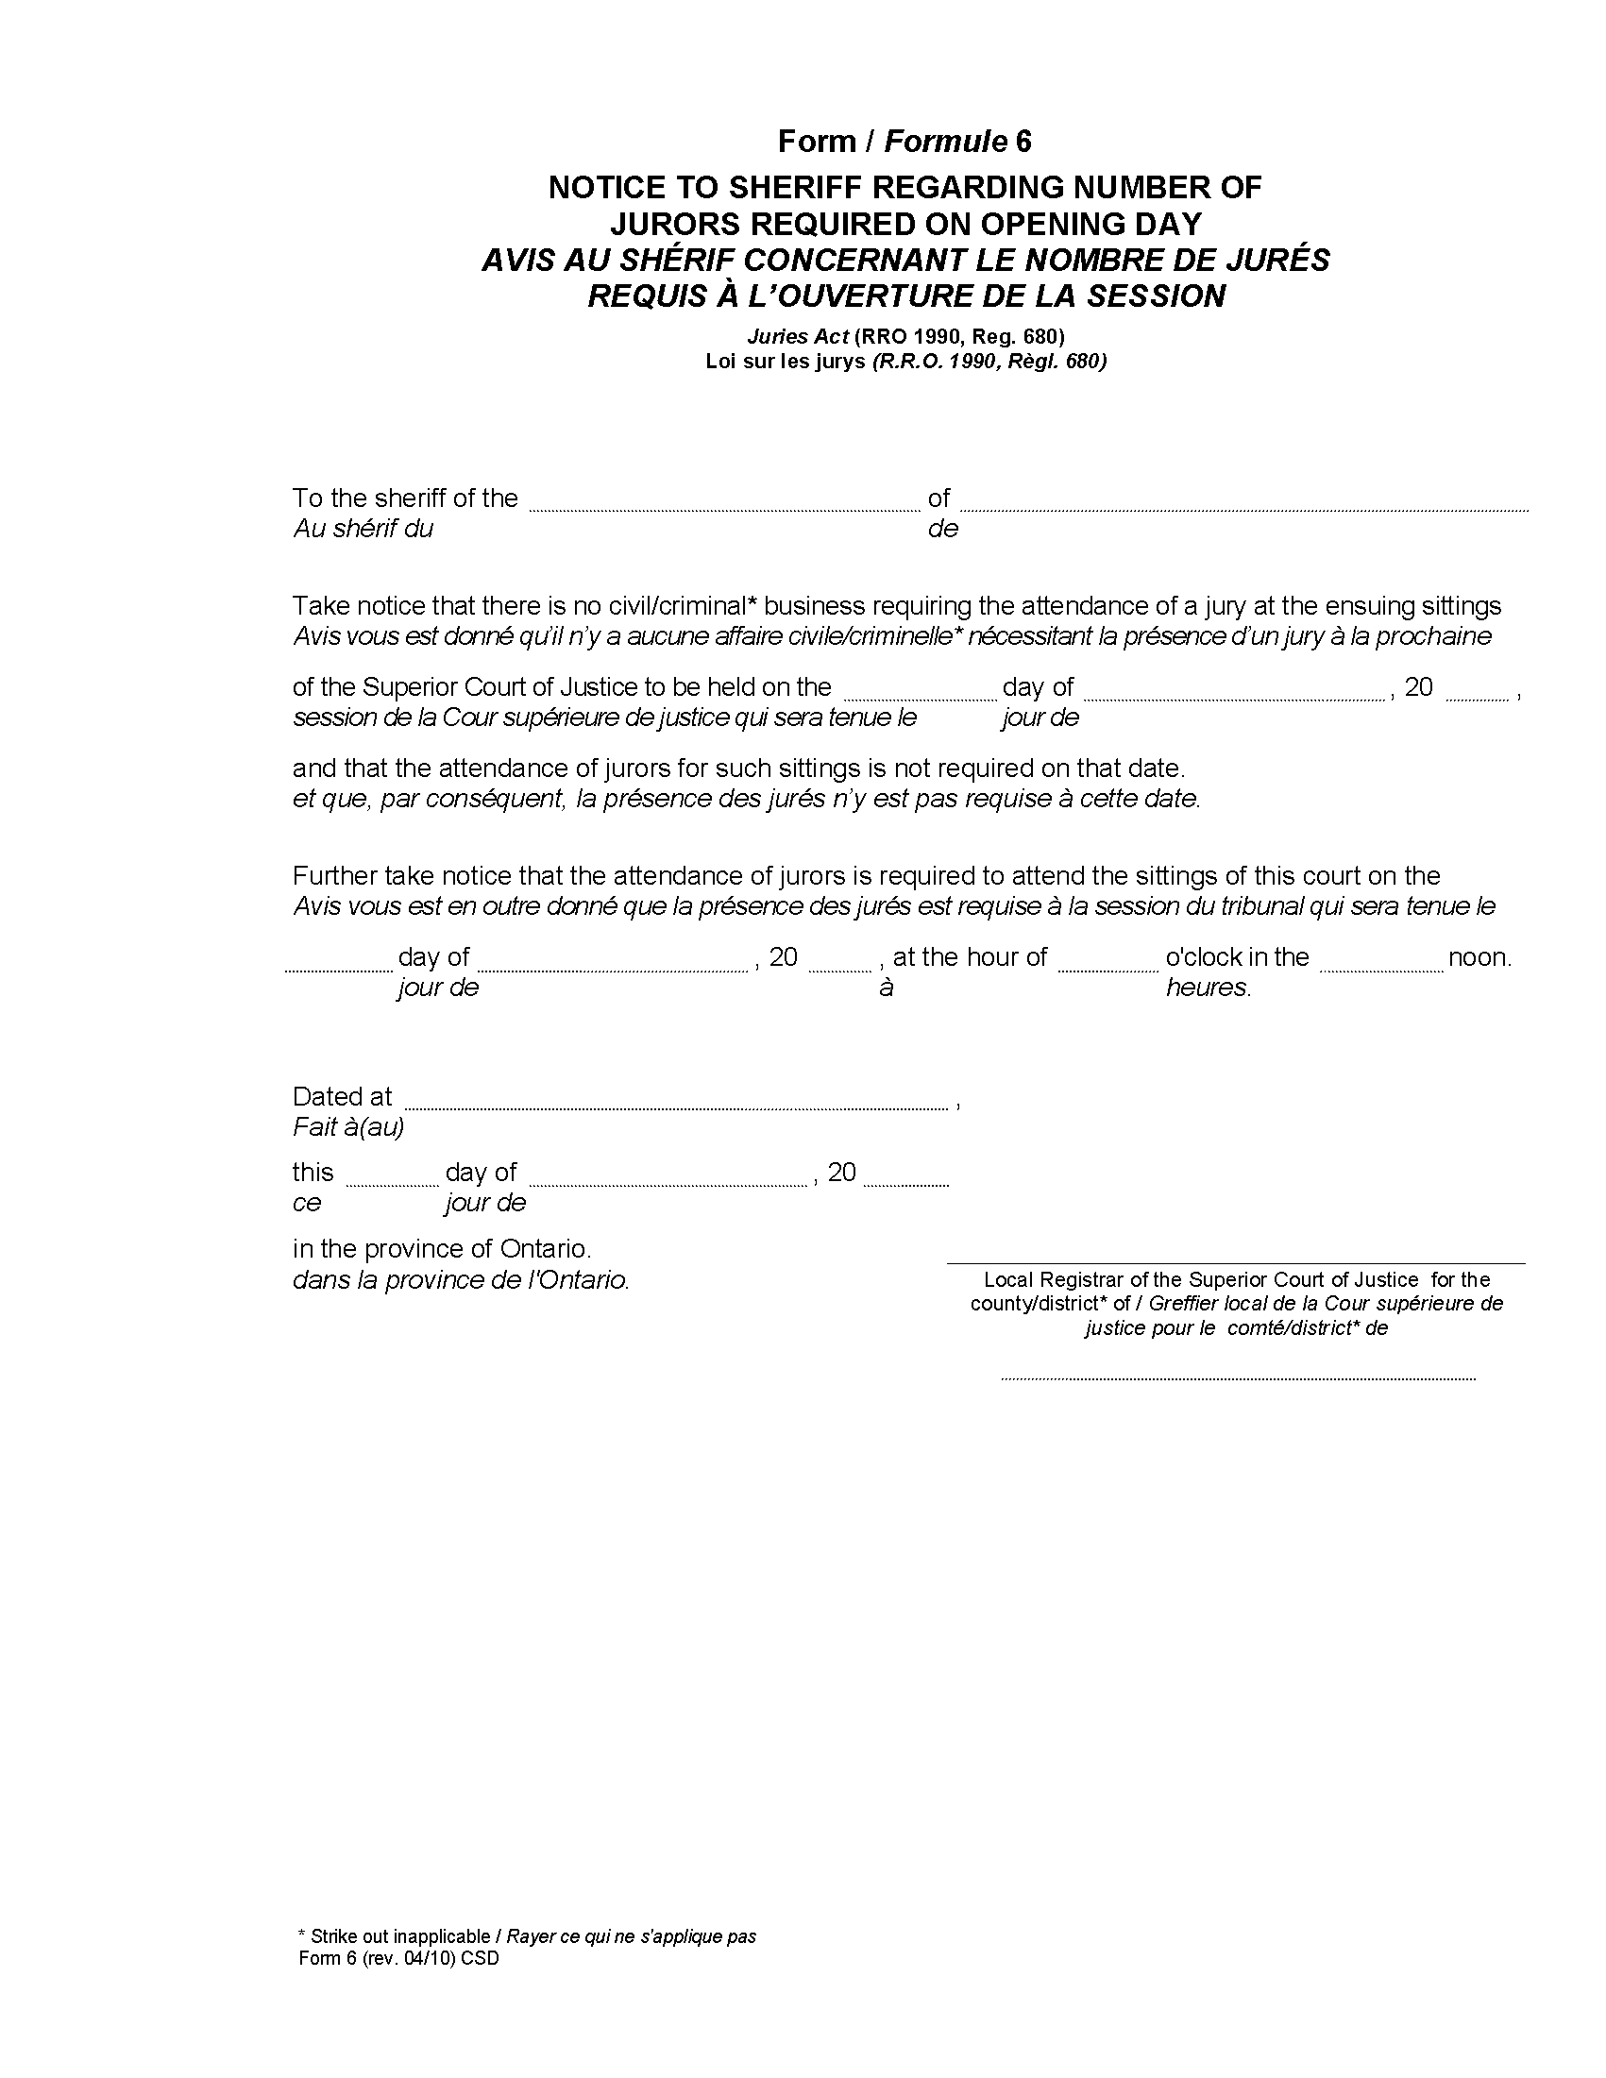
O. Reg. 231/10, s. 2.
Form 7 / formule 7
notice to juror regarding cancellation of summons / avis au jurÉ — Annulation d’assignation
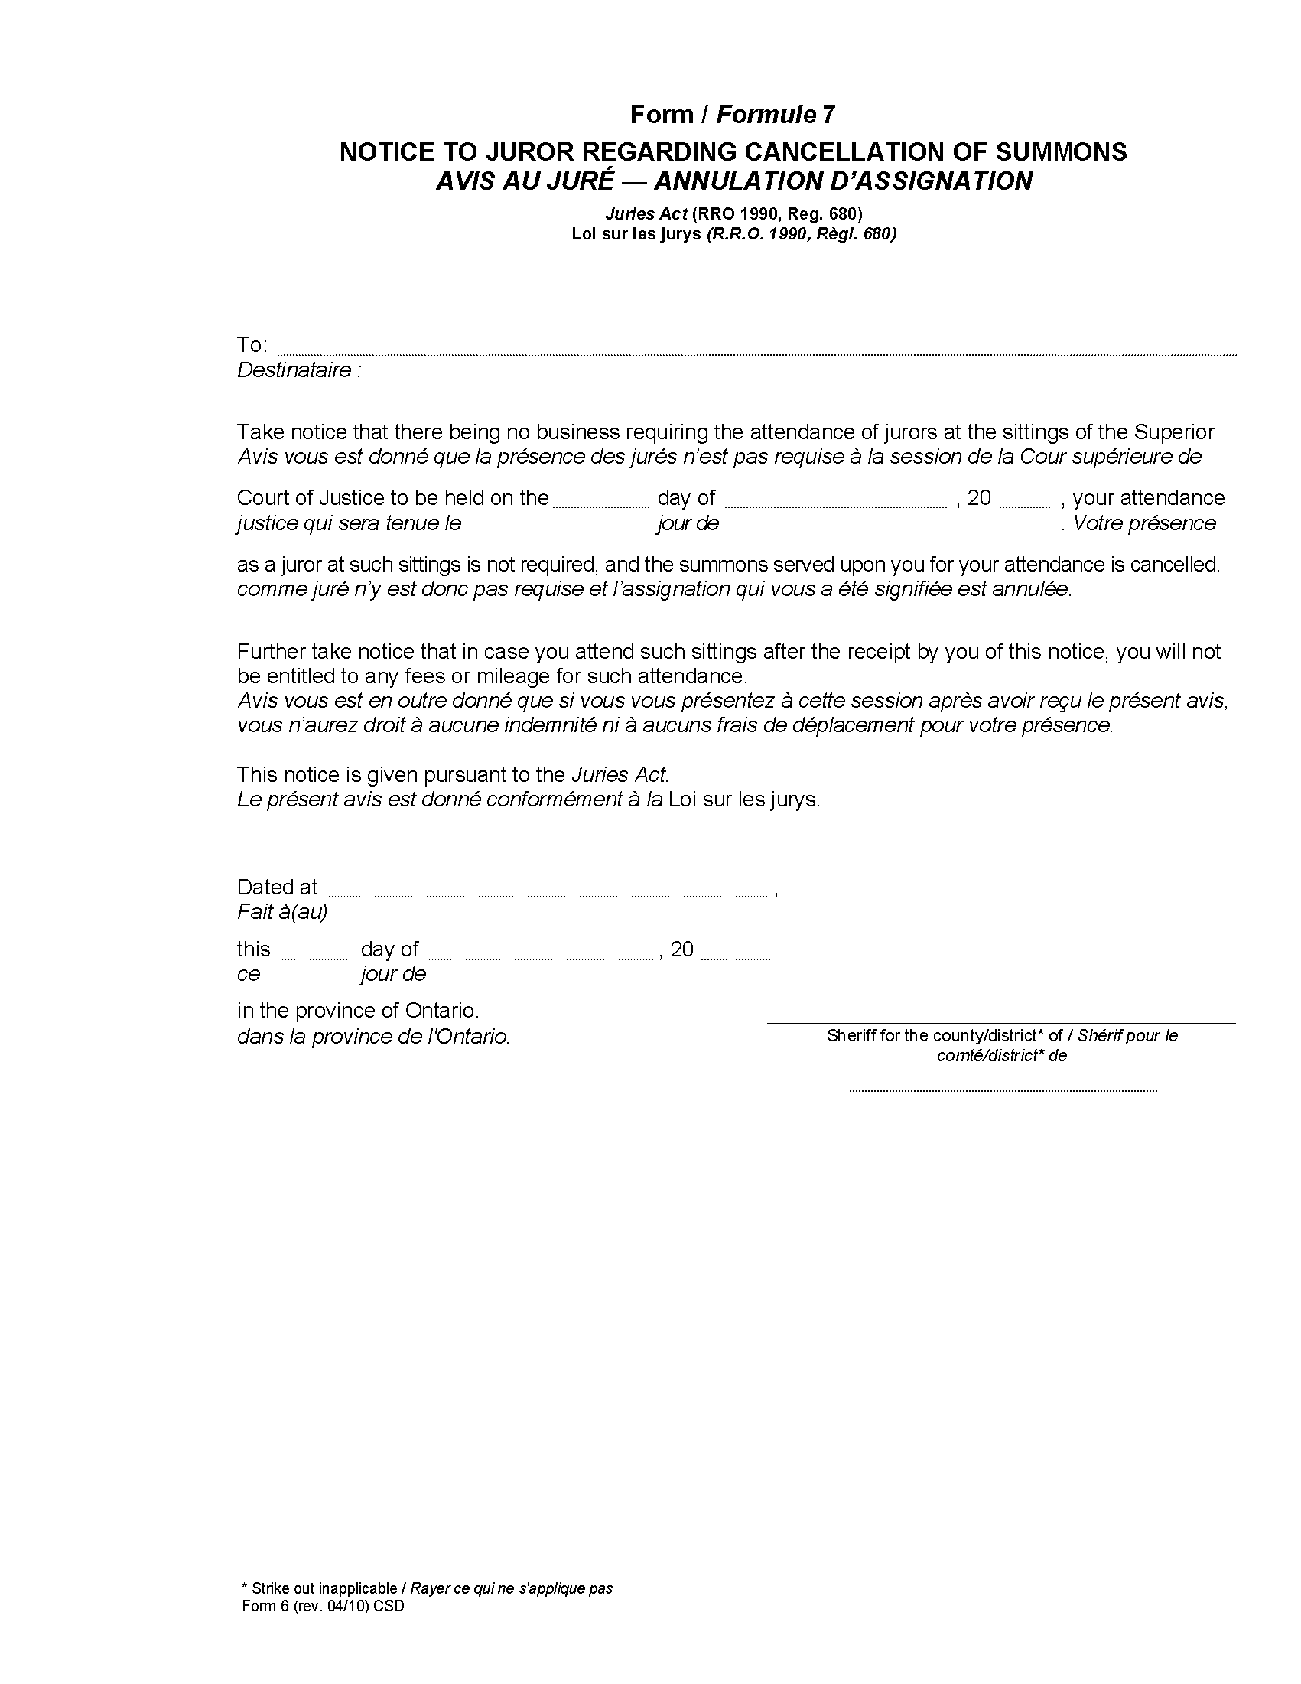
O. Reg. 231/10, s. 2.
Form 8 / Formule 8
Notice to juror regarding amendment of date to report for service / avis au jurÉ sur la modification de la date de convocation pour remplir les fonctions de jurÉ
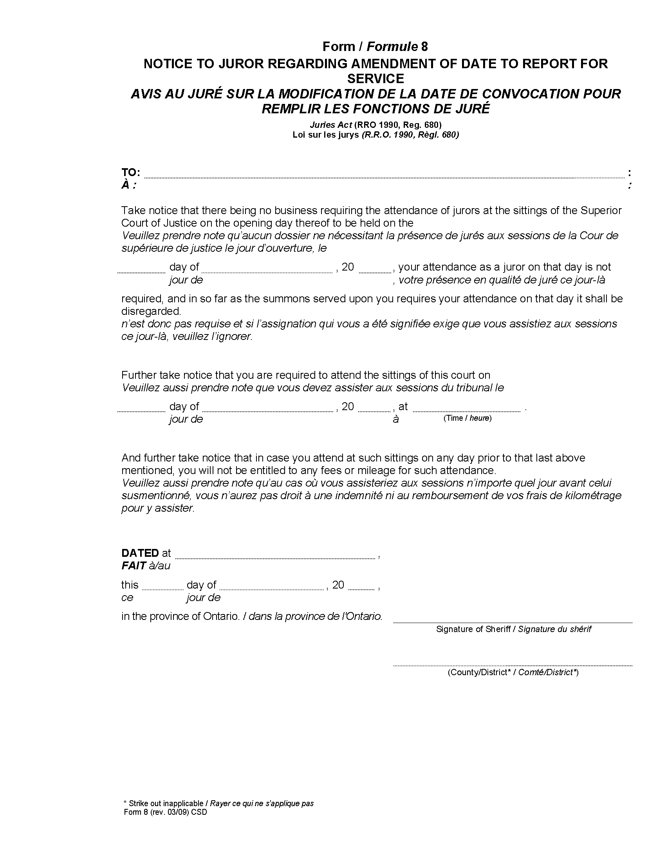
O. Reg. 231/10, s. 2.
Form 9 / Formule 9
Jury panels for the superior court of justice / Tableaux du jury pour la cour supÉrieure de justice
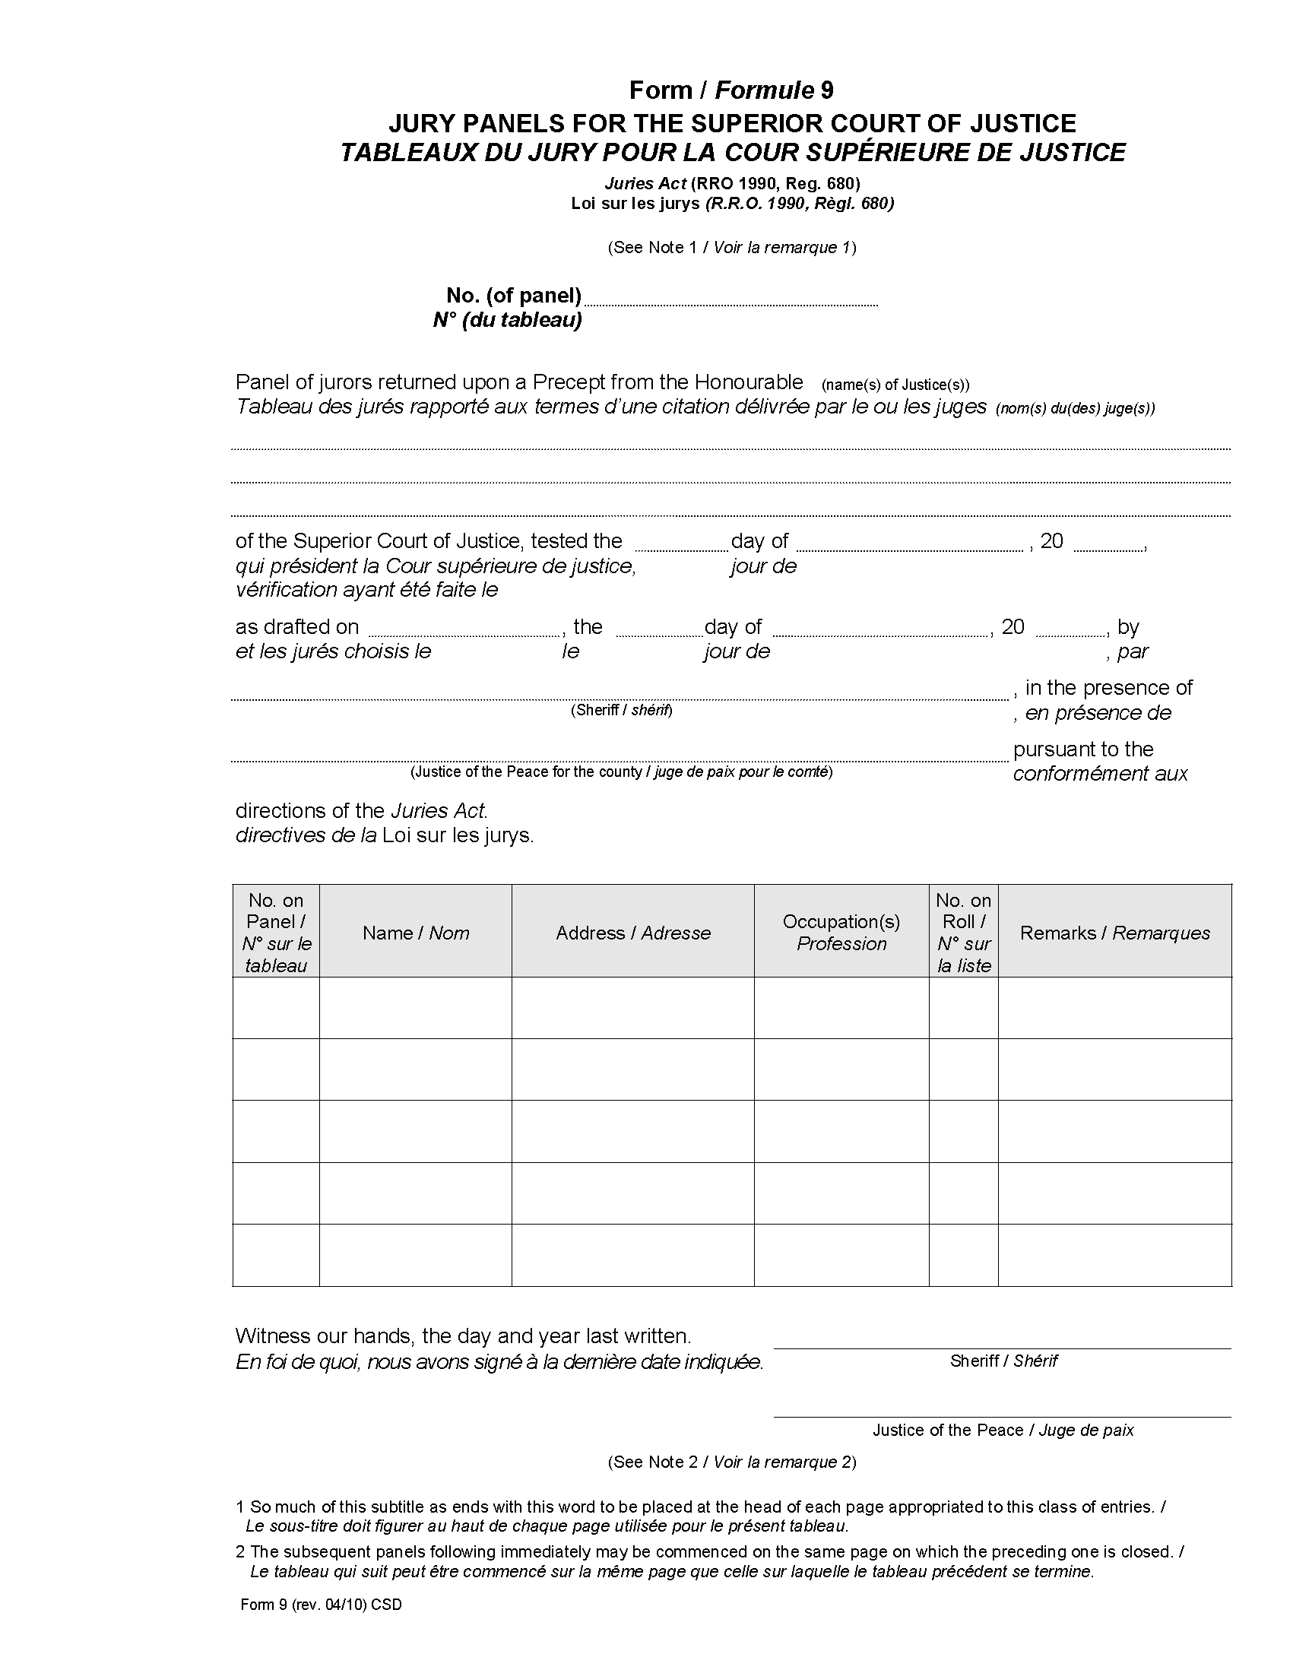
O. Reg. 231/10, s. 2.

Back to top

