Marriage Act
Loi sur le mariage
R.R.O. 1990, REGULATION 738
Amended to O. Reg. 301/04
GENERAL
Historical version for the period October 1, 2004 to June 12, 2005.
Disclaimer: The HTML version of this consolidation is not an official copy of the law because some portion of it may not be fully legible. The Word version remains an official copy of the law.
This Regulation is made in English only.
1. (1) Where there is an application for a licence in Form 2,
(a) both applicants for the licence shall complete Form 3 and Form 4; or
(b) both applicants for the licence shall complete Form 3 and one of the applicants shall complete Form 4, and
(i) produce to the issuer the birth certificate of the other applicant, or
(ii) deposit with the issuer Form 5 completed by the other applicant. R.R.O. 1990, Reg. 738, s. 1 (1).
(2) Form 6 is the consent prescribed for the purposes of subsection 5 (2) of the Act. R.R.O. 1990, Reg. 738, s. 1 (2).
(3) Subject to section 16 of the Act, an applicant for a licence shall pay a fee of $75 on the issue of the licence. O. Reg. 418/96, s. 1.
(4) Where both applicants for a licence are Indians to whom section 16 of the Act applies, one of the applicants shall complete Form 8. R.R.O. 1990, Reg. 738, s. 1 (4).
1.1 For the purposes of subsection 24 (1) of the Act, the clerk of a local municipality is authorized to solemnize marriages under the authority of a licence. O. Reg. 285/04, s. 1.
2. (1) The parties to the marriage shall complete the particulars in Form 7 and leave it with the person who will solemnize the marriage or who will perform the duties imposed by the Act in accordance with subsection 20 (4) of the Act. R.R.O. 1990, Reg. 738, s. 2 (1).
(2) Form 7 and Form 9 shall be completed by,
(a) the parties to a marriage;
(b) two witnesses to the marriage; and
(c) the person who solemnized the marriage or who performed the duties imposed by the Act in accordance with subsection 20 (4) of the Act. R.R.O. 1990, Reg. 738, s. 2 (2).
(3) Every person who solemnizes a marriage or who performs the duties imposed by the Act in accordance with subsection 20 (4) of the Act shall forward Form 7 duly completed in accordance with subsections (1) and (2) to the Registrar General within two days following the day of the marriage. R.R.O. 1990, Reg. 738, s. 2 (3).
3. (1) A fee of $75 is payable for the solemnization of a marriage by a judge or a justice of the peace. O. Reg. 418/96, s. 2.
(2) The judge or justice of the peace who receives the fee shall remit it to the Minister of Finance. O. Reg. 418/96, s. 2.
3.1 Revoked: O. Reg. 441/98, s. 2.
4. The duties of an issuer of licences are,
(a) to requisition from the Minister and maintain on hand sufficient supplies of licences and other forms prescribed by the regulations; and
(b) to ensure that every applicant for a licence is aware of the prohibited degrees of affinity and consanguinity set out in the Form to the Act. R.R.O. 1990, Reg. 738, s. 4.
5. (1) For each licence issued, the issuer of the licence shall remit $48 to the Minister of Finance and retain $27. O. Reg. 418/96, s. 3.
(2) Where the issuer is the clerk of a municipality, the council of the municipality may commute the issuer’s fees provided for in subsection (1) for a fixed sum payable annually by the municipality to the issuer, in which case the fees that would otherwise be retained by the issuer shall belong to the municipality. R.R.O. 1990, Reg. 738, s. 5 (2).
(3) Where the council and the issuer do not agree upon the amount of the commutation, the amount may be fixed by a judge. R.R.O. 1990, Reg. 738, s. 5 (3).
6. Revoked: O. Reg. 301/04, s. 1.
Form Revoked: 1998, c. 18, Sched. E, s. 182.
Form 2
MINISTER OF CONSUMER AND COMMERCIAL RELATIONS AND REGISTRAR GENERAL
Marriage Act
Insert regs\graphics\1990\738\738002au.tif
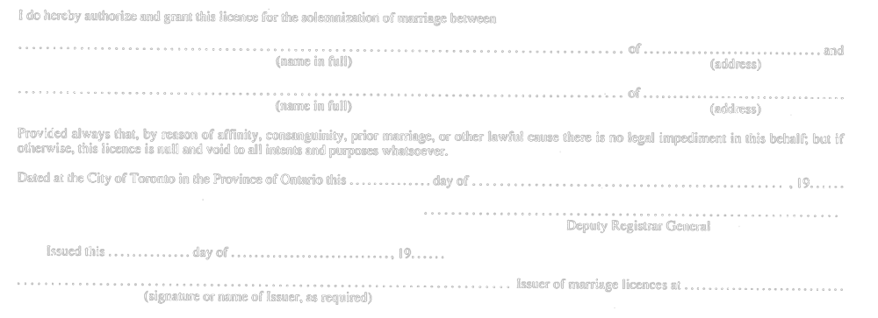
R.R.O. 1990, Reg. 738, Form 2.
Form 3
MARRIAGE LICENCE APPLICATION
Marriage Act
Insert regs\graphics\1990\738\738003au.tif
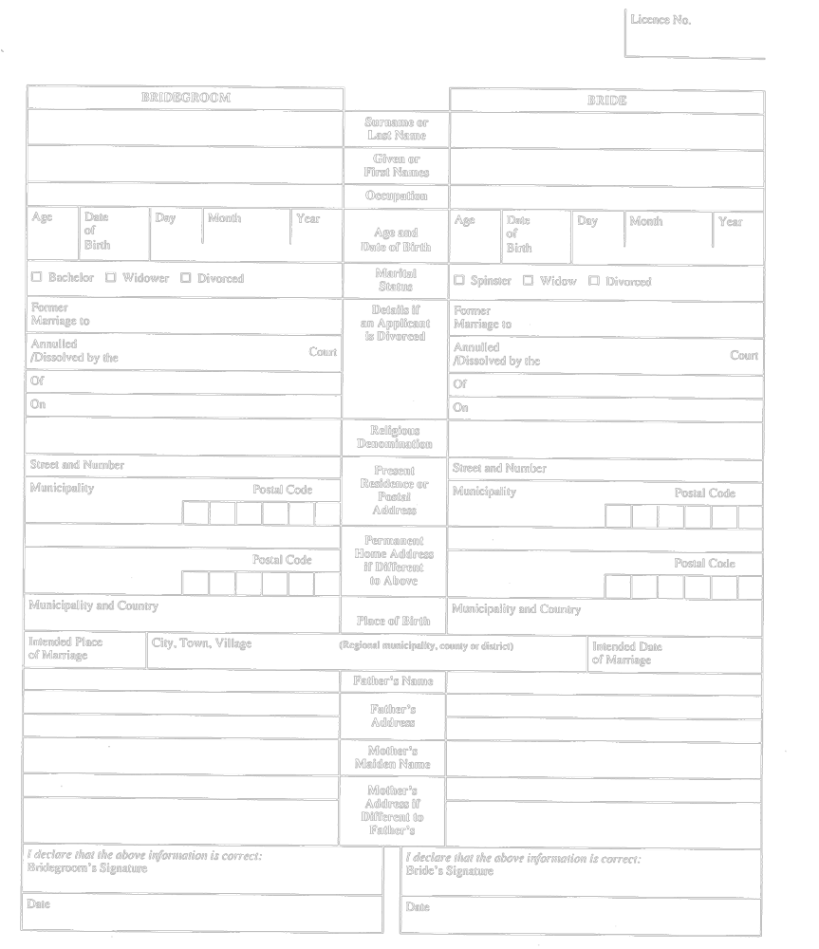
R.R.O. 1990, Reg. 738, Form 3.
Form 4
AFFIDAVIT
Marriage Act
Insert regs\graphics\1990\738\738004au.tif
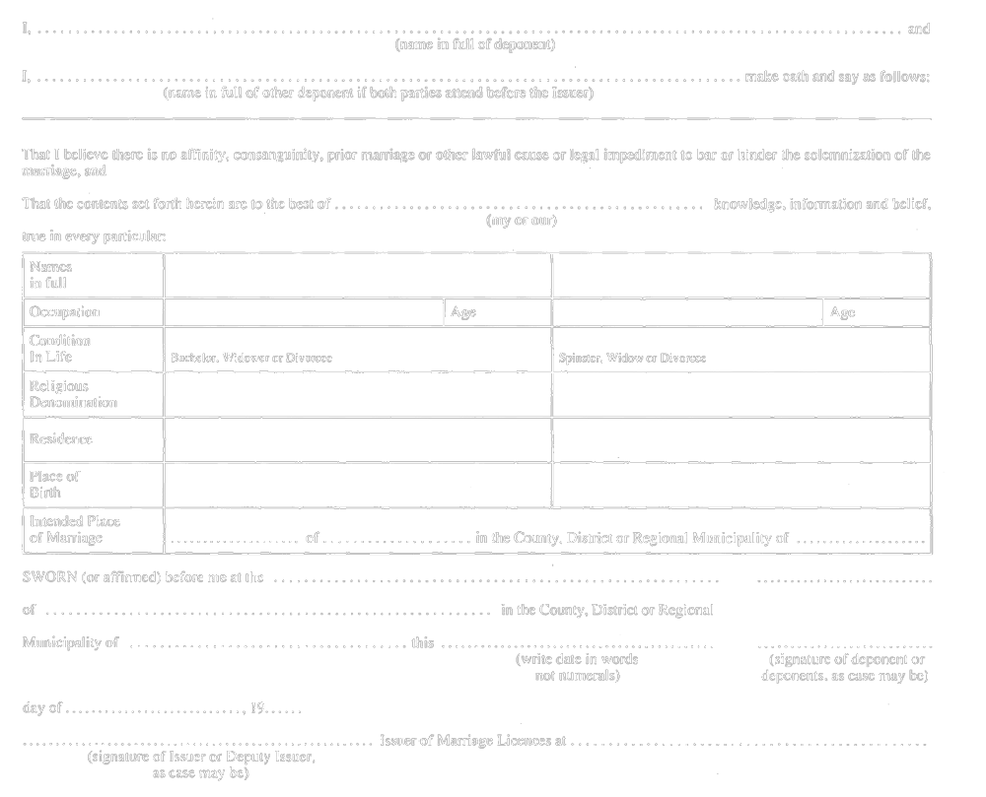
R.R.O. 1990, Reg. 738, Form 4.
Form 5
AFFIDAVIT OF AGE
Marriage Act
Insert regs\graphics\1990\738\738005au.tif
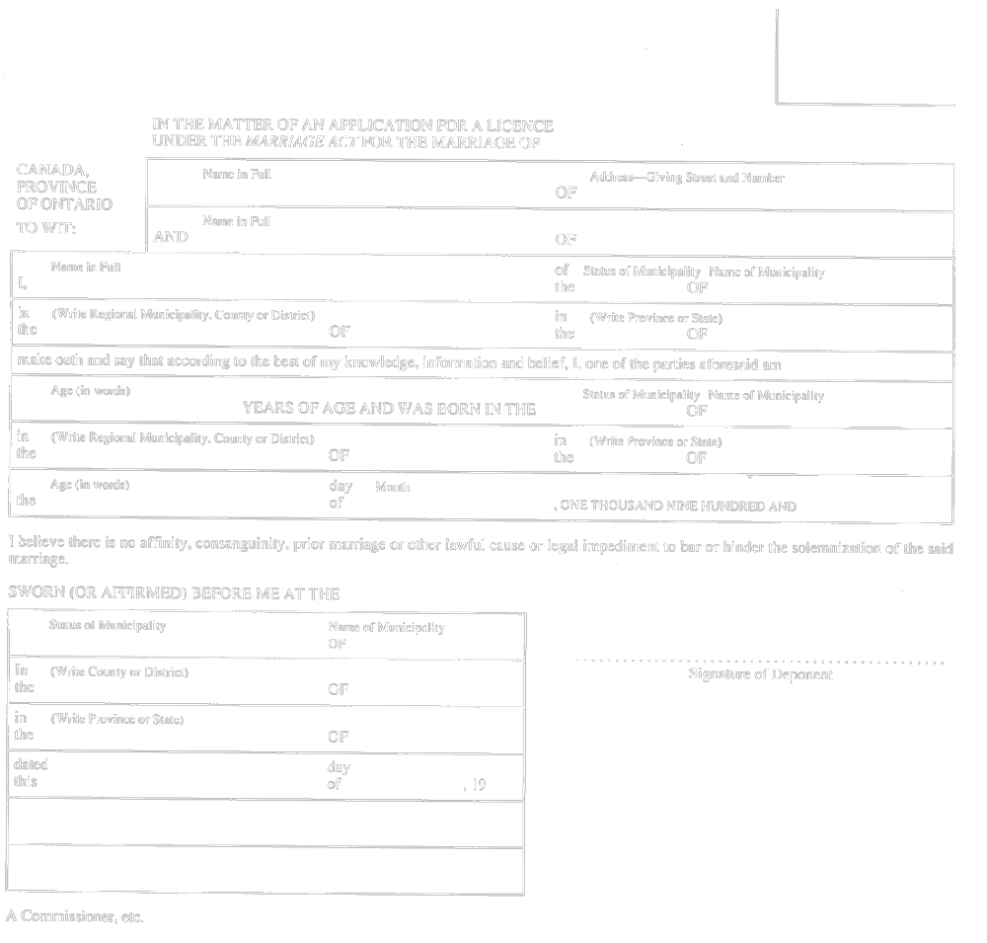
R.R.O. 1990, Reg. 738, Form 5.
Form 6
CONSENT OF PARENT OR GUARDIAN TO MARRIAGE
Marriage Act
Insert regs\graphics\1990\738\738006au.tif
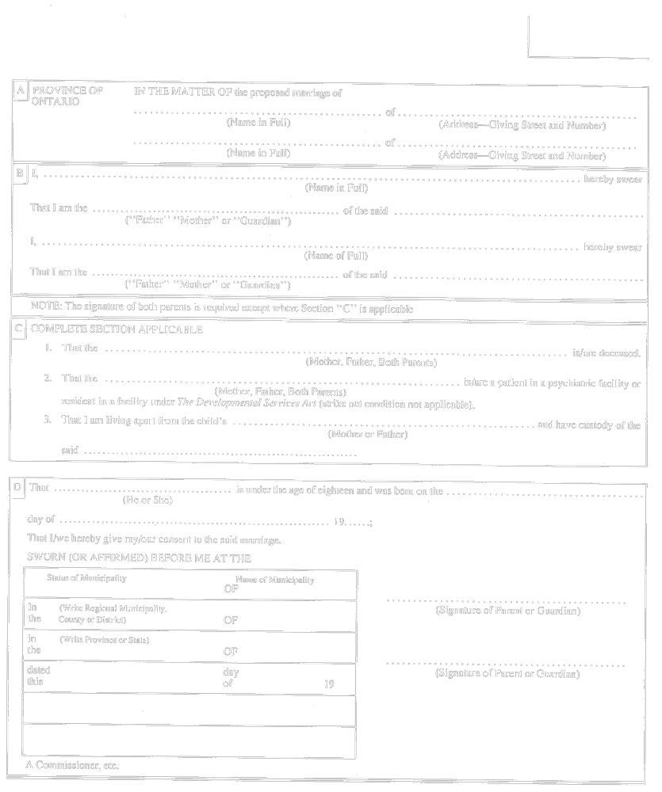
R.R.O. 1990, Reg. 738, Form 6.
Form 7
STATEMENT OF MARRIAGE
Marriage Act
Insert regs\graphics\1990\738\738007au.tif
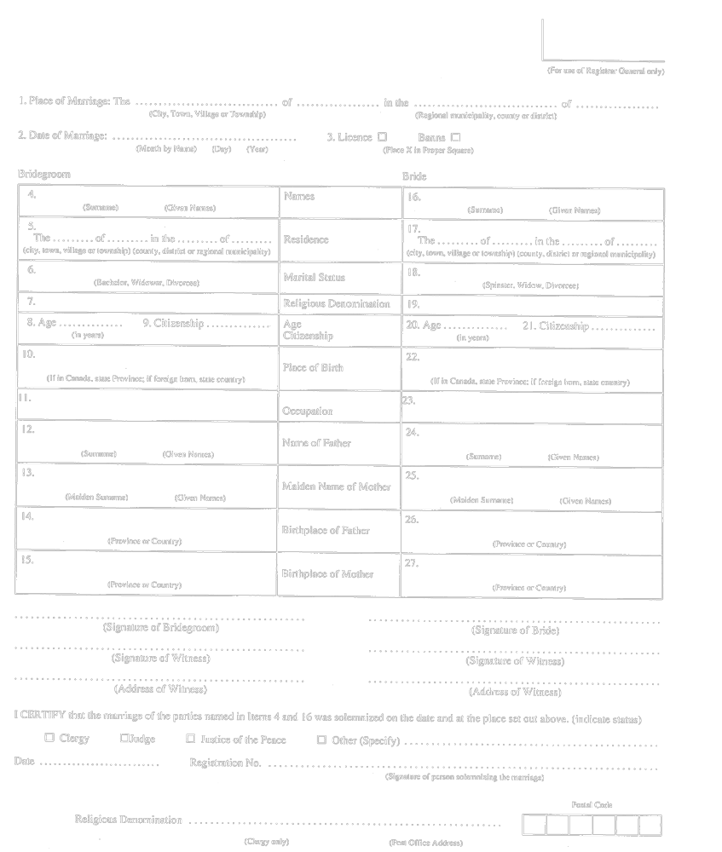
R.R.O. 1990, Reg. 738, Form 7.
Form 8
AFFIDAVIT BY INDIAN
Marriage Act
Insert regs\graphics\1990\738\738008au.tif
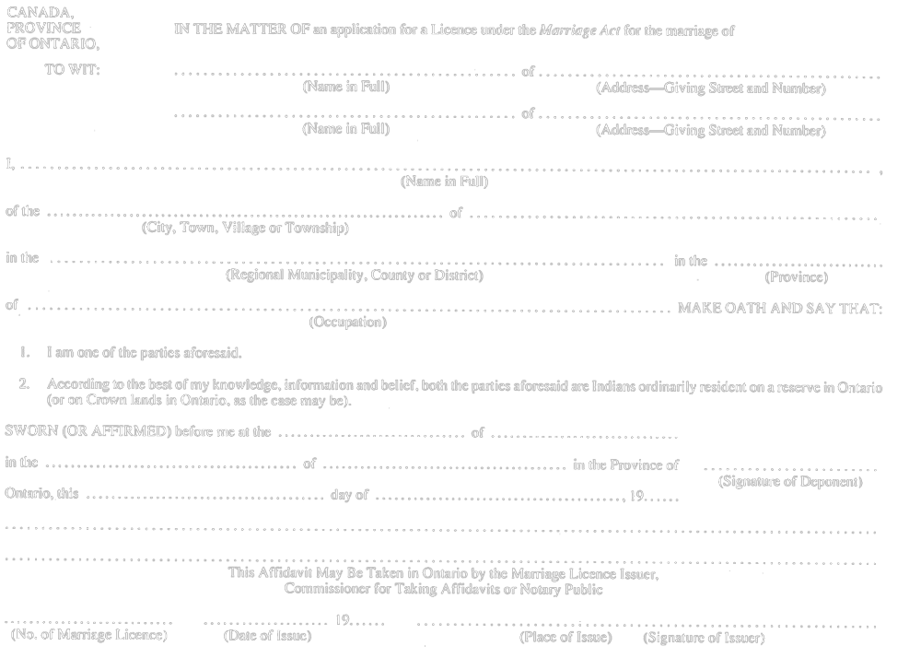
R.R.O. 1990, Reg. 738, Form 8.
Form 9
PARTICULARS OF MARRIAGE
Marriage Act
Insert regs\graphics\1990\738\738009au.tif
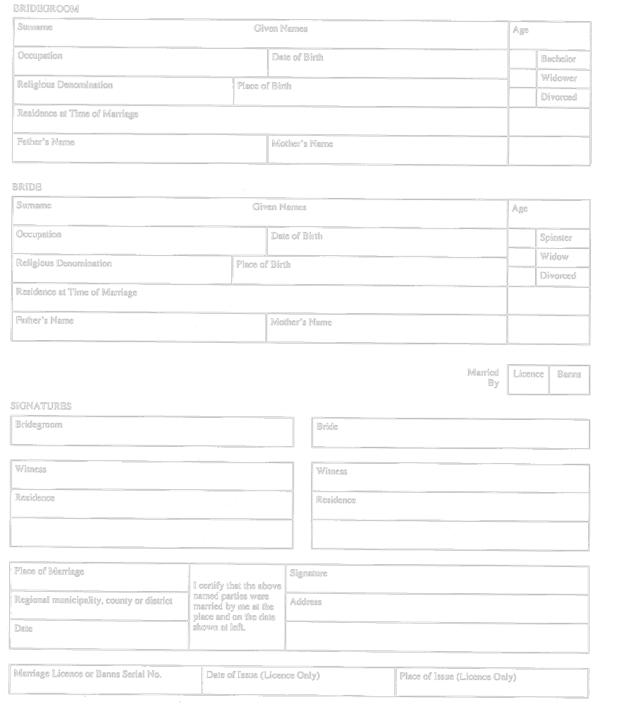
R.R.O. 1990, Reg. 738, Form 9.

Back to top

