Motor Vehicle Accident Claims Act
Loi sur l’indemnisation des victimes d’accidents de véhicules automobiles
R.R.O. 1990, REGULATION 800
Amended to O. Reg. 208/04
GENERAL
Historical version for the period July 22, 2004 to August 31, 2004.
This Regulation is made in English only.
Fees and Forms
1. The fee payable by a person under subsection 2 (2) of the Act is 50 cents for each six-month period or part of a six-month period during which the licence is valid. R.R.O. 1990, Reg. 800, s. 1; O. Reg. 152/94, s. 1; O. Reg. 252/97, s. 1.
Note: On September 1, 2004, section 1 is amended by striking out “50 cents” and substituting “$1.50”. See: O. Reg. 208/04, ss. 1, 5.
2. The application referred to in subsection 7 (1) of the Act shall be in Form 1. R.R.O. 1990, Reg. 800, s. 2.
Note: On September 1, 2004, section 2 is revoked and the following substituted:
2. The application referred to in subsection 7 (1) of the Act shall be in Form 1, which form is available on the website of the Financial Services Commission of Ontario. O. Reg. 208/04, s. 2.
See: O. Reg. 208/04, ss. 2, 5.
3. (1) A person indebted to the Fund who is making repayment to the Fund in instalments may apply for the restoration of the person’s driver’s licence. R.R.O. 1990, Reg. 800, s. 3 (1).
(2) An application for the restoration of a person’s driver’s licence shall be in Form 2 and shall be filed with the Director. R.R.O. 1990, Reg. 800, s. 3 (2).
Note: On September 1, 2004, subsection (2) is revoked and the following substituted:
(2) An application for the restoration of a person’s driver’s licence shall be in a form approved by the Director and shall be filed with the Director. O. Reg. 208/04, s. 3 (1).
See: O. Reg. 208/04, ss. 3 (1), 5.
(3) A person filing an application under subsection (2) who owns a motor vehicle shall file with the application,
(a) a certificate of insurance for the motor vehicle; and
(b) an undertaking and authorization in Form 3. R.R.O. 1990, Reg. 800, s. 3 (3).
Note: On September 1, 2004, clause (b) is revoked and the following substituted:
(b) an undertaking and authorization in a form approved by the Director.
See: O. Reg. 208/04, ss. 3 (2), 5.
(4) A person filing an application under subsection (2) who does not own a motor vehicle shall file with the application an undertaking and authorization in Form 4. R.R.O. 1990, Reg. 800, s. 3 (4).
Note: On September 1, 2004, subsection (4) is revoked and the following substituted:
(4) A person filing an application under subsection (2) who does not own a motor vehicle shall file with the application an undertaking and authorization in a form approved by the Director. O. Reg. 208/04, s. 3 (3).
See: O. Reg. 208/04, ss. 3 (3), 5.
(5) In subsections (3) and (4),
“certificate of insurance” means a certificate issued under a motor vehicle liability policy issued by an insurer licensed under the Insurance Act. R.R.O. 1990, Reg. 800, s. 3 (5).
Instalment Payments
4. (1) The amount of monthly instalment payments by an applicant for the restoration of a driver’s licence shall be agreed upon by the applicant and the Director. R.R.O. 1990, Reg. 800, s. 4 (1).
(2) Subject to subsection (3), the minimum amount of monthly instalment payments shall be 10 per cent of an applicant’s gross monthly earnings. R.R.O. 1990, Reg. 800, s. 4 (2).
(3) If the Director considers that the monthly instalment payments required by subsection (2) would cause an applicant undue hardship, the Director may permit the applicant to make payments that are less than those required by subsection (2). R.R.O. 1990, Reg. 800, s. 4 (3).
5. It is a condition for the restoration of a licence that where the income or financial worth of an indebted person significantly changes, the indebted person, when so required by the Director, shall submit a new proposal that, with such amendment as the Director may make, shall be substituted for the previous proposal and payments under the new proposal shall be the instalment payments referred to in section 11 of the Act. R.R.O. 1990, Reg. 800, s. 5.
6. Every instalment payment shall be made in cash or by certified cheque, bank draft or money order payable to the Minister of Finance and shall be received by the Director not later than the tenth day after the date on which the Director requests removal of suspension of the driver’s licence of the person indebted to the Fund and on that day of each subsequent month until the total indebtedness owing to the Fund is discharged. R.R.O. 1990, Reg. 800, s. 6.
Form 1
ministry of consumer and commercial relations the motor vehicle accident claims fund
Motor Vehicle Accident Claims Act
Insert regs\graphics\1990\800\800001au.tif
Insert regs\graphics\1990\800\800001bu.tif
Insert regs\graphics\1990\800\800001cu.tif
Insert regs\graphics\1990\800\800001du.tif
Insert regs\graphics\1990\800\800001eu.tif
R.R.O. 1990, Reg. 800, Form 1.
Note: On September 1, 2004, Form 1 is revoked. See: O. Reg. 208/04, ss. 4, 5.
Form 2
application for the restoration of a driver’s licence
Motor Vehicle Accident Claims Act
Insert regs\graphics\1990\800\800002au.tif
Insert regs\graphics\1990\800\800002bu.tif
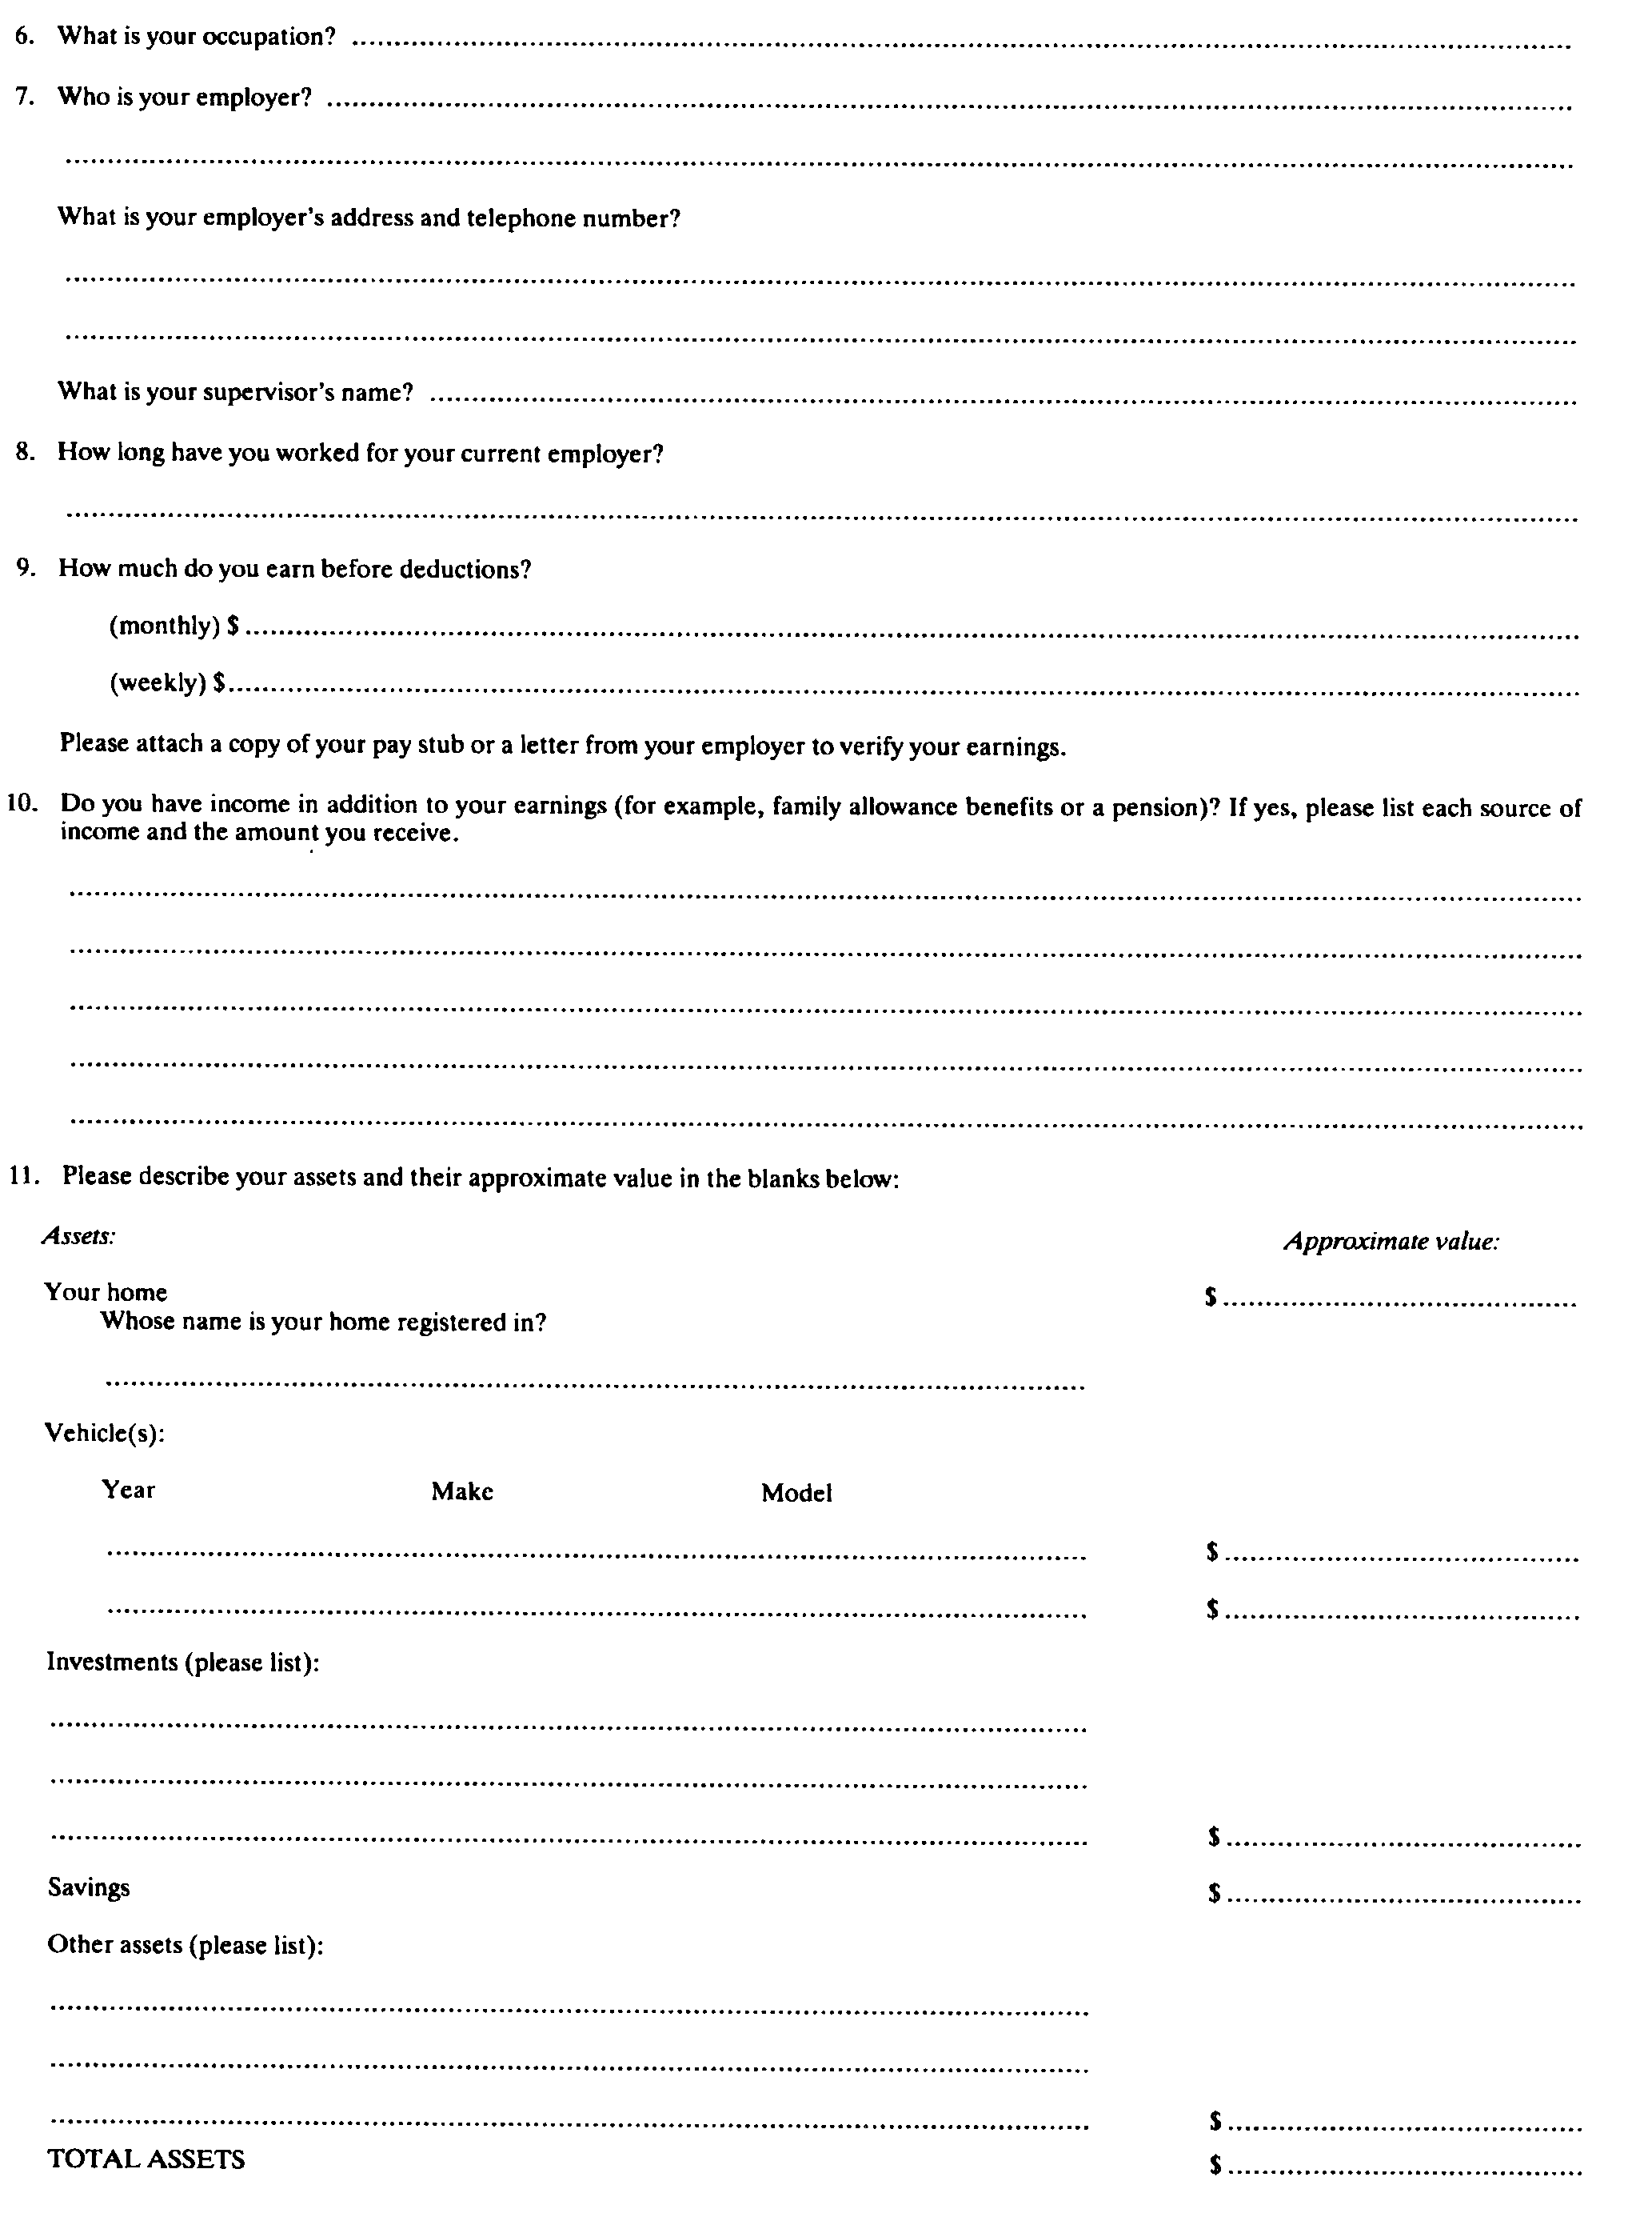
Insert regs\graphics\1990\800\800002cu.tif
R.R.O. 1990, Reg. 800, Form 2.
Note: On September 1, 2004, Form 2 is revoked. See: O. Reg. 208/04, ss. 4, 5.
Form 3
undertaking and authorization by a person who owns a motor vehicle
Motor Vehicle Accident Claims Act
Insert regs\graphics\1990\800\800003au.tif
Insert regs\graphics\1990\800\800003bu.tif
R.R.O. 1990, Reg. 800, Form 3.
Note: On September 1, 2004, Form 3 is revoked. See: O. Reg. 208/04, ss. 4, 5.
Form 4
undertaking and authorization by a person who does not own a motor vehicle
Motor Vehicle Accident Claims Act
Insert regs\graphics\1990\800\800004au.tif
R.R.O. 1990, Reg. 800, Form 4.
Note: On September 1, 2004, Form 4 is revoked. See: O. Reg. 208/04, ss. 4, 5.
(Note: By Order in Council made February 3, 1993, the powers and duties of the Treasurer of Ontario were transferred to the Minister of Finance.)

Back to top

