Police Services Act
Loi sur les services policiers
R.R.O. 1990, REGULATION 925
No Amendments
ARBITRATION
Historical version for the period December 31, 1990 to February 17, 2005.
This Regulation is made in English only.
1. A copy of a decision of an arbitration board for filing in the Ontario Court (General Division), under subsection 124 (7) of the Act shall be in Form 1. R.R.O. 1990, Reg. 925, s. 1.
Form 1
Police Services Act
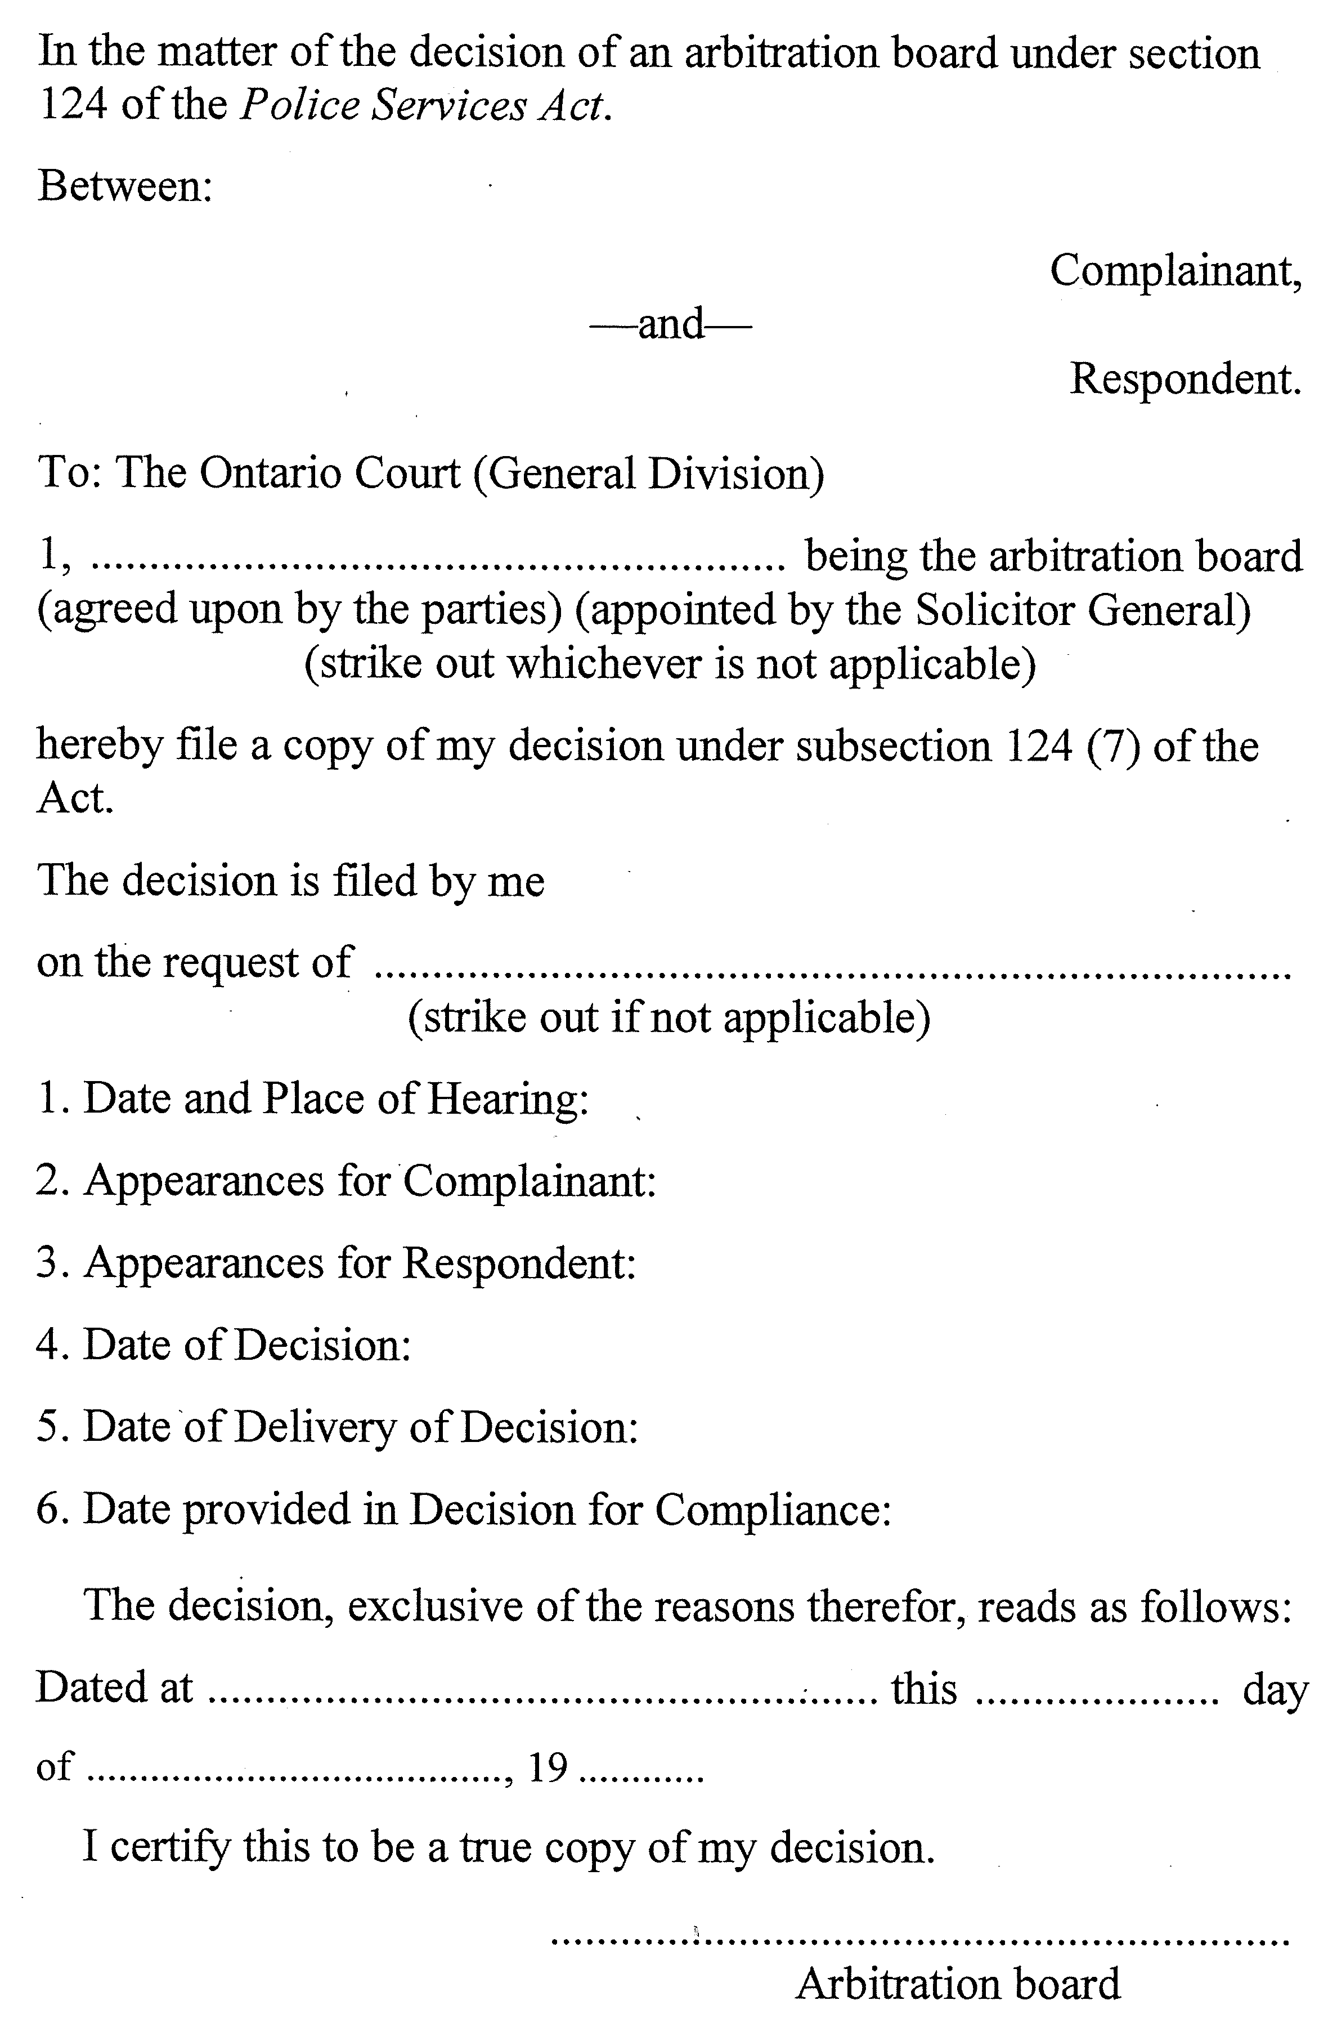
R.R.O. 1990, Reg. 925, Form 1.

Back to top

