Vital Statistics Act
Loi sur les statistiques de l’état civil
R.R.O. 1990, REGULATION 1094
Amended to O. Reg. 463/06
GENERAL
Historical version for the period September 29, 2006 to October 1, 2006.
Disclaimer: The HTML version of this consolidation is not an official copy of the law because some portion of it may not be fully legible. The Word version remains an official copy of the law.
This Regulation is made in English only.
Registration of Births
1. A notice of birth under subsection 8 (1) of the Act shall be in Form 1. R.R.O. 1990, Reg. 1094, s. 1.
Note: On January 2, 2007, section 1 is revoked and the following substituted:
1. (1) Upon the birth in Ontario of a child, the following persons shall give notice of the birth under section 8 of the Act:
1. Each legally qualified medical practitioner or midwife who attends at the birth, except if another legally qualified medical practitioner or midwife who attends at the birth gives the notice.
2. The nurse in attendance at the birth, if no legally qualified medical practitioner or midwife is in attendance at the birth. O. Reg. 401/06, s. 1.
(2) The notice of birth shall be in the form that the Registrar General requires under section 42 of the Act. O. Reg. 401/06, s. 1.
(3) The person giving the notice of birth shall deliver or mail it within two days after the day of birth to the division registrar of the registration division within which the child was born. O. Reg. 401/06, s. 1.
(4) Upon receiving the notice of birth, the division registrar shall transmit it to the Registrar General. O. Reg. 401/06, s. 1.
See: O. Reg. 401/06, ss. 1, 3 (2).
2. (1) A statement of birth under subsection 9 (2) of the Act shall be in Form 2. R.R.O. 1990, Reg. 1094, s. 2 (1).
(2) A statutory declaration under subsection 9 (4) or (5) of the Act shall be in Form 33. R.R.O. 1990, Reg. 1094, s. 2 (2).
Note: On January 2, 2007, section 2 is revoked and the following substituted:
2. (1) In this section,
“assisted conception” means conception that occurs through a means other than sexual intercourse;
“incapable” means unable, because of illness or death, to make a statement;
“other parent” means a person whom a child’s mother acknowledges as the other parent, who wishes to be acknowledged as the other parent and who agrees to certify the statement with respect to the child where the father is unknown and conception occurred through assisted conception;
“statement” means a statement mentioned in subsection (4) respecting the birth in Ontario of a child. O. Reg. 401/06, s. 1.
(2) Subject to subsection (3), for the purposes of subsection 9 (1) of the Act, either of the following groups of persons, and no other persons, are required to certify the birth in Ontario of a child:
1. The mother and the father of the child.
2. The mother and the other parent of the child. O. Reg. 401/06, s. 1.
(3) The duty in subsection 9 (1) of the Act to certify the birth in Ontario of a child does not apply to,
(a) the child’s mother, if she is incapable;
(b) the child’s father, if he is incapable or is unacknowledged by or unknown to the mother; or
(c) the child’s other parent, if the person is incapable. O. Reg. 401/06, s. 1.
(4) A person who is required to certify the birth in Ontario of a child shall make and certify a statement in the form that the Registrar General requires respecting the birth and, subject to subsection (5), shall, within 30 days of the birth, mail or deliver the statement to the division registrar of the registration division within which the child was born. O. Reg. 401/06, s. 1.
(5) If a person has applied for a court order under section 4, 5 or 6 of the Children’s Law Reform Act within 30 days of the birth in Ontario of a child, a person who is required under subsection (4) to make and certify the statement with respect to the child shall deliver the statement to the Registrar General within the earlier of,
(a) 45 days from the date on which the court finally disposes of the application, subject to whatever extension the court has granted under subsection (6); and
(b) the first anniversary of the date of birth of the child, subject to whatever extension the court has granted under subsection (6). O. Reg. 401/06, s. 1.
(6) The court may grant an extension of a time period specified in clause (5) (a) or (b). O. Reg. 401/06, s. 1.
(7) A parent who makes the statement without the other person who is a parent because that other person is incapable shall attach a statutory declaration of the fact to the statement. O. Reg. 401/06, s. 1.
(8) Another person acting on behalf of a child’s parents may make and certify the statement if,
(a) both parents are incapable; or
(b) the child’s mother is incapable and the father is,
(i) unacknowledged by the mother, or
(ii) unknown to the mother if there is no other parent of the child. O. Reg. 401/06, s. 1.
(9) A person acting on behalf of a child’s parents who makes and certifies the statement under subsection (8) shall mail or deliver the statement, together with a statutory declaration that the circumstances described in clause (8) (a) or (b) apply, to the division registrar of the registration division within which the child was born. O. Reg. 401/06, s. 1.
(10) A statement shall contain particulars of the parents listed on it. O. Reg. 401/06, s. 1.
(11) If the appropriate division registrar does not receive a statement respecting a child within the time required by subsection (4) or (5), as applicable, the Registrar General may complete, certify and register a statement. O. Reg. 401/06, s. 1.
(12) For the purposes of subsection 9 (3) of the Act, on receiving a certified copy of an order under section 4, 5 or 6 of the Children’s Law Reform Act respecting a child who was born in Ontario, but whose birth is not registered in Ontario, the Registrar General may register the child’s birth to show the particulars of the child’s parents so that the registration accords with the order. O. Reg. 401/06, s. 1.
(13) On receiving a certified copy of an order under section 97 of the Courts of Justice Act that a person is not a parent of a child who was born in Ontario, the Registrar General may consider the order in determining how to register the child’s birth or to amend the registration to show the particulars of the child’s parents. O. Reg. 401/06, s. 1.
(14) If a pregnancy results in the birth of more than one child, a separate statement shall be made in respect of the birth of each child. O. Reg. 401/06, s. 1.
(15) If a statement completed by only one parent of the child or by a person who is not the child’s parent is registered, any parent or both parents of the child may apply to the Registrar General under subsection 9 (6) of the Act to amend the statement. O. Reg. 401/06, s. 1.
(16) A parent who applies to amend the statement without the other person who is a parent shown on the statement or who will be a parent shown on the statement once amended may do so only if that other person is incapable and the applicant attaches a statutory declaration to the application stating that the other person is incapable. O. Reg. 401/06, s. 1.
(17) Sections 8, 9, 10, 11, 12, 13, 17, 21, 22, 23, 24, 25, 26 and 27 of the Act and this section and sections 1, 3 to 15 and 35 to 47 of this Regulation apply with necessary modifications to still-births. O. Reg. 401/06, s. 1.
See: O. Reg. 401/06, ss. 1, 3 (2).
3. (1) An application under subsection 9 (9) of the Act to amend a statement of birth shall be in Form 34. R.R.O. 1990, Reg. 1094, s. 3 (1).
(2) A statutory declaration under subsection 9 (11) of the Act shall be in Form 33. R.R.O. 1990, Reg. 1094, s. 3 (2).
Note: On January 2, 2007, section 3 is revoked and the following substituted:
3. (1) For the purposes of subsection 9 (2) of the Act, a person who finds a new-born deserted child or who has received custody or care and control of an abandoned child shall provide the information concerning the birth of the child that the person possesses. O. Reg. 401/06, s. 1.
(2) The person shall provide the information to the division registrar of the registration division, within which the child is found, within seven days after finding the child or receiving custody or care and control of the child. O. Reg. 401/06, s. 1.
See: O. Reg. 401/06, ss. 1, 3 (2).
4. An application under subsection 13 (1) of the Act to register the birth of a child that has not been registered within one year from the date of birth shall be in Forms 4 and 5. R.R.O. 1990, Reg. 1094, s. 4.
5. A statement under clause 13 (2) (b) of the Act shall be in Form 4. R.R.O. 1990, Reg. 1094, s. 5.
6. A statutory declaration under clause 13 (2) (c) of the Act shall be in Form 5. R.R.O. 1990, Reg. 1094, s. 6.
7. (1) Subject to section 9, there shall be filed with the Registrar General under clause 13 (2) (d) of the Act at least one item of Class A evidence of birth. R.R.O. 1990, Reg. 1094, s. 7 (1).
(2) The evidence under clauses 8 (a) to (e) shall set out the date and place of birth and the names of either or both parents. R.R.O. 1990, Reg. 1094, s. 7 (2).
8. Class A evidence of birth consists of,
(a) a copy of the hospital record of the birth, certified by a competent official of the hospital;
(b) a copy of the record of the legally qualified medical practitioner or nurse in attendance at the birth, certified by the practitioner or nurse, as the case may be;
(c) a notarial copy of the record of the legally qualified medical practitioner or nurse in attendance at the birth;
(d) a baptismal certificate or other church record of the birth or a notarial copy of a baptismal certificate or other church record of the birth, if the baptism took place or the record was made not later than four years after the birth;
(e) an insurance policy on the life of the child, taken out before the child was more than four years of age;
(f) a newspaper, a notarial copy thereof or a notarial extract therefrom, containing,
(i) the date of publication of the newspaper,
(ii) an announcement of the birth, made not more than fifteen days after the date of the birth, and
(iii) the date and place of the birth and the names of the parents;
(g) a certified copy of any record of a child welfare organization but only where,
(i) the organization is approved by the Deputy Minister of Community and Social Services, and
(ii) the record was made before the child was four years of age, and sets out the age of the child or the date of birth; or
(h) a notice of birth in Form 1. R.R.O. 1990, Reg. 1094, s. 8.
9. Where an applicant for registration of the birth of a child after one year from the day of the birth is unable to obtain Class A evidence of the birth, he or she may file with the Registrar General,
(a) an affidavit setting out the applicant’s attempts to obtain Class A evidence of birth, together with the correspondence he or she has had in respect of those attempts; and
(b) at least two items of Class B evidence of birth. R.R.O. 1990, Reg. 1094, s. 9.
10. (1) Class B evidence of birth consists of,
(a) at least one letter or telegram,
(i) addressed to either or both parents,
(ii) dated not more than one month after the birth, and
(iii) setting out the date of birth;
(b) a certified copy of the pay list issued by the federal Department of Indian and Inuit Affairs setting out the name of the child and the child’s age or date of birth;
(c) at least one book,
(i) addressed to the child before his or her fourth birthday, and
(ii) setting out the date of birth;
(d) a copy of any public or separate school record,
(i) setting out the name of the child and his or her age or date of birth, and
(ii) certified by the principal of the school or by a person who has custody of the record;
(e) a notarial copy of the birth entries in the family Bible but only where the certificate of the notary public sets out,
(i) that he or she has examined the family Bible,
(ii) that he or she has made an exact copy of the entries therein, and
(iii) that there have been no erasures or changes in the entries,
and, where known, in whose handwriting the entries were made;
(f) a certified copy of a census, immigration or consular record setting out the age of the child or the date of birth;
(g) a certified copy of any official health record,
(i) made before the child was twelve years of age, and
(ii) setting out the age of the child or the date of birth;
(h) a certified copy of any record of a child welfare organization but only where,
(i) the organization is approved by the Deputy Minister of Community and Social Services, and
(ii) the record was made before the child was ten years of age, and sets out the age of the child or the date of birth;
(i) an official marriage certificate setting out the date and place of birth;
(j) a baptismal certificate or other church record of the birth or a notarial copy of a baptismal certificate or other church record of the birth, where the baptism took place or the record was made after four years after the birth;
(k) affidavits of two persons, each stating,
(i) that the deponent is not related to the child,
(ii) the date when and place where the child was born,
(iii) that the deponent first saw the child not later than three months after the date of birth, or
(iv) the circumstances by which the deponent remembers the date of birth; or
(l) any other documentary evidence of birth. R.R.O. 1990, Reg. 1094, s. 10 (1).
(2) The circumstances given by the deponent under subclause (1) (k) (iv) shall be verified by documentary evidence of a death, marriage or another birth or other event. R.R.O. 1990, Reg. 1094, s. 10 (2).
(3) The affidavits under clause (1) (k) shall together be deemed to be one item of Class B evidence of birth. R.R.O. 1990, Reg. 1094, s. 10 (3).
(4) The fee for a search to provide Class B evidence of birth under clause (1) (i) and (l) and subsection (2) is $15, even though no certificate is provided to the applicant. O. Reg. 328/93, s. 1.
11. (1) An election under section 14 of the Act shall be in Form 35. R.R.O. 1990, Reg. 1094, s. 11 (1).
(2) A notice of election under subsection 14 (3) of the Act shall be in Form 36. R.R.O. 1990, Reg. 1094, s. 11 (2).
(3) An acknowledgment of notice referred to in clause 14 (5) (a) of the Act shall be in Form 37. R.R.O. 1990, Reg. 1094, s. 11 (3).
12. An election under section 15 of the Act shall be in Form 38. R.R.O. 1990, Reg. 1094, s. 12.
13. Revoked: O. Reg. 510/01, s. 1.
14. The fee for registration of the birth of a child under section 17 of the Act is $22. O. Reg. 328/91, s. 3.
15. The fee payable for an amendment of a registration of a birth in accordance with subsection 9 (9) of the Act is $22. O. Reg. 328/91, s. 4.
16. An application to set aside the registration of a birth and cause the substitution of a new registration of birth in accordance with the facts contained in an adoption order, judgment or decree shall be in Form 6 and shall have attached thereto a statement of birth in Form 2 completed and certified by one of the adopting parents. R.R.O. 1990, Reg. 1094, s. 16.
Alterations and Additions of Names in Birth Registrations
17. The fee for the addition of a forename where the child was registered without a forename is $37. O. Reg. 328/91, s. 5.
18. The fee for the alteration under section 14 of the Act of the name by which a child was registered is $37. O. Reg. 328/91, s. 5.
Registration of Still-Births
19. A notice of a still-birth shall be in Form 1. R.R.O. 1990, Reg. 1094, s. 19.
20. A statement of a still-birth under subsection 18 (1) of the Act shall be in Form 7. R.R.O. 1990, Reg. 1094, s. 20.
21. An acknowledgment of registration of a still-birth shall be in Form 3. R.R.O. 1990, Reg. 1094, s. 21.
22. A medical certificate as to the cause of a still-birth shall be in Form 8. R.R.O. 1990, Reg. 1094, s. 22.
23. An application for registration of a still-birth after one year from the date of the still-birth shall be in Form 9. R.R.O. 1990, Reg. 1094, s. 23.
24. The statutory declaration to be filed with the Registrar General upon an application for registration of a still-birth after one year from the day of the still-birth shall be in Form 10. R.R.O. 1990, Reg. 1094, s. 24.
25. (1) Subject to section 27, there shall be filed with the Registrar General upon an application for registration of a still-birth after one year from the day of the still-birth at least one item of Class A evidence of still-birth. R.R.O. 1990, Reg. 1094, s. 25 (1).
(2) The evidence under clause 26 (a), (b) or (c) shall set out the date and place of still-birth and the names of the parents. R.R.O. 1990, Reg. 1094, s. 25 (2).
26. Class A evidence of still-birth consists of,
(a) a copy of the hospital record of the still-birth, certified by a competent official of the hospital;
(b) a copy of the record of the duly qualified medical practitioner or nurse in attendance at the still-birth, certified by the practitioner or nurse, as the case may be;
(c) a notarial copy of the record of the duly qualified medical practitioner or nurse in attendance at the still-birth;
(d) a newspaper, a notarial copy thereof or a notarial extract therefrom, containing,
(i) the date of publication of the newspaper,
(ii) an announcement of the still-birth, made not more than fifteen days after the date of the still-birth, and
(iii) the date and place of the still-birth and the names of the parents;
(e) a notice of still-birth, in Form 1; or
(f) an acknowledgment of registration of still-birth, in Form 3. R.R.O. 1990, Reg. 1094, s. 26.
27. Where an applicant for registration of a still-birth after one year from the day of the still-birth is unable to obtain Class A evidence of the still-birth, he or she may file with the Registrar General,
(a) an affidavit setting out the applicant’s attempts to obtain Class A evidence of still-birth, together with the correspondence he or she has had in respect of those attempts; and
(b) at least two items of Class B evidence of still-birth. R.R.O. 1990, Reg. 1094, s. 27.
28. (1) Class B evidence of still-birth consists of,
(a) at least one letter or telegram,
(i) addressed to either or both parents,
(ii) dated not more than one month after the still-birth, and
(iii) setting out the date of still-birth;
(b) a notarial copy of the birth and still-birth entries in the family Bible but only where the certificate of the notary public sets out,
(i) that he or she has examined the family Bible,
(ii) that he or she has made an exact copy of the entries therein, and
(iii) that there have been no erasures or changes in the entries,
and, where known, in whose handwriting the entries were made;
(c) affidavits of two persons, each stating,
(i) that the deponent is not related to the still-born child,
(ii) the date when and place where the still-birth occurred, and
(iii) the circumstances by which the deponent remembers the date of the still-birth; or
(d) any other documentary evidence of still-birth. R.R.O. 1990, Reg. 1094, s. 28 (1).
(2) The circumstances given by the deponent under subclause (1) (c) (iii) shall be verified by documentary evidence of a birth, death, marriage or another still-birth or other event. R.R.O. 1990, Reg. 1094, s. 28 (2).
(3) The affidavits under clause (1) (c) shall together be deemed to be one item of Class B evidence of still-birth. R.R.O. 1990, Reg. 1094, s. 28 (3).
29. The fee for registration of a still-birth that has not been registered within one year from the day of the still-birth is $22. O. Reg. 328/91, s. 6.
Registration of Marriage
30. An acknowledgment of receipt of a statement of marriage under subsection 19 (2) of the Act shall be in Form 11. R.R.O. 1990, Reg. 1094, s. 30.
31. (1) Where a marriage has not been registered within one year of the day of the marriage, application for the registration of the marriage may be made to the Registrar General by either party to the marriage or by any other person. R.R.O. 1990, Reg. 1094, s. 31 (1).
(2) The application shall,
(a) be in the form required by the Registrar General; and
(b) be accompanied by,
(i) particulars of the marriage in the form required by the Registrar General,
(ii) a statutory declaration by the applicant in the form required by the Registrar General,
(iii) a fee of $22, and
(iv) one item of Class A evidence of marriage or at least two items of Class B evidence of marriage. R.R.O. 1990, Reg. 1094, s. 31 (2); O. Reg. 328/91, s. 7; O. Reg. 303/05, s. 1.
32. Class A evidence of marriage consists of,
(a) a notarial copy of the record of the marriage in the marriage register of the church where solemnized;
(b) a certified copy of the record of the marriage in the marriage register of the church where the marriage was solemnized;
(c) an affidavit of the person solemnizing the marriage, setting out the names of the parties and the date and place of their marriage; or
(d) an acknowledgment of receipt of a statement of marriage in Form 11. R.R.O. 1990, Reg. 1094, s. 32.
33. Where an applicant for registration of a marriage not registered within one year of the day of marriage is unable to obtain Class A evidence of the marriage, he or she may file with the Registrar General,
(a) an affidavit setting out the applicant’s attempts to obtain Class A evidence of the marriage, together with the correspondence he or she has had in respect thereto; and
(b) at least two items of Class B evidence of marriage. R.R.O. 1990, Reg. 1094, s. 33.
34. (1) Class B evidence of marriage consists of,
(a) a telegram dated the day of the marriage and addressed to either or both parties to the marriage;
(b) a wedding invitation or wedding announcement setting out the date and place of marriage and the names of the parties;
(c) a newspaper, a notarial copy thereof or a notarial extract therefrom, containing,
(i) the date of publication of the newspaper, and
(ii) an announcement of the marriage, the date and place thereof and the names of the parties;
(d) affidavits of two persons other than parties to the marriage, each stating,
(i) the date and place of the marriage and the names of the parties, and
(ii) that the deponent was present at the marriage ceremony; or
(e) any other documentary evidence of the marriage. R.R.O. 1990, Reg. 1094, s. 34 (1).
(2) The affidavits referred to in clause (1) (d) shall together be deemed to be one item of Class B evidence of marriage. R.R.O. 1990, Reg. 1094, s. 34 (2).
Registration of Deaths
35. A statement of a death under subsection 21 (2) of the Act shall be in Form 15. R.R.O. 1990, Reg. 1094, s. 35.
36. The notice of registration of a death or still-birth under clause 39 (p) of the Act shall be in Form 17. R.R.O. 1990, Reg. 1094, s. 36.
37. A medical certificate of a death under subsection 21 (3) or (4) of the Act shall be in Form 16. R.R.O. 1990, Reg. 1094, s. 37.
37.1 For the purposes of subsection 21 (3.1) of the Act, a registered nurse who holds an extended certificate of registration under the Nursing Act, 1991 shall comply with that subsection if,
(a) the nurse has had primary responsibility for the care of the deceased during the last illness of the deceased;
(b) the death was expected during the last illness of the deceased;
(c) there was a documented medical diagnosis of a terminal disease for the deceased made by a legally qualified medical practitioner during the last illness of the deceased;
(d) there was a predictable pattern of decline for the deceased during the last illness of the deceased; and
(e) there were no unexpected events or unexpected complications during the last illness of the deceased. O. Reg. 176/01, s. 1.
38. An acknowledgment of registration of a death under clause 22 (3) (a) of the Act shall be in Form 18. R.R.O. 1990, Reg. 1094, s. 38.
39. A burial permit under clause 22 (3) (b) of the Act shall be in Form 19. R.R.O. 1990, Reg. 1094, s. 39.
40. The fee for registration in another registration division under subsection 23 (1) of the Act is $10. R.R.O. 1990, Reg. 1094, s. 40.
41. An application for registration of a death after one year from the day of the death shall be in Form 20. R.R.O. 1990, Reg. 1094, s. 41.
42. The statutory declaration to be filed with the Registrar General under clause 27 (2) (c) of the Act shall be in Form 21. R.R.O. 1990, Reg. 1094, s. 42.
43. (1) Subject to section 45, there shall be filed with the Registrar General under clause 27 (2) (d) of the Act at least one item of Class A evidence of death. R.R.O. 1990, Reg. 1094, s. 43 (1).
(2) The evidence under clause 44 (a) or (b) shall set out the date and place of death and the name of the deceased. R.R.O. 1990, Reg. 1094, s. 43 (2).
44. Class A evidence of death consists of,
(a) a medical certificate of death, in Form 16;
(b) a notarial copy of the record of the funeral director; or
(c) an acknowledgment of registration of death, in Form 18. R.R.O. 1990, Reg. 1094, s. 44.
45. Where an applicant for registration of a death after one year from the day of the death is unable to obtain Class A evidence of the death, he or she may file with the Registrar General,
(a) an affidavit setting out the applicant’s attempts to obtain Class A evidence of the death, together with the correspondence he or she has had in respect thereto; and
(b) at least two items of Class B evidence of death. R.R.O. 1990, Reg. 1094, s. 45.
46. (1) Class B evidence of a death consists of,
(a) a letter or telegram,
(i) addressed to the applicant or a relative of the deceased,
(ii) dated not more than one month after the death, and
(iii) setting out the date of death and the name of the deceased;
(b) a newspaper, a notarial copy thereof or a notarial extract therefrom, containing,
(i) the date of publication of the newspaper, and
(ii) an announcement of the death, the date and place thereof, and the name of the deceased;
(c) a notarial copy of a burial permit or any cemetery record that sets forth the name of the deceased and the date of death;
(d) affidavits of two persons, each stating,
(i) the name of the deceased and the date and place of death,
(ii) the relationship between the deponent and the deceased, and
(iii) that the deponent was present at the funeral and saw the body of the deceased; or
(e) any documentary evidence of death. R.R.O. 1990, Reg. 1094, s. 46 (1).
(2) The affidavits referred to in clause (1) (d) shall together be deemed to be one item of Class B evidence of death. R.R.O. 1990, Reg. 1094, s. 46 (2).
47. The fee for registration of a death that is not registered within one year from the day of the death is $22. O. Reg. 328/91, s. 8.
48. Revoked: O. Reg. 303/05, s. 2.
Change of Sex Designation
49. (1) An application under section 36 of the Act to have the designation of sex on the registration of birth changed shall be in Form 40. R.R.O. 1990, Reg. 1094, s. 49 (1).
(2) The fee for an application under subsection 36 (1) of the Act to change the designation of sex on the registration of birth is $37. O. Reg. 328/91, s. 9.
(3) A medical certificate under clause 36 (2) (a) of the Act shall be in Form 41. R.R.O. 1990, Reg. 1094, s. 49 (3).
(4) A medical certificate under clause 36 (2) (b) of the Act shall be in Form 42. R.R.O. 1990, Reg. 1094, s. 49 (4).
Correction of Errors in Registrations
50. The statutory declaration referred to in subsection 34 (3) of the Act shall be in Form 23. R.R.O. 1990, Reg. 1094, s. 50.
51. The fee for a correction by the Registrar General under subsection 34 (3) of the Act of an error in a registration is $22. O. Reg. 328/91, s. 10.
52. (1) The fee for a search for the purpose of producing evidence to the Registrar General in support of an application to correct an error in registration is $15 even though no certificate is provided to the applicant. O. Reg. 328/93, s. 2.
(2) The fee under subsection (1) is payable for each search within each five-year period in respect of each name. O. Reg. 328/93, s. 2.
Substitution of Registration
53. The statutory declaration referred to in subsection 35 (1) of the Act shall be in Form 24. R.R.O. 1990, Reg. 1094, s. 53.
54. The fee for a new registration under subsection 35 (1) of the Act is $22. O. Reg. 328/91, s. 12.
Registration Divisions
55. (1) The territorial districts of Ontario are divided into ninety-three registration divisions, each of which is described in one of the Schedules. R.R.O. 1990, Reg. 1094, s. 55 (1).
(2) In the Schedules,
“township”, except where otherwise provided, means geographic township. R.R.O. 1990, Reg. 1094, s. 55 (2).
(3) In the Schedules, a reference to a lettered township, a numbered township or a numbered and lettered township, whether in a range or otherwise, is a reference to that township as it was so designated on the 2nd day of July, 1975. R.R.O. 1990, Reg. 1094, s. 55 (3).
(4) Every Indian agent in Ontario is authorized to act, by virtue of office, as division registrar for the Indians under the agent’s jurisdiction. R.R.O. 1990, Reg. 1094, s. 55 (4).
(5) In this section,
“Schedules” means the Schedules to Regulation 942 of the Revised Regulations of Ontario, 1980, as those Schedules existed on the 31st day of December, 1990. R.R.O. 1990, Reg. 1094, s. 55 (5).
Duties of Division Registrars
56. A division registrar shall transmit to the Registrar General at the beginning of each week,
(a) the statements of personal particulars;
(b) notices of births and still-births;
(c) medical certificates as to the cause of still-births; and
(d) medical certificates of deaths,
received by the division registrar in respect of the registrations made by the division registrar of births, deaths and still-births during the preceding week. R.R.O. 1990, Reg. 1094, s. 56.
57. (1) The division registrar shall keep separate indexes for registrations of births, deaths and still-births. R.R.O. 1990, Reg. 1094, s. 57 (1).
(2) The index for registrations of birth shall contain the following particulars of each birth:
1. Name of the child.
2. Date of birth.
3. Place of birth.
4. Sex.
5. Date of registration.
6. Registration No.
7. Name and post office address of,
i. the person who completed the statement of birth, and
ii. the legally qualified medical practitioner or nurse in attendance at the birth. R.R.O. 1990, Reg. 1094, s. 57 (2).
(3) The index for registrations of deaths shall contain the following particulars of each death:
1. Name of deceased.
2. Date of death.
3. Place of death.
4. Cause of death.
5. Sex.
6. Date of registration.
7. Registration No.
8. Name and post office address of,
i. the person who completed the statement of death,
ii. the legally qualified medical practitioner or coroner who completed the medical certificate of death, and
iii. the funeral director in charge of the body. R.R.O. 1990, Reg. 1094, s. 57 (3).
(4) The index for registrations of still-births shall contain the following particulars of each still-birth:
1. Name of the still-born child.
2. Date of still-birth.
3. Place of still-birth.
4. Sex.
5. Date of registration.
6. Registration No.
7. Name and post office address of,
i. the person who completed the statement of still-birth,
ii. the legally qualified medical practitioner or coroner who completed the medical certificate as to the cause of a still-birth, and
iii. the funeral director in charge of the body. R.R.O. 1990, Reg. 1094, s. 57 (4).
Certificates
58. A certificate of the Registrar General under subsection 41 (1) of the Act shall be in Form 27. R.R.O. 1990, Reg. 1094, s. 58.
59. (1) A change of name certificate shall be in Form 26. O. Reg. 690/94, s. 1.
(2) Revoked: O. Reg. 510/01, s. 2.
(3) Revoked: O. Reg. 328/93, s. 3.
(4) Revoked: O. Reg. 328/93, s. 3.
60. (1) A birth certificate of a live birth shall be in Form 28. O. Reg. 690/94, s. 2.
(2) Revoked: O. Reg. 510/01, s. 3.
(3) Revoked: O. Reg. 328/93, s. 4.
(4) Revoked: O. Reg. 328/93, s. 4.
61. (1) A marriage certificate shall be in the form required by the Registrar General. O. Reg. 303/05, s. 3.
(2) Revoked: O. Reg. 510/01, s. 4.
62. (1) A death certificate shall be in Form 31. O. Reg. 328/93, s. 5.
(2) Revoked: O. Reg. 510/01, s. 5.
63. Revoked: O. Reg. 510/01, s. 6.
63.1 The persons described in this section are prescribed as guarantors for the purposes of section 45.1 of the Act:
1. Canadian citizens who have known the applicant for at least two years and who are currently serving as one of the following:
i. Judge, justice of the peace, officer of the Royal Canadian Mounted Police or person duly authorized as a municipal, provincial or First Nations police officer.
ii. Mayor.
iii. Member of the Legislative Assembly of Ontario.
iv. Minister of religion authorized under provincial law to perform marriages.
v. Municipal clerk or treasurer who is a member of the Association of Municipal Managers, Clerks and Treasurers of Ontario.
vi. Notary public.
vii. Principal or vice-principal of a primary or secondary school.
viii. Senior administrator or professor in a university or a senior administrator in a community college or in a CEGEP in Quebec.
ix. Signing officer of a bank, caisse d’économie, caisse populaire, credit union or trust company.
x. Chief of a band recognized under the Indian Act (Canada).
2. Canadian citizens who have known the applicant for at least two years and who are practising members in good standing of a provincial regulatory body established by law to govern one of the following professions:
i. Chiropractor, dentist, midwife, nurse, optometrist, pharmacist, physician or surgeon, psychologist or veterinarian.
ii. Lawyer.
iii. Professional accountant.
iv. Professional engineer.
v. Social worker or social service worker.
vi. Teacher in a primary or secondary school. O. Reg. 11/02, s. 1; O. Reg. 573/05, s. 1.
Fee for Searches
64. (1) A fee of $15 is payable for a search for the registration of a birth, marriage, death or still-birth in the indexes kept in the office of the Registrar General. O. Reg. 328/93, s. 6 (1).
(2) A fee under subsection (1) is payable for each search within each five-year period in respect of each name. O. Reg. 328/91, s. 18.
(3) A fee of $15 is payable for a search for the registration of,
(a) an adoption order, judgment or decree or change of name; or
(b) a statement of divorce under subsection 32 (2) of the Act. O. Reg. 328/91, s. 18; O. Reg. 328/93, s. 6 (2).
(4) A fee under subsection (3) is payable for each search within each five-year period in respect of each name. O. Reg. 328/91, s. 18.
65. (1) There is a fee of $22 for a search for and certified copy of one of the following:
1. A statutory declaration filed under section 12 of the Children’s Law Reform Act.
2. A request filed under subsection 9 (5) of the Act as it existed on the 30th day of June, 1986.
3. A statutory declaration filed under subsection 9 (8) of the Act as it existed on the 30th day of June, 1986.
4. A statement respecting an order or judgment confirming or making a finding of parentage filed with the Registrar General under section 14 of the Children’s Law Reform Act.
5. An order made under section 4, 5 or 6 of the Children’s Law Reform Act and filed with the Registrar General.
6. An application made under subsection 9 (9) of the Act. O. Reg. 328/91, s. 19.
(2) A fee under subsection (1) is payable for each search within each five-year period in respect of each name. O. Reg. 328/91, s. 19.
(3) The fee for a search for and a certified copy of each statutory declaration under subsection 9 (4), (5) or (11) of the Act is $22 for each search within each five-year period in respect of each name. O. Reg. 328/91, s. 19.
Powers and Duties of Deputy Registrar General
66. (1) Except as set forth in subsections 3 (3), (4) and (5) of the Act, the powers and duties of the Registrar General under the Act are delegated to the Deputy Registrar General. R.R.O. 1990, Reg. 1094, s. 66 (1).
(2) Despite subsection (1), the Registrar General may exercise the powers and perform the duties prescribed for him or her under the Act. R.R.O. 1990, Reg. 1094, s. 66 (2).
Duties of Inspectors
67. (1) An inspector shall, in the registration divisions assigned to him or her,
(a) inspect the offices of division registrars;
(b) examine the registrations, records, notices, documents and indexes in the possession of division registrars in order to ensure that the Act and this Regulation have been complied with;
(c) inspect the registrations in the possession of the division registrars to ensure that the registrations have been written legibly in durable ink;
(d) instruct division registrars in their duties and advise them on any matter arising under the Act or this Regulation;
(e) visit persons who have failed to comply and investigate the reasons for the failure;
(f) advise legally qualified medical practitioners, nurses, coroners, funeral directors and cemetery owners of their duties under the Act and this Regulation;
(g) investigate and prepare a written report on any matter referred to the inspector by the Registrar General or the Deputy Registrar General;
(h) visit cemetery owners and inspect the burial permits in their possession in order to ensure that the deaths have been registered in accordance with the Act and this Regulation;
(i) investigate complaints arising under the Act or this Regulation;
(j) investigate contraventions of the Act or this Regulation that are reported to the inspector and prepare a written report thereon in duplicate;
(k) prepare a separate report, in triplicate, on each registration division he or she has inspected during the week; and
(l) prepare a summary in duplicate that sets out,
(i) the registration divisions and hospitals the inspector has visited, and
(ii) the names of the persons the inspector has visited in the course of the inspector’s investigations,
since the last summary. R.R.O. 1990, Reg. 1094, s. 67 (1).
(2) The original of the report referred to in clause (1) (j) shall be forwarded to the Deputy Registrar General and the copy shall be retained by the inspector. R.R.O. 1990, Reg. 1094, s. 67 (2).
68. (1) A report referred to in clause 67 (1) (k) shall,
(a) be signed by the inspector; and
(b) set out in detail the result of the inspection and the inspector’s recommendations. R.R.O. 1990, Reg. 1094, s. 68 (1).
(2) The original of the report shall be forwarded to the Deputy Registrar General. R.R.O. 1990, Reg. 1094, s. 68 (2).
(3) One copy of the report shall be given to the division registrar and the other copy shall be retained by the inspector. R.R.O. 1990, Reg. 1094, s. 68 (3).
69. (1) The original of the summary referred to in clause 67 (1) (l) shall be forwarded to the Deputy Registrar General. R.R.O. 1990, Reg. 1094, s. 69 (1).
(2) The copy of the summary shall be retained by the inspector. R.R.O. 1990, Reg. 1094, s. 69 (2).
International Classification of Diseases
70. The Ninth Revision of the International Classification of Diseases adopted by the Twenty-ninth World Health Assembly of the World Health Organization is hereby adopted for the purposes of classifying diseases under the Act. R.R.O. 1990, Reg. 1094, s. 70.
Transfer of Records to Archives
70.1 (1) The Registrar General shall transfer the registrations and records referred to in the Appendix to the Archives of Ontario following the timetables set out in the Appendix. O. Reg. 484/91, s. 1.
(2) The Registrar General shall,
(a) annually review the registrations and records of the events described in the Appendix; and
(b) annually transfer those that deal with events that, because of the timetables in the Appendix, qualify for transfer under the Appendix. O. Reg. 484/91, s. 1.
(3) Despite subsection (1) and clause (2) (b), if the registrations and records are recorded in a volume, the Registrar General shall delay transferring them until all of the registrations and records contained in the volume fall within the timetables set out in the Appendix. O. Reg. 484/91, s. 1.
(4) The Registrar General shall transfer to the Archives of Ontario those records entitled “Ontario Statistics — Overseas Deaths” for the years 1939 to 1947. O. Reg. 484/91, s. 1.
Sub-Registrars
71. Where, with the approval of the Registrar General, the division registrar in a city having a population of 50,000 or over appoints a sub-registrar to carry out the provisions of the Act with respect to the registration of deaths and for the issuing of burial permits, the sub-registrar shall,
(a) within twenty-four hours after he or she issues a burial permit, forward to the division registrar by whom he or she was appointed,
(i) the statement of death, in Form 15, and
(ii) the medical certificate of death, in Form 16; and
(b) keep a chronological index containing the following particulars of each death:
1. Name of deceased.
2. Date of death.
3. Place of death.
4. Cause of death.
5. Sex.
6. The name and address of the person who completed the statement of death.
7. The name and address of the legally qualified medical practitioner or coroner who completed the medical certificate of death.
8. The name and address of the funeral director in charge of the body. R.R.O. 1990, Reg. 1094, s. 71.
Access to and Information from Records
72. (1) The following persons, only after taking an oath of secrecy in Form 32, may have access to or be given information from the records in the Registrar General’s office:
1. The Regional Director of Family Allowances for Canada.
2. A representative of Canada, duly authorized in writing.
3. A representative of Ontario or another province, duly authorized in writing.
4. Upon application to the Registrar General, a representative of a state or country other than Ontario or Canada.
5. A member of a police force of a municipality in Ontario.
6. A representative of a Children’s Aid Society that is approved under the Child and Family Services Act.
7. A person undertaking statistical, epidemiological or other research that is in the public interest. R.R.O. 1990, Reg. 1094, s. 72 (1).
(2) The following persons, only after taking an oath of secrecy in Form 32, may be given information from the records in any division registrar’s office:
1. A medical officer of health of a board of health.
2. An employee of a board of health who is designated in writing for the purpose by the medical officer of health. R.R.O. 1990, Reg. 1094, s. 72 (2).
(3) The following persons may be given such information from the records in the Registrar General’s office as is appropriate in the circumstances:
1. A person undertaking genealogical research in respect of the person’s family. R.R.O. 1990, Reg. 1094, s. 72 (3).
(4) The payment of any fee for information given under subsections (1) and (2) may be waived. R.R.O. 1990, Reg. 1094, s. 72 (4).
(5) The fee for a search for information to be given under subsection (3) is $22 for each search within each five-year period in respect of each name searched. O. Reg. 328/91, s. 20.
Note: On October 2, 2006, the Regulation is amended by adding the following sections:
72.1 (1) The Canada Employment Insurance Commission is prescribed as an institution for the purposes of section 48.13 of the Act. O. Reg. 463/06, s. 1.
(2) The following requirements are prescribed for the purposes of clause 48.13 (2) (c) of the Act with respect to an application for the disclosure of information to an institution:
1. The applicant shall identify in the application the persons within the institution and within agents acting on its behalf who will have access to the information immediately upon its disclosure.
2. Before the Registrar General discloses the information, the applicant and the persons described in paragraph 1 shall undergo a security clearance check that meets the standards specified by the Registrar General and the applicant shall provide evidence in writing of the security clearance checks to the Registrar General.
3. Before the Registrar General discloses the information, the applicant and the persons described in paragraph 1 shall take an oath of secrecy and the applicant shall provide evidence in writing of the oath to the Registrar General. O. Reg. 463/06, s. 1.
(3) An agreement mentioned in clause 48.13 (2) (d) of the Act with respect to an application for the disclosure of information to an institution shall set out,
(a) a description of the information;
(b) if the information is disclosed under subsection 48.13 (5) of the Act, a description of the other information that the institution has before making the application and that necessitates the disclosure of the information;
(c) a statement that the Registrar General does not guarantee the accuracy or sufficiency of the information;
(d) the frequency, method and timing of disclosure of the information;
(e) a description of the time period of the agreement, subject to the right of the Registrar General to terminate it under subsection 72.2 (3);
(f) a description of whatever right the institution has under the agreement to renew it and the process for doing so;
(g) a list of the agents of the institution who will be acting on its behalf in using the information;
(h) subject to subsection 48.13 (6) of the Act, the purpose for which the institution and agents of the institution acting on its behalf will use the information;
(i) a description of the protocol regarding the persons within the institution and within agents of the institution acting on its behalf who will be given access to the information in addition to those identified in the application;
(j) a requirement that the additional persons described in clause (i) shall take an oath of secrecy and undergo a security clearance check that meets the standards specified by the Registrar General before accessing the information;
(k) a description of the policies and practices of the institution for protecting the information;
(l) a description of the policies and practices of the institution for storing the information at all times, including security measures to ensure the confidentiality of the information;
(m) a requirement that the institution and agents of the institution acting on its behalf use, access and store the information at all times at a location in Canada;
(n) a description of the manner in which the institution is required to destroy the information;
(o) a requirement that the institution notify the Registrar General of all changes to information contained in the agreement about the institution and its agents acting on its behalf;
(p) a requirement that the institution notify the Registrar General upon becoming aware that any term or condition set out in the agreement has been breached, including notification of any loss, theft, malfunction; and
(q) a description of events that allow the Registrar General to terminate the agreement. O. Reg. 463/06, s. 1.
72.2 (1) At the request of the Registrar General, an institution to whom the Registrar General discloses information under section 48.13 of the Act shall give the Registrar General a copy of the policies and practices described in clause 72.1 (3) (k) or (l). O. Reg. 463/06, s. 1.
(2) An institution to whom the Registrar General discloses information under section 48.13 of the Act shall not allow persons within the institution or within agents acting on its behalf access to the information, in addition to the persons identified in the institution’s application for disclosure of the information, until those additional persons take an oath of secrecy and undergo a security clearance check that meets the standards specified by the Registrar General. O. Reg. 463/06, s. 1.
(3) If an event described in the agreement mentioned in clause 48.13 (2) (d) of the Act in accordance with clause 72.1 (3) (q) occurs, the Registrar General may terminate the agreement and, in that case, the Registrar General may,
(a) require that the institution and persons authorized to have access to the information immediately discontinue using the information;
(b) demand that the institution return the information to the Registrar General and destroy all copies of the information; and
(c) require the institution to comply with any other demand regarding the use, retention and destruction of the information. O. Reg. 463/06, s. 1.
72.3 An institution to whom the Registrar General discloses information under section 48.13 of the Act shall destroy the information no later than one year after receiving it. O. Reg. 463/06, s. 1.
See: O. Reg. 463/06, ss. 1, 2.
Officers to Sign Registrations and Notations
73. The following officers may sign registrations and notations:
1. The Registrar General.
2. The Deputy Registrar General.
3. The Assistant Deputy Registrar General.
4. The Program Manager.
5. Team Managers. O. Reg. 673/94, s. 1.
Copies of Documents
74. (1) The fee for a certified copy of any document required under subsection 8 (3) of the Marriage Act that is forwarded to the Registrar General under section 14 of that Act is $22. O. Reg. 328/91, s. 21.
(2) No certified copy of any document mentioned in subsection (1) shall be issued by the Registrar General except to one of the parties to the marriage that was dissolved or annulled, to the solicitor of one of the parties or to the solicitor of one of the parties to a subsequent marriage. R.R.O. 1990, Reg. 1094, s. 74 (2).
75. (1) The Registrar General may issue a statement in Form 39 respecting particulars of the birth of a person if,
(a) the person has been adopted in Ontario, and was born in a jurisdiction where a birth certificate in the adoptive name is not obtainable; and
(b) the applicant files with the Registrar General a certified copy of the person’s original birth certificate and a certified copy of the adoption order. O. Reg. 328/91, s. 22.
(2) The fee for a statement issued under subsection (1) is $15. O. Reg. 328/93, s. 7.
76. Revoked: O. Reg. 510/01, s. 7.
77. The fee for a certified copy of a document for which no fee is specifically prescribed is $22. O. Reg. 328/91, s. 24.
78. (1) For the purposes of section 29 of the Act, the information set out in an extract of information from an original birth registration is prescribed information. R.R.O. 1990, Reg. 1094, s. 78 (1).
(2) An extract of information from an original birth registration under section 29 of the Act shall be in Form 43. R.R.O. 1990, Reg. 1094, s. 78 (2).
(3) The fee for an extract of information under section 29 of the Act is $15. O. Reg. 328/93, s. 9.
79. Revoked: O. Reg. 510/01, s. 8.
APPENDIX
1. All registrations and records relating to births and still-births, including those registrations and records deposited with the Registrar General under section 29 of the Vital Statistics Act (R.S.O. 1980, c. 524), that were created before the 1st day of January, 1897 or were created more than ninety-four years before the 1st day of January of the year of the transfer of the registrations and records.
2. All registrations and records relating to deaths, including those registrations and records deposited with the Registrar General under section 29 of the Vital Statistics Act (R.S.O. 1980, c. 524), that were created before the 1st day of January, 1922 or were created more than sixty-nine years before the 1st day of January of the year of the transfer of the registrations and records.
3. All registrations and records relating to marriages, including those registrations and records deposited with the Registrar General under section 29 of the Vital Statistics Act (R.S.O. 1980, c. 524), that were created before the 1st day of January, 1912 or were created more than seventy-nine years before the 1st day of January of the year of the transfer of the registrations and records.
4. All registrations and records relating to adoptions, including those registrations and records deposited with the Registrar General under section 29 of the Vital Statistics Act (R.S.O. 1980, c. 524), that were created before the 1st day of January, 1892 or were created more than ninety-nine years before the 1st day of January of the year of the transfer of the registrations and records, except for any adoption registrations and records that were ordered sealed by a court. O. Reg. 484/91, s. 2.
Form 1
notice of live birth or still-birth (section 8)
Vital Statistics Act
Insert regs\graphics\1990\1094\094001ae.tif
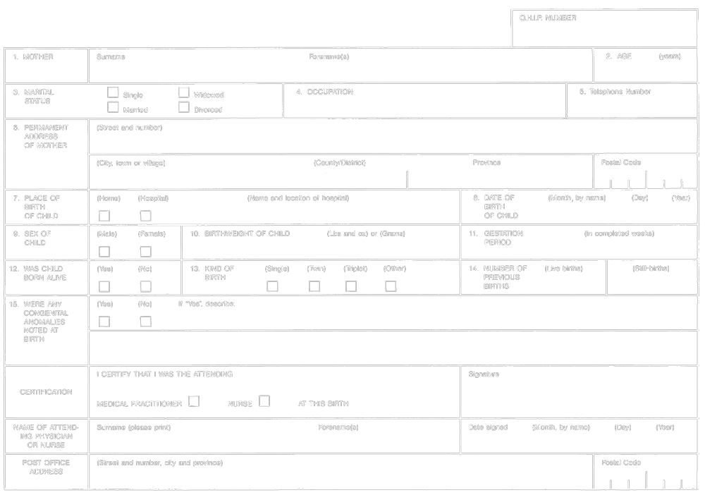
Formule 1
avis de naissance vivante ou de mortinaissance (article 8)
Loi sur les statistiques de l’état civil
Insert regs\graphics\1990\1094\094001af.tif
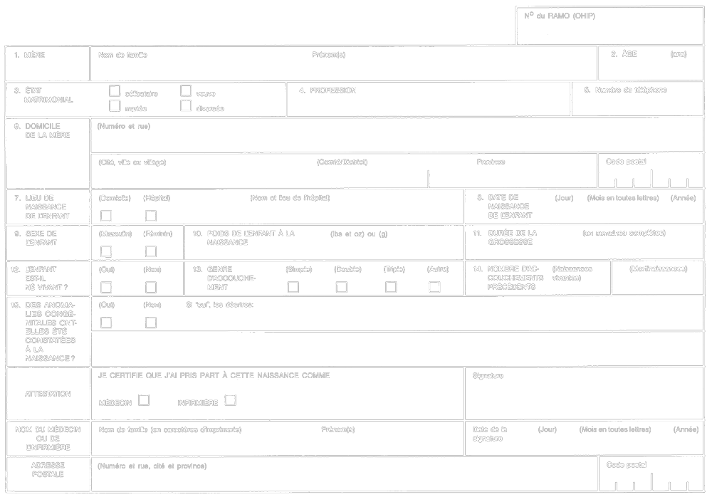
R.R.O. 1990, Reg. 1094, Form 1.
Note: On January 2, 2007, Form 1 is revoked. See: O. Reg. 401/06, ss. 2, 3 (2).
Form 2
statement of live birth
Vital Statistics Act
Insert regs\graphics\1990\1094\094002ae.tif
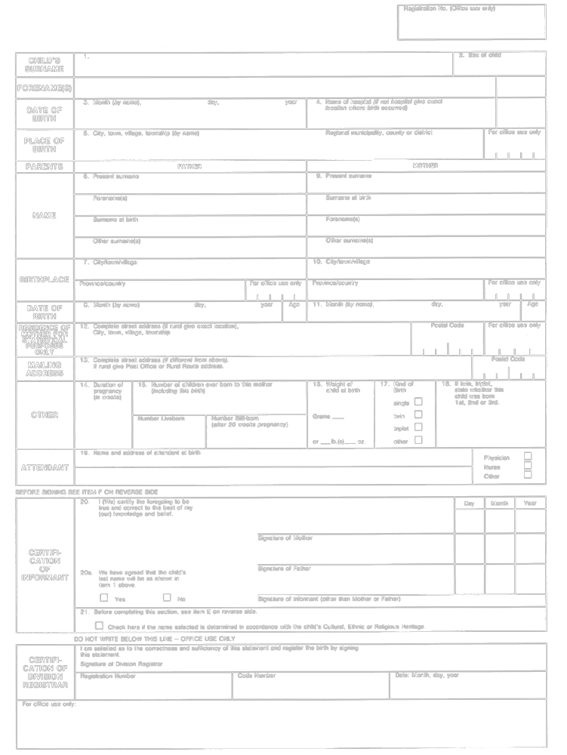
Formule 2
dÉclaration de naissance vivante
Loi sur les statistiques de l’état civil
Insert regs\graphics\1990\1094\094002af.tif
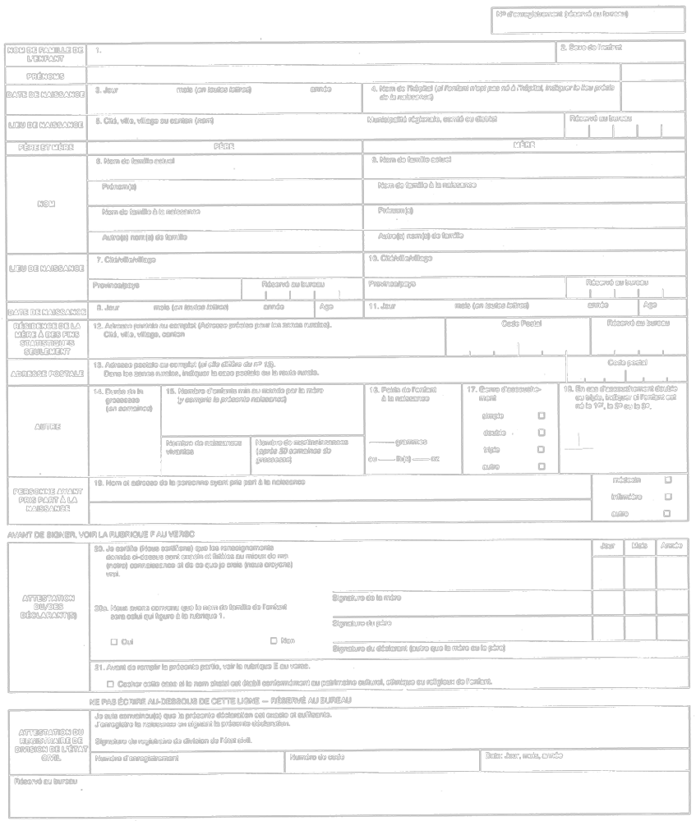
R.R.O. 1990, Reg. 1094, Form 2.
Note: On January 2, 2007, Form 2 is revoked. See: O. Reg. 401/06, ss. 2, 3 (2).
Form 3
ACKNOWLEDGMENT OF REGISTRATION OF STILL-BIRTH
Vital Statistics Act
Insert regs\graphics\1990\1094\094003au.tif
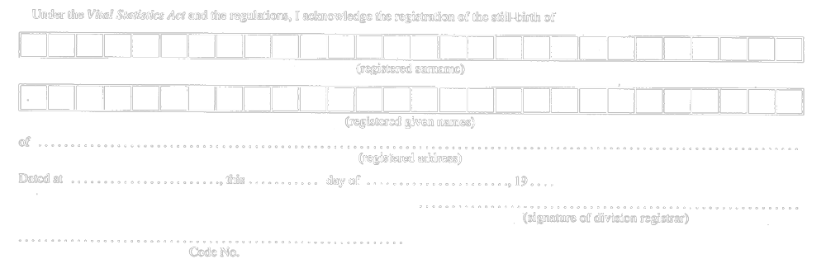
R.R.O. 1990, Reg. 1094, Form 3.
Form 4
DELAYED STATEMENT OF BIRTH
Vital Statistics Act
Insert regs\graphics\1990\1094\094004au.tif
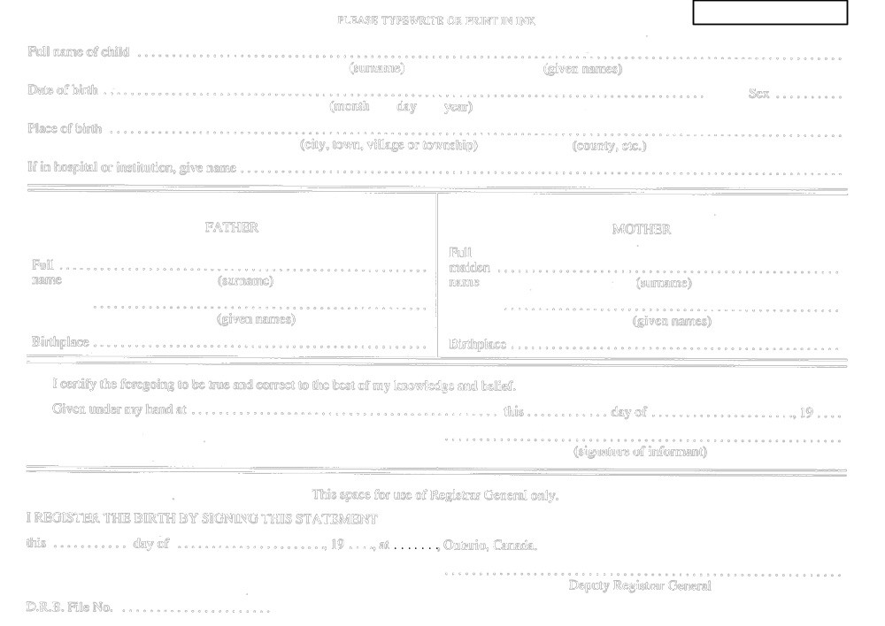
R.R.O. 1990, Reg. 1094, Form 4; O. Reg. 690/94, s. 3.
Form 5
STATUTORY DECLARATION IN SUPPORT OF AN APPLICATION FOR REGISTRATION OF A BIRTH NOT REGISTERED WITHIN ONE YEAR OF THE DAY OF THE BIRTH
Vital Statistics Act
Insert regs\graphics\1990\1094\094005au.tif
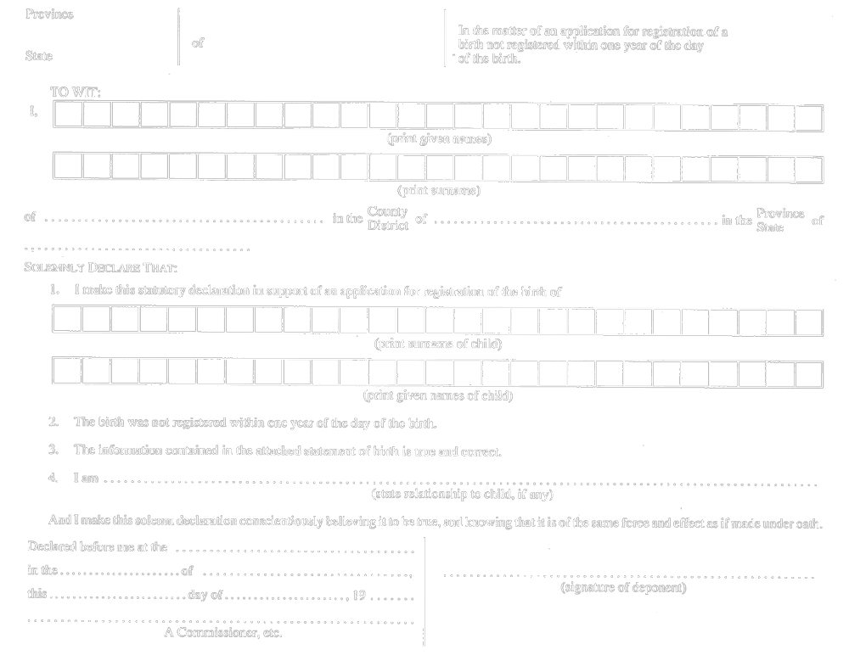
R.R.O. 1990, Reg. 1094, Form 5.
Form 6
APPLICATION FOR SUBSTITUTED REGISTRATION ON ADOPTION
Vital Statistics Act
Insert regs\graphics\1990\1094\094006au.tif
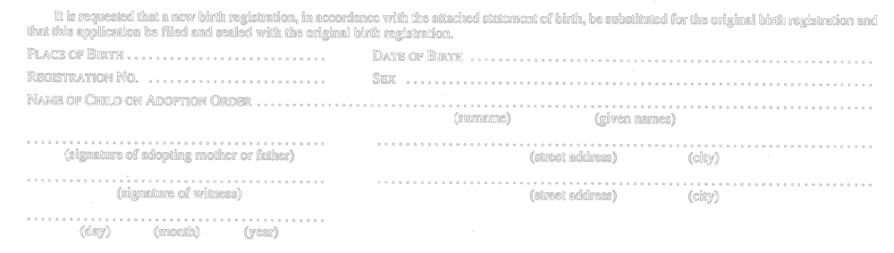
R.R.O. 1990, Reg. 1094, Form 6.
Form 7
STATEMENT OF STILL-BIRTH
Vital Statistics Act
Insert regs\graphics\1990\1094\094007au.tif
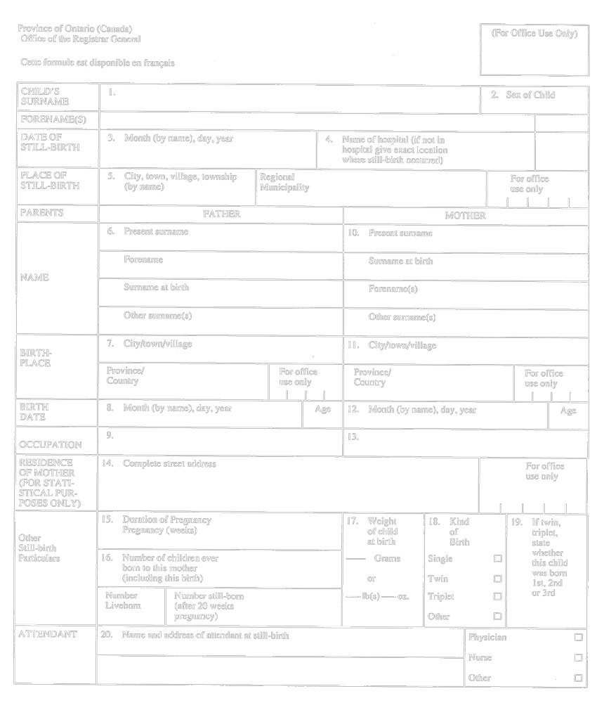
Insert regs\graphics\1990\1094\094007bu.tif
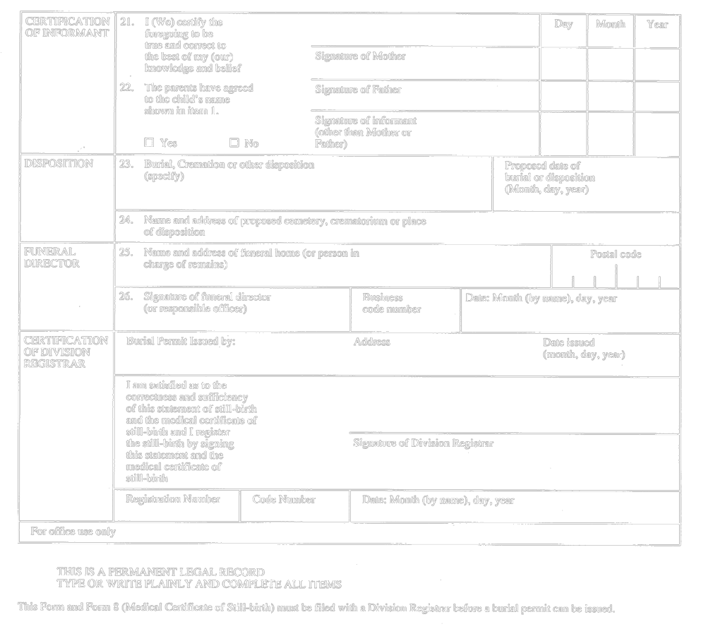
R.R.O. 1990, Reg. 1094, Form 7.
Form 8
medical certificate of still-birth
Vital Statistics Act
Insert regs\graphics\1990\1094\094008ae.tif
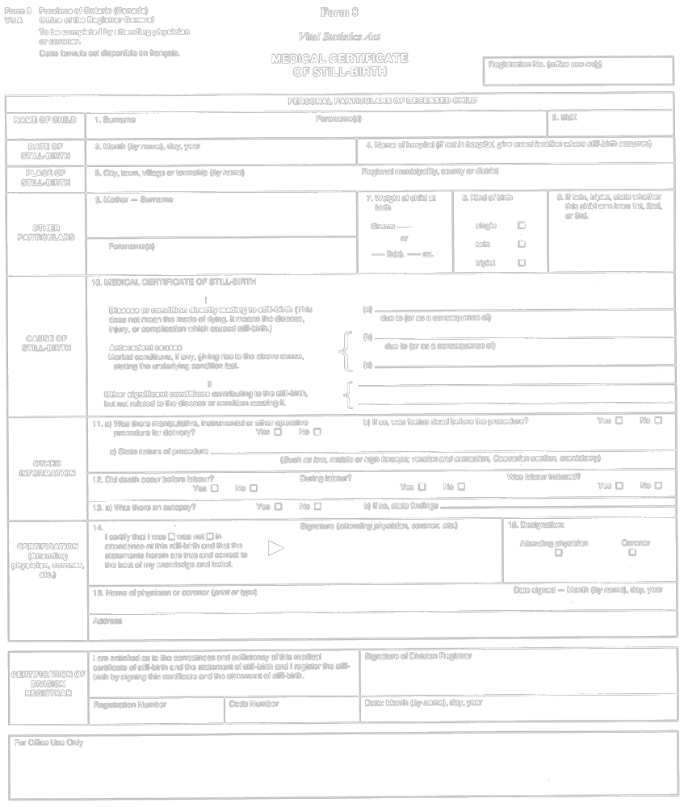
Formule 8
certificat mÉdical de mortinaissance
Loi sur les statistiques de l’état civil
Insert regs\graphics\1990\1094\094008af.tif
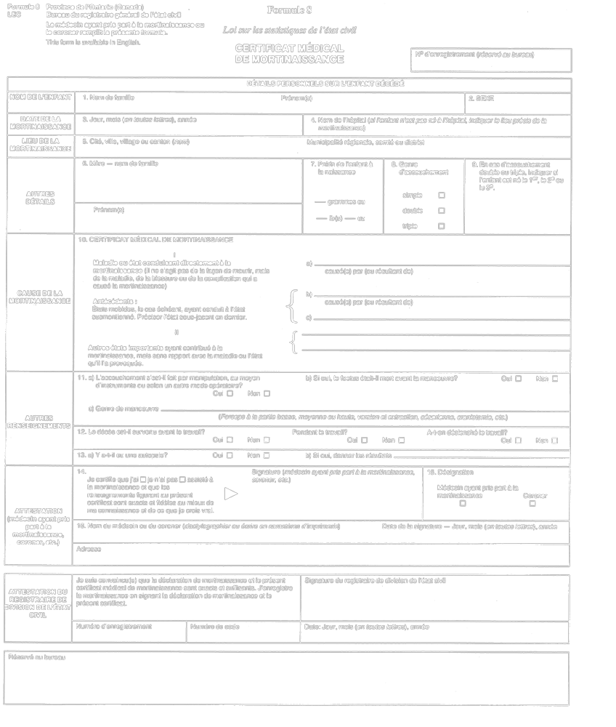
R.R.O. 1990, Reg. 1094, Form 8.
Form 9
APPLICATION FOR REGISTRATION OF A STILL-BIRTH NOT REGISTERED WITHIN ONE YEAR OF THE DAY OF STILL-BIRTH
Vital Statistics Act
Insert regs\graphics\1990\1094\094009au.tif
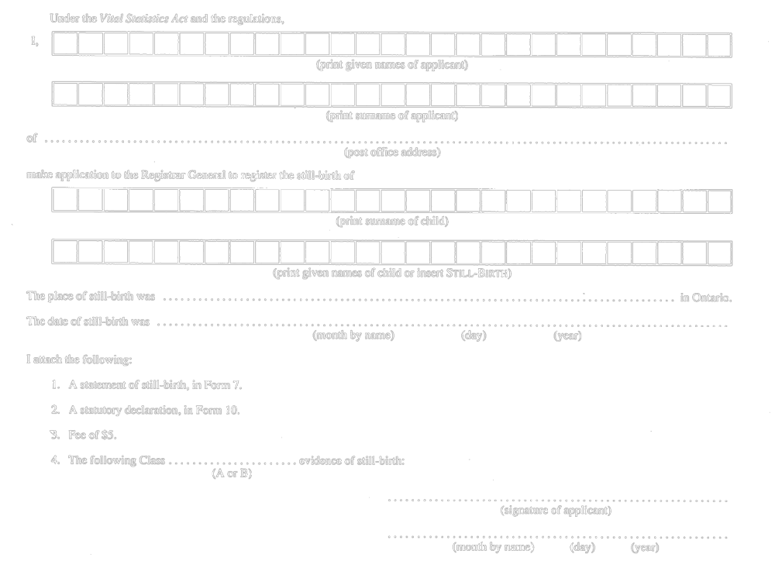
R.R.O. 1990, Reg. 1094, Form 9.
Form 10
statutory declaration in support of an application for registration of a still-birth not registered within one year of the day of the still-birth
Vital Statistics Act
Insert regs\graphics\1990\1094\094010au.tif
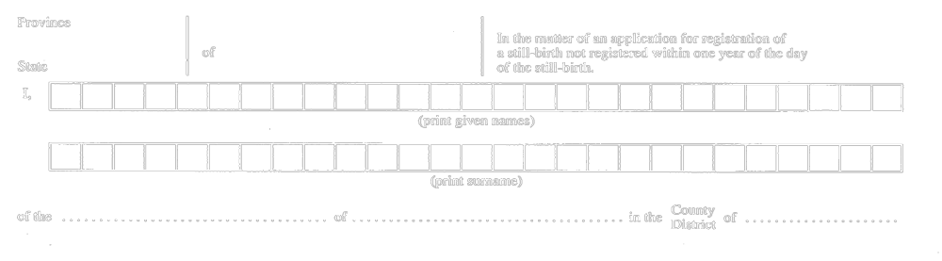
Insert regs\graphics\1990\1094\094010bu.tif
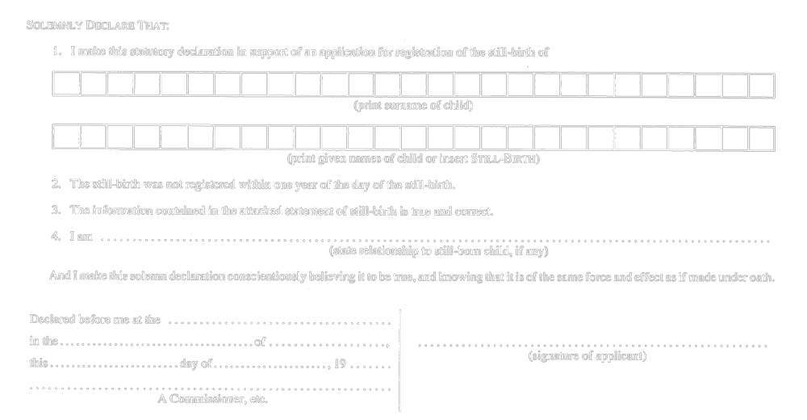
R.R.O. 1990, Reg. 1094, Form 10.
Form 11
ACKNOWLEDGMENT OF RECEIPT OF A STATEMENT OF MARRIAGE
Vital Statistics Act
Insert regs\graphics\1990\1094\094011au.tif
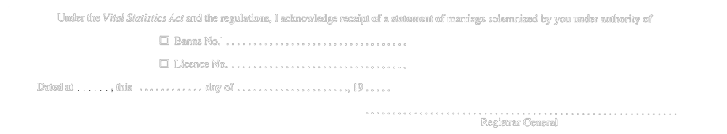
R.R.O. 1990, Reg. 1094, Form 11; O. Reg. 690/94, s. 3.
Form 12 Revoked: O. Reg. 303/05, s. 4.
Form 13 Revoked: O. Reg. 303/05, s. 4.
Form 14 Revoked: O. Reg. 303/05, s. 4.
Form 15
STATEMENT OF DEATH
Vital Statistics Act
Insert regs\graphics\1990\1094\094015au.tif
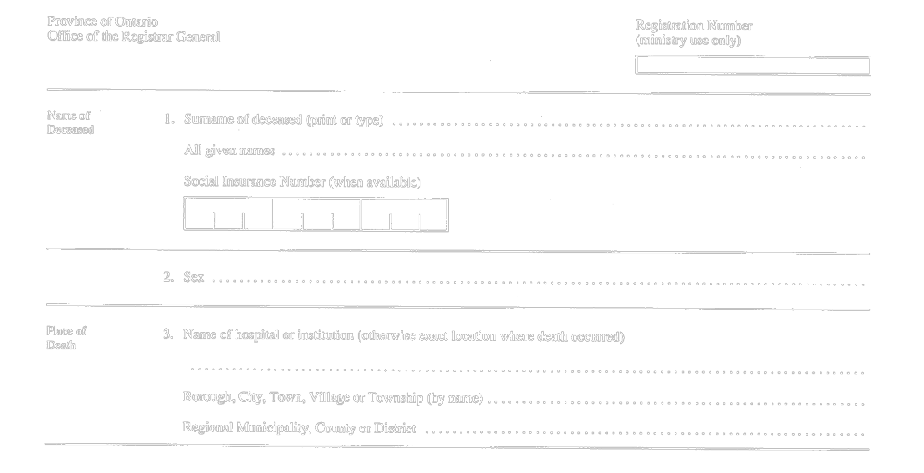
Insert regs\graphics\1990\1094\094015bu.tif
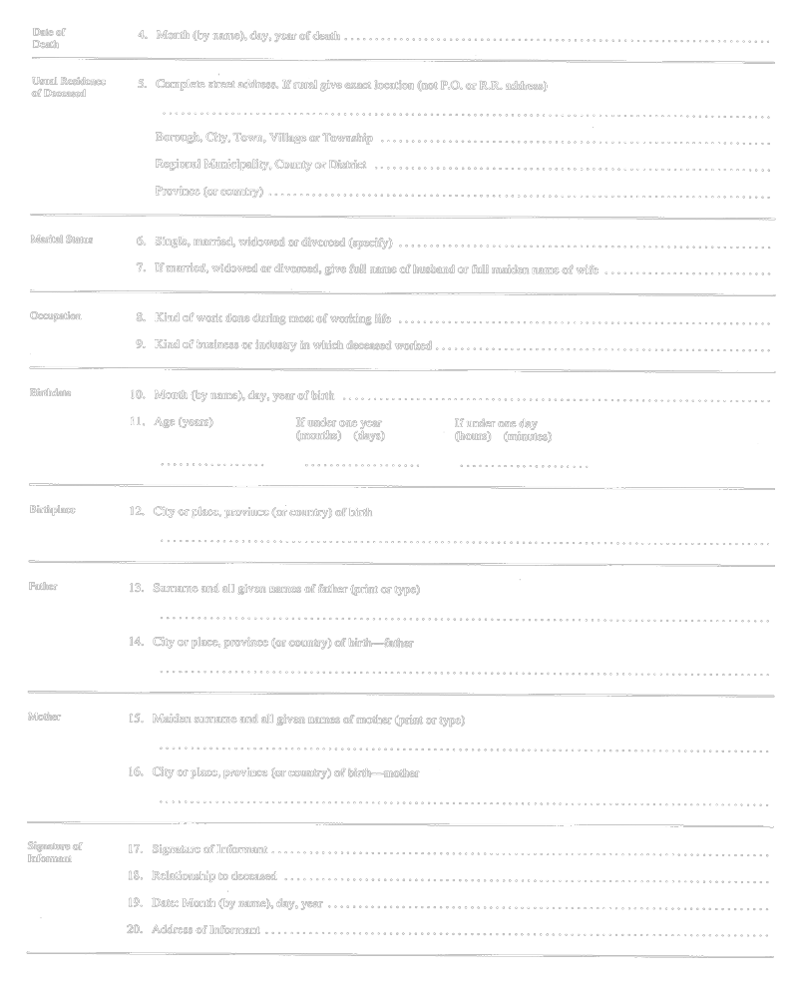
Insert regs\graphics\1990\1094\094015cu.tif
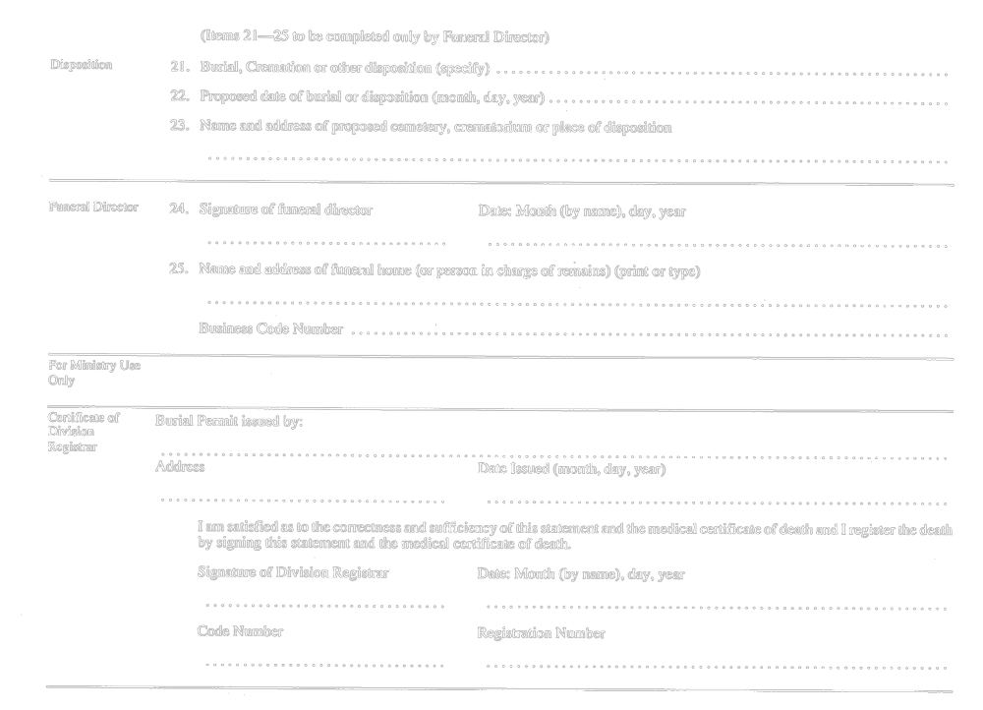
R.R.O. 1990, Reg. 1094, Form 15.
Form 16
MEDICAL CERTIFICATE OF DEATH
Vital Statistics Act
Insert regs\graphics\1990\1094\094016au.tif
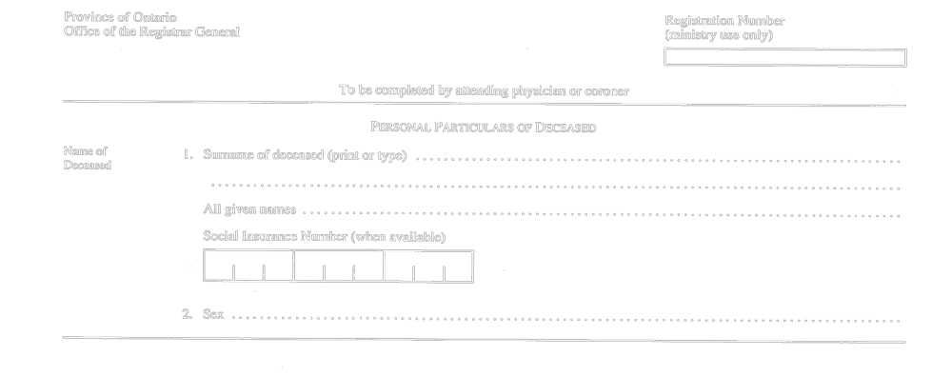
Insert regs\graphics\1990\1094\094016bu.tif
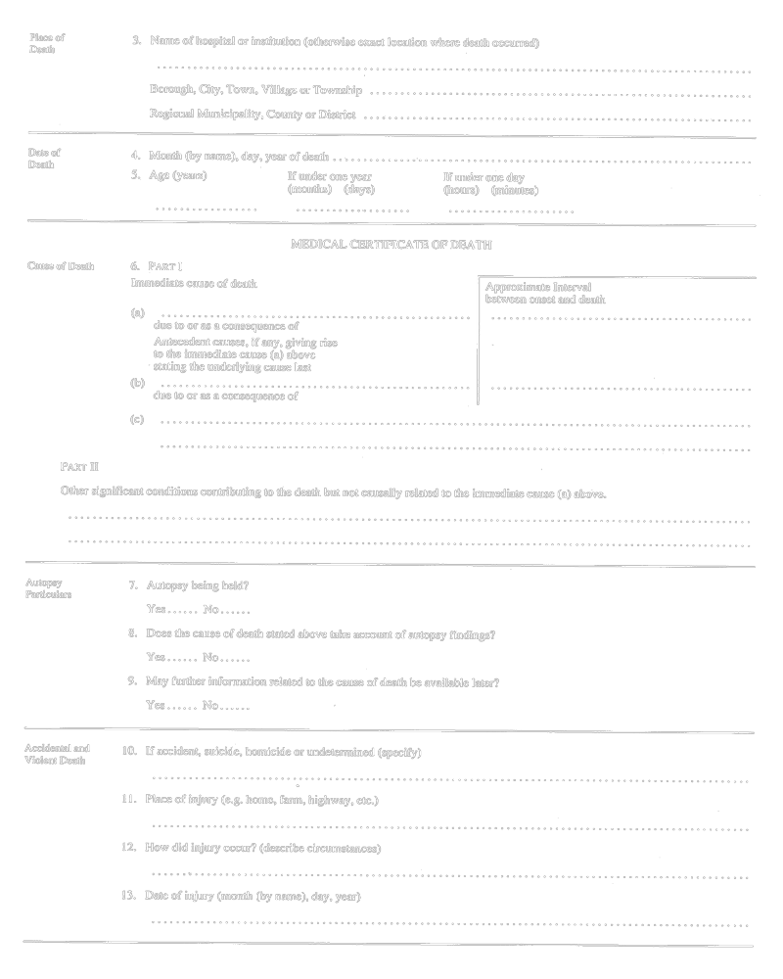
Insert regs\graphics\1990\1094\094016cu.tif
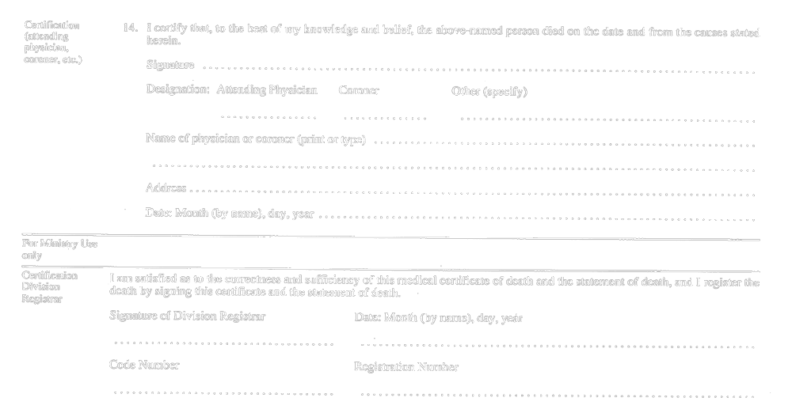
R.R.O. 1990, Reg. 1094, Form 16.
Form 17
NOTICE OF REGISTRATION OF DEATH OR STILL-BIRTH
Vital Statistics Act
Insert regs\graphics\1990\1094\094017au.tif
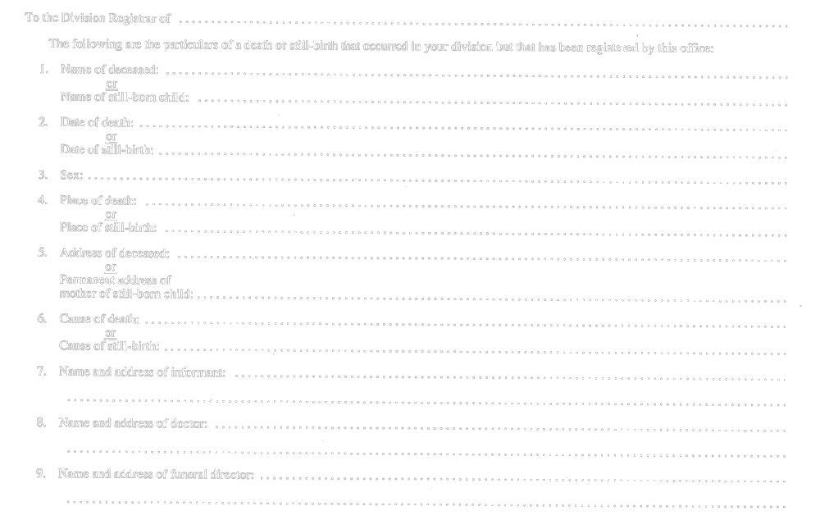
Insert regs\graphics\1990\1094\094017bu.tif
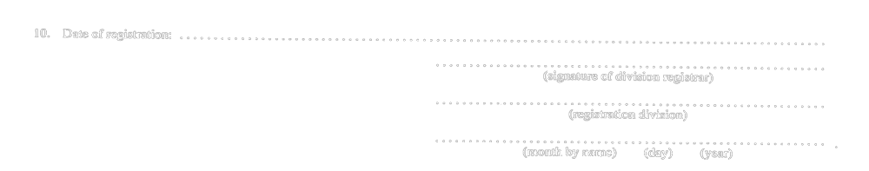
R.R.O. 1990, Reg. 1094, Form 17.
Form 18
ACKNOWLEDGMENT OF REGISTRATION OF DEATH
Vital Statistics Act
Insert regs\graphics\1990\1094\094018au.tif
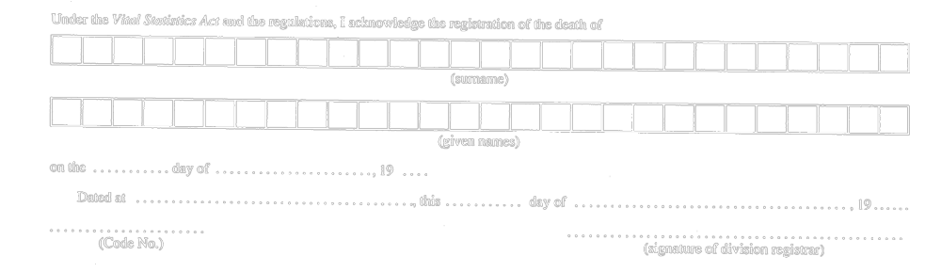
R.R.O. 1990, Reg. 1094, Form 18.
Form 19
BURIAL PERMIT
Vital Statistics Act
Insert regs\graphics\1990\1094\094019au.tif
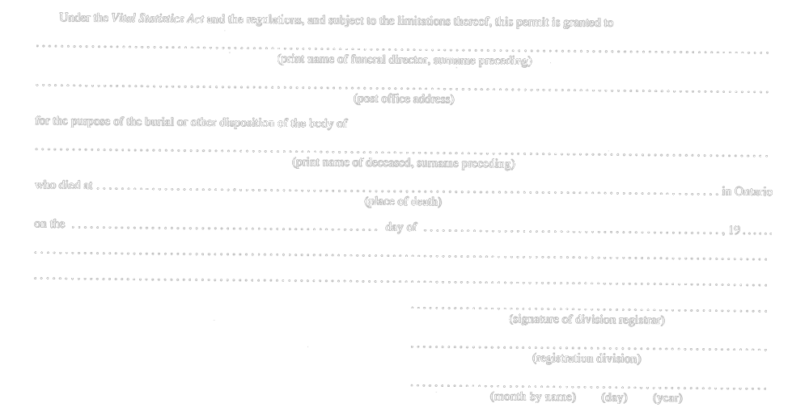
R.R.O. 1990, Reg. 1094, Form 19.
Form 20
APPLICATION FOR REGISTRATION OF A DEATH NOT REGISTERED WITHIN ONE YEAR OF THE DAY OF THE DEATH
Vital Statistics Act
Insert regs\graphics\1990\1094\094020au.tif
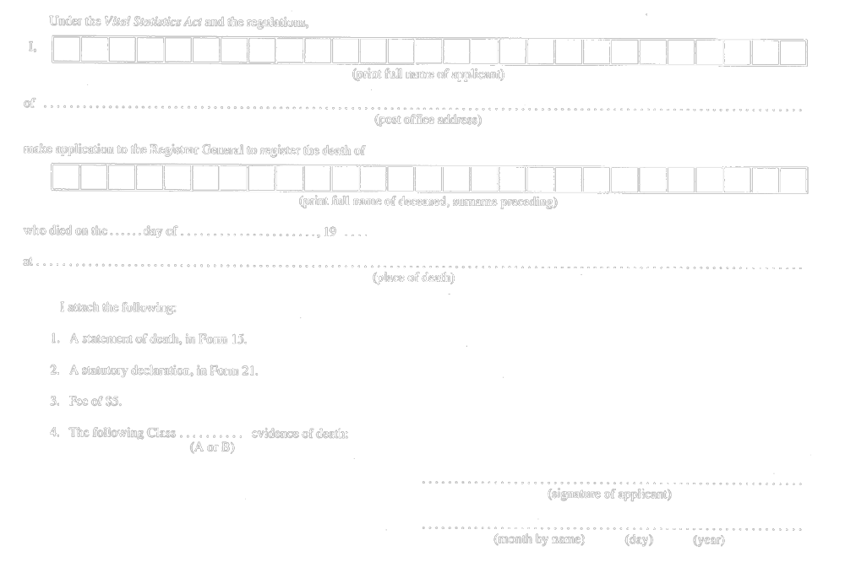
R.R.O. 1990, Reg. 1094, Form 20.
Form 21
STATUTORY DECLARATION IN SUPPORT OF AN APPLICATION FOR REGISTRATION OF A DEATH NOT REGISTERED WITHIN ONE YEAR OF THE DAY OF THE DEATH
Vital Statistics Act
Insert regs\graphics\1990\1094\094021au.tif
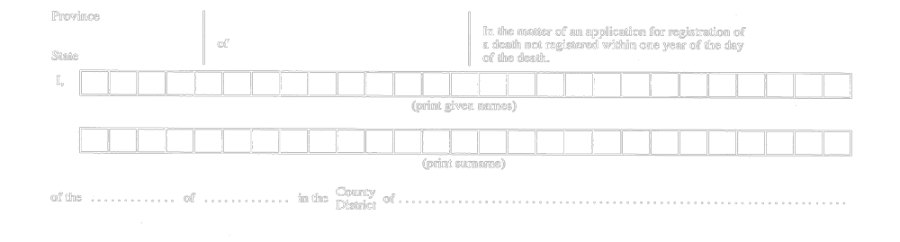
Insert regs\graphics\1990\1094\094021bu.tif
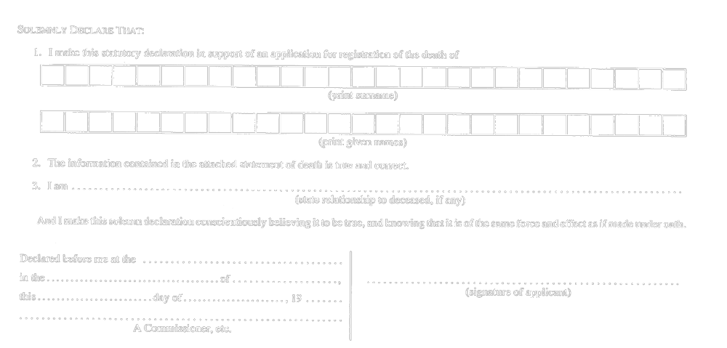
R.R.O. 1990, Reg. 1094, Form 21.
Form 22 Revoked: O. Reg. 303/05, s. 4.
Form 23
STATUTORY DECLARATION BY AN APPLICANT TO CORRECT AN ERROR IN REGISTRATION
Vital Statistics Act
Insert regs\graphics\1990\1094\094023au.tif
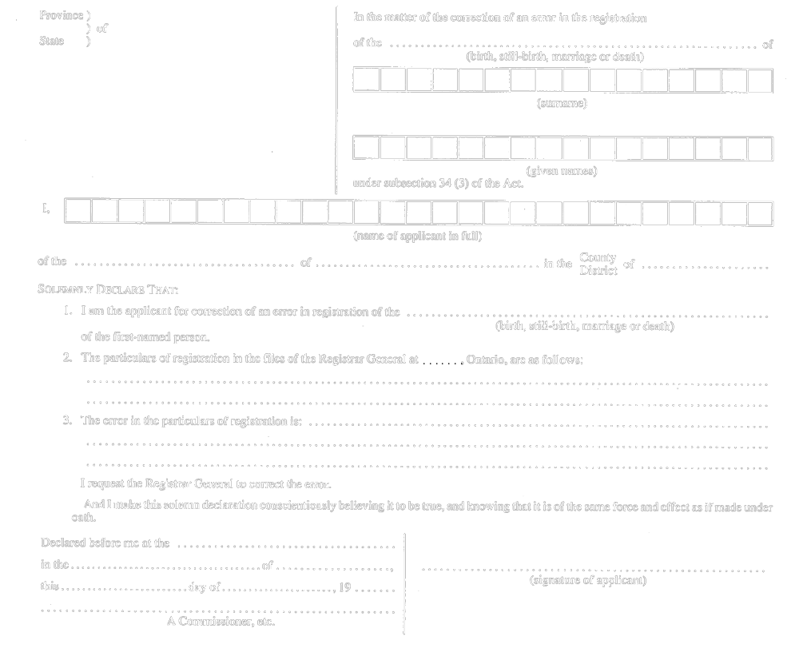
R.R.O. 1990, Reg. 1094, Form 23; O. Reg. 690/94, s. 3.
Form 24
STATUTORY DECLARATION UNDER SUBSECTION 35 (1) OF THE ACT
Vital Statistics Act
Insert regs\graphics\1990\1094\094024au.tif

Insert regs\graphics\1990\1094\094024bu.tif
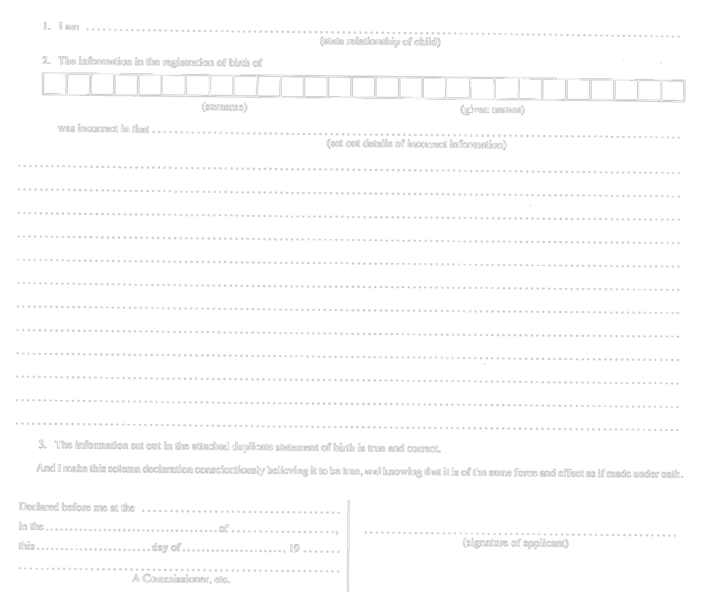
R.R.O. 1990, Reg. 1094, Form 24.
Form 25
CHANGE OF NAME
Vital Statistics Act
Insert regs\graphics\1990\1094\094025au.tif
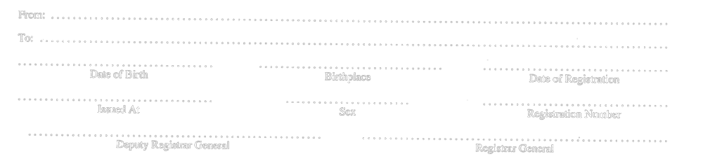
R.R.O. 1990, Reg. 1094, Form 25.
Form 26
CHANGE OF NAME
Vital Statistics Act
Insert regs\graphics\1990\1094\094026au.tif

R.R.O. 1990, Reg. 1094, Form 26.
Form 27
CERTIFICATE AS TO REGISTRATIONS RECEIVED FROM A DIVISION REGISTRAR
Vital Statistics Act
Insert regs\graphics\1990\1094\094027au.tif
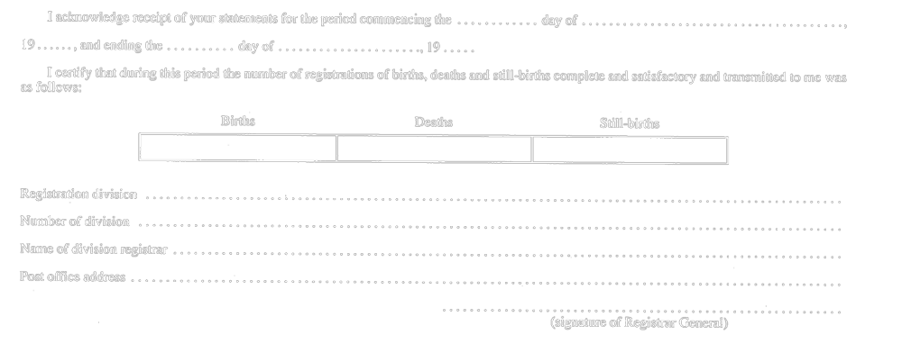
R.R.O. 1990, Reg. 1094, Form 27.
Form 28
BIRTH CERTIFICATE
Vital Statistics Act
Insert regs\graphics\1990\1094\094028au.tif
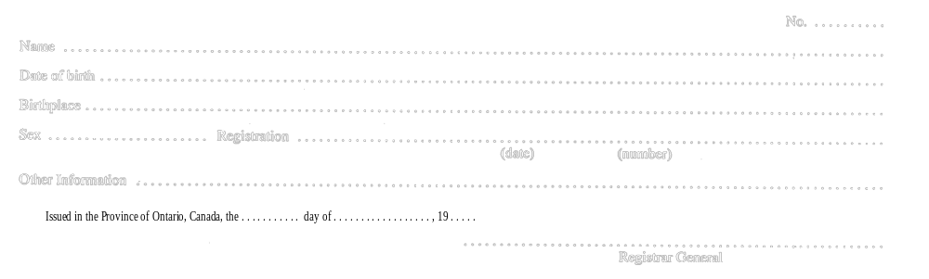
R.R.O. 1990, Reg. 1094, Form 28; O. Reg. 690/94, s. 4.
Form 29 / Formule 29
CERTIFICATE OF BIRTH / CERTIFICAT DE NAISSANCE
Vital Statistics Act / Loi sur les statistiques de l’état civil
Insert regs\graphics\1990\1094\094029ab.tif
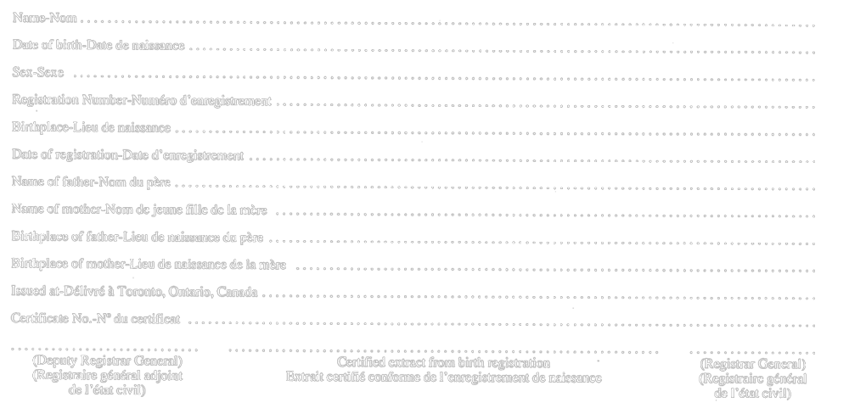
R.R.O. 1990, Reg. 1094, Form 29.
Form 30 Revoked: O. Reg. 303/05, s. 4.
Form 31
DEATH CERTIFICATE
Vital Statistics Act
Insert regs\graphics\1990\1094\094031au.tif

Insert regs\graphics\1990\1094\094031bu.tif
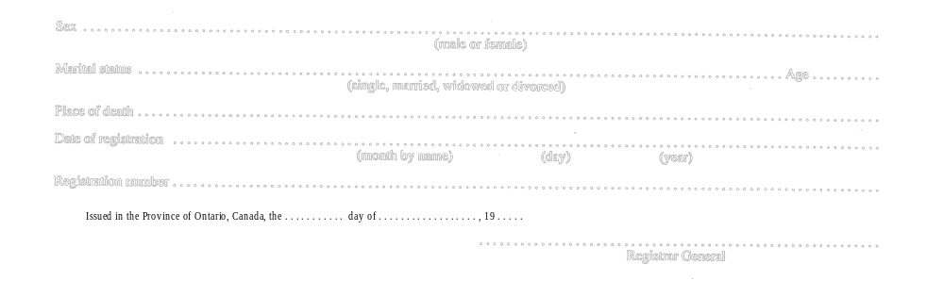
R.R.O. 1990, Reg. 1094, Form 31; O. Reg. 690/94, s. 4.
Form 32
OATH OF SECRECY
Vital Statistics Act
Insert regs\graphics\1990\1094\094032au.tif
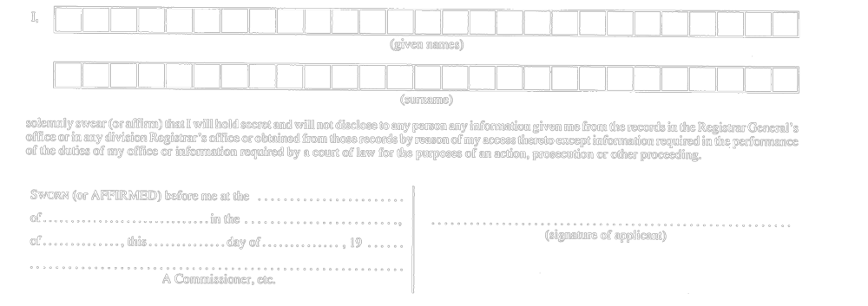
R.R.O. 1990, Reg. 1094, Form 32.
Form 33 / Formule 33
Vital Statistics Act / Loi sur les statistiques de l’état civil
Insert regs\graphics\1990\1094\094033ab.tif
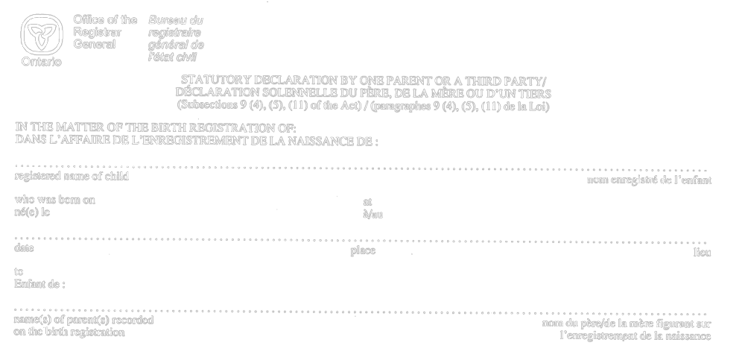
Insert regs\graphics\1990\1094\094033bb.tif
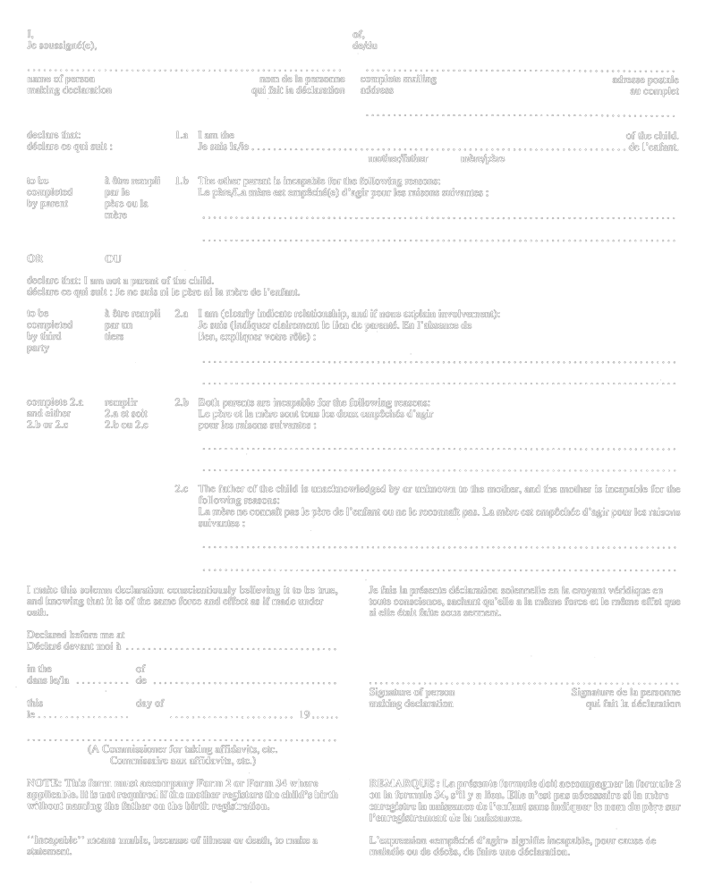
R.R.O. 1990, Reg. 1094, Form 33.
Note: On January 2, 2007, Form 33 is revoked. See: O. Reg. 401/06, ss. 2, 3 (2).
Form 34 / Formule 34
Vital Statistics Act / Loi sur les statistiques de l’état civil
Insert regs\graphics\1990\1094\094034ab.tif
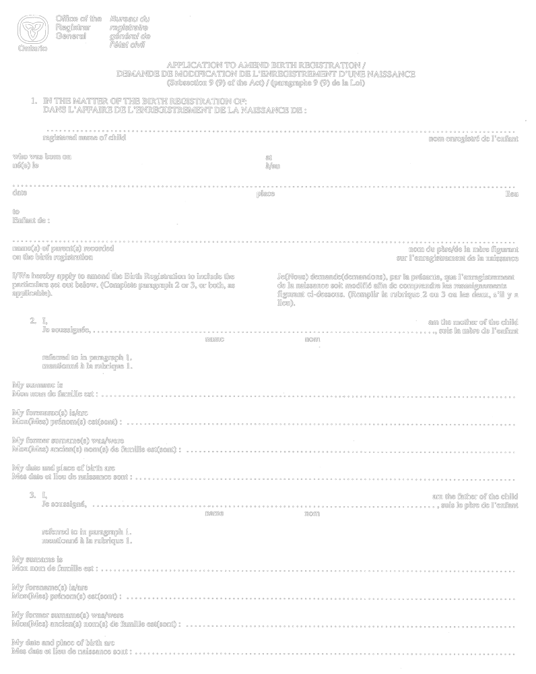
Insert regs\graphics\1990\1094\094034bb.tif
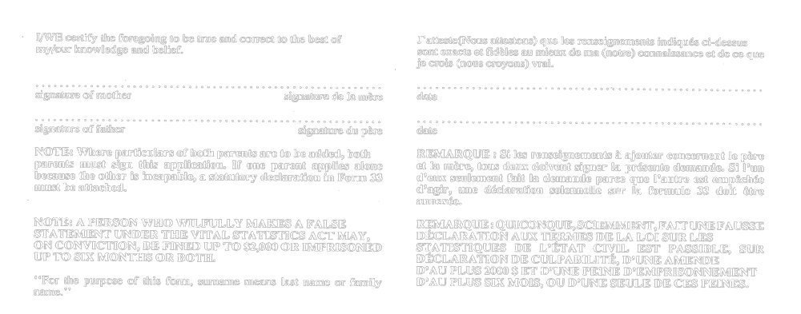
R.R.O. 1990, Reg. 1094, Form 34.
Note: On January 2, 2007, Form 34 is revoked. See: O. Reg. 401/06, ss. 2, 3 (2).
Form 35
election to change name of a child under the age of twelve (section 14 of the Act)
Vital Statistics Act
Insert regs\graphics\1990\1094\094035ae.tif
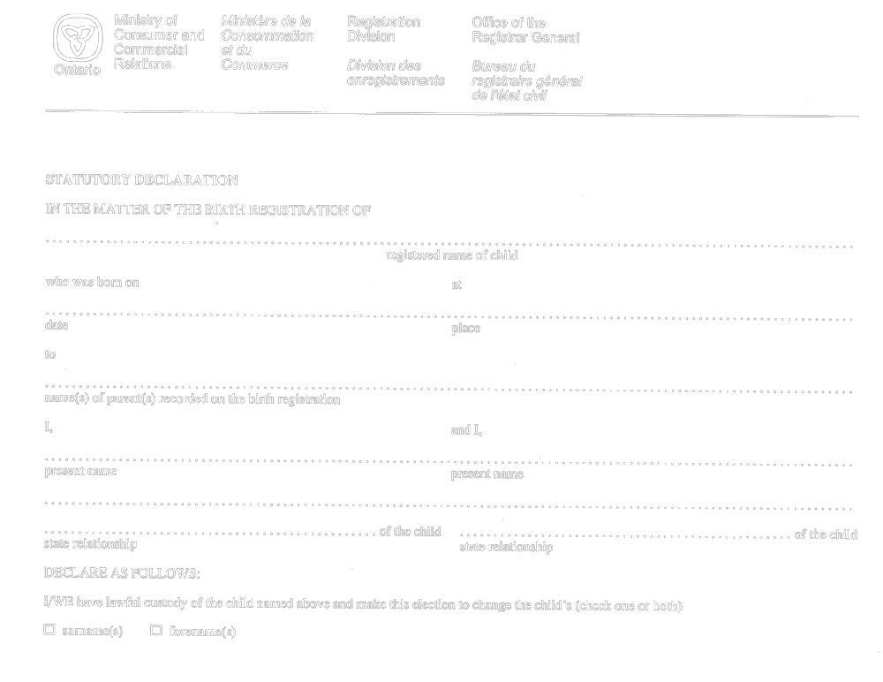
Insert regs\graphics\1990\1094\094035be.tif
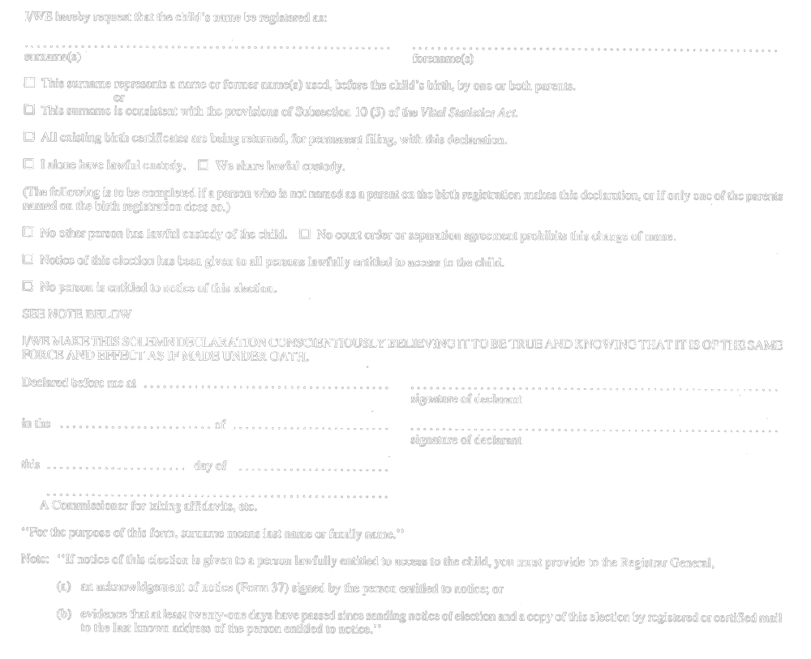
Formule 35
dÉcision de changer le nom d’un enfant de moins de douze ans (article 14 de la Loi)
Loi sur les statistiques de l’état civil
Insert regs\graphics\1990\1094\094035af.tif
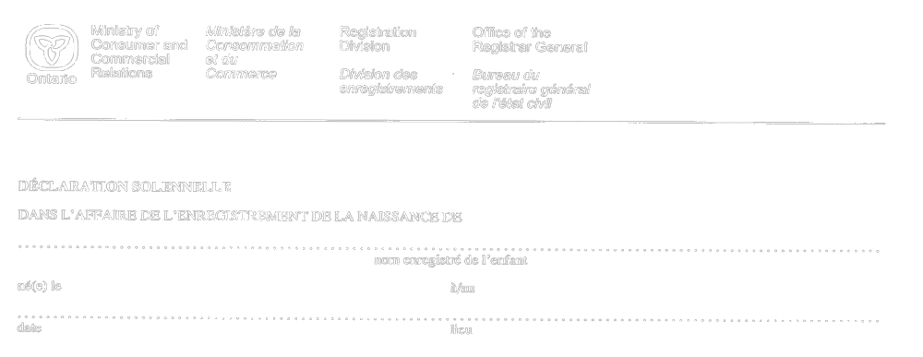
Insert regs\graphics\1990\1094\094035bf.tif
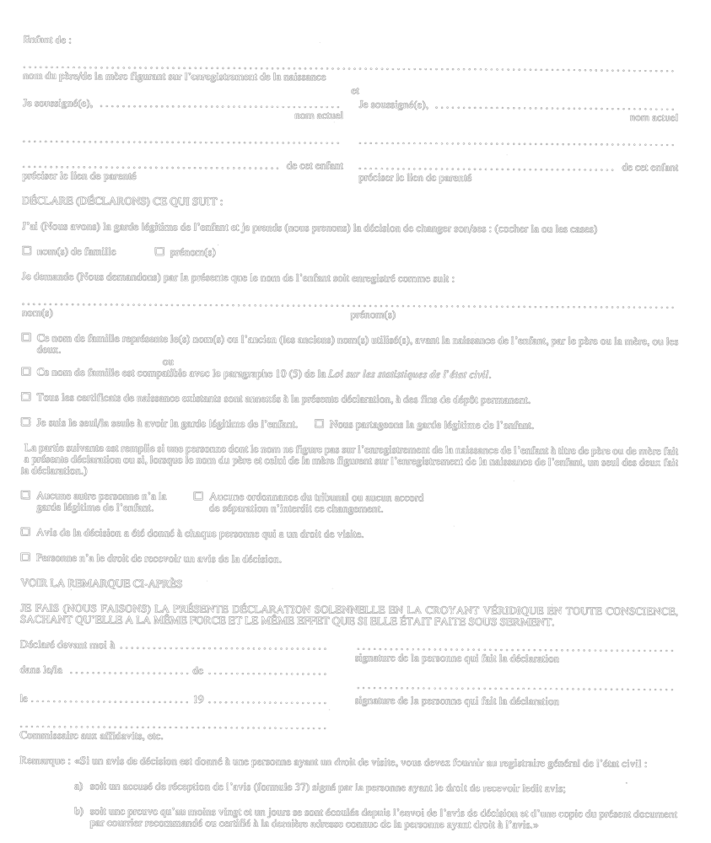
R.R.O. 1990, Reg. 1094, Form 35.
Form 36 / Formule 36
notice of election (subsection 14 (3) of the act) / avis de dÉcision (paragraphe 14 (3) de la loi)
Vital Statistics Act / Loi sur les statistiques de l’état civil
Insert regs\graphics\1990\1094\094036ab.tif
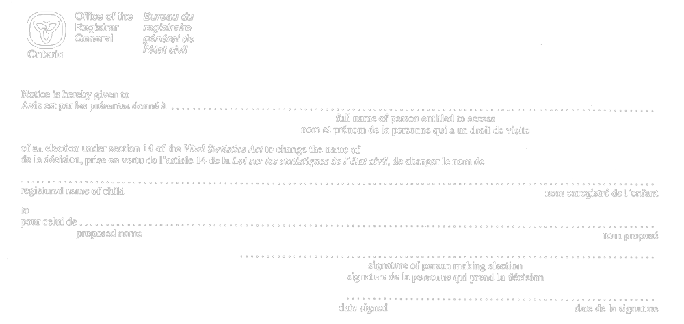
R.R.O. 1990, Reg. 1094, Form 36.
Form 37 / Formule 37
acknowledgment of notice (subsection 14 (5) of the act) / accusÉ de rÉception de l’avis (paragraphe 14 (5) de la loi)
Vital Statistics Act / Loi sur les statistiques de l’état civil
Insert regs\graphics\1990\1094\094037ab.tif
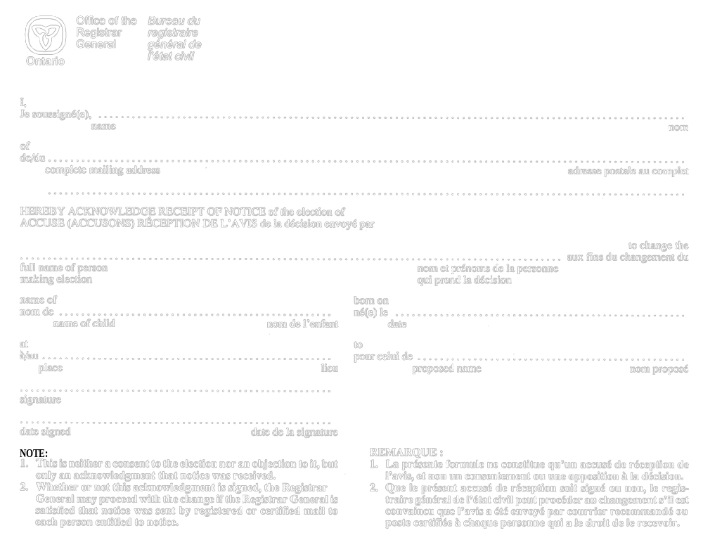
R.R.O. 1990, Reg. 1094, Form 37.
Form 38 / formule 38
election to add forename to birth registration (section 15 of the act) / dÉcision d’ajouter un prÉnom À l’enregistrement de la naissance (article 15 de la loi)
Vital Statistics Act / Loi sur les statistiques de l’état civil
Insert regs\graphics\1990\1094\094038ab.tif
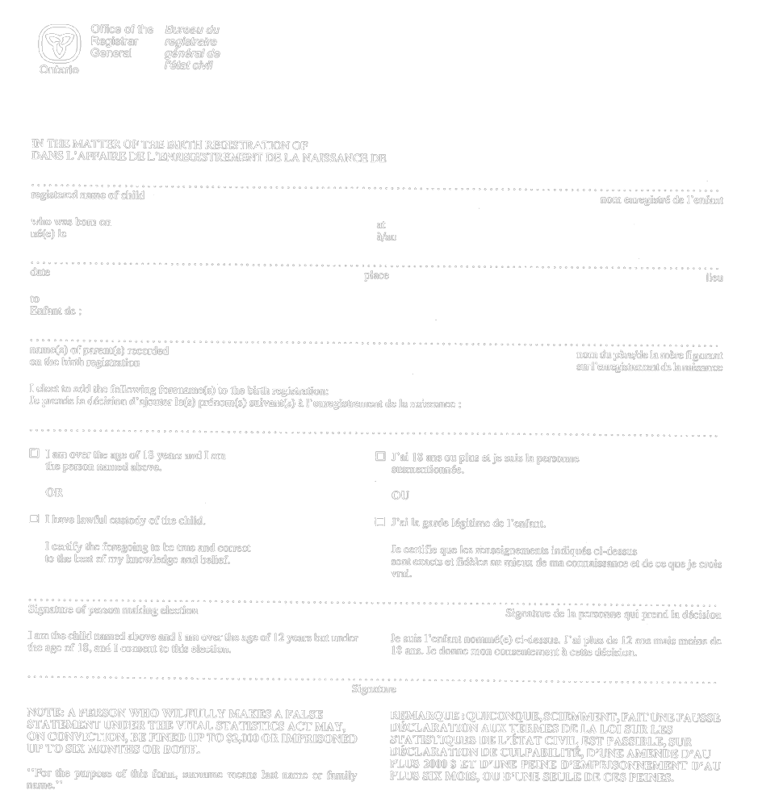
R.R.O. 1990, Reg. 1094, Form 38.
Form 39
statement respecting particulars of birth
Vital Statistics Act
Insert regs\graphics\1990\1094\094039au.tif

R.R.O. 1990, Reg. 1094, Form 39; O. Reg. 690/94, s. 5.
Form 40
APPLICATION FOR CHANGE OF SEX DESIGNATION ON BIRTH REGISTRATION
Vital Statistics Act
Insert regs\graphics\1990\1094\094040au.tif
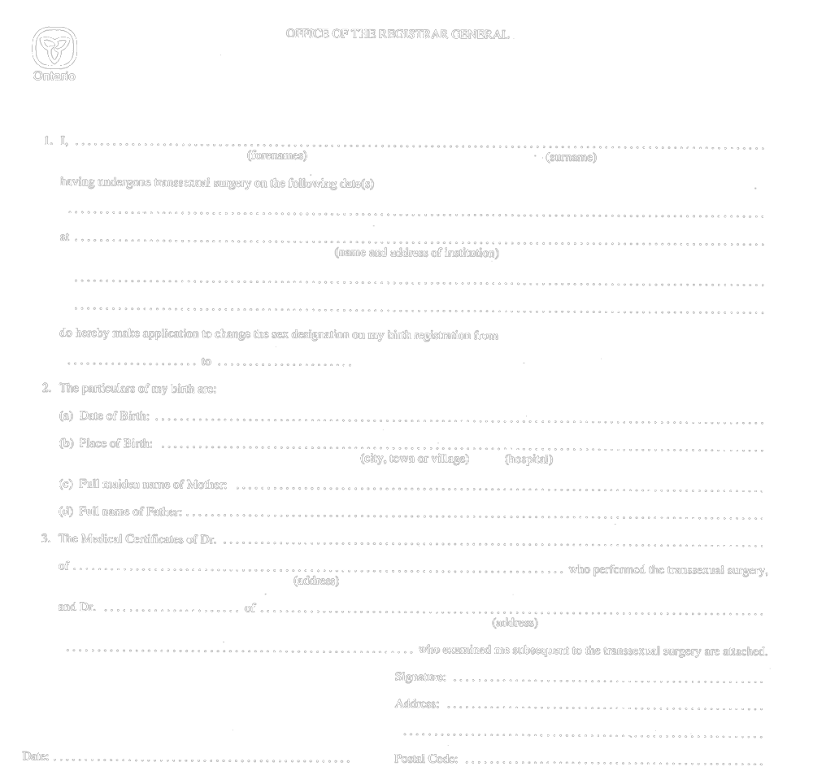
R.R.O. 1990, Reg. 1094, Form 40.
Form 41
MEDICAL CERTIFICATE TO SUBSTANTIATE TRANSSEXUAL SURGERY WAS PERFORMED
Vital Statistics Act
Insert regs\graphics\1990\1094\094041au.tif

Insert regs\graphics\1990\1094\094041bu.tif
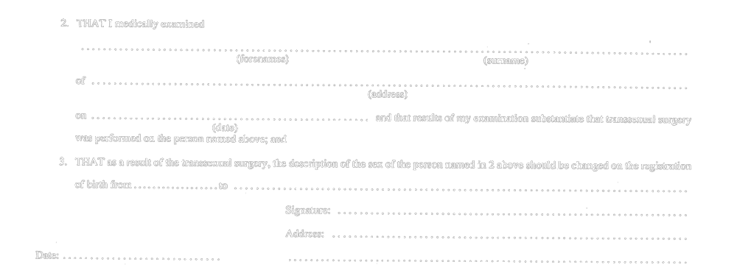
R.R.O. 1990, Reg. 1094, Form 41.
Form 42
MEDICAL CERTIFICATE OF TRANSSEXUAL SURGERY
Vital Statistics Act
Insert regs\graphics\1990\1094\094042au.tif
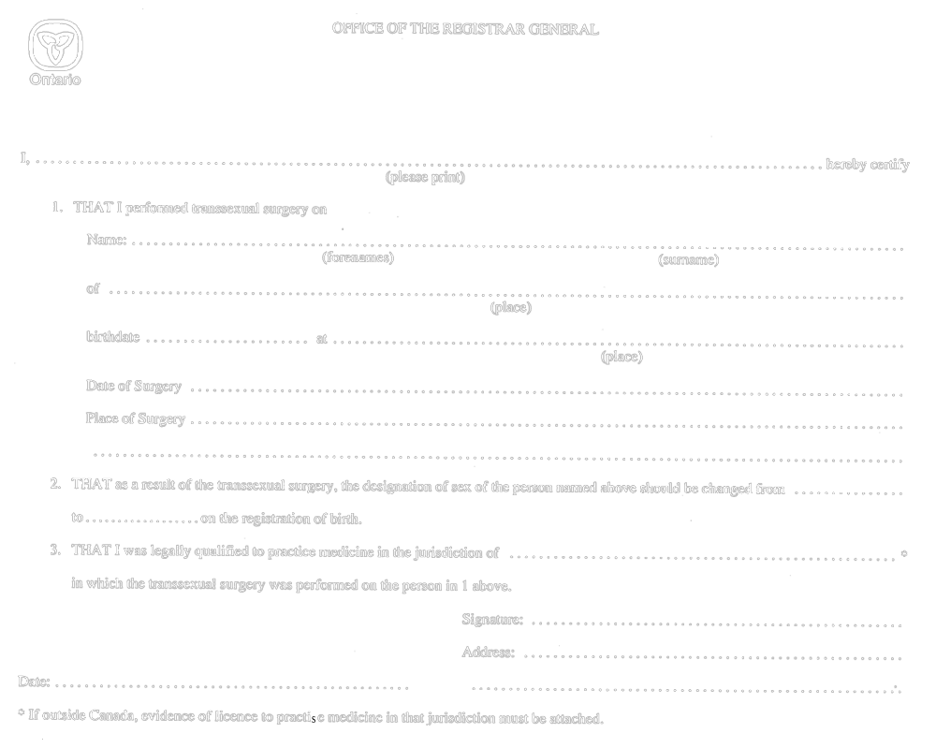
R.R.O. 1990, Reg. 1094, Form 42.
Form 43
EXTRACT OF INFORMATION FROM ORIGINAL BIRTH REGISTRATION
Vital Statistics Act
Insert regs\graphics\1990\1094\094043ae.tif
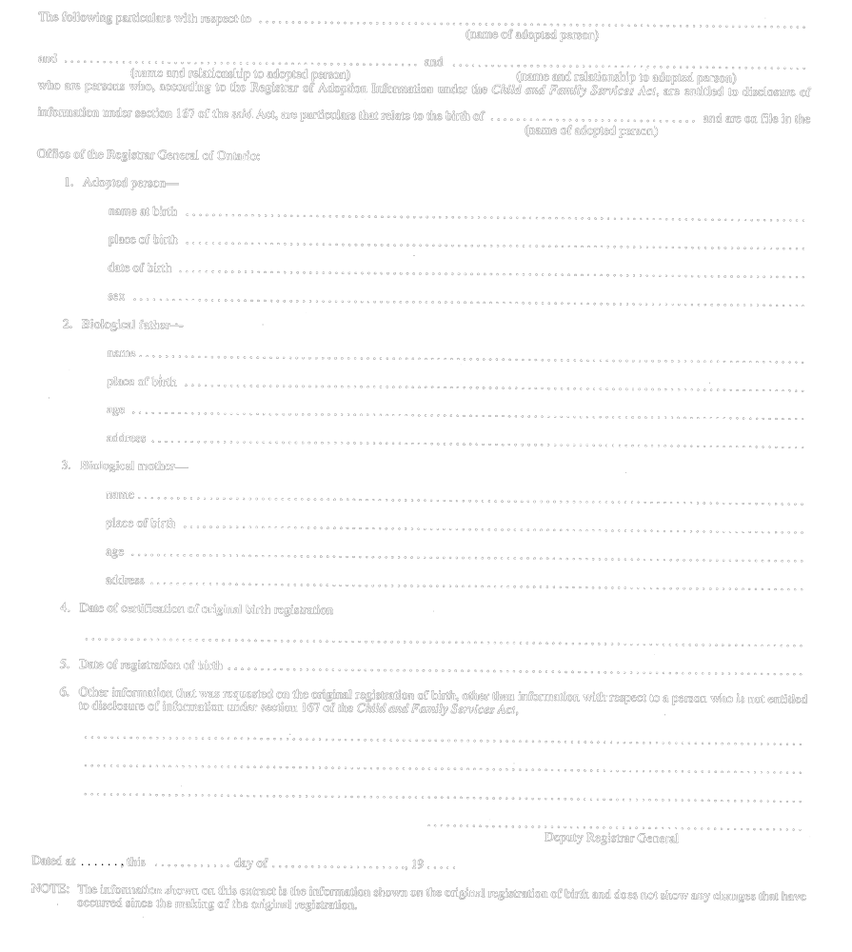
Formule 43
EXTRAIT DE RENSEIGNEMENTS FIGURANT SUR L’ENREGISTREMENT INITIAL DE LA NAISSANCE
Loi sur les statistiques de l’état civil
Insert regs\graphics\1990\1094\094043af.tif
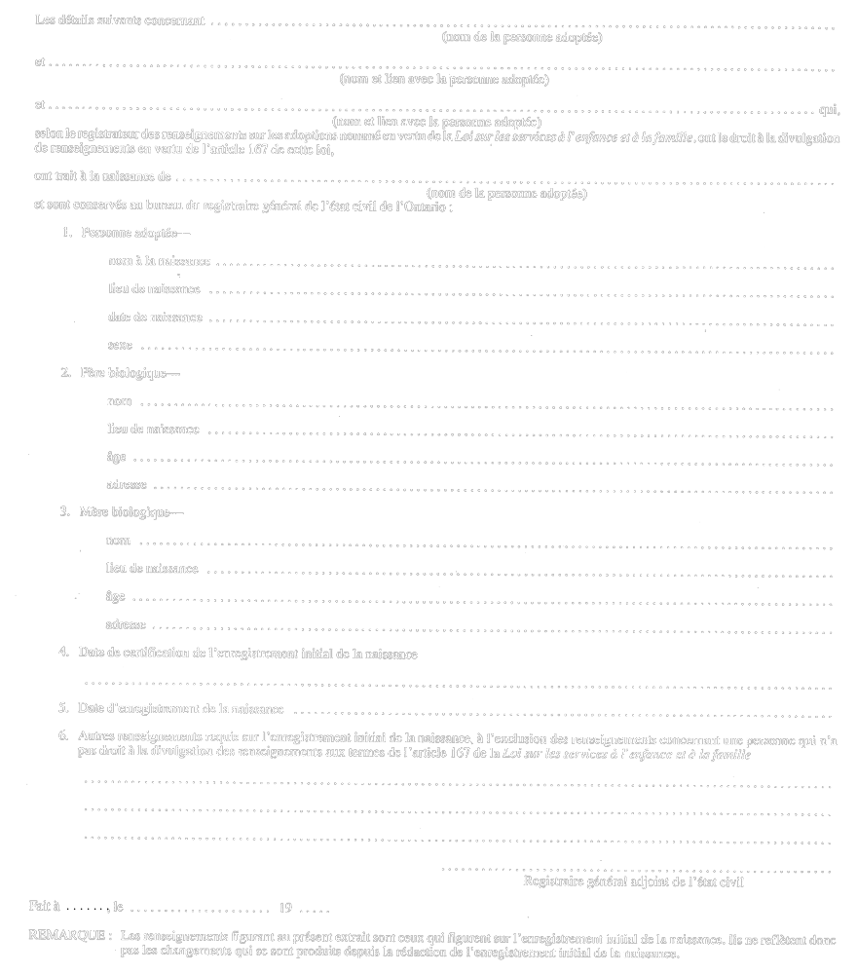
R.R.O. 1990, Reg. 1094, Form 43; O. Reg. 690/94, s. 6.

Back to top

