Occupational Health and Safety Act
Loi sur la santé et la sécurité au travail
ONTARIO REGULATION 213/91
Amended to O. Reg. 85/04
CONSTRUCTION PROJECTS
Historical version for the period October 1, 2004 to December 7, 2005.
This Regulation is made in English only.
Skip Table of Contents
CONTENTS
 |  | Sections
PART I | GENERAL
 | Interpretation and Application | 1-2
 | Alternative Methods and Materials | 3
 | Designation of a Project | 4
 | Registration and Notices | 5-7
 | Accident Notices and Reports under Sections 51-53 of the Act | 8-12
 | General Requirements | 13-19
PART II | GENERAL CONSTRUCTION
 | Application | 20
 | Protective Clothing, Equipment and Devices | 21-27
 | Hygiene | 28-30
 | General Requirements | 31-34
 | Housekeeping | 35-48
 | Temporary Heat | 49-51
 | Fire Safety | 52-58
 | Dust Control | 59
 | Confined Spaces | 60-63
 | Public Way Protection | 64-66
 | Traffic Control | 67-69.1
 | Access To and Egress From Work Areas | 70-72
 | Platforms, Runways and Ramps | 73-74
 | Stairs and Landings | 75-77
 | Ladders | 78-86
 | Forms, Formwork, Falsework and Re-shoring | 87-92
 | Equipment, General | 93-116
 | Explosive Actuated Fastening Tool | 117-121
 | Welding and Cutting | 122-124
 | Scaffolds and Work Platforms | 125-136
 | Suspended Platforms and Scaffolds and Boatswain’s Chairs | 136.1-142
 | Multi-Point Suspended Scaffolds | 142.1-142.8
 | Elevating Work Platforms | 143-149
 | Cranes, Hoisting and Rigging | 150-156
 | Tower Cranes | 157-165
 | Derricks, Stiff-Leg Derricks and Similar Hoisting Devices | 166-167
 | Cables, Slings, Rigging | 168-180
 | Electrical Hazards | 181-195
 | Explosives | 196-206
 | Roofing | 207-210
 | Hot Tar or Bitumen Roadtankers | 211
 | Demolition and Damaged Structures | 212-221
PART III | EXCAVATIONS
 | Interpretation and Application | 222-223
 | Entry and Working Alone | 224-225
 | Soil Types | 226-227
 | Precautions Concerning Services | 228
 | Protection of Adjacent Structures | 229
 | General Requirements | 230-233
 | Support Systems | 234-242
PART IV | TUNNELS, SHAFTS, CAISSONS AND COFFERDAMS
 | Application | 243
 | Land Requirements | 244
 | Notice | 245
 | Working Alone and Entry | 246-247
 | Fire Protection | 248-259
 | Facilities for Workers | 260
 | First Aid | 261-263
 | Rescue of Workers | 264-268
 | Communications | 269-273
 | Lighting and Electricity Supply | 274-277
 | Shafts | 278-287
 | Hoistways | 288-305
 | Tunnels | 306-308
 | Tunnel Equipment | 309-316
 | Explosives | 317-328
 | Ventilation | 329-331
PART V | WORK IN COMPRESSED AIR
 | Interpretation and Application | 332-333
 | General Requirements | 334-339
 | Communications | 340-341
 | Fire Prevention | 342-345
 | Lighting and Electrical Supply | 346-349
 | Sanitation | 350
 | Medical Requirements | 351-354
 | Medical Locks | 355-358
 | Air Compressors | 359-363
 | Air Locks and Work Chambers | 364-385
 | Work Periods and Rest Periods | 386-388
 | Lock Tenders | 389-394
 | Decompression Procedures | 395-399
Table 1
Table 2
Form 1 | Record of compressed air worker
PART I
GENERAL
Interpretation and Application
1. (1) In this Regulation,
“adequate”, in relation to a procedure, material, device, object or thing, means,
(a) sufficient for both its intended and its actual use, and
(b) sufficient to protect a worker from occupational illness or occupational injury,
and “adequately” has a corresponding meaning;
“allowable unit stress”, in relation to a material, means,
(a) the allowable unit stress assigned to a material by the standards required under the Building Code, or
(b) if no allowable unit stress is assigned under clause (a), the allowable unit stress for the material as determined by a professional engineer in accordance with good engineering practice;
“approved”, in relation to a form, means approved by the Minister;
“blocker truck” means a truck that weighs at least 6,800 kilograms and has four-way flashers and a mounted flashing arrowboard sign;
“boom” means the projecting part of a backhoe, shovel, crane or similar lifting device from which a load is likely to be supported;
“Building Code” means Ontario Regulation 403/97 made under the Building Code Act, 1992;
“caisson” means,
(a) a casing below ground or water level whether or not it is designed to contain air at a pressure greater than atmospheric pressure,
(b) an excavation, including a waterwell but not a well within the meaning of the Petroleum Resources Act, drilled by an auger and into which a person may enter;
“cofferdam” means a structure constructed entirely or partially below water level or below the level of the groundwater table and intended to provide a work place that is free of water;
“competent worker”, in relation to specific work, means a worker who,
(a) is qualified because of knowledge, training and experience to perform the work,
(b) is familiar with the Occupational Health and Safety Act and with the provisions of the regulations that apply to the work, and
(c) has knowledge of all potential or actual danger to health or safety in the work;
“conduit” means a sewer, a water main, a duct or cable for a telegraphic, telephonic, television or electrical service, a pipe or duct for the transportation of any solid, liquid or gas or any combination of these items and includes a service connection made or intended to be made thereto;
“confined space” means a space to which or from which access or egress is restricted and in which, because of its construction, location or contents or the work activity therein, a hazardous gas, vapour, dust or fume or an oxygen-deficient atmosphere may occur;
“crash truck” means a blocker truck that is equipped with a crash-attenuating device;
“excavation” means the hole that is left in the ground, as a result of removing material;
“excavation depth” means the vertical dimension from the highest point of the excavation wall to a point level with the lowest point of the excavation;
“excavation width” means the least horizontal dimension between the two opposite walls of the excavation;
“fall arrest system” means an assembly of components joined together so that when the assembly is connected to a fixed support, it is capable of arresting a worker’s fall;
“fall restricting system” means a type of fall arrest system that has been designed to limit a worker’s fall to a specified distance;
“falsework”, in relation to a form or structure, means the structural supports and bracing used to support all or part of the form or structure;
“fixed support” means a permanent or temporary structure or a component of such a structure that can withstand all loads and forces the structure or component is intended to support or resist and is sufficient to protect a worker’s health and safety, and includes equipment or devices that are securely fastened to the structure or component;
“flammable liquid” means a liquid with a flash point below 37.8 degrees celsius and a vapour pressure not exceeding 275 kilopascals absolute at 37.8 degrees celsius;
“form” means the mould into which concrete or another material is to be placed;
“formwork” means a system of forms connected together;
“freeway” means a controlled-access highway that has a continuous dividing median and a normal posted speed limit of 90 kilometres per hour or more;
“full body harness” means a device that can arrest an accidental vertical or near vertical fall of a worker and which can guide and distribute the impact forces of the fall by means of leg and shoulder strap supports and an upper dorsal suspension assembly which, after the arrest, will not by itself permit the release or further lowering of the worker;
“guardrail system” means an assembly of components joined together to provide a barrier to prevent a worker from falling from the edge of a surface;
“highway” means a common and public highway, street, avenue, parkway, driveway, square, place, bridge, viaduct or trestle, any part of which is intended for or used by the general public for the passage of vehicles;
“longitudinal buffer area” means the area of a project between the end of a lane closure taper and the start of a work area;
“magazine” means a place in which explosives are stored or kept, whether above or below ground;
“multi-point suspended scaffold” means a suspended scaffold or suspended work platform or a system of suspended scaffolds or suspended work platforms, each scaffold or platform being more than 750 millimetres in width, that is supported from an overhead support system by at least three primary load-carrying means of suspension to maintain the system’s stability;
“professional engineer” means a person who is a professional engineer within the meaning of the Professional Engineers Act;
“public way” means a highway or other street, avenue, parkway, driveway, square, place, bridge, viaduct, or other open space to which the public has access, as of right or by expressed or implied invitation;
“roadway” means the travelled portion of a highway;
“safety belt” means a belt worn around the waist of a worker and all the fittings for the belt appropriate for the use being made of it;
“safety factor” means the ratio of the failure load to the specified load or rated load;
“safety net” means a safety net that complies with section 26.8, and is located and supported in such a way that it arrests the fall of a worker who may fall into it without endangering the worker;
“service shaft” means a shaft by which people or materials are passed into or out of a tunnel under construction;
“shaft” means an excavation with a longitudinal axis at an angle greater than 45 degrees from the horizontal that is used to pass people or materials into or out of a tunnel or that leads to a tunnel or that is used as an access to a boring or augering operation;
“sheathing” means the members of shoring that are placed up against the walls of an excavation to directly resist the pressure exerted from the walls of the excavation;
“sign truck” means a vehicle that has,
(a) four-way flashers and a mounted flashing arrowboard sign, or
(b) a portable trailer with a mounted flashing arrowboard sign;
“strut” means a transverse member of shoring that directly resists pressure from a wale;
“suitable”, in relation to a procedure, material, device, object or thing, means sufficient to protect a worker from damage to the worker’s body or health;
“tower crane” means a travelling, fixed or climbing mechanical device or structure that has,
(a) a boom, a jib or both,
(b) a power-driven drum and wire rope to raise, lower or move material, and
(c) a vertical mast;
“travel restraint system” means an assembly of components capable of restricting a worker’s movement on a work surface and preventing the worker from reaching a location from which he or she could fall;
“traverse”, when used in relation to a multi-point suspended scaffold, means to move the scaffold horizontally, in a controlled manner, along the building or structure to which it is attached;
“trench” means an excavation where the excavation depth exceeds the excavation width;
“tunnel” means a subterranean passage into which a person may enter that is made by excavating beneath the overburden;
“underground”, in relation to work, means inside a shaft, tunnel or caisson;
“vehicle” means a vehicle propelled by mechanical power and includes a trailer, a traction engine and a road-building machine;
“wale” means a longitudinal member of the shoring that is placed against the sheathing to directly resist the pressure from the sheathing;
“work belt” means a belt that has a back support pad and a connecting hook at the front and that is capable of supporting a worker. O. Reg. 213/91, s. 1 (1); O. Reg. 631/94, s. 1; O. Reg. 145/00, s. 1 (1-13); O. Reg. 85/04, s. 1.
(2) In this Regulation, a short form listed in Column 1 of the Table to this subsection has the same meaning as the term set out opposite to it in Column 2.
TABLE

Column 1 | Column 2
Short forms | Corresponding terms
ANSI | American National Standards Institute
CSA | Canadian Standards Association
CAN | National Standards of Canada
DIN | Deutsche Industrie Norm
Ga | Gauge
O. Reg. 213/91, s. 1 (2); O. Reg. 145/00, s. 1 (4).
1.1 In this Regulation, a requirement that something be done in accordance with good engineering practice includes a requirement that it be done in a manner that protects the health and safety of all workers. O. Reg. 85/04, s. 2.
1.2 In this Regulation, a requirement that a design, drawing, instruction, report, specification, opinion or other document be prepared by a professional engineer includes a requirement that he or she sign and seal it. O. Reg. 85/04, s. 2.
2. This Part applies with respect to all projects. O. Reg. 213/91, s. 2.
Alternative Methods and Materials
3. An employer, owner or constructor may vary a procedure required by this Regulation or the composition, design, size or arrangement of a material, object, device or thing as required by this Regulation,
(a) if the procedure, composition, design, size or arrangement as varied affords protection for the health and safety of workers that is at least equal to the protection that would otherwise be given; and
(b) if the employer, owner or constructor gives written notice of the varied procedure, composition, design, size or arrangement to the joint health and safety committee or the health and safety representative, if any, for the work place. O. Reg. 213/91, s. 3.
Designation of a Project
4. A Director may designate in writing a part of a project as a project and the designated project is considered to be a project for the purposes of the Act and this Regulation. O. Reg. 213/91, s. 4; O. Reg. 145/00, s. 2.
Registration and Notices
5. (1) Before beginning work at a project, each constructor and employer engaged in construction shall complete an approved registration form. O. Reg. 145/00, s. 3.
(2) The constructor shall ensure that,
(a) each employer at the project provides to the constructor a completed approved registration form; and
(b) a copy of the employer’s completed form is kept at the project while the employer is working there. O. Reg. 145/00, s. 3.
6. (1) This section applies with respect to a project if,
(a) the total cost of labour and materials for the project is expected to exceed $50,000;
(b) the work is the erection or structural alteration of a building more than two storeys or more than 7.5 metres high;
(c) the work is the demolition of a building at least four metres high with a floor area of at least thirty square metres;
(d) the work is the erection, structural alteration or structural repair of a bridge, an earth-retaining structure or a water-retaining structure more than three metres high or of a silo, chimney or a similar structure more than 7.5 metres high;
(e) work in compressed air is to be done at the project;
(f) a tunnel, caisson, cofferdam or well into which a person may enter is to be constructed at the project;
(g) a trench into which a person may enter is to be excavated at the project and the trench is more than 300 metres long or more than 1.2 metres deep and over thirty metres long; or
(h) a part of the permanent or temporary work is required by this Regulation to be designed by a professional engineer. O. Reg. 213/91, s. 6 (1).
(2) The constructor shall comply with subsection (3) or (4) before beginning work at the project. O. Reg. 145/00, s. 4.
(3) The constructor shall complete an approved notification form and file it at the Ministry office located nearest to the project. O. Reg. 145/00, s. 4.
(4) If the constructor believes that the work at the project will not take more than 14 days, the constructor may provide the relevant information to an inspector at the Ministry office located nearest to the project,
(a) by faxing the completed form to the inspector; or
(b) by providing the information that would be required to complete the form to the inspector by telephone. O. Reg. 145/00, s. 4.
(5) Despite subsection (2), the constructor may begin work at a project before complying with subsection (3) or (4) if the following conditions are met:
1. It is necessary to do the work immediately to prevent injury to people or damage to property.
2. Before beginning the work, the constructor gives an inspector notice of the information required in the form by telephone or fax. O. Reg. 145/00, s. 4.
(6) The constructor shall keep the completed notification form posted in a conspicuous place at the project or available at the project for review by an inspector. O. Reg. 145/00, s. 4.
(7) Revoked: O. Reg. 145/00, s. 4.
7. If section 6 does not apply to a project but the project includes work on a trench more than 1.2 metres deep into which a worker may enter, the constructor shall, before any work at the project is begun, give notice in person, by telephone or by fax to the Ministry office located nearest to the project. O. Reg. 145/00, s. 5.
Accident Notices and Reports under Sections 51-53 of the Act
8. A written report under subsection 51 (1) of the Act respecting an occurrence in which a person is killed or critically injured shall set out,
(a) the name and address of the constructor and the employer, if the person involved is a worker;
(b) the nature and the circumstances of the occurrence and the bodily injury sustained by the person;
(c) a description of the machinery or equipment involved;
(d) the time and place of the occurrence;
(e) the name and address of the person involved;
(f) the names and addresses of all witnesses to the occurrence;
(g) the name and address of the any legally qualified medical practitioner by whom the person was or is being attended for the injury; and
(h) the steps taken to prevent a recurrence. O. Reg. 213/91, s. 8; O. Reg. 145/00, s. 6.
9. (1) A notice under subsection 52 (1) of the Act respecting an occurrence involving a worker shall set out,
(a) the name, address and type of business of the employer;
(b) the nature and the circumstances of the occurrence and the bodily injury or illness sustained by the worker;
(c) a description of the machinery or equipment involved;
(d) the time and place of the occurrence;
(e) the name and address of the worker involved;
(f) the names and addresses of all witnesses to the occurrence;
(g) the name and address of any legally qualified medical practitioner by whom the worker was or is being attended for the injury or illness;
(g.1) the name and address of each medical facility, if any, where the worker was or is being attended for the injury or illness; and
(h) the steps taken to prevent a recurrence. O. Reg. 213/91, s. 9 (1); O. Reg. 145/00, s. 7 (1).
(2) A notice under subsection 52 (2) of the Act (information and particulars respecting a worker’s occupational illness) shall contain the following information:
1. The employer’s name, address and type of business.
2. The nature of the illness.
3. The worker’s name and address.
4. The name and address of any legally qualified medical practitioner by whom the worker was or is being attended for the illness.
5. The name and address of each medical facility, if any, where the worker was or is being attended for the illness.
6. A description of the steps taken to prevent a recurrence. O. Reg. 145/00, s. 7 (2).
10. (1) An employer shall keep in the employer’s permanent records a record of any accident, explosion or fire involving a worker that causes injury requiring medical attention but does not disable the worker from performing his or her usual work. O. Reg. 213/91, s. 10 (1).
(2) The record shall include particulars of,
(a) the nature and circumstances of the occurrence and the injury sustained by the worker;
(b) the time and place of the occurrence;
(c) the name and address of the injured worker; and
(d) the steps taken to prevent a recurrence. O. Reg. 213/91, s. 10 (2).
(3) An employer to whom subsection (1) applies shall make the record available to an inspector upon request. O. Reg. 213/91, s. 10 (3).
11. (1) The following incidents are prescribed for the purpose of section 53 of the Act:
1. A worker falling a vertical distance of three metres or more.
2. A worker falling and having the fall arrested by a fall arrest system other than a fall restricting system.
3. A worker becoming unconscious for any reason.
4. Accidental contact by a worker or by a worker’s tool or equipment with a live electrical conductor or live electrical equipment.
5. Contact by a backhoe, shovel, crane or similar lifting device or its load with an energized power line rated at more than 750 volts.
6. Structural failure of all or part of falsework designed by, or required by this Regulation to be designed by, a professional engineer.
7. Structural failure of a principal supporting member, including a column, beam, wall or truss, of a structure.
8. Failure of all or part of the structural supports of a scaffold.
9. Structural failure of all or part of an earth- or water-retaining structure, including a failure of the temporary or permanent supports for a shaft, tunnel, caisson, cofferdam or trench.
10. Failure of a wall of an excavation or of similar earthwork with respect to which a professional engineer has given a written opinion that the stability of the wall is such that no worker will be endangered by it.
11. Overturning or the structural failure of all or part of a crane or similar hoisting device. O. Reg. 213/91, s. 11 (1); O. Reg. 85/04, s. 3.
(2) A notice under section 53 of the Act shall set out the circumstances of the occurrence and the steps taken to prevent a recurrence. O. Reg. 213/91, s. 11 (2).
12. (1) This section applies with respect to an occurrence for which a report under subsection 51 (1) of the Act or a notice under section 52 or 53 of the Act is given, if the occurrence involves a failure of all or part of,
(a) temporary or permanent works;
(b) a structure;
(c) an excavation wall or similar earthwork for which a professional engineer has given a written opinion that the stability of the wall is such that no worker will be endangered by it; or
(d) a crane or similar hoisting device. O. Reg. 213/91, s. 12 (1).
(2) A constructor or employer who submits a report under subsection 51 (1) of the Act (notice of death or injury) or gives a notice under section 52 or 53 of the Act (notice of accident, etc.) shall also provide, within 14 days after the occurrence, a professional engineer’s written opinion stating the cause of the occurrence. O. Reg. 145/00, s. 8.
General Requirements
13. (1) A constructor shall post in a conspicuous place at a project and keep posted while work is done at the project a notice setting out,
(a) the constructor’s name and if the constructor carries on business in a different name, the business name;
(b) the address and telephone number of the constructor’s head office or principal place of business in Ontario; and
(c) the address and telephone number of the nearest office of the Ministry. O. Reg. 213/91, s. 13 (1); O. Reg. 145/00, s. 9.
(2) Within forty-eight hours after a health and safety representative or joint health and safety committee members are selected for a project, a constructor shall add to the notice the name, trade and employer of the health and safety representative or of each of the committee members. O. Reg. 213/91, s. 13 (2).
14. (1) A constructor shall appoint a supervisor for every project at which five or more workers will work at the same time. O. Reg. 213/91, s. 14 (1).
(2) The supervisor shall supervise the work at all times either personally or by having an assistant, who is a competent person, do so personally. O. Reg. 213/91, s. 14 (2).
(3) A supervisor or a competent person appointed by the supervisor shall inspect all machinery and equipment, including fire extinguishing equipment, magazines, electrical installations, communication systems, sanitation and medical facilities, buildings and other structures, temporary supports and means of access and egress at the project to ensure that they do not endanger any worker. O. Reg. 213/91, s. 14 (3).
(4) An inspection shall be made at least once a week or more frequently as the supervisor determines is necessary in order to ensure that the machinery and equipment referred to in subsection (3) do not endanger any worker. O. Reg. 213/91, s. 14 (4).
(5) A competent person shall perform tests and observations necessary for the detection of hazardous conditions on a project. O. Reg. 213/91, s. 14 (5).
15. (1) An employer of five or more workers on a project shall appoint a supervisor for the workers. O. Reg. 213/91, s. 15.
(2) The supervisor shall supervise the work at all times either personally or by having an assistant, who is a competent person, do so personally. O. Reg. 145/00, s. 10.
16. At a project, no person younger than 16 years of age shall,
(a) be employed in or about the workplace; or
(b) be permitted to be present in or about the workplace while work is being performed. O. Reg. 145/00, s. 11.
17. (1) A constructor shall establish for a project written procedures to be followed in the event of an emergency and shall ensure that the procedures are followed at the project. O. Reg. 145/00, s. 11.
(2) The constructor shall review the emergency procedures with the joint health and safety committee or the health and safety representative for the project, if any. O. Reg. 145/00, s. 11.
(3) The constructor shall ensure that the emergency procedures are posted in a conspicuous place at the project. O. Reg. 145/00, s. 11.
18. The constructor shall ensure that every worker at the project has ready access to a telephone, two-way radio or other system of two-way communication in the event of an emergency. O. Reg. 145/00, s. 11.
19. If, under this Regulation, a record is required to be kept available for inspection at a project, the constructor or employer, as the case may be, shall keep the record for at least one year after the project is finished. O. Reg. 213/91, s. 19.
PART II
GENERAL CONSTRUCTION
Application
20. This Part applies with respect to all projects. O. Reg. 213/91, s. 20.
Protective Clothing, Equipment and Devices
21. (1) A worker shall wear such protective clothing and use such personal protective equipment or devices as are necessary to protect the worker against the hazards to which the worker may be exposed. O. Reg. 213/91, s. 21 (1).
(2) A worker’s employer shall require the worker to comply with subsection (1). O. Reg. 213/91, s. 21 (2).
(3) A worker required to wear protective clothing or use personal protective equipment or devices shall be adequately instructed and trained in the care and use of the clothing, equipment or device before wearing or using it. O. Reg. 213/91, s. 21 (3).
22. (1) Every worker shall wear protective headwear at all times when on a project. O. Reg. 213/91, s. 22 (1).
(2) Protective headwear shall be a safety hat that,
(a) consists of a shell and suspension that is adequate to protect a person’s head against impact and against flying or falling small objects; and
(b) has a shell which can withstand a dielectric strength test at 20,000 volts phase to ground. O. Reg. 213/91, s. 22 (2).
23. (1) Every worker shall wear protective footwear at all times when on a project. O. Reg. 213/91, s. 23 (1).
(2) Protective footwear shall be a safety shoe or safety boot,
(a) with a box toe that is adequate to protect the wearer’s toes against injury due to impact and is capable of resisting at least 125 joules impact; and
(b) with a sole or insole that is adequate to protect the wearer’s feet against injury due to puncture and is capable of resisting a penetration load of 1.2 kilonewtons when tested with a DIN standard pin. O. Reg. 213/91, s. 23 (2).
24. A worker shall use protection appropriate in the circumstances when there is a risk of eye injury to the worker. O. Reg. 213/91, s. 24.
25. A worker shall use protection appropriate in the circumstances when there is a risk of injury on a project from contact between the worker’s skin and,
(a) a noxious gas, liquid, fume or dust;
(b) an object that may puncture, cut or abrade the skin;
(c) a hot object, hot liquid or molten metal; or
(d) radiant heat. O. Reg. 213/91, s. 25.
26. Sections 26.1 to 26.9 apply where a worker is exposed to any of the following hazards:
1. Falling more than 3 metres.
2. Falling more than 1.2 metres, if the work area is used as a path for a wheelbarrow or similar equipment.
3. Falling into operating machinery.
4. Falling into water or another liquid.
5. Falling into or onto a hazardous substance or object.
6. Falling through an opening on a work surface. O. Reg. 145/00, s. 12; O. Reg. 85/04, s. 4.
26.1 (1) A worker shall be adequately protected by a guardrail system that meets the requirements of subsections 26.3 (2) to (8). O. Reg. 145/00, s. 12.
(2) Despite subsection (1), if it is not reasonably possible to install a guardrail system as that subsection requires, a worker shall be adequately protected by at least one of the following methods of fall protection:
1. A travel restraint system that meets the requirements of section 26.4.
2. A fall restricting system that meets the requirements of section 26.5.
3. A fall arrest system, other than a fall restricting system designed for use in wood pole climbing, that meets the requirements of section 26.6.
4. A safety net that meets the requirements of section 26.8. O. Reg. 145/00, s. 12; O. Reg. 85/04, s. 5 (1).
(3) The components of any system listed in subsection (2) shall be designed by a professional engineer in accordance with good engineering practice, and shall meet the requirements of any of the following National Standards of Canada standards that are applicable:
1. CAN/CSA-Z259.1-95 (R1999): Safety Belts and Lanyards.
2. CAN/CSA-Z259.2.1-98: Fall Arresters, Vertical Lifelines and Rails.
3. CAN/CSA-Z259.2.2-98: Self-Retracting Devices for Personal Fall-Arrest Systems.
4. CAN/CSA-Z259.2.3-99: Descent Control Devices.
5. CAN/CSA-Z259.10-M90 (R1998): Full Body Harnesses.
6. CAN/CSA-Z259.11-M92 (R1998): Shock Absorbers for Personal Fall-Arrest Systems.
7. CAN/CSA-Z259.14-01: Fall Restrict Equipment for Wood Pole Climbing.
8. CAN/CSA-Z259.12-01: Connecting Components for Personal Fall Arrest Systems (PFAS). O. Reg. 85/04, s. 5 (2).
(4) Before any use of a fall arrest system or a safety net by a worker at a project, the worker’s employer shall develop written procedures for rescuing the worker after his or her fall has been arrested. O. Reg. 145/00, s. 12.
26.2 (1) An employer shall ensure that a worker who may use a fall protection system is adequately trained in its use and given adequate oral and written instructions by a competent person. O. Reg. 145/00, s. 13.
(2) The employer shall ensure that the person who provides the training and instruction referred to in subsection (1) prepares a written training and instruction record for each worker and signs the record. O. Reg. 145/00, s. 13.
(3) The training and instruction record shall include the worker’s name and the dates on which training and instruction took place. O. Reg. 145/00, s. 13.
(4) The employer shall make the training and instruction record for each worker available to an inspector on request. O. Reg. 145/00, s. 13.
26.3 (1) Despite paragraph 1 of section 26, a guardrail system that meets the requirements of this section shall be used if a worker has access to the perimeter or an open side of any of the following work surfaces and is exposed to a fall of 2.4 metres or more:
1. A floor, including the floor of a mezzanine or balcony.
2. The surface of a bridge.
3. A roof while formwork is in place.
4. A scaffold platform or other work platform, runway or ramp. O. Reg. 145/00, s. 14.
(2) One of the following precautions shall be used to prevent a worker from falling through an opening on a work surface:
1. A guardrail system that meets the requirements of this section.
2. A protective covering that,
i. completely covers the opening,
ii. is securely fastened,
iii. is adequately identified as covering an opening,
iv. is made from material adequate to support all loads to which the covering may be subjected, and
v. is capable of supporting a live load of at least 2.4 kilonewtons per square metre without exceeding the allowable unit stresses for the material used. O. Reg. 145/00, s. 14.
(3) The guardrail system or protective covering required under subsection (1) or (2) may be removed temporarily to perform work in or around the opening if a worker is adequately protected and signs are posted in accordance with subsections 44 (1) and (2). O. Reg. 145/00, s. 14.
(4) The following are the specifications for a guardrail system:
1. It shall have a top rail, an intermediate rail and a toe board.
2. The intermediate rail may be replaced by material that can withstand a point load of 450 newtons applied in a lateral or vertical downward direction.
3. The top of the guardrail system shall be located at least 0.9 metres but not more than 1.1 metres above the surface on which the system is installed.
4. The toe board shall extend from the surface to which the guardrail system is attached to a height of at least 100 millimetres or, if the toe board is made of wood, at least 89 millimetres.
5. If the guardrail system is located at the perimeter of a work surface, the distance between the edge of the surface and the guardrail system shall not be greater than 300 millimetres. O. Reg. 145/00, s. 14.
(5) A guardrail system shall be capable of resisting anywhere along the length of the system the following loads when applied separately, without exceeding the allowable unit stress for each material used:
1. A point load of 675 newtons applied in a lateral direction to the top rail.
2. A point load of 450 newtons applied in a vertical downward direction to the top rail.
3. A point load of 450 newtons applied in a lateral or vertical downward direction to the intermediate rail, or midway between the top rail and the toe board.
4. A point load of 225 newtons applied in a lateral direction to the toe board. O. Reg. 145/00, s. 14.
(6) If the distance between any two adjacent posts of the guardrail system is greater than 2.4 metres, the system shall be capable of resisting the loads specified in subsection (5) increased in proportion to the greater distance between the posts. O. Reg. 145/00, s. 14.
(7) The following additional requirements apply to a guardrail system that is made of wood:
1. The wood shall be spruce, pine or fir (S-P-F) timber of construction grade quality or better.
2. The wood shall be free of sharp objects such as splinters and protruding nails.
3. The system shall have posts that are at least 38 millimetres by 89 millimetres, are securely fastened to the surface and are spaced at intervals of not more than 2.4 metres.
4. The top rail and the intermediate rail shall each be at least 38 millimetres by 89 millimetres. O. Reg. 145/00, s. 14.
(8) The following additional requirements apply to a guardrail system that is made of wire rope:
1. The top rail and intermediate rail shall be made of wire rope that is at least 10 millimetres in diameter, and the rope shall be kept taut by a turnbuckle.
2. The outward deflection of the top rail and intermediate rail resulting from the loads specified in subsection (5) shall not extend beyond the edge of a work surface.
3. The system shall have vertical separators at intervals of not more than 2.4 metres and horizontal supports at intervals of not more than 9 metres.
4. The intermediate rail shall be located midway between the top rail and the toe board. O. Reg. 145/00, s. 14.
26.4 (1) A travel restraint system shall consist of a full body harness with adequate attachment points or a safety belt. O. Reg. 145/00, s. 14.
(2) The full body harness or safety belt shall be attached by a lifeline or lanyard to a fixed support that meets the requirements of section 26.7. O. Reg. 145/00, s. 14.
(3) The travel restraint system shall be inspected by a competent worker before each use. O. Reg. 145/00, s. 14.
(4) If a component of the travel restraint system is found to be defective on inspection, the defective component shall immediately be taken out of service. O. Reg. 145/00, s. 14.
26.5 (1) A fall restricting system that is not designed for use in wood pole climbing shall consist of an assembly of components that is,
(a) attached to an independent fixed support that meets the requirements of section 26.7; and
(b) designed and arranged in accordance with the manufacturer’s instructions and so that a worker’s free fall distance does not exceed 0.6 metres. O. Reg. 85/04, s. 6.
(2) A fall restricting system that is designed for use in wood pole climbing,
(a) shall consist of an assembly of components that is designed and arranged in accordance with the manufacturer’s instructions; and
(b) shall not allow pole slippage in excess of the distances set out in the applicable National Standards of Canada standard referred to in subsection 26.1 (3). O. Reg. 85/04, s. 6.
(3) A fall restricting system shall be inspected by a competent worker before each use. O. Reg. 85/04, s. 6.
(4) If a component of the fall restricting system is found to be defective on inspection, the component shall be taken out of service immediately. O. Reg. 85/04, s. 6.
(5) If a worker who is using the fall restricting system falls or slips more than the distance determined under clause (1) (b) or (2) (b), as the case may be, the system shall be taken out of service immediately and shall not be used again by a worker unless all components of the system have been certified by the manufacturer as being safe for reuse. O. Reg. 85/04, s. 6.
26.6 (1) A fall arrest system shall consist of a full body harness with adequate attachment points and a lanyard equipped with a shock absorber or similar device. O. Reg. 145/00, s. 14.
(2) The fall arrest system shall be attached by a lifeline or by the lanyard to an independent fixed support that meets the requirements of section 26.7. O. Reg. 145/00, s. 14.
(3) The fall arrest system shall be arranged so that a worker cannot hit the ground or an object or level below the work. O. Reg. 145/00, s. 14.
(4) Despite subsection (1), the fall arrest system shall not include a shock absorber if wearing or using one could cause a worker to hit the ground or an object or level below the work. O. Reg. 145/00, s. 14.
(5) The fall arrest system shall not subject a worker who falls to a peak fall arrest force greater than 8 kilonewtons. O. Reg. 145/00, s. 14.
(6) The fall arrest system shall be inspected by a competent worker before each use. O. Reg. 145/00, s. 14.
(7) If a component of the fall arrest system is found to be defective on inspection, the defective component shall immediately be taken out of service. O. Reg. 145/00, s. 14.
(8) If a worker who is using the fall arrest system falls, the system shall be immediately removed from service and shall not be used again by a worker unless all components of the system have been certified by the manufacturer as being safe for re-use. O. Reg. 145/00, s. 14.
(9) Subsections (1) to (8) do not apply to fall restricting systems designed for use in wood pole climbing. O. Reg. 85/04, s. 7.
26.7 (1) A permanent anchor system shall be used as the fixed support in a fall arrest system, fall restricting system or travel restraint system if the following conditions are met:
1. The anchor system has been installed according to the Building Code.
2. It is safe and practical to use the anchor system as the fixed support. O. Reg. 145/00, s. 14.
(2) If the conditions set out in subsection (1) are not met, a temporary fixed support shall be used that meets the following requirements:
1. Subject to paragraph 2, a support used in a fall arrest system shall be capable of supporting a static force of at least 8 kilonewtons without exceeding the allowable unit stress for each material used.
2. If a shock absorber is also used in the fall arrest system, the support shall be capable of supporting a static force of at least 6 kilonewtons without exceeding the allowable unit stress for each material used.
3. Subject to paragraph 4, a support used in a fall restricting system must be capable of supporting a static force of at least 6 kilonewtons without exceeding the allowable unit stress for each material used.
4. Paragraph 3 does not apply to a support that is used in accordance with the manufacturer’s written instructions and is adequate to protect a worker.
5. A support used in a travel restraint system shall be capable of supporting a static force of at least 2 kilonewtons without exceeding the allowable unit stress for each material used. O. Reg. 145/00, s. 14.
(3) Despite the requirements listed in subsection (2), the support capacity of a temporary fixed support used in a fall protection system may be determined by dynamic testing in accordance with good engineering practice to ensure that the temporary fixed support has adequate capacity to arrest a worker’s fall. O. Reg. 145/00, s. 14.
(4) A fixed support shall not have any sharp edges that could cut, chafe or abrade the connection between it and another component of the system. O. Reg. 145/00, s. 14.
(5) Subsections (1) to (4) do not apply to fall restricting systems designed for use in wood pole climbing. O. Reg. 85/04, s. 8.
26.8 (1) A safety net shall be designed, tested and installed in accordance with ANSI Standard 10.11-1989, Personnel and Debris Nets for Construction and Demolition Operations. O. Reg. 145/00, s. 14.
(2) The safety net shall be installed by a competent worker. O. Reg. 145/00, s. 14.
(3) A professional engineer or a competent person under the engineer’s supervision shall inspect and test the installation of the safety net before it is put in service. O. Reg. 145/00, s. 14.
(4) The engineer shall document the inspection and testing of the safety net. O. Reg. 145/00, s. 14; O. Reg. 85/04, s. 9.
(5) A copy of the document shall be kept at the project while the safety net is in service. O. Reg. 145/00, s. 14.
26.9 (1) This section applies to a lanyard or lifeline that is part of a travel restraint system or a fall arrest system. O. Reg. 145/00, s. 14.
(2) The following requirements apply to a lanyard or a lifeline:
1. It shall not be used in such a way that it is likely to be cut, chafed or abraded.
2. It shall not be subjected to extreme temperature, flame, abrasive or corrosive materials or other hazards that may damage it.
3. The free end of the lanyard or lifeline shall be kept clear of equipment and machinery. O. Reg. 145/00, s. 14.
(3) Only one person at a time may use a lanyard. O. Reg. 145/00, s. 14.
(4) The connecting ends of a lanyard shall be wrapped around a protective thimble and securely fastened with a swaged fitting or eye splice supplied by the manufacturer of the lanyard. O. Reg. 145/00, s. 14.
(5) A horizontal or vertical lifeline shall be kept free from splices or knots, except knots used to connect it to a fixed support. O. Reg. 145/00, s. 14.
(6) Only one person at a time may use a vertical lifeline. O. Reg. 145/00, s. 14.
(7) A vertical lifeline shall,
(a) extend to the ground; or
(b) have a positive stop that prevents the rope grab or other similar device from running off the end of the lifeline. O. Reg. 145/00, s. 14.
(8) The following requirements apply to a horizontal lifeline system:
1. It shall be designed by a professional engineer in accordance with good engineering practice.
2. The design may be a standard design or a custom design.
3. The design shall,
i. show the arrangement of the system including the anchorage or fixed support system,
ii. indicate the components used,
iii. state the number of workers that can safely be attached to it,
iv. set out instructions for installation or erection, and
v. show the design loads for the system.
4. The system shall be installed or erected, and maintained, in accordance with the professional engineer’s design.
5. Before each use, the system shall be inspected by a professional engineer or a competent worker designated by a supervisor.
6. The constructor shall keep the design at the project while the system is in use. O. Reg. 145/00, s. 14.
26.10 Revoked: O. Reg. 85/04, s. 10.
26.11 Revoked: O. Reg. 85/04, s. 10.
27. (1) A worker who may drown shall wear a lifejacket. O. Reg. 213/91, s. 27 (1).
(2) If a worker may drown at a project,
(a) at least two workers trained to perform rescue operations shall be available to perform rescue operations;
(b) rescue equipment shall be provided in a suitable location on or near the project; and
(c) all workers on the project shall be advised of the rescue procedures to be followed and their role, if any, in carrying out a rescue. O. Reg. 213/91, s. 27 (2).
(3) The rescue equipment shall include,
(a) a seaworthy boat equipped with a ring buoy attached to fifteen metres of polypropylene rope that is 9.5 millimetres in diameter, a boat hook and, for every person required for a rescue operation using the boat, a lifejacket;
(b) if there is a current in the water, a line extending across the water with floating objects attached to it that are capable of providing support for a person in the water; and
(c) an alarm system capable of warning a worker of the necessity of carrying out a rescue operation. O. Reg. 213/91, s. 27 (3).
(4) The boat shall be power-driven if the water is likely to be rough or swift. O. Reg. 213/91, s. 27 (4).
(5) The alarm system shall be activated when a rescue operation is necessary. O. Reg. 213/91, s. 27 (5).
(6) In this section,
“lifejacket” means a personal flotation device that provides buoyancy adequate to keep a worker’s head above water, face up, without effort by the worker. O. Reg. 213/91, s. 27 (6).
Hygiene
28. (1) A reasonable supply of potable drinking water shall be kept readily accessible at a project for the use of workers. O. Reg. 213/91, s. 28 (1).
(2) Drinking water shall be supplied from a piping system or from a clean, covered container with a drain faucet. O. Reg. 213/91, s. 28 (2).
(3) Workers shall be given a sanitary means of drinking the drinking water. O. Reg. 213/91, s. 28 (3).
(4) Workers shall not be required to share a common drinking cup to drink water. O. Reg. 213/91, s. 28 (4).
29. (1) In this section,
“facilities” means toilet, urinal and clean-up facilities;
“service”, when used as a verb, means to have waste pumped out and to have the facilities replenished where necessary. O. Reg. 527/00, s. 1.
(2) Revoked: O. Reg. 527/00, s. 1.
(3) The constructor shall ensure,
(a) that facilities are provided or arranged for workers before work has started at a project; and
(b) that workers at the project have reasonable access to these facilities. O. Reg. 145/00, s. 15.
(4) Subject to subsections (5) and (6), the facilities shall be located within 180 metres horizontally of the work area of the project. O. Reg. 145/00, s. 15.
(5) If work is being performed in a tunnel, the facilities shall be located within 180 metres horizontally from the entrance to the tunnel. O. Reg. 145/00, s. 15.
(6) The facilities may be located within 3 kilometres of the work area if transportation to the facilities is provided for workers where reasonably required. O. Reg. 145/00, s. 15.
(7) If the project is the construction of a building, then in addition to the requirement of subsection (4), the facilities must also be located within 9 metres vertically of the level at which work is being performed. O. Reg. 145/00, s. 15.
(8) The location of the facilities under subsection (7) may be varied if the arrangement affords reasonable accessibility for workers. O. Reg. 145/00, s. 15.
(9) If the location of the facilities is varied under subsection (8), the constructor shall document in writing the location and the reasons for the variance, and shall provide the document to,
(a) the joint health and safety committee or the health and safety representative, if any, for the workplace; or
(b) the workers, if there is no committee or representative for the workers. O. Reg. 145/00, s. 15.
(10) The constructor shall,
(a) inform workers of the location of the facilities; and
(b) post the location of the facilities in a conspicuous place at the project if it is practical to do so. O. Reg. 145/00, s. 15.
(11) The facilities shall be serviced, cleaned and sanitized as frequently as necessary to maintain them in a clean and sanitary condition. O. Reg. 145/00, s. 15.
(12) The constructor shall keep at the project for the duration of the project,
(a) a record of the servicing, cleaning and sanitizing of the facilities; and
(b) a copy of the document required under subsection (9), if any. O. Reg. 145/00, s. 15.
(13) Facilities that are not under the constructor’s control satisfy the requirements of this section only if the constructor has received permission from the facilities’ owner for workers to use the facilities. O. Reg. 145/00, s. 15.
29.1 (0.1) In this section,
“non-sewered flush toilet facilities” means water flush toilets or chemical flush toilets that have the features listed in subsection (0.2);
“sewered toilet facilities” means water flush toilets that are connected to a sanitary sewer system and equipped with a trap in accordance with Part 7 of the Building Code. O. Reg. 527/00, s. 2 (1).
(0.2) The features referred to in the definition of “non-sewered flush toilet facilities” in subsection (0.1) are:
1. The toilets are not connected to a sanitary sewer system.
2. They are equipped with a trap or a positive seal separating stored waste from the bowl.
3. The waste is first flushed from the bowl with water or with water containing chemical additives. Then the waste is deposited into a container and chemically treated sufficiently for the container’s maximum capacity. O. Reg. 527/00, s. 2 (1).
(1) Each toilet facility shall meet the following requirements:
1. There shall be a toilet with an open-front toilet seat.
2. There shall be a toilet paper holder and an adequate supply of toilet paper. If the facility is intended for use by female workers, there shall be a disposal receptacle for sanitary napkins.
3. The facility shall afford the user privacy and protection from weather and from falling objects. There shall be a self-closing door that can be locked from inside the facility.
4. The facility shall be,
i. illuminated by natural or artificial light,
ii. adequately heated, if that is possible, and
iii. adequately ventilated.
5. If the facility is intended for use by males only or by females only, it shall have a sign indicating that fact.
6. The facility shall be kept in good repair at all times. O. Reg. 145/00, s. 15; O. Reg. 527/00, s. 2 (2, 3).
(2) Separate toilet facilities shall be provided for male and female workers, unless the facilities are intended to be used by only one worker at a time. O. Reg. 145/00, s. 15.
(3) Sewered toilet facilities or non-sewered flush toilet facilities shall be provided at a project, subject to subsection (4). O. Reg. 145/00, s. 15.
(4) If a project is being carried out in a remote unpopulated area and it is not reasonably possible to provide the toilet facilities required under subsection (3), other types of toilet facilities that come as close as possible to having the features of non-sewered flush toilet facilities shall be provided instead. O. Reg. 527/00, s. 2 (4).
(5) When water flush toilets or non-recirculating chemical flush toilets are provided, the minimum number of toilets required at the project is as follows:
TABLE 1

Minimum number of toilets | Number of workers regularly employed at the project
1 | 1-15
2 | 16-30
3 | 31-45
4 | 46-60
4, plus 1 additional toilet for each additional group of 15 or fewer workers | 61 or more
O. Reg. 145/00, s. 15; O. Reg. 527/00, s. 2 (5).
(6) If the toilets are located in a multiple water flush toilet facility and are intended to be used by male workers, water flush urinals may be substituted for a maximum of two-thirds of the number of toilets required by subsection (5). O. Reg. 145/00, s. 15.
(7) When toilets other than water flush toilets or non-recirculating chemical flush toilets are provided, the minimum number of toilets required at the project is as follows:
TABLE 2

Minimum number of toilets | Number of workers regularly employed at the project
1 | 1-10
2 | 11-20
3 | 21-30
4 | 31-40
4, plus 1 additional toilet for each additional group of 15 or fewer workers | 41 or more
O. Reg. 145/00, s. 15; O. Reg. 527/00, s. 2 (6).
(8) If the toilets are located in a portable single-unit toilet facility intended for use by male workers, there shall be at least one urinal for each toilet. O. Reg. 145/00, s. 15.
(9) Portable urinals equipped with clean-up facilities are permitted in addition to the requirements of this section. O. Reg. 145/00, s. 15.
29.2 (1) Each single-toilet facility shall be provided with its own clean-up facility. O. Reg. 527/00, s. 3.
(1.1) In a multiple-toilet facility at a project, one clean-up facility shall be provided for every two toilets. O. Reg. 527/00, s. 3.
(2) Each clean-up facility shall meet the following requirements:
1. Subject to subsection (3), the facility shall have a wash basin with running water. Both hot and cold running water shall be available if reasonably possible.
2. Soap or hand cleanser shall be provided.
3. Paper towels or a hand dryer shall be provided. If paper towels are provided, there shall be a waste disposal receptacle nearby. O. Reg. 145/00, s. 15.
(3) If it is not reasonably possible to have a wash basin with running water at a clean-up facility, hand cleanser that can be used without water shall be provided instead. O. Reg. 145/00, s. 15.
30. Workers who handle or use corrosive, poisonous or other substances likely to endanger their health shall be provided with washing facilities with clean water, soap and individual towels. O. Reg. 213/91, s. 30.
General Requirements
31. (1) Every part of a project, including a temporary structure,
(a) shall be designed and constructed to support or resist all loads and forces to which it is likely to be subjected without exceeding the allowable unit stress for each material used; and
(b) shall be adequately braced to prevent any movement that may affect its stability or cause its failure or collapse. O. Reg. 213/91, s. 31 (1).
(2) If two structural steel columns or structural steel beams are connected to a common column or common beam,
(a) the connection shall be made using a clipped double connection; or
(b) the first column or beam shall be secured in a seated connection. O. Reg. 213/91, s. 31 (2).
(3) No part of a project, including a temporary structure, shall be subjected to a load in excess of the load it is designed and constructed to bear. O. Reg. 213/91, s. 31 (3).
32. (1) During the construction of a building, temporary or permanent flooring shall be installed progressively as the building is erected. O. Reg. 213/91, s. 32 (1).
(2) Temporary flooring,
(a) shall consist of material that, without exceeding the allowable unit stress for the material used, is capable of supporting,
(i) any load to which it is likely to be subjected, and
(ii) a load of at least 2.4 kilonewtons per square metre;
(b) shall be securely fastened to and supported on girders, beams or other structural members that are capable of supporting any load likely to be applied to the flooring without exceeding the allowable unit stress for the structural members; and
(c) shall extend over the whole area of the surface on or above which work is being carried out. O. Reg. 213/91, s. 32 (2).
(3) Temporary flooring shall not be subjected to a load in excess of the load that it is designed and constructed to bear. O. Reg. 213/91, s. 32 (3).
33. (1) Subject to subsection (2), work on a building shall not be carried out at a distance higher than the higher of two storeys or the first column splice above the temporary or permanent flooring. O. Reg. 213/91, s. 33 (1).
(2) If the vertical distance between the tiers of column splices on a building exceeds two storeys, work shall not be carried out higher than three storeys above the temporary or permanent flooring. O. Reg. 213/91, s. 33 (2).
(3) This section does not apply to work carried out by a worker,
(a) who is working from a scaffold;
(b) whose fall would be arrested by means of a safety net without endangering the worker; or
(c) who is using a fall arrest system attached to the project. O. Reg. 213/91, s. 33 (3).
34. (1) If material may fall on a worker, overhead protection shall be provided,
(a) at every means of access to and egress from a building or other structure under construction; and
(b) above every area where work is being carried out. O. Reg. 213/91, s. 34 (1).
(2) Overhead protection shall consist of material capable of supporting 2.4 kilonewtons per square metre without exceeding the allowable unit stress for the material used. O. Reg. 213/91, s. 34 (2).
Housekeeping
35. (1) Waste material and debris shall be removed to a disposal area and reusable material shall be removed to a storage area as often as is necessary to prevent a hazardous condition arising and, in any event, at least once daily. O. Reg. 213/91, s. 35 (1).
(2) Rubbish, debris and other materials shall not be permitted to fall freely from one level to another but shall be lowered by a chute, in a container or by a crane or hoist. O. Reg. 213/91, s. 35 (2).
(3) Despite subsection (2), rubbish, debris and other materials from demolition on a project may be permitted to fall or may be dropped into an enclosed designated area to which people do not have access. O. Reg. 213/91, s. 35 (3).
(4) A chute,
(a) shall be adequately constructed and rigidly fastened in place;
(b) if it has a slope exceeding a gradient of one in one, shall be enclosed on its four sides;
(c) shall have a gate at the bottom end if one is necessary to control the flow of material; and
(d) shall discharge into a container or an enclosed area surrounded by barriers. O. Reg. 213/91, s. 35 (4).
(5) The entrance to a chute,
(a) shall be constructed to prevent spilling over when rubbish, debris and other materials are being deposited into the chute;
(b) if it is at or below floor level, shall have a curb that is at least 100 millimetres high;
(c) shall not be more than 1.2 metres high;
(d) shall be kept closed when the chute is not in use; and
(e) shall be designed so that any person will be discouraged from entering it. O. Reg. 213/91, s. 35 (5).
36. If a formwork tie, reinforcing steel, a nail or another object protruding from concrete or another surface may endanger a worker, the protrusion shall be removed, cut off at the surface or otherwise protected as soon as practicable. O. Reg. 213/91, s. 36.
37. (1) Material or equipment at a project shall be stored and moved in a manner that does not endanger a worker. O. Reg. 213/91, s. 37 (1).
(2) No material or equipment to be moved by a crane or similar hoisting device shall be stored under or in close proximity to an energized outdoor overhead electrical conductor. O. Reg. 213/91, s. 37 (2).
38. Blocking, support chains, metal bands, wire rope and rigging components shall be removed from material or equipment in a manner that does not endanger a worker. O. Reg. 213/91, s. 38.
39. Material and equipment at a project shall be piled or stacked in a manner that prevents it from tipping, collapsing or rolling. O. Reg. 213/91, s. 39.
40. (1) No material shall be stored, stacked or piled within 1.8 metres of,
(a) an opening in a floor or roof;
(b) the open edge of a floor, roof or balcony; or
(c) an excavation. O. Reg. 213/91, s. 40 (1).
(2) Subsection (1) does not apply with respect to material in a building or a completely enclosed part of a building that is used solely for storing and distributing materials. O. Reg. 213/91, s. 40 (2).
(3) Subsection (1) does not apply with respect to small masonry units including bricks, blocks and similar objects,
(a) that can be handled by one worker;
(b) that are to be used at the edge of a floor, a roof, an excavation or an opening in a floor or roof; and
(c) that are stacked in a pile whose height is less than the distance from the face of the pile to the edge of the floor, roof, excavation or opening in a floor or roof. O. Reg. 213/91, s. 40 (3).
41. A combustible, corrosive or toxic substance shall be stored in a suitable container. O. Reg. 213/91, s. 41.
42. (1) A storage cylinder for compressed gas shall be secured in an upright position. O. Reg. 213/91, s. 42 (1).
(2) The control valve of a storage cylinder for compressed gas, other than a cylinder connected to a regulator, supply line or hose, shall be covered by a protective cap that is secured in its proper position. O. Reg. 213/91, s. 42 (2).
(3) A spent storage cylinder shall not be stored inside a building. O. Reg. 213/91, s. 42 (3).
(4) No storage cylinder for propane shall be placed closer than three metres to a source of ignition or fire. O. Reg. 213/91, s. 42 (4).
(5) Subsection (4) does not apply to a storage cylinder,
(a) that forms part of hand-held propane equipment;
(b) that forms part of a lead pot used in plumbing or electrical work;
(c) that forms part of a propane-powered or propane-heated vehicle; or
(d) that is protected from a source of ignition by a barrier, wall or other means of separation. O. Reg. 213/91, s. 42 (5).
43. (1) A flammable liquid or gas shall be stored in a building or storage tank that is suitable for the purpose and, if practicable, not less than 100 metres from a magazine for explosives. O. Reg. 213/91, s. 43 (1).
(2) No more than one work day’s normal supply of a flammable liquid shall be stored in a building or structure on a project unless it is stored,
(a) in a container that is suitable for the particular hazards of the liquid; and
(b) in a controlled access area or a room,
(i) that has sufficient window area to provide explosion relief to the outside, and
(ii) that is remote from the means of egress from the building or structure. O. Reg. 213/91, s. 43 (2).
(3) A portable container used to store or transport flammable liquids,
(a) shall be approved for use for that liquid by a recognized testing laboratory; and
(b) shall have a label stating the use for which the container is approved and the name of the testing laboratory which gave the approval required by clause (a). O. Reg. 213/91, s. 43 (3).
44. (1) Signs meeting the requirements of subsection (2) shall be posted in prominent locations and in sufficient numbers to warn workers of a hazard on a project. O. Reg. 213/91, s. 44 (1).
(2) A sign shall contain the word “DANGER” written in legible letters that are at least 150 millimetres in height and shall state that entry by any unauthorized person to the area where the hazard exists is forbidden. O. Reg. 213/91, s. 44 (2).
(3) Without limiting the generality of subsection (1), a sign shall be posted,
(a) adjacent to a hoisting area;
(b) under a boatswain’s chair, a suspended scaffold or a suspended platform;
(c) at the outlet from a chute;
(d) at a means of access to a place where there may be a noxious gas, vapour dust or fume, noxious substance or a lack of oxygen; and
(e) where there is a potential hazard from an energized overhead electrical conductor at more than 750 volts. O. Reg. 213/91, s. 44 (3).
(4) No person shall enter an area in which a sign is posted other than a worker authorized to work in the area. O. Reg. 213/91, s. 44 (4).
45. (1) The areas in which a worker is present and the means of access to and egress from those areas shall be adequately lit. O. Reg. 213/91, s. 45 (1).
(2) A light bulb used in a temporary lighting system shall be enclosed by a mechanical protection device. O. Reg. 213/91, s. 45 (2).
46. (1) A project shall be adequately ventilated by natural or mechanical means,
(a) if a worker may be injured by inhaling a noxious gas, vapour, dust or fume or from a lack of oxygen; or
(b) if a gas, vapour, dust or fume may be capable of forming an explosive mixture with air. O. Reg. 213/91, s. 46 (1).
(2) If it is not practicable to provide natural or mechanical ventilation in the circumstances described in clause (1) (a), respiratory protective equipment suitable for the hazard shall be provided to and used by the workers. O. Reg. 213/91, s. 46 (2).
47. No internal combustion engine shall be operated,
(a) in an excavation unless provision is made to ensure that exhaust gases and fumes will not accumulate in the excavation; or
(b) in a building or other enclosed structure,
(i) unless the exhaust gases and fumes from the engine are discharged directly outside the building or structure to a point sufficiently remote to prevent the return of the gases and fumes, or
(ii) unless there is an adequate supply of air for combustion and adequate natural or mechanical ventilation to ensure exhaust gases and fumes will not accumulate. O. Reg. 213/91, s. 47.
48. (1) When a drum, tank, pipeline or other container is to be repaired or altered,
(a) its internal pressures shall be adjusted to atmospheric pressure before any fastening is removed;
(b) it shall be drained, cleaned and ventilated or otherwise rendered free from any explosive, flammable or harmful substance; and
(c) it shall not be refilled during repair or alteration if the substance which is to be placed in it may vaporize or ignite. O. Reg. 213/91, s. 48 (1).
(2) Clauses (1) (a) and (b) do not apply with respect to a pipeline if hot-tapping and boxing-in are carried out by a competent worker under controlled conditions that provide for the protection of all persons. O. Reg. 213/91, s. 48 (2).
Temporary Heat
49. (1) A fuel-fired heating device shall be located, protected and used in such a way that there is no risk of igniting a tarpaulin or similar temporary enclosure or combustible materials adjacent to it. O. Reg. 213/91, s. 49 (1).
(2) No fuel-fired heating device shall be used in a confined or enclosed space unless there is an adequate supply of air for combustion and adequate general ventilation. O. Reg. 213/91, s. 49 (2).
(3) A fuel-fired heating device shall be protected from damage and from overturning. O. Reg. 213/91, s. 49 (3).
(4) No fuel-fired heating device shall be located so as to restrict any means of egress. O. Reg. 213/91, s. 49 (4).
(5) A fuel-fired heating device that generates noxious products of combustion shall discharge the products of combustion outside the building or structure in which it is located. O. Reg. 213/91, s. 49 (5).
50. All fuel supply lines shall be constructed, guarded or placed in such a way as to be protected from damage. O. Reg. 213/91, s. 50.
51. (1) Temporary steam-piping shall be installed and supported so as not to endanger a worker. O. Reg. 213/91, s. 51 (1).
(2) Temporary steam-piping shall be insulated or otherwise protected if a worker is likely to come into contact with it. O. Reg. 213/91, s. 51 (2).
Fire Safety
52. (1) Fire extinguishing equipment shall be provided at readily accessible and adequately marked locations at a project. O. Reg. 213/91, s. 52 (1).
(1.1) Every worker who may be required to use fire extinguishing equipment shall be trained in its use. O. Reg. 145/00, s. 16.
(2) Without limiting subsection (1), at least one fire extinguisher shall be provided,
(a) where flammable liquids or combustible materials are stored, handled or used;
(b) where oil-fired or gas-fired equipment, other than permanent furnace equipment in a building, is used;
(c) where welding or open-flame operations are carried on; and
(d) on each storey of an enclosed building being constructed or altered. O. Reg. 213/91, s. 52 (2).
(3) At least one fire extinguisher shall be provided in a workshop for each 300 or fewer square metres of floor area. O. Reg. 213/91, s. 52 (3).
(4) Clause (2) (d) and subsection (3) do not apply to a building,
(a) that is to be used as a detached or semi-detached single-family dwelling;
(b) that has two storeys or less and is to be used as a multiple family dwelling; or
(c) that has one storey with no basement or cellar. O. Reg. 213/91, s. 52 (4).
53. (1) Fire extinguishing equipment shall be of a suitable type and size to permit the evacuation of workers during a fire. O. Reg. 213/91, s. 53 (1).
(2) Every fire extinguisher,
(a) shall be a type whose contents are discharged under pressure; and
(b) shall have an Underwriters’ Laboratories of Canada 4A40BC rating. O. Reg. 213/91, s. 53 (2).
54. (1) Fire extinguishing equipment shall be protected from physical damage and from freezing. O. Reg. 213/91, s. 54 (1).
(2) After a fire extinguisher is used, it shall be refilled or replaced immediately. O. Reg. 213/91, s. 54 (2).
55. Every fire extinguisher shall be inspected for defects or deterioration at least once a month by a competent worker who shall record the date of the inspection on a tag attached to it. O. Reg. 213/91, s. 55.
56. No work shall be carried out at a height of 84 metres or more in a building unless the building has temporary or permanent fire pumps that provide a minimum water flow of 1,890 litres per minute at a discharge pressure of at least 450 kilopascals at and above the 84-metre height. O. Reg. 145/00, s. 17.
57. (1) As construction proceeds in a building with two or more storeys, a permanent or temporary standpipe shall be installed to within two storeys of the uppermost work level. O. Reg. 145/00, s. 18 (1).
(2) Subsection (1) does not apply to work carried out in a building which is not required by the Building Code to have a permanent standpipe. O. Reg. 213/91, s. 57 (2).
(3) A permanent standpipe,
(a) shall have sufficient hose outlets to permit every part of the building to be protected by a hose not longer than twenty-three metres;
(b) shall have a connection for the use of the local fire department located on the street side of the building not more than 900 millimetres and not less than 300 millimetres above ground level and to which there is clear access at all times; and
(c) shall be maintained so as to be readily operable if required to be used. O. Reg. 213/91, s. 57 (3).
(4) Every hose outlet in a permanent standpipe shall have a valve. O. Reg. 213/91, s. 57 (4).
(5) Every hose used with a permanent standpipe,
(a) shall be at least thirty-eight millimetres in diameter;
(b) shall have a combination straight stream and fog nozzle; and
(c) shall be stored on a rack in such a way as to protect it from damage and keep it available for immediate use. O. Reg. 213/91, s. 57 (5).
(6) If a temporary standpipe has been installed, it shall not be disconnected until the permanent standpipe is connected, so that there is always a standpipe in service. O. Reg. 145/00, s. 18 (2).
(7) A temporary standpipe shall be maintained so that it is readily operable. O. Reg. 145/00, s. 18 (2).
(8) A temporary standpipe shall have at least one hose outlet per floor, with a valve and a hose attached to each hose outlet and a nozzle attached to each hose. O. Reg. 145/00, s. 18 (2).
(9) In addition to the requirements of subsection (8), there shall be a connection to which there is clear access at all times, located between 30 and 90 centimetres above ground level on a side of the building that faces the street. O. Reg. 145/00, s. 18 (2).
(10) A hose outlet on a temporary standpipe,
(a) shall have a valve; and
(b) shall be capable of accepting a hose that is 38 millimetres in diameter. O. Reg. 145/00, s. 18 (2).
(11) If a temporary standpipe is installed in a building under construction, the constructor shall post at the project, or have available for review, a floor plan of the building indicating,
(a) the location of the hose outlets on each floor;
(b) the location of the point on the perimeter of each floor that is furthest from the hose outlet on that floor; and
(c) the location of each exit on each floor. O. Reg. 145/00, s. 18 (2).
(12) The constructor shall give a copy of the floor plan to the fire department located nearest to the project. O. Reg. 145/00, s. 18 (2).
58. No flammable liquid shall be transferred from one container to another by the direct application of air under pressure. O. Reg. 213/91, s. 58.
Dust Control
59. If the dissemination of dust is a hazard to a worker, the dust shall be adequately controlled or each worker who may be exposed to the hazard shall be provided with adequate personal protective equipment. O. Reg. 145/00, s. 19.
Confined Spaces
60. (1) No worker shall be present in a confined space on a project unless,
(a) there is a means of egress from the parts of the confined space that are accessible to workers;
(b) all mechanical equipment in the confined space is disconnected from its power source and locked out;
(c) all pipes and other supply lines in the confined space whose contents are likely to create a hazard are blanked off; and
(d) the confined space is certified in accordance with subsection (3) to be safe for workers. O. Reg. 213/91, s. 60 (1).
(2) A competent worker shall test and evaluate a confined space before a worker enters it to determine whether it is free from hazard to a worker while the worker is present in it and as often as necessary to ensure that it remains free from hazard. O. Reg. 213/91, s. 60 (2).
(3) The worker who performs the tests shall certify in writing whether the confined space may endanger a worker. O. Reg. 213/91, s. 60 (3).
(4) The employer shall keep a permanent record of the results of all tests performed on a confined space. O. Reg. 213/91, s. 60 (4).
61. (1) No worker shall be present in a confined space in which there is or is likely to be a hazardous gas, vapour, dust, mist, smoke or fume or an oxygen content of less than 18 per cent or more than 23 per cent, measured at atmospheric pressure, unless this section is complied with. O. Reg. 213/91, s. 61 (1).
(2) The confined space shall be purged and ventilated to provide an atmosphere which does not endanger workers and measures necessary to maintain the atmosphere shall be taken. O. Reg. 213/91, s. 61 (2).
(3) Suitable arrangements shall be made to remove a worker from the confined space should assistance be required. O. Reg. 213/91, s. 61 (3).
(4) When a worker is present in the confined space, another worker shall be stationed outside it. O. Reg. 213/91, s. 61 (4).
(5) If the person stationed outside the confined space is not adequately trained in artificial respiration, a person so trained shall be conveniently available. O. Reg. 213/91, s. 61 (5).
62. (1) Despite subsections 60 (1) and 61 (1), a worker may be present in a confined space that is not purged and ventilated and for which no certificate under subsection 60 (3) has been given if this section is complied with. O. Reg. 213/91, s. 62 (1).
(2) A worker in a confined space shall use suitable protective breathing apparatus and a full body harness securely attached to a rope,
(a) whose free end is attached securely to a fixed support located outside the confined space; and
(b) that is being held by a worker outside the confined space who is equipped with an alarm. O. Reg. 213/91, s. 62 (2).
(3) A means of communication between a worker in the confined space and the worker outside it shall be provided. O. Reg. 213/91, s. 62 (3).
(4) A person trained in artificial respiration and equipped and able to perform rescue operations shall be readily available outside the confined space while a worker is inside it. O. Reg. 213/91, s. 62 (4).
(5) A competent worker shall inspect all equipment mentioned in subsection (2) as often as is necessary to ensure that it is in working order. O. Reg. 213/91, s. 62 (5).
63. (1) No worker shall be present in a confined space that contains or is likely to contain explosive or flammable gas, dust, mist or vapour except as provided in this section. O. Reg. 213/91, s. 63 (1).
(2) A worker may engage in cleaning or inspecting activities that do not create a source of ignition in a confined space in which the concentration of explosive or flammable gas or vapour is not likely to exceed 50 per cent of the lower explosive limit of the gas or vapour. O. Reg. 213/91, s. 63 (2).
(3) A worker may engage in cold work in a confined space in which the concentration of explosive or flammable gas or vapour is not likely to exceed 10 per cent of the lower explosive limit of the gas or vapour. O. Reg. 213/91, s. 63 (3).
(4) In this section,
“cold work” means a work procedure that does not generate heat and does not cause sparks or open flame, explosions or flash fires. O. Reg. 213/91, s. 63 (4).
Public Way Protection
64. (1) No work shall be carried out on a building or structure located within 4.5 metres of a public way unless a covered way is constructed over the part of the public way that is adjacent to the project. O. Reg. 213/91, s. 64 (1).
(2) Subsection (1) does not apply with respect to a building or structure if the work being done is enclosed. O. Reg. 213/91, s. 64 (2).
(3) A covered way,
(a) shall have an unobstructed height of not less than 2.4 metres;
(b) shall have an unobstructed width of not less than 1.1 metres or, if it is over a sidewalk that is less than 1.1 metres wide, have a width equal to the width of the sidewalk;
(c) shall be capable of supporting any load likely to be applied to it and capable of supporting a load of at least 2.4 kilonewtons per square metre;
(d) shall have a weather-tight roof;
(e) shall have the side adjacent to the project covered with a partition that has a smooth surface on the public way side;
(f) shall have a railing one metre high from ground level on the street side; and
(g) shall have adequate lighting within the public way. O. Reg. 213/91, s. 64 (3).
65. If work on a project may endanger a person using a public way, a sturdy fence at least 1.8 metres in height shall be constructed between the public way and the project. O. Reg. 213/91, s. 65.
66. Machinery, equipment and material that is being used, left or stored where it may be a hazard to traffic on a public way shall be marked by flashing devices. O. Reg. 213/91, s. 66; O. Reg. 145/00, s. 20.
Traffic Control
67. (1) In this section,
“barricade” means a device that provides a visual indicator of the path a motorist is supposed to take;
“barrier” means a device that provides a physical limitation through which a vehicle would not normally pass, and includes a concrete barrier;
“mobile operation” means work, including a paving operation, that is done on a highway or the shoulder of a highway and moves along at speeds of less than 30 kilometres per hour. O. Reg. 145/00, s. 21.
(2) If a worker at a project on a highway may be endangered by vehicular traffic unrelated to the project, the project shall make use of as many of the following measures as is necessary to adequately protect the worker:
1. Barriers.
2. Barricades.
3. Delineators.
4. Lane control devices.
5. Warning signs.
6. Flashing lights.
7. Flares.
8. Traffic control devices.
9. Blocker trucks.
10. Crash trucks.
11. Sign trucks.
12. Speed control devices.
13. Longitudinal buffer areas. O. Reg. 145/00, s. 21.
(3) In addition to the measures listed in subsection (2) but subject to section 68, a worker may be used to direct traffic. O. Reg. 145/00, s. 21.
(4) Every employer shall develop in writing and implement a traffic protection plan for the employers’ workers at a project if any of them may be exposed to a hazard from vehicular traffic. O. Reg. 145/00, s. 21.
(5) The traffic protection plan,
(a) shall specify the vehicular traffic hazards and the measures described in subsection (2) to be used to protect workers; and
(b) shall be kept at the project and made available to an inspector or a worker on request. O. Reg. 145/00, s. 21.
(6) A worker who is required to set up or remove measures described in subsection (2) on a roadway or a shoulder of a roadway,
(a) shall be a competent worker;
(b) shall not perform any other work while setting up or removing the measures; and
(c) shall be given adequate written and oral instructions, in a language that he or she understands, with respect to setting up or removing the measures. O. Reg. 145/00, s. 21.
(7) Subject to subsection (8), adequate barriers shall be installed to protect workers at a project from vehicular traffic if the project,
(a) is on a freeway;
(b) is not a mobile operation; and
(c) is expected to require more than five days to complete. O. Reg. 145/00, s. 21.
(8) Until January 1, 2003, if a project to which subsection (7) would otherwise apply is expected to require five days or less to complete, or if it is not practical to install barriers as that subsection requires, the following measures shall be taken to protect workers at the project:
1. An adequate longitudinal buffer area shall be provided if physically possible.
2. If information about the annual average daily travel rate of vehicular traffic on the freeway is available and the rate is less than 25,000, blocker trucks shall be adequately positioned between vehicular traffic and workers.
3. If the annual average daily travel rate of vehicular traffic on the freeway is 25,000 or more or if information about the rate is unavailable, crash trucks shall be adequately positioned between vehicular traffic and workers. O. Reg. 145/00, s. 21.
(9) If subsection (8) applies and information about the annual average daily travel rate of vehicular traffic on the freeway is available, a record of the rate shall be maintained at the project and be made available to an inspector upon request. O. Reg. 145/00, s. 21.
(10) On and after January 1, 2003, if it is not practical to install barriers as subsection (7) requires, or if the project is expected to require five days or less to complete, crash trucks shall be adequately positioned to protect workers. O. Reg. 145/00, s. 21.
(11) If work on a shoulder of a freeway is expected to take less than 30 minutes to complete, a vehicle with four-way flashers and a 360-degree beacon light shall be provided. O. Reg. 145/00, s. 21.
(12) The following measures shall be taken to protect a worker at a project if the project is on a freeway and involves a mobile operation:
1. Until January 1, 2003, an adequate number of blocker trucks shall be adequately positioned between vehicular traffic and the worker.
2. On and after January 1, 2003, an adequate number of crash trucks shall be adequately positioned between vehicular traffic and the worker.
3. If the operation involves intermittent stops averaging 30 minutes or less, an adequate number of barricades or delineators shall be adequately positioned between vehicular traffic and the worker.
4. If the operation involves intermittent stops averaging more than 30 minutes,
i. an adequate longitudinal buffer area shall be provided if physically possible,
ii. the lane on which work is being done shall be adequately identified with lane closure signs and a lane closure taper, and
iii. an adequate number of barricades or delineators shall be adequately positioned between vehicular traffic and the work area. O. Reg. 145/00, s. 21.
68. The following requirements apply with respect to a sign used by a worker to direct vehicular traffic:
1. It shall be octagonal in shape, measure 450 millimetres between opposite sides, and be mounted on a pole that is 1.2 metres long.
2. It shall be made of material with at least the rigidity of plywood that is six millimetres thick.
3. On one side it shall be high-intensity retro-reflective grade red in colour, with the word “STOP” written in legible high-intensity retro-reflective grade white letters 150 millimetres high in a central position on the sign.
4. On the other side it shall be high retro-reflective micro-prismatic fluorescent chartreuse in colour, with a black diamond-shaped border that is at least 317 millimetres by 317 millimetres, and with the word “SLOW” written in legible black letters 120 millimetres high in a central position on the sign.
5. It shall be maintained in a clean and legible condition. O. Reg. 145/00, s. 22.
69. (1) This section applies with respect to directing vehicular traffic that may be a hazard to workers on a public way. O. Reg. 145/00, s. 23.
(2) A worker shall not direct vehicular traffic for more than one lane in the same direction. O. Reg. 145/00, s. 23.
(3) A worker shall not direct vehicular traffic if the normal posted speed limit of the public way is more than 90 kilometres per hour. O. Reg. 145/00, s. 23.
(4) A worker who is required to direct vehicular traffic,
(a) shall be a competent worker;
(b) shall not perform any other work while directing vehicular traffic;
(c) shall be positioned in such a way that he or she is endangered as little as possible by vehicular traffic; and
(d) shall be given adequate written and oral instructions, in a language that he or she understands, with respect to directing vehicular traffic, and those instructions shall include a description of the signals that are to be used. O. Reg. 145/00, s. 23.
(5) The written instructions referred to in clause (4) (d) shall be kept at the project. O. Reg. 145/00, s. 23.
69.1 (1) A worker who may be endangered by vehicular traffic shall wear a garment that covers at least his or her upper body and has the following features:
1. The garment shall be fluorescent blaze or international orange in colour.
2. On the front and the back, there shall be two yellow stripes that are 5 centimetres wide. The yellow area shall total at least 500 square centimetres on the front and at least 570 square centimetres on the back.
3. On the front, the stripes shall be arranged vertically and centred and shall be approximately 225 millimetres apart, measured from the centre of each stripe. On the back, they shall be arranged in a diagonal “X” pattern.
4. The stripes shall be retro-reflective and fluorescent. O. Reg. 145/00, s. 23.
(2) If the garment is a vest, it shall have adjustable fit. O. Reg. 145/00, s. 23.
(3) On and after January 1, 2001, a nylon vest to which this section applies shall also have a side and front tear-away feature. O. Reg. 145/00, s. 23.
(4) In addition, a worker who may be endangered by vehicular traffic during night-time hours shall wear retro-reflective silver stripes encircling each arm and leg, or equivalent side visibility-enhancing stripes with a minimum area of 50 square centimetres per side. O. Reg. 145/00, s. 23.
Access To and Egress From Work Areas
70. (1) Access to and egress from a work area located above or below ground level shall be by stairs, runway, ramp or ladder. O. Reg. 213/91, s. 70 (1).
(2) Subsection (1) does not apply to a work area that is a suspended scaffold able to be moved to give access to a floor, roof or platform or to ground level. O. Reg. 213/91, s. 70 (2).
71. Adequate means of egress shall be provided from a work area to permit the evacuation of workers during an emergency. O. Reg. 213/91, s. 71.
72. A work area, a route to and from a work area and a scaffold platform on which work is being performed shall be maintained at all times in a condition that does not endanger workers and, without limiting the generality of the foregoing,
(a) shall be kept clear of obstructions;
(b) shall be kept clear of snow, ice or other slippery material; and
(c) shall be treated with sand or similar material when necessary to ensure a firm footing. O. Reg. 213/91, s. 72.
Platforms, Runways and Ramps
73. (1) Runways, ramps and platforms other than scaffold platforms shall meet the requirements of this section. O. Reg. 213/91, s. 73 (1).
(2) A runway, ramp or platform shall be designed, constructed and maintained to support or resist, without exceeding the allowable unit stresses for the materials of which it is made,
(a) all loads and forces to which it is likely to be subjected; and
(b) at least 2.4 kilonewtons per square metre. O. Reg. 213/91, s. 73 (2).
(3) No runway, ramp or platform shall be loaded in excess of the load that it is designed and constructed to bear. O. Reg. 213/91, s. 73 (3).
(4) A runway, ramp or platform shall be at least 460 millimetres wide and shall be securely fastened in place. O. Reg. 213/91, s. 73 (4).
74. (1) A ramp shall have,
(a) a slope not exceeding a gradient of 1 in 3; and
(b) if its slope exceeds a gradient of 1 in 8, cross cleats made from nineteen millimetres by thirty-eight millimetres boards that are securely nailed to the ramp and spaced at regular intervals not exceeding 500 millimetres. O. Reg. 213/91, s. 74 (1).
(2) Subsection (1) does not apply to a ramp installed in the stairwell of a building not exceeding two storeys in height if the ramp,
(a) has a slope not exceeding a gradient of 1 in 1; and
(b) has cross cleats made from thirty-eight millimetres by thirty-eight millimetres boards that are securely nailed to the ramp and spaced at regular intervals not exceeding 300 millimetres. O. Reg. 213/91, s. 74 (2).
Stairs and Landings
75. (1) No work shall be performed in a building or structure that will be at least two storeys high when it is finished unless stairs are installed in accordance with this section. O. Reg. 213/91, s. 75 (1).
(2) As the construction of a building or structure progresses, permanent or temporary stairs shall be installed up to,
(a) the uppermost work level; or
(b) if stairs would interfere with work on the uppermost work level, to within the lesser of two storeys or nine metres below the uppermost work level. O. Reg. 213/91, s. 75 (2).
(3) Subsection (2) does not apply with respect to,
(a) a part of a building or structure in which only the structural steel beams or columns are erected; or
(b) a structure to which a permanent ladder is attached before the structure is raised into position. O. Reg. 213/91, s. 75 (3).
76. (1) Temporary stairs and landings shall be designed, constructed and maintained to support a live load of 4.8 kilonewtons per square metre without exceeding the allowable unit stresses for each material used. O. Reg. 213/91, s. 76 (1).
(2) No temporary stair or landing shall be loaded in excess of the load it is designed and constructed to bear. O. Reg. 213/91, s. 76 (2).
77. (1) No work shall be performed in a building or structure with stairs unless the stairs meet the requirements of this section. O. Reg. 213/91, s. 77 (1).
(2) Stairs shall have,
(a) a clear width of at least 500 millimetres;
(b) treads and risers of uniform width, length and height;
(c) subject to subsection (3), stringers with a maximum slope of 50 degrees from the horizontal;
(d) landings that are less than 4.5 metres apart measured vertically;
(e) a securely fastened and supported wooden handrail on the open sides of each flight; and
(f) a guardrail on the open side of each landing. O. Reg. 213/91, s. 77 (2).
(3) The stringers of prefabricated stairs erected inside a tower formed by scaffold frame sections shall have a maximum slope of 60 degrees from the horizontal. O. Reg. 213/91, s. 77 (3).
(4) A wooden handrail shall measure thirty-eight millimetres by eighty-nine millimetres and shall be free of loose knots, sharp edges, splinters and shakes. O. Reg. 213/91, s. 77 (4).
(5) Skeleton steel stairs shall have temporary wooden treads securely fastened in place that are made of suitable planking extending the full width and breadth of the stairs and landings. O. Reg. 213/91, s. 77 (5).
Ladders
78. (1) A ladder shall be designed, constructed and maintained so as not to endanger a worker and shall be capable of withstanding all loads to which it may be subjected. O. Reg. 213/91, s. 78 (1).
(2) A ladder,
(a) shall be free from defective or loose rungs;
(b) shall have rungs spaced at 300 millimetres on centres;
(c) shall have side rails at least 300 millimetres apart;
(d) shall be placed on a firm footing; and
(e) shall be situated so that its base is not less than one-quarter, and not more than one-third, of the length of the ladder from a point directly below the top of the ladder and at the same level as the base of the ladder, if the ladder is not securely fastened. O. Reg. 213/91, s. 78 (2).
(3) The maximum length of a ladder measured along its side rail shall not be more than,
(a) five metres for a trestle ladder or for each of the base and extension sections of an extension trestle ladder;
(b) six metres for a step-ladder;
(c) nine metres for a single ladder or an individual section of a ladder;
(d) fifteen metres for an extension ladder with two sections; and
(e) twenty metres for an extension ladder with more than two sections. O. Reg. 213/91, s. 78 (3).
(4) No ladder shall be lashed to another ladder to increase its length. O. Reg. 213/91, s. 78 (4).
(5) In this section,
“extension trestle ladder” means a combination of a trestle ladder and a vertically-adjustable single ladder with a suitable means of securely locking the ladders together. O. Reg. 213/91, s. 78 (5).
79. No ladder shall be present in an elevator shaft or a similar hoisting area when the shaft or area is being used for hoisting. O. Reg. 213/91, s. 79.
80. A ladder used as a regular means of access between levels of a structure,
(a) shall extend at the upper level at least 900 millimetres above the landing or floor;
(b) shall have a clear space of at least 150 millimetres behind every rung;
(c) shall be located so that an adequate landing surface that is clear of obstructions is available at the top and bottom of the ladder; and
(d) shall be secured at the top and bottom to prevent movement. O. Reg. 213/91, s. 80.
81. (1) A wooden ladder,
(a) shall be made of wood that is straight-grained and free of loose knots, sharp edges, splinters and shakes; and
(b) shall not be painted or coated with an opaque material. O. Reg. 213/91, s. 81 (1).
(2) The side rails of a wooden ladder of the cleat type,
(a) shall be not less than 400 millimetres and not more than 610 millimetres apart; and
(b) shall measure not less than,
(i) thirty-eight millimetres by eighty-nine millimetres if the ladder is 5.8 metres or less long, or
(ii) thirty-eight millimetres by 140 millimetres if the ladder is more than 5.8 metres long. O. Reg. 213/91, s. 81 (2).
(3) The rungs of a wooden ladder of the cleat type,
(a) shall measure not less than,
(i) nineteen millimetres by sixty-four millimetres if the side rails are 400 millimetres apart, or
(ii) nineteen millimetres by eighty-nine millimetres if the side rails are more than 400 millimetres and not more than 610 millimetres apart; and
(b) shall be braced by filler blocks that are nineteen millimetres thick and are located between the rungs. O. Reg. 213/91, s. 81 (3).
82. A double-width wooden ladder,
(a) shall have three evenly-spaced rails that measure at least thirty-eight millimetres by 140 millimetres;
(b) shall have rungs that,
(i) measure at least thirty-eight millimetres by eighty-nine millimetres,
(ii) extend the full width of the ladder, and
(iii) are braced by filler blocks that are at least 19 millimetres thick; and
(c) shall not be less than 1.5 metres wide and not more than two metres wide. O. Reg. 213/91, s. 82.
83. (1) When a step-ladder is being used as a self-supporting unit, its legs shall be fully-spread and its spreader shall be locked. O. Reg. 213/91, s. 83 (1).
(2) No worker shall stand on the top of or the pail shelf of a step-ladder. O. Reg. 213/91, s. 83 (2).
84. (1) Subject to subsection (2), an access ladder fixed in position,
(a) shall be vertical;
(b) shall have rest platforms at not more than nine metre intervals;
(c) shall be offset at each rest platform;
(d) where the ladder extends over three metres above grade, floor or landing, shall have a safety cage commencing not more than 2.2 metres above grade, floor or landing and continuing at least 90 centimetres above the top landing with openings to permit access by a worker to rest platforms or to the top landing;
(e) shall have side rails that extend 90 centimetres above the landing; and
(f) shall have rungs that are at least 15 centimetres from the wall and spaced at regular intervals. O. Reg. 631/94, s. 2.
(2) Subsection (1) does not apply to an access ladder on a tower, water tank, chimney or similar structure that has a safety device that will provide protection should a worker using the ladder fall. O. Reg. 631/94, s. 2.
85. Revoked: O. Reg. 145/00, s. 24.
86. Revoked: O. Reg. 145/00, s. 24.
Forms, Formwork, Falsework and Re-shoring
87. (1) Formwork, falsework and re-shoring shall be designed, constructed, supported and braced so that they are capable of withstanding all loads and forces likely to be applied to them,
(a) without exceeding the allowable working loads established for any component of the structure; and
(b) without causing uplift, sliding, overturning or lateral displacement of the system. O. Reg. 213/91, s. 87 (1).
(2) No formwork, falsework or re-shoring shall be loaded in excess of the load that it is designed and constructed to bear. O. Reg. 213/91, s. 87 (2).
(3) The allowable working load of the formwork, falsework or re-shoring shall be established,
(a) by a professional engineer in accordance with good engineering practice; or
(b) by testing the principal components to their ultimate strength in a manner that simulates the actual loading conditions to which the formwork, falsework or re-shoring is likely to be subjected and by applying a reduction factor, in accordance with good engineering practice, to the values of ultimate strength. O. Reg. 213/91, s. 87 (3).
(4) The results of the testing in clause (3) (b) shall be verified and certified by a professional engineer and made available to an inspector upon request. O. Reg. 213/91, s. 87 (4).
(5) If single post shores are placed more than one tier high, the junction of each tier shall be braced against a fixed support in at least two directions in order to prevent any lateral movement. O. Reg. 213/91, s. 87 (5).
88. Formwork and falsework shall not be removed unless,
(a) the concrete is strong enough to support itself and any loads that may be applied to the structure; or
(b) the concrete and the structure are adequately re-shored. O. Reg. 213/91, s. 88.
89. (1) This section applies with respect to formwork, falsework and re-shoring that includes,
(a) a tubular metal frame;
(b) a column whose effective length is dependent upon lateral restraints between the ends of the column;
(c) shores placed one upon another to form a supporting system that is more than one tier in height;
(d) shores which are three metres or more in height;
(e) a truss;
(f) members so connected to one another that a load applied to one member may alter or induce stress in another member; or
(g) a unitized modular formwork or falsework structure intended to be moved as a unit. O. Reg. 213/91, s. 89 (1).
(2) Formwork and falsework shall be designed by a professional engineer in accordance with good engineering practice and be installed or erected in accordance with the design drawings. O. Reg. 213/91, s. 89 (2).
(3) Formwork and falsework shall, before the placement of concrete, be inspected by a professional engineer or by a competent worker designated in writing by the professional engineer. O. Reg. 213/91, s. 89 (3).
(4) The person carrying out the inspection shall state in writing whether the formwork and falsework is installed or erected in accordance with the design drawings for it. O. Reg. 213/91, s. 89 (4).
(5) The constructor shall keep the design drawings and the statements on the project while the formwork or the falsework is in use. O. Reg. 213/91, s. 89 (5).
90. Re-shoring shall be designed by a professional engineer in accordance with good engineering practice and be erected in accordance with the design drawings. O. Reg. 213/91, s. 90.
91. Falsework and re-shoring,
(a) shall have sound and rigid footings capable of carrying the maximum load to which the footings may be subjected without settlement or deformation of the soil or structure below the footings; and
(b) shall be adequately protected to prevent deformation caused by frost heave. O. Reg. 213/91, s. 91.
92. (1) Design drawings by a professional engineer for the formwork, falsework or re-shoring,
(a) if a manufactured system is used, shall identify the components;
(b) if non-manufactured system components are used, shall show the size, grade and specifications of the non-manufactured system components;
(c) shall show the design loads for the structure and shall detail the bracing and external ties required to adequately support the design loads;
(d) if the structure is a unitized modular formwork or falsework structure intended to be lifted or moved as a unit, shall show the attachment points for rigging and hoisting; and
(e) shall set out the erection instructions that are specified by the manufacturer or by the professional engineer.
(f) Revoked: O. Reg. 85/04, s. 11.
O. Reg. 213/91, s. 92 (1); O. Reg. 85/04, s. 11.
(2) The constructor shall keep the design drawings on the project while the formwork, falsework or re-shoring is in use. O. Reg. 213/91, s. 92 (2).
Equipment, General
93. (1) All vehicles, machinery, tools and equipment shall be maintained in a condition that does not endanger a worker. O. Reg. 213/91, s. 93 (1).
(2) No vehicle, machine, tool or equipment shall be used,
(a) while it is defective or hazardous;
(b) when the weather or other conditions are such that its use is likely to endanger a worker; or
(c) while it is being repaired or serviced, unless the repair or servicing requires that it be operated. O. Reg. 213/91, s. 93 (2); O. Reg. 145/00, s. 25 (1).
(3) All vehicles, machines, tools and equipment shall be used in accordance with any operating manuals issued by the manufacturers. O. Reg. 145/00, s. 25 (2).
(4) For vehicles, machines, tools and equipment rated at greater than 10 horsepower, copies of any operating manuals issued by the manufacturers shall be kept readily available at the project. O. Reg. 145/00, s. 25 (2).
94. (1) All mechanically-powered vehicles, machines, tools and equipment rated at greater than 10 horsepower shall be inspected by a competent worker to determine whether they can handle their rated capacity and to identify any defects or hazardous conditions. O. Reg. 145/00, s. 26.
(2) The inspections shall be performed before the vehicles, machines, tools or equipment are first used at the project and thereafter at least once a year or more frequently as recommended by the manufacturer. O. Reg. 145/00, s. 26.
95. (1) Every replacement part for a vehicle, machine, tool or equipment shall have at least the same safety factor as the part it is replacing. O. Reg. 213/91, s. 95 (1).
(2) No modification to, extension to, repair to or replacement of a part of a vehicle, machine, tool or equipment shall result in a reduction of the safety factor of the vehicle, machine, tool or equipment. O. Reg. 213/91, s. 95 (2).
96. (1) No worker shall operate a vehicle at a project unless he or she is competent to do so. O. Reg. 145/00, s. 26.
(2) However, a worker being trained in the operation of a vehicle may operate it while being instructed and supervised by a competent person. O. Reg. 145/00, s. 26.
97. (1) Every vehicle other than a trailer shall be equipped with brakes and a seat or other place for the vehicle operator. O. Reg. 213/91, s. 97 (1).
(2) No person other than the operator shall ride on a vehicle unless a seat is provided for the use of, and is used by, the person. O. Reg. 213/91, s. 97 (2).
98. The means of access to any operator’s station in a vehicle, machine or equipment shall not endanger the operator and shall have skid-resistant walking, climbing and work surfaces. O. Reg. 213/91, s. 98.
99. A cab or screen shall be provided to protect a worker who is exposed to an overhead hazard while operating a vehicle. O. Reg. 213/91, s. 99.
100. (1) No vehicle, machine or equipment shall be drawn or towed by another vehicle on a project unless there are two separate means of attachment to the vehicle drawing or towing it. O. Reg. 213/91, s. 100 (1).
(2) Subsection (1) does not apply with respect to a vehicle being drawn or towed in which there is an operator and that has brakes that are able to stop the vehicle with its load, if any. O. Reg. 213/91, s. 100 (2).
(3) Each means of attachment referred to in subsection (1) shall be constructed and attached in such a way that the failure of one means of attachment does not permit the vehicle, machine or equipment being drawn or towed to become detached from the other vehicle. O. Reg. 213/91, s. 100 (3).
101. (1) No worker shall remain on or in a vehicle, machine or equipment while it is being loaded or unloaded if the worker might be endangered by remaining there. O. Reg. 213/91, s. 101 (1).
(2) Such action as may be necessary to prevent an unattended vehicle, machine or equipment from being started or set in motion by an unauthorized person shall be taken. O. Reg. 213/91, s. 101 (2).
(3) An unattended vehicle, machine or equipment shall have its brakes applied and its wheels blocked to prevent movement when the vehicle, machine or equipment is on sloping ground or is adjacent to an excavation. O. Reg. 213/91, s. 101 (3).
102. No operator shall leave unattended the controls of,
(a) a front-end loader, backhoe or other excavating machine with its bucket raised;
(b) a bulldozer with its blade raised;
(c) a fork-lift truck with its forks raised; or
(d) a crane or other similar hoisting device with its load raised. O. Reg. 213/91, s. 102.
103. (1) No worker shall operate a shovel, backhoe or similar excavating machine in such a way that it or part of its load passes over a worker. O. Reg. 213/91, s. 103 (1).
(2) No worker shall operate a crane or similar hoisting device in such a way that part of its load passes over another worker unless the other worker is receiving the load or is engaged in sinking a shaft. O. Reg. 213/91, s. 103 (2).
(3) If practicable, a worker who is receiving a load or is engaged in sinking a shaft shall be positioned so that no load or part of a load carried by a crane or similar hoisting device passes over the worker. O. Reg. 213/91, s. 103 (3).
104. (1) Every project shall be planned and organized so that vehicles, machines and equipment are not operated in reverse or are operated in reverse as little as possible. O. Reg. 145/00, s. 27.
(2) Vehicles, machines and equipment at a project shall not be operated in reverse unless there is no practical alternative to doing so. O. Reg. 145/00, s. 27.
(3) Operators of vehicles, machines and equipment shall be assisted by signallers if either of the following applies:
1. The operator’s view of the intended path of travel is obstructed.
2. A person could be endangered by the vehicle, machine or equipment or by its load. O. Reg. 145/00, s. 27.
(4) Subsection (3) also applies to shovels, backhoes and similar excavating machines and to cranes and similar hoisting devices. O. Reg. 145/00, s. 27.
(5) The operator and the signaller shall,
(a) jointly establish the procedures by which the signaller assists the operator; and
(b) follow those procedures. O. Reg. 145/00, s. 27.
(6) If subsection (3) applies to the project and it is not possible to carry out the project without some operation of vehicles and equipment in reverse, signs shall be posted at the project in conspicuous places warning workers of the danger. O. Reg. 145/00, s. 27.
105. A dump truck shall be equipped with an automatic audible alarm that signals when the truck is being operated in reverse. O. Reg. 145/00, s. 27.
106. (1) A signaller shall be a competent worker and shall not perform other work while acting as a signaller. O. Reg. 213/91, s. 106 (1).
(1.1) The signaller shall wear a garment that covers at least his or her upper body and has the following features:
1. The garment shall be fluorescent blaze or international orange in colour.
2. On the front and the back, there shall be two yellow stripes that are 5 centimetres wide. The yellow area shall total at least 500 square centimetres on the front and at least 570 square centimetres on the back.
3. On the front, the stripes shall be arranged vertically and centred and shall be approximately 225 millimetres apart, measured from the centre of each stripe. On the back, they shall be arranged in a diagonal “X” pattern.
4. The stripes shall be retro-reflective and fluorescent. O. Reg. 145/00, s. 28.
(1.2) If the garment is a vest, it shall have adjustable fit. O. Reg. 145/00, s. 28.
(1.3) On and after January 1, 2001, a nylon vest to which this section applies shall also have a side and front tear-away feature. O. Reg. 145/00, s. 28.
(1.4) In addition, a signaller who may be endangered during night-time hours shall wear retro-reflective silver stripes encircling each arm and leg, or equivalent side visibility-enhancing stripes with a minimum area of 50 square centimetres per side. O. Reg. 145/00, s. 28.
(1.5) The employer shall,
(a) ensure that the signaller has received adequate oral training in his or her duties and has received adequate oral and written instructions in a language that he or she understands; and
(b) keep the written instructions at the project. O. Reg. 145/00, s. 28.
(2) A signaller,
(a) shall be clear of the intended path of travel of the vehicle, machine or equipment, crane or similar hoisting device, shovel, backhoe or similar excavating machine or its load;
(b) shall be in full view of the operator of the vehicle, machine or equipment, crane or similar hoisting device, shovel, backhoe or similar excavating machine;
(c) shall have a clear view of the intended path of travel of the vehicle, machine or equipment, crane or similar hoisting device, shovel, backhoe or similar excavating machine or its load; and
(d) shall watch the part of the vehicle, machine or equipment or crane or similar hoisting device, shovel, backhoe or similar excavating machine or its load whose path of travel the operator cannot see. O. Reg. 213/91, s. 106 (2).
(3) The signaller shall communicate with the operator by means of a telecommunication system or, where visual signals are clearly visible to the operator, by means of prearranged visual signals. O. Reg. 213/91, s. 106 (3).
107. No worker shall use as a work place a platform, bucket, basket, load, hook or sling that is capable of moving and that is supported by a fork-lift truck, front-end loader or similar machine. O. Reg. 213/91, s. 107.
108. Blocking shall be installed to prevent the collapse or movement of part or all of a piece of equipment that is being dismantled, altered or repaired if its collapse or movement may endanger a worker. O. Reg. 213/91, s. 108.
109. Every gear, pulley, belt, chain, shaft, flywheel, saw and other mechanically-operated part of a machine to which a worker has access shall be guarded or fenced so that it will not endanger a worker. O. Reg. 213/91, s. 109.
110. (1) Safety chains, cages or other protection against blown-off side or lock rings shall be used when inflating a tire mounted on a rim. O. Reg. 213/91, s. 110 (1).
(2) If a cage is used, the tire shall be inflated by remote means. O. Reg. 213/91, s. 110 (2).
111. (1) A lifting jack shall have its rated capacity legibly cast or stamped on it in a place where it can be readily seen. O. Reg. 213/91, s. 111 (1).
(2) A lifting jack shall be equipped with a positive stop to prevent overtravel or, if a positive stop is not practicable, with an overtravel indicator. O. Reg. 213/91, s. 111 (2).
112. (1) Every chain-saw shall have a chain that minimizes kickback and a device to stop the chain in the event of a kickback. O. Reg. 213/91, s. 112 (1).
(1.1) No worker shall use a chain-saw unless he or she has been adequately trained in its use. O. Reg. 145/00, s. 29.
(1.2) No worker shall use a chain-saw unless he or she is wearing,
(a) adequate personal protective equipment and clothing, including gloves; and
(b) adequate eye protection and hearing protection. O. Reg. 145/00, s. 29.
(2) A worker shall hold a chain-saw firmly when starting it and firmly in both hands when using it. O. Reg. 213/91, s. 112 (2).
(3) The chain of a chain-saw shall be stopped when not cutting. O. Reg. 213/91, s. 112 (3).
113. No object or material shall be placed, left or stored in a location or manner that may endanger a worker. O. Reg. 213/91, s. 113.
114. A hose that may whip shall be attached to a rope or chain in order to prevent whipping. O. Reg. 213/91, s. 114.
115. No barrel, box or other loose object shall be used as a work place or as a support for a ladder, scaffold or work platform. O. Reg. 213/91, s. 115.
116. No stilts or leg extension devices shall be present at or used on a project. O. Reg. 213/91, s. 116.
Explosive Actuated Fastening Tool
117. (1) No worker shall use an explosive actuated fastening tool unless he or she has been adequately trained in its use. O. Reg. 145/00, s. 30.
(2) When using an explosive actuated fastening tool, the worker shall carry proof of his or her training in its use. O. Reg. 145/00, s. 30.
(3) No worker shall use an explosive actuated fastening tool unless he or she is wearing,
(a) adequate personal protective equipment; and
(b) adequate eye protection. O. Reg. 145/00, s. 30.
118. A worker using an explosive actuated fastening tool shall inspect it before using it to ensure,
(a) that it is clean;
(b) that all moving parts operate freely;
(c) that its barrel is free from obstruction; and
(d) that it is not defective. O. Reg. 213/91, s. 118.
119. (1) No worker shall use an explosive actuated fastening tool unless it has a suitable protective guard,
(a) that is at least seventy-five millimetres in diameter;
(b) that is mounted at right angles to the barrel of the tool; and
(c) that is centred on the muzzle end of the tool, if practicable. O. Reg. 213/91, s. 119 (1).
(2) An explosive actuated fastening tool shall be inoperable unless,
(a) its muzzle end is held against a surface using a force at least 22 newtons greater than the force equivalent of the weight of the tool measured in newtons; and
(b) when a protective guard is centred on the muzzle end of the tool, the bearing surface of the guard is not tilted more than eight degrees from the work surface. O. Reg. 145/00, s. 31.
(3) Subsection (1) and clause (2) (b) do not apply with respect to an explosive actuated fastening tool if the velocity of a fastener fired from it does not exceed 90 metres per second measured at a distance of two metres from its muzzle end when propelled by the maximum commercially-available explosive load it is chambered to accept. O. Reg. 213/91, s. 119 (3).
(4) An explosive actuated fastening tool that is designed to require dismantling into separate parts for loading shall be inoperable unless the separate parts are locked together. O. Reg. 145/00, s. 31.
(5) An explosive actuated fastening tool shall have a firing mechanism that prevents the tool from being fired if it is dropped or while it is being loaded and prepared for firing. O. Reg. 213/91, s. 119 (5).
(6) The firing movement for an explosive actuated fastening tool shall be a separate action from the operation of bringing the tool into firing position. O. Reg. 145/00, s. 31.
(7) An explosive actuated fastening tool shall not be capable of being fired until the operator performs the two separate actions described in subsection (6). O. Reg. 145/00, s. 31.
120. (1) Every explosive actuated fastening tool shall be stored in a locked container when not in use. O. Reg. 213/91, s. 120 (1).
(2) No explosive actuated fastening tool shall be left unattended when out of its container. O. Reg. 213/91, s. 120 (2).
(3) No explosive actuated fastening tool shall be loaded unless it is being prepared for immediate use. O. Reg. 213/91, s. 120 (3).
(4) No explosive actuated fastening tool, whether or not it is loaded, shall be pointed at a person. O. Reg. 213/91, s. 120 (4).
121. (1) Every explosive load for an explosive actuated fastening tool,
(a) shall be marked or labelled so that a worker can easily identify its strength; and
(b) shall be stored in a locked container unless it is required for immediate use. O. Reg. 213/91, s. 121 (1).
(2) No explosive load for an explosive actuated fastening tool,
(a) shall be stored in a container with explosive loads of other strengths; or
(b) shall be left unattended where it may be available to a worker who is not qualified to operate an explosive actuated fastening tool. O. Reg. 213/91, s. 121 (2).
(3) A misfired explosive load removed from an explosive actuated fastening tool shall be placed in a water-filled container on the project until the misfired explosive load is removed from the project. O. Reg. 213/91, s. 121 (3).
Welding and Cutting
122. (1) Cylinders, piping and fittings used in welding and cutting shall be protected against damage. O. Reg. 213/91, s. 122 (1).
(2) No cylinder of compressed gas used in welding and cutting shall be dropped, hoisted by slings or magnets or transported or stored in a horizontal position. O. Reg. 213/91, s. 122 (2).
(3) The valve of a cylinder shall be closed when the cylinder is spent or is not being used. O. Reg. 213/91, s. 122 (3).
123. Precautions to prevent a fire shall be taken when using a blow torch or welding or cutting equipment or a similar piece of equipment. O. Reg. 213/91, s. 123.
124. (1) No arc welding electrode or ground lead shall be hung over a compressed gas cylinder. O. Reg. 213/91, s. 124 (1).
(2) An area where electric welding is carried on shall be kept free of electrode stubs and metal scrap. O. Reg. 213/91, s. 124 (2).
(3) Receptacles for electrode stubs shall be provided and used. O. Reg. 213/91, s. 124 (3).
Scaffolds and Work Platforms
125. (1) A scaffold which meets the requirements of sections 126, 128, 129, 130, 134, 135, 137, 138, 139, 140, 141 and 142 shall be provided for workers where work cannot be done on or from the ground or from a building or other permanent structure without hazard to the workers. O. Reg. 213/91, s. 125 (1).
(2) A worker who is on or under a scaffold while it is being erected, altered or dismantled shall be on a part of the scaffold or scaffold platform that meets the requirements of sections 126, 128, 129, 130, 134, 135, 137, 138, 139, 140, 141 and 142. O. Reg. 213/91, s. 125 (2).
126. (1) Every scaffold shall be designed and constructed to support or resist,
(a) two times the maximum load or force to which it is likely to be subjected, without exceeding the allowable unit stresses for the materials of which it is made; and
(b) four times the maximum load or force to which it is likely to be subjected without overturning. O. Reg. 213/91, s. 126 (1).
(2) Despite clause (1) (a), a scaffold with structural components whose capacity can only be determined by testing shall be designed and constructed to support or resist three times the maximum load or force to which it is likely to be subjected without causing the failure of any component. O. Reg. 213/91, s. 126 (2).
(3) No scaffold shall be loaded in excess of the load that it is designed and constructed to bear. O. Reg. 213/91, s. 126 (3).
127. (1) The failure load of a scaffold which consists of structural components whose capacity cannot be determined by testing shall be established by testing the components in a manner that simulates the actual loading conditions for which each of the components is fabricated. O. Reg. 213/91, s. 127 (1).
(2) A professional engineer shall verify and certify the results of a test and the corresponding rated load of the scaffold. O. Reg. 213/91, s. 127 (2).
(3) The constructor shall make available to an inspector upon request a copy of the certification by the professional engineer. O. Reg. 213/91, s. 127 (3).
128. (1) Every scaffold,
(a) shall have uprights braced diagonally in the horizontal and vertical planes to prevent lateral movement;
(b) shall have horizontal members that are adequately secured to prevent lateral movement and that do not have splices between the points of support;
(c) shall have footings, sills or supports that are sound, rigid and capable of supporting at least two times the maximum load to which the scaffold may be subjected without settlement or deformation that may affect the stability of the scaffold;
(d) shall have all fittings and gear, including base plates or wheels, installed in accordance with the manufacturer’s instructions;
(e) shall have connecting devices between frames that provide positive engagement in tension and compression;
(f) shall have safety catches on all hooks; and
(g) shall be adequately secured at vertical intervals not exceeding three times the least lateral dimension of the scaffold, measured at the base, to prevent lateral movement. O. Reg. 213/91, s. 128 (1).
(2) A scaffold shall be constructed of suitable structural materials and, if lumber is used, it shall be construction grade or Number 1 Grade spruce. O. Reg. 213/91, s. 128 (2).
(3) A scaffold mounted on pneumatic tires shall not be supported by the pneumatic tires while the scaffold is being erected, used or dismantled. O. Reg. 213/91, s. 128 (3).
(4) If tubular metal frames are used to support masonry units on a scaffold platform, each frame leg shall have a minimum working load of,
(a) twenty-two kilonewtons for standard frames; and
(b) 16.7 kilonewtons for walk-through frames. O. Reg. 213/91, s. 128 (4).
129. (1) A scaffold mounted on castors or wheels,
(a) shall be equipped with a suitable braking device on each castor or wheel; and
(b) shall have the brakes applied when a worker is on the scaffold. O. Reg. 213/91, s. 129 (1).
(2) A scaffold mounted on castors or wheels shall be equipped with guy wires or outriggers to prevent its overturning if the height of the scaffold platform exceeds three times the least lateral dimension of the scaffold,
(a) measured at the base of the scaffold; or
(b) if outriggers are used, measured between the outriggers. O. Reg. 213/91, s. 129 (2).
(3) No scaffold mounted on castors or wheels that has a scaffold platform more than 2.4 metres above the base shall be moved when a worker is on it unless,
(a) the worker is wearing a full body harness as part of a fall arrest system attached to a fixed support; and
(b) the scaffold is being moved on a firm level surface. O. Reg. 213/91, s. 129 (3).
130. (1) A scaffold shall be designed by a professional engineer and shall be erected in accordance with the design if the scaffold exceeds,
(a) fifteen metres in height above its base support; or
(b) ten metres in height above its base support if the scaffold is constructed of a tube and clamp system. O. Reg. 213/91, s. 130 (1).
(2) Design drawings for a scaffold shall set out erection instructions and the rated loads for the scaffold. O. Reg. 85/04, s. 12.
(3) A professional engineer or a competent worker designated by the supervisor of the project shall inspect the scaffold before it is used to ensure that it is erected in accordance with the design drawings. O. Reg. 213/91, s. 130 (3).
(4) The person carrying out an inspection shall state in writing whether the scaffold is erected in accordance with the design drawings. O. Reg. 213/91, s. 130 (4).
(5) The constructor shall keep at a project the design drawings and the written statement for a scaffold while the scaffold is erected. O. Reg. 213/91, s. 130 (5).
131. Only a competent worker shall supervise the erection, alteration and dismantling of a scaffold. O. Reg. 213/91, s. 131.
132. (1) A professional engineer shall inspect and give a written opinion as to the structural adequacy of a centre pole scaffold used in silo construction when required by subsection (2). O. Reg. 213/91, s. 132 (1).
(2) An inspection shall be performed on the earlier of,
(a) the twenty-fourth time the scaffold is erected following the most recent inspection; or
(b) for a scaffold used in the construction of,
(i) a monolithic silo, two years after the scaffold is erected or after the most recent inspection, and
(ii) a stave silo, one year after the scaffold is erected or after the most recent inspection. O. Reg. 213/91, s. 132 (2).
(3) The employer responsible for constructing the silo shall keep with a scaffold every written opinion by a professional engineer concerning the scaffold while it is in use on a project. O. Reg. 213/91, s. 132 (3).
(4) The employer responsible for constructing the silo shall record information about the frequency of use of the scaffold in a log book which shall be kept with the scaffold while it is in use on a project. O. Reg. 213/91, s. 132 (4).
133. (1) This section applies with respect to a worker who is installing reinforcing steel on a vertical surface consisting of horizontal reinforcing steel bars. O. Reg. 213/91, s. 133 (1).
(2) A scaffold shall be provided for a worker who is working more than 3.7 metres above the ground or a floor. O. Reg. 213/91, s. 133 (2).
(3) If a scaffold cannot be erected, a worker shall use and wear a work belt. O. Reg. 213/91, s. 133 (3).
(4) No worker who is climbing the vertical surface shall carry reinforcing steel bars. O. Reg. 213/91, s. 133 (4).
134. (1) Every scaffold platform and other work platform shall be designed, constructed and maintained to support or resist, without exceeding the allowable unit stresses for the materials of which it is constructed,
(a) all loads and forces to which it is likely to be subjected; and
(b) at least 2.4 kilonewtons per square metre. O. Reg. 213/91, s. 134 (1).
(2) Each component of a scaffold platform or other work platform shall be capable of supporting a load of at least 2.2 kilonewtons without exceeding the allowable unit stress for each material used. O. Reg. 213/91, s. 134 (2).
(3) No scaffold platform or other work platform shall be loaded in excess of the load that it is designed and constructed to bear. O. Reg. 213/91, s. 134 (3).
135. (1) A scaffold platform or other work platform,
(a) shall be at least 460 millimetres wide;
(b) if it is 2.4 metres or more above a floor, roof or other surface, consist of planks laid tightly side by side for the full width of the scaffold;
(c) shall be provided with a guardrail as required by section 26.3;
(d) shall be provided with a means of access as required by section 70;
(e) shall not have any unguarded openings; and
(f) shall have each component secured against slipping from its supports. O. Reg. 213/91, s. 135 (1); O. Reg. 527/00, s. 4.
(2) A scaffold platform or other work platform made of sawn lumber planks shall have planks of number 1 grade spruce that do not have any defect affecting their load-carrying capacity and,
(a) that bear a legible grade identification stamp or are permanently identified as being number 1 grade spruce;
(b) that are at least forty-eight millimetres thick by 248 millimetres wide;
(c) that are arranged so that their span does not exceed 2.1 metres;
(d) that overhang their supports by not less than 150 millimetres and not more than 300 millimetres; and
(e) that are cleated or otherwise secured against slipping. O. Reg. 213/91, s. 135 (2).
136. (1) Cubes of masonry units on a scaffold platform shall be placed directly over the scaffold frame. O. Reg. 213/91, s. 136 (1).
(2) If it is not practicable to comply with subsection (1), the masonry units shall be placed on the scaffold platform in a manner that conforms with the load capability provisions of the scaffold platform as set out in section 134. O. Reg. 213/91, s. 136 (2).
(3) The surface of an outrigger bracket platform used by a masonry worker shall be not more than one metre below the associated material storage platform. O. Reg. 213/91, s. 136 (3).
(4) Masonry units to be installed in a building or structure shall be distributed along the scaffold platform before being used. O. Reg. 213/91, s. 136 (4).
Suspended Platforms and Scaffolds and Boatswain’s Chairs
136.1 Sections 137 to 142 do not apply to multi-point suspended scaffolds. O. Reg. 85/04, s. 13.
137. (1) Every suspended platform, suspended scaffold and boatswain’s chair shall meet the requirements of this section. O. Reg. 213/91, s. 137 (1).
(2) A suspended platform, suspended scaffold or boatswain’s chair shall be attached to a fixed support or outrigger beam in accordance with the manufacturer’s instructions. O. Reg. 213/91, s. 137 (2).
(3) A fixed support or outrigger beam shall be capable of supporting at least four times the maximum load to which it may be subjected without exceeding the allowable unit stresses for the materials of which it is constructed and without overturning. O. Reg. 213/91, s. 137 (3).
(4) An outrigger beam shall be tied back to a fixed support with a secondary line, each of which is capable of supporting the weight of the suspended load and the supporting system. O. Reg. 213/91, s. 137 (4).
(5) An outrigger beam shall be secured against horizontal and vertical movement. O. Reg. 213/91, s. 137 (5).
(6) An outrigger beam shall have securely attached counterweights that are designed and manufactured for the purpose. O. Reg. 213/91, s. 137 (6).
(7) Adequate legible instructions for the use of the counterweights shall be affixed to the outrigger beam. O. Reg. 213/91, s. 137 (7).
(8) Every part of the hoisting and rigging system for a suspended platform, suspended scaffold or boatswain’s chair shall be capable of supporting at least ten times the maximum load to which the part is likely to be subjected. O. Reg. 213/91, s. 137 (8).
(9) A suspended platform, suspended scaffold or boatswain’s chair that is capable of moving either horizontally or vertically shall have,
(a) supporting cables,
(i) that are vertical from the fixed support or outrigger beam,
(ii) that are parallel if there is more than one supporting cable, and
(iii) that extend to the ground or have a positive stop that prevents the suspended platform, suspended scaffold or boatswain’s chair from running off the end of the supporting cables; and
(b) rope falls equipped with suitable pulley blocks or a mechanical hoisting device that,
(i) has legible operating and safety instructions affixed to it in a conspicuous location, and
(ii) is equipped with a positive device to prevent the platform, scaffold or boatswain’s chair from falling freely. O. Reg. 213/91, s. 137 (9).
(10) A suspended platform, suspended scaffold or boatswain’s chair shall have steel wire rope support cables,
(a) if the distance between the platform, scaffold or boatswain’s chair and the fixed support exceeds 90 metres;
(b) if a corrosive substance is in the vicinity of the support rope; or
(c) if mechanical grinding or flame-cutting equipment is used in the vicinity of the support rope. O. Reg. 213/91, s. 137 (10).
(11) A competent worker shall inspect a suspended platform, suspended scaffold or boatswain’s chair before each day’s use if it is operated by mechanical power. O. Reg. 213/91, s. 137 (11).
138. (1) Every suspended platform and suspended scaffold shall meet the requirements of this section. O. Reg. 213/91, s. 138 (1).
(2) A suspended platform or suspended scaffold shall have hangers located at least 150 millimetres but not more than 450 millimetres from the ends of the platform or scaffold that are securely attached to it. O. Reg. 213/91, s. 138 (2).
(3) A suspended platform or suspended scaffold shall be firmly anchored to the building or structure if practicable unless the platform or scaffold is being raised or lowered. O. Reg. 213/91, s. 138 (3).
(4) Wire mesh at least 1.6 millimetres in diameter and capable of rejecting a ball thirty-eight millimetres in diameter shall be securely fastened in place from the toe-board to the top rail of the guardrails of a suspended platform or suspended scaffold. O. Reg. 213/91, s. 138 (4).
139. (1) Every suspended scaffold that consists of more than one platform and every suspended platform that, together with its components, weighs more than 525 kilograms shall meet the requirements of this section. O. Reg. 213/91, s. 139 (1).
(2) A professional engineer shall design a suspended scaffold or suspended platform in accordance with good engineering practice. O. Reg. 213/91, s. 139 (2).
(3) There shall be design drawings for a suspended scaffold or suspended platform that,
(a) set out the size and specification of all components of the scaffold or platform including the type and grade of all materials to be used;
(b) state the maximum live load of the scaffold or platform; and
(c) state that, in the opinion of the professional engineer who designed the scaffold or platform, the design meets the requirements of this section.
(d) Revoked: O. Reg. 85/04, s. 14.
O. Reg. 213/91, s. 139 (3); O. Reg. 85/04, s. 14.
(4) A suspended scaffold or suspended platform shall be erected in accordance with the design drawings. O. Reg. 213/91, s. 139 (4).
(5) Before a suspended scaffold or suspended platform is used, a professional engineer shall inspect it and state in writing that it has been erected in accordance with the design drawings. O. Reg. 213/91, s. 139 (5).
(6) No person shall use a suspended scaffold or suspended platform until the statement required by subsection (5) has been given. O. Reg. 213/91, s. 139 (6).
(7) The constructor shall keep a copy of the design drawings and the statement required by subsection (5) on a project while the suspended scaffold or suspended platform is on the project. O. Reg. 213/91, s. 139 (7).
(8) If it is stacked or tiered a suspended platform or suspended scaffold shall have at least two independent means of support which shall be so arranged that the failure of one support will not result in the failure of the suspended platform or suspended scaffold. O. Reg. 213/91, s. 139 (8).
140. (1) A boatswain’s chair shall be at least 600 millimetres long and 250 millimetres wide. O. Reg. 213/91, s. 140 (1).
(2) A boatswain’s chair which is or is to be used by a worker who is using a corrosive substance or mechanical-grinding or flame-cutting equipment shall be supported by a sling consisting of wire rope at least nine millimetres in diameter. O. Reg. 213/91, s. 140 (2).
141. (1) A worker who is on or is getting on or off a suspended platform, suspended scaffold or boatswain’s chair shall wear a full body harness connected to a fall arrest system. O. Reg. 213/91, s. 141 (1).
(2) Every lifeline used with a suspended platform, suspended scaffold or boatswain’s chair,
(a) shall be suspended independently from the platform, scaffold or boatswain’s chair; and
(b) shall be securely attached to a fixed support so that the failure of the platform, scaffold or boatswain’s chair or its supporting system will not cause the lifeline to fail. O. Reg. 213/91, s. 141 (2).
(3) Despite clause (2) (a), the fall arrest system shall be securely fastened to the suspended platform or suspended scaffold if,
(a) all or part of the platform or scaffold has more than one means of support or suspension; and
(b) the platform or scaffold is so designed, constructed and maintained that the failure of one means of support or suspension will not cause the collapse of all or part of the platform or scaffold. O. Reg. 213/91, s. 141 (3).
142. (1) The distance between the platform of an outrigger scaffold and the wall beyond which the scaffold extends shall not exceed 75 millimetres. O. Reg. 213/91, s. 142 (1).
(2) The outrigger beams of an outrigger scaffold shall be secured against horizontal and vertical movement. O. Reg. 213/91, s. 142 (2).
Multi-Point Suspended Scaffolds
142.1 Sections 142.2 to 142.8 apply to every multi-point suspended scaffold. O. Reg. 85/04, s. 15.
142.2 (1) A multi-point suspended scaffold and all its components shall be designed by a professional engineer in accordance with good engineering practice and with this section. O. Reg. 85/04, s. 15.
(2) A multi-point suspended scaffold shall be designed to support, in addition to its dead load, live loads uniformly distributed over the platform surface of at least,
(a) 2.4 kilonewtons per square metre if the platform is to be used for masonry work;
(b) 3.6 kilonewtons per square metre if the platform is to be used for demolition work or for storage of masonry units or other related material or equipment; or
(c) 1.2 kilonewtons per square metre in any other case. O. Reg. 85/04, s. 15.
(3) In addition to the loads specified in subsection (2), a multi-point suspended scaffold shall be able to support or resist,
(a) 1.1 kilonewtons concentrated on an area measuring 0.3 metres by 0.3 metres that is located on the platform at the position having the most adverse effect on the component under consideration;
(b) the wind load determined in accordance with Table 2.5.1.1. (Design Data for Selected Locations in Ontario) of the Building Code, assuming a probability factor of at least one in ten; and
(c) any other loads likely to be applied to it. O. Reg. 85/04, s. 15.
(4) The wind load referred to in clause (3) (b) may be reduced by 30 per cent if the professional engineer who designs the scaffold determines that it is appropriate to do so and indicates in writing that he or she has made the determination. O. Reg. 85/04, s. 15.
(5) Subject to clause (2) (c) and subsections (3) and (4), the professional engineer who designs the scaffold shall determine the minimum specified loads for erecting, dismantling, traversing, or otherwise moving multi-point suspended scaffolds. O. Reg. 85/04, s. 15.
(6) If a multi-point suspended scaffold is to be used for abrasive blasting operations, there shall be an additional load allowance for the accumulation of grit on the platform to a depth of at least 25 millimetres. O. Reg. 85/04, s. 15.
(7) Subject to subsection (8), in designing a multi-point suspended scaffold and its structural members, the following values of load factors, as described in Section 4.1.3. (Limit States Design) of the Building Code, shall be applied to the load requirements referred to in subsections (2) to (6):
1. Live load factor α_{L} = 3.0.
2. Dead load factor α_{D} = 1.5.
3. Wind load factor α_{W} = 1.5. O. Reg. 85/04, s. 15.
(8) In designing the suspension and anchorage system of a multi-point suspended scaffold,
(a) the value of the live load factor α_{L} shall be 4.0;
(b) the value of the dead load factor α_{D} shall be 2.0; and
(c) the value of the wind load factor α_{W} shall be 2.0. O. Reg. 85/04, s. 15.
(9) Despite subsections (7) and (8), a multi-point suspended scaffold and its components may be designed by working stress design if the safety factors for the scaffold and the structural members are at least equal to what would otherwise be provided under those subsections. O. Reg. 85/04, s. 15.
(10) Despite subsections (7) and (8), if the failure load of a component has been determined by testing, the minimum safety factors shall be,
(a) 3.0 for components of the multi-point suspended scaffold;
(b) 4.0 for components of the suspension and anchorage system; and
(c) 10.0 for wire ropes, cables or chains used for hoisting, traversing or otherwise moving the multi-point suspended scaffold. O. Reg. 85/04, s. 15.
(11) The failure load of a component referred to in subsection (10) shall be verified in writing by a professional engineer. O. Reg. 85/04, s. 15.
(12) A multi-point suspended scaffold shall be designed, constructed and maintained in such a way that,
(a) the failure of one means of support or suspension will not cause any part of the scaffold to collapse or fail, under the most adverse loading condition as determined by the professional engineer who designs the scaffold; and
(b) compliance with subsections (7), (8), (9) and (10) is maintained in all fixed and moving conditions. O. Reg. 85/04, s. 15.
(13) The design of a multi-point suspended scaffold shall include adequate movement-limiting devices to be used when traversing or otherwise moving it. O. Reg. 85/04, s. 15.
(14) Before a multi-point suspended scaffold is erected, the constructor shall ensure that the professional engineer responsible for the structural integrity of the permanent building or structure from which the scaffold is suspended provides a written report approving the design loads imposed on the building or structure by the scaffold. O. Reg. 85/04, s. 15.
(15) Design drawings for a multi-point suspended scaffold shall include,
(a) a statement by the professional engineer that the design meets the requirements of this Regulation;
(b) the size and specifications of all components, including the type and grade of all materials to be used;
(c) the load factors and safety factors for the scaffold and all its components;
(d) all the specified loads, including the loads during erection, dismantling, traversing and otherwise moving; and
(e) the procedures for erection, dismantling, traversing and otherwise moving. O. Reg. 85/04, s. 15.
(16) The design drawings shall be followed, subject to subsection (17). O. Reg. 85/04, s. 15.
(17) A deviation from the design drawings is permitted if the deviation,
(a) is approved, in advance and in writing, by a professional engineer; and
(b) complies with this Regulation. O. Reg. 85/04, s. 15.
142.3 (1) Before erecting or dismantling a multi-point suspended scaffold, the constructor shall give notice, in person, by telephone, by fax or by electronic means, to the Ministry office located nearest the project. O. Reg. 85/04, s. 15.
(2) A multi-point suspended scaffold shall be inspected by a professional engineer to determine whether it complies with the design drawings, or the design drawings subject to any deviations approved under subsection 142.2 (17), as the case may be,
(a) after it is erected but before it is first used; and
(b) if the scaffold is moved to another anchorage position, before it is used there. O. Reg. 85/04, s. 15.
(3) The inspection under subsection (2) shall include a determination of whether all components are in adequate condition. O. Reg. 85/04, s. 15.
(4) The professional engineer who conducts the inspection under subsection (2) shall prepare a written report of the inspection. O. Reg. 85/04, s. 15.
(5) The written report is a positive report if it indicates that,
(a) the multi-point suspended scaffold complies with the design drawings, or the design drawings subject to any deviations approved under subsection 142.2 (17), as the case may be; and
(b) all components are in adequate condition. O. Reg. 85/04, s. 15.
(6) Subsections (1), (2), (3), (4) and (5) do not apply to a multi-point suspended scaffold whose platform area is six square metres or less. O. Reg. 85/04, s. 15.
(7) A competent worker shall inspect a multi-point suspended scaffold each day before it is used. O. Reg. 85/04, s. 15.
142.4 The constructor shall keep at the project a copy of,
(a) the written report under subsection 142.2 (14);
(b) the design drawings under subsection 142.2 (15);
(c) any written approvals under subsection 142.2 (17); and
(d) the written reports under subsection 142.3 (4). O. Reg. 85/04, s. 15.
142.5 (1) A multi-point suspended scaffold shall be erected, dismantled, traversed or otherwise moved only by a competent worker under the supervision of a competent person and in accordance with the design drawings, or the design drawings subject to any deviations approved under subsection 142.2 (17), as the case may be. O. Reg. 85/04, s. 15.
(2) Before a worker is on a multi-point suspended scaffold for the first time, the employer shall provide the worker with adequate oral and written instructions for using the scaffold, including,
(a) the manufacturer’s instructions or a professional engineer’s instructions;
(b) instructions on the load limitations;
(c) instructions in, and a hands-on demonstration of, the proper operation of the scaffold. O. Reg. 85/04, s. 15.
(3) A worker who is to erect, dismantle, traverse or otherwise move a multi-point suspended scaffold shall, in addition to the instructions set out in subsection (2), be given instructions in the procedures described in clause 142.2 (15) (e). O. Reg. 85/04, s. 15.
(4) No person shall use a multi-point suspended scaffold until the design drawings described in subsection 142.2 (15) have been given to the constructor and the following documents have been prepared and given to the constructor:
1. The report described in subsection 142.2 (14).
2. A positive report described in subsections 142.3 (4) and (5), if applicable.
3. Any approval described in subsection 142.2 (17), if applicable. O. Reg. 85/04, s. 15.
142.6 (1) A multi-point suspended scaffold shall not be loaded in excess of the specified loads indicated on the design drawings for the scaffold. O. Reg. 85/04, s. 15.
(2) Signs indicating the specified live loads shall be posted in conspicuous places on the scaffold. O. Reg. 85/04, s. 15.
142.7 (1) A worker who is on a multi-point suspended scaffold while it is being erected, dismantled, traversed or otherwise moved shall use a fall arrest system that is,
(a) connected to a fixed support independent from the scaffold; and
(b) designed, constructed and maintained in accordance with this Regulation. O. Reg. 85/04, s. 15.
(2) Despite subsection (1), a worker is not required to use a fall arrest system while the scaffold is stationary if guardrails are installed in accordance with section 26.3. O. Reg. 85/04, s. 15.
142.8 (1) The constructor of a project where a multi-point suspended scaffold is used shall keep a written record of all inspections, tests, repairs, modifications and maintenance performed on the scaffold and make copies of the record available to an inspector upon request. O. Reg. 85/04, s. 15.
(2) The record referred to in subsection (1) shall,
(a) be kept up to date;
(b) include the signature, name and business address of each person who performs an inspection, test, repair, modification or maintenance; and
(c) be kept at the project while the scaffold is there. O. Reg. 85/04, s. 15.
Elevating Work Platforms
143. (1) Subject to subsection (2), every elevating work platform, including elevating rolling work platforms, self-propelled elevating work platforms, boom-type elevating work platforms and vehicle-mounted aerial devices shall comply with section 144. O. Reg. 213/91, s. 143 (1).
(2) Subsection (1) does not apply to,
(a) suspended scaffolds or suspended work platforms; and
(b) buckets or baskets suspended from or attached to the boom of a crane. O. Reg. 213/91, s. 143 (2).
144. (1) An elevating work platform shall be designed by a professional engineer in accordance with good engineering practice,
(a) to meet the requirements of the applicable National Standards of Canada standard, set out in the Table to subsection (6); and
(b) to support a minimum of 1.3 kilonewtons rated working load as determined in accordance with the applicable National Standards of Canada standard set out in the Table to subsection (6). O. Reg. 213/91, s. 144 (1).
(2) An elevating work platform shall be manufactured in accordance with the design referred to in subsection (1). O. Reg. 213/91, s. 144 (2).
(3) An elevating work platform,
(a) shall be tested in accordance with the National Standards of Canada standard set out in the Table to subsection (6); and
(b) shall be inspected each day before use, in accordance with the manufacturer’s instructions by a worker trained in accordance with section 147. O. Reg. 213/91, s. 144 (3).
(4) An elevating work platform shall only be used if a professional engineer has certified in writing that it complies with the National Standards of Canada standard set out in the Table to subsection (6). O. Reg. 213/91, s. 144 (4).
(5) The certification required by subsection (4) shall include the details of testing. O. Reg. 213/91, s. 144 (5).
(6) The National Standards of Canada standard applicable to the type of elevating work platform listed in Column 1 of the Table to this subsection are the standards set out opposite it in Column 2:
TABLE

Column 1 | Column 2
Elevating Work Platform | National Standards of Canada standard
Elevating Rolling Work Platform | CAN3-B354.1-M82
Self-Propelled Elevating Work Platform | CAN3-B354.2-M82 and CAN3-B354.3-M82
Boom-Type Elevating Work Platform | CAN3-B354.4-M82
Vehicle-Mounted Aerial Device | CAN-CSA-C225-M88
O. Reg. 213/91, s. 144 (6).
(7) An elevating work platform shall be equipped with guardrails. O. Reg. 213/91, s. 144 (7).
(8) An elevating work platform shall have signs that are clearly visible to an operator at its controls indicating,
(a) the rated working load;
(b) all limiting operating conditions including the use of outriggers, stabilizers and extendable axles;
(c) the specific firm level surface conditions required for use in the elevated position;
(d) such warnings as may be specified by the manufacturer;
(e) other than for a boom-type elevating work platform, the direction of machine movement for each operating control;
(f) the name and number of the National Standards of Canada standard to which it was designed; and
(g) the name and address of the owner. O. Reg. 213/91, s. 144 (8).
145. (1) The owner of an elevating work platform shall maintain it such that the safety factors of the original design are maintained. O. Reg. 213/91, s. 145 (1).
(2) The owner of an elevating work platform shall keep a permanent record of all inspections, tests, repairs, modifications and maintenance performed on it. O. Reg. 213/91, s. 145 (2).
(3) The permanent record required by subsection (2),
(a) shall be kept up-to-date;
(b) shall include complete records from the more recent of,
(i) the date of purchase, or
(ii) the date this Regulation is filed; and
(c) shall include the signature and name of the person who performed the inspection, test, repair, modification or maintenance. O. Reg. 213/91, s. 145 (3).
146. A maintenance and inspection record tag,
(a) shall be provided and attached to the elevating work platform near the operator’s station; and
(b) shall include,
(i) the date of the last maintenance and inspection,
(ii) the signature and name of the person who performed the maintenance and inspection, and
(iii) an indication that the maintenance has been carried out in accordance with the manufacturer’s recommendations. O. Reg. 213/91, s. 146.
147. (1) A worker who operates an elevating work platform shall, before using it for the first time, be given oral and written instruction on the operation and be trained to operate that class of elevating work platform. O. Reg. 213/91, s. 147 (1).
(2) The instruction and training required by subsection (1) shall include,
(a) the manufacturer’s instruction;
(b) instruction in the load limitations;
(c) instruction in and a hands-on demonstration of the proper use of all controls; and
(d) instruction in the limitations on the kinds of surfaces on which it is designed to be used. O. Reg. 213/91, s. 147 (2).
148. An elevating work platform,
(a) shall not be loaded in excess of its rated working load;
(b) shall be used only on a firm level surface;
(c) shall be used only in accordance with the written instructions of the manufacturer;
(d) shall not be loaded and used in such a manner as to affect its stability or endanger a worker; and
(e) shall not be moved unless all workers on it are protected against falling by a safety belt attached to the platform. O. Reg. 213/91, s. 148.
149. An operator’s manual for an elevating work platform shall be kept with it while it is on a project. O. Reg. 213/91, s. 149.
Cranes, Hoisting and Rigging
150. (1) No worker shall operate a crane or similar hoisting device that is capable of raising, lowering or moving material that weighs more than 7,260 kilograms unless the worker is certified as a hoisting engineer under the Trades Qualification and Apprenticeship Act. O. Reg. 631/94, s. 3.
(1.1) Subsection (1) does not apply when a worker is using excavation equipment to place pipes into a trench. O. Reg. 631/94, s. 3.
(2) No worker shall operate a crane or similar hoisting device, other than one described in subsection (1), unless,
(a) the worker has written proof of training indicating that he or she is trained in the safe operation of the crane or similar hoisting device; or
(b) the worker is being instructed in the operation of the crane or similar hoisting device and is accompanied by a person who meets the requirements of clause (a). O. Reg. 213/91, s. 150 (2).
(3) A worker shall carry his or her proof of training while operating a crane or similar hoisting device. O. Reg. 213/91, s. 150 (3).
151. (1) No crane or similar hoisting device shall be subjected to a load greater than its rated load-carrying capacity. O. Reg. 213/91, s. 151 (1).
(2) The manufacturer of a crane or similar hoisting device or a professional engineer shall determine its rated load-carrying capacity in accordance with,
(a) for a mobile crane, Canadian Standards Association Standard Z150-1974 Safety Code for Mobile Cranes; and
(b) for a tower crane, Canadian Standards Association Standard Z248-1976 Code for Tower Cranes. O. Reg. 213/91, s. 151 (2).
(3) Every crane or similar hoisting device shall have affixed to it a load rating plate,
(a) that the operator can read while at the controls; and
(b) that contains enough information for the operator to determine the load that can be lifted for each configuration of the crane. O. Reg. 213/91, s. 151 (3).
(4) A luffing boom crane, other than a tower crane, shall have affixed to it a boom angle indicator that the operator can read while at the controls. O. Reg. 213/91, s. 151 (4).
152. (1) The owner of a crane or similar hoisting device shall keep a permanent record of all inspections of, tests of, repairs to, modifications to and maintenance of the crane or similar hoisting device. O. Reg. 213/91, s. 152 (1).
(2) The owner of a crane or similar hoisting device shall prepare a log book for it for use at a project that shall include the record referred to in subsection (1) covering the period that is the greater of,
(a) the immediately preceding twelve months; and
(b) the period the crane or similar hoisting device is on the project. O. Reg. 213/91, s. 152 (2).
(3) The log book shall be kept with the crane or similar hoisting device. O. Reg. 213/91, s. 152 (3).
(4) The owner of a crane or similar hoisting device shall retain and make available to the constructor on request copies of all log books and records for the crane or similar hoisting device. O. Reg. 213/91, s. 152 (4).
153. (1) No worker shall use as a workplace a platform, bucket, basket, load, hook, sling or similar device that is capable of moving and is supported by a cable attached to the boom of a crane or similar hoisting device, except in accordance with this section. O. Reg. 631/94, s. 4.
(2) A crane may be used to raise, support or lower a worker only if,
(a) conventional access equipment cannot be used;
(b) the platform that the worker is on,
(i) is designed by a professional engineer in accordance with good engineering practice,
(ii) is constructed in accordance with the design drawings,
(iii) is equipped with more than one means of suspension or support,
(iv) is equipped with anchor points for the attachment of the worker’s fall arrest systems,
(v) is equipped with a guardrail in accordance with section 26.3,
(vi) is suspended from, or supported by, a direct attachment to the boom of the crane,
(vii) is designed, constructed and maintained so that the failure of one means of support or suspension will not cause the collapse of all or part of the platform, and
(viii) has its maximum rated load capacity legibly and permanently marked in a conspicuous place on it; and
(c) the crane,
(i) is equipped with fail-safe mechanisms that will prevent the boom and the suspended platform from free falling in the event of a power source or system failure or the inadvertent release of any operating controls,
(ii) is not used to hoist material while the platform is being used to support a worker,
(iii) is not loaded in excess of 25 per cent of its maximum rated load,
(iv) has a revised load rating chart prepared by a professional engineer in accordance with good engineering practice and affixed in a conspicuous place on the crane,
(v) has, on its hoist line, hooks equipped with self-closing safety catches at the point where the platform is suspended, and
(vi) is equipped with an automatic limit switch that prevents the platform and load from reaching beyond the highest permissible position specified by the crane manufacturer. O. Reg. 631/94, s. 4; O. Reg. 527/00, s. 5.
(3) Any modifications or repairs to the boom of the crane shall be made in accordance with the instructions of the crane manufacturer or a professional engineer. O. Reg. 631/94, s. 4.
(4) Every worker on the platform shall wear a full body harness connected independently to anchor points on the platform and used in conjunction with a lanyard fitted with a shock absorber. O. Reg. 631/94, s. 4.
(5) The design drawings of the platform shall,
(a) set out the size and specifications of all components of the platform, including the type and grade of materials used for it;
(b) state the maximum live load of the platform;
(c) specify the model and type of crane to be used in conjunction with the platform; and
(d) include a statement that, in the opinion of the professional engineer who designed the platform, the design meets the requirements of clauses (a), (b) and (c).
(e) Revoked: O. Reg. 85/04, s. 16.
O. Reg. 631/94, s. 4; O. Reg. 85/04, s. 16.
(6) Before the platform is used, a competent worker shall inspect it and verify in writing that it has been constructed in accordance with the design drawings. O. Reg. 631/94, s. 4.
(7) No person shall use the platform until the verification required under subsection (6) is given. O. Reg. 631/94, s. 4.
(8) A professional engineer or a competent worker designated by the professional engineer shall inspect the crane to ensure its structural integrity using non-destructive testing methods approved by the Canadian General Standards Board before the crane is used to lift persons and then at least once every 12 months after that. O. Reg. 631/94, s. 4.
(9) A competent worker shall visually inspect the crane’s structural elements and the rigging equipment for defects before each use of the crane. O. Reg. 631/94, s. 4.
(10) The employer shall ensure that an adequate means of communication between the worker on the platform and the crane operator is established, maintained and used. O. Reg. 631/94, s. 4.
(11) Before beginning any hoisting operation under this section, the constructor shall notify by telephone an inspector in the office of the Ministry of Labour nearest to the project. O. Reg. 631/94, s. 4.
(12) The employer shall ensure that every worker involved with the hoisting operation receives adequate instructions about the requirements, restrictions and hazards associated with the hoisting operation. O. Reg. 631/94, s. 4.
(13) The employer shall develop adequate emergency rescue procedures and communicate these in writing to all workers involved with the hoisting operation. O. Reg. 631/94, s. 4.
(14) The constructor shall keep all design drawings, test reports, written statements and certification documents required under this section with the crane at all times during the hoisting operation. O. Reg. 631/94, s. 4.
(15) On request, the constructor shall provide an inspector with copies of any document described in subsection (14). O. Reg. 631/94, s. 4.
154. (1) A crane or similar hoisting device shall be set up, assembled, extended and dismantled only by a competent worker acting in accordance with the written instructions of the manufacturer and in such a manner as to not endanger any person or property. O. Reg. 213/91, s. 154 (1).
(2) No crane or similar hoisting device shall include sections that are not designed for it or that are damaged. O. Reg. 213/91, s. 154 (2).
(3) No crane or similar hoisting device shall include nuts, bolts, pins or fastenings that are not the size and quality specified by the manufacturer. O. Reg. 213/91, s. 154 (3).
155. Unless otherwise specified by its manufacturer, a crane or similar hoisting device,
(a) shall be equipped with a device to indicate whether its turntable is level; and
(b) shall be operated with its turntable level. O. Reg. 213/91, s. 155.
156. An outrigger or stabilizing device used on a crane or similar hoisting device,
(a) shall be extended to meet load capacity chart requirements; and
(b) shall rest on blocking able to support the crane or similar hoisting device and its maximum load without failure or without deformation or settlement which affects its stability. O. Reg. 213/91, s. 156.
Tower Cranes
157. (1) No tower crane shall be erected at a project except in accor-dance with this section. O. Reg. 213/91, s. 157 (1).
(2) The foundations supporting a tower crane shall be designed by a professional engineer in accordance with the crane manufacturer’s specifications and shall be constructed in accordance with the design. O. Reg. 213/91, s. 157 (2).
(3) The shoring and bracing that support a tower crane or tie it in place shall be designed by a professional engineer in accordance with the crane manufacturer’s specifications and shall be installed in accordance with the design. O. Reg. 213/91, s. 157 (3).
(4) The structural engineer responsible for the structural integrity of the building or structure shall review the design drawings for the foundation, shoring and bracing for a tower crane before the crane is erected at a project to ensure the structural integrity of the building or structure. O. Reg. 213/91, s. 157 (4).
(5) The structural engineer who reviews the design drawings shall sign the drawings upon approving them. O. Reg. 213/91, s. 157 (5).
(6) The constructor shall keep at the project while a tower crane is erected a copy of the signed design drawings for its foundation, shoring and bracing and any written opinion about the drawings by a structural engineer. O. Reg. 213/91, s. 157 (6).
158. (1) Before a tower crane is erected at a project, a professional engineer or a competent worker designated by a professional engineer shall inspect its structural elements and components using methods of non-destructive testing approved by the Canadian General Standards Board to determine their structural integrity. O. Reg. 213/91, s. 158 (1); O. Reg. 631/94, s. 5.
(2) The professional engineer conducting an inspection or under whose direction an inspection is done shall prepare a written report of the test results. O. Reg. 213/91, s. 158 (2); O. Reg. 85/04, s. 17.
(3) The constructor shall keep the report at the project while the crane is erected. O. Reg. 213/91, s. 158 (3).
159. (1) A professional engineer or a competent worker designated by a professional engineer shall visually inspect for defects the structural elements and components of a tower crane,
(a) after the crane is erected and before it is used; and
(b) after the inspection under clause (a), at intervals not greater than twelve months. O. Reg. 213/91, s. 159 (1).
(2) No tower crane shall be used until any defects found during an inspection are repaired in accordance with the instructions of the crane’s manufacturer or a professional engineer. O. Reg. 213/91, s. 159 (2).
(3) A professional engineer or a competent worker designated by a professional engineer shall inspect a tower crane that has been repaired to ensure that the defects are corrected. O. Reg. 213/91, s. 159 (3).
(4) The professional engineer conducting an inspection or under whose direction the inspection is done shall prepare a written report of the test results. O. Reg. 213/91, s. 159 (4); O. Reg. 85/04, s. 18.
(5) The constructor shall keep the report at a project while the crane is erected. O. Reg. 213/91, s. 159 (5).
160. (1) A tower crane shall have automatic limit switches and automatic overload limit devices that prevent,
(a) overloading at relative radii;
(b) a load on the crane from reaching beyond the highest permissible position specified by the manufacturer; and
(c) the trolley from reaching beyond the permissible travel limit specified by the manufacturer. O. Reg. 213/91, s. 160 (1).
(2) In addition to automatic limit switches and overload limit devices, a tower crane shall have such other switches and devices as the manufacturer specifies. O. Reg. 213/91, s. 160 (2).
161. (1) A competent worker shall perform operational tests on a tower crane to ensure that its automatic limit switches and overload limit devices are installed and functioning in accordance with the manufacturer’s specifications, if any. O. Reg. 213/91, s. 161 (1).
(2) Operational tests shall be done,
(a) after the tower crane is erected on the project and before it is used; and
(b) at one-week intervals after the test under clause (a) while the crane is erected on the project. O. Reg. 213/91, s. 161 (2).
(3) Overload limit devices for a tower crane shall be tested using test blocks designed for the purpose that have their weight clearly marked on them. O. Reg. 213/91, s. 161 (3).
(4) The test blocks shall be kept on the project while the crane is erected. O. Reg. 213/91, s. 161 (4).
162. (1) A tower crane boom shall be able to slew freely when the crane is unattended except when,
(a) the boom may collide with another crane, a structure or another object; or
(b) to slew freely would be contrary to the written procedures of the crane’s manufacturer. O. Reg. 213/91, s. 162 (1).
(2) When a tower crane boom is not permitted to slew freely it shall be secured in accordance with the written procedures of the crane’s manufacturer. O. Reg. 213/91, s. 162 (2).
163. (1) Subject to subsection (2), the operator’s cabin of a tower crane shall be located on and attached to or positioned on the crane in accordance with the instructions of the crane’s manufacturer for the specific model and configuration of the crane and in such a manner that in the event of a failure of the boom, the cabin will not be crushed against the mast. O. Reg. 213/91, s. 163 (1).
(2) The operator’s cabin shall not be located on or attached to the boom unless,
(a) the cabin and its attachments have been specifically designed and fabricated for that purpose by the original manufacturer of the crane in accordance with good engineering practice;
(b) the boom of the crane cannot affect or be affected by the operation of another crane or make contact with a structure or equipment;
(c) the crane is not overlapped by any part of another crane;
(d) because of specific site conditions, the location of the cabin on the boom provides greater visibility for the operator than does the manufacturer’s standard cabin location;
(e) the means of access to the cabin or other locations on the boom is by a catwalk constructed of skid resistant expanded metal or similar material and fitted with solidly constructed guardrails and devices which provide fall protection for the operator;
(f) the structural, environmental and ergonomic design of the cabin is equal to or greater than that of the crane’s manufacturer’s standard cabin design; and
(g) the proposed location and attachment method provide a structural and mechanical safety factor equal to or greater than that of a cabin located on the crane mast or attached to the slewing ring. O. Reg. 213/91, s. 163 (2).
(3) If the crane manufacturer specifies the location of the operator’s cabin to be on the boom of a tower crane, the crane manufacturer shall provide to the owner of the crane a report for the specific model and specific configuration of crane on a project. O. Reg. 213/91, s. 163 (3).
(4) The crane manufacturer’s report shall include,
(a) the crane load restrictions, reductions or modifications resulting from the effect of the cabin weight and its offset from the boom centreline;
(b) the crane configuration and operating restrictions resulting from the effect of the cabin location and attachment method; and
(c) engineering design drawings that include,
(i) the structural and ergonomic design of the cabin,
(ii) the location of the cabin on the boom,
(iii) the attachment method including all fittings and hardware, and
(iv) all means of access. O. Reg. 213/91, s. 163 (4).
164. A load block of an unattended tower crane shall be left empty, at the top position and located at minimum radius. O. Reg. 213/91, s. 164.
165. (1) The track bed of a rail-mounted tower crane shall have a sound and rigid base capable of carrying all loads to which it is likely to be subjected without deformation or settlement which affects the stability of the crane. O. Reg. 213/91, s. 165 (1).
(2) The undercarriage of a rail-mounted tower crane shall be fitted with rail clamps that can be firmly attached to the rails to lock the crane in position. O. Reg. 213/91, s. 165 (2).
(3) A rail-mounted tower crane shall be locked in position on the rails when not in use. O. Reg. 213/91, s. 165 (3).
(4) A rail-mounted tower crane shall have rail stops or bumpers that extend at least as high as the centre of the undercarriage wheels and that are securely attached to the rail at both ends. O. Reg. 213/91, s. 165 (4).
Derricks, Stiff-Leg Derricks and Similar Hoisting Devices
166. (1) No derrick, stiff-leg derrick or similar hoisting device shall be attached to a building or structure unless this section is complied with. O. Reg. 213/91, s. 166 (1).
(2) A professional engineer shall prepare design drawings and specifications for the attachment of a derrick, stiff-leg derrick or similar hoisting device to a building or structure. O. Reg. 213/91, s. 166 (2).
(3) The design drawings and specifications shall include,
(a) the location of the derrick, stiff-leg derrick or similar hoisting device on the building or structure;
(b) the location of anchor bolts, guy wires, supports and shoring for it;
(c) particulars of the weight of the loads and the radius at which the loads are to be lifted; and
(d) particulars of the loads and forces on the building or structure imposed by the derrick, stiff-leg derrick or similar hoisting device. O. Reg. 213/91, s. 166 (3).
(4) The constructor shall ensure that the structural engineer responsible for the structural integrity of a building or structure reviews and approves in writing the design drawings and specifications for a derrick, stiff-leg derrick or similar hoisting device before it is installed. O. Reg. 213/91, s. 166 (4).
(5) A professional engineer shall inspect a derrick, stiff-leg derrick or similar hoisting device before it is first used on a building or structure to ensure that it is installed in accordance with the design drawings and specifications. O. Reg. 213/91, s. 166 (5).
(6) The professional engineer conducting the inspection shall prepare a written report of the inspection. O. Reg. 213/91, s. 166 (6); O. Reg. 85/04, s. 19.
(7) The constructor shall keep a copy of the design drawings and specifications for a derrick, stiff-leg derrick or similar hoisting device and the report prepared under subsection (6) at a project while the derrick, stiff-leg derrick or similar hoisting device is on the project. O. Reg. 213/91, s. 166 (7).
167. (1) The pilot of a helicopter that is hoisting materials shall be competent to fly an externally-loaded helicopter. O. Reg. 213/91, s. 167 (1).
(2) The pilot shall be in charge of the hoisting operation and shall determine the size and weight of loads to be hoisted and the method by which they are attached to the helicopter. O. Reg. 213/91, s. 167 (2).
(3) Ground personnel including signallers for a helicopter being used to hoist materials shall be competent workers. O. Reg. 213/91, s. 167 (3).
(4) The constructor shall take precautions against hazards caused by helicopter rotor downwash. O. Reg. 213/91, s. 167 (4).
Cables, Slings, Rigging
168. (1) A cable used by a crane or similar hoisting device,
(a) shall be steel wire rope of the type, size, grade and construction recommended by the manufacturer of the crane or similar hoisting device;
(b) shall be compatible with the sheaves and the drum of the crane or similar hoisting device;
(c) shall be lubricated to prevent corrosion and wear;
(d) shall not be spliced; and
(e) shall have its end connections securely fastened and shall be kept with at least three full turns on the drum. O. Reg. 213/91, s. 168 (1).
(2) No cable used by a crane or similar hoisting device,
(a) subject to subsection (3), shall contain six randomly-distributed wires that are broken in one rope lay or three or more wires that are broken in one strand in a rope lay;
(b) shall be smaller than its nominal rope diameter by more than,
(i) one millimetre for a diameter up to and including nineteen millimetres,
(ii) two millimetres for a diameter greater than nineteen millimetres up to and including twenty-nine millimetres, and
(iii) three millimetres for a diameter greater than twenty-nine millimetres;
(c) shall be worn by more than one-third of the original diameter of its outside individual wires;
(d) shall show evidence of kinking, bird-caging, corrosion or other damage resulting in distortion of the rope structure; or
(e) shall show evidence of possible rope failure including rope damage caused by contact with electricity. O. Reg. 213/91, s. 168 (2).
(3) No cable that is static or is used for pendants,
(a) shall contain three or more broken wires in one lay or in a section between end connectors; or
(b) shall have more than one broken wire at an end connector. O. Reg. 213/91, s. 168 (3).
(4) Rotation-resistant wire rope shall not be used for a cable for boom hoist reeving and pendants. O. Reg. 213/91, s. 168 (4).
(5) Rotation-resistant wire rope shall not be used where an inner wire or strand for a cable is damaged or broken. O. Reg. 213/91, s. 168 (5).
169. A cable used by a crane or similar hoisting device shall be capable of supporting at least,
(a) three and one-half times the maximum load to which it is likely to be subjected if it is used on a device other than a tower crane and it winds on a drum or passes over a sheave;
(b) five times the maximum load to which it is likely to be subjected if it is used on a tower crane and it winds on a drum or passes over a sheave;
(c) three times the maximum load to which it is likely to be subjected if it is a pendant or is not subject to winding or bending; and
(d) ten times the maximum load to which it is likely to be subjected if the crane or similar hoisting device is used for supporting persons. O. Reg. 213/91, s. 169.
170. (1) All cable used by a crane or similar hoisting device shall be visually inspected by a competent worker at least once a week when the crane or similar hoisting device is being used. O. Reg. 213/91, s. 170 (1).
(2) The worker performing an inspection shall record the condition of the rope or cable inspected in the log book for the crane or similar hoisting device. O. Reg. 213/91, s. 170 (2).
171. (1) A cable used by a crane or similar hoisting device shall be securely attached,
(a) by binding and fastening the cable around an oval thimble in a way that is strong enough to prevent the cable thimble from separating; or
(b) by fastening the cable within either a tapered socket by means of virgin zinc or a wedge-type socket fitted with a wire rope clip at the dead end to prevent the accidental release or loosening of the wedge. O. Reg. 213/91, s. 171 (1).
(2) The dead end cable of a wedge socket assembly on a hoisting line shall extend between 100 millimetres and 300 millimetres out of the socket. O. Reg. 213/91, s. 171 (2).
172. (1) A container, sling or similar device for rigging or hoisting an object, including its fittings and attachments,
(a) shall be suitable for its intended use;
(b) shall be suitable for and capable of supporting the object being rigged or hoisted;
(c) shall be so arranged as to prevent the object or any part of the object from slipping or falling;
(d) shall be capable of supporting at least five times the maximum load to which it may be subjected; and
(e) shall be capable of supporting at least ten times the load to which it may be subjected if it is to be used to support a person. O. Reg. 213/91, s. 172 (1).
(2) A sling or similar device made of web-type fabric or nylon shall be labelled to indicate its load rating capacity. O. Reg. 213/91, s. 172 (2).
(3) No sling or similar device for rigging or hoisting made of web-type fabric or nylon shall be used if it may be cut. O. Reg. 213/91, s. 172 (3).
173. (1) Every hoisting hook shall be equipped with a safety catch. O. Reg. 213/91, s. 173 (1).
(2) No safety catch is required on a hoisting hook used in placing structural members if the method of placing protects workers to the same standard as a safety catch does. O. Reg. 213/91, s. 173 (2).
(3) A hoisting hook shall have its load rating legibly cast or stamped on it in a location where the person using the hook can readily see it. O. Reg. 213/91, s. 173 (3).
(4) A hoisting hook shall not be used if it is cracked, has a throat opening that is greater than as manufactured or is twisted from the plane of the unbent hook. O. Reg. 213/91, s. 173 (4).
174. A hook block shall have its load rating and weight legibly cast or stamped on it in a conspicuous location. O. Reg. 213/91, s. 174.
175. (1) An overhauling weight used on the cable of a crane or similar hoisting device,
(a) shall be prevented from sliding up or down the cable; and
(b) shall be securely attached to the load hook and the cable. O. Reg. 213/91, s. 175 (1).
(2) No overhauling weight used on the cable of a crane or similar hoisting device shall be split. O. Reg. 213/91, s. 175 (2).
176. Only an alloy steel chain or a chain manufactured for the purpose shall be used for hoisting. O. Reg. 213/91, s. 176.
177. (1) No alloy chain shall be annealed or welded. O. Reg. 213/91, s. 177 (1).
(2) A chain used for hoisting shall be selected, annealed, normalized and repaired in accordance with the specifications of its manufacturer. O. Reg. 213/91, s. 177 (2).
178. A friction-type clamp used in hoisting materials shall be constructed so that an accidental slackening of the hoisting cable does not release the clamp. O. Reg. 213/91, s. 178.
179. (1) If a worker may be endangered by the rotation or uncontrolled motion of a load being hoisted by a crane or similar hoisting device, one or more guide ropes or tag lines shall be used to prevent the rotation or uncontrolled motion. O. Reg. 213/91, s. 179 (1).
(2) No guide rope or tag line shall be removed from a load referred to in subsection (1) until the load is landed and there is no danger of it tipping, collapsing or rolling. O. Reg. 213/91, s. 179 (2).
180. (1) Piles and sheet-piling shall be adequately supported to prevent their uncontrolled movement while they are being hoisted, placed, removed or withdrawn. O. Reg. 213/91, s. 180 (1).
(2) No worker shall be in an area where piles or sheet-piling are being hoisted, placed, removed or withdrawn unless the worker is directly engaged in the operation. O. Reg. 213/91, s. 180 (2).
Electrical Hazards
181. (1) No worker other than an electrician certified under the Trades Qualification and Apprenticeship Act to do electrical work or a person with equivalent qualifications by training and experience shall connect, maintain or modify electrical equipment or installations. O. Reg. 213/91, s. 181 (1); O. Reg. 631/94, s. 6.
(2) Subsection (1) does not apply to work performed in compliance with section 183. O. Reg. 213/91, s. 181 (2).
(3) A worker without the qualifications described in subsection (1) may insert an attachment plug cap on the cord of electrical equipment or tool into, or remove it from, a convenience receptacle. O. Reg. 213/91, s. 181 (3).
182. Every reasonable precaution shall be taken to prevent a hazard to a worker from an energized electrical conductor or equipment. O. Reg. 213/91, s. 182.
183. Except where otherwise required by this Regulation, work performed on electrical transmission or outdoor distribution systems rated at more than 750 volts shall be performed in accordance with,
(a) the Rule Book, Electric Utility Operations published in 1990 by the Electrical Utilities Safety Association of Ontario, Incorporated; or
(b) the Ontario Hydro Corporate Safety Rules and Policies, dated 1994. O. Reg. 213/91, s. 183; O. Reg. 143/99, s. 1.
184. (1) No person, other than a person authorized to do so by the supervisor in charge of the project, shall enter or be permitted to enter a room or other enclosure containing exposed energized electrical parts. O. Reg. 213/91, s. 184 (1).
(2) The entrance to a room or other enclosure containing exposed energized electrical parts shall be marked by conspicuous warning signs stating that entry by unauthorized persons is prohibited. O. Reg. 213/91, s. 184 (2).
185. Electrical equipment, conductors and insulating materials shall be suitable for its or their use and shall be installed, maintained, modified and operated so as not to pose a hazard to a worker. O. Reg. 213/91, s. 185.
186. (1) No object shall be brought closer to an energized over-head electrical conductor with a nominal phase-to-phase voltage rating set out in Column 1 of the Table to this subsection than the distance specified opposite to it in Column 2.
TABLE

Column 1 | Column 2
Nominal phase-to-phase voltage rating | Minimum distance
750 to 150,000 volts | 3 metres
more than 150,000 to 250,000 volts | 4.5 metres
more than 250,000 volts and over | 6 metres
O. Reg. 213/91, s. 186 (1).
(2) Subsection (1) does not apply,
(a) if mats, shields or other protective devices adequate to ensure protection from electrical shock and burns are installed under the authority of the owner of the electrical conductor or equipment; and
(b) if the person who is responsible for the object being within the minimum distance has been instructed in, and is using, procedures adequate to ensure protection from electrical shocks and burns. O. Reg. 213/91, s. 186 (2).
187. (1) This section applies if a crane, hoisting device, backhoe, power shovel or other vehicle or equipment is operated near an energized overhead electrical conductor and if it is possible for a part of the equipment or its load to encroach upon the minimum distance permitted under section 186, or when the hoisting device is positioned closer than the length of its boom to an energized overhead electrical conductor. O. Reg. 213/91, s. 187 (1).
(2) A legible sign, visible to the operator and warning of the potential electrical hazard, shall be posted at the operator’s station. O. Reg. 213/91, s. 187 (2).
(3) A competent worker, designated as a signaller, with a clear view of the equipment and the conductor shall be stationed in full view of the operator to warn the operator each time any part of the equipment or its load may approach the minimum distance. O. Reg. 213/91, s. 187 (3).
(4) Sections 104, 105 and 106 apply, with necessary modifications, when a signaller is required. O. Reg. 213/91, s. 187 (4).
188. (1) The power supply to electrical installations, equipment or conductors shall be disconnected, locked out of service and tagged before any work is done, and while it is being done, on or near live exposed parts of the installations, equipment or conductors. O. Reg. 213/91, s. 188 (1).
(2) Locking out is not required,
(a) if the conductors are adequately grounded with a visible grounding mechanism; or
(b) if the voltage is less than 300 volts and there is no locking device for the circuit breakers or fuses and procedures are in place adequate to ensure that the circuit is not inadvertently energized. O. Reg. 213/91, s. 188 (2).
(3) If locking out is not required, the employer shall ensure that the procedures set out in clause (2) (b) are carried out. O. Reg. 213/91, s. 188 (3).
(4) Before beginning the work, each worker shall determine if the requirements of subsection (1) have been complied with. O. Reg. 213/91, s. 188 (4).
(5) If more than one worker is involved in the work referred to in subsection (1), a means of communicating the purpose and status of the disconnecting or locking out shall be provided. O. Reg. 213/91, s. 188 (5).
(6) If a tag is used as a means of communication, the tag,
(a) shall be made of non-conducting material;
(b) shall be secured to prevent its inadvertent removal;
(c) shall be placed in a conspicuous location;
(d) shall state the reason the switch is open;
(e) shall show the name of the person responsible for opening the switch; and
(f) shall show the date on which the switch was opened. O. Reg. 213/91, s. 188 (6).
(7) Written procedures for compliance with this section shall be established and implemented. O. Reg. 213/91, s. 188 (7).
189. (1) Despite section 188, this section applies if it is not practicable to disconnect electrical equipment or conductors from the power supply before working on, or near, live exposed parts of the equipment or conductors. O. Reg. 213/91, s. 189 (1).
(2) Only a worker with the qualifications described in section 181 shall perform the work. O. Reg. 213/91, s. 189 (2).
(3) The worker shall use rubber gloves, mats, shields and other protective equipment and procedures adequate to ensure protection from electrical shock and burns while performing the work. O. Reg. 213/91, s. 189 (3).
(4) If the equipment or conductor is operating at a nominal voltage of 300 volts or more, a suitably equipped competent worker who is able to recognize the hazards and perform rescue operations including artificial respiration shall be available and able to see the worker who is performing the work. O. Reg. 213/91, s. 189 (4).
(5) Subsection (4) does not apply to equipment testing and trouble-shooting operations. O. Reg. 213/91, s. 189 (5).
190. (1) A switch and temporary panel board controlling a service entrance, service feeder or branch circuit shall meet the requirements of this section. O. Reg. 213/91, s. 190 (1).
(2) A switch and temporary panel board shall be securely mounted on a soundly constructed vertical surface and shall have a cover over uninsulated parts carrying current. O. Reg. 213/91, s. 190 (2).
(3) A switch and temporary panel board shall be located in an area where water will not accumulate and shall be within easy reach of, and be readily accessible to, workers. O. Reg. 213/91, s. 190 (3).
(4) The area in front of a panel board shall be kept clear of obstruction. O. Reg. 213/91, s. 190 (4).
(5) No switch that controls a service entrance, service feeder or branch circuit shall be locked in the closed position. O. Reg. 213/91, s. 190 (5).
(6) A switch that controls a service entrance, service feeder or branch circuit shall be housed in a lockable enclosure and shall be provided with a device for locking the enclosure. O. Reg. 213/91, s. 190 (6).
191. (1) Cord-connected electrical equipment or tools shall have a casing that is adequately grounded. O. Reg. 213/91, s. 191 (1).
(2) Subsection (1) does not apply to cord-connected electrical equipment or tools that are adequately double-insulated and whose insulated casing shows no evidence of cracks or defects. O. Reg. 213/91, s. 191 (2).
(3) Subsection (1) does not apply to a portable electrical generator in which the equipment is not exposed to an external electric power source if the casing of portable electrical tools connected to the generator are bonded to a non-current-carrying part of the generator. O. Reg. 213/91, s. 191 (3).
192. When used outdoors or in wet locations, portable electrical tools shall be protected by a ground fault circuit interrupter installed at the receptacle or on the circuit at the panel. O. Reg. 213/91, s. 192.
193. A ground fault that may pose a hazard shall be investigated and removed without delay. O. Reg. 213/91, s. 193.
194. Tools, ladders, scaffolding and other equipment or materials capable of conducting electricity shall not be stored or used so close to an energized electrical installation, equipment or conductor that they can make electrical contact with an energized conductor. O. Reg. 213/91, s. 194.
195. (1) Electrical equipment or a power line that is not to be used for the purpose for which it was designed shall be isolated and de-energized. O. Reg. 213/91, s. 195 (1).
(2) In addition to the requirements in subsection (1), the electrical equipment or power line shall be,
(a) removed; or
(b) left in place and tagged and locked out or effectively grounded. O. Reg. 213/91, s. 195 (2).
Explosives
196. (1) If explosives are to be used on a project, the employer responsible for blasting shall designate a competent worker to be in charge of blasting operations. O. Reg. 213/91, s. 196 (1).
(2) The employer shall post the name of the worker in charge of blasting operations for a project in a conspicuous place on the project and in every magazine. O. Reg. 213/91, s. 196 (2).
(3) The worker in charge of blasting operations for a project shall personally supervise blasting operations at the project, including the loading, priming and initiating of all charges. O. Reg. 213/91, s. 196 (3).
(4) The worker in charge of blasting operations for a project,
(a) shall inspect for hazardous conditions explosives and the magazines in which they are stored,
(i) at least once a month, and
(ii) on the day they are to be used;
(b) shall promptly report the results of inspections under clause (a) to the supervisor in charge of the project;
(c) shall take immediate steps to correct any hazardous condition; and
(d) shall dispose of all deteriorated explosives. O. Reg. 213/91, s. 196 (4).
(5) If an act of careless placing or handling of explosives on the project is discovered by, or reported to the worker in charge of blasting operations, the worker shall promptly investigate the circumstances and report the results of the investigation to the supervisor in charge of the project. O. Reg. 213/91, s. 196 (5).
197. Only a competent worker or a worker who is working under the direct personal supervision of a competent worker shall handle, transport, prepare and use explosives on a project. O. Reg. 213/91, s. 197.
198. (1) A magazine containing an explosive shall be securely locked at all times when the competent worker described in section 197 is not present. O. Reg. 213/91, s. 198 (1).
(2) No explosive shall be outside a magazine unless the explosive is required for immediate use. O. Reg. 213/91, s. 198 (2).
(3) An explosive outside a magazine shall be attended at all times. O. Reg. 213/91, s. 198 (3).
199. An explosive shall remain in its original wrapper unless it is manufactured and intended for use other than in its original wrapper. O. Reg. 213/91, s. 199.
200. (1) No fire or other naked flame shall be located in a magazine or within eight metres of any explosive. O. Reg. 213/91, s. 200 (1).
(2) No person shall smoke in a magazine or within eight metres of any explosive. O. Reg. 213/91, s. 200 (2).
201. Blasting mats shall be used to prevent flying objects caused by blasting operations from endangering persons and property located on or adjacent to a project. O. Reg. 213/91, s. 201.
202. (1) This section applies if electric blasting caps are used on a project. O. Reg. 213/91, s. 202 (1).
(2) The protective shunt shall not be removed from the leg wire until connections are made. O. Reg. 213/91, s. 202 (2).
(3) The firing circuit shall be short-circuited while the leads from the blasting caps are being connected to each other and to the firing cables. O. Reg. 213/91, s. 202 (3).
(4) The short circuit shall not be removed until immediately before blasting and until all workers have left the area affected by the blasting operations. O. Reg. 213/91, s. 202 (4).
(5) The source of energy for a blasting operation shall be disconnected from the firing circuit immediately after firing. O. Reg. 213/91, s. 202 (5).
203. (1) Before blasting begins, the worker in charge of blasting operations shall post workers at the approaches to the affected area in order to prevent access to it. O. Reg. 213/91, s. 203 (1).
(2) Before blasting begins, the worker in charge of blasting operations shall ensure,
(a) that only workers required to carry out the blasting are located in the affected area;
(b) that no workers remain in an area whose means of egress passes the affected area; and
(c) that a warning that is clearly audible within a radius of one kilometre of the blast is given by siren. O. Reg. 213/91, s. 203 (2).
204. (1) Before a drill hole for loading explosives is drilled, the exposed surface shall be examined for drill holes or remnants of drill holes that may contain explosives and any explosive found shall be removed if practicable. O. Reg. 213/91, s. 204 (1).
(2) No drill hole shall be drilled,
(a) within 7.5 metres of another hole that is being loaded with or contains explosives; and
(b) within 150 millimetres of another hole or remnant of a hole that has been charged or blasted unless adequate precautions have been taken to ensure that the other hole is free from explosives. O. Reg. 213/91, s. 204 (2).
(3) Clause (2) (a) does not apply to a hole being drilled adjacent to another hole that is being loaded with explosives,
(a) if a professional engineer prepares a specification showing the location of the drill hole and the adjacent hole and describing the precautions to be taken to prevent the accidental detonation by the drilling operation of the explosives in the adjacent hole; and
(b) if the drilling is done as described in the specification referred to in clause (a). O. Reg. 213/91, s. 204 (3).
(4) No drill hole permitted under subsection (3) shall be drilled within one metre of another hole containing explosives. O. Reg. 213/91, s. 204 (4).
(5) The professional engineer’s specification shall be in writing. O. Reg. 213/91, s. 204 (5); O. Reg. 85/04, s. 20.
(6) The employer responsible for blasting shall keep a copy of the specification at the project until the blasting to which the specification refers is completed. O. Reg. 213/91, s. 204 (6).
205. (1) If cartridges of explosives are to be used in a drill hole, the hole shall be made large enough that a cartridge can be inserted easily to the bottom of the hole. O. Reg. 213/91, s. 205 (1).
(2) No drill hole shall be charged with explosives unless a properly prepared detonation agent is placed in the charge. O. Reg. 213/91, s. 205 (2).
(3) Drill holes charged with explosives in one loading operation shall be fired in one operation. O. Reg. 213/91, s. 205 (3).
(4) No drill hole that is charged with explosives shall be left unfired for any longer than is required in a continuing operation to complete the charging and blasting of adjacent holes. O. Reg. 213/91, s. 205 (4).
206. Only a non-sparking tool or rod shall be used in the charging of a drill hole or in a drill hole containing explosives. O. Reg. 213/91, s. 206.
Roofing
207. (1) If a built-up roof is being constructed, repaired or resurfaced, a barrier shall be placed in the immediate work area at least two metres from the perimeter of the roof. O. Reg. 213/91, s. 207 (1).
(2) The barrier shall consist of portable weighted posts supporting a taut chain, cable or rope that is located 1.1 metres above the roof level. O. Reg. 213/91, s. 207 (2).
208. (1) A pipe that supplies hot tar or bitumen to a roof shall be securely fixed and supported to prevent its deflection. O. Reg. 213/91, s. 208 (1).
(2) If a pipe discharges hot tar or bitumen within two metres of the edge of a roof, a guardrail shall be provided at the edge of the roof. O. Reg. 213/91, s. 208 (2).
209. (1) A hoist used on a roof,
(a) shall have a guardrail installed on both sides of the frame at the edge of the roof; and
(b) shall be positioned in such a way that the hoist cable is vertical at all times while a load is being hoisted. O. Reg. 213/91, s. 209 (1).
(2) Only a competent worker shall operate a hoist used on a roof. O. Reg. 213/91, s. 209 (2).
210. The counterweights on a roofer’s hoist,
(a) shall be suitable for the purpose;
(b) shall not consist of roofing or other construction material;
(c) shall be securely attached to the hoist; and
(d) shall provide a safety factor against overturning of not less than three. O. Reg. 213/91, s. 210.
Hot Tar or Bitumen Roadtankers
211. (1) Only a competent worker shall operate a hot tar or bitumen roadtanker or kettle. O. Reg. 213/91, s. 211 (1).
(2) If a hot tar or bitumen roadtanker or kettle is fitted with a propane-fuelled heater,
(a) the storage cylinder for propane shall not be placed closer than three metres to a source of fire or ignition;
(b) the lines connecting the storage cylinder for propane to the heating device shall be located so that they do not come into contact with the hot tar or bitumen in the case of a spill or a failure of a component of the system; and
(c) a fire extinguisher with an Underwriters’ Laboratories of Canada rating of at least 4A40BC shall be provided with the roadtanker or kettle. O. Reg. 213/91, s. 211 (2).
(3) A propane burner used on a bitumen roadtanker or kettle,
(a) shall have a thermal rating no greater than that recommended by the manufacturer of the roadtanker or kettle; and
(b) shall consist of components that are adequate for their intended use. O. Reg. 213/91, s. 211 (3).
(4) Hot tar or bitumen shall be transferred from a roadtanker to a kettle through enclosed piping. O. Reg. 213/91, s. 211 (4).
Demolition and Damaged Structures
212. (1) If a structure is so damaged that a worker is likely to be endangered by its partial or complete collapse,
(a) the structure shall be braced and shored; and
(b) safeguards appropriate in the circumstances shall be provided to prevent injury to a worker. O. Reg. 213/91, s. 212 (1).
(2) Safeguards shall be installed progressively from a safe area towards the hazard so that the workers installing the safeguards are not endangered. O. Reg. 213/91, s. 212 (2).
213. (1) Only a worker who is directly engaged in the demolition, dismantling or moving of a building or structure shall be in, on or near it. O. Reg. 213/91, s. 213 (1).
(2) If the demolition or dismantling of a building or structure is discontinued, barriers shall be erected to prevent access by people to the remaining part of the building or structure. O. Reg. 213/91, s. 213 (2).
(3) A worker shall enter only the part of a building or structure being demolished that will safely support the worker. O. Reg. 213/91, s. 213 (3).
214. (1) No building or structure shall be demolished, dismantled or moved until this section is complied with. O. Reg. 213/91, s. 214 (1).
(2) Precautions shall be taken to prevent injury to a person on or near the project or the adjoining property that may result from the demolition, dismantling or moving of a building or structure. O. Reg. 213/91, s. 214 (2).
(3) All gas, electrical and other services that may endanger persons who have access to a building or structure shall be shut off and disconnected before, and shall remain shut off and disconnected during, the demolition, dismantling or moving of the building or structure. O. Reg. 213/91, s. 214 (3).
(4) All toxic, flammable or explosive substances shall be removed from a building or structure that is to be demolished, dismantled or moved. O. Reg. 213/91, s. 214 (4).
215. (1) Sections 216, 217, 218 and 220 do not apply with respect to a building or structure that is being demolished by,
(a) a heavy weight suspended by cable from a crane or similar hoisting device;
(b) a power shovel, bulldozer or other vehicle;
(c) the use of explosives; or
(d) a combination of methods described in clauses (a) to (c). O. Reg. 213/91, s. 215 (1).
(2) The controls of a mechanical device used to demolish a building or structure shall be operated from a location that is as remote as is practicable from the building or structure. O. Reg. 213/91, s. 215 (2).
(3) If a swinging weight is used to demolish a building or structure, the supporting cable of the weight shall be short enough or shall be so restrained that the weight does not swing against another building or structure. O. Reg. 213/91, s. 215 (3).
216. (1) Demolition and dismantling of a building or structure shall proceed systematically and continuously from the highest to the lowest point unless a worker is endangered by this procedure. O. Reg. 213/91, s. 216 (1).
(2) Despite subsection (1), the skeleton structural frame in a skeleton structural frame building may be left in place during the demolition or dismantling of the masonry if the masonry and any loose material are removed from the frame systematically and continuously from the highest to the lowest point. O. Reg. 213/91, s. 216 (2).
(3) The work above a tier or floor of a building or structure shall be completed before the support of the tier or floor is affected by demolition or dismantling operations. O. Reg. 213/91, s. 216 (3).
217. No exterior wall of a building or structure shall be demolished until all glass is removed from windows, doors, interior partitions and components containing glass or is protected to prevent the glass from breaking during the demolition. O. Reg. 213/91, s. 217.
218. (1) Masonry walls of a building or structure being demolished or dismantled shall be removed in reasonably level courses. O. Reg. 213/91, s. 218 (1).
(2) No materials in a masonry wall of a building or structure being demolished or dismantled shall be loosened or permitted to fall in masses that are likely to endanger,
(a) a person; or
(b) the structural stability of a scaffold or of a floor or other support of the building or structure. O. Reg. 213/91, s. 218 (2).
219. No worker shall stand on top of a wall, pier or chimney to remove material from it unless flooring, scaffolding or staging is provided on all sides of it not more than 2.4 metres below the place where the worker is working. O. Reg. 213/91, s. 219.
220. No truss, girder or other structural member of a building or structure being demolished or dismantled shall be disconnected until,
(a) it is relieved of all loads other than its own weight; and
(b) it has temporary support. O. Reg. 213/91, s. 220.
221. (1) A basement, cellar or excavation left after a building or structure is demolished, dismantled or moved,
(a) shall be backfilled to grade level; or
(b) shall have fencing along its open sides. O. Reg. 213/91, s. 221 (1).
(2) Subsection (1) does not apply to a basement or cellar that is enclosed by a roof, floor or other solid covering if all openings in the roof, floor or covering are covered with securely fastened planks. O. Reg. 213/91, s. 221 (2).
PART III
EXCAVATIONS
Interpretation and Application
222. In this Part,
“engineered support system” means an excavation or trench shoring system, designed for a specific project or location, assembled in place and which cannot be moved as a unit;
“hydraulic support system” means a system capable of being moved as a unit, designed to resist the earth pressure from the walls of an excavation by applying a hydraulic counterpressure through the struts;
“prefabricated support system” means a trench box, trench shield or similar structure, composed of members connected to each other and capable of being moved as a unit, and designed to resist the pressure from the walls of an excavation but does not include a hydraulic support system;
“pressure”, in relation to a wall of an excavation, means the lateral pressure of the earth on the wall calculated in accordance with generally accepted engineering principles and includes hydrostatic pressure and pressure due to surcharge. O. Reg. 213/91, s. 222.
223. This Part applies to all excavating and trenching operations. O. Reg. 213/91, s. 223.
Entry and Working Alone
224. No person shall enter or be permitted to enter an excavation that does not comply with this Part. O. Reg. 213/91, s. 224.
225. Work shall not be performed in a trench unless another worker is working above ground in close proximity to the trench or to the means of access to it. O. Reg. 213/91, s. 225.
Soil Types
226. (1) For the purposes of this Part, soil shall be classified as Type 1, 2, 3 or 4 in accordance with the descriptions set out in this section. O. Reg. 213/91, s. 226 (1).
(2) Type 1 soil,
(a) is hard, very dense and only able to be penetrated with difficulty by a small sharp object;
(b) has a low natural moisture content and a high degree of internal strength;
(c) has no signs of water seepage; and
(d) can be excavated only by mechanical equipment. O. Reg. 213/91, s. 226 (2).
(3) Type 2 soil,
(a) is very stiff, dense and can be penetrated with moderate difficulty by a small sharp object;
(b) has a low to medium natural moisture content and a medium degree of internal strength; and
(c) has a damp appearance after it is excavated. O. Reg. 213/91, s. 226 (3).
(4) Type 3 soil,
(a) is stiff to firm and compact to loose in consistency or is pre-viously-excavated soil;
(b) exhibits signs of surface cracking;
(c) exhibits signs of water seepage;
(d) if it is dry, may run easily into a well-defined conical pile; and
(e) has a low degree of internal strength. O. Reg. 213/91, s. 226 (4).
(5) Type 4 soil,
(a) is soft to very soft and very loose in consistency, very sensitive and upon disturbance is significantly reduced in natural strength;
(b) runs easily or flows, unless it is completely supported before excavating procedures;
(c) has almost no internal strength;
(d) is wet or muddy; and
(e) exerts substantial fluid pressure on its supporting system. O. Reg. 213/91, s. 226 (5).
227. (1) The type of soil in which an excavation is made shall be determined by visual and physical examination of the soil,
(a) at the walls of the excavation; and
(b) within a horizontal distance from each wall equal to the depth of the excavation measured away from the excavation. O. Reg. 213/91, s. 227 (1).
(2) The soil in which an excavation is made shall be classified as the type described in section 226 that the soil most closely resembles. O. Reg. 213/91, s. 227 (2).
(3) If an excavation contains more than one type of soil, the soil shall be classified as the type with the highest number as described in section 226 among the types present. O. Reg. 213/91, s. 227 (3).
Precautions Concerning Services
228. (1) Before an excavation is begun,
(a) gas, electrical and other services in and near the area to be excavated shall be accurately located and marked; and
(b) if a service may pose a hazard, the service shall be shut off and disconnected. O. Reg. 213/91, s. 228 (1).
(2) The employer who is responsible for the excavation shall request the owner of the service to locate and mark the service. O. Reg. 213/91, s. 228 (2).
(3) If a service may pose a hazard and cannot be shut off or disconnected, the owner of the service shall be requested to supervise the uncovering of the service during the excavation. O. Reg. 213/91, s. 228 (3).
(4) Pipes, conduits and cables for gas, electrical and other services in an excavation shall be supported to prevent their failure or breakage. O. Reg. 213/91, s. 228 (4).
Protection of Adjacent Structures
229. (1) If an excavation may affect the stability of an adjacent building or structure, the constructor shall take precautions to prevent damage to the adjacent building or structure. O. Reg. 213/91, s. 229 (1).
(2) A professional engineer shall specify in writing the precautions required under subsection (1). O. Reg. 213/91, s. 229 (2).
(3) Such precautions as the professional engineer specifies shall be taken. O. Reg. 213/91, s. 229 (3).
General Requirements
230. Every excavation that a worker may be required to enter shall be kept reasonably free of water. O. Reg. 213/91, s. 230.
231. An excavation in which a worker may work shall have a clear work space of at least 450 millimetres between the wall of the excavation and any formwork or masonry or similar wall. O. Reg. 213/91, s. 231.
232. (1) The walls of an excavation shall be stripped of loose rock or other material that may slide, roll or fall upon a worker. O. Reg. 213/91, s. 232 (1).
(2) The walls of an excavation cut in rock shall be supported by rock anchors or wire mesh if support is necessary to prevent the spalling of loose rock. O. Reg. 213/91, s. 232 (2).
233. (1) A level area extending at least one metre from the upper edge of each wall of an excavation shall be kept clear of equipment, excavated soil, rock and construction material. O. Reg. 213/91, s. 233 (1).
(2) The stability of a wall of an excavation shall be maintained where it may be affected by stockpiling excavated soil or rock or construction materials. O. Reg. 213/91, s. 233 (2).
(3) No person shall operate a vehicle or other machine and no vehicle or other machine shall be located in such a way as to affect the stability of a wall of an excavation. O. Reg. 213/91, s. 233 (3).
(4) If a person could fall into an excavation that is more than 2.4 metres deep, a barrier at least 1.1 metres high shall be provided at the top of every wall of the excavation that is not sloped as described in clauses 234 (2) (e), (f) and (g). O. Reg. 213/91, s. 233 (4).
Support Systems
234. (1) The walls of an excavation shall be supported by a support system that complies with sections 235, 236, 237, 238, 239 and 241. O. Reg. 213/91, s. 234 (1).
(2) Subsection (1) does not apply with respect to an excavation,
(a) that is less than 1.2 metres deep;
(b) that no worker is required to enter;
(c) that is not a trench and with respect to which no worker is required to be closer to a wall than the height of the wall;
(d) that is cut in sound and stable rock;
(e) made in Type 1 or Type 2 soil and whose walls are sloped to within 1.2 metres of its bottom with a slope having a minimum gradient of one horizontal to one vertical;
(f) made in Type 3 soil and whose walls are sloped from its bottom with a slope having a minimum gradient of one horizontal to one vertical;
(g) made in Type 4 soil and whose walls are sloped from its bottom with a slope having a minimum gradient of three horizontal to one vertical; or
(h) that is not a trench and is not made in Type 4 soil and with respect to which a professional engineer has given a written opinion that the walls of the excavation are sufficiently stable that no worker will be endangered if no support system is used. O. Reg. 213/91, s. 234 (2).
(3) The opinion in clause (2) (h) shall include details of,
(a) the specific project and the location thereon;
(b) any specific condition for which the opinion applies; and
(c) the frequency of inspections. O. Reg. 213/91, s. 234 (3).
(4) The constructor shall keep on the project a copy of every opinion given by a professional engineer for the purpose of clause (2) (h) while the project is in progress. O. Reg. 213/91, s. 234 (4).
(5) The professional engineer who gives an opinion described in clause (2) (h), or a competent worker designated by him or her, shall inspect the excavation to which the opinion relates as frequently as the opinion specifies. O. Reg. 213/91, s. 234 (5).
235. (1) Subject to subsection (2), a support system shall consist of,
(a) timbering and shoring that meets the requirements of subsection 238 (2), if no hydrostatic pressure is present in the soil, and if the width and depth of the excavation are equal to or less than the width and depth indicated in the Table to section 238;
(b) a prefabricated support system that complies with sections 236 and 237;
(c) a hydraulic support system that complies with sections 236 and 237; or
(d) an engineered support system that complies with section 236. O. Reg. 213/91, s. 235 (1).
(2) Where the excavation is a trench and the depth exceeds six metres or the width exceeds 3.6 metres, the support system shall consist of an engineered support system designed for the specific location and project. O. Reg. 213/91, s. 235 (2); O. Reg. 631/94, s. 7.
236. (1) Every prefabricated, hydraulic or engineered support system shall be designed by a professional engineer. O. Reg. 213/91, s. 236 (1).
(2) Every prefabricated, hydraulic or engineered support system shall be constructed, installed, used and maintained in accordance with its design drawings and specifications. O. Reg. 213/91, s. 236 (2).
(3) The design drawings and specifications for a prefabricated, hydraulic or an engineered support system,
(a) shall indicate the size of the system and the type and grade of materials of which it is to be made;
(b) shall indicate the maximum depth and the types of soil for which it is designed;
(c) shall indicate the proper positioning of the system in the excavation, including the maximum allowable clearance between the walls of the support system and the walls of the excavation; and
(d) shall indicate how to install and remove the system.
(e) Revoked: O. Reg. 85/04, s. 21.
O. Reg. 213/91, s. 236 (3); O. Reg. 85/04, s. 21.
(4) In addition to the requirements of subsection (3), the design drawings and specifications for a hydraulic support system,
(a) shall indicate the minimum working pressure required for the system; and
(b) shall require the use of a device to ensure the protection of workers if a loss of hydraulic pressure occurs in the system. O. Reg. 213/91, s. 236 (4).
(5) Before a variation from the design drawings and specifications for a prefabricated, hydraulic or an engineered support system is permitted, the variation shall be approved in writing by a professional engineer. O. Reg. 213/91, s. 236 (5).
(6) If the soil conditions on a project differ from those assumed by the professional engineer in designing a prefabricated, hydraulic or an engineered support system, a professional engineer shall modify the design drawings and specifications for the actual soil conditions or shall approve the support system for use in the actual soil conditions. O. Reg. 213/91, s. 236 (6).
(7) The constructor shall keep the design drawings and specifications for a prefabricated, hydraulic or an engineered support system at a project while the system is on the project. O. Reg. 213/91, s. 236 (7).
(8) The constructor shall file with a Director two copies of the design drawings and specifications for an engineered support system before it is used on the project. O. Reg. 213/91, s. 236 (8); O. Reg. 145/00, s. 32.
237. (1) Subject to subsection (2),
(a) no prefabricated or hydraulic support system shall be used in type 4 soil;
(b) the space between the walls of a prefabricated support system and the walls of the excavation shall be restricted to the minimum clearance required for the forward progression of the support system; and
(c) the walls of a hydraulic support system shall touch the walls of the excavation. O. Reg. 631/94, s. 8.
(2) A prefabricated or hydraulic support system may be used for repairing underground pipe breaks if the system,
(a) meets the requirements of section 236;
(b) has four side walls;
(c) is designed for a maximum depth of 3.6 metres;
(d) is not used at a greater depth than 3.6 metres;
(e) is designed to resist all hydrostatic and earth pressures found in type 3 and type 4 soils;
(f) is installed so as to extend to the bottom of the excavation;
(g) is installed so that the walls of the system touch the walls of the excavation; and
(h) is not pulled forward after being installed in the excavation. O. Reg. 631/94, s. 8.
(3) Before a support system is used as described in subsection (2), the constructor shall submit two copies of its design drawings and specifications to the office of the Ministry of Labour nearest to the project. O. Reg. 631/94, s. 8.
238. (1) In this section,
“cleat” means a member of shoring that directly resists the downward movement of a wale or strut;
“o/c” means the maximum distance measured from the centre of one member of sheathing, wale or strut to the centre of the adjacent member of sheathing, wale or strut;
“post” means a vertical member of shoring that acts as a spacer between the wales;
“10 millimetres gap” means that the space between two adjacent members of sheathing is a maximum of ten millimetres. O. Reg. 213/91, s. 238 (1).
(2) Timbering and shoring referred to in clause 235 (1) (a) for the walls of an excavation with a depth and located in a soil type described in Column 1 of the Table to this section shall meet the corresponding specifications set out in Columns 2 to 4 of the Table. O. Reg. 213/91, s. 238 (2).
(3) Every piece of sheathing referred to in the Table to this section shall be made of sound Number 1 Grade spruce and,
(a) shall be placed against the side of the excavation so that it is vertical;
(b) shall be secured in place by wales; and
(c) shall be driven into the soil and firmly secured in place if the excavation is made in Type 3 or 4 soil. O. Reg. 213/91, s. 238 (3).
(4) Every strut referred to in the Table to this section shall be made of sound number 1 structural grade spruce and,
(a) shall be placed in the excavation so that it is horizontal and at right angles to the wales;
(b) shall be cut to the proper length and held in place by at least two wedges driven between the strut and the wales; and
(c) shall be cleated with cleats that extend over the top of the strut and rest on the wales or that are attached securely to the wales by spikes or bolts. O. Reg. 213/91, s. 238 (4).
(5) Every wale referred to in the Table to this section shall be made of sound number 1 structural grade spruce and,
(a) shall be placed in the excavation so that it is parallel to the bottom, or proposed bottom, of the excavation; and
(b) shall be supported by either cleats secured to the sheathing or posts set on the wale next below it or, if it is the lowest wale, on the bottom of the excavation. O. Reg. 213/91, s. 238 (5).
TABLE
EXCAVATION SHORING AND TIMBERING (METRIC SIZES)

Column 1 |  | Column 2 | Column 3 |  |  |  | Column 4
Excavation Depth | Soil Type | Sheathing | Struts
Excavation Depth | Soil Type | Sheathing | Width of Excavation at Strut Location |  | Strut Spacing |  | Wales
 |  |  | 1.8 m to 3.6 m | Up to 1.8 m | Vertical | Horizontal
3.0 m or less | 1 | 50 mm × 200 mm at 1.2 m o/c | 200 mm × 200 mm | 150 mm × 150 mm | 1.2 m | * 2.4 m | *200 mm × 200 mm
 | 2 | 50 mm × 200 mm at 1.2 m o/c | 200 mm × 200 mm | 150 mm × 150 mm | 1.2 m | * 2.4 m | *200 mm × 200 mm
 | 3 | 50 mm × 200 mm at 10 mm gap | 200 mm × 200 mm | 200 mm × 200 mm | 1.2 m | 2.4 m | 250 mm × 250 mm
 | 4 | 75 mm × 200 mm at 10 mm gap | 250 mm × 250 mm | 200 mm × 200 mm | 1.2 m | 2.4 m | 300 mm × 300 mm
Over 3.0 m to 4.5 m | 1 | 50 mm × 200 mm with 10 mm gap | 200 mm × 200 mm | 150 mm × 150 mm | 1.2 m | 2.4 m | 200 mm × 200 mm
 | 2 | 50 mm × 200 mm with 10 mm gap | 200 mm × 200 mm | 200 mm × 200 mm | 1.2 m | 2.4 m | 250 mm × 250 mm
 | 3 | 50 mm × 200 mm with 10 mm gap | 250 mm × 250 mm | 250 mm × 250 mm | 1.2 m | 2.4 m | 250 mm × 250 mm
Over 3.0 m to 4.0 m | 4 | 75 mm × 200 mm with 10 mm gap | 300 mm × 300 mm | 300 mm × 300 mm | 1.2 m | 2.4 m | 300 mm × 300 mm
Over 4.5 m to 6.0 m | 1 | 50 mm × 200 mm with 10 mm gap | 200 mm × 200 mm | 200 mm × 200 mm | 1.2 m | 2.4 m | 200 mm × 200 mm
 | 2 | 50 mm × 200 mm with 10 mm gap | 250 mm × 250 mm | 250 mm × 250 mm | 1.2 m | 2.4 m | 250 mm × 250 mm
 | 3 | 50 mm × 200 mm with 10 mm gap | 300 mm × 300 mm | 300 mm × 300 mm | 1.2 m | 2.4 m | 300 mm × 300 mm
* Note: For excavations to 3 m deep in soil types 1 and 2, the wales can be omitted if the struts are used at 1.2 m horizontal spacings.
O. Reg. 213/91, s. 238, Table; O. Reg. 631/94, s. 9.
239. (1) A support system for the walls of an excavation shall be installed,
(a) progressively in an excavation in Type 1, 2 or 3 soil; and
(b) in advance of an excavation in Type 4 soil, if practicable. O. Reg. 213/91, s. 239 (1).
(2) A support system for the walls of an excavation shall provide continuous support for it. O. Reg. 213/91, s. 239 (2).
(3) No support system for the walls of an excavation shall be removed until immediately before the excavation is backfilled. O. Reg. 213/91, s. 239 (3).
(4) A competent person shall supervise the removal of a support system for the walls of an excavation. O. Reg. 213/91, s. 239 (4).
240. If a support system is used for the walls of an excavation, a ladder for access to or egress from the excavation shall be placed within the area protected by the support system. O. Reg. 213/91, s. 240.
241. (1) A support system for the walls of an excavation shall extend at least 0.3 metres above the top of the excavation unless otherwise permitted or required by this section. O. Reg. 213/91, s. 241 (1).
(2) If an excavation is located where there is vehicular or pedestrian traffic and if the excavation will be covered when work on or in it is not in progress, the support system for the walls of the excavation shall extend at least to the top of the excavation. O. Reg. 213/91, s. 241 (2).
(3) If the upper portion of the walls of an excavation are sloped for the soil types as described in clauses 234 (2) (e), (f) and (g) and the lower portion of the walls are vertical or near vertical, the walls shall be supported by a support system which extends at least 0.5 metres above the vertical walls. O. Reg. 213/91, s. 241 (3).
242. (1) A metal trench-jack or trench-brace may be used in place of a timber strut,
(a) if the allowable working load of the trench-jack or trench-brace is equal to or greater than that of the timber strut; and
(b) if the size of the replaced timber strut is shown on the trench-jack or trench-brace. O. Reg. 213/91, s. 242 (1).
(2) The allowable working load of a metal trench-jack or trench-brace shall be determined by a professional engineer in accordance with good engineering practice and shall be legibly cast or stamped on the trench-jack or trench-brace. O. Reg. 213/91, s. 242 (2).
(3) No metal trench-jack or trench-brace shall be extended beyond the length used to establish its maximum allowable working load. O. Reg. 213/91, s. 242 (3).
(4) Every metal trench-jack or trench-brace, when it is used,
(a) shall be placed against the wales in such a way that the load from the wales is applied axially to the trench-jack or trench-brace; and
(b) shall be adequately supported so that it does not move out of position. O. Reg. 213/91, s. 242 (4).
PART IV
TUNNELS, SHAFTS, CAISSONS AND COFFERDAMS
Application
243. This Part applies with respect to,
(a) tunnels and shafts other than those located at or used in connection with a mine; and
(b) caissons and cofferdams. O. Reg. 213/91, s. 243.
Land Requirements
244. A tunnel or shaft shall be commenced or started only where sufficient land space is available to permit compliance with Parts IV and V. O. Reg. 213/91, s. 244.
Notice
245. (1) An employer who will be constructing a tunnel, shaft, caisson or cofferdam shall file a notice with a Director before beginning work on a tunnel, shaft, caisson or cofferdam. O. Reg. 213/91, s. 245 (1); O. Reg. 145/00, s. 33 (1).
(2) The notice shall,
(a) describe the work;
(b) provide specifications and drawings showing profiles, transverse sections and plans for the tunnel, shaft, caisson or cofferdam signed and sealed by the professional engineer who designed the support system for the tunnel, shaft, caisson or cofferdam;
(c) provide complete details of all temporary and permanent ground support;
(d) state the name, mailing address, address for service and telephone number of the constructor, of the owner and of the employer in charge of the work;
(e) state the name of the supervisor in charge of the work and the supervisor’s mailing address, address for service and telephone number;
(f) provide the municipal address of the work or include a description of its location relative to the nearest highway such that the Director is able to locate the work;
(g) state the starting date and the anticipated duration of the work;
(h) state the estimated total cost for labour and materials for the work; and
(i) list all designated substances that may be used, handled or disturbed by the work. O. Reg. 213/91, s. 245 (2); O. Reg. 145/00, s. 33 (2).
Working Alone and Entry
246. Work shall not be performed in a shaft, tunnel, caisson or cofferdam unless another worker is working above ground in close proximity to the shaft, tunnel, caisson or cofferdam or to the means of access to it. O. Reg. 213/91, s. 246.
247. (1) No worker shall enter a well or augured caisson where the excavation is deeper than 1.2 metres unless,
(a) a steel liner of adequate capacity is installed in the well or caisson;
(b) the requirements of sections 60, 61, 62 and 63 are complied with; and
(c) the worker is inside the steel liner and is wearing a fall arrest system with a full body harness secured to a fixed support. O. Reg. 213/91, s. 247 (1).
(2) A steel liner,
(a) shall extend sixty centimetres above ground level and to within 1.2 metres of the point in the well or caisson where work is being done;
(b) shall be supported on two sides by steel wire rope and steel beams; and
(c) shall have a diameter which is not less than 100 millimetres less than the diameter of the excavation. O. Reg. 213/91, s. 247 (2).
Fire Protection
248. Notices describing how to sound a fire alarm shall be posted in conspicuous places on a project to which this Part applies. O. Reg. 213/91, s. 248.
249. (1) A means of extinguishing fire shall be provided,
(a) at the top and bottom of every shaft;
(b) if a project consists of or includes a tunnel, at each panel board for electricity, on each electric-powered locomotive and at each battery charging station; and
(c) within thirty metres of each work face of a tunnel and of each location where a fire hazard exists. O. Reg. 213/91, s. 249 (1).
(2) The means of extinguishing fire shall be inspected at least once a week to ensure that it is in working order. O. Reg. 213/91, s. 249 (2).
250. (1) A fire suppression system for equipment that contains flammable hydraulic fluids shall be provided while the equipment is underground. O. Reg. 213/91, s. 250 (1).
(2) A fire suppression system shall include a dry chemical fire extinguisher with an Underwriters’ Laboratories of Canada 4A40BC rating. O. Reg. 213/91, s. 250 (2).
251. (1) If the diameter of a tunnel will be equal to or greater than 1.5 metres when it is completed, a standpipe, a fire line and a hose shall be provided in the tunnel. O. Reg. 213/91, s. 251 (1).
(2) A siamese connection shall be provided on the fire line at the surface of the shaft. O. Reg. 213/91, s. 251 (2).
252. (1) Every standpipe in a tunnel,
(a) shall be made of metal pipe that has at least a fifty-one millimetres inside diameter; and
(b) shall have a connection for the use of the local fire department outside the shaft or tunnel to which there is clear and ready access at all times. O. Reg. 213/91, s. 252 (1).
(2) Every standpipe in a shaft shall be installed progressively as the shaft is excavated. O. Reg. 213/91, s. 252 (2).
253. (1) Every fire line in a tunnel,
(a) shall be made of metal pipe that has at least a fifty-one millimetres inside diameter; and
(b) shall have, at intervals of not more than forty-five metres along it, an outlet with a valve. O. Reg. 213/91, s. 253 (1).
(2) Every fire line in a tunnel shall be installed progressively as the tunnel is excavated. O. Reg. 213/91, s. 253 (2).
254. (1) Every hose in a tunnel,
(a) shall have at least a thirty millimetres inside diameter;
(b) shall have a combination straight stream and fog nozzle; and
(c) shall be at least twenty-three metres long. O. Reg. 213/91, s. 254 (1).
(2) A hose shall be provided in a tunnel at forty-six metre intervals horizontally along it. O. Reg. 213/91, s. 254 (2).
(3) Every hose shall be stored on a rack when it is not in use so as to be readily available. O. Reg. 213/91, s. 254 (3).
255. (1) No flammable liquid or gas shall be brought underground except as permitted by this section. O. Reg. 213/91, s. 255 (1).
(2) A compressed gas storage cylinder to which gas welding or flame-cutting equipment is attached may be brought underground. O. Reg. 213/91, s. 255 (2).
(3) Fuel may be brought underground if,
(a) it is in a tank that is supplied with and that forms a part of an engine or heating device; or
(b) it is in a container and is intended for transfer into a tank described in clause (a). O. Reg. 213/91, s. 255 (3).
(4) The maximum amount of fuel that may be brought underground in a container referred to in clause (3) (b) is the amount required for eight hours use of the engine or heating device. O. Reg. 213/91, s. 255 (4).
256. (1) A flammable liquid or gas shall be stored,
(a) as far as is practicable from a shaft; and
(b) in a place from which it is impossible for spilled liquid to flow underground. O. Reg. 213/91, s. 256 (1).
(2) Lubricating oil shall be stored in a suitable building or storage tank located in a place from which spilled liquid cannot run toward any shaft or tunnel. O. Reg. 213/91, s. 256 (2).
257. Oil for use in hydraulic-powered equipment underground shall be of the type that,
(a) is not readily flammable; and
(b) does not readily support combustion. O. Reg. 213/91, s. 257.
258. (1) No combustible equipment, including welding cable and air-hoses, shall be stored underground unless the equipment is required for immediate use. O. Reg. 213/91, s. 258 (1).
(2) No electrical cable or gas hose shall be taken or used underground unless,
(a) it has an armoured casing or jacket made of a material that is not readily flammable and that does not readily support combustion; and
(b) it is marked to indicate that it has the casing or jacket required by clause (a). O. Reg. 213/91, s. 258 (2).
259. (1) No combustible rubbish, used or decayed timber, scrap wood or paper shall be accumulated underground. O. Reg. 213/91, s. 259 (1).
(2) Material described in subsection (1) shall be promptly removed from underground. O. Reg. 213/91, s. 259 (2).
Facilities for Workers
260. (1) A heated room shall be provided for the use of underground workers. O. Reg. 213/91, s. 260 (1).
(2) The wet clothes of workers employed underground shall be dried using sanitary means in a change room on the project. O. Reg. 213/91, s. 260 (2).
(3) A change room,
(a) shall have an open floor area no smaller than the greater of,
(i) ten square metres, and
(ii) one square metre per worker on a shift;
(b) shall be equipped with mechanical ventilation that provides no less than six air changes per hour;
(c) shall have suitable drainage facilities;
(d) shall be kept at a temperature of at least 27 degrees celsius; and
(e) shall have, for every worker employed underground, a locker that locks. O. Reg. 213/91, s. 260 (3).
(4) Every change room shall be scrubbed once every twenty-four hours. O. Reg. 213/91, s. 260 (4).
(5) If workers are employed underground, a change room shall be provided with one shower and one washbasin for each group of ten or fewer workers. O. Reg. 213/91, s. 260 (5).
(6) Showers and washbasins provided in a change room shall be supplied with hot and cold water, soap or hand cleaner and paper towels or individual hand towels. O. Reg. 213/91, s. 260 (6).
First Aid
261. The supervisor in charge of a project shall appoint at least one competent worker to be available to give first aid at a shaft or tunnel. O. Reg. 213/91, s. 261.
262. (1) A first aid kit shall be kept in the immediate vicinity of the above-ground entrance to every shaft, tunnel, caisson or cofferdam. O. Reg. 213/91, s. 262 (1).
(2) At least one first aid kit shall be kept underground in every shaft and tunnel. O. Reg. 213/91, s. 262 (2).
263. (1) At least one stretcher for each group of twenty-five or fewer workers who are underground shall be kept at every tunnel, shaft or cofferdam. O. Reg. 213/91, s. 263 (1).
(2) Every stretcher shall be a wire-basket type and shall be designed and equipped to permit the safe hoisting and transport of a worker. O. Reg. 213/91, s. 263 (2).
Rescue of Workers
264. (1) Before a project begins, an employer shall establish in writing emergency procedures for the rescue of underground workers. O. Reg. 213/91, s. 264 (1).
(2) Copies of the rescue procedures signed by the employer and supervisor of the underground workers shall be posted in conspicuous places on the project. O. Reg. 213/91, s. 264 (2).
(3) The emergency procedures shall be practised in preparation for an emergency and shall be followed in an emergency. O. Reg. 213/91, s. 264 (3).
265. (1) At least four workers at a project or, if fewer than four workers work at the project, all workers shall be trained in and readily available to perform rescues of underground workers. O. Reg. 213/91, s. 265 (1).
(2) Rescue workers shall be provided with suitable equipment to perform rescues. O. Reg. 213/91, s. 265 (2).
(3) Rescue workers shall be trained by a competent person appointed by a Director. O. Reg. 213/91, s. 265 (3); O. Reg. 145/00, s. 34 (1).
(4) A Director who makes an appointment described in subsection (3) shall, in doing so, consider any recommendations of the representatives of labour and of management. O. Reg. 145/00, s. 34 (2).
(5) Rescue workers shall be trained within thirty days before tunnelling operations begin and retrained at least every thirty days after the initial training. O. Reg. 213/91, s. 265 (5).
(6) Before a project begins, the supervisor of the construction of a tunnel shall designate a rescue worker who shall inspect and test all rescue equipment every thirty days. O. Reg. 213/91, s. 265 (6).
266. (1) This section applies if, on a project, there is a tunnel and shaft whose combined length exceeds forty-five metres. O. Reg. 213/91, s. 266 (1).
(2) Every rescue worker shall be provided with a self-contained breathing apparatus that meets the requirements of subsection (5) and subsection (6), (7) or (8), as is appropriate to the length of the underground work place. O. Reg. 213/91, s. 266 (2).
(3) A competent person referred to in subsection 265 (3) shall train rescue workers in the proper operation of the self-contained breathing apparatus. O. Reg. 213/91, s. 266 (3).
(4) The training required by subsection (3) shall be repeated at least every thirty days. O. Reg. 213/91, s. 266 (4).
(5) The self-contained breathing apparatus shall have a full face mask. O. Reg. 213/91, s. 266 (5).
(6) For use in an underground work place that is less than 100 metres long, the minimum rated duration of use for a self-contained breathing apparatus shall be one-half hour. O. Reg. 213/91, s. 266 (6).
(7) For use in an underground work place that is 100 metres or more but less than 150 metres long, the minimum rated duration of use for a self-contained breathing apparatus shall be one hour. O. Reg. 213/91, s. 266 (7).
(8) For use in an underground work place that is 150 metres or more long, the minimum rated duration of use for a self-contained breathing apparatus shall be one and one-half hours. O. Reg. 213/91, s. 266 (8).
(9) All self-contained breathing apparatuses intended for rescue work on a project shall be the same model and made by the same manufacturer. O. Reg. 213/91, s. 266 (9).
(10) All self-contained breathing apparatuses shall be kept in close proximity to the means of access to an underground work place and shall be readily available. O. Reg. 213/91, s. 266 (10).
(11) A sufficient number, four as a minimum, of self-contained breathing apparatuses shall be available on the project to provide for all rescue work that may be required. O. Reg. 213/91, s. 266 (11).
(12) A competent person shall inspect every self-contained breathing apparatus at least once a month or as often as is required by the manufacturer to ensure it is in proper condition. O. Reg. 213/91, s. 266 (12).
267. Every worker who is in, or may be required to enter, a tunnel or a shaft leading to it shall be provided with a self-rescue respirator for the worker’s exclusive use which is suitable for protection against hazardous gases. O. Reg. 631/94, s. 10.
268. (1) A worker’s self-rescue respirator shall be kept in the vicinity of the worker while he or she is in a tunnel or shaft. O. Reg. 213/91, s. 268 (1).
(2) All workers on a tunnel project shall be instructed in the proper use, care, maintenance and limitations of the self-rescue respirator in accordance with the manufacturer’s specifications. O. Reg. 213/91, s. 268 (2).
Communications
269. (1) Subject to subsection (2), a telephone connected to a public telephone system shall be installed at a project that is to be over fourteen days duration. O. Reg. 213/91, s. 269 (1).
(2) If it is not practicable to install at a project a telephone connected to a public telephone system, a radio telephone shall be available that permits communication with an office of the constructor that has a telephone connected to a public telephone system. O. Reg. 213/91, s. 269 (2).
(3) At a project of fourteen or fewer days duration, before work is begun, a public telephone or a radio telephone shall be installed or shall be arranged for nearby if,
(a) the services of a police or fire department or ambulance are reasonably available; and
(b) prompt direct telephone communication is possible with the police or fire department or ambulance. O. Reg. 213/91, s. 269 (3).
270. (1) A telephone system shall be provided at a tunnel if the work at the face of the tunnel is or will be done twenty-three metres or more from,
(a) the top of the service shaft; or
(b) the opening into the tunnel, if the tunnel is not constructed from a service shaft. O. Reg. 213/91, s. 270 (1).
(2) A telephone system shall be installed before work on the tunnel is begun. O. Reg. 213/91, s. 270 (2).
(3) A telephone system shall consist of telephones that are located,
(a) in the office of the supervisor in charge of the project;
(b) at the top and bottom of the service shaft or at the opening into the tunnel, if the tunnel is not constructed from a service shaft;
(c) at all other means of access to the service shaft, if any; and
(d) at intervals not exceeding thirty metres in every area of the tunnel where work is being performed. O. Reg. 213/91, s. 270 (3).
(4) A notice shall be posted by each telephone,
(a) indicating how to call every other telephone in the system;
(b) describing the emergency signal to be used; and
(c) stating that a worker who hears the emergency signal shall answer the telephone. O. Reg. 213/91, s. 270 (4).
(5) A telephone system shall be installed in such a way that a conversation can be carried on between any two telephones in the system. O. Reg. 213/91, s. 270 (5).
(6) The voice communication circuits used in a telephone system shall be independent from the circuits used to signal from one telephone to another. O. Reg. 213/91, s. 270 (6).
271. During the construction of a shaft, an effective means of communicating between the lowest point of the shaft and the surface shall be provided. O. Reg. 213/91, s. 271.
272. A completed service shaft more than six metres deep shall have a means, other than a telephone, of exchanging distinct and definite signals between the top and bottom of the shaft. O. Reg. 213/91, s. 272.
273. (1) If a person is about to be conveyed by a hoist in a shaft, the pit bottom worker shall notify the hoist operator before the person enters the conveyance. O. Reg. 213/91, s. 273 (1).
(2) A hoist operator shall acknowledge every signal received by repeating the signal. O. Reg. 213/91, s. 273 (2).
(3) A signal to a hoist operator to move a conveyance shall be given only from the landing from which the conveyance is being moved. O. Reg. 213/91, s. 273 (3).
(4) The following signals shall be used to give signals between a hoist operator, the top or bottom of a shaft and all landings in the shaft:
Code of Signals

Where the conveyance is in motion –
1 signal | STOP
Where the conveyance is stationary –
1 signal | HOIST
2 signals together | LOWER
3 signals together (to be given before any person enters the conveyance) | Person will be on conveyance. OPERATE CAREFULLY.
O. Reg. 213/91, s. 273 (4).
(5) The supervisor in charge of a project may establish signals in addition to those set out in subsection (4) if required for the operation of a hoist on the project. O. Reg. 213/91, s. 273 (5).
(6) A notice setting out the signals used for a hoist shall be securely posted,
(a) where it is readily visible to the hoist operator; and
(b) at each landing of the hoistway. O. Reg. 213/91, s. 273 (6).
(7) The notice shall be on a board or a metal plate that is not less than 450 millimetres by 450 millimetres and shall be written in letters that are at least thirteen millimetres high. O. Reg. 213/91, s. 273 (7).
Lighting and Electricity Supply
274. All electrical circuits of 100 volts or more shall be in an insulated cable that consists of at least two feed wires and a grounding wire. O. Reg. 213/91, s. 274.
275. All electrical pumps and electrical tools shall be either adequately grounded or double-insulated. O. Reg. 213/91, s. 275.
276. (1) An area of a tunnel or shaft that is not adequately lit by natural light shall be electrically illuminated. O. Reg. 213/91, s. 276 (1).
(2) Flashlights shall be readily available at the top and bottom of every shaft and near the work face of a tunnel. O. Reg. 213/91, s. 276 (2).
(3) If electric lighting is used in a tunnel or shaft, an emergency lighting system shall be installed in the tunnel or shaft. O. Reg. 213/91, s. 276 (3).
(4) An emergency lighting system,
(a) shall be connected to the electrical supply so that in the event of the failure of the electrical supply, the system will automatically turn on;
(b) shall be provided with a testing switch, if the system is battery-powered; and
(c) shall be tested at least as frequently as is recommended by its manufacturer to ensure that the system will function in an emer-gency. O. Reg. 213/91, s. 276 (4).
277. Portable electrical tools used in a tunnel, shaft, caisson or cofferdam shall be protected by a ground fault circuit interruptor installed at the receptacle or on the circuit at the panel. O. Reg. 213/91, s. 277.
Shafts
278. (1) Every shaft shall be large enough that its walls can be adequately shored and shall have enough clear space for work to be done. O. Reg. 213/91, s. 278 (1).
(2) In a service shaft that is more than six metres deep or that serves a tunnel more than fifteen metres long,
(a) the minimum inside dimension of the shaft, measured between the wales or other wall supports, shall be 2.4 metres for a cylindrical shaft and 1.5 metres for a shaft that is not cylindrical; and
(b) the minimum transverse cross-sectional area of a shaft that is not cylindrical shall be 5.7 square metres. O. Reg. 213/91, s. 278 (2).
279. (1) The walls of a shaft shall be supported by shoring and bracing adequate to prevent their collapse. O. Reg. 213/91, s. 279 (1).
(2) Subsection (1) does not apply to the walls of a shaft that is less than 1.2 metres deep or is cut in sound rock. O. Reg. 213/91, s. 279 (2).
(3) If a shaft is to be cut in sound rock, the constructor shall obtain a written opinion from a professional engineer as to whether the walls of the shaft need to be supported by rock bolts or wire mesh to prevent the spalling of loose rock. O. Reg. 213/91, s. 279 (3).
(4) The walls of a shaft cut in sound rock shall be supported by rock bolts or wire mesh where necessary in the opinion of the professional engineer. O. Reg. 213/91, s. 279 (4).
280. (1) Shoring and bracing for a shaft that is more than 1.2 metres deep shall be capable of withstanding all loads likely to be applied to them. O. Reg. 213/91, s. 280 (1).
(2) The shoring and bracing,
(a) shall be designed by a professional engineer in accordance with good engineering practice; and
(b) shall be constructed in accordance with the professional engineer’s design. O. Reg. 213/91, s. 280 (2).
(3) Design drawings by a professional engineer for the shoring and bracing shall show the size and specifications of the shoring and bracing including the type and grade of all materials to be used in their construction. O. Reg. 213/91, s. 280 (3).
(4) The constructor shall submit to a Director duplicate copies of design drawings for the shoring and bracing before construction of the shoring and bracing is begun. O. Reg. 213/91, s. 280 (4); O. Reg. 145/00, s. 35; O. Reg. 85/04, s. 22.
(5) The constructor shall keep a copy of design drawings for the shoring and bracing at the project while the shoring and bracing are in use. O. Reg. 213/91, s. 280 (5).
281. (1) If a square or rectangular shaft is not more than six metres deep and has walls that are not more than 3.6 metres wide, the walls,
(a) shall be fully sheathed with Number 1 Grade spruce planks that are at least fifty-one millimetres thick by 152 millimetres wide and are placed side by side; and
(b) shall be supported by wales and struts. O. Reg. 213/91, s. 281 (1); O. Reg. 631/94, s. 11.
(2) Wales and struts,
(a) shall be made of number 1 structural grade spruce planks that are,
(i) at least 152 millimetres by 152 millimetres, for a shaft that is not more than 2.7 metres deep,
(ii) at least 203 millimetres by 203 millimetres, for a shaft that is more than 2.7 metres but not more than 4.3 metres deep, and
(iii) at least 254 millimetres by 254 millimetres, for a shaft that is more than 4.3 metres but not more than six metres deep;
(b) shall be spaced not more than 1.2 metres apart vertically; and
(c) shall be adequately supported by vertical posts that extend to the bottom of the shaft. O. Reg. 213/91, s. 281 (2).
282. (1) An adequate barrier that is at least 1.1 metres high shall be provided around the top of an uncovered shaft. O. Reg. 213/91, s. 282 (1).
(2) A barrier around the top of an uncovered shaft that is more than 2.4 metres deep,
(a) shall consist of a top rail, an intermediate rail and a toe-board; and
(b) shall be made of thirty-eight by 140 millimetres lumber securely fastened to vertical supports that are spaced at intervals of not more than 2.4 metres. O. Reg. 213/91, s. 282 (2).
(3) A barrier shall be kept free of splinters and protruding nails. O. Reg. 213/91, s. 282 (3).
(4) A gate in a barrier around the top of an uncovered shaft shall be kept closed and latched. O. Reg. 213/91, s. 282 (4).
(5) The ground adjacent to a barrier around the top of a shaft shall be sloped away from the barrier. O. Reg. 213/91, s. 282 (5).
283. A shaft shall be kept clear of ice and loose objects that may endanger a worker. O. Reg. 213/91, s. 283.
284. A shaft shall be kept reasonably free of water when a worker is required to be in the shaft. O. Reg. 213/91, s. 284.
285. Every shaft shall have a means of access and egress by stairway, ladder or ladderway for its full depth during its construction and when it is completed. O. Reg. 213/91, s. 285.
286. (1) A stairway, ladder or ladderway for a shaft that is more than six metres deep,
(a) shall have landings or rest platforms spaced at intervals not greater than 4.5 metres;
(b) shall be off-set at each landing or rest platform; and
(c) shall be located in a sheathed compartment that is constructed in such a way that a worker who falls while on the stairway, ladder or ladderway will land on the landing or rest platform below. O. Reg. 213/91, s. 286 (1).
(2) Every landing and rest platform shall be wide enough to permit at least two workers to pass on it safely. O. Reg. 213/91, s. 286 (2).
(3) Every opening and ladderway shall be wide enough to permit the passage of a worker wearing rescue equipment and shall be at least 750 cm by 750 cm. O. Reg. 631/94, s. 12.
287. (1) Every conveyance located in a service shaft that is more than six metres deep shall be separated from a stairway, ladder or ladderway in the shaft by a lining described in subsection (3). O. Reg. 213/91, s. 287 (1).
(2) Subsection (1) does not apply with respect to a conveyance located in a service shaft if the hoisting area is so remote from the stairway, ladder or ladderway that it is not possible for a load, bucket or device being hoisted or lowered to come into contact with the stairway, ladder or ladderway. O. Reg. 213/91, s. 287 (2).
(3) A lining shall consist of solid planks at least fifty-one millimetres thick and spaced not more than ten millimetres apart. O. Reg. 213/91, s. 287 (3).
Hoistways
288. (1) This section applies with respect to a hoistway that is more than six metres deep in which hoisting is carried out by mechanical power. O. Reg. 213/91, s. 288 (1).
(2) Every landing on a hoistway shall have a gate located within 200 millimetres of the hoistway that,
(a) extends the full width of the hoistway from within fifty millimetres of the floor level to a height of at least 1.8 metres;
(b) is constructed without any gaps that would permit the entry of a ball thirty-eight millimetres in diameter; and
(c) is equipped with a light readily visible to the hoist operator indicating when the gate is closed. O. Reg. 213/91, s. 288 (2).
(3) Subsection (2) does not apply to a landing at the bottom of a hoistway if the landing has one or more red lights that,
(a) are located where a person approaching the hoistway from a tunnel or from the lower end of a stair or ladder can see at least one of them; and
(b) are controlled by a switch readily accessible to a shaft attendant. O. Reg. 213/91, s. 288 (3).
(4) A gate required by subsection (2) shall be kept closed unless a conveyance is stopped at the landing. O. Reg. 213/91, s. 288 (4).
(5) The red lights referred to in subsection (3) shall be continuously flashed off and on during a hoisting operation. O. Reg. 213/91, s. 288 (5).
289. (1) All parts of a hoisting apparatus used in a hoistway or shaft shall be able to be conveniently inspected. O. Reg. 213/91, s. 289 (1).
(2) Every hoist drum shall have a flange at each end to keep the hoist rope on the drum. O. Reg. 213/91, s. 289 (2).
290. (1) A hoist operator shall operate and watch over a hoist and all machinery associated with the hoist to detect any hazardous conditions. O. Reg. 213/91, s. 290 (1).
(2) A hoist operator shall report immediately to the supervisor in charge of the project any defects in the hoisting machinery and safety appliances. O. Reg. 213/91, s. 290 (2).
(3) The hoist operator shall test all safety devices on a hoisting apparatus to ensure that they function and shall perform the tests,
(a) before a conveyance is first put into service on a project;
(b) at least once every three months after being put into service on the project; and
(c) daily, if the hoisting apparatus is used to hoist persons. O. Reg. 213/91, s. 290 (3).
(4) The hoist operator shall make a record of tests performed under subsection (3). O. Reg. 213/91, s. 290 (4).
(5) The hoist operator shall keep available for inspection at the project the record of tests performed under subsection (3). O. Reg. 213/91, s. 290 (5).
291. (1) No person other than a competent worker appointed by the supervisor in charge of a project shall operate a hoist in a hoistway or shaft. O. Reg. 213/91, s. 291 (1).
(2) No person, other than a worker required to do so as a part of the worker’s job, shall enter or attend the machine room of a hoist. O. Reg. 213/91, s. 291 (2).
292. A hoist operator shall inspect the hoisting machinery and safety appliances connected to it at least once a day and shall make a record of the inspection in a log book. O. Reg. 213/91, s. 292.
293. (1) A hoist operator and all shaft attendants shall understand the signal code established for the hoist. O. Reg. 213/91, s. 293 (1).
(2) No hoist operator shall converse with another person while the hoist is in motion or signals are being given. O. Reg. 213/91, s. 293 (2).
(3) No hoist operator shall turn over the controls of a hoist to another person while a conveyance is in motion. O. Reg. 213/91, s. 293 (3).
(4) No hoist operator shall operate a hoist,
(a) unless it is equipped with,
(i) indicators showing the position of the conveyance on the hoist, and
(ii) brakes and distance markers on the hoisting ropes and cables;
(b) in a compartment of a shaft in which work is being done unless the hoist is being operated for the purpose of work in the compartment. O. Reg. 213/91, s. 293 (4).
(5) After a hoist has been stopped for repairs, a hoist operator shall run an empty conveyance up and down the shaft at least once and shall determine that the hoist is in good working order before carrying a load in it. O. Reg. 213/91, s. 293 (5).
294. (1) The supervisor in charge of a project,
(a) shall establish the maximum speed for a conveyance transporting persons in a hoistway; and
(b) shall determine the maximum number of persons and the maximum weight of material that may be carried safely on a conveyance in a hoistway. O. Reg. 213/91, s. 294 (1).
(2) A notice setting out the maximums referred to in subsection (1) shall be conspicuously posted near each hoistway entrance. O. Reg. 213/91, s. 294 (2).
(3) No person shall load a conveyance in a hoistway beyond the maximum limits established under clause (1) (b). O. Reg. 213/91, s. 294 (3).
(4) A hoist operator shall operate a hoist in accordance with the notice posted under subsection (2). O. Reg. 213/91, s. 294 (4).
295. (1) The supervisor in charge of a project shall appoint shaft attendants for a shaft where a hoist is being used. O. Reg. 213/91, s. 295 (1).
(2) No shaft attendant shall be less than nineteen years of age. O. Reg. 213/91, s. 295 (2).
(3) At least one shaft attendant shall be on duty at the top of a shaft if a hoist, crane or similar hoisting device is being used or if a worker is present in the shaft or in a tunnel connected to the shaft. O. Reg. 213/91, s. 295 (3).
(4) A shaft attendant,
(a) shall give the hoist operator the signals for starting and stopping the hoist;
(b) shall warn workers of hazards in or near the shaft; and
(c) as far as is practicable, shall remove known hazards. O. Reg. 213/91, s. 295 (4).
296. (1) The supervisor in charge of a project shall, before a hoist is used on the project, establish a communication system of signals to be used between a hoist operator, shaft attendants and any other attendants working at a hoist. O. Reg. 213/91, s. 296 (1).
(2) The supervisor in charge of a project shall ensure that all hoist operators, shaft attendants and other attendants working at a hoist know and understand the signals. O. Reg. 213/91, s. 296 (2).
297. (1) The supervisor in charge of a project shall appoint workers to control the movement of materials to and from a conveyance on a hoist at every landing and at the bottom of a shaft. O. Reg. 213/91, s. 297 (1).
(2) A worker appointed under subsection (1) shall control and direct the movement of materials to and from a conveyance. O. Reg. 213/91, s. 297 (2).
298. No worker shall be transported in a conveyance or a hoist while it is being used to carry materials or equipment other than hand tools or similar small objects. O. Reg. 213/91, s. 298.
299. The path of travel of an object being hoisted from or lowered into a shaft by a crane shall not pass over a manway unless the manway has adequate overhead protection. O. Reg. 213/91, s. 299.
300. (1) A service shaft that will be over thirty metres deep when completed shall have a hoist with a conveyance consisting of a cage or car suitable for transporting workers. O. Reg. 213/91, s. 300 (1).
(2) A hoist shall be installed in the service shaft as soon as is practicable. O. Reg. 213/91, s. 300 (2).
(3) A hoist,
(a) shall have a headframe that is grounded for protection against lightning and is designed by a professional engineer;
(b) shall have guides to control the movement of the conveyance;
(c) shall have a device that automatically stops the conveyance when it runs beyond the limit of its normal travel; and
(d) shall have a brake on the hoisting machine that automatically stops and holds the conveyance if the hoist fails or the power to the hoist is interrupted. O. Reg. 213/91, s. 300 (3).
(4) A shaft in sound rock may be excavated to a depth of not more than thirty metres before the headframe and guides are installed on the hoist. O. Reg. 213/91, s. 300 (4).
301. (1) Every conveyance on a hoist used for transporting workers in a shaft shall have a suitable device that, if the cable breaks or becomes slack,
(a) automatically prevents the conveyance from falling; and
(b) is capable of holding the conveyance stationary when it contains the maximum number of passengers it is permitted to carry. O. Reg. 213/91, s. 301 (1).
(2) Subsection (1) does not apply with respect to a bucket or a skip operated in accordance with sections 303 and 305. O. Reg. 213/91, s. 301 (2).
(3) A device shall be installed to warn the hoist operator when a conveyance transporting workers in a shaft has reached the normal limit of its travel. O. Reg. 213/91, s. 301 (3).
302. (1) A cage or car on a hoist used for transporting workers in a shaft,
(a) shall be at least 1.8 metres high;
(b) shall be solidly enclosed, except for openings for access and egress;
(c) shall have a maximum of two openings for access and egress;
(d) shall have a gate at each opening for access and egress; and
(e) shall have a protective cover suitable to protect passengers from falling objects. O. Reg. 213/91, s. 302 (1).
(2) A gate for access and egress,
(a) shall be constructed without any gaps that would permit the entry of a ball thirty-eight millimetres in diameter;
(b) shall extend the full width of the opening and from within fifty millimetres of the floor of the cage or car to a height of at least 1.8 metres; and
(c) shall not open outward. O. Reg. 213/91, s. 302 (2).
(3) A protective cover referred to in clause (1) (e) shall have a trap door for emergency access which measures not less than 600 millimetres by 600 millimetres. O. Reg. 213/91, s. 302 (3).
303. (1) Subject to subsection (2), a bucket or similar conveyance shall not be used to transport a worker in a shaft. O. Reg. 213/91, s. 303 (1).
(2) A bucket or similar conveyance may be used to transport a worker in a shaft for the purpose of inspecting the hoistway if no other method of access to the parts of the hoistway is available. O. Reg. 213/91, s. 303 (2).
(3) A bucket referred to in subsection (2),
(a) shall be at least 1.2 metres deep;
(b) shall have smoothly-contoured outer surfaces to prevent it from tipping or becoming snagged by an obstacle during hoisting or lowering; and
(c) shall not be self-opening. O. Reg. 213/91, s. 303 (3).
(4) If a pivoted bucket that is manually-dumped and is not self-guided is being used to transport a worker, the bucket,
(a) shall be equipped with a lock to prevent tipping; and
(b) shall be pivoted in such a way that it does not automatically invert when the lock is released. O. Reg. 213/91, s. 303 (4).
(5) A bucket that is not controlled by a cross head running in vertical guides shall not be hoisted or lowered at a speed greater than 0.5 metres per second when it is transporting a worker. O. Reg. 213/91, s. 303 (5).
304. (1) A hinged door that opens upward shall be provided over the opening at the top of a shaft. O. Reg. 213/91, s. 304 (1).
(2) The door shall be closed while a worker is entering or leaving a bucket over the opening at the top of the shaft. O. Reg. 213/91, s. 304 (2).
305. A skip shall not be used to transport a worker unless,
(a) the worker is inspecting guiderails or shaft supports; and
(b) the skip is protected by an overwind device to prevent the skip from being hoisted to the dump position. O. Reg. 213/91, s. 305.
Tunnels
306. (1) A tunnel shall have enough clear space for the passage of vehicles and the movement of workers. O. Reg. 213/91, s. 306 (1).
(2) The diameter of a circular or elliptical tunnel and the width and height of a square or rectangular tunnel shall be at least 760 millimetres. O. Reg. 213/91, s. 306 (2).
(3) A clear space of at least 450 millimetres shall be left between the side of a tunnel and the nearer side of,
(a) all trackless haulage equipment being used; and
(b) all locomotives, haulage cars and machines operating on a track. O. Reg. 213/91, s. 306 (3).
(4) A circular or elliptical tunnel shall have safety platforms at sixty metre intervals along it. O. Reg. 213/91, s. 306 (4).
(5) A safety platform shall be long enough for a crew of workers to stand on, shall be constructed above the tunnel invert and shall be clear of passing equipment. O. Reg. 213/91, s. 306 (5).
307. (1) Except for a tunnel cut in sound rock, the sides and roof of a tunnel shall be supported by timbers set on ribs or beams or by an equivalent system of lining. O. Reg. 213/91, s. 307 (1).
(2) If a tunnel is to be cut in sound rock, the constructor shall obtain a written opinion from a professional engineer as to whether the sides and roof of the tunnel need to be supported by rock bolts or wire mesh to prevent the spalling of loose rock. O. Reg. 213/91, s. 307 (2).
(3) The sides and roof of a tunnel cut in sound rock,
(a) shall be supported, where necessary in the opinion of the professional engineer, by rock bolts or wire mesh;
(b) shall be inspected daily by a competent worker; and
(c) shall have all loose pieces of rock removed. O. Reg. 213/91, s. 307 (3).
(4) If the permanent lining of a tunnel will, when completed, consist of a primary lining and a secondary lining, the primary lining shall be strong enough to support the sides and roof of the tunnel until the secondary lining is installed. O. Reg. 213/91, s. 307 (4).
(5) If the permanent lining of a tunnel consists only of a concrete cast-in-place lining, the tunnel shall not be excavated beyond the leading edge of the permanent lining unless adequate temporary shoring is installed as soon as is practicable. O. Reg. 213/91, s. 307 (5).
(6) The primary supports of a tunnel,
(a) shall be designed by a professional engineer in accordance with good engineering practice to withstand all loads likely to be applied to them; and
(b) shall be constructed in accordance with the design. O. Reg. 213/91, s. 307 (6).
(7) The constructor shall keep available for inspection at a project the design drawings for the primary supports. O. Reg. 213/91, s. 307 (7); O. Reg. 85/04, s. 23.
308. A tunnel shall be kept reasonably free of water when a worker is required to be in the tunnel. O. Reg. 213/91, s. 308.
Tunnel Equipment
309. When a haulage locomotive, trackless haulage equipment or a hoist in a shaft or tunnel is left unattended,
(a) its controls shall be left in the neutral position; and
(b) its brakes shall be set or other measures, such as blocking, shall be taken to prevent its moving. O. Reg. 213/91, s. 309.
310. (1) A haulage locomotive shall have suitable brakes, an audible bell and controls that can be operated only by a worker at the driver’s station. O. Reg. 213/91, s. 310 (1).
(2) A haulage locomotive shall be designed so that power for its driving mechanism is cut off unless the control regulating the power is continuously operated by a worker at the driver’s station. O. Reg. 213/91, s. 310 (2).
(3) The driver of a haulage locomotive shall sound the bell when the locomotive is set in motion or is approaching someone. O. Reg. 213/91, s. 310 (3).
(4) No person other than the driver shall ride on a haulage locomotive. O. Reg. 213/91, s. 310 (4).
311. No worker shall ride on a haulage train except in a car provided to carry passengers. O. Reg. 213/91, s. 311.
312. A haulage car shall have a device to prevent uncontrolled travel by the car. O. Reg. 213/91, s. 312.
313. (1) Track for haulage equipment shall be securely fastened to the ties on which it is laid. O. Reg. 213/91, s. 313 (1).
(2) If the ties interfere with the use of the bottom of the tunnel as a walkway, a solid walkway that is at least 300 millimetres wide shall be provided. O. Reg. 213/91, s. 313 (2).
314. (1) The air inlet to an air compressor shall be located in such a position that fumes or noxious contaminants are not drawn in with the air to be compressed. O. Reg. 213/91, s. 314 (1).
(2) A valve connected to a vessel used for storing compressed air,
(a) shall be connected at the lowest point of the vessel to permit the discharge of the compressed air; and
(b) shall be opened at least once each shift for the purpose of ejecting oil, water and other matter from the vessel. O. Reg. 213/91, s. 314 (2).
315. (1) A project shall have pumping equipment of sufficient capacity to handle the pumping requirements of the project. O. Reg. 213/91, s. 315 (1).
(2) Pumping equipment shall be connected to an adequate source of energy. O. Reg. 213/91, s. 315 (2).
(3) Sufficient spare pumping equipment and an alternative source of energy for it shall be readily available at the project in case of emergency. O. Reg. 213/91, s. 315 (3).
316. No internal combustion engine shall be used in a tunnel on a project without the prior written consent of a Director. O. Reg. 213/91, s. 316; O. Reg. 145/00, s. 36.
Explosives
317. Before blasting begins in a shaft, tunnel, caisson or cofferdam that is located within the greater of 4.5 metres and twice the length of the longest drill rod used away from another shaft, tunnel, caisson or cofferdam, the worker in charge of the blasting operations shall determine whether work in the adjacent shaft, tunnel, caisson or cofferdam can safely continue during blasting operations. O. Reg. 213/91, s. 317.
318. (1) No vehicle or conveyance being used to transport explosives or blasting agents shall carry any other cargo or any person other than the vehicle operator. O. Reg. 213/91, s. 318 (1).
(2) No detonator shall be transported in a vehicle or conveyance while it is carrying explosives or other blasting agents. O. Reg. 213/91, s. 318 (2).
(3) Where mechanical track haulage is used in a tunnel, explosives or blasting agents shall not be transported on the locomotive or in the same car as the detonators. O. Reg. 213/91, s. 318 (3).
319. (1) A vehicle or conveyance, including trackless equipment, that is transporting explosives or blasting agents in a tunnel by mechanical haulage,
(a) shall be given an uninterrupted and a clear passage of travel;
(b) shall be conspicuously marked by signs or red flags that are easily visible from the front and the rear;
(c) shall not travel at a speed greater than six kilometres per hour; and
(d) shall not be left unattended. O. Reg. 213/91, s. 319 (1).
(2) Explosives and blasting agents referred to in subsection (1),
(a) shall be in a box made of wood or be separated from every metal part of the vehicle or conveyance in which they are being transported by a lining made of wood; and
(b) shall be arranged or secured so as to prevent any part of an explosive or blasting agent from being dislodged. O. Reg. 213/91, s. 319 (2).
320. If explosives or blasting agents are to be transported in a shaft, the worker in charge of blasting operations shall notify the hoist operator and shaft attendants before the explosives or blasting agents are put in the conveyance. O. Reg. 213/91, s. 320.
321. A flashlight shall be provided to every worker who is engaged in blasting operations in a tunnel or is in an area from which the means of egress passes a place where blasting is to be done. O. Reg. 213/91, s. 321.
322. Drilling or charging operations in a shaft or tunnel shall not be done simultaneously,
(a) above or below one another on the same face; or
(b) within a 7.5 metre horizontal distance from one another. O. Reg. 213/91, s. 322.
323. (1) Explosives and blasting agents shall be fired electrically. O. Reg. 213/91, s. 323 (1).
(2) Despite subsection (1), tape fuse may be used to fire explosives and blasting agents if block holing is to be done. O. Reg. 213/91, s. 323 (2).
324. (1) If a portable direct current battery or a blasting machine is the source of current for blasting, the firing cables or wires,
(a) shall not be connected to the source of current until immediately before the charges are fired; and
(b) shall be disconnected immediately after the charges are fired. O. Reg. 213/91, s. 324 (1).
(2) All firing cables or wires leading to a face shall be short-circuited while the leads from the blasting caps are being connected to one another and to the firing cables. O. Reg. 213/91, s. 324 (2).
(3) No short-circuit of a firing cable or wire shall be removed until all workers have retreated from the face and are so located that, should a premature explosion occur, the workers are not endangered. O. Reg. 213/91, s. 324 (3).
(4) A short-circuit shall be replaced immediately after the firing cables or wires are disconnected from the blasting machine or the blasting switch is opened. O. Reg. 213/91, s. 324 (4).
(5) Separate firing cables or wires for firing charges shall be used for each work location. O. Reg. 213/91, s. 324 (5).
(6) Firing cables or wires,
(a) shall be located as far as is practicable from every other electrical circuit; and
(b) shall not be permitted to come in contact with power, lighting or communication cables, or pipes, rails or other continuous metal grounded surfaces. O. Reg. 213/91, s. 324 (6).
325. (1) Every device, other than a portable hand-operated device, used for firing a charge shall meet the requirements of this section. O. Reg. 213/91, s. 325 (1).
(2) No person other than a competent worker shall use a device used for firing a charge. O. Reg. 213/91, s. 325 (2).
(3) A device used for firing a charge shall have a switch mechanism that automatically returns by gravity to the open position. O. Reg. 213/91, s. 325 (3).
(4) The live side of a device used for firing a charge shall be installed in a fixed locked box which is accessible only to the worker doing the blasting. O. Reg. 213/91, s. 325 (4).
(5) The lock on the box referred to in subsection (4) shall be able to be closed only when the contacts of the device are open and a short-circuiting device is in place. O. Reg. 213/91, s. 325 (5).
(6) The leads to the face shall be short-circuited when the contacts of the device are in the open position. O. Reg. 213/91, s. 325 (6).
326. (1) A circuit used for blasting shall originate from an isolated ungrounded power source and shall be used only for blasting. O. Reg. 213/91, s. 326 (1).
(2) Subsection (1) does not apply with respect to blasting done with a portable hand-operated device. O. Reg. 213/91, s. 326 (2).
327. (1) When a charge is fired and after a shot is heard, every worker in a place of refuge from a blast shall remain there and not return to the blast area for at least ten minutes. O. Reg. 213/91, s. 327 (1).
(2) If a charge is fired and no shot is heard, before the circuit is repaired,
(a) the blasting circuit shall be locked in the open position; and
(b) the lead wires shall be short-circuited. O. Reg. 213/91, s. 327 (2).
(3) A worker who suspects a misfire of an explosive or a blasting agent shall report it to the supervisor in charge of the project. O. Reg. 213/91, s. 327 (3).
(4) A charge of an explosive or a blasting agent that has misfired shall be left in place and blasted as soon as it is discovered. O. Reg. 213/91, s. 327 (4).
328. When a blasting operation is completed, the blasting switch shall be locked in the open position, the lead wires short-circuited and the blasting box locked. O. Reg. 213/91, s. 328.
Ventilation
329. An adequate supply of fresh air shall be provided and circulated throughout an underground work place. O. Reg. 213/91, s. 329.
330. (1) An underground work place shall be tested regularly for noxious or toxic gases, fumes or dust. O. Reg. 213/91, s. 330 (1).
(2) A competent worker shall regularly test the air and the mechanical ventilation for an underground work place to ensure that the mechanical ventilation is adequate. O. Reg. 213/91, s. 330 (2).
(3) When the results of the tests referred to in subsection (2) indicate there is a need for respiratory protective equipment, the employer shall provide respiratory protective equipment. O. Reg. 213/91, s. 330 (3).
331. (1) Mechanical ventilation shall be provided in a shaft in which an internal combustion engine or other device which emits a noxious gas or fume operates. O. Reg. 213/91, s. 331 (1).
(2) Subsection (1) does not apply if the noxious gas or fume is discharged outside the shaft in such a way that its return to the shaft is prevented. O. Reg. 213/91, s. 331 (2).
PART V
WORK IN COMPRESSED AIR
Interpretation and Application
332. In this Part,
“air lock” means a chamber designed for the passage of persons or materials from one place to another place that has a different air pressure from the first;
“compressed air” means air whose pressure is mechanically raised to more than atmospheric pressure;
“decompression sickness”, in relation to a worker, means a condition of bodily malfunction caused by a change from a higher to a lower air pressure and includes the condition commonly known as “the bends”;
“kilopascals”, except in section 376, means kilopascals relative to atmospheric pressure;
“maximum air pressure”, in relation to a worker, means the greatest level of air pressure to which a worker is subjected for a period of more than five minutes;
“medical lock” means a chamber in which workers may be subjected to changes in air pressure for medical purposes;
“superintendent” means the person appointed by a constructor to be supervisor over and in charge of work done in compressed air;
“work chamber” means a part of a project that is used for work in compressed air but does not include an air lock or a medical lock. O. Reg. 213/91, s. 332.
333. This Part applies with respect to work done in compressed air, other than work done in diving bells or work done by divers. O. Reg. 213/91, s. 333.
General Requirements
334. (1) No constructor or employer shall begin work at a project where a worker may be subjected to compressed air until the requirements of this section are met. O. Reg. 213/91, s. 334 (1).
(2) The employer of workers who may be subjected to compressed air at a project shall give a Director written notice of the intended use of compressed air on the project at least fourteen days before beginning work on the project. O. Reg. 213/91, s. 334 (2); O. Reg. 145/00, s. 37 (1).
(3) Before work is begun in compressed air, the employer shall obtain written permission from a Director. O. Reg. 213/91, s. 334 (3); O. Reg. 145/00, s. 37 (2).
335. (1) Before work is begun in compressed air at a project, a constructor shall give written notice,
(a) to the local police department and the fire department and public hospital nearest to the project; and
(b) to a Director, together with the names and addresses of those to whom notice is given under clause (a). O. Reg. 213/91, s. 335 (1); O. Reg. 145/00, s. 38.
(2) A notice shall set out,
(a) the location of the project;
(b) the name, address and telephone number of the project physician and the superintendent; and
(c) the location of a medical lock for the project and of every other readily-available medical lock. O. Reg. 213/91, s. 335 (2).
(3) The employer shall give notice of the completion of work in compressed air at the project to those who were given notice under clause (1) (a). O. Reg. 213/91, s. 335 (3).
336. (1) The employer shall appoint a competent person as superintendent of all work in compressed air at a project. O. Reg. 213/91, s. 336 (1).
(2) The superintendent, before a worker is first subjected to compressed air,
(a) shall ensure that the worker is fully instructed,
(i) in the hazards of working in compressed air, and
(ii) in the measures to be taken to safeguard the health and safety of the worker and other workers on the project; and
(b) shall obtain an acknowledgement signed by the worker who is receiving the instruction stating that the worker has been so instructed. O. Reg. 213/91, s. 336 (2).
337. (1) A superintendent at a project shall designate for each shift at least one competent worker as lock tender who shall attend to the controls of an air lock. O. Reg. 213/91, s. 337 (1).
(2) A lock tender must be able to speak, read and write English competently. O. Reg. 213/91, s. 337 (2).
(3) A superintendent at a project shall ensure that at least one competent worker in addition to the lock tender is available in an emergency to perform the duties of the lock tender while a worker is working in compressed air. O. Reg. 213/91, s. 337 (3).
338. (1) The superintendent shall keep available at a project for inspection by an inspector,
(a) all Form 1 reports by a project physician;
(b) all records required under section 373 of air pressure in air locks on the project; and
(c) all records required under section 394 to be kept by a lock tender. O. Reg. 213/91, s. 338 (1).
(2) The superintendent shall send all Form 1 reports to a Director promptly when work in compressed air at the project is finished. O. Reg. 213/91, s. 338 (2); O. Reg. 145/00, s. 39.
339. (1) A worker who works in compressed air shall wear for at least twenty-four hours after working in compressed air a sturdy metal or plastic badge that meets the requirements of subsection (2). O. Reg. 213/91, s. 339 (1).
(2) A badge shall measure at least fifty millimetres in diameter and shall set out,
(a) the name of the constructor of the project;
(b) the name and telephone number of the project physician;
(c) the location of a medical lock at the project; and
(d) the words, “compressed air worker – in case of decompression sickness take immediately to a medical lock”. O. Reg. 213/91, s. 339 (2).
(3) The constructor at a project shall provide workers with the badge required under subsection (1). O. Reg. 213/91, s. 339 (3).
Communications
340. (1) A telephone system for work in compressed air shall be provided at a project. O. Reg. 213/91, s. 340 (1).
(2) A telephone system shall consist of telephones located,
(a) at a location as close as is practicable to the work face;
(b) in every work chamber near a door that leads to an air lock;
(c) in every air lock;
(d) near every lock tender’s work position;
(e) adjacent to every compressor plant; and
(f) in the superintendent’s office. O. Reg. 213/91, s. 340 (2).
341. (1) An electric buzzer or bell system for work in compressed air shall be provided at a project. O. Reg. 213/91, s. 341 (1).
(2) An electric buzzer or bell system shall consist of a switch and a buzzer or bell located,
(a) in every work chamber near a door that leads to an air lock;
(b) in every air lock; and
(c) near every lock tender’s work position. O. Reg. 213/91, s. 341 (2).
(3) The following code shall be used to give signals between a work chamber, an air lock and the lock tender’s work position:

1 signal | When no people are in the air lock, MATERIAL IS COMING OUT.
 | When people are in the air lock, STOP COMPRESSING.
3 signals | PEOPLE ARE COMING OUT OF THE AIR LOCK.
O. Reg. 213/91, s. 341 (3).
(4) A copy of the signal code shall be posted near every switch of an electric buzzer or bell system. O. Reg. 213/91, s. 341 (4).
(5) A lock tender shall acknowledge every signal received on an electric buzzer or bell system by returning the same signal. O. Reg. 213/91, s. 341 (5).
Fire Prevention
342. (1) No person shall use acetylene while working in compressed air. O. Reg. 213/91, s. 342 (1).
(2) No person shall smoke or be permitted to smoke in an air lock or work chamber, other than in an area designated as a smoking area by the superintendent. O. Reg. 213/91, s. 342 (2).
343. Before a flame-cutting, gas-welding or similar source of ignition is introduced into a work chamber that is in the vicinity of a combustible material,
(a) a firewatch shall be established and maintained;
(b) a fire hose shall be prepared for use;
(c) the fire hose shall be tested to ensure there is an adequate supply of water and water pressure to extinguish a fire; and
(d) a fire extinguisher suitable for the hazard shall be provided nearby. O. Reg. 213/91, s. 343.
344. As far as practicable, no combustible material shall be installed in or stored in an air lock or work chamber. O. Reg. 213/91, s. 344.
345. (1) A standpipe connected to a source of water or connected to other pipes above ground shall be installed in every air lock and work chamber at a project. O. Reg. 213/91, s. 345 (1).
(2) A standpipe shall have,
(a) valves that isolate the standpipe from the rest of the fire prevention system;
(b) a fitting that is controlled by a valve installed on the standpipe on the work chamber side of the bulkhead and by a valve inside the material lock;
(c) a fitting and valve similar to that described in clause (b) installed at the end of the standpipe nearest to the work face; and
(d) the location of the fittings and valves clearly marked. O. Reg. 213/91, s. 345 (2).
(3) A fitting described in clause (2) (b) shall be such that a fire hose of the local fire department can be connected to it. O. Reg. 213/91, s. 345 (3).
Lighting and Electrical Supply
346. Electrical wiring passing through an air lock or the bulkheads adjacent to an air lock, other than telephone and signal system wiring, shall be installed in a rigid metal conduit. O. Reg. 213/91, s. 346.
347. (1) A lighting system shall be provided in each work chamber. O. Reg. 213/91, s. 347 (1).
(2) Electric light bulbs used in an air lock shall be enclosed in a glass and metal protective screen cover. O. Reg. 213/91, s. 347 (2).
(3) Flashlights shall be readily available at the entrance to an air lock, on the atmospheric side in an air lock and at every telephone required by section 340. O. Reg. 213/91, s. 347 (3).
348. An auxiliary source of supply of electricity that is not a portable emergency source of supply shall be provided for the lighting system. O. Reg. 213/91, s. 348.
349. (1) An emergency electrical lighting system shall be provided and maintained in each air lock or work chamber. O. Reg. 213/91, s. 349 (1).
(2) An emergency electrical lighting system,
(a) shall be connected to the electrical supply so that it automatically turns on in the event of the failure of the electrical supply; and
(b) shall have a testing switch, if the system is battery-powered. O. Reg. 213/91, s. 349 (2).
(3) An emergency electrical lighting system shall be tested at intervals that are at least as frequent as recommended by the manufacturer and that are adequate to ensure that it will function in an emergency. O. Reg. 213/91, s. 349 (3).
Sanitation
350. A work chamber shall be provided with a reasonable supply of drinking water and at least one chemical toilet. O. Reg. 213/91, s. 350.
Medical Requirements
351. (1) An employer who is constructing a tunnel or caisson in which a worker works or will work in compressed air shall employ as project physician at least one legally qualified medical practitioner. O. Reg. 213/91, s. 351 (1).
(2) The project physician shall conduct such medical examinations of workers as in his or her opinion are necessary and shall establish a medical treatment program for the workers. O. Reg. 213/91, s. 351 (2).
(3) A project physician shall be reasonably available to render medical treatment or advice on the treatment of decompression sickness while a worker is working in compressed air. O. Reg. 213/91, s. 351 (3).
(4) The employer shall ensure that the project physician instruct workers on the hazards of working in compressed air and the necessary precautions to be taken to avoid decompression sickness. O. Reg. 213/91, s. 351 (4).
(5) If the pressure in a work chamber at a project may exceed 350 kilopascals for a period of more than five minutes, a project physician shall establish procedures to control decompression sickness including,
(a) the maximum length of work periods for the workers in the chamber;
(b) the minimum length of rest periods for workers in the chamber; and
(c) compression and decompression procedures. O. Reg. 213/91, s. 351 (5).
352. (1) No worker shall work or be permitted to work in compressed air on a project unless,
(a) the project physician has complied with subsection (4); and
(b) the project physician indicates on Form 1 that the worker is physically fit to work in compressed air. O. Reg. 213/91, s. 352 (1).
(2) Subsection (1) does not apply with respect to an inspector or with respect to a worker accompanying an inspector at the inspector’s request. O. Reg. 213/91, s. 352 (2).
(3) Every worker working in compressed air at a project shall have a medical examination performed by the project physician before beginning work in compressed air and every two months thereafter while the worker is working in compressed air to determine the worker’s fitness for working in compressed air. O. Reg. 213/91, s. 352 (3).
(4) The project physician shall complete Form 1 for the worker, stating whether the worker is physically fit to work in compressed air and ensure that the superintendent receives a copy. O. Reg. 213/91, s. 352 (4).
(5) The medical examination shall include,
(a) a physical examination;
(b) a test under compressed air, if the worker has not previously worked in compressed air; and
(c) such clinical tests as the project physician may require. O. Reg. 213/91, s. 352 (5).
(6) The clinical tests referred to in clause (5) (c) shall include x-rays of the chest and shoulders, and hip and knee joints taken at least once every five years. O. Reg. 213/91, s. 352 (6).
(7) If a worker undergoes a medical examination, the employer shall pay,
(a) the worker’s costs for any medical examinations and tests; and
(b) the worker’s reasonable travel costs respecting any medical examinations and tests. O. Reg. 213/91, s. 352 (7).
(8) The time the worker spends to undergo medical examinations and tests, including travel time, shall be deemed to be work time for which the worker shall be paid by the employer at the worker’s regular or premium rate, as may be proper. O. Reg. 213/91, s. 352 (8).
(9) The project physician conducting the physical examination or clinical tests or under whose supervision the examination or tests are made shall advise the employer whether the worker is fit or is fit with limitations or unfit for work in compressed air, without giving or disclosing to the employer the records or results of the examination or tests. O. Reg. 213/91, s. 352 (9).
(10) The employer shall act on the advice given by the physician under subsection (9). O. Reg. 213/91, s. 352 (10).
(11) Where a project physician advises the employer that a worker, because of a condition resulting from work in compressed air, is fit with limitations or is unfit, the project physician shall forthwith communicate such advice to the Chief Physician, Occupational Health Medical Service of the Ministry. O. Reg. 213/91, s. 352 (11).
(12) The records of medical examinations, tests, medical treatment and worker exposure to compressed air made or obtained by the project physician under sections 351 and this section shall be kept in a secure place by the project physician who has conducted the examinations and tests or under whose supervision the examinations and tests have been made, for at least six years. O. Reg. 213/91, s. 352 (12).
(13) After six years, the project physician may forward the records to the Chief Physician, Occupational Health Medical Service of the Ministry, or a physician designated by the Chief Physician, and, in any event, the records shall not be destroyed for a period the greater of forty years from the time such records were first made or twenty years from the time the last of such records were made. O. Reg. 213/91, s. 352 (13).
353. (1) A worker who is about to work in compressed air and who does not feel well for any reason shall report the fact as soon as is practicable to the superintendent or a project physician before working in compressed air. O. Reg. 213/91, s. 353 (1).
(2) A worker who is working in compressed air and who does not feel well for any reason shall report the fact as soon as practicable to the superintendent or a project physician. O. Reg. 213/91, s. 353 (2).
354. A worker who is absent for a period of ten or more days from working in compressed air shall not resume work in compressed air until a project physician indicates on Form 1 that the worker is physically fit to resume work in compressed air. O. Reg. 213/91, s. 354.
Medical Locks
355. (1) A first aid room shall be provided in close proximity to each medical lock at a project. O. Reg. 213/91, s. 355 (1).
(2) A first aid room shall contain all equipment necessary for first aid for workers working in compressed air and facilities adequate for conducting medical examinations. O. Reg. 213/91, s. 355 (2).
356. (1) A constructor shall supply at least one medical lock at a project where work in compressed air is done and shall maintain it ready for operation while work in compressed air is being done. O. Reg. 213/91, s. 356 (1).
(2) A certificate of inspection issued under the Boilers and Pressure Vessels Act for a working pressure of at least 520 kilopascals is required for every medical lock on a project. O. Reg. 213/91, s. 356 (2).
357. (1) A medical lock shall be not less than 1.8 metres high at its centre line. O. Reg. 213/91, s. 357 (1).
(2) A medical lock shall be divided into two pressure compartments. O. Reg. 213/91, s. 357 (2).
(3) Each compartment of a medical lock shall have air valves that are arranged so that the compartment can be pressurized and depressurized from inside and outside the lock. O. Reg. 213/91, s. 357 (3).
(4) An observation window shall be installed in each door and in the rear wall of a medical lock. O. Reg. 213/91, s. 357 (4).
(5) A medical lock shall be equipped with,
(a) a pressure release valve which will automatically blow-off at a pressure not greater than seventy kilopascals more than the operating pressure of the work chamber;
(b) a pressure gauge, a thermometer, a telephone, a cot, seating and a radiant heater; and
(c) a cot mattress, mattress cover and blankets all of which are made of material that is not readily flammable. O. Reg. 213/91, s. 357 (5).
(6) The pressure release valve shall be tested and calibrated before the medical lock is used. O. Reg. 213/91, s. 357 (6).
(7) A medical lock shall be maintained at a temperature of at least 18 degrees celsius, well-lit and well-ventilated and kept clean and sanitary. O. Reg. 213/91, s. 357 (7).
358. (1) A project physician shall control the medical treatment of workers in a medical lock at a project. O. Reg. 213/91, s. 358 (1).
(2) While a worker is working in compressed air and for twenty-four hours afterwards, at least one worker experienced in the decompression of persons suffering from decompression sickness,
(a) shall be present on the project, if the work in compressed air was done at a pressure greater than 100 kilopascals; or
(b) shall be readily available, if the work in compressed air was done at a pressure of 100 kilopascals or less. O. Reg. 213/91, s. 358 (2).
Air Compressors
359. (1) The superintendent shall designate at least one competent worker to be in charge of the compressors compressing air for a work chamber and air lock. O. Reg. 213/91, s. 359 (1).
(2) No worker shall be designated under subsection (1) unless the worker is qualified as a hoisting engineer under the Trades Qualification and Apprenticeship Act or as a stationary engineer under the Operating Engineers Act. O. Reg. 213/91, s. 359 (2); O. Reg. 631/94, s. 13 (1); O. Reg. 571/99, s. 1.
(3) A competent worker designated under subsection (1) shall attend to the compressors,
(a) while a person is in compressed air in the work chamber or air lock; and
(b) for twenty-four hours after a person has been in compressed air with a pressure exceeding 100 kilopascals in the work chamber or air lock. O. Reg. 213/91, s. 359 (3).
(4) Subsection (2) does not apply to a worker who is in charge of compressors compressing air for a work chamber and air lock,
(a) if the compressors are immediately adjacent to a hoist;
(b) if the combined brake power of the prime movers of the compressors is fifty-six kilowatts or less; and
(c) if the operator of the hoist holds a certificate of qualification as a hoisting engineer under the Trades Qualification and Apprenticeship Act and is present at the project. O. Reg. 213/91, s. 359 (4); O. Reg. 631/94, s. 13 (2).
360. (1) At least two air compressors shall be provided for every work chamber and air lock at a project. O. Reg. 213/91, s. 360 (1).
(2) The air compressors for a work chamber or an air lock shall have capacity enough to ensure that, if one compressor is not operating, the remaining compressors are capable of supplying the air required for the work chamber or air lock. O. Reg. 213/91, s. 360 (2).
361. (1) The energy required to furnish compressed air to a work chamber or an air lock shall be readily available at a project from at least two independent sources. O. Reg. 213/91, s. 361 (1).
(2) The two sources of energy shall be arranged so that, should the principal energy source fail, an auxiliary source automatically energizes the compressor. O. Reg. 213/91, s. 361 (2).
(3) An auxiliary source of energy shall be inspected and tested by being operated at regular intervals of not more than seven days to ensure that it works. O. Reg. 213/91, s. 361 (3).
362. (1) A compressor for a work chamber or an air lock shall be constructed so as to ensure that lubricating oil is not discharged with the air that the compressor supplies. O. Reg. 213/91, s. 362 (1).
(2) The air intake for a compressor shall be located so as to prevent the entry of exhaust gases from internal combustion engines or other contaminants. O. Reg. 213/91, s. 362 (2).
363. Air supplied for use in a work chamber or an air lock,
(a) shall be clean and free from excessive moisture, oil or other contaminants; and
(b) shall be kept between 10 degrees and 27 degrees celsius, as far as is practicable. O. Reg. 213/91, s. 363.
Air Locks and Work Chambers
364. One air lock shall be provided for each work chamber at a project. O. Reg. 213/91, s. 364.
365. (1) An air lock, including the bulkheads and doors, shall be designed by a professional engineer in accordance with good engineering practice to withstand the pressures to be used in the work chamber and in the air lock. O. Reg. 213/91, s. 365 (1).
(2) An air lock shall be constructed in accordance with the professional engineer’s design drawings for it. O. Reg. 213/91, s. 365 (2).
(3) An air lock used for people,
(a) shall measure at least two metres laterally and vertically;
(b) shall be large enough to accommodate the maximum number of people expected to be in the work chamber without them being in cramped positions;
(c) other than an ancillary air lock that complies with section 367, shall contain a functional and accurate electric time piece, thermometer and pressure gauge. O. Reg. 213/91, s. 365 (3).
(4) The constructor shall send to a Director before construction of an air lock begins a copy of the design drawings for the air lock. O. Reg. 213/91, s. 365 (4); O. Reg. 145/00, s. 40; O. Reg. 85/04, s. 24.
(5) The constructor shall keep at a project a copy of the design drawings for an air lock while the air lock is at the project. O. Reg. 213/91, s. 365 (5).
366. Separate air locks shall be used for people and for materials,
(a) if the air lock is in a shaft; or
(b) where practicable, if the air locks are installed in a tunnel and if the air pressure is likely to exceed 100 kilopascals. O. Reg. 213/91, s. 366.
367. (1) Every air lock shall have an ancillary air lock that,
(a) can be pressurized independently of the primary air lock;
(b) has a door into the primary air lock or into the work chamber; and
(c) has a door into air at atmospheric pressure. O. Reg. 213/91, s. 367 (1).
(2) Except in an emergency, a door in an ancillary air lock into air at atmospheric pressure shall be kept open. O. Reg. 213/91, s. 367 (2).
(3) A vertical air lock in a shaft or pneumatic caisson shall not be used to decompress workers unless a separate worker-lock with its own controls for compression and decompression is provided. O. Reg. 213/91, s. 367 (3).
(4) An ancillary air lock shall be used to enter the work chamber only,
(a) when the door between the chamber and the primary air lock is open; and
(b) when it is impossible or impracticable for the door to be closed. O. Reg. 213/91, s. 367 (4).
(5) Except in an emergency, an ancillary air lock shall not be used to decompress people. O. Reg. 213/91, s. 367 (5).
368. (1) At least two pipes shall supply air to each work chamber and each air lock. O. Reg. 213/91, s. 368 (1).
(2) Each of the pipes shall have a valve installed in the vicinity of the compressors to enable one pipe to be disconnected while another pipe remains in service at the work chamber or air lock. O. Reg. 213/91, s. 368 (2).
(3) The outlet end of a pipe supplying air to a work chamber or an air lock shall have a hinged flap valve. O. Reg. 213/91, s. 368 (3).
369. (1) Each work chamber and each air lock, including an ancillary air lock, shall have a means of controlling and of automatically limiting the maximum air pressure in it. O. Reg. 213/91, s. 369 (1).
(2) The air pressure control mechanism shall be set at a level not greater than,
(a) for an air lock, the pressure for which the air lock, bulkheads and doors are designed; and
(b) for a work chamber, seventy kilopascals more than the maximum air pressure to be used in the chamber. O. Reg. 213/91, s. 369 (2).
370. At each set of valves controlling the air supply to and discharge from an air lock, there shall be,
(a) a pressure gauge showing the air pressure in the air lock;
(b) a pressure gauge showing the air pressure in the work chamber;
(c) an electric time piece;
(d) a thermometer showing the temperature in the air lock; and
(e) a legible copy of the procedures governing maximum work periods and minimum decompression times for the air lock. O. Reg. 213/91, s. 370.
371. (1) Separate valves controlling the air supply to and discharge from an air lock shall be provided inside and outside the lock. O. Reg. 213/91, s. 371 (1).
(2) The valves shall be arranged so that a person can enter or leave the air lock or work chamber if no lock tender is attending the air lock. O. Reg. 213/91, s. 371 (2).
372. If an automatic compression and decompression device is installed in an air lock used for people, the air lock shall have a manual means of controlling the air pressure in the lock. O. Reg. 213/91, s. 372.
373. (1) An air lock, other than an ancillary air lock, used for people shall have an automatic recording gauge to permanently record the air pressure in the lock. O. Reg. 213/91, s. 373 (1).
(2) The gauge shall be a rotating dial or strip-chart rectilinear type. O. Reg. 213/91, s. 373 (2).
(3) The gauge,
(a) shall be installed so that the lock tender cannot see it when at the controls of the air lock;
(b) shall indicate the change in air pressure at intervals of not more than five minutes; and
(c) shall be kept locked except when the recording paper is being changed. O. Reg. 213/91, s. 373 (3).
(4) Despite subsection (2) and clause (3) (b), the gauge for an air lock at a work chamber whose air pressure exceeds 100 kilopascals shall be the strip-chart rectilinear type and shall indicate the change in air pressure at intervals of not more than one minute. O. Reg. 213/91, s. 373 (4).
(5) The recording paper used in a gauge shall be changed every seven days and shall be marked to identify the period of time to which it relates. O. Reg. 213/91, s. 373 (5).
374. (1) An air lock shall have a pressure gauge that can be read from the work chamber and that shows the air pressure in the lock. O. Reg. 213/91, s. 374 (1).
(2) A pressure gauge, other than a portable pressure gauge, shall have fittings for attaching test gauges to it and shall be tested daily for accuracy. O. Reg. 213/91, s. 374 (2).
375. A work chamber shall contain, in a protective container within fifteen metres of the work face, a portable pressure gauge and a thermometer. O. Reg. 213/91, s. 375.
376. (1) Only one unit of measuring pressure (either kilopascals or pounds per square inch) shall be used on a project. O. Reg. 213/91, s. 376 (1).
(2) Pressure gauges for decompression equipment and decompression procedures established for a project shall be calibrated using the unit of pressure for the project. O. Reg. 213/91, s. 376 (2).
377. (1) The door between an air lock and a work chamber shall be kept open,
(a) unless the air lock is being used to compress or decompress people or to move materials; or
(b) when people are in the work chamber. O. Reg. 213/91, s. 377 (1).
(2) Clause (1) (a) does not apply with respect to an ancillary air lock. O. Reg. 213/91, s. 377 (2).
378. Every air lock door shall have a transparent observation window. O. Reg. 213/91, s. 378.
379. If practicable, an air lock used for people, other than an ancillary air lock, shall have one seat for each person being decompressed at one time. O. Reg. 213/91, s. 379.
380. (1) An air lock in which people are decompressed shall have a means of radiant heat if the air pressure in the lock exceeds 100 kilopascals. O. Reg. 213/91, s. 380 (1).
(2) The temperature in an air lock used for people shall not exceed 27 degrees celsius. O. Reg. 213/91, s. 380 (2).
381. (1) A smoke line shall be provided from each work face of a work chamber if an air lock or bulkhead is located between the chamber and the surface. O. Reg. 213/91, s. 381 (1).
(2) Each smoke line shall extend to within fifteen metres of a work face. O. Reg. 213/91, s. 381 (2).
(3) Each smoke line shall have two quick opening valves at least 100 millimetres in diameter,
(a) one located within seventeen metres of the work face; and
(b) one located between the air lock closest to the work chamber and the work chamber and within two meters of the air lock. O. Reg. 213/91, s. 381 (3).
(4) Each smoke line shall be at least 100 millimetres in diameter and shall have a readily-accessible outlet above ground,
(a) that has a quick opening valve at least 100 millimetres in diameter;
(b) that is clearly marked with a sign stating “SMOKE LINE – TO BE USED ONLY IN CASE OF EMERGENCY”; and
(c) that is sealed to prevent the inadvertent opening of the valve. O. Reg. 213/91, s. 381 (4).
(5) Each smoke line shall extend from inside the work chamber to above ground and shall pass vertically through either the air lock or the bulkhead between the work chamber and air at atmospheric pressure. O. Reg. 213/91, s. 381 (5).
382. (1) No bulkhead in a work chamber shall interfere with the free passage from the work face to an air lock of people in a tunnel or shaft. O. Reg. 213/91, s. 382 (1).
(2) Subsection (1) does not apply with respect to a partial bulkhead in a sub-aqueous tunnel if the bulkhead is designed and placed to trap air so that workers can escape from the tunnel if it is flooded. O. Reg. 213/91, s. 382 (2).
383. (1) Except when it is necessary to protect people during an emergency, the pressure in a work chamber shall not exceed 350 kilopascals for more than five minutes. O. Reg. 213/91, s. 383 (1).
(2) If the pressure in a work chamber exceeds 350 kilopascals for more than five minutes,
(a) the superintendent shall promptly notify an inspector by telephone, two-way radio or in person; and
(b) the pressure maintained in the work chamber shall be the least possible pressure required to meet the emergency. O. Reg. 213/91, s. 383 (2).
384. (1) Subject to subsection (2), no worker shall work or be permitted to work in a work chamber in which the temperature exceeds the greater of,
(a) 27 degrees celsius; and
(b) the temperature at the entrance to the service shaft above ground. O. Reg. 213/91, s. 384 (1).
(2) No worker shall work or be permitted to work in a work chamber in which the temperature exceeds 38 degrees celsius. O. Reg. 213/91, s. 384 (2).
385. (1) Water on the floor of a work chamber or an air lock shall be drained by a pipe or mop line and, if necessary, a pump. O. Reg. 213/91, s. 385 (1).
(2) A pipe or mop line shall have an inside diameter of at least fifty-one millimetres. O. Reg. 213/91, s. 385 (2).
(3) At least one inlet with a valve to a pipe or mop line for an air lock and work chamber shall be located,
(a) in the air lock;
(b) within fifteen metres of the work face; and
(c) at intervals of not more than thirty metres along the length of the work chamber. O. Reg. 213/91, s. 385 (3).
(4) An inlet shall be diverted downward. O. Reg. 213/91, s. 385 (4).
(5) An outlet from an air lock shall discharge downward under atmospheric air pressure. O. Reg. 213/91, s. 385 (5).
Work Periods and Rest Periods
386. (1) Subject to subsection (2), no worker shall,
(a) work for more than two working periods in any consecutive twenty-four hour period where the maximum air pressure is not greater than 100 kilopascals; or
(b) work for more than one working period in any consecutive twenty-four hour period where the maximum air pressure is more than 100 kilopascals. O. Reg. 213/91, s. 386 (1).
(2) No worker shall work or be permitted to work more than eight hours in a period of twenty-four hours. O. Reg. 213/91, s. 386 (2).
(3) No lock tender shall work or be permitted to work more than nine hours in a period of twenty-four hours. O. Reg. 213/91, s. 386 (3).
(4) The period between the end of one work period and the beginning of the next for a worker doing manual work under compressed air where the maximum air pressure exceeds 100 kilopascals shall be at least twelve hours. O. Reg. 213/91, s. 386 (4).
387. (1) A worker who is working in compressed air shall have a rest period of at least,
(a) ¼ hour, if the worker was working in pressure of 100 kilopascals or less;
(b) ¾ hour, if the worker was working in pressure greater than 100 kilopascals up to and including 140 kilopascals;
(c) 1½ hours, if the worker was working in pressure greater than 140 kilopascals up to and including 220 kilopascals; or
(d) two hours, if the worker was working in pressure greater than 220 kilopascals. O. Reg. 213/91, s. 387 (1).
(2) No worker shall be permitted to perform manual work or engage in physical exertion during a rest period. O. Reg. 213/91, s. 387 (2).
(3) No worker shall be permitted to leave a project during a rest period. O. Reg. 213/91, s. 387 (3).
388. (1) The employer shall provide, free of charge, sugar and hot beverages for workers working in compressed air to consume during their rest periods. O. Reg. 213/91, s. 388 (1).
(2) An employer shall keep containers and cups for beverages in a sanitary condition and shall store them in a closed container. O. Reg. 213/91, s. 388 (2).
Lock Tenders
389. (1) A lock tender shall supervise the controls of an air lock when a worker is about to be, or is being, subjected to compressed air in the air lock or work chamber. O. Reg. 213/91, s. 389 (1).
(2) Subject to subsection (3), a lock tender shall tend only one air lock at a time. O. Reg. 213/91, s. 389 (2).
(3) A lock tender may tend two locks if,
(a) they are in close proximity;
(b) the pressure in each work chamber does not exceed 100 kilopascals; and
(c) only one of the locks is being used to compress or decompress a worker. O. Reg. 213/91, s. 389 (3).
390. (1) A lock tender shall ensure that the requirements of this section are met before a worker enters an air lock. O. Reg. 213/91, s. 390 (1).
(2) A worker shall be examined by a project physician before the worker enters an air lock in preparation for working in compressed air. O. Reg. 213/91, s. 390 (2).
(3) A lock tender shall ensure that any worker who enters the air lock in preparation for working in compressed air has been examined by a physician in accordance with subsection (2). O. Reg. 213/91, s. 390 (3).
(4) The means of air supply, air pressure gauges and controls, lock equipment and other devices necessary for the safe operation of an air lock and the protection of workers shall be in working order. O. Reg. 213/91, s. 390 (4).
391. (1) A lock tender shall increase the air pressure on a worker in an air lock in accordance with this section. O. Reg. 213/91, s. 391 (1).
(2) Air pressure shall be increased uniformly and to no more than thirty-five kilopascals in the first two minutes of application of compressed air. O. Reg. 213/91, s. 391 (2).
(3) Air pressure shall not be increased to more than thirty-five kilopascals until the lock tender ensures that every worker in the air lock is free from discomfort due to air pressure. O. Reg. 213/91, s. 391 (3).
(4) Air pressure shall be increased above thirty-five kilopascals at a uniform rate of not greater than thirty-five kilopascals per minute. O. Reg. 213/91, s. 391 (4).
(5) A lock tender shall observe a worker in an air lock while increasing the air pressure on the worker and, if the worker shows signs of discomfort and the discomfort does not quickly disappear, the lock tender shall gradually decrease the air pressure until the worker reports that the discomfort has ceased or until the air pressure reaches atmospheric pressure. O. Reg. 213/91, s. 391 (5).
392. (1) A lock tender shall decrease the air pressure on a worker in an air lock in accordance with this section and section 395. O. Reg. 213/91, s. 392 (1).
(2) Air pressure shall be decreased uniformly in each of the stages of decompression referred to in section 395. O. Reg. 213/91, s. 392 (2).
(3) A lock tender shall constantly observe a worker in an air lock while decreasing the air pressure on the worker and, if the worker shows signs of discomfort and the discomfort does not quickly disappear, the lock tender shall gradually increase the air pressure until the worker reports that the discomfort has ceased or until the air pressure equals the pressure in the work chamber. O. Reg. 213/91, s. 392 (3).
393. (1) If a worker in an air lock appears to be suffering from decompression sickness, a lock tender shall notify, and follow the instructions of, a project physician, the superintendent or a person designated by the superintendent. O. Reg. 213/91, s. 393 (1).
(2) If a worker in an air lock appears to be injured or to be unwell from a cause unrelated to air pressure, a lock tender shall notify, and follow the instructions of, a project physician. O. Reg. 213/91, s. 393 (2).
(3) In the circumstances described in subsection (2), a lock tender shall decompress the worker unless otherwise instructed by the project physician. O. Reg. 213/91, s. 393 (3).
394. (1) A lock tender shall record information about the compression and decompression of a worker in an air lock. O. Reg. 213/91, s. 394 (1).
(2) A separate record shall be kept for each air lock and each compression and decompression of a worker. O. Reg. 213/91, s. 394 (2).
(3) The information to be recorded is,
(a) the description of the air lock;
(b) the worker’s name;
(c) the time of the beginning and end of each compression or decompression to which the worker is subjected;
(d) the pressure and temperature in the air lock before and after each compression or decompression to which the worker is subjected; and
(e) a description of any unusual occurrence respecting the worker, the air lock or any related matter. O. Reg. 213/91, s. 394 (3).
(4) A lock tender shall give the record to the superintendent. O. Reg. 213/91, s. 394 (4).
Decompression Procedures
395. (1) A worker who has been in air pressure greater than atmospheric air pressure for more than five minutes shall be decompressed down to atmospheric pressure in accordance with this section. O. Reg. 213/91, s. 395 (1).
(2) Subject to subsection (3), decompression shall be done in accordance with the Tables to this Regulation. O. Reg. 213/91, s. 395 (2).
(3) The rate of decompression required by subsection (2) may be doubled with respect to a worker if, while performing the work in compressed air, the worker,
(a) has not been exposed to air pressure greater than 220 kilopascals;
(b) has remained under compressed air for a maximum of thirty minutes; and
(c) has not done manual work. O. Reg. 213/91, s. 395 (3).
(4) Subsection (3) applies only if every worker who is in the air lock,
(a) meets the requirements of clauses 3 (a), (b) and (c); and
(b) has previously experienced decompression. O. Reg. 213/91, s. 395 (4).
(5) A copy of the Tables to this Regulation shall be kept posted at a project,
(a) in each air lock;
(b) at the controls outside each air lock; and
(c) in each change room. O. Reg. 213/91, s. 395 (5).
396. A worker who believes he or she has decompression sickness shall promptly notify,
(a) the superintendent or a project physician; or
(b) the lock tender, if the worker is under compressed air. O. Reg. 213/91, s. 396.
397. (1) The superintendent shall make a report at least once a week to a Director concerning every case of decompression sickness at a project occurring since the previous report, if any. O. Reg. 213/91, s. 397 (1); O. Reg. 145/00, s. 41 (1).
(2) The superintendent shall promptly make a report by telephone, two-way radio or other direct means to a Director concerning a case of decompression sickness that does not respond to first-aid treatment. O. Reg. 213/91, s. 397 (2); O. Reg. 145/00, s. 41 (2).
(3) A report under this section shall indicate, for each case of decompression sickness,
(a) the air pressure to which the worker was subjected;
(b) the length of time the worker was subjected to the air pressure;
(c) the nature of the medical treatment given to the worker; and
(d) the extent of the worker’s recovery. O. Reg. 213/91, s. 397 (3).
398. Omitted (revokes other Regulations). O. Reg. 213/91, s. 398.
399. Omitted (provides for coming into force of provisions of this Regulation). O. Reg. 213/91, s. 399.
table 1
Insert regs\graphics\1991\213\213fg01a.tif
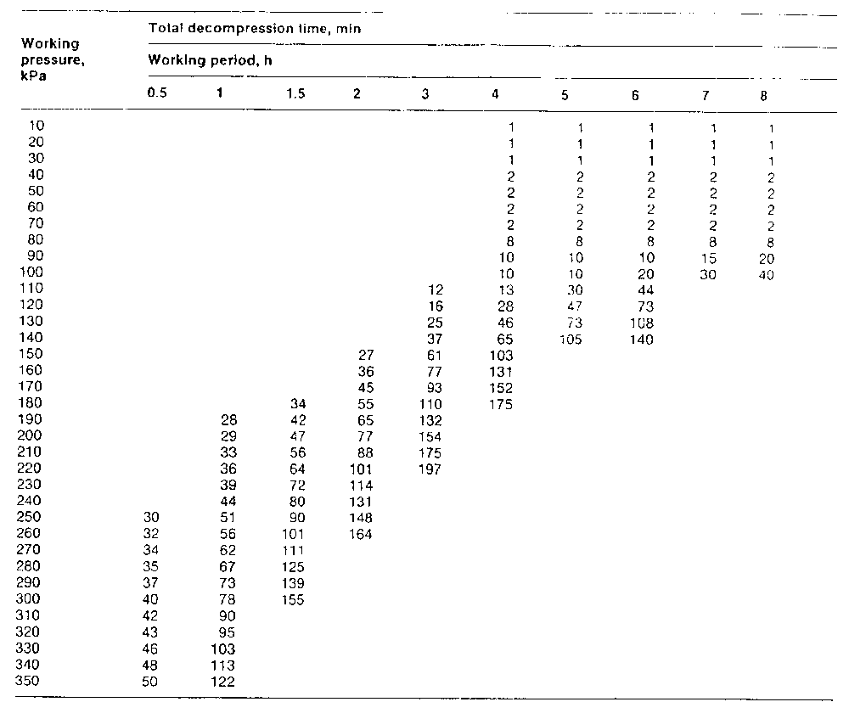
O. Reg. 213/91, Table 1.
table 2
Insert regs\graphics\1991\213\213fg02a.tif
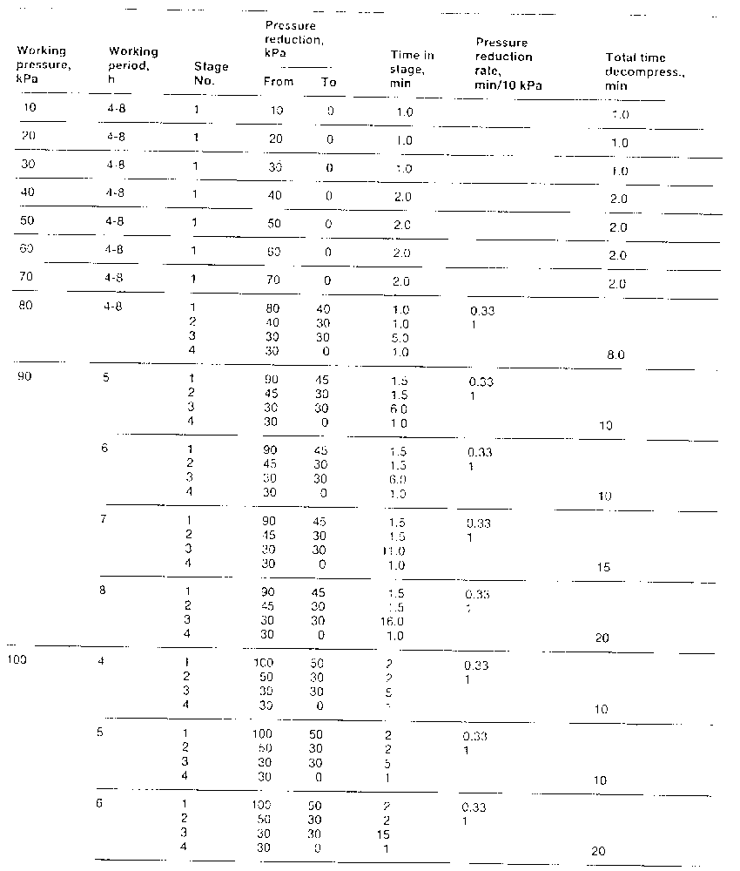
Insert regs\graphics\1991\213\213fg02b.tif
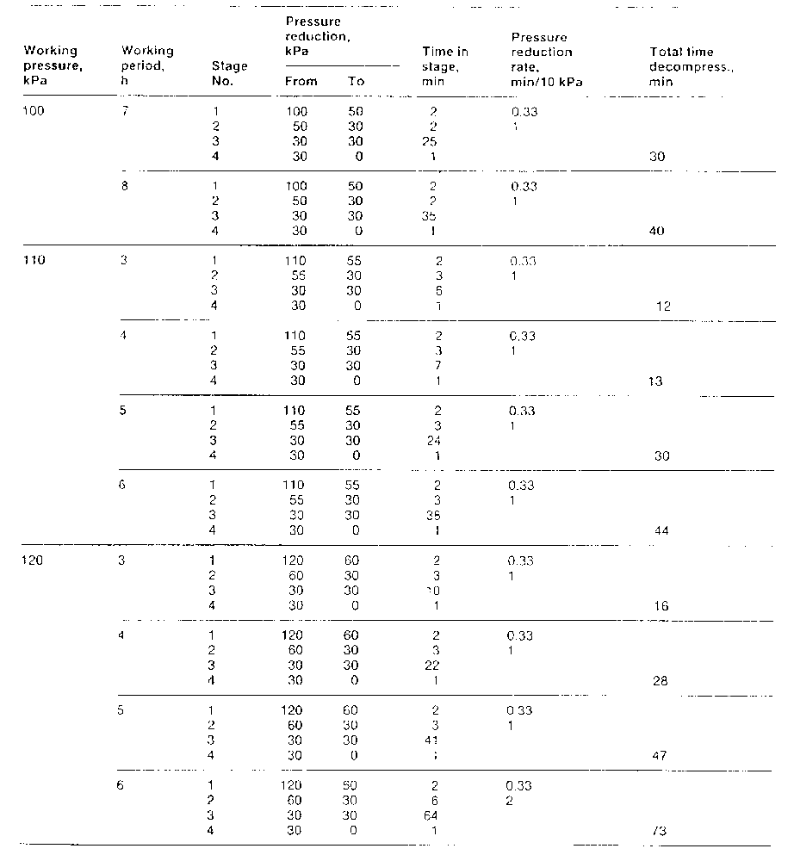
Insert regs\graphics\1991\213\213fg02c.tif
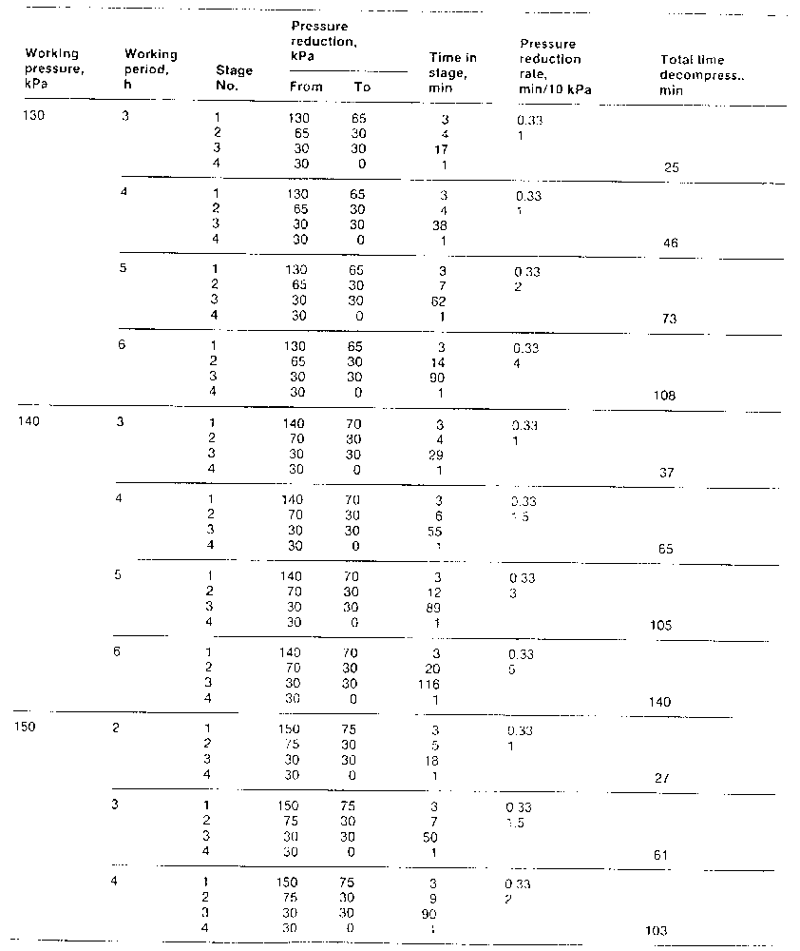
Insert regs\graphics\1991\213\213fg02d.tif
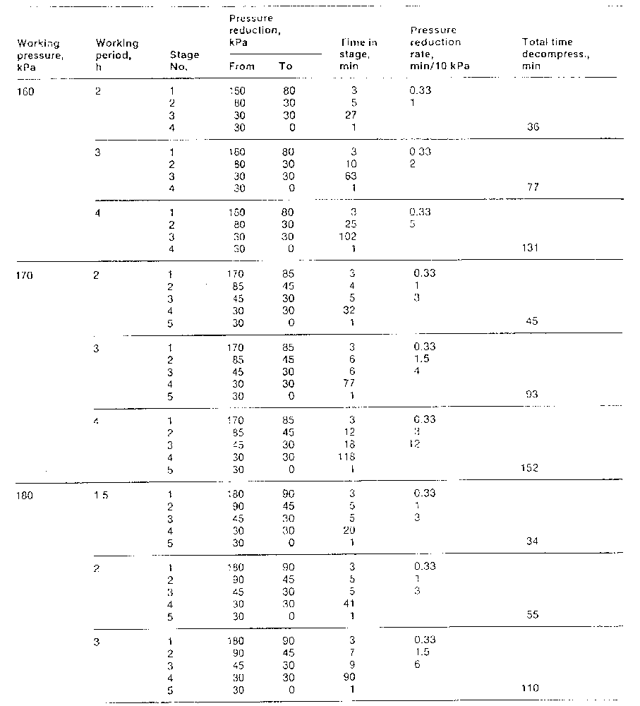
Insert regs\graphics\1991\213\213fg02e.tif
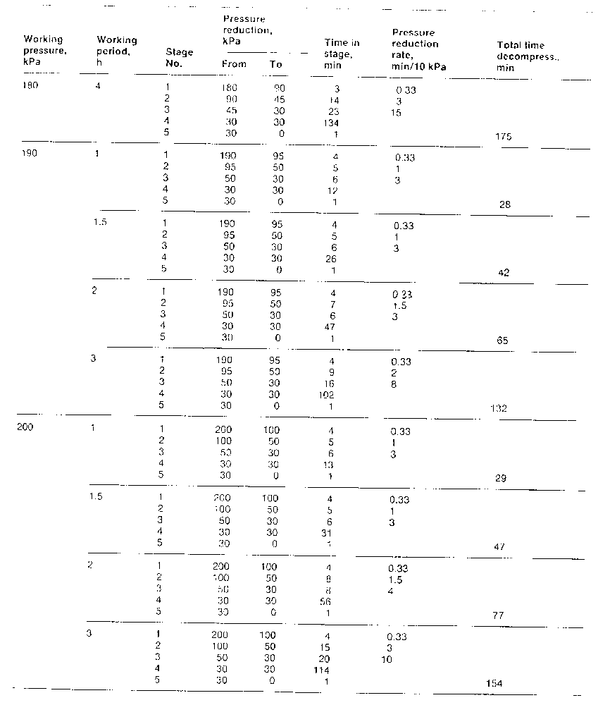
Insert regs\graphics\1991\213\213fg02f.tif
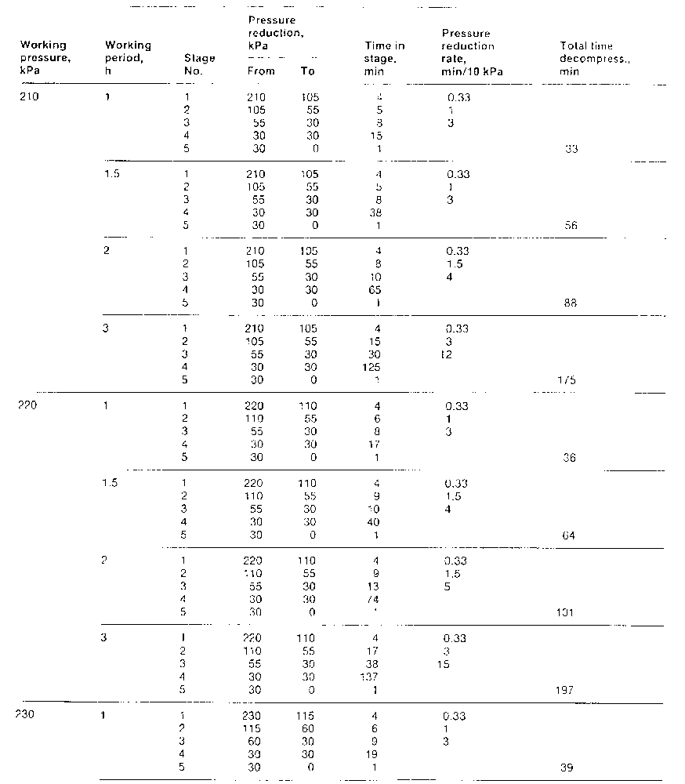
Insert regs\graphics\1991\213\213fg02g.tif
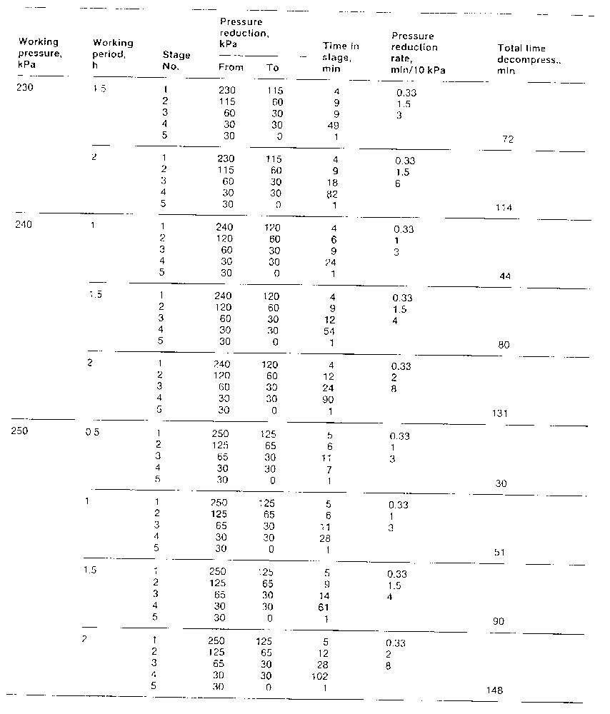
Insert regs\graphics\1991\213\213fg02h.tif
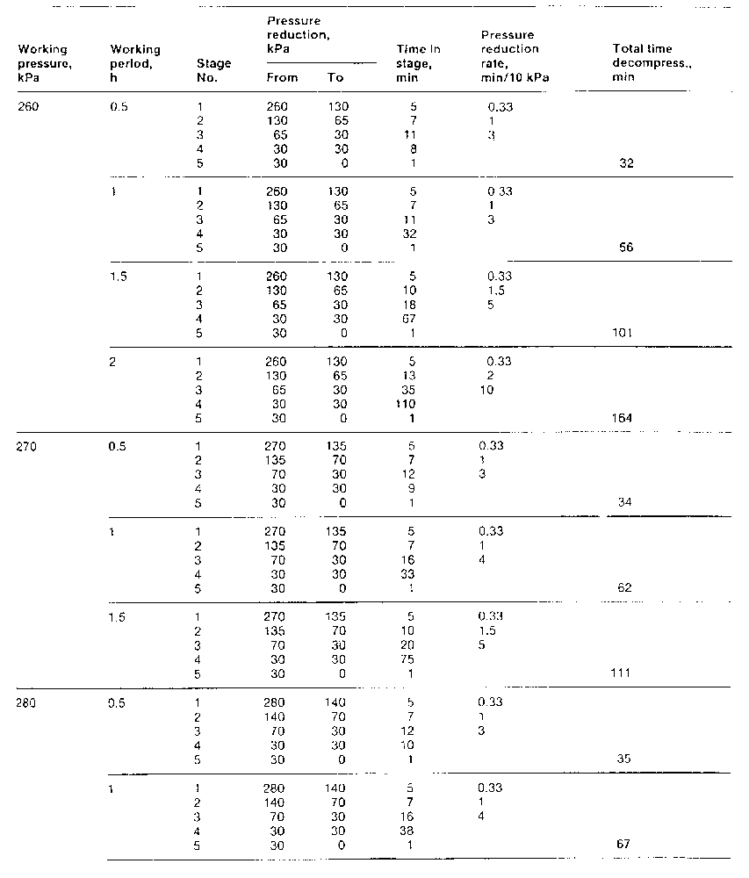
Insert regs\graphics\1991\213\213fg02i.tif
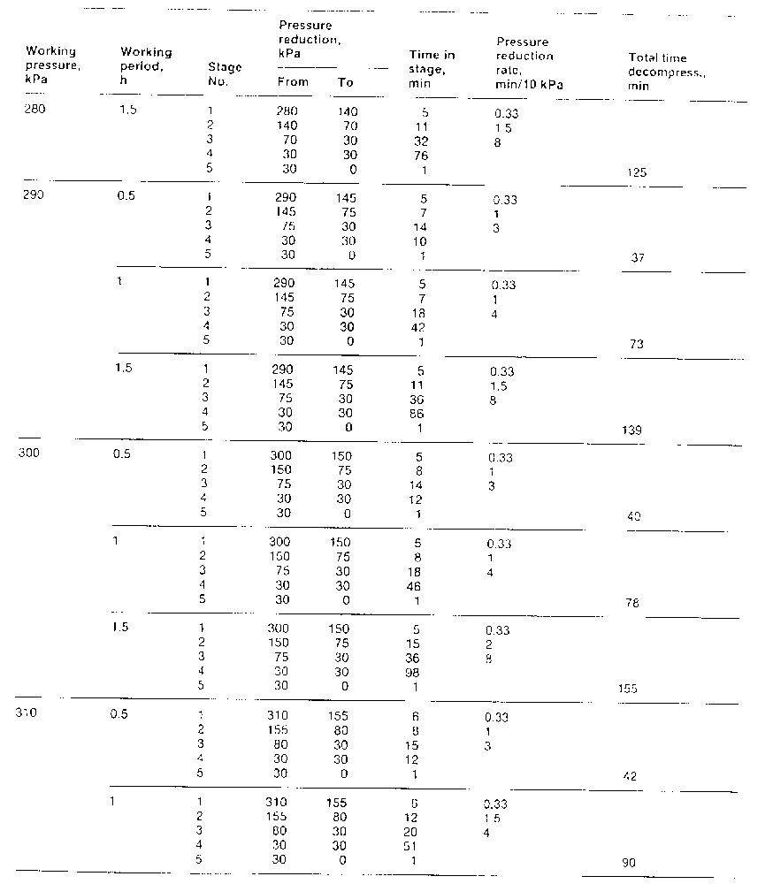
Insert regs\graphics\1991\213\213fg02j.tif
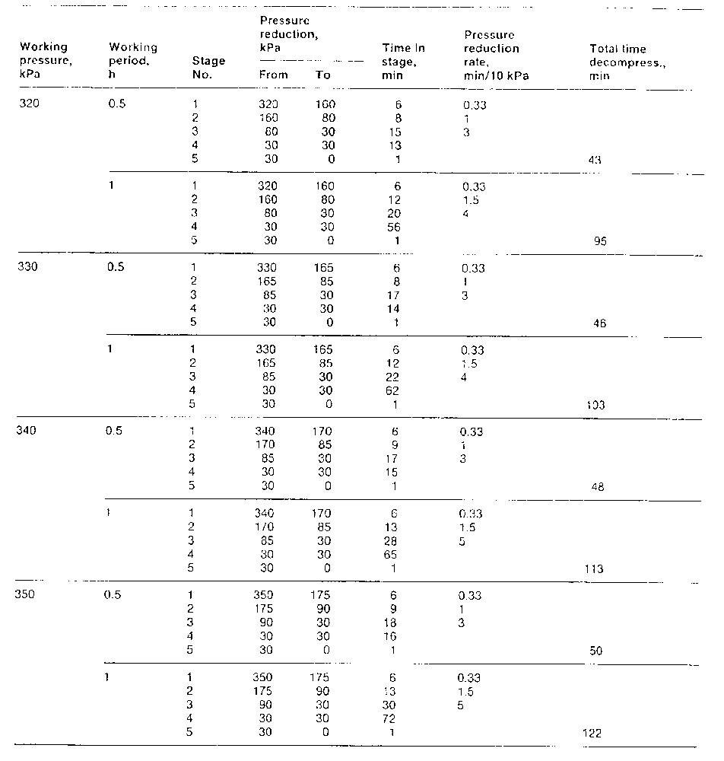
O. Reg. 213/91, Table 2.
Form 1
record of compressed air worker
Occupational Health and Safety Act
Insert regs\graphics\1991\213\213001au.tif
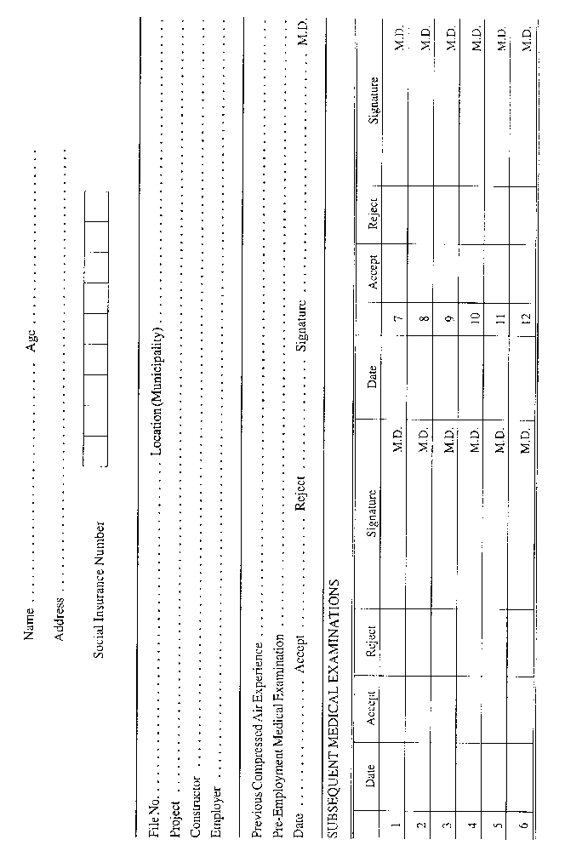
O. Reg. 213/91, Form 1.

Back to top

