Substitute Decisions Act, 1992
ontario regulation 26/95
GENERAL
Historical version for the period December 14, 2012 to December 31, 2012.
Last amendment: O. Reg. 411/12.
This is the English version of a bilingual regulation.
1. For the purposes of subsection 40 (1) of the Act, a guardian of property or an attorney under a continuing power of attorney shall be entitled, subject to an increase under subsection 40 (3) of the Act or an adjustment pursuant to a passing of the guardian’s or attorney’s accounts under section 42 of the Act, to compensation of,
(a) 3 per cent on capital and income receipts;
(b) 3 per cent on capital and income disbursements; and
(c) three-fifths of 1 per cent on the annual average value of the assets as a care and management fee. O. Reg. 26/95, s. 1; O. Reg. 159/00, s. 1.
2. The prescribed amount per page to be paid for photocopies under paragraph 5 of subsection 83 (4) of the Act is 50 cents. O. Reg. 26/95, s. 2.
3. (1) An application to replace the Public Guardian and Trustee as statutory guardian of property by a person authorized to apply under subsection 17 (1) of the Act shall be in Form 1. O. Reg. 101/96, s. 1.
(2) A management plan required by subsection 17 (3) or clause 70 (1) (b) of the Act shall be in Form 2. O. Reg. 101/96, s. 1.
(3) A guardianship plan required by clause 70 (2) (b) of the Act shall be in Form 3. O. Reg. 101/96, s. 1.
(4) A request for an assessment of one’s own or another person’s capacity under subsection 16 (1) of the Act shall be in Form 4. O. Reg. 101/96, s. 1.
(5) A statement required by paragraph 1 of subsection 50 (1) of the Act shall be in Form 5. O. Reg. 101/96, s. 1.
(6) A statement in support of an application under subsection 71 (1) of the Act shall be in Form 6. O. Reg. 101/96, s. 1.
(7) A statement in support of a motion under subsection 71 (2) of the Act shall be in Form 7. O. Reg. 101/96, s. 1.
(8) A statement of a person who is not an assessor under section 72 of the Act shall be in Form 8. O. Reg. 101/96, s. 1.
(9) A statement of a person who is not an assessor under section 73 of the Act shall be in Form 9. O. Reg. 101/96, s. 1.
4. Omitted (provides for coming into force of provisions of this Regulation). O. Reg. 26/95, s. 4.
Note: On January 1, 2013, section 4 is revoked and the following substituted: (See: O. Reg. 411/12, ss. 1, 2)
4. For the purposes of clause (d) of the definition of “facility” in subsection 1 (1) of the Act, a facility that receives funding for emergency shelter solutions or housing with related supports under the Community Homelessness Prevention Initiative of the Ministry of Municipal Affairs and Housing is a prescribed facility. O. Reg. 411/12, s. 1.
Form 1
application to replace the public guardian and trustee as statutory guardian of property by a person authorized to apply under subsection 17 (1) 1, 2, 3, 4
Substitute Decisions Act, 1992
Insert regs\graphics\1995\26\026001ae.tif
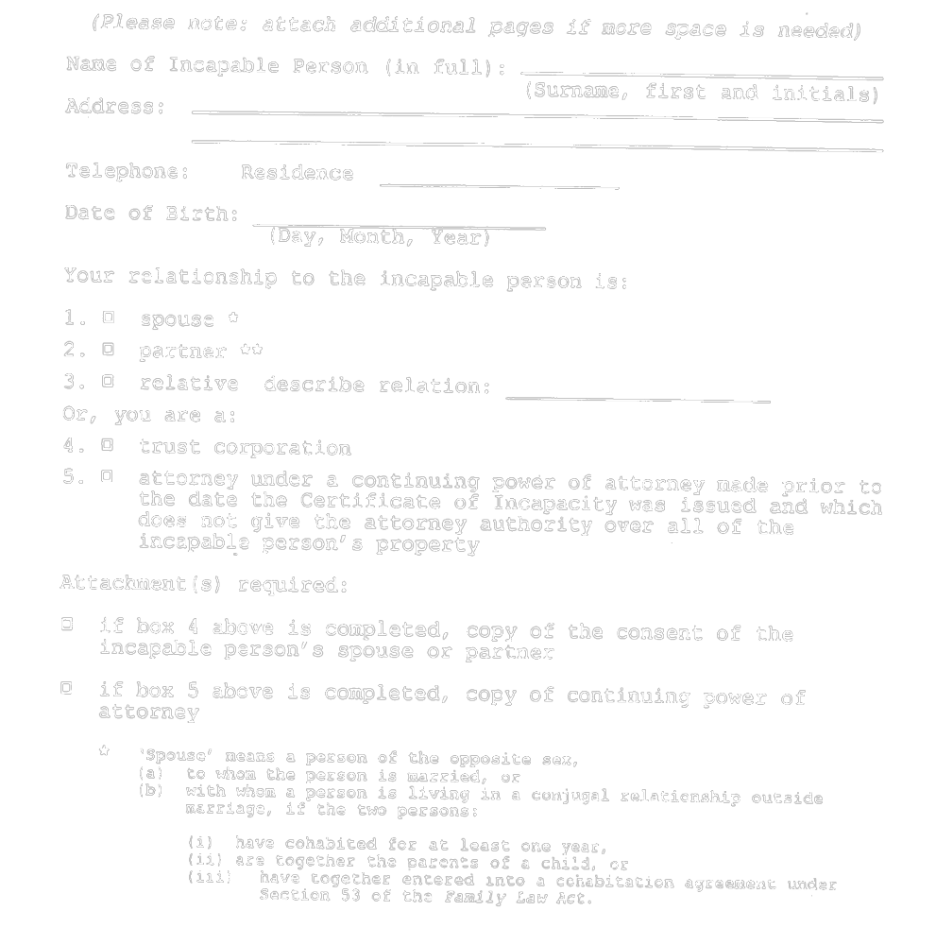
Insert regs\graphics\1995\26\026001be.tif
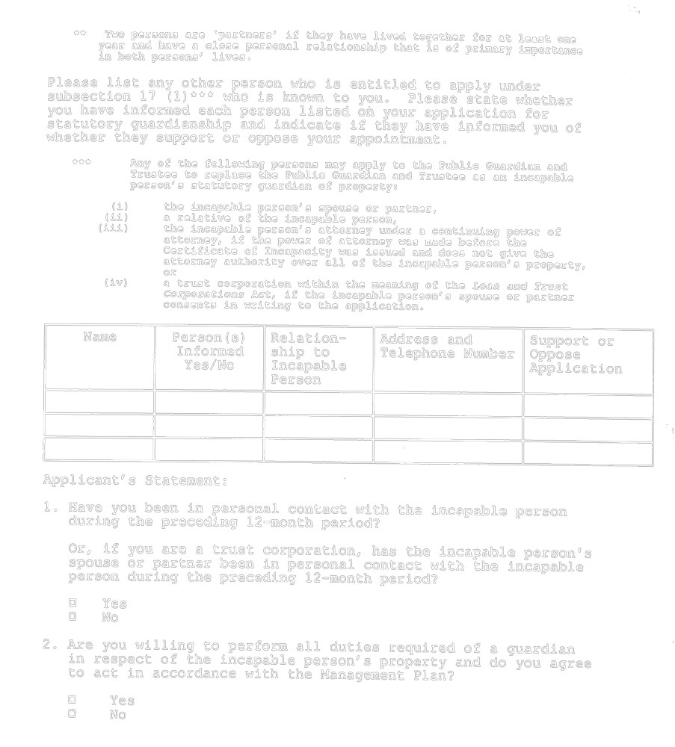
Insert regs\graphics\1995\26\026001ce.tif
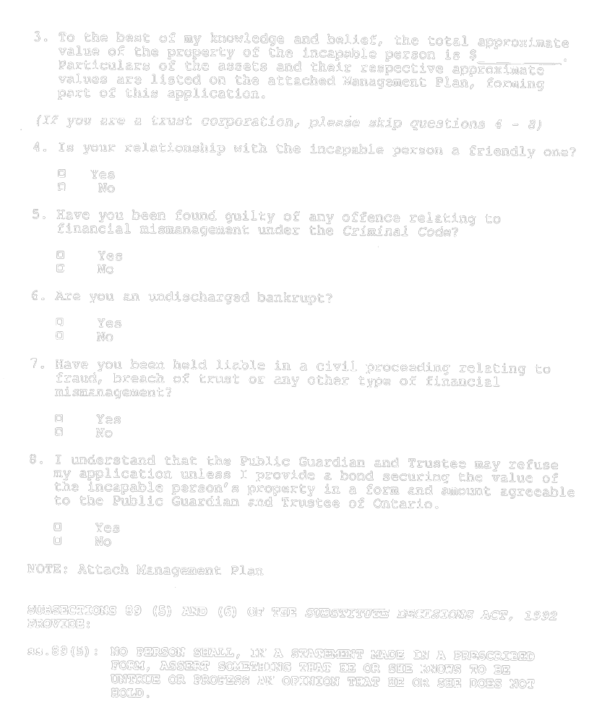
Insert regs\graphics\1995\26\026001de.tif
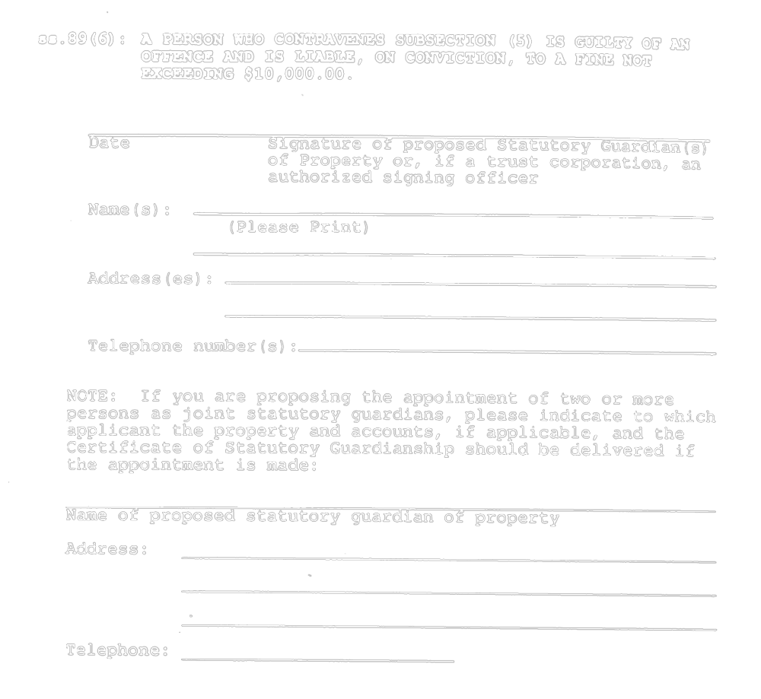
Insert regs\graphics\1995\26\026001ee.tif

O. Reg. 101/96, s. 2.
Form 2
management plan
Substitute Decisions Act, 1992

Note: Where the document is completed as part of an application for court appointed guardianship of property, please insert general heading and court file number.
Insert regs\graphics\1995\26\026002ae.tif
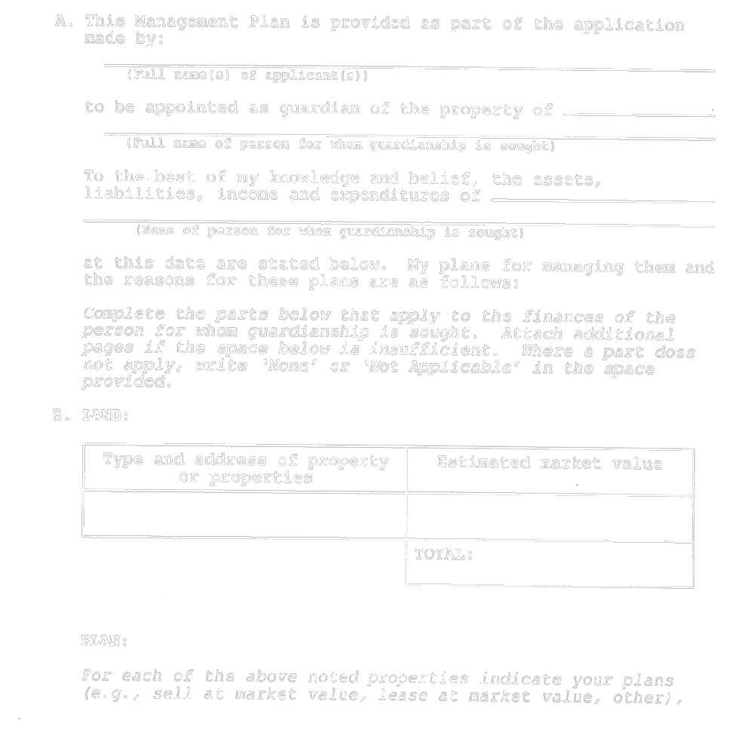
Insert regs\graphics\1995\26\026002be.tif
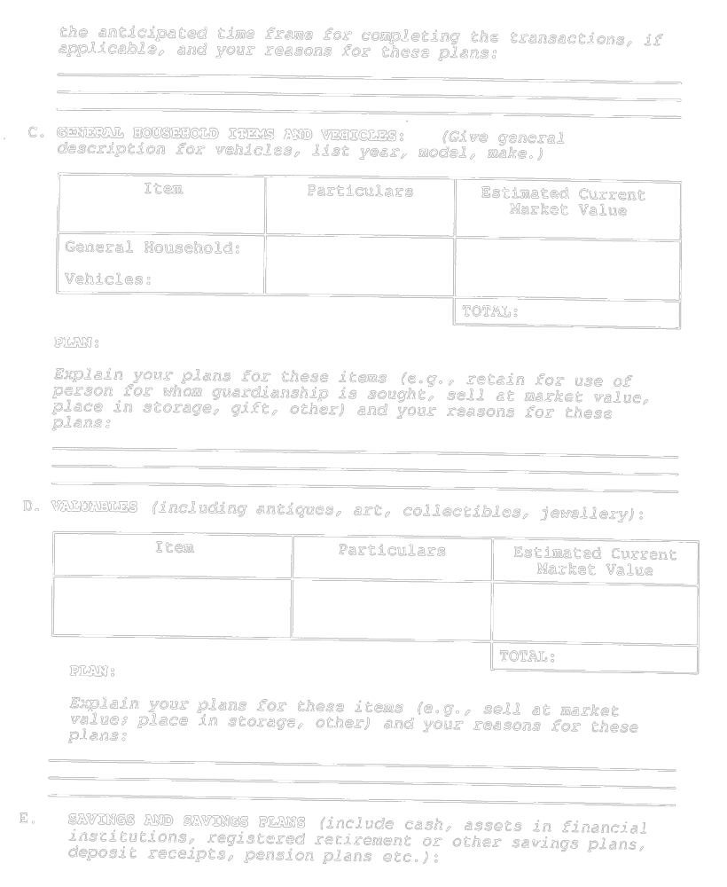
Insert regs\graphics\1995\26\026002ce.tif
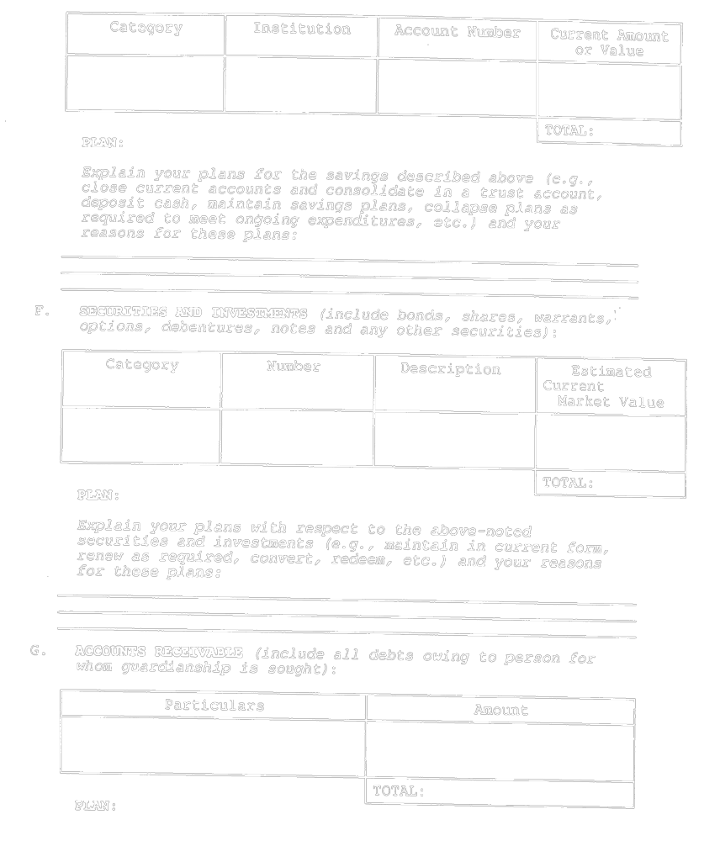
Insert regs\graphics\1995\26\026002de.tif
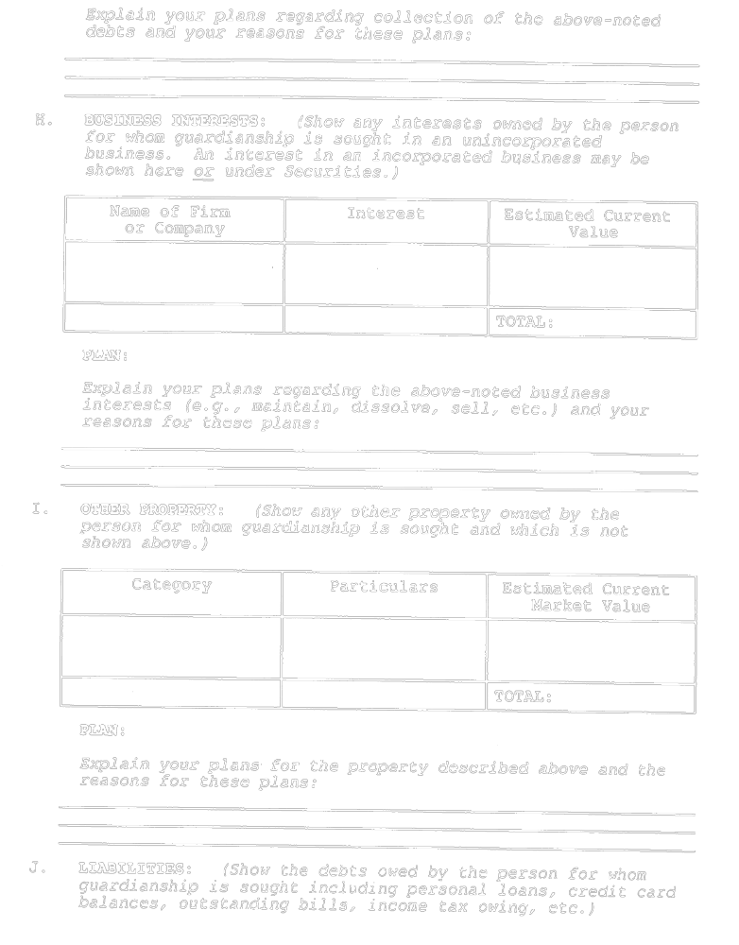
Insert regs\graphics\1995\26\026002ee.tif
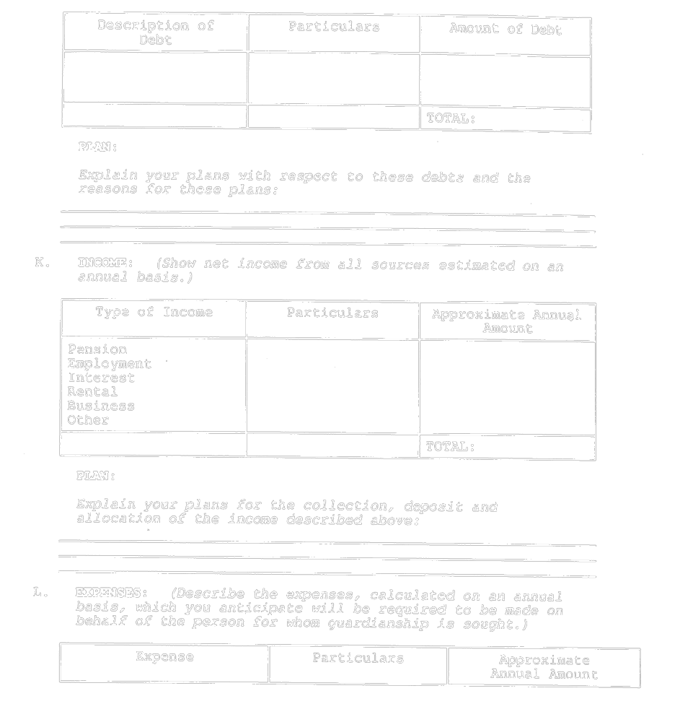
Insert regs\graphics\1995\26\026002fe.tif
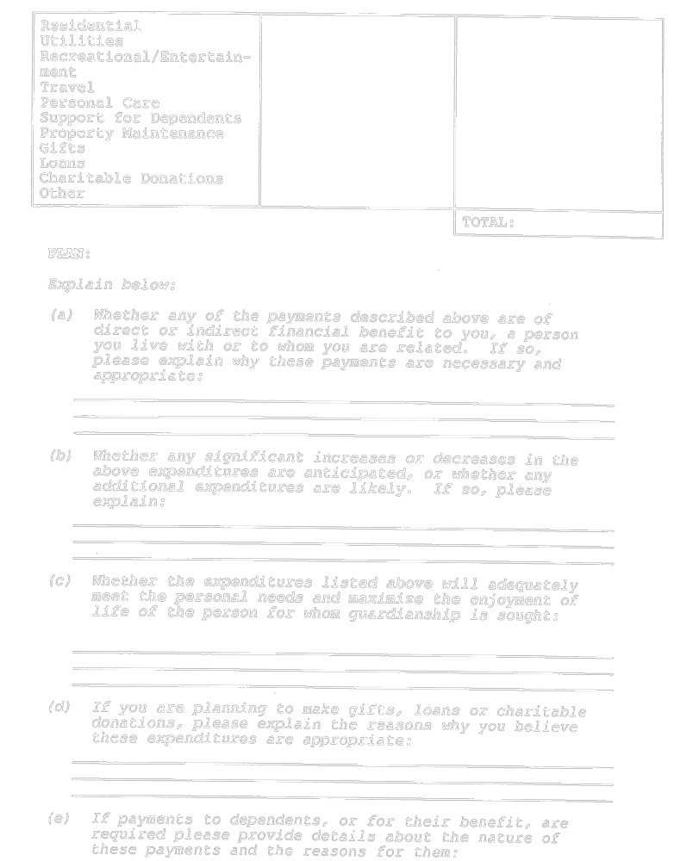
Insert regs\graphics\1995\26\026002ge.tif
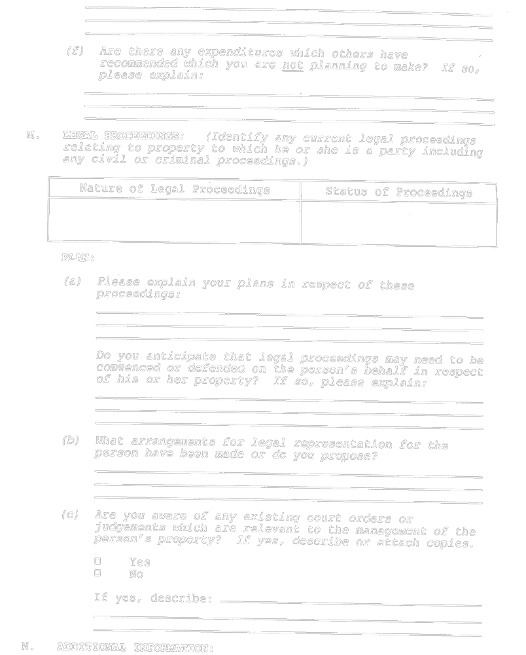
Insert regs\graphics\1995\26\026002he.tif
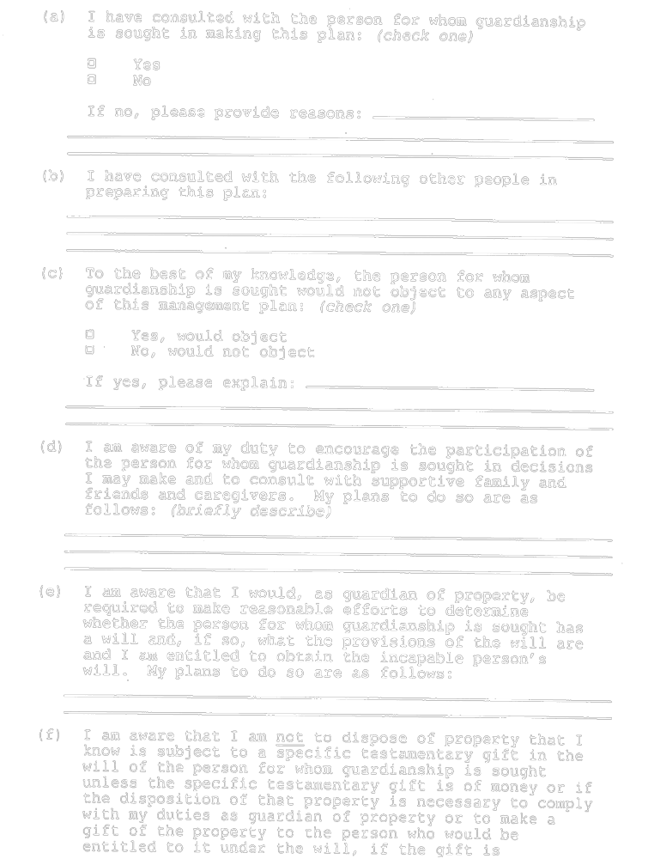
Insert regs\graphics\1995\26\026002ie.tif
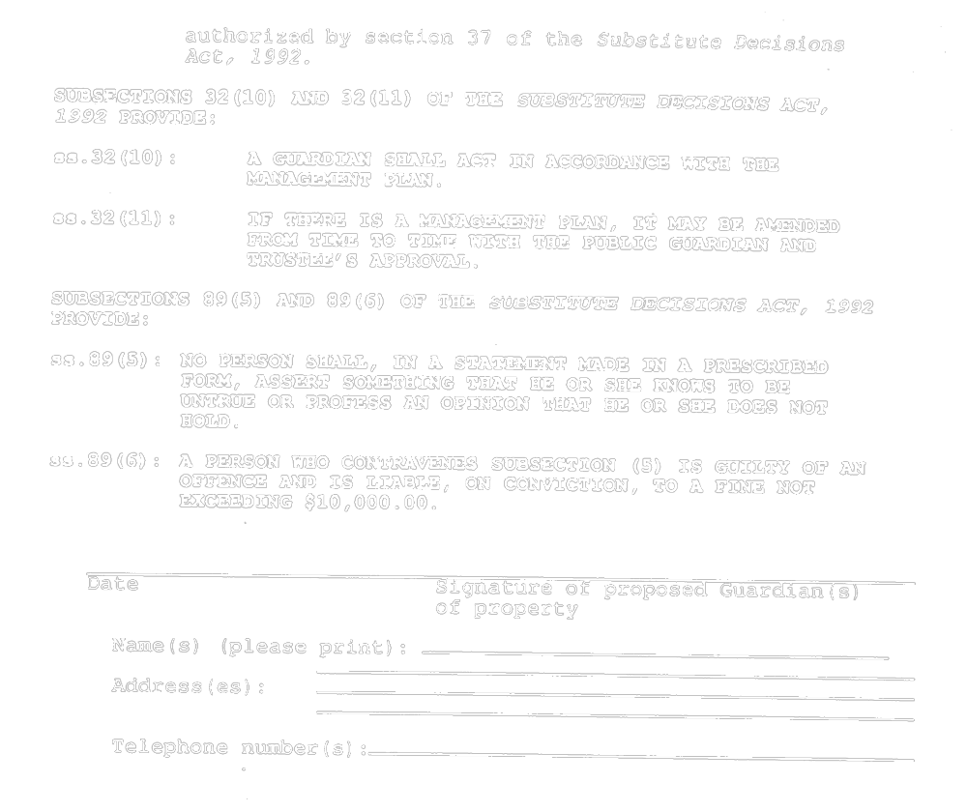
O. Reg. 101/96, s. 2.
Form 3
guardianship plan
Substitute Decisions Act, 1992

Note: Where this document is completed as part of an application for court appointed guardianship of the person, please insert general heading and court file number.
Insert regs\graphics\1995\26\026003ae.tif
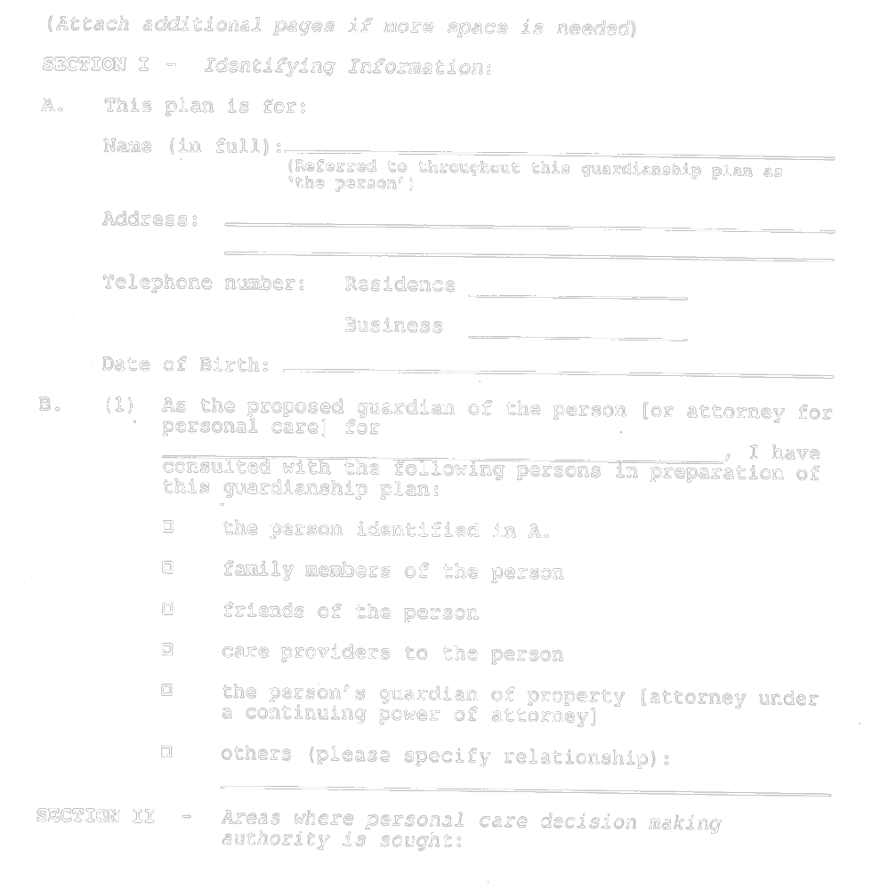
Insert regs\graphics\1995\26\026003be.tif
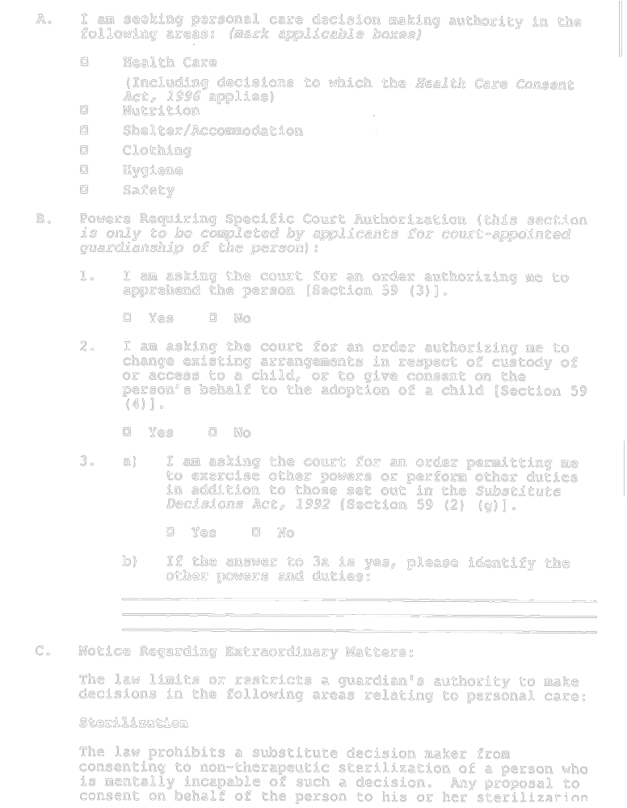
Insert regs\graphics\1995\26\026003ce.tif
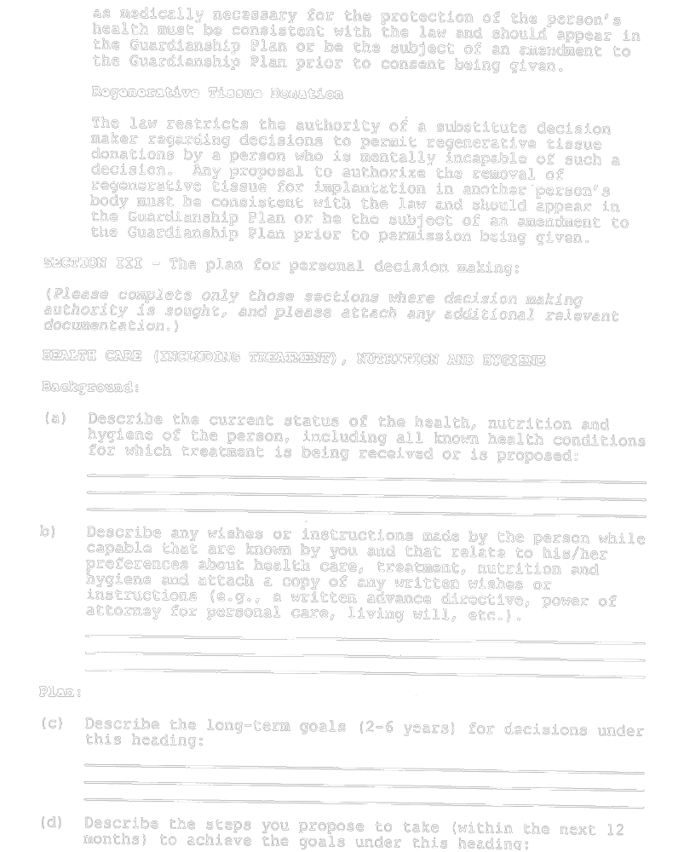
Insert regs\graphics\1995\26\026003de.tif
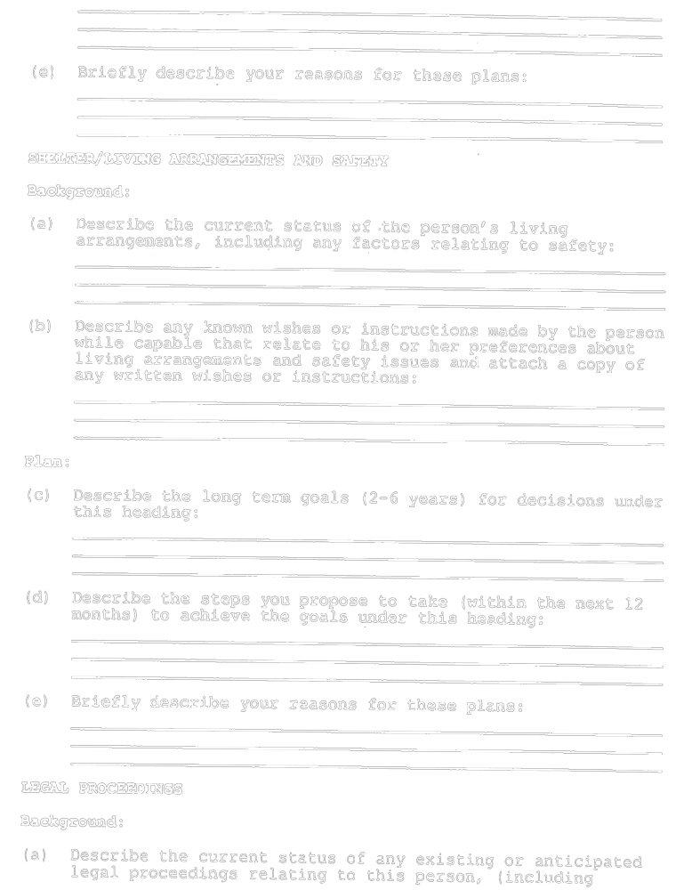
Insert regs\graphics\1995\26\026003ee.tif
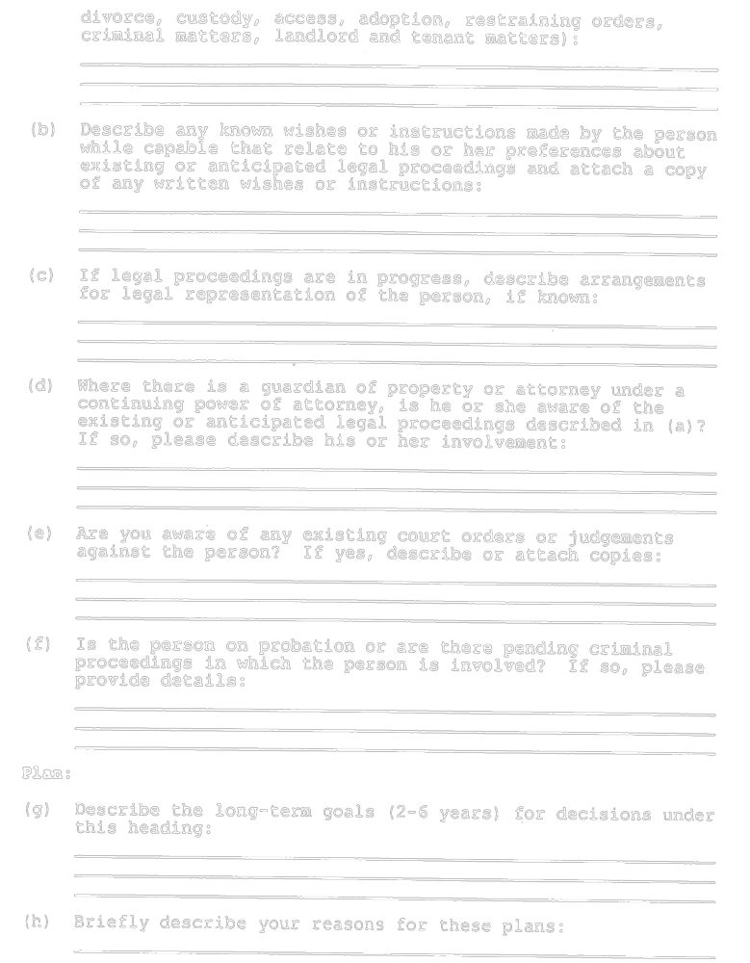
Insert regs\graphics\1995\26\026003fe.tif
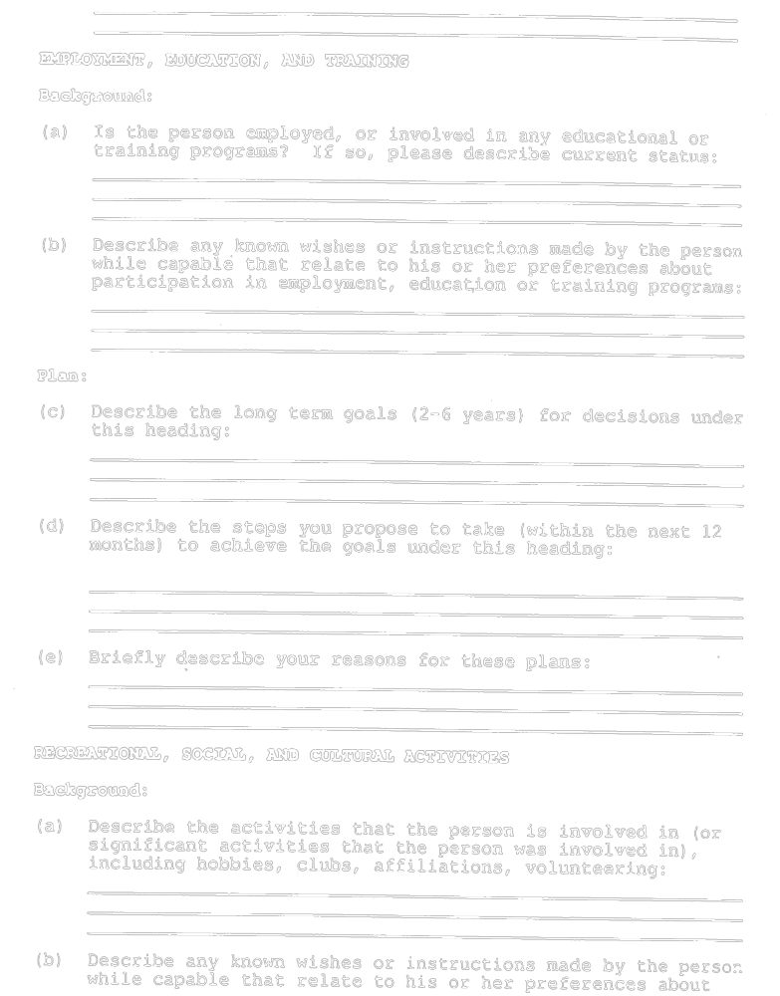
Insert regs\graphics\1995\26\026003ge.tif
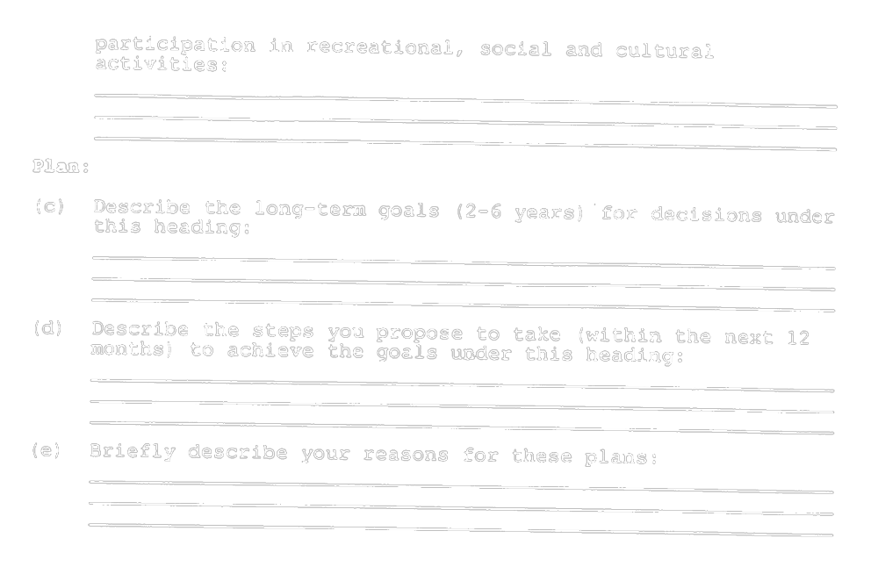
Insert regs\graphics\1995\26\026003he.tif
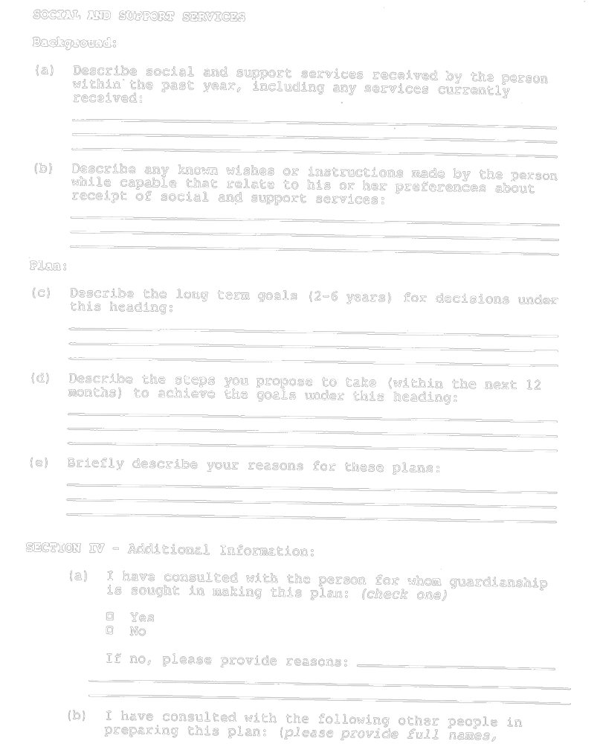
Insert regs\graphics\1995\26\026003ie.tif
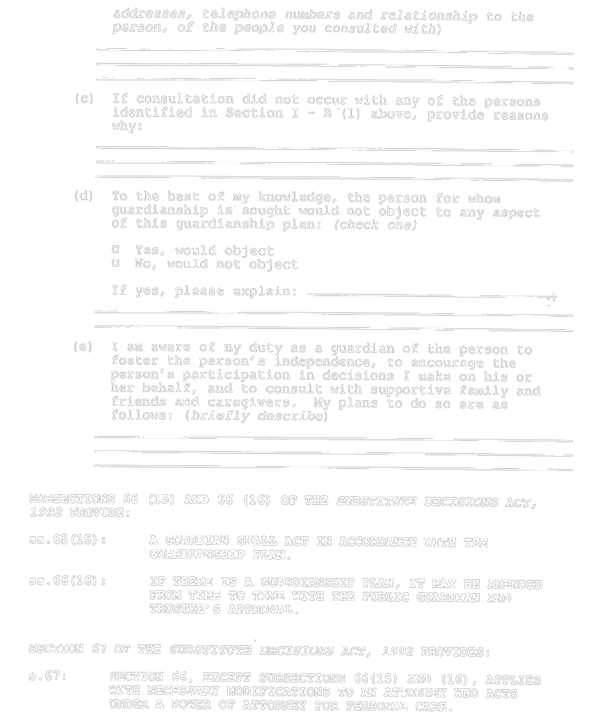
Insert regs\graphics\1995\26\026003je.tif
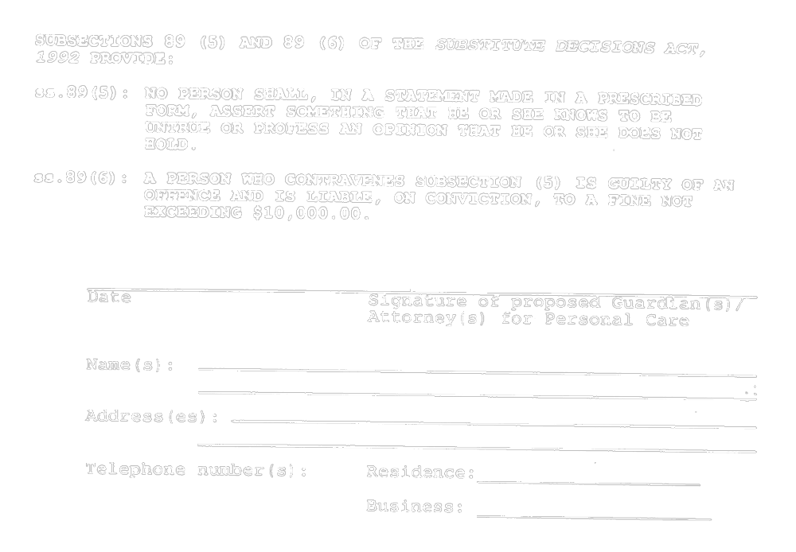
O. Reg. 101/96, s. 2.
Form 4
request for assessment of capacity under subsection 16 (1) of the act
Substitute Decisions Act, 1992
Insert regs\graphics\1995\26\026004ae.tif
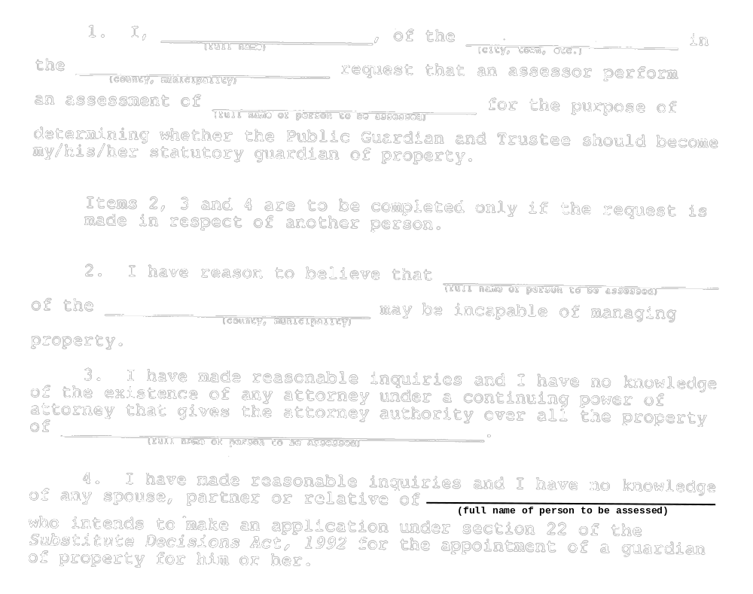
Insert regs\graphics\1995\26\026004be.tif
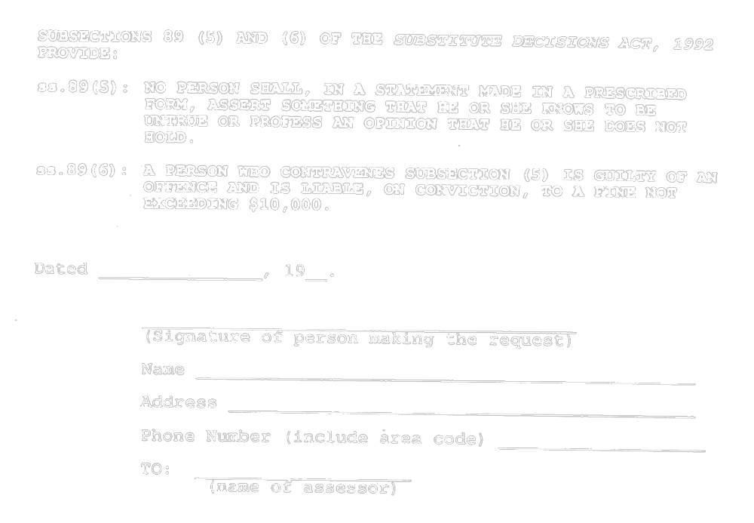
O. Reg. 101/96, s. 2.
Form 5
statement required under paragraph 1 of section 50 (1) of the act
Substitute Decisions Act, 1992
Insert regs\graphics\1995\26\026005ae.tif
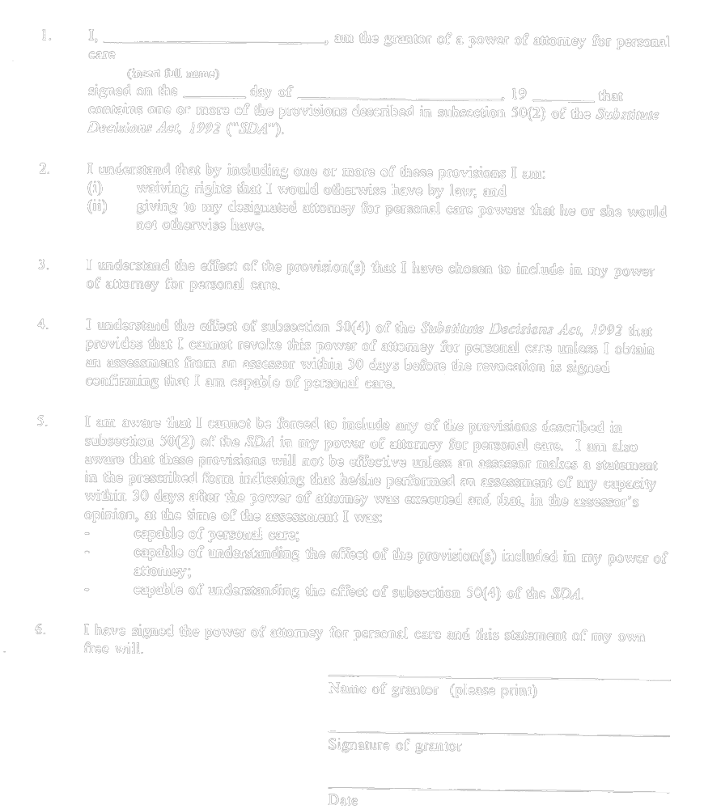
O. Reg. 101/96, s. 2.
Form 6
Substitute Decisions Act, 1992
Insert regs\graphics\1995\26\026006ae.tif
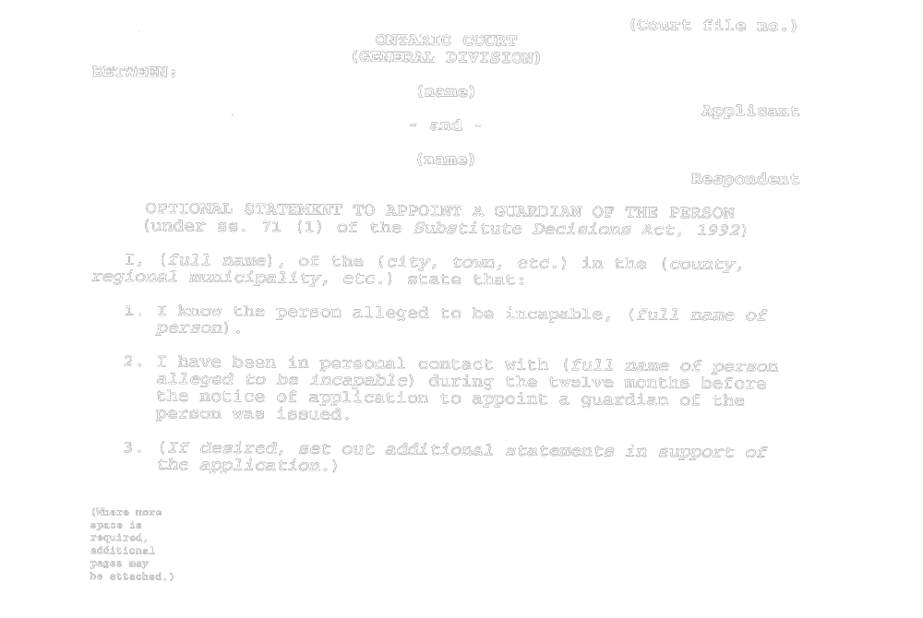
Insert regs\graphics\1995\26\026006be.tif
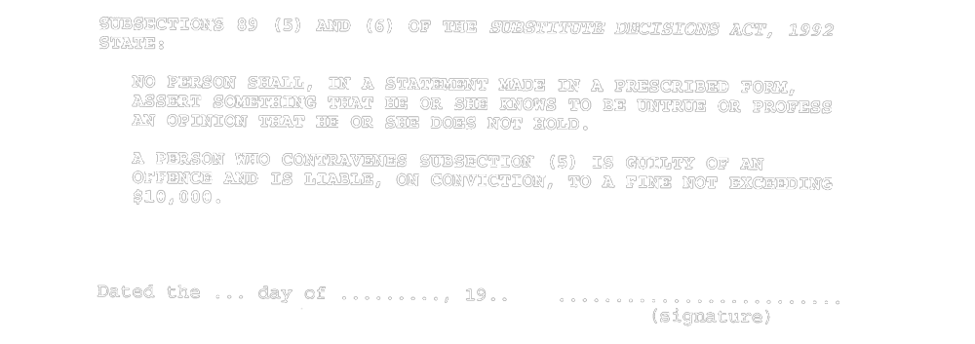
O. Reg. 26/95, Form 6.
Form 7
Substitute Decisions Act, 1992
Insert regs\graphics\1995\26\026007ae.tif
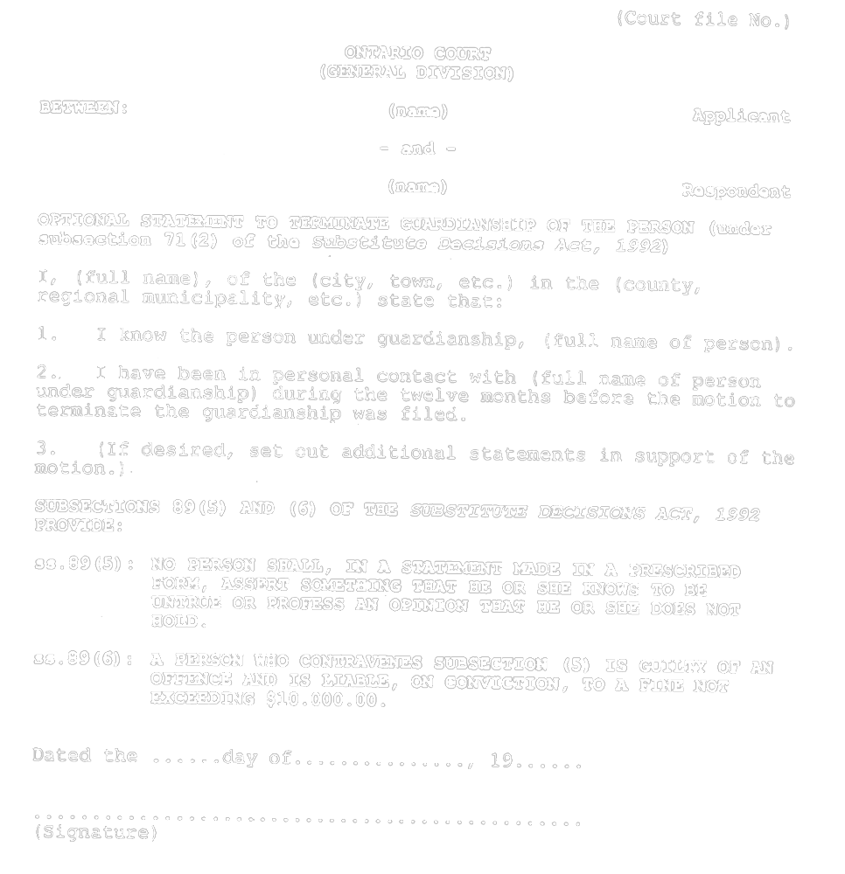
O. Reg. 101/96, s. 2.
Form 8
Substitute Decisions Act, 1992
Insert regs\graphics\1995\26\026008ae.tif
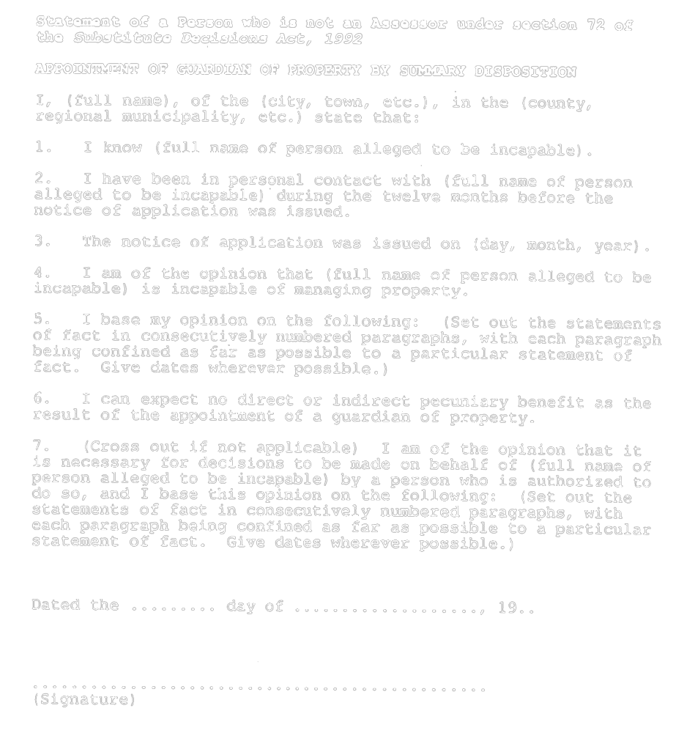
O. Reg. 101/96, s. 2.
Form 9
Substitute Decisions Act, 1992
Insert regs\graphics\1995\26\026009ae.tif
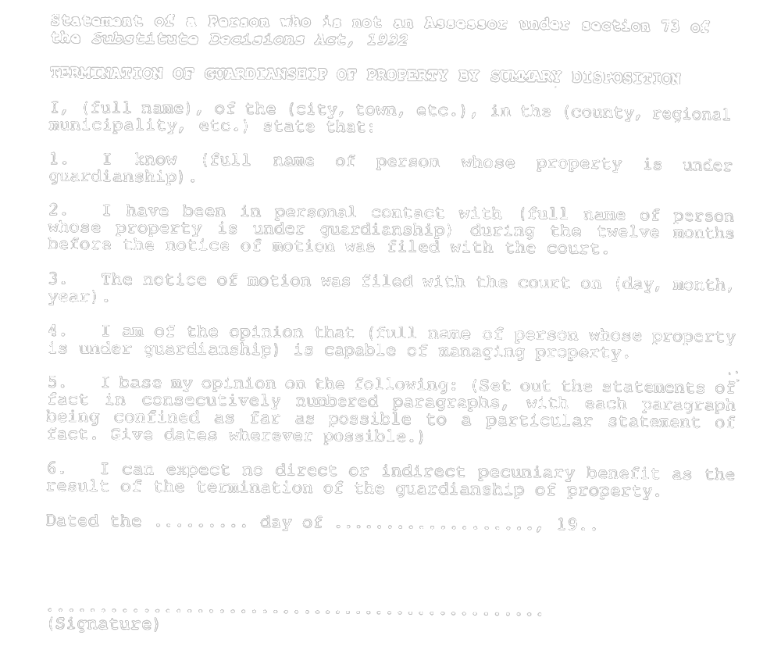
O. Reg. 101/96, s. 2.

Back to top

