Education Act
Loi sur l’éducation
ONTARIO REGULATION 277/97
ASSESSMENT AND TAX ADJUSTMENTS — 1997
Historical version for the period July 24, 1997 to August 14, 2008.
Disclaimer: The HTML version of this consolidation is not an official copy of the law because some portion of it may not be fully legible. The Word version remains an official copy of the law.
No amendments.
This Regulation is made in English only.
1. (1) For purposes of taxation in 1997, the proportions of assessment of designated ratepayers rated and assessed in each municipality set out in Column 1 of Schedule 1, and the allocation or payment of the tax levied under subsections 159 (12) and (13) of the Municipal Act in each of those municipalities, shall be adjusted as follows:
1. For public school purposes, to the percentage of the assessment, or the tax, as the case may be, set out in Column 2 opposite the municipality.
2. For separate school purposes, to the percentage of the assessment, or the tax, as the case may be, set out in Column 3 opposite the municipality. O. Reg. 277/97, s. 1 (1).
(2) The assessment commissioner shall adjust the assessment roll returned for each municipality in 1996 for taxation in 1997 according to the calculations made under subsection (1). O. Reg. 277/97, s. 1 (2).
(3) The council of each municipality shall allocate or pay the tax levied under subsections 159 (12) and (13) of the Municipal Act according to the proportions determined under subsection (1). O. Reg. 277/97, s. 1 (3).
2. (1) For purposes of taxation in 1997, the proportions of assessment of designated ratepayers rated and assessed in each area municipality of The Regional Municipality of Ottawa-Carleton set out in Column 1 of Schedule 2, and the allocation or payment of the tax levied under subsections 159 (12) and (13) of the Municipal Act in each of those municipalities, shall be adjusted as follows:
1. For The Ottawa Board of Education or The Carleton Board of Education, to the percentage of the assessment or the tax, as the case may be, set out in Column 2 opposite the area municipality.
2. For The Ottawa Roman Catholic Separate School Board or The Carleton Roman Catholic Separate School Board, to the percentage of the assessment or the tax, as the case may be, set out in Column 3 opposite the area municipality.
3. For the Conseil des écoles publiques d’Ottawa-Carleton, to the percentage of the assessment or the tax, as the case may be, set out in Column 4 opposite the area municipality.
4. For the Conseil des écoles catholiques de langue française de la région d’Ottawa-Carleton, to the percentage of the assessment or the tax, as the case may be, set out in Column 5 opposite the area municipality. O. Reg. 277/97, s. 2 (1).
(2) The assessment commissioner shall adjust the assessment roll returned for each area municipality in The Regional Municipality of Ottawa-Carleton in 1996 for taxation in 1997 according to the calculations made under subsection (1). O. Reg. 277/97, s. 2 (2).
(3) The council of each area municipality in The Regional Municipality of Ottawa-Carleton shall allocate or pay the tax levied under subsections 159 (12) and (13) of the Municipal Act according to the proportions determined under subsection (1). O. Reg. 277/97, s. 2 (3).
3. (1) For purposes of taxation in 1997, the proportions of assessment of designated ratepayers rated and assessed in each municipality in the united counties of Prescott and Russell set out in Column 1 of Schedule 3, and the allocation or payment of the tax levied under subsections 159 (12) and (13) of the Municipal Act in each of those municipalities, shall be adjusted as follows:
1. For The Prescott and Russell County Board of Education, to the percentage of the assessment or the tax, as the case may be, set out in Column 2 opposite the municipality.
2. For the Conseil des écoles séparées catholiques de langue française de Prescott-Russell, to the percentage of the assessment or the tax, as the case may be, set out in Column 3 opposite the municipality.
3. For The Prescott and Russell County Roman Catholic English-Language Separate School Board, to the percentage of the assessment or the tax, as the case may be, set out in Column 4 opposite the municipality. O. Reg. 277/97, s. 3 (1).
(2) The assessment commissioner shall adjust the assessment roll returned for each municipality in the united counties of Prescott and Russell in 1996 for taxation in 1997 according to the calculations made under subsection (1). O. Reg. 277/97, s. 3 (2).
(3) The council of each municipality in the united counties of Prescott and Russell shall allocate or pay the tax levied under subsections 159 (12) and (13) of the Municipal Act according to the proportions determined under subsection (1). O. Reg. 277/97, s. 3 (3).
Schedule 1
Insert regs\graphics\1997\277\277001au.tif
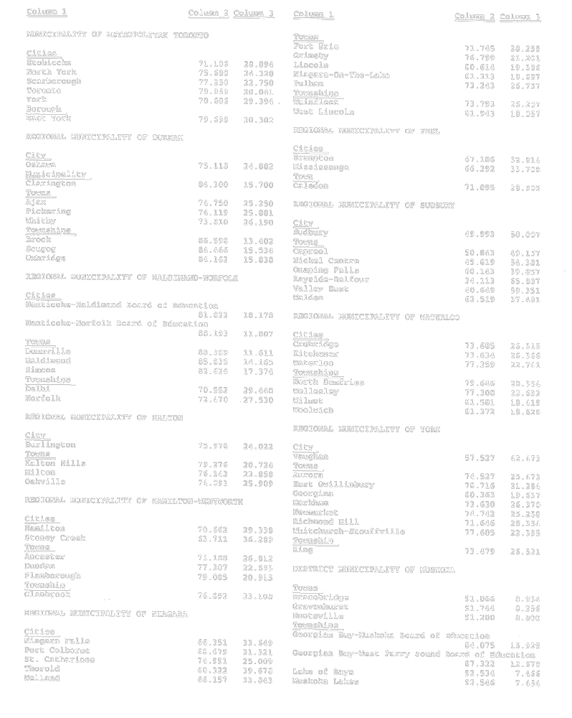
Insert regs\graphics\1997\277\277001bu.tif
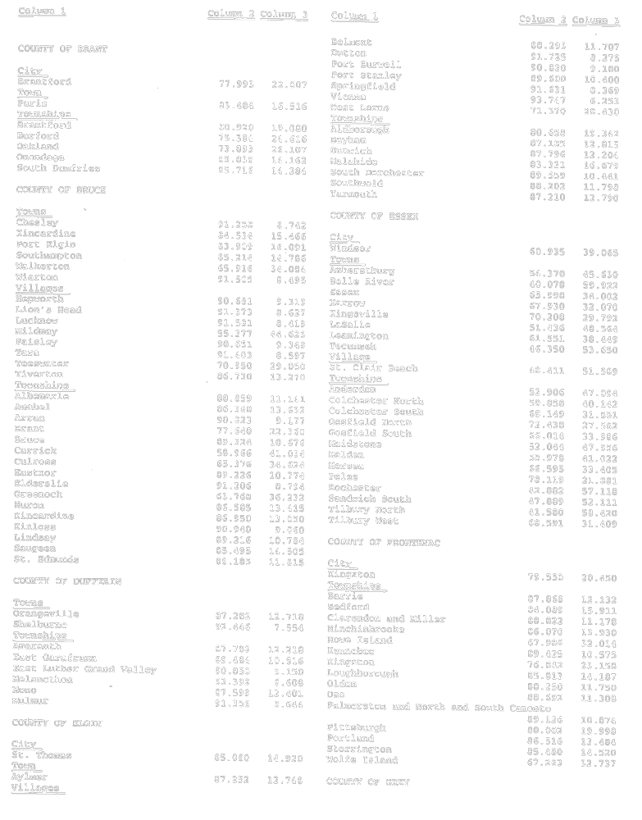
Insert regs\graphics\1997\277\277001cu.tif
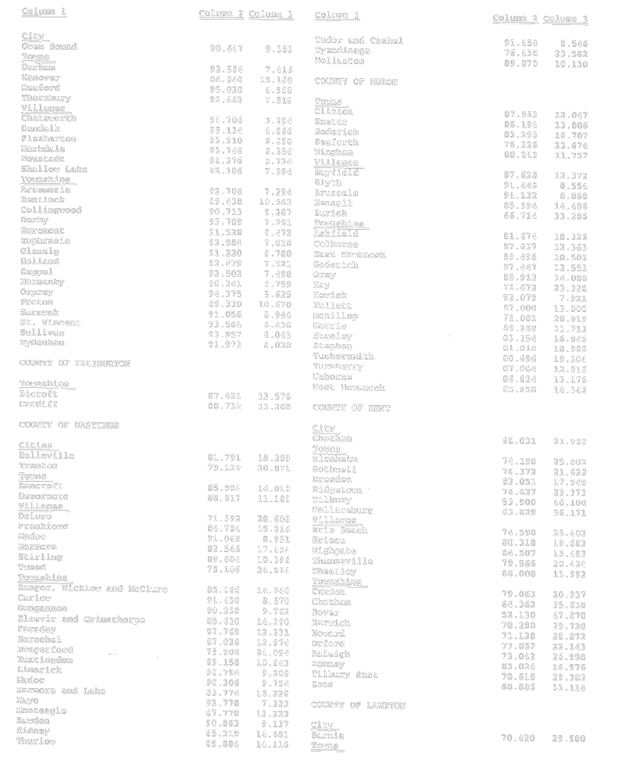
Insert regs\graphics\1997\277\277001du.tif
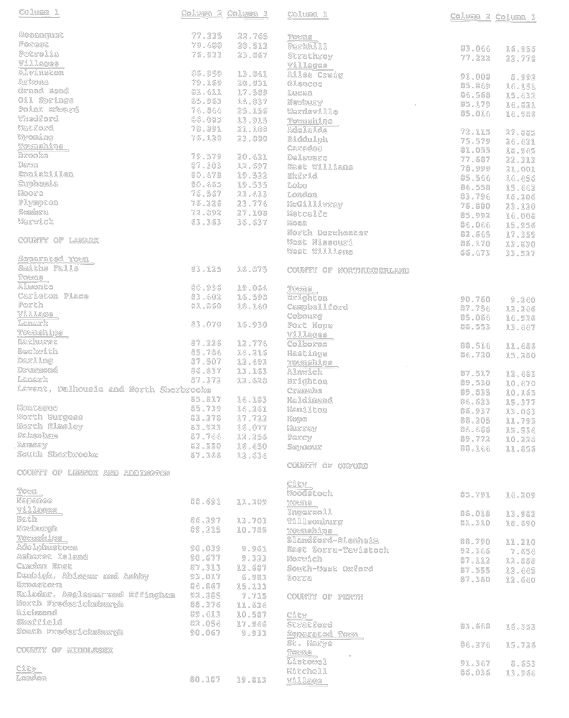
Insert regs\graphics\1997\277\277001eu.tif
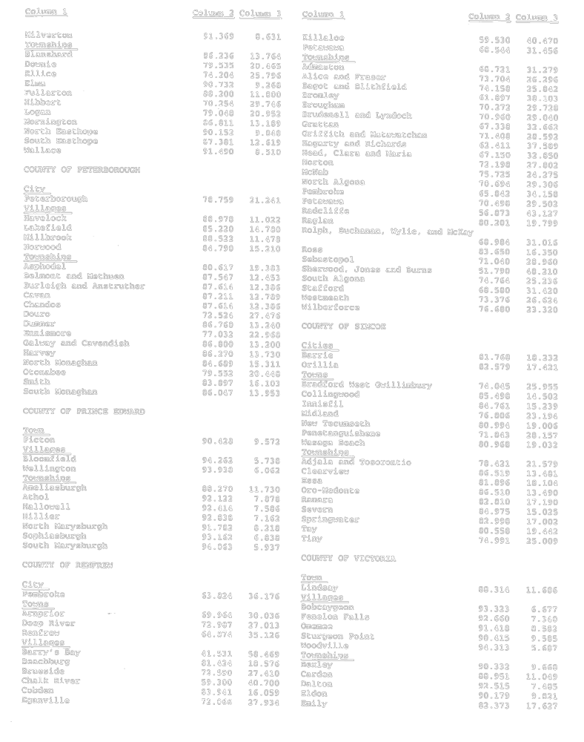
Insert regs\graphics\1997\277\277001fu.tif
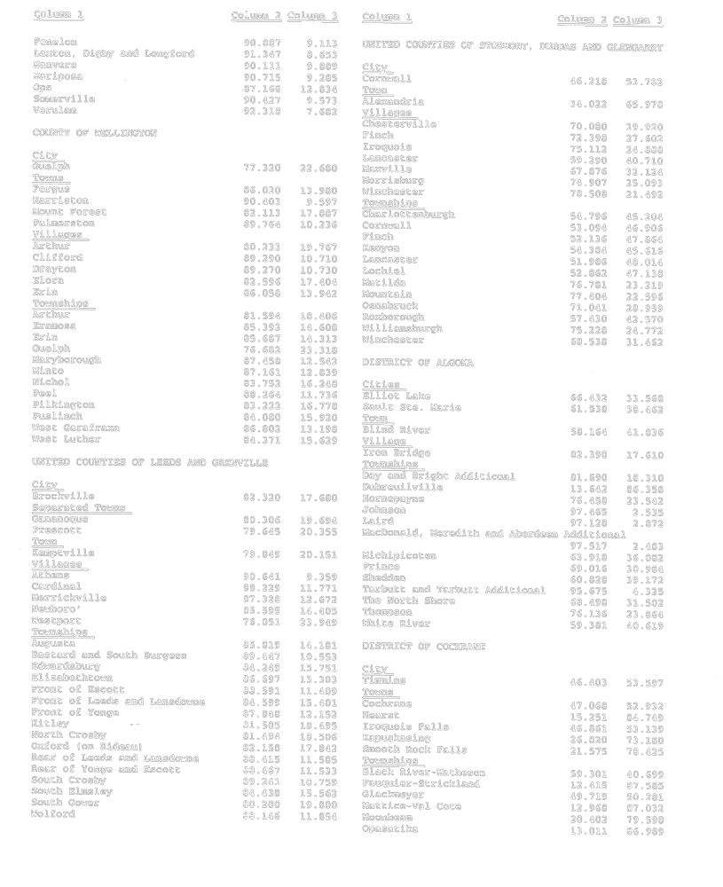
Insert regs\graphics\1997\277\277001gu.tif
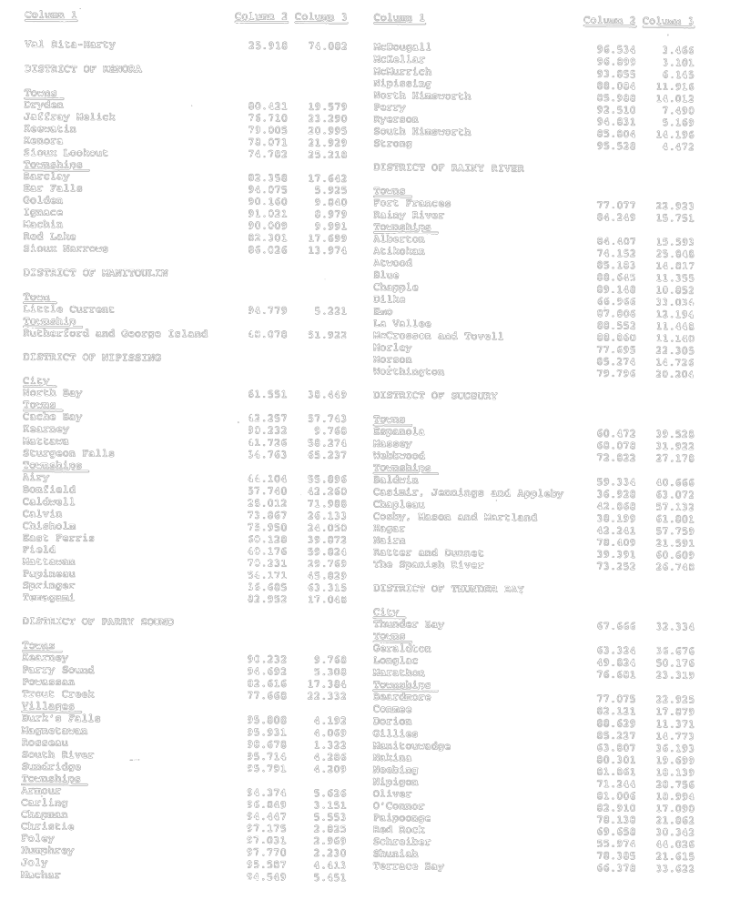
Insert regs\graphics\1997\277\277001hu.tif
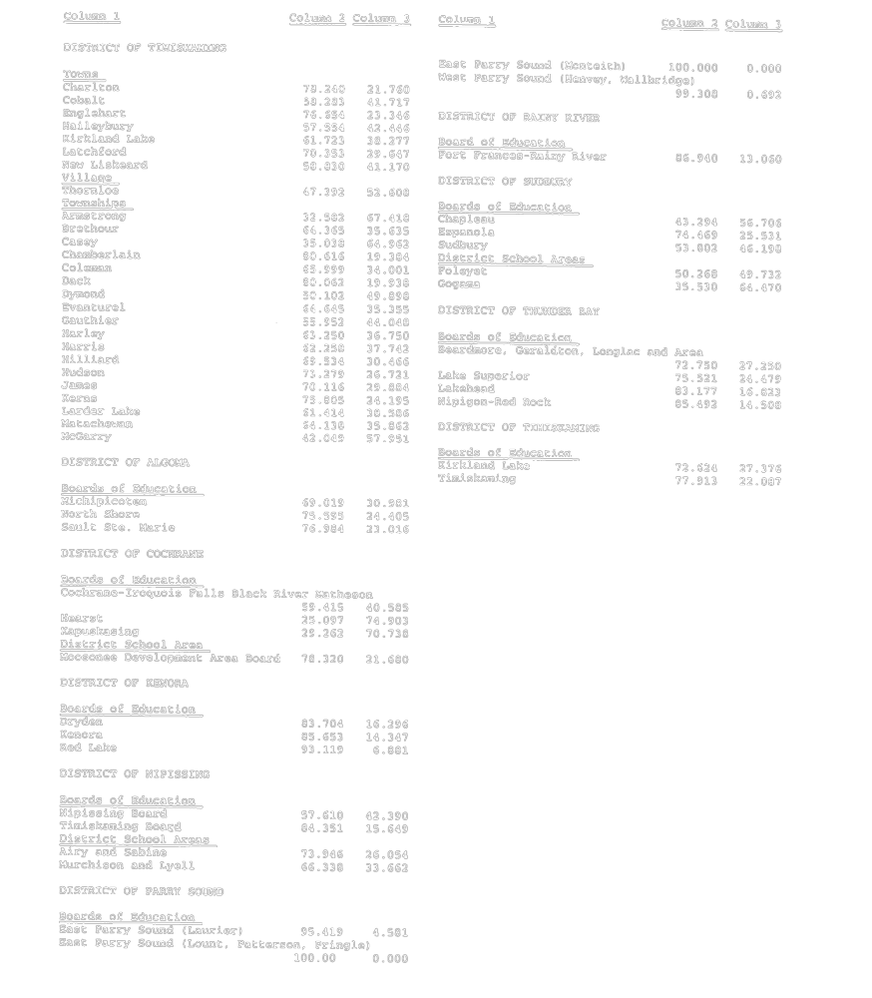
O. Reg. 277/97, Sched. 1.
Schedule 2
Insert regs\graphics\1997\277\277002au.tif
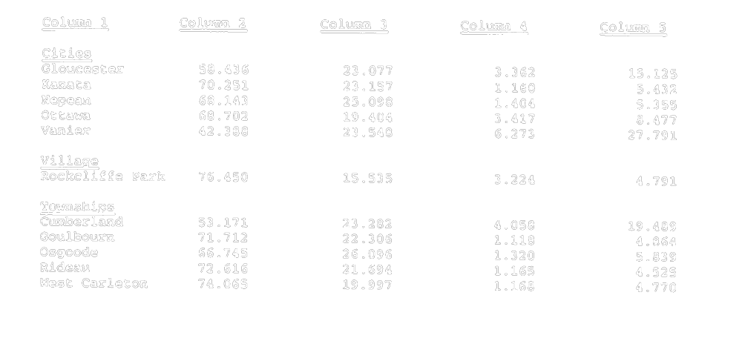
O. Reg. 277/97, Sched. 2.
Schedule 3
Insert regs\graphics\1997\277\277003au.tif
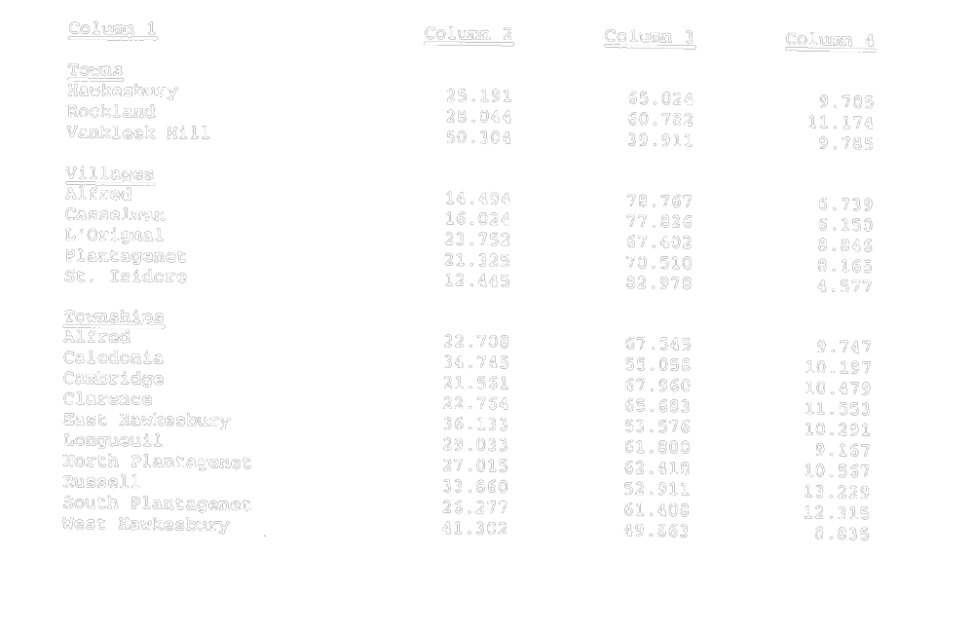
O. Reg. 277/97, Sched. 3.

Back to top

