Coroners Act
ONTARIO REGULATION 264/99
FEES, ALLOWANCES AND FORMS
Historical version for the period July 17, 2009 to July 26, 2009.
Last amendment: O. Reg. 276/09.
This is the English version of a bilingual regulation.
Skip Table of Contents
CONTENTS
 |  | Sections
 | Fees and Allowances | 1-7
 | Forms | 8-23
Schedule 1 | Constables
Schedule 2 | Recording of evidence
Schedule 3 | Jurors
Schedule 4 | Witnesses
Schedule 5 | Post mortem examinations, etc.
Schedule 6 | Kilometre allowances
Form 1 | Warrant to take possession of the body of a deceased person
Form 2 | Warrant to bury the body of a deceased person
Form 3 | Warrant for holding an inquest
Form 4 | Warrant for post mortem examination
Form 5 | Warrant for the provision of names from the jury roll
Form 6 | Sheriff’s list of names provided from the jury roll
Form 7 | Summons to serve as a juror on an inquest
Form 8 | Notice of holding of inquest
Form 9 | Return of constable
Form 10 | Verdict of coroner’s jury
Form 11 | Notice of holding of inquest
Form 12 | Affidavit of service
Form 13 | Certificate for shipment of body outside Ontario
Form 14 | Summons to a witness before an inquest (section 40)
Form 15 | Bench warrant (subsection 40 (3))
Fees and Allowances
1. A person appointed as a constable under subsection 48 (2) of the Act shall be paid the fees and allowances set out in Schedule 1. O. Reg. 264/99, s. 1.
2. A person appointed by a coroner to record the evidence upon an inquest or any part of it shall be paid the fees and allowances set out in Schedule 2. O. Reg. 264/99, s. 2.
3. A police officer or a salaried employee of the Government of Ontario shall not be paid a fee or an allowance under section 1 or 2. O. Reg. 264/99, s. 3.
4. A person who serves as a juror at an inquest shall be paid the fees and allowances set out in Schedule 3. O. Reg. 264/99, s. 4.
5. A person who attends at an inquest as a witness upon the summons of the coroner shall be paid the fees and allowances set out in Schedule 4. O. Reg. 264/99, s. 5.
6. The fees and allowances set out in Schedule 5 are payable for,
(a) a post mortem examination of a body;
(b) any other examination or analysis;
(c) the use of facilities for post mortem examination in a hospital or other place;
(d) transporting a dead body for further investigation upon the authorization of a coroner; and
(e) travel in connection with an examination or analysis. O. Reg. 264/99, s. 6.
7. For the purposes of the Schedules, the dividing line between northern Ontario and southern Ontario is as follows:
Healey Lake (Municipal) Road from Healey Lake easterly to its junction with Highway 612; Highway 612 southerly to its junction with Highway 69; Highway 69 easterly to its junction with Highway 169; Highway 169 easterly to its junction with Highway 118; Highway 118 through Bracebridge to its junction with Highway 11; Highway 11 northerly to its junction with Highway 60 at Huntsville; Highway 60 easterly to its junction with Highway 62 at Killaloe; Highway 62 to Pembroke; the above-named highways to be included in southern Ontario.
O. Reg. 264/99, s. 7.
Forms
8. A coroner’s warrant to take possession of a body shall be in Form 1. O. Reg. 264/99, s. 8.
Note: On the day that subsection 28 (2) of the Coroners Amendment Act, 2009 comes into force, section 8 is revoked and the following substituted:
Forms
8. A warrant issued under subsection 40 (3) of the Act shall be in Form 1. O. Reg. 276/09, s. 1.
See: O. Reg. 276/09, ss. 1, 3.
9. A coroner’s warrant to bury a body shall be in Form 2. O. Reg. 264/99, s. 9.
Note: On the day that subsection 28 (2) of the Coroners Amendment Act, 2009 comes into force, section 9 is revoked. See: O. Reg. 276/09, ss. 1, 3.
10. A coroner’s warrant for the holding of an inquest shall be in Form 3. O. Reg. 264/99, s. 10.
Note: On the day that subsection 28 (2) of the Coroners Amendment Act, 2009 comes into force, section 10 is revoked. See: O. Reg. 276/09, ss. 1, 3.
11. A coroner’s warrant for a post mortem examination shall be in Form 4. O. Reg. 264/99, s. 11.
Note: On the day that subsection 28 (2) of the Coroners Amendment Act, 2009 comes into force, section 11 is revoked. See: O. Reg. 276/09, ss. 1, 3.
12. A coroner’s warrant to a sheriff for the provision of names taken from the jury roll prepared under the Juries Act shall be in Form 5. O. Reg. 264/99, s. 12.
Note: On the day that subsection 28 (2) of the Coroners Amendment Act, 2009 comes into force, section 12 is revoked. See: O. Reg. 276/09, ss. 1, 3.
13. A sheriff’s list of names under subsection 34 (2) of the Act shall be in Form 6. O. Reg. 264/99, s. 13.
Note: On the day that subsection 28 (2) of the Coroners Amendment Act, 2009 comes into force, section 13 is revoked. See: O. Reg. 276/09, ss. 1, 3.
14. A constable’s summons to a juror shall be in Form 7. O. Reg. 264/99, s. 14.
Note: On the day that subsection 28 (2) of the Coroners Amendment Act, 2009 comes into force, section 14 is revoked. See: O. Reg. 276/09, ss. 1, 3.
15. A constable’s notice to a person designated as a person with standing at an inquest or to a person who may be substantially and directly interested in the inquest shall be in Form 8. O. Reg. 264/99, s. 15.
Note: On the day that subsection 28 (2) of the Coroners Amendment Act, 2009 comes into force, section 15 is revoked. See: O. Reg. 276/09, ss. 1, 3.
16. A constable’s return in respect of jurors and persons with standing shall be in Form 9. O. Reg. 264/99, s. 16.
Note: On the day that subsection 28 (2) of the Coroners Amendment Act, 2009 comes into force, section 16 is revoked. See: O. Reg. 276/09, ss. 1, 3.
17. The verdict of a coroner’s jury shall be in Form 10. O. Reg. 264/99, s. 17.
Note: On the day that subsection 28 (2) of the Coroners Amendment Act, 2009 comes into force, section 17 is revoked. See: O. Reg. 276/09, ss. 1, 3.
18. A coroner’s notice to the Crown Attorney of the holding of an inquest shall be in Form 11. O. Reg. 264/99, s. 18.
Note: On the day that subsection 28 (2) of the Coroners Amendment Act, 2009 comes into force, section 18 is revoked. See: O. Reg. 276/09, ss. 1, 3.
19. An affidavit of service of a summons upon a juror or a witness shall be in Form 12. O. Reg. 264/99, s. 19.
Note: On the day that subsection 28 (2) of the Coroners Amendment Act, 2009 comes into force, section 19 is revoked. See: O. Reg. 276/09, ss. 1, 3.
20. A coroner’s certificate for the shipment of a dead body to any place outside Ontario shall be in Form 13. O. Reg. 264/99, s. 20.
Note: On the day that subsection 28 (2) of the Coroners Amendment Act, 2009 comes into force, section 20 is revoked. See: O. Reg. 276/09, ss. 1, 3.
21. A summons issued under section 40 of the Act shall be in Form 14. O. Reg. 264/99, s. 21.
Note: On the day that subsection 28 (2) of the Coroners Amendment Act, 2009 comes into force, section 21 is revoked. See: O. Reg. 276/09, ss. 1, 3.
22. A warrant issued under subsection 40 (3) of the Act shall be in Form 15. O. Reg. 264/99, s. 22.
Note: On the day that subsection 28 (2) of the Coroners Amendment Act, 2009 comes into force, section 22 is revoked. See: O. Reg. 276/09, ss. 1, 3.
23. Omitted (provides for coming into force of provisions of this Regulation). O. Reg. 264/99, s. 23.
Note: On the day that subsection 28 (2) of the Coroners Amendment Act, 2009 comes into force, section 23 is revoked. See: O. Reg. 276/09, ss. 1, 3.
Schedule 1
CONSTABLES
1. | For summoning a jury for an inquest, a fee per hour of | $10
2. | For attendance at an inquest, a fee per hour of | 10
3. | Where an inquest continues past one-half day and in the opinion of the coroner it is desirable that a constable be reimbursed the cost of a meal, an amount equal to the amount reasonably and actually paid by the constable for the meal.
4. | For each kilometre of necessary travel by private automobile in connection with the service of summonses, an allowance in accordance with Schedule 6 (Kilometre Allowances).
O. Reg. 264/99, Sched. 1.
Schedule 2
RECORDING OF EVIDENCE
1. For recording the evidence upon an inquest or any part of it, a fee in accordance with Ontario Regulation 587/91 (Court Reporters and Court Monitors).
2. For copies of the transcription of the evidence upon an inquest, a fee payable by the person ordering or requesting the transcripts in accordance with Ontario Regulation 587/91 (Court Reporters and Court Monitors).
3. Where a person appointed to record the evidence upon an inquest resides elsewhere than the place where the inquest is held and in the opinion of the coroner it is desirable that the person remain overnight at such place, an amount equal to the amount reasonably and actually paid by the person for overnight accommodation.
4. Where an inquest continues past one-half day and in the opinion of the coroner it is desirable that a person appointed to record the evidence upon the inquest be reimbursed the cost of a meal, an amount equal to the amount reasonably and actually paid by the person for the meal.
5. Where a person appointed to record the evidence upon an inquest resides elsewhere than the place where the inquest is held, for each kilometre of necessary travel by private automobile between the person’s residence and the place where the inquest is held, an allowance in accordance with Schedule 6 (Kilometre Allowances).
O. Reg. 264/99, Sched. 2.
Schedule 3
JURORS
1. | For each day of attendance at an inquest after the tenth day, up to and including the forty-ninth day, a fee of | $50
2. | For each day of attendance at an inquest after the forty-ninth day, a fee of | 100
3. | For each kilometre of necessary travel by private automobile between the juror’s place of residence and the place where the inquest is held, an allowance in accordance with Schedule 6 (Kilometre Allowances), but where the inquest is held in the locality in which the juror resides, a total allowance of $3.
4. | Where a juror is required to attend the inquest on more than one day and it is reasonable that the juror return to his or her place of residence at night, the allowance mentioned in paragraph 3 is payable in respect of each day’s attendance.
5. | Where a juror resides elsewhere than the place where the inquest is held and in the opinion of the coroner it is desirable that the juror remain overnight at such place, an amount equal to the amount reasonably and actually paid by the juror for overnight accommodation.
6. | Where an inquest continues past one-half day and in the opinion of the coroner it is desirable that a juror be reimbursed the cost of a meal, an amount equal to the amount reasonably and actually paid by the juror for the meal.
7. | If in special circumstances a juror incurs expenses, other than travel, accommodation or meal expenses, related to his or her attendance at an inquest, an allowance in respect of the expenses in such amount as is approved by the Chief Coroner.
O. Reg. 264/99, Sched. 3.
Schedule 4
WITNESSES
1. For each day of attendance of an expert witness, including the medical practitioner who performed the post mortem examination of the body, such fee not exceeding $200 as the coroner considers proper or such greater fee as the Chief Coroner approves if, in his or her opinion, the greater fee is justified having regard to the special circumstances of the case.
2. For each kilometre of necessary travel by private automobile between the place of residence of the witness and the place where the inquest is held, an allowance in accordance with Schedule 6 (Kilometre Allowances), but where the inquest is held in the locality in which the witness resides, a total allowance of $3.
3. Where a witness actually, reasonably and necessarily travels by a means other than by private automobile, an amount equal to the amount of the fare actually, reasonably and necessarily paid for the transportation from his or her place of residence to the place where the inquest is held and return.
4. Where a witness is required to attend the inquest on more than one day and it is reasonable that the witness returns to his or her place of residence at night, the allowance mentioned in paragraph 2 or 3, as the case may be, is payable in respect of each day’s attendance.
5. Where a witness resides elsewhere than the place where the inquest is held and in the opinion of the coroner it is desirable that the witness remain overnight at such place, an amount equal to the amount reasonably and actually paid by the witness for overnight accommodation.
6. Where a witness is required to attend the inquest past one-half day and in the opinion of the coroner it is desirable that the witness be reimbursed the cost of a meal, an amount equal to the amount reasonably and actually paid by the witness for the meal.
7. If in special circumstances a witness incurs expenses, other than travel, accommodation or meal expenses, related to his or her attendance at an inquest, an allowance in respect of the expenses in such amount as is approved by the Chief Coroner.
O. Reg. 264/99, Sched. 4.
Schedule 5
POST MORTEM EXAMINATIONS, ETC.
1. | For an external post mortem examination by a legally qualified medical practitioner, including the service of an assistant when necessary, a fee of $300.
2. | For an internal post mortem examination by a legally qualified medical practitioner, including necessary microscopic sections to prove diagnosis and including the service of an assistant when necessary, a fee of,
 | i. on and after August 13, 2008 and before April 1, 2009, $1,050,
 | ii. on and after April 1, 2009 and before April 1, 2010, $1,100,
 | iii. on and after April 1, 2010 and before April 1, 2011, $1,150, and
 | iv. on and after April 1, 2011, $1,200.
3. | The fees mentioned in paragraphs 1 and 2 may be increased by the Chief Coroner where, in his or her opinion, the increase is justified having regard to the special circumstances of the case, to such amount as he or she considers appropriate, but not exceeding,
 | i. on and after August 13, 2008 and before April 1, 2009, $1,450,
 | ii. on and after April 1, 2009 and before April 1, 2010, $1,500,
 | iii. on and after April 1, 2010 and before April 1, 2011, $1,575, and
 | iv. on and after April 1, 2011, $1,650.
4. | For any other examination or analysis, a fee in an amount equal to the cost of the examination or analysis, not exceeding $50.
5. | The fee mentioned in paragraph 4 may be increased by the Chief Coroner to such amount as he or she considers appropriate where, in his or her opinion, the increase is justified having regard to the special circumstances of the case.
6. | For the use of facilities for post mortem examination in a hospital or other place, for each post mortem examination, a fee of $400.
7. | The fee mentioned in paragraph 6 may be increased by the Chief Coroner to such amount as he or she considers appropriate where, in his or her opinion, the increase is justified having regard to the special circumstances of the case.
8. | For transporting a dead body for further investigation on the authorization of the coroner, if the trip begins on or after the day O. Reg. 137/09 comes into force and before April 1, 2010, the greater of,
 | i. a fee of $244.80, and
 | ii. an allowance for necessary travel to pick up the body, deliver the body and return to the place of origin, calculated at the rate of,
 | A. $2.00 for each kilometre in southern Ontario, and
 | B. $2.07 for each kilometre in northern Ontario.
8.1 | For transporting a dead body for further investigation on the authorization of the coroner, if the trip begins on or after April 1, 2010 and before April 1, 2011, the greater of,
 | i. a fee of $249.70, and
 | ii. an allowance for necessary travel to pick up the body, deliver the body and return to the place of origin, calculated at the rate of,
 | A. $2.04 for each kilometre in southern Ontario, and
 | B. $2.11 for each kilometre in northern Ontario.
8.2 | For transporting a dead body for further investigation on the authorization of the coroner, if the trip begins on or after April 1, 2011, the greater of,
 | i. a fee of $254.69 and
 | ii. an allowance for necessary travel to pick up the body, deliver the body and return to the place of origin, calculated at the rate of,
 | A. $2.08 for each kilometre in southern Ontario, and
 | B. $2.15 for each kilometre in northern Ontario.
9. | If more than one dead body is transported on the same trip for further investigation on the authorization of the coroner, a fee for each additional body of,
 | i. $24.48, if the trip begins on or after the day O. Reg. 137/09 comes into force and before April 1, 2010,
 | ii. $24.97, if the trip begins on or after April 1, 2010 and before April 1, 2011, and
 | iii. $25.47, if the trip begins on or after April 1, 2011.
10. | The fee mentioned in subparagraph 8 i may be increased by the Chief Coroner to such amount as he or she considers appropriate where, in his or her opinion, the increase is justified having regard to the special circumstances of the case.
11. | For waiting time in excess of one-half hour necessarily incurred in connection with the transportation of a dead body or bodies for further investigation on the authorization of the coroner, a fee of,
 | i. $24.48 per hour, on or after the day O. Reg. 137/09 comes into force and before April 1, 2010,
 | ii. $24.97 per hour, on or after April 1, 2010 and before April 1, 2011, and
 | iii. $25.47 per hour, on or after April 1, 2011.
12. | Where it is necessary to transport a dead body by a means other than a motor vehicle, or where transportation by a means other than a motor vehicle is more economical, an amount equal to the amount actually, reasonably and necessarily paid for the transportation of the dead body.
13. | For each kilometre of necessary travel by private automobile by a legally qualified medical practitioner in connection with an examination or analysis, an allowance in accordance with Schedule 6 (Kilometre Allowances).
O. Reg. 558/07, s. 1; O. Reg. 559/07, s. 1; O. Reg. 286/08, s. 1; O. Reg. 137/09, s. 1.
Schedule 6
KILOMETRE ALLOWANCES
1. | 41 cents per kilometre in northern Ontario.
2. | 40 cents per kilometre in southern Ontario.
O. Reg. 558/07, s. 1.
Form 1
WARRANT TO TAKE POSSESSION OF THE BODY OF A DECEASED PERSON
Coroners Act
Insert regs\graphics\1999\264\264001ae.tif
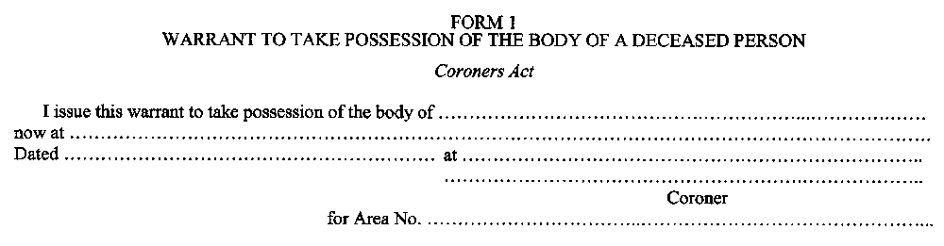
O. Reg. 264/99, Form 1.
Note: On the day that subsection 28 (2) of the Coroners Amendment Act, 2009 comes into force, Form 1 is revoked and the following substituted:
Form 1
Coroners Act
(Subsection 40 (3))
Bench Warrant
TO: ……………………………………….…………, Police Officer.
WHEREAS proof has been made before me that ………………………………………… was duly summoned to appear before an inquest into the death of …………………………….. deceased, at ……………………….. on the ……. day of ………………………., ………..; that the presence of the said person is material to the inquest, and that the said person has failed to attend in accordance with the requirements of the summons.
THESE are therefore to command you to take the said …………………………………….. to bring and have [him or her] before the said inquest at ………………………… there to testify what [he or she] may know concerning the matters in question in the said inquest, and that you detain [him or her] in your custody until [he or she] has given [his or her] evidence or until the said inquest has ended or until other orders may be made concerning [him or her].
GIVEN UNDER MY HAND this …….. day of …………………………, ..………. at ………………….……………...
……………………………………………
Judge of the Superior Court of Justice
O. Reg. 276/09, s. 2.
See: O. Reg. 276/09, ss. 2, 3.
Form 2
WARRANT TO BURY THE BODY OF A DECEASED PERSON
Coroners Act
Insert regs\graphics\1999\264\264002ae.tif
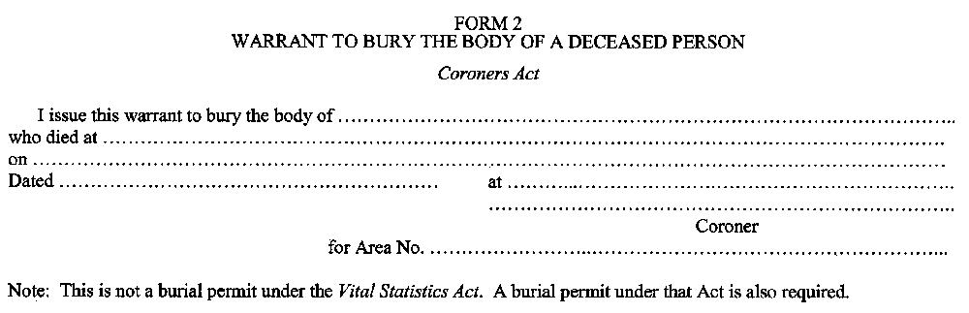
O. Reg. 264/99, Form 2.
Note: On the day that subsection 28 (2) of the Coroners Amendment Act, 2009 comes into force, Form 2 is revoked. See: O. Reg. 276/09, ss. 2, 3.
Form 3
WARRANT FOR HOLDING AN INQUEST
Coroners Act
Insert regs\graphics\1999\264\264003ae.tif
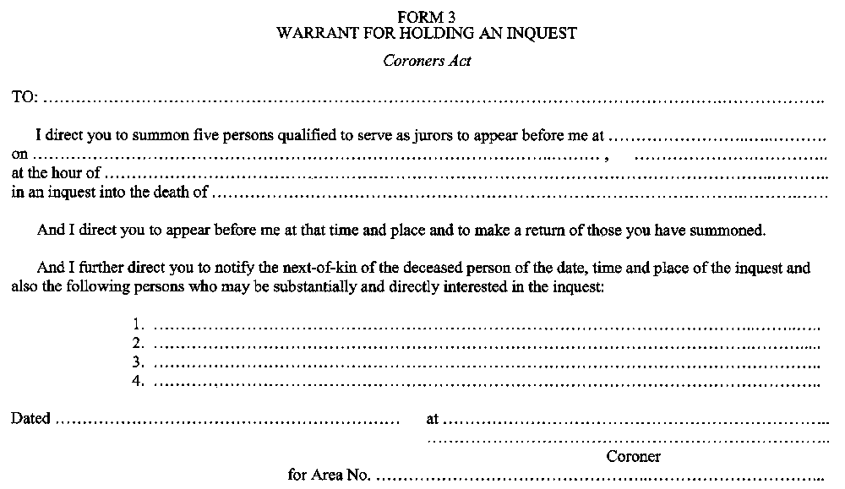
O. Reg. 264/99, Form 3.
Note: On the day that subsection 28 (2) of the Coroners Amendment Act, 2009 comes into force, Form 3 is revoked. See: O. Reg. 276/09, ss. 2, 3.
Form 4
WARRANT FOR POST MORTEM EXAMINATION
Coroners Act
Insert regs\graphics\1999\264\264004ae.tif
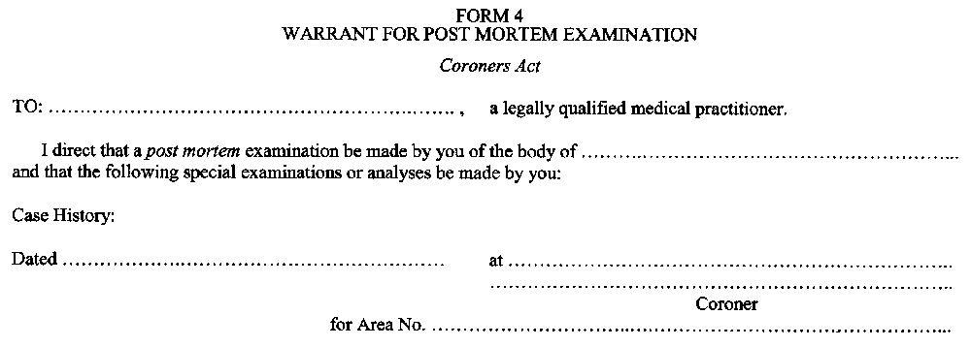
O. Reg. 264/99, Form 4.
Note: On the day that subsection 28 (2) of the Coroners Amendment Act, 2009 comes into force, Form 4 is revoked. See: O. Reg. 276/09, ss. 2, 3.
Form 5
WARRANT FOR THE PROVISION OF NAMES FROM THE JURY ROLL
Coroners Act
Insert regs\graphics\1999\264\264005ae.tif
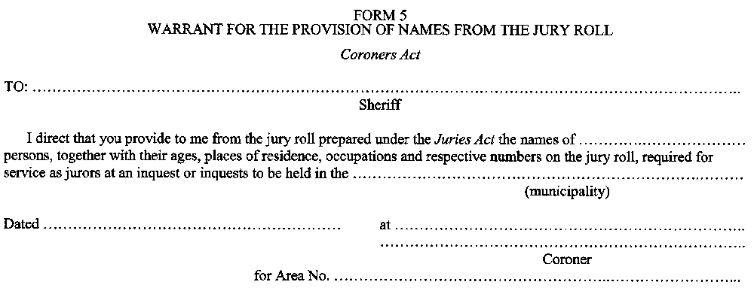
O. Reg. 264/99, Form 5.
Note: On the day that subsection 28 (2) of the Coroners Amendment Act, 2009 comes into force, Form 5 is revoked. See: O. Reg. 276/09, ss. 2, 3.
Form 6
SHERIFF’S LIST OF NAMES PROVIDED FROM THE JURY ROLL
Coroners Act
Insert regs\graphics\1999\264\264006ae.tif
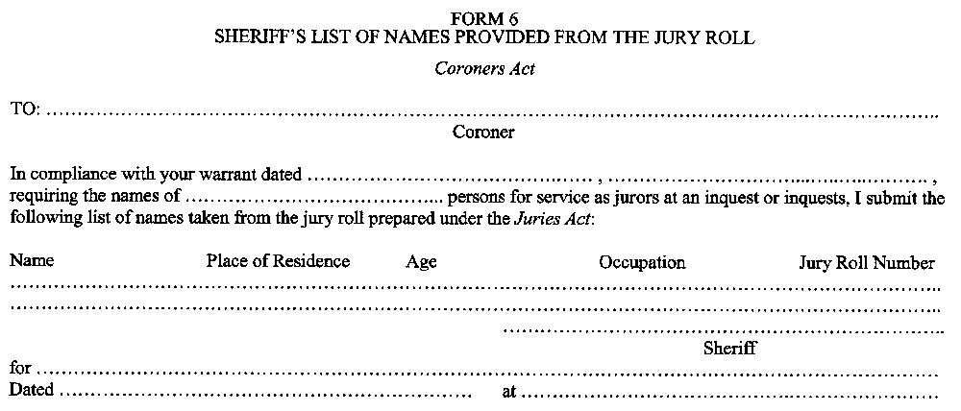
O. Reg. 264/99, Form 6.
Note: On the day that subsection 28 (2) of the Coroners Amendment Act, 2009 comes into force, Form 6 is revoked. See: O. Reg. 276/09, ss. 2, 3.
Form 7
SUMMONS TO SERVE AS A JUROR ON AN INQUEST
Coroners Act
Insert regs\graphics\1999\264\264007ae.tif
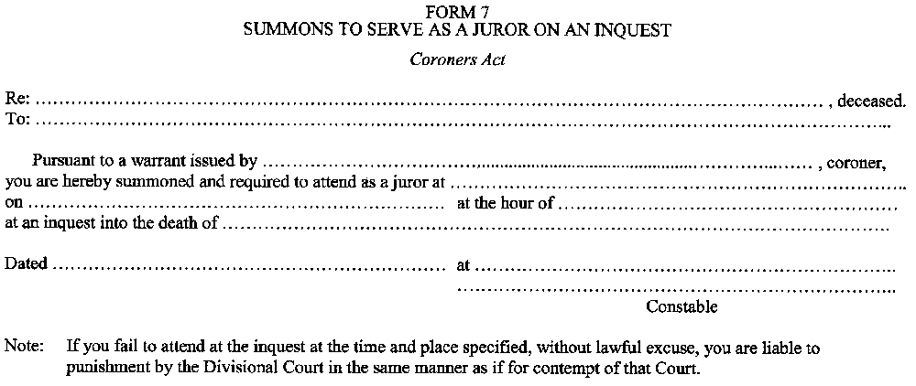
O. Reg. 264/99, Form 7.
Note: On the day that subsection 28 (2) of the Coroners Amendment Act, 2009 comes into force, Form 7 is revoked. See: O. Reg. 276/09, ss. 2, 3.
Form 8
NOTICE OF HOLDING OF INQUEST
Coroners Act
Insert regs\graphics\1999\264\264008ae.tif
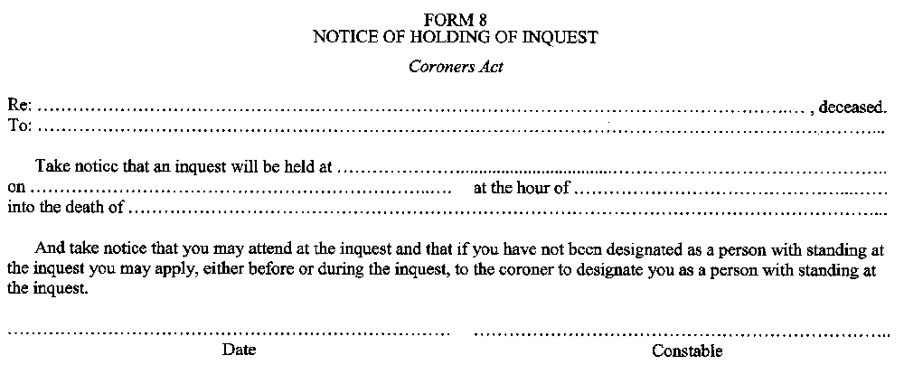
O. Reg. 264/99, Form 8.
Note: On the day that subsection 28 (2) of the Coroners Amendment Act, 2009 comes into force, Form 8 is revoked. See: O. Reg. 276/09, ss. 2, 3.
Form 9
RETURN OF CONSTABLE
Coroners Act
Insert regs\graphics\1999\264\264009ae.tif
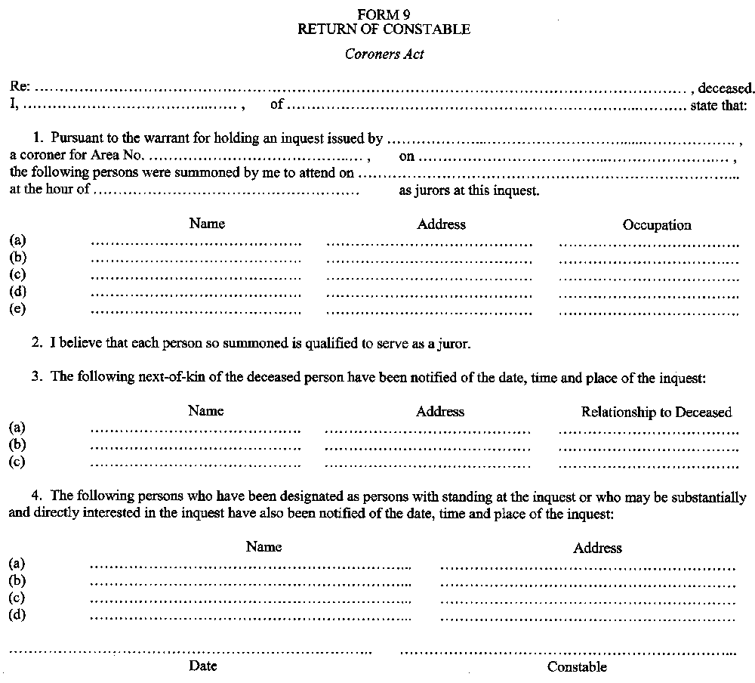
O. Reg. 264/99, Form 9.
Note: On the day that subsection 28 (2) of the Coroners Amendment Act, 2009 comes into force, Form 9 is revoked. See: O. Reg. 276/09, ss. 2, 3.
Form 10
VERDICT OF CORONER’S JURY
Coroners Act
Insert regs\graphics\1999\264\264010ae.tif
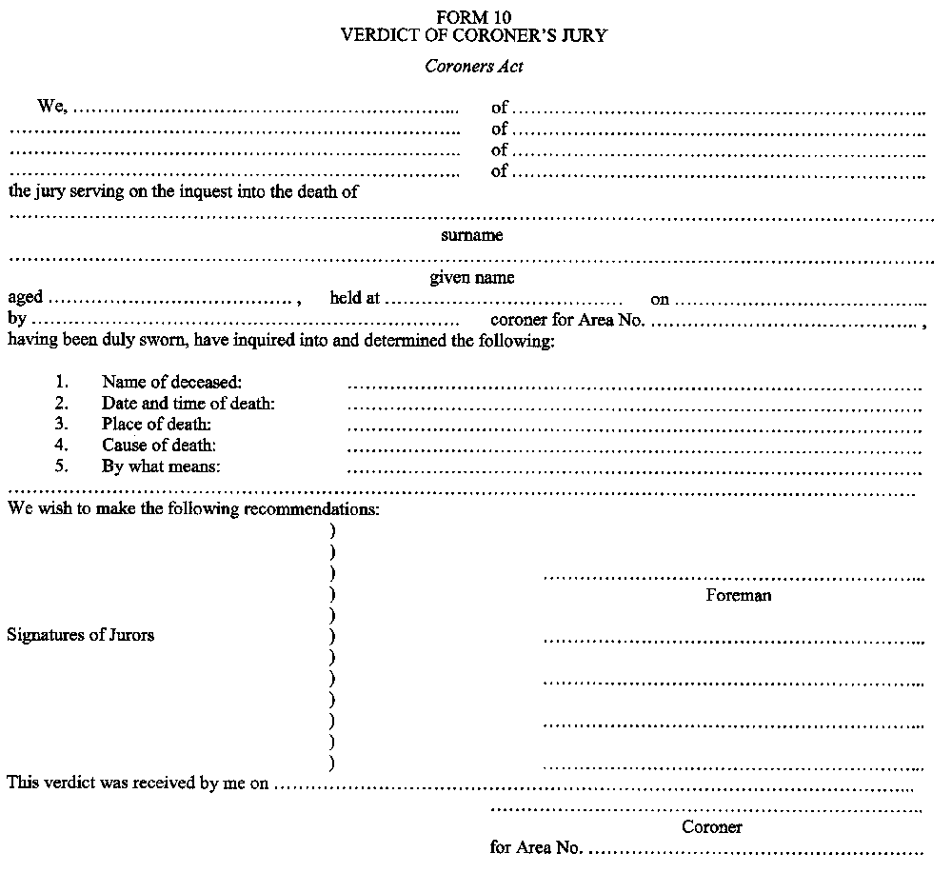
O. Reg. 264/99, Form 10.
Note: On the day that subsection 28 (2) of the Coroners Amendment Act, 2009 comes into force, Form 10 is revoked. See: O. Reg. 276/09, ss. 2, 3.
Form 11
NOTICE OF HOLDING OF INQUEST
Coroners Act
Insert regs\graphics\1999\264\264011ae.tif
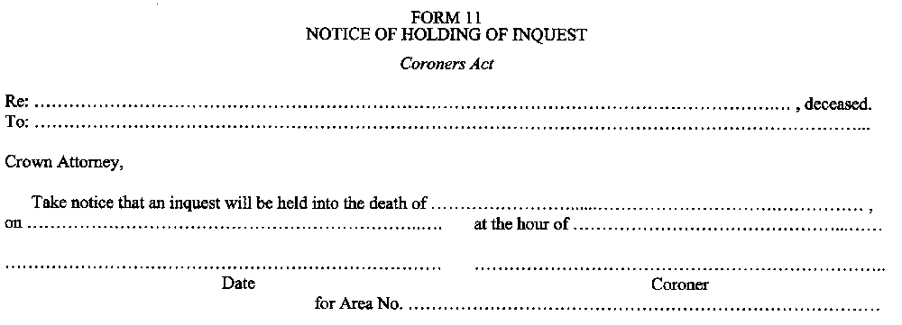
O. Reg. 264/99, Form 11.
Note: On the day that subsection 28 (2) of the Coroners Amendment Act, 2009 comes into force, Form 11 is revoked. See: O. Reg. 276/09, ss. 2, 3.
Form 12
AFFIDAVIT OF SERVICE
Coroners Act
Insert regs\graphics\1999\264\264012ae.tif
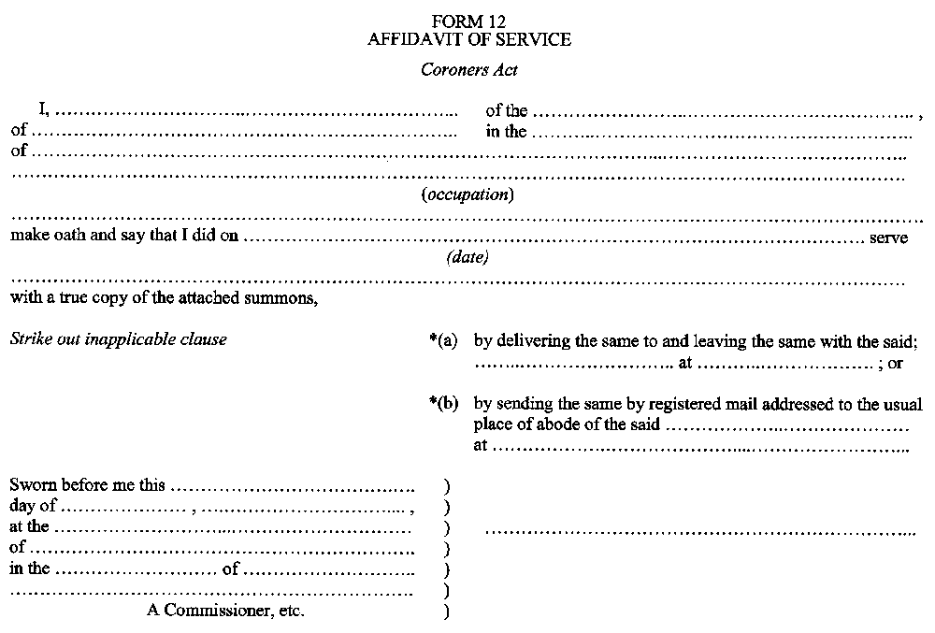
O. Reg. 264/99, Form 12.
Note: On the day that subsection 28 (2) of the Coroners Amendment Act, 2009 comes into force, Form 12 is revoked. See: O. Reg. 276/09, ss. 2, 3.
Form 13
CERTIFICATE FOR SHIPMENT OF BODY OUTSIDE ONTARIO
Coroners Act
Insert regs\graphics\1999\264\264013ae.tif
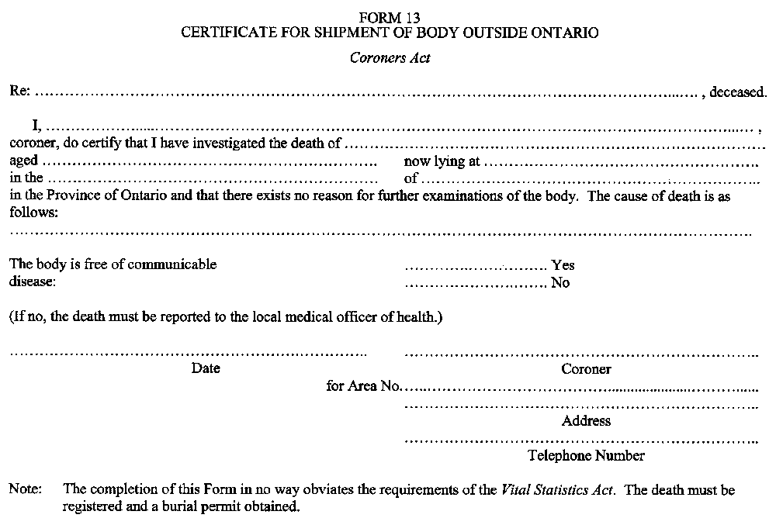
O. Reg. 264/99, Form 13.
Note: On the day that subsection 28 (2) of the Coroners Amendment Act, 2009 comes into force, Form 13 is revoked. See: O. Reg. 276/09, ss. 2, 3.
Form 14
SUMMONS TO A WITNESS BEFORE AN INQUEST (Section 40)
Coroners Act
Insert regs\graphics\1999\264\264014ae.tif
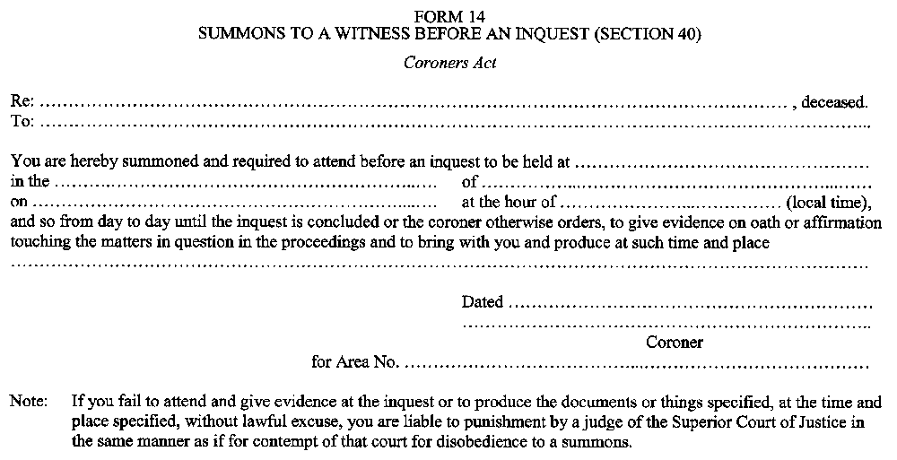
O. Reg. 264/99, Form 14.
Note: On the day that subsection 28 (2) of the Coroners Amendment Act, 2009 comes into force, Form 14 is revoked. See: O. Reg. 276/09, ss. 2, 3.
Form 15
BENCH WARRANT (Subsection 40 (3))
Coroners Act
Insert regs\graphics\1999\264\264015ae.tif
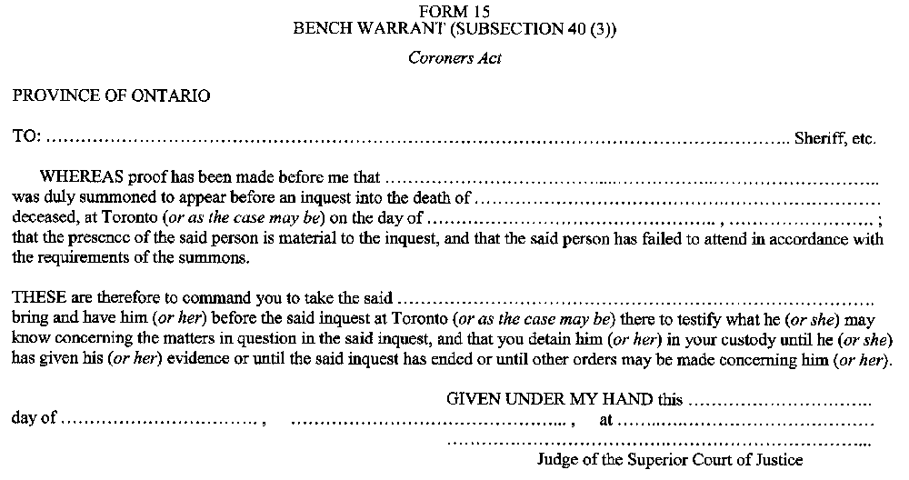
O. Reg. 264/99, Form 15.
Note: On the day that subsection 28 (2) of the Coroners Amendment Act, 2009 comes into force, Form 15 is revoked. See: O. Reg. 276/09, ss. 2, 3.

Back to top

