Français
Labour Relations Act, 1995
R.R.O. 1990, REGULATION 684
formerly under Labour Relations Act
Amended to O. Reg. 94/07
GENERAL
Note: This Regulation was revoked on March 12, 2007. See: O. Reg. 94/07, s. 4.
This is the English version of a bilingual regulation.
1. Revoked: O. Reg. 517/99, s. 1.
Conciliation Board — Remuneration
2. (1) The rate of remuneration of a chair of a conciliation board shall not exceed,
(a) $450 a day if the time spent in a hearing or in executive session exceeds three hours;
(b) $225 if the time spent in a hearing or in executive session is three hours or less; and
(c) $56.25 an hour for the preparation of a decision or an award, up to a maximum of $450 a day. R.R.O. 1990, Reg. 684, s. 2 (1).
(2) The rate of remuneration of a member of a conciliation board, other than a chair, shall not exceed,
(a) $250 a day if the time spent in a hearing or in executive session exceeds three hours;
(b) $125 if the time spent in a hearing or in executive session is three hours or less; and
(c) $31.25 an hour for the preparation of a decision or an award, up to a maximum of $250 a day. R.R.O. 1990, Reg. 684, s. 2 (2).
(3) The rate of remuneration of a mediator shall not exceed,
(a) $400 a day if the time spent in mediation exceeds three hours;
(b) $200 a day if the time spent in mediation is three hours or less; and
(c) $50 an hour for the preparation of a report, up to a maximum of $400 a day. R.R.O. 1990, Reg. 684, s. 2 (3).
3. The amount of necessary travelling and out of pocket expenses of a chair, or member of a conciliation board or a mediator shall be allowed in accordance with the policy on Travel, Meal and Hospitality Expenses established by Management Board of Cabinet in the Manual of Administration. R.R.O. 1990, Reg. 684, s. 3.
Filing of Arbitration Decisions
4. (1) Every arbitrator shall, within ten days of issuing an award, file a copy thereof with the Minister. R.R.O. 1990, Reg. 684, s. 4 (1).
(2) A record shall be maintained of each award filed with the Minister under subsection (1) and upon payment of the prescribed fee, the Ministry shall supply a copy of the award to any person applying therefor. R.R.O. 1990, Reg. 684, s. 4 (2).
Forms
5. (1) An order of the Board for filing in the Ontario Court (General Division) under subsection 11.1 (7) of the Act shall be in Form 1. O. Reg. 750/92, s. 1.
(2) A copy of a decision of an arbitrator or arbitration board for filing in the Ontario Court (General Division) under subsection 45 (11) of the Act shall be in Form 2. O. Reg. 750/92, s. 1.
(3) A decision of the Board for filing in the Ontario Court (General Division) under subsection 73.2 (22) of the Act shall be in Form 3. O. Reg. 750/92, s. 1.
(4) A determination of the Board for filing in the Ontario Court (General Division) under subsection 91 (6) of the Act shall be in Form 4. O. Reg. 750/92, s. 1.
(5) An interim order of the Board for filing in the Ontario Court (General Division) under subsection 92.1 (2) of the Act shall be in Form 5. O. Reg. 750/92, s. 1.
(6) An order of the Board for filing in the Ontario Court (General Division) under subsection 93 (10) of the Act shall be in Form 8. O. Reg. 750/92, s. 1.
(7) A direction of the Board for filing in the Ontario Court (General Division) under section 96 or subsection 137 (4) of the Act shall be in Form 12. O. Reg. 750/92, s. 1.
(8) A copy of a decision of an arbitration board for filing in the Ontario Court (General Division) under subsection 45 (11) of the Act, as made applicable by subsection 97 (8) of the Act, shall be in Form 13. O. Reg. 750/92, s. 1.
6. A statement filed with the Board under section 84 of the Act shall be in Form 6. R.R.O. 1990, Reg. 684, s. 6.
7. A notice filed with the Board under section 89 of the Act shall be in Form 7. R.R.O. 1990, Reg. 684, s. 7.
8. A notice filed with the Board under section 138 of the Act shall be in Form 9. R.R.O. 1990, Reg. 684, s. 8.
9. A declaration under section 152 of the Act by,
(a) an employer bargaining agency or employers’ organization shall be in Form 10; or
(b) an employee bargaining agency or affiliated bargaining agent shall be in Form 11. R.R.O. 1990, Reg. 684, s. 9.
10. (1) The following rules relate to the filing of schedules of fees by arbitrators:
1. An arbitrator who has not already filed a schedule with the Minister shall do so upon being appointed.
2. Paragraph 1 does not apply to a person who is appointed as a member of a board of arbitration unless the person is appointed as the chair.
3. A person who is named to the list of approved arbitrators established by the Minister and who has not already filed a schedule with the Minister shall do so upon being named to the list.
4. A person may file a schedule with the Minister even if the person is not required to do so.
5. A person may file a schedule to replace a schedule filed earlier.
6. A person who is on the list of approved arbitrators on the 1st day of January, 1993 shall file a schedule with the Minister on or before the 1st day of February, 1993. O. Reg. 781/92, s. 1.
(2) An arbitrator shall, upon being appointed, provide the parties with a copy of the schedule of fees the arbitrator filed most recently before being appointed or, if the arbitrator has not yet filed a schedule, with a copy of the schedule the arbitrator files upon being appointed. O. Reg. 781/92, s. 1.
(3) An arbitrator shall not charge fees except in accordance with the schedule of fees he or she filed most recently before being appointed or, if the arbitrator did not file a schedule before being appointed, in accordance with the schedule the arbitrator filed upon being appointed. O. Reg. 781/92, s. 1.
(4) Subsections (2) and (3) do not apply to a person who is appointed as a member of a board of arbitration unless the person is appointed as the chair. O. Reg. 781/92, s. 1.
Form 1
Labour Relations Act
Insert regs\graphics\1990\684\684001ae.tif
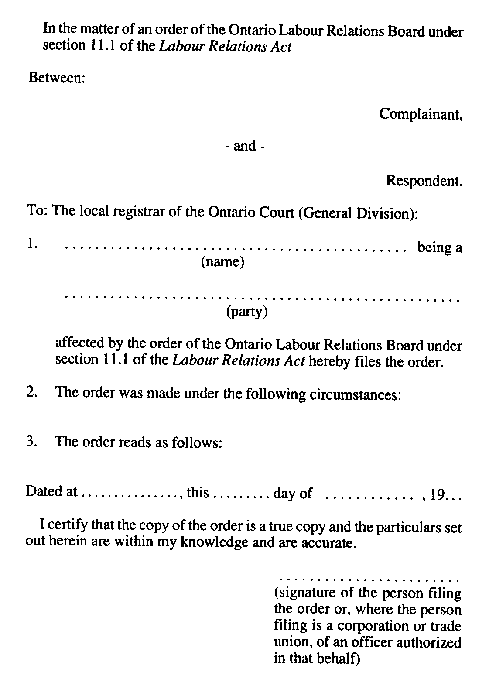
O. Reg. 750/92, s. 2.
Form 2
Labour Relations Act
Insert regs\graphics\1990\684\684002ae.tif
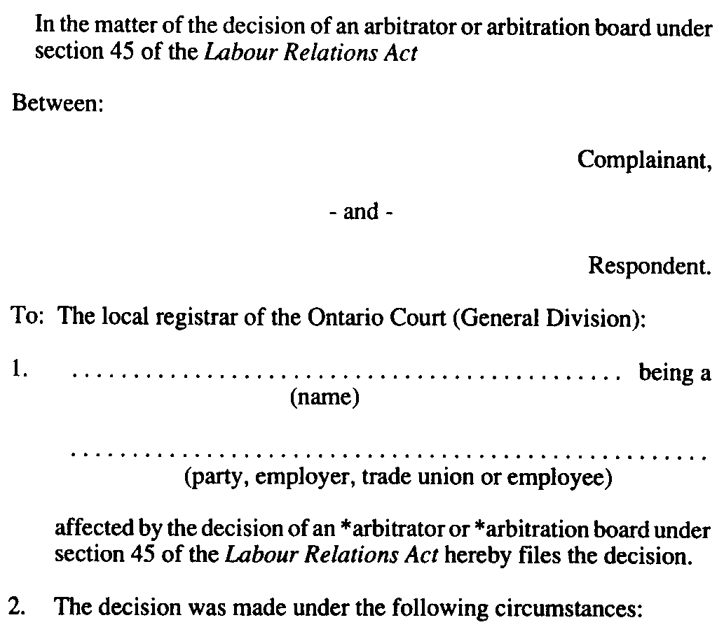
Insert regs\graphics\1990\684\684002be.tif
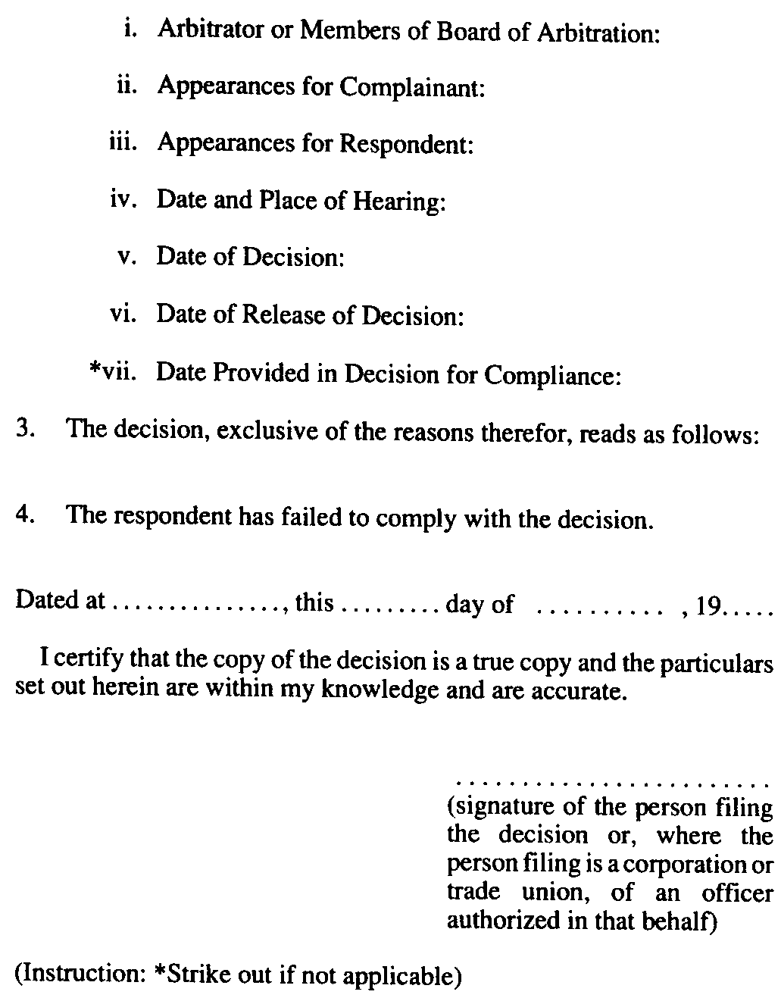
O. Reg. 750/92, s. 2.
Form 3
Labour Relations Act
Insert regs\graphics\1990\684\684003ae.tif
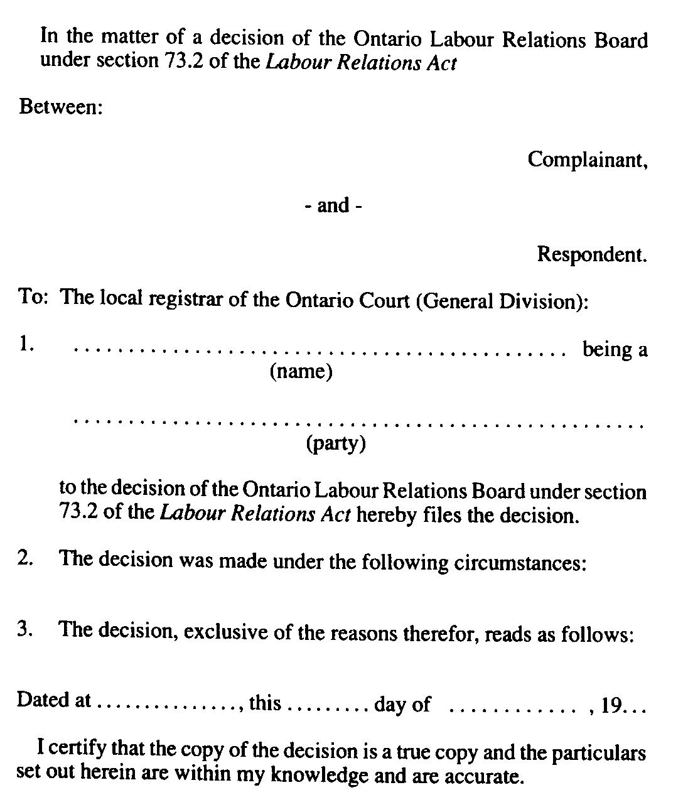
Insert regs\graphics\1990\684\684003be.tif

O. Reg. 750/92, s. 2.
Form 4
Labour Relations Act
Insert regs\graphics\1990\684\684004ae.tif
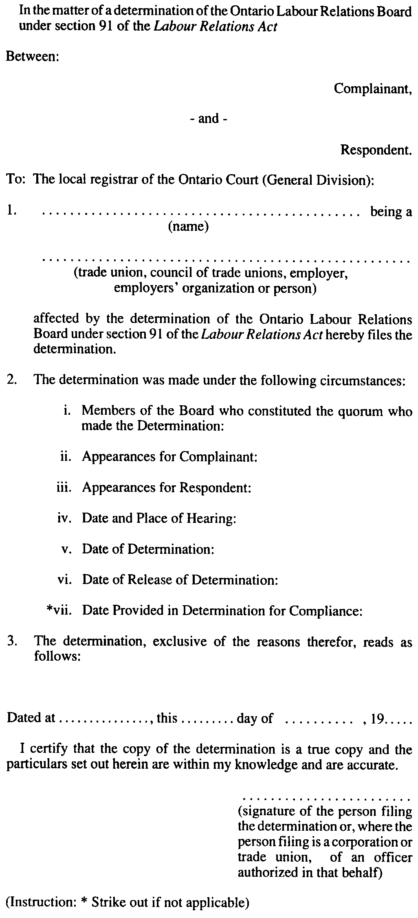
O. Reg. 750/92, s. 2.
Form 5
Labour Relations Act
Insert regs\graphics\1990\684\684005ae.tif
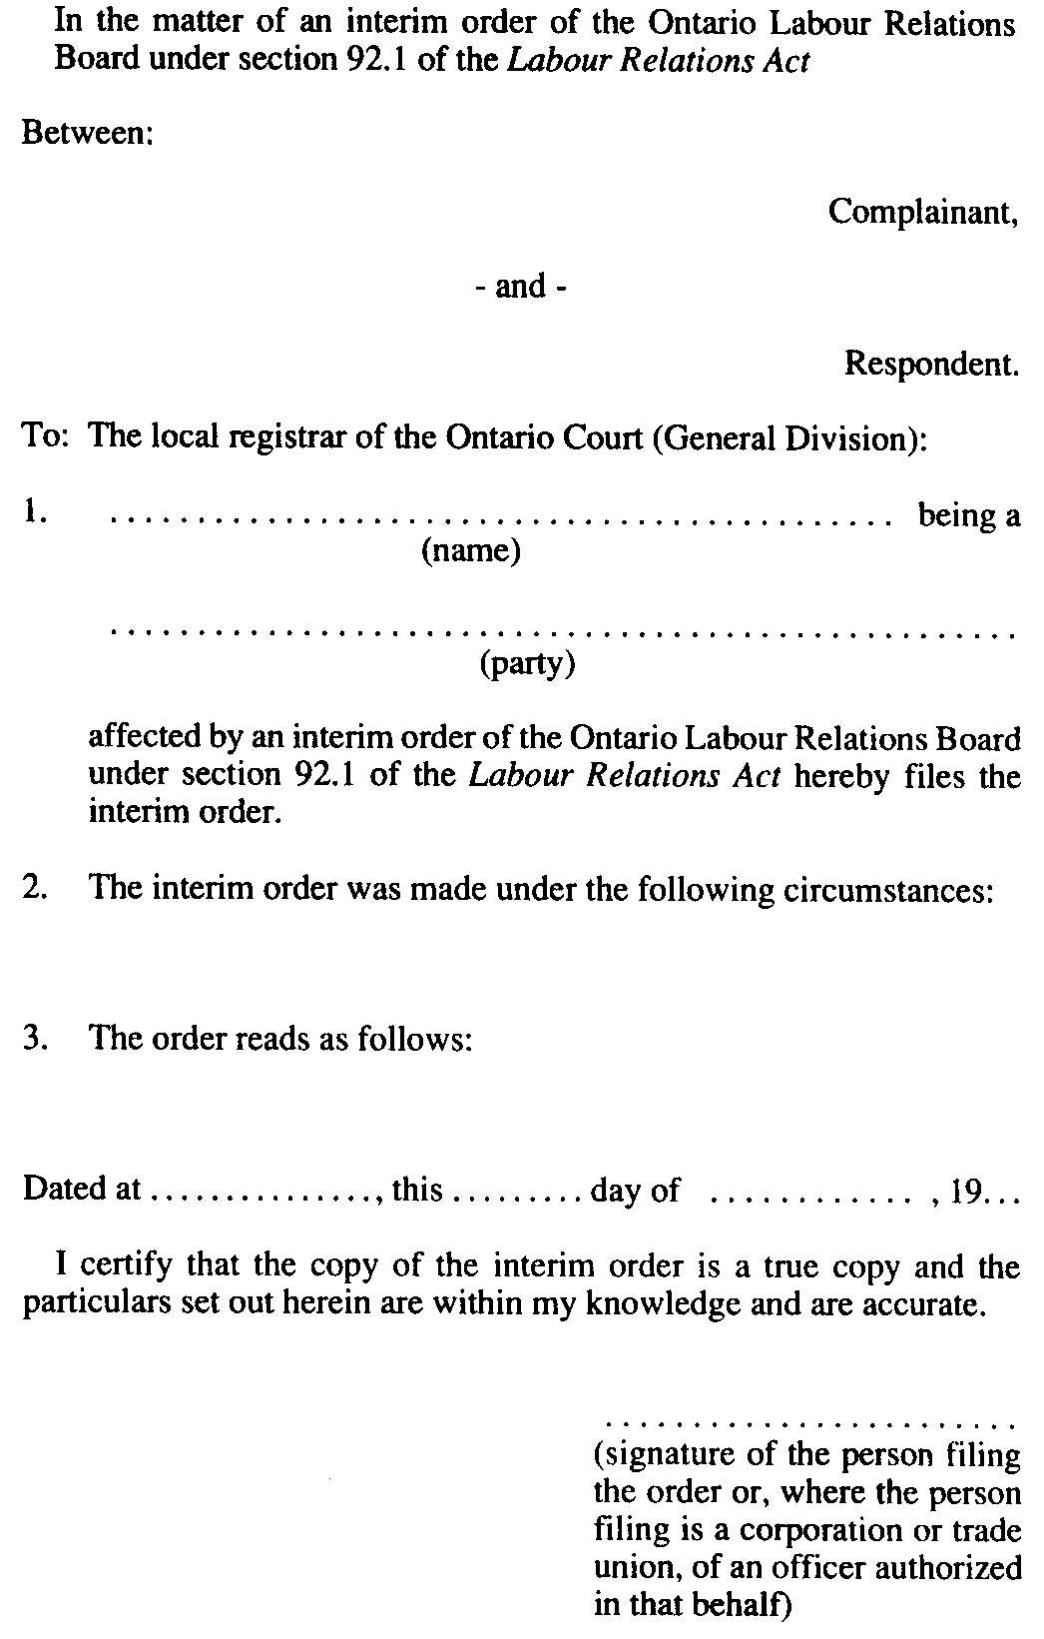
O. Reg. 750/92, s. 2.
Form 6
STATEMENT OF TRUSTEESHIP OVER LOCAL UNION TO THE ONTARIO LABOUR RELATIONS BOARD
Labour Relations Act
Insert regs\graphics\1990\684\684006ae.tif
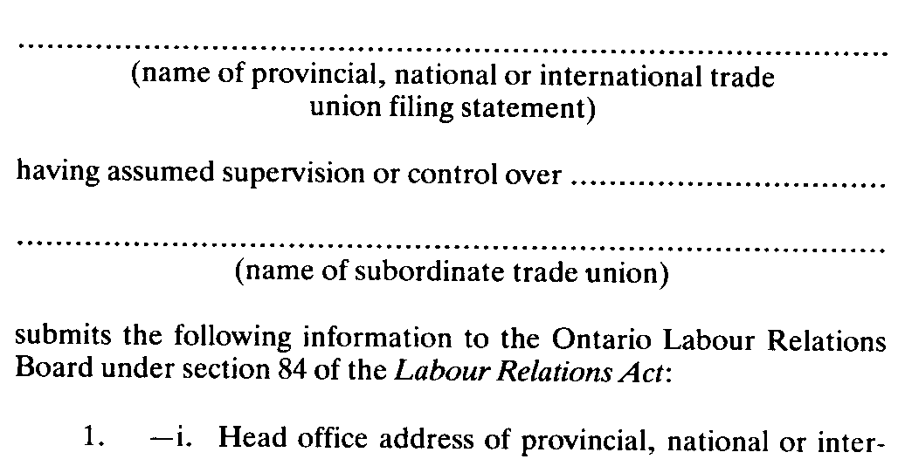
Insert regs\graphics\1990\684\684006be.tif
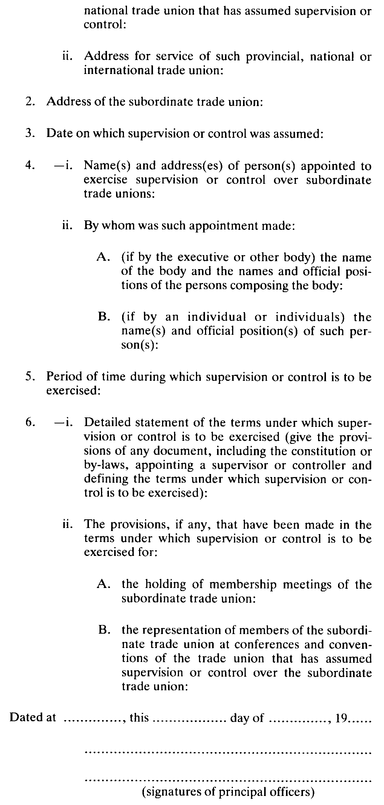
R.R.O. 1990, Reg. 684, Form 6.
Form 7
NOTICE AUTHORIZING REPRESENTATIVE FOR SERVICE OF PROCESS UNDER SECTION 89 OF THE LABOUR RELATIONS ACT
Labour Relations Act
Insert regs\graphics\1990\684\684007ae.tif
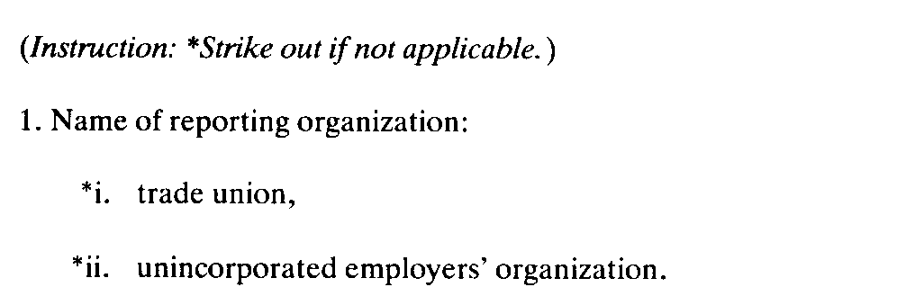
Insert regs\graphics\1990\684\684007be.tif
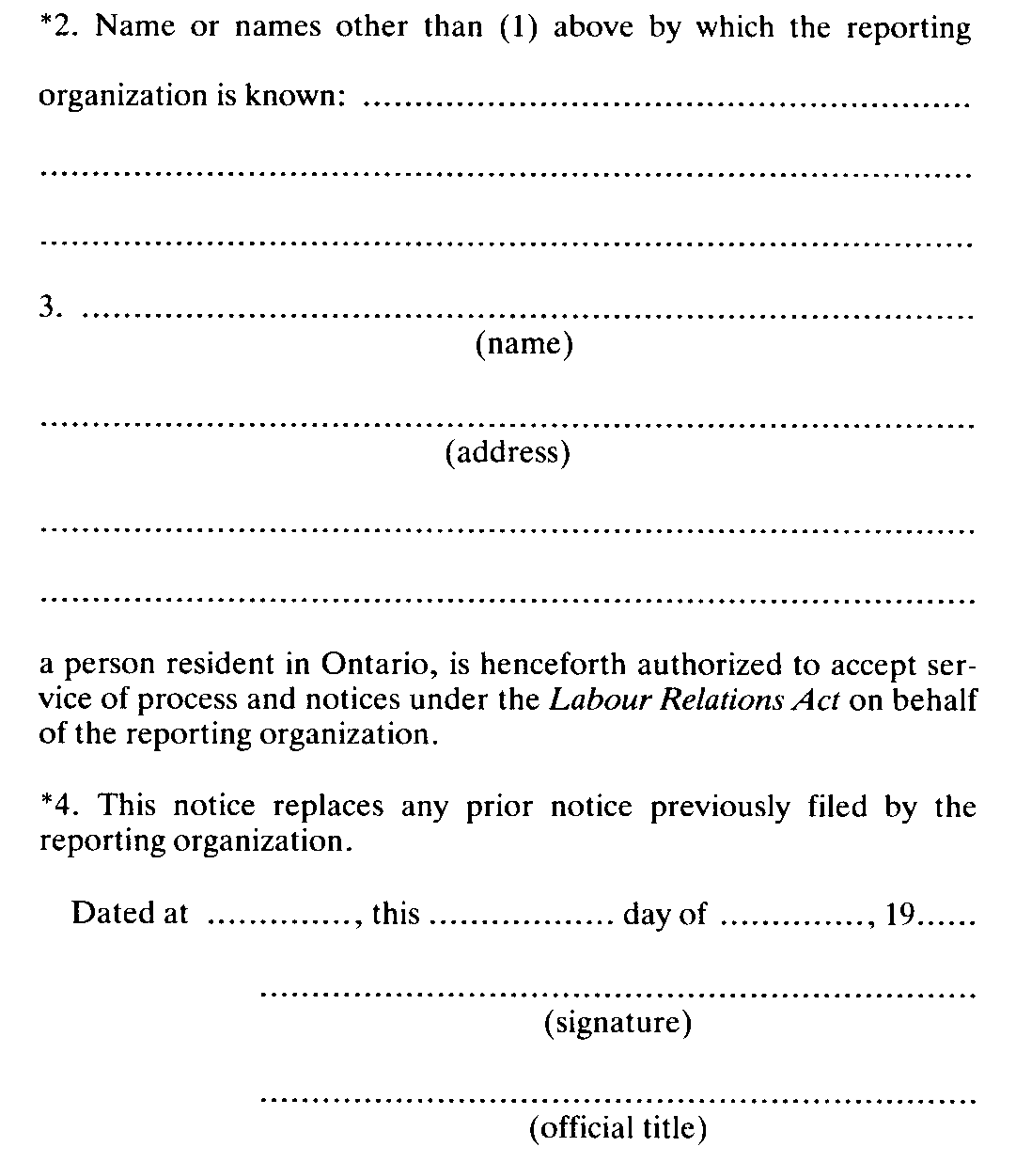
R.R.O. 1990, Reg. 684, Form 7.
Form 8
Labour Relations Act
Insert regs\graphics\1990\684\684008ae.tif
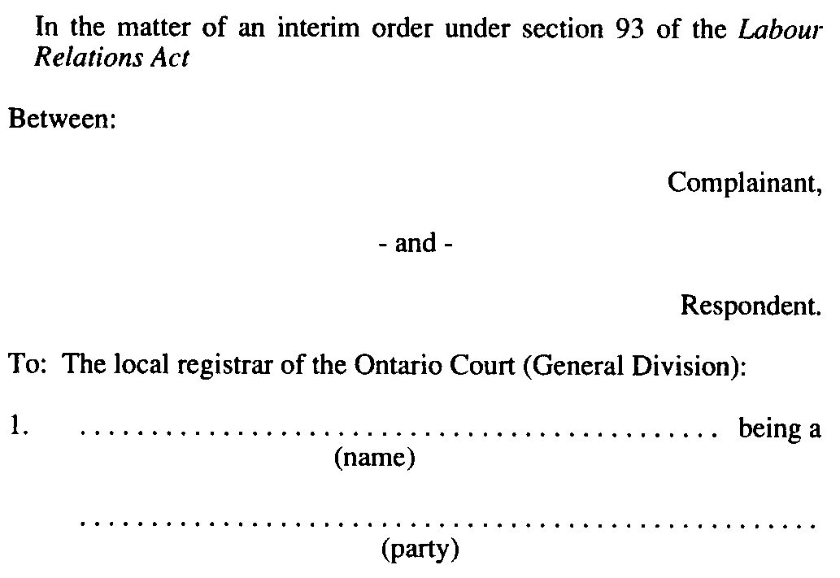
Insert regs\graphics\1990\684\684008be.tif
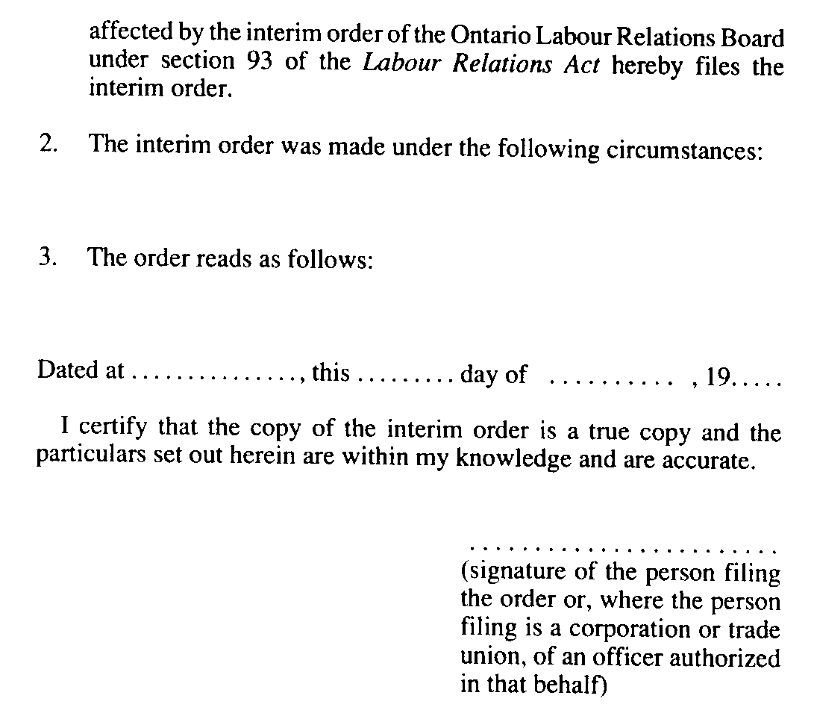
O. Reg. 750/92, s. 2.
Form 9
NOTICE OF DESIGNATED JURISDICTIONAL REPRESENTATIVES UNDER SECTION 138 OF THE LABOUR RELATIONS ACT (CONSTRUCTION INDUSTRY)
Labour Relations Act
Insert regs\graphics\1990\684\684009ae.tif
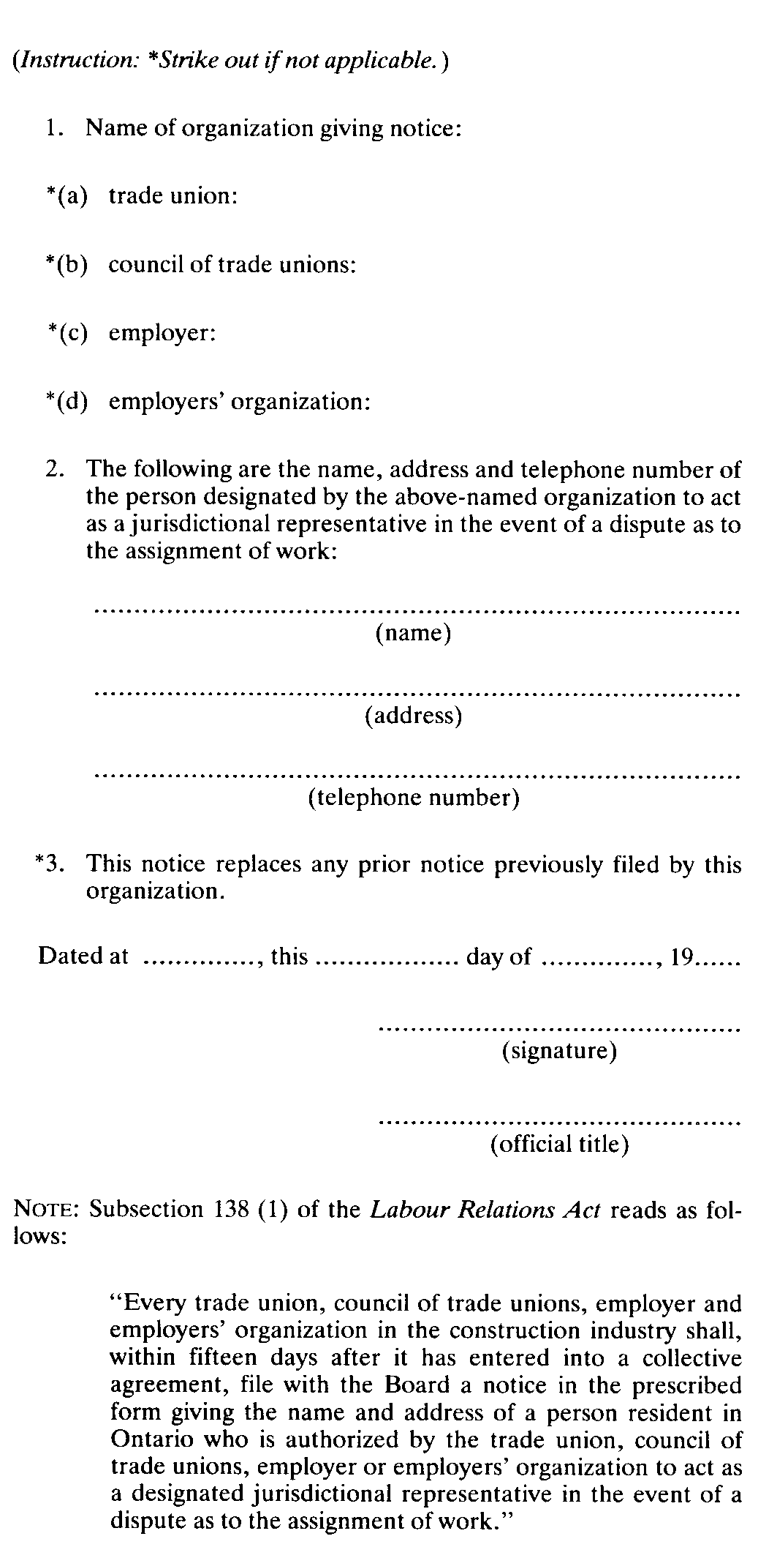
R.R.O. 1990, Reg. 684, Form 9.
Form 10
DECLARATION OF EMPLOYER BARGAINING AGENCY OR EMPLOYERS’ ORGANIZATION UNDER SECTION 152 OF THE LABOUR RELATIONS ACT
Labour Relations Act
Insert regs\graphics\1990\684\684010ae.tif
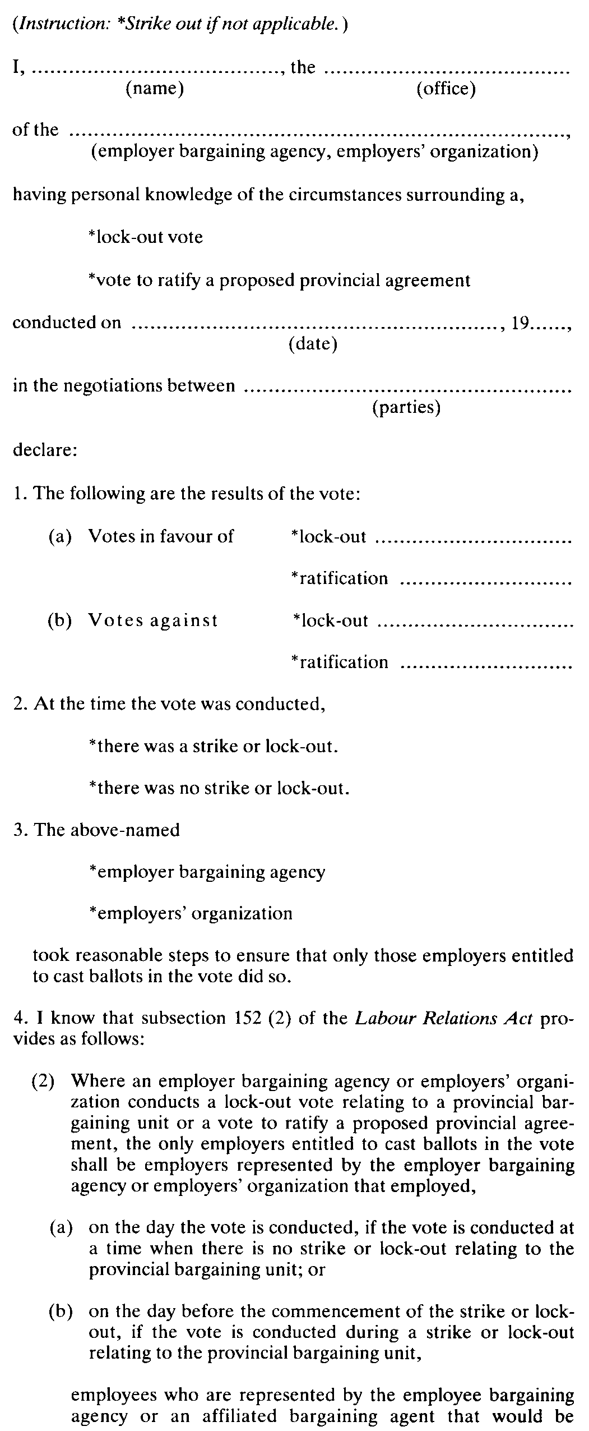
Insert regs\graphics\1990\684\684010be.tif
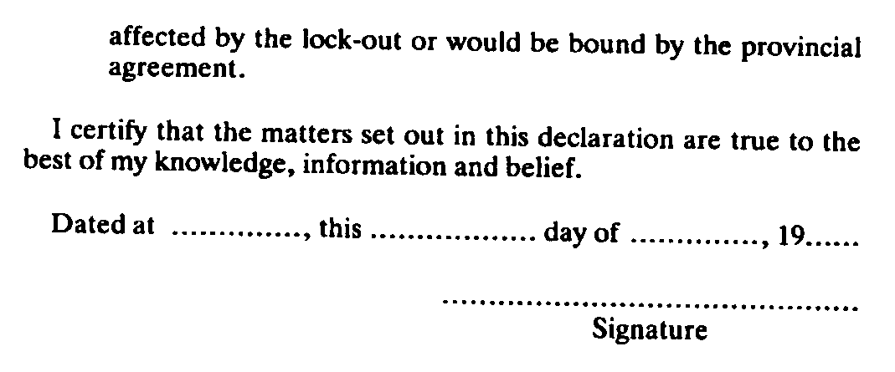
R.R.O. 1990, Reg. 684, Form 10.
Form 11
DECLARATION OF EMPLOYEE BARGAINING AGENCY OR AFFILIATED BARGAINING AGENT
Labour Relations Act
Insert regs\graphics\1990\684\684011ae.tif
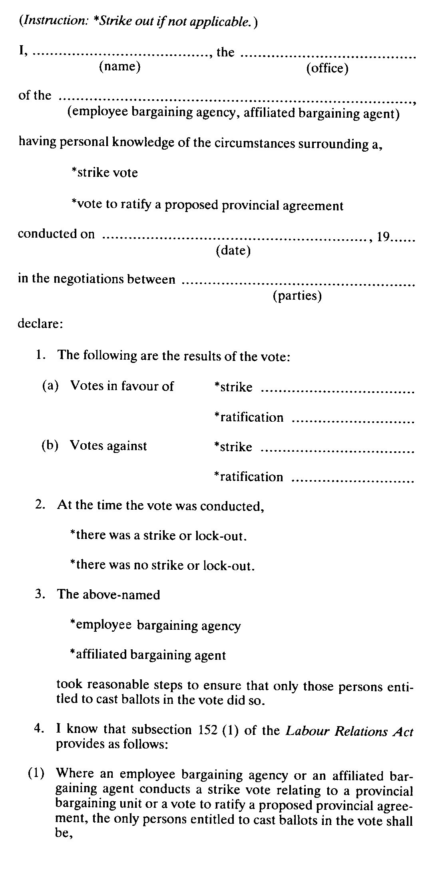
Insert regs\graphics\1990\684\684011be.tif
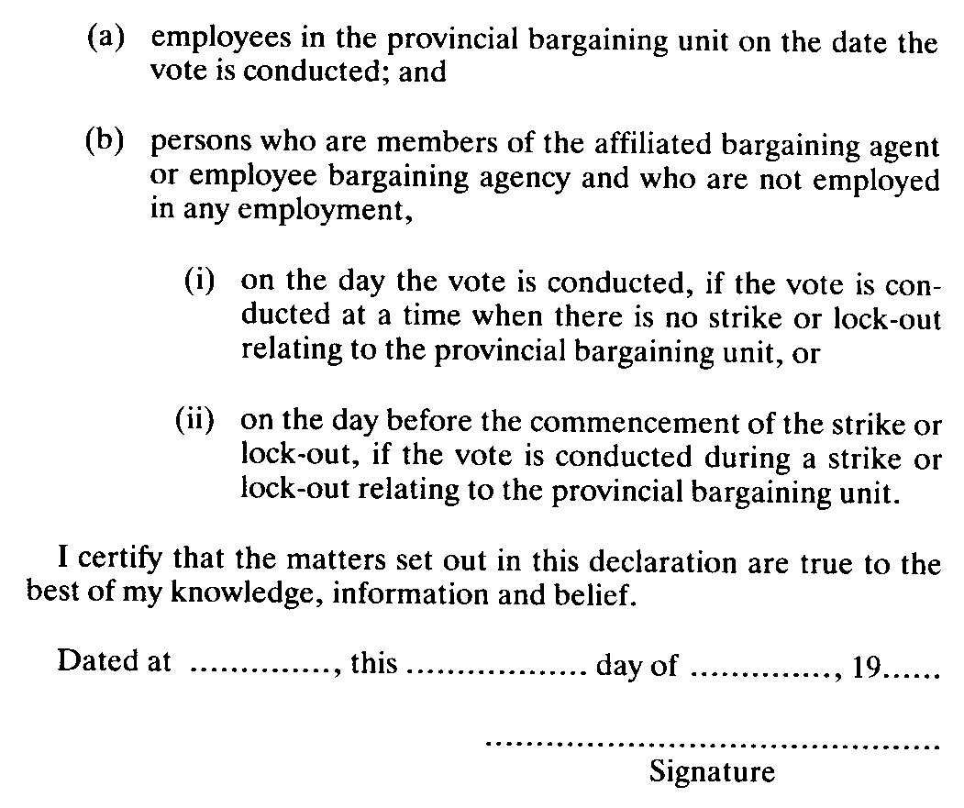
R.R.O. 1990, Reg. 684, Form 11.
Form 12
Labour Relations Act
Insert regs\graphics\1990\684\684012ae.tif
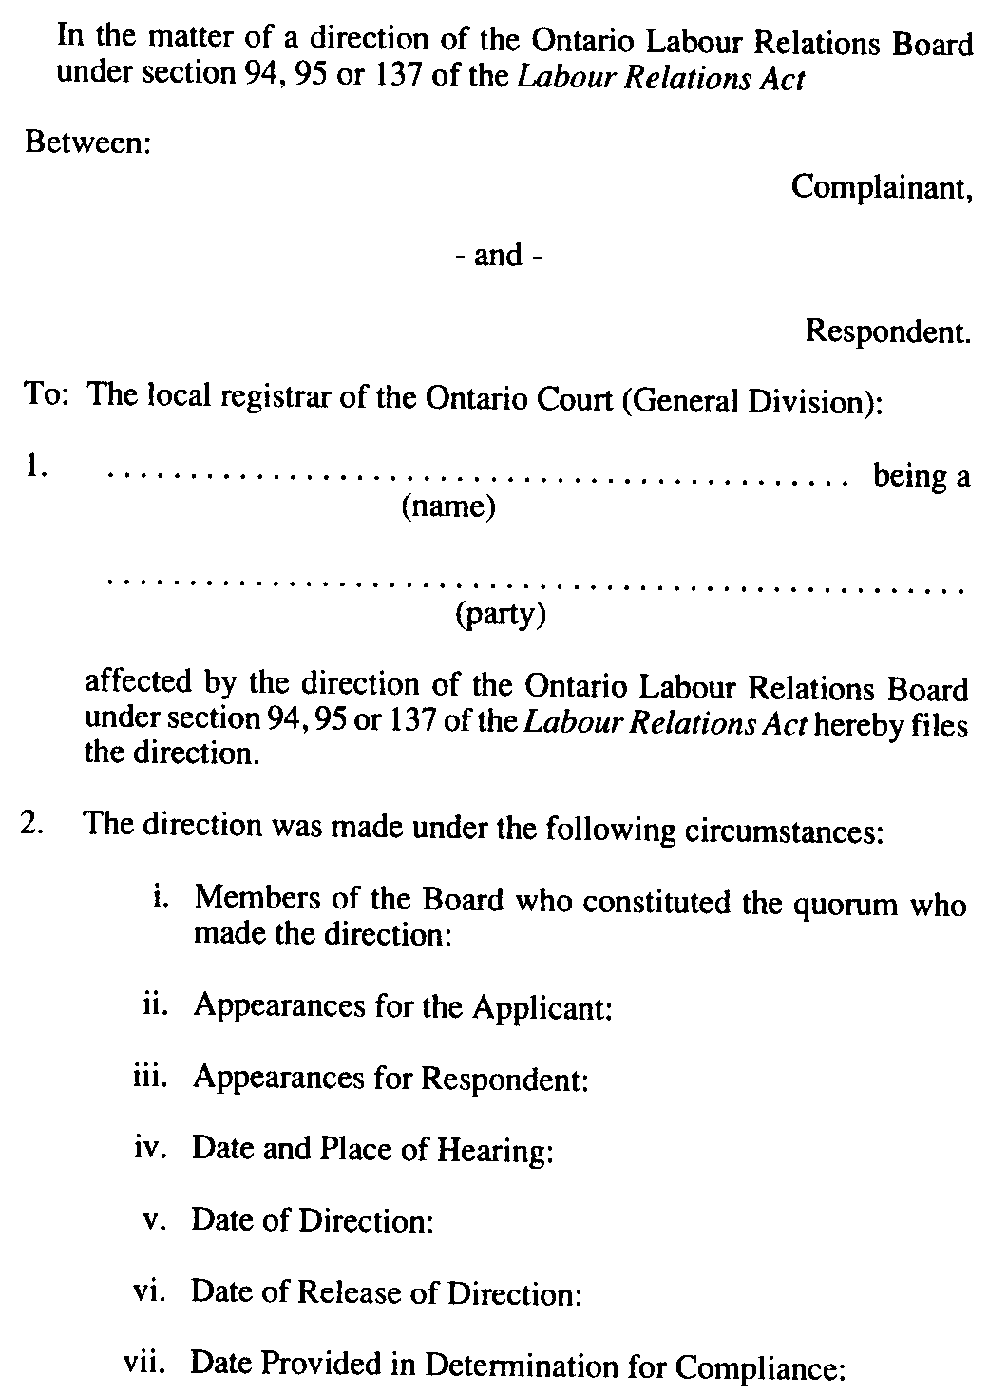
Insert regs\graphics\1990\684\684012be.tif
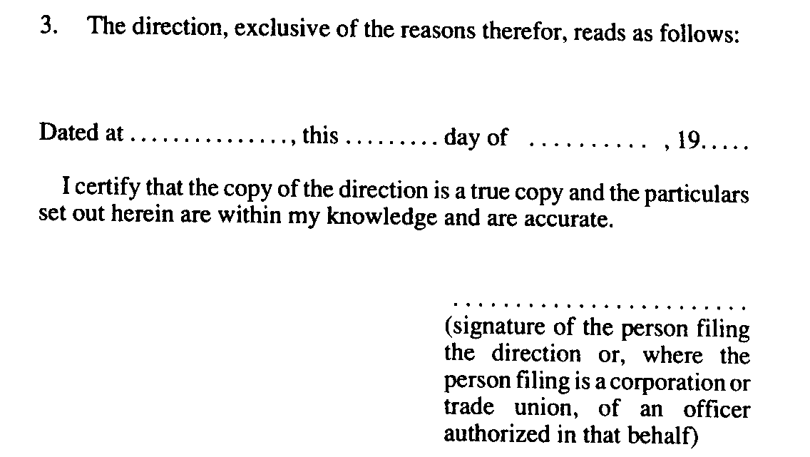
O. Reg. 750/92, s. 3.
Form 13
Labour Relations Act
Insert regs\graphics\1990\684\684013ae.tif
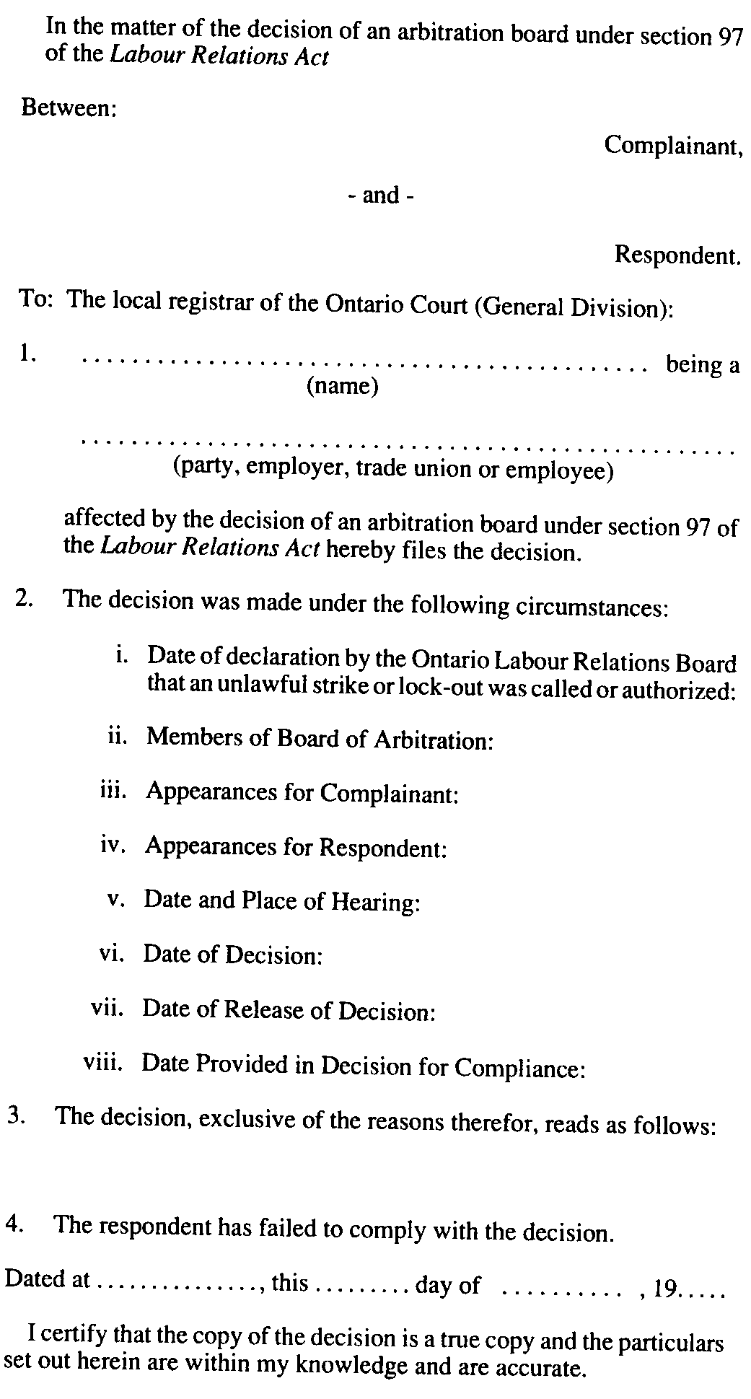
Insert regs\graphics\1990\684\684013be.tif

O. Reg. 750/92, s. 3.

Français

Back to top

