Français
Municipal Act, 2001
R.R.O. 1990, REGULATION 824
formerly under Municipal Tax Sales Act
Amended to: O. Reg. 181/03
MUNICIPAL TAX SALES RULES
Note: This Regulation was revoked on May 5, 2003. See: O. Reg. 181/03, s. 28.
This is the English version of a bilingual regulation.
1. In this Regulation,
“accumulated taxes” means real property taxes that have accumulated with respect to a parcel of land from the first day of advertising of the parcel for sale by public sale until the day a successful purchaser is declared. R.R.O. 1990, Reg. 824, r. 1.
2. (1) This Regulation may be cited as the Municipal Tax Sales Rules. R.R.O. 1990, Reg. 824, r. 2 (1).
(2) A public sale of land under the Act shall be conducted in accordance with these rules. R.R.O. 1990, Reg. 824, r. 2 (2).
PART I
FORMS
3. (1) A tax arrears certificate shall be in Form 1. R.R.O. 1990, Reg. 824, r. 3 (1).
(2) A notice required by section 4 of the Act shall be in Form 2. R.R.O. 1990, Reg. 824, r. 3 (2).
(3) A statutory declaration required by subsection 4 (4) of the Act shall be in Form 3. R.R.O. 1990, Reg. 824, r. 3 (3).
(4) A tax arrears cancellation certificate referred to in subsection 5 (2), 8 (5) or 12 (3) of the Act shall be in Form 4. R.R.O. 1990, Reg. 824, r. 3 (4).
(5) A final notice required by subsection 9 (1) of the Act shall be in Form 5. R.R.O. 1990, Reg. 824, r. 3 (5).
(6) A statutory declaration required by subsection 9 (2) of the Act shall be in Form 6. R.R.O. 1990, Reg. 824, r. 3 (6).
(7) A tax deed and the statutory declaration related thereto, as required by subsection 9 (4) of the Act, shall be in Form 10. R.R.O. 1990, Reg. 824, r. 3 (7).
(8) A notice of vesting and the statutory declaration related thereto, as required by subsection 9 (4) of the Act, shall be in Form 11. R.R.O. 1990, Reg. 824, r. 3 (8).
(9) The statement required by subsection 10 (2) of the Act shall be in Form 12. R.R.O. 1990, Reg. 824, r. 3 (9).
(10) A notice of forfeiture under section 23 of the Municipal Tax Sales Act, 1984 shall be in Form 13. R.R.O. 1990, Reg. 824, r. 3 (10).
4. The French version of a form prescribed by this Regulation that is to be registered in a land registry office may be used only with respect to land registered in a land titles division designated for the purposes of section 85 of the Land Titles Act or registered in a registry division designated for the purposes of section 44 of the Registry Act. R.R.O. 1990, Reg. 824, r. 4.
PART II
SALE BY PUBLIC TENDER
5. (1) Where the treasurer conducts a sale under the Act by public tender, the advertisement required by clause 9 (2) (d) of the Act shall be in Form 7 and the treasurer shall allow at least seven days after the publication of the last advertisement in The Ontario Gazette or newspaper, or, where there is no newspaper, the posting of the notice, for the submission of tenders. R.R.O. 1990, Reg. 824, r. 5 (1).
(2) An advertisement may relate to the sale of any number of parcels of land. R.R.O. 1990, Reg. 824, r. 5 (2).
6. (1) A tender shall be in Form 8 and shall be,
(a) typewritten or legibly handwritten in ink;
(b) accompanied by a deposit of at least 20 per cent of the tender amount, which deposit shall be made by way of money order or by way of bank draft or cheque certified by a bank, trust corporation or Province of Ontario Savings Office;
(c) submitted in a sealed envelope on the outside of which is indicated “Tax Sale For (insert short description or municipal address of property sufficient to permit the treasurer to identify the parcel of land to which the tender relates)”; and
(d) addressed to the treasurer. R.R.O. 1990, Reg. 824, r. 6 (1).
(2) A tender shall relate to only one parcel of land. R.R.O. 1990, Reg. 824, r. 6 (2).
7. (1) On receiving an envelope identified as containing a tender, the treasurer shall mark on it the time and date on which it was received and shall retain it unopened in a safe place. R.R.O. 1990, Reg. 824, r. 7 (1).
(2) For the purposes of this Part, where two or more tenders are equal, the tender that was received earlier shall be deemed to be the higher. R.R.O. 1990, Reg. 824, r. 7 (2).
8. (1) A tender is withdrawn if the tenderer’s written request to have the tender withdrawn is received by the treasurer before 3 p.m. local time on the last date for receiving tenders. R.R.O. 1990, Reg. 824, r. 8 (1).
(2) The envelope containing a withdrawn tender shall be opened at the time of the opening of the sealed envelopes. R.R.O. 1990, Reg. 824, r. 8 (2).
9. (1) The treasurer, at a place in the municipality that is open to the public, shall open the sealed envelopes containing the tenders as soon as possible after 3 p.m. local time on the last date for receiving tenders. R.R.O. 1990, Reg. 824, r. 9 (1).
(2) The sealed envelopes shall be opened in the presence of at least one person who did not submit a tender, which person may be a municipal employee. R.R.O. 1990, Reg. 824, r. 9 (2).
(3) After opening the sealed envelopes, the treasurer shall examine their contents and shall reject every tender that,
(a) is not equal to or greater than the minimum tender amount as shown in the advertisement;
(b) does not comply with rule 6;
(c) includes any term or condition not provided for in these rules; or
(d) has been withdrawn as set out in subrule 8 (1). R.R.O. 1990, Reg. 824, r. 9 (3).
(4) After complying with subrule (3), the treasurer shall reject all but the two highest of the remaining tenders. R.R.O. 1990, Reg. 824, r. 9 (4).
(5) Every rejected tender shall be returned to the tenderer together with the tenderer’s deposit, if any, and a statement of the reason for rejection. R.R.O. 1990, Reg. 824, r. 9 (5).
10. If, after complying with rule 9, no tenders remain, the treasurer shall declare that there is no successful purchaser and the treasurer shall register forthwith a notice of vesting in the name of the municipality. R.R.O. 1990, Reg. 824, r. 10.
11. (1) If, after complying with rule 9, two tenders remain, the treasurer shall forthwith notify the higher tenderer, by ordinary mail sent to the address shown in the tender, that the tenderer will be declared to be the successful purchaser if, within fourteen calendar days of the mailing of the notice, the balance of the amount tendered, the applicable land transfer tax and the accumulated taxes are paid, in cash, to the treasurer. R.R.O. 1990, Reg. 824, r. 11 (1).
(2) If the higher tenderer makes the payment as set out in subrule (1), the treasurer shall declare the tenderer to be the successful purchaser. R.R.O. 1990, Reg. 824, r. 11 (2).
(3) If the higher tenderer does not make the payment as set out in subrule (1), the tenderer’s deposit shall be forfeited forthwith to the municipality and the treasurer shall offer the parcel of land to the lower tenderer in accordance with rule 12. R.R.O. 1990, Reg. 824, r. 11 (3).
12. (1) If, after complying with rule 9, only one tender remains or if, in accordance with subrule 11 (3), the treasurer is required to offer the parcel of land to the lower tenderer, the treasurer shall forthwith notify the tenderer, by ordinary mail sent to the address shown in the tender, that the tenderer will be declared to be the successful purchaser if, within fourteen calendar days of the mailing of the notice, the balance of the amount tendered, the applicable land transfer tax and the accumulated taxes are paid, in cash, to the treasurer. R.R.O. 1990, Reg. 824, r. 12 (1).
(2) If the tenderer makes the payment as set out in subrule (1), the treasurer shall declare the tenderer to be the successful purchaser. R.R.O. 1990, Reg. 824, r. 12 (2).
(3) If the tenderer does not make the payment as set out in subrule (1),
(a) the treasurer shall declare that there is no successful purchaser and shall register forthwith a notice of vesting in the name of the municipality; and
(b) the tenderer’s deposit shall be forfeited forthwith to the municipality. R.R.O. 1990, Reg. 824, r. 12 (3).
PART III
SALE BY PUBLIC AUCTION
13. (1) Where the treasurer conducts a sale under the Act by public auction, the advertisement required by clause 9 (2) (d) of the Act shall be in Form 9 and the treasurer shall allow at least seven calendar days after the publication of the last advertisement in The Ontario Gazette or newspaper, or, where there is no newspaper, the posting of the notice, before holding the auction. R.R.O. 1990, Reg. 824, r. 13 (1).
(2) The auction shall be held at such place in the district municipality, metropolitan municipality, regional municipality, county or district in which the land is situate as the treasurer may name in the advertisement. R.R.O. 1990, Reg. 824, r. 13 (2).
(3) An advertisement may relate to the sale of any number of parcels of land. R.R.O. 1990, Reg. 824, r. 13 (3).
14. (1) The treasurer or such other person as the treasurer may name shall act as auctioneer. R.R.O. 1990, Reg. 824, r. 14 (1).
(2) The auctioneer shall open the auction by declaring the tax sale officially open and by reading out rules 15, 16, 17 and 18. R.R.O. 1990, Reg. 824, r. 14 (2).
15. For each parcel of land to be sold during the auction, the auctioneer shall,
(a) in opening or reopening the bidding on the parcel, state the minimum bid as set out in the advertisement;
(b) acknowledge each bidder, repeat each bid made and call for higher bids; and
(c) if no higher bid is made, repeat the last bid three times and if there is still no higher bid, acknowledge the highest bidder. R.R.O. 1990, Reg. 824, r. 15.
16. The highest bidder shall be declared to be the successful purchaser if the bidder immediately pays the amount bid, the applicable land transfer tax and the accumulated taxes, in cash, to the auctioneer. R.R.O. 1990, Reg. 824, r. 16.
17. If the highest bidder fails to make the payment as set out in rule 16 and the bidding has not been previously reopened under this rule, the auctioneer shall forthwith reopen the bidding. R.R.O. 1990, Reg. 824, r. 17.
18. If no bid is made for a parcel of land after the opening of the bidding or if, after the reopening of the bidding under rule 17, no bid is made or there is no successful purchaser, the treasurer shall register forthwith a notice of vesting in the name of the municipality. R.R.O. 1990, Reg. 824, r. 18.
19. The auctioneer shall issue a receipt to the successful purchaser for the amounts received under rule 16 and the receipt shall include a legal description of the parcel of land and the name of the purchaser and the name in which the tax deed will be registered. R.R.O. 1990, Reg. 824, r. 19.
20. The auctioneer shall declare the auction closed upon completion of the bidding on all the parcels of land offered for sale in the auction. R.R.O. 1990, Reg. 824, r. 20.
21. The auctioneer shall prepare and keep a list showing each parcel of land offered for sale in the auction and the name and address of the successful purchaser or, where there is no successful purchaser, the name of the municipality. R.R.O. 1990, Reg. 824, r. 21.
PART IV
GENERAL
22. (1) If the treasurer is of the opinion that it is impractical to complete a sale under the Act or to do so would be unfair to the bidders or tenderers, the treasurer may cancel the sale and conduct a new sale under the Act. R.R.O. 1990, Reg. 824, r. 22 (1).
(2) If the treasurer cancels a sale by public tender, the treasurer, if he or she has not already done so, shall open the sealed envelopes and return the tenders to the tenderers together with tenderers’ deposits, if any, and a statement for the reason for the return and if the sale is cancelled after the opening of tenders, the treasurer shall return any tenders he or she retains and any deposits related thereto to the tenderers together with a reason for the return. R.R.O. 1990, Reg. 824, r. 22 (2).
23. As soon as possible after a successful purchaser is declared in a sale under the Act, the treasurer shall prepare and register the necessary documents in accordance with the Act. R.R.O. 1990, Reg. 824, r. 23.
24. Subject to clause 6 (1) (b), any payment required by these rules to be made in cash may be made by way of cash or money order or by way of bank draft or cheque certified by a bank, trust corporation or Province of Ontario Savings Office. R.R.O. 1990, Reg. 824, r. 24.
25. All deposits forfeited under these rules to a municipality shall form part of the general funds of the municipality. R.R.O. 1990, Reg. 824, r. 25.
Form 1
Municipal Act, 2001
DOCUMENT GENERAL
Insert regs\graphics\1990\824\824001ae.tif
R.R.O. 1990, Reg. 824, Form 1.
Form 2
Municipal Act, 2001
NOTICE OF REGISTRATION OF TAX ARREARS CERTIFICATE
Insert regs\graphics\1990\824\824002ae.tif
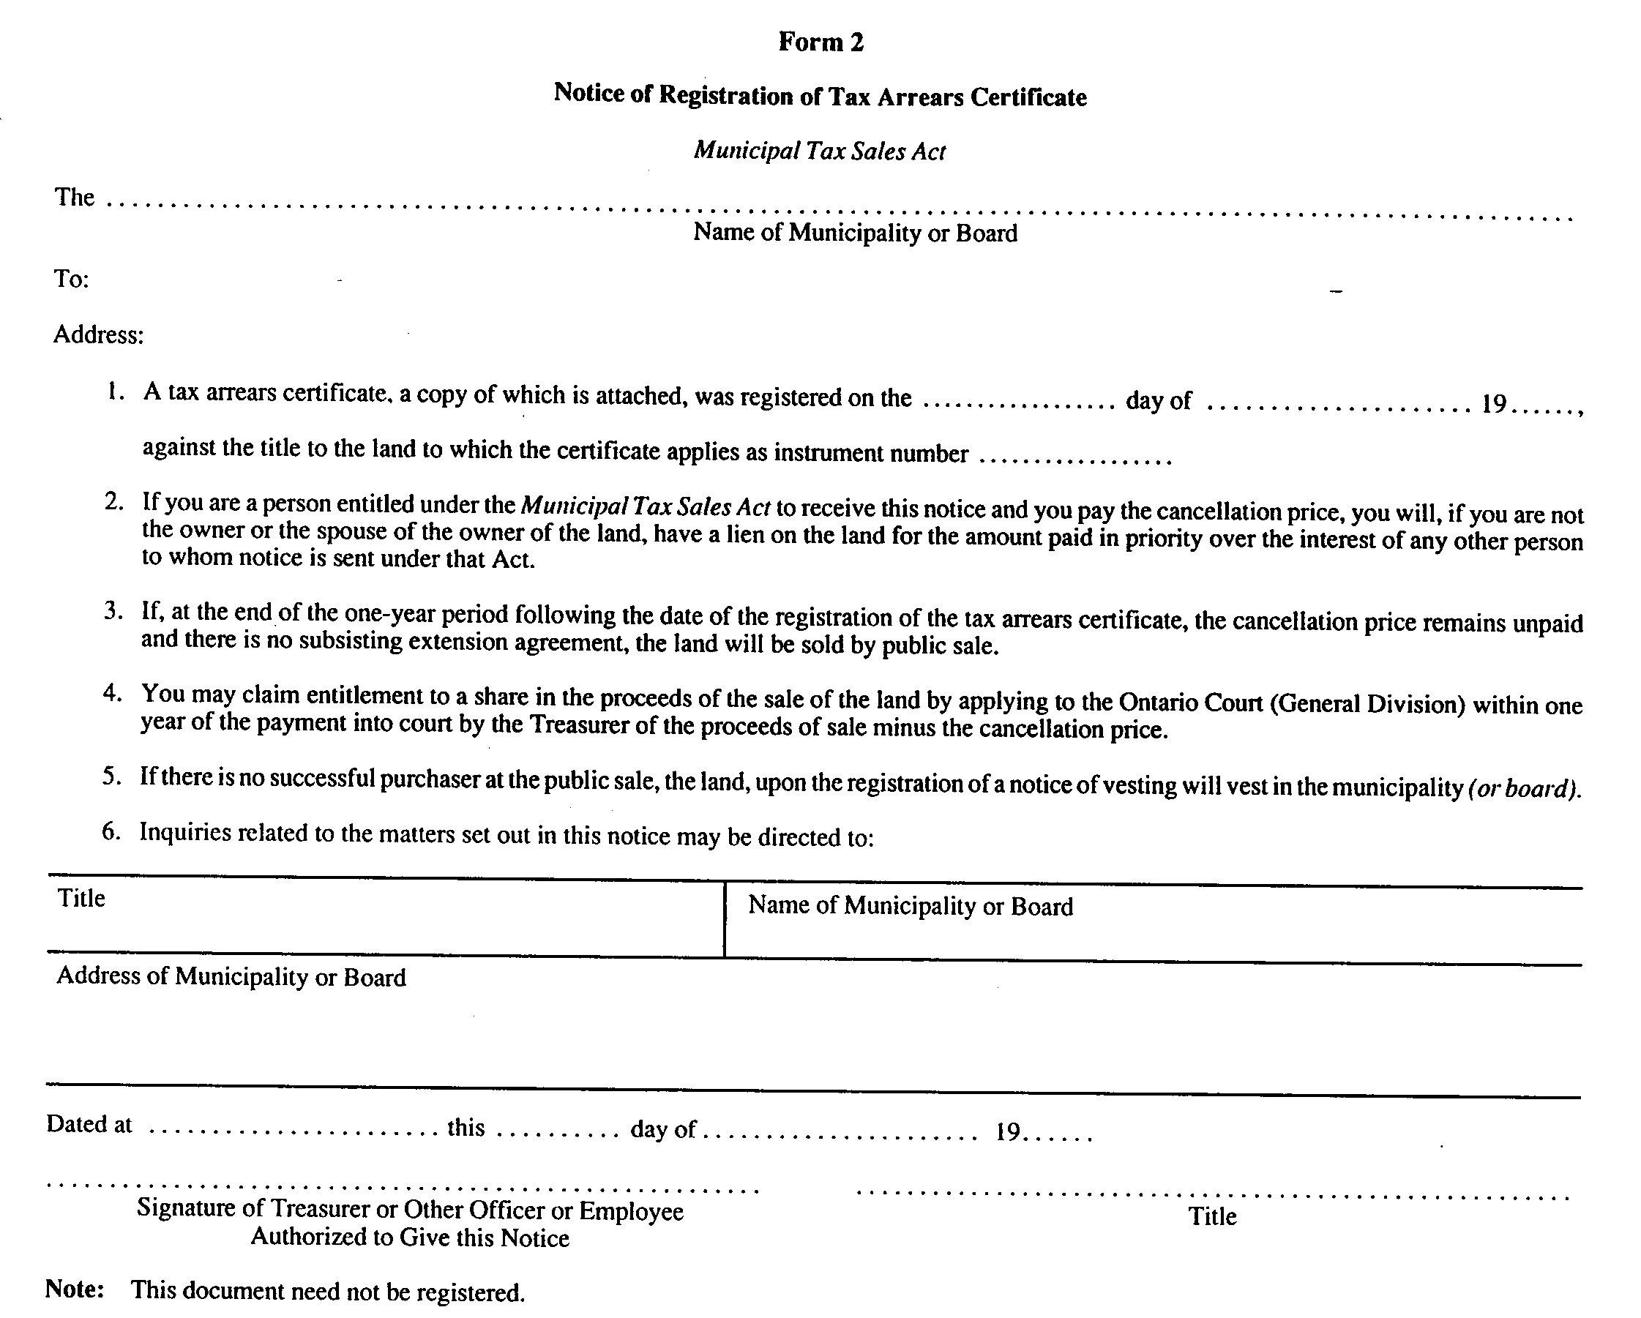
R.R.O. 1990, Reg. 824, Form 2.
Form 3
Municipal Act, 2001
DOCUMENT GENERAL
Insert regs\graphics\1990\824\824003ae.tif
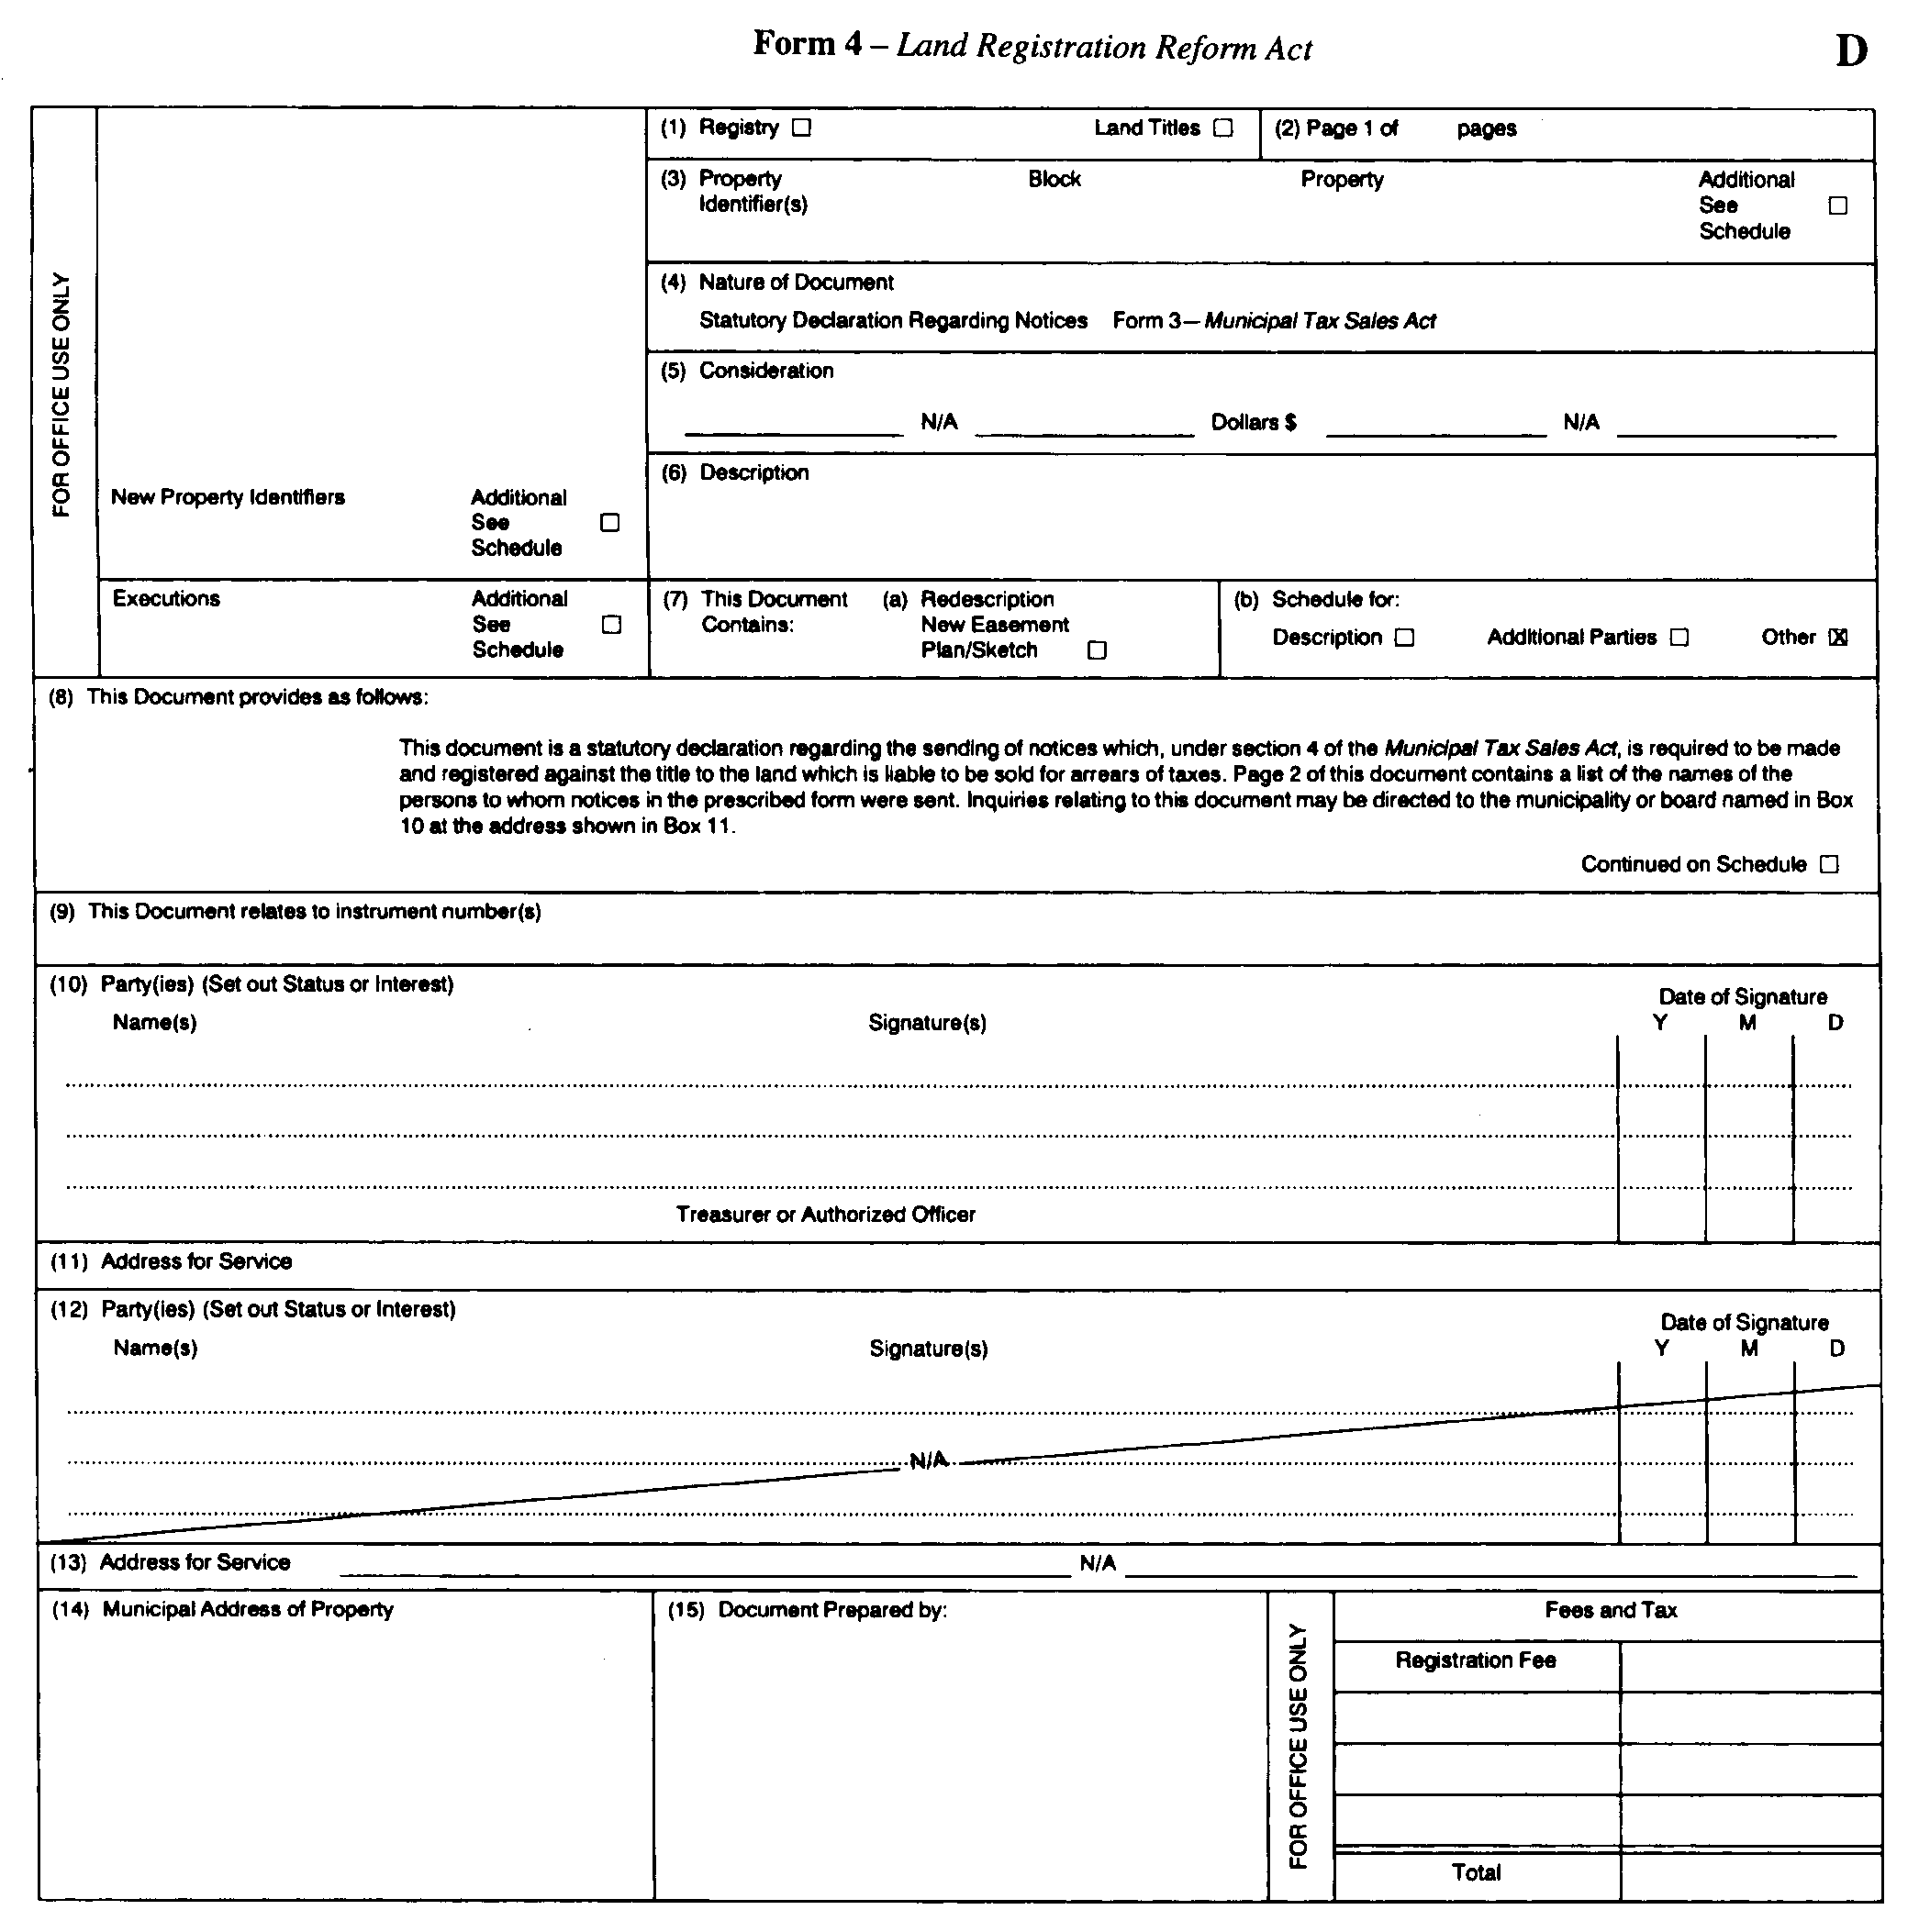
Insert regs\graphics\1990\824\824003be.tif
R.R.O. 1990, Reg. 824, Form 3.
Form 4
Municipal Act, 2001
DOCUMENT GENERAL
Insert regs\graphics\1990\824\824004ae.tif
R.R.O. 1990, Reg. 824, Form 4.
Form 5
Municipal Act, 2001
FINAL NOTICE
Insert regs\graphics\1990\824\824005ae.tif
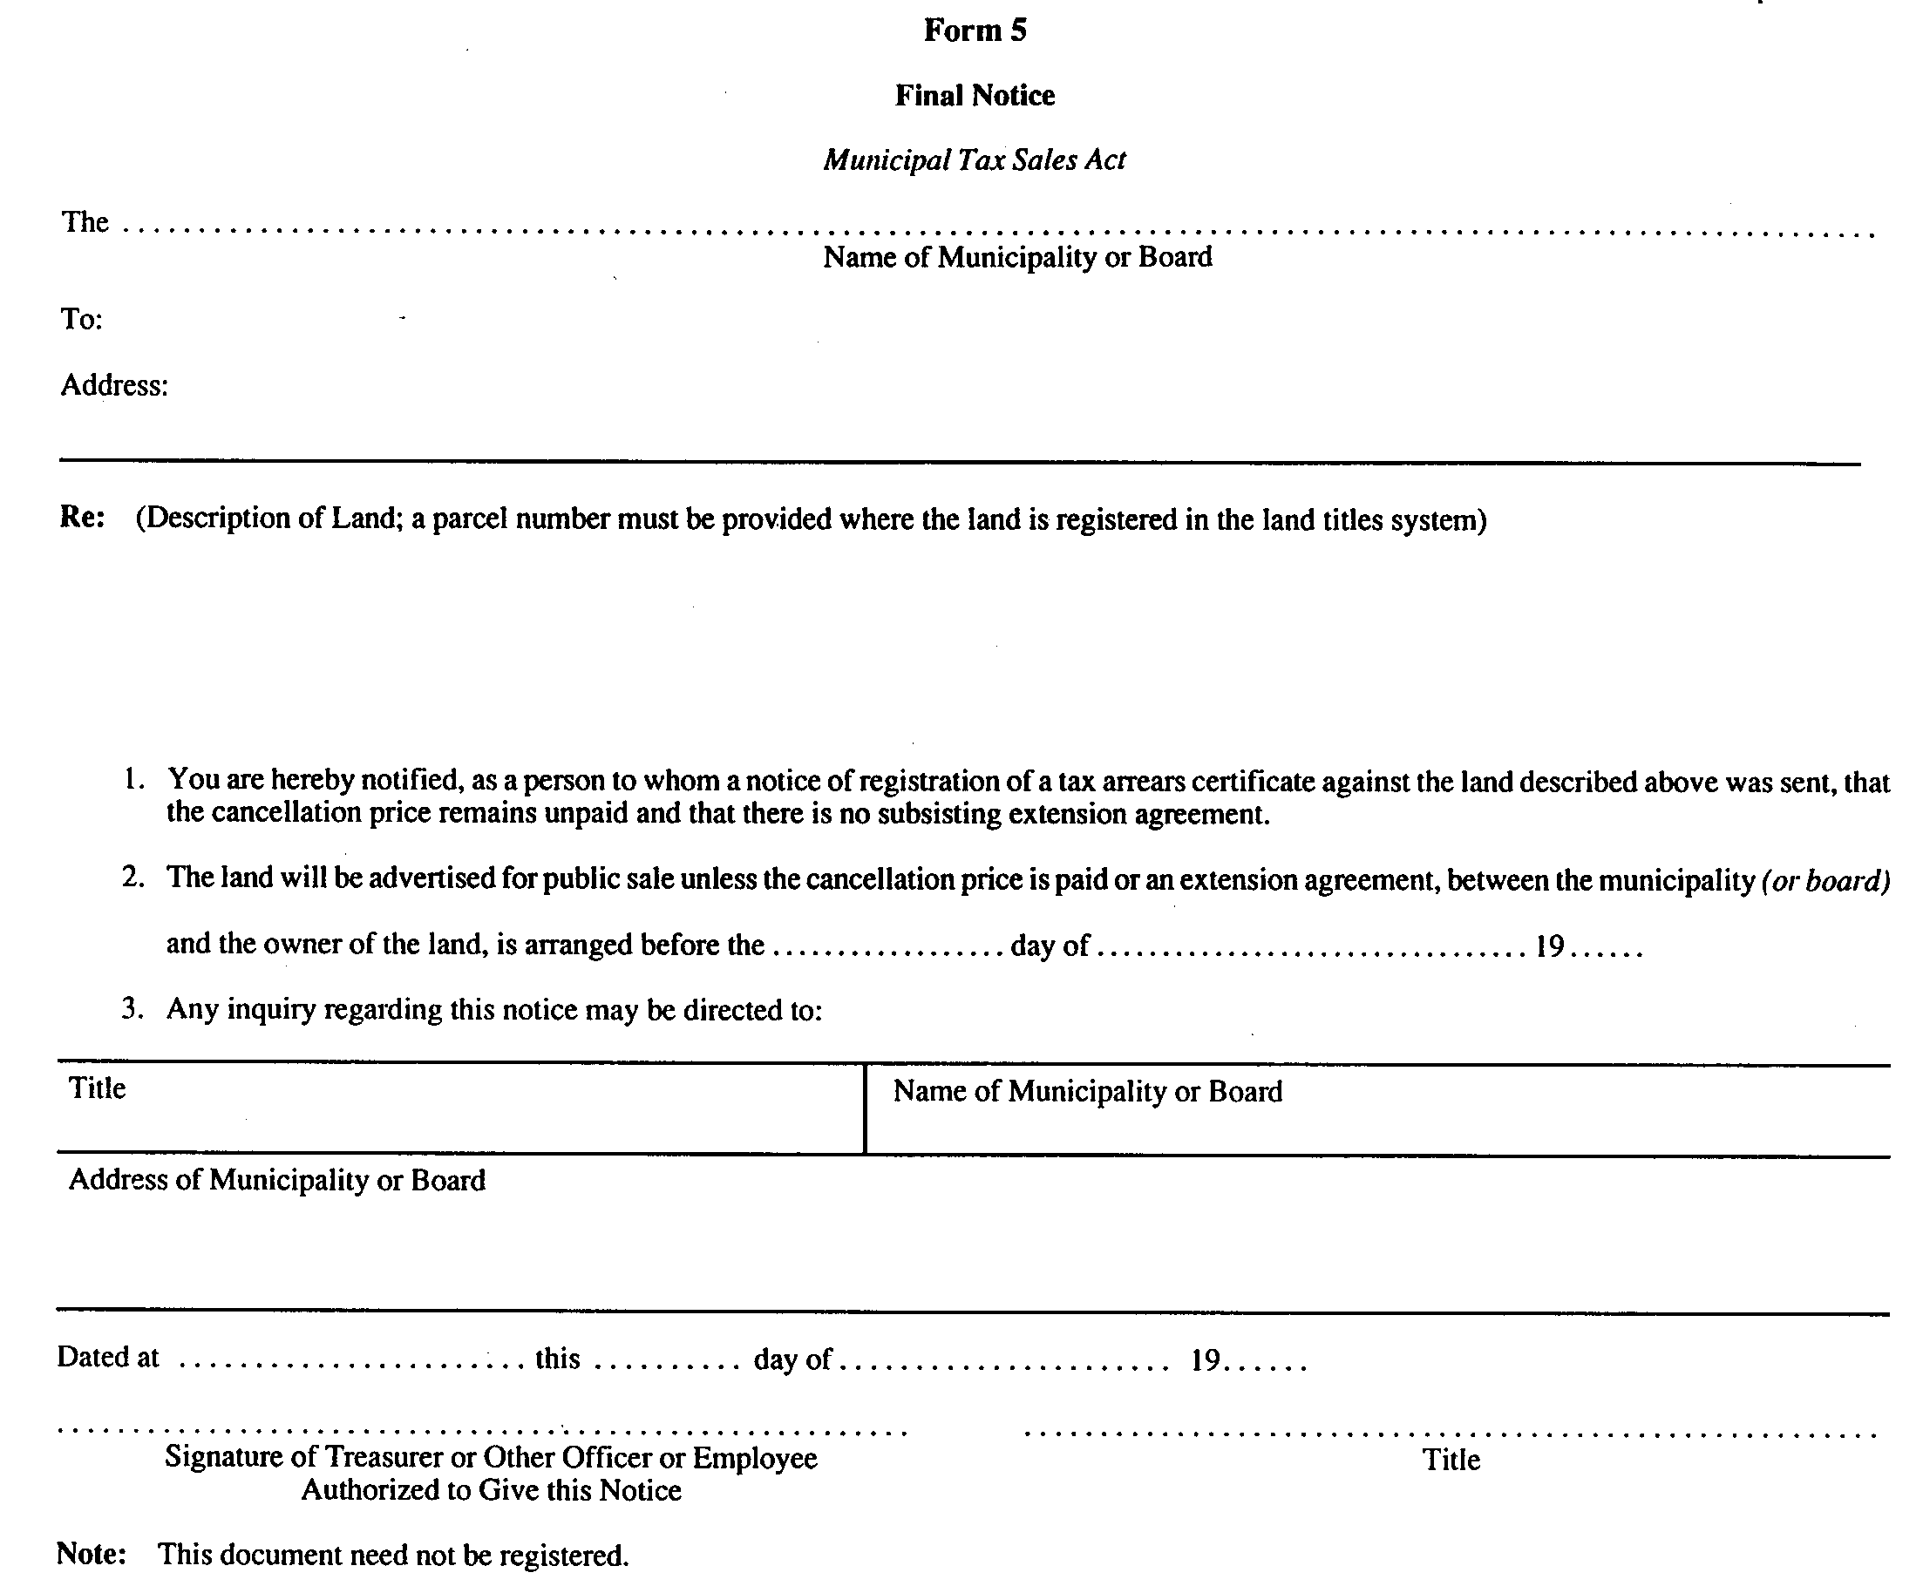
R.R.O. 1990, Reg. 824, Form 5.
Form 6
Municipal Act, 2001
STATUTORY DECLARATION REGARDING THE SENDING OF NOTICE
Insert regs\graphics\1990\824\824006ae.tif
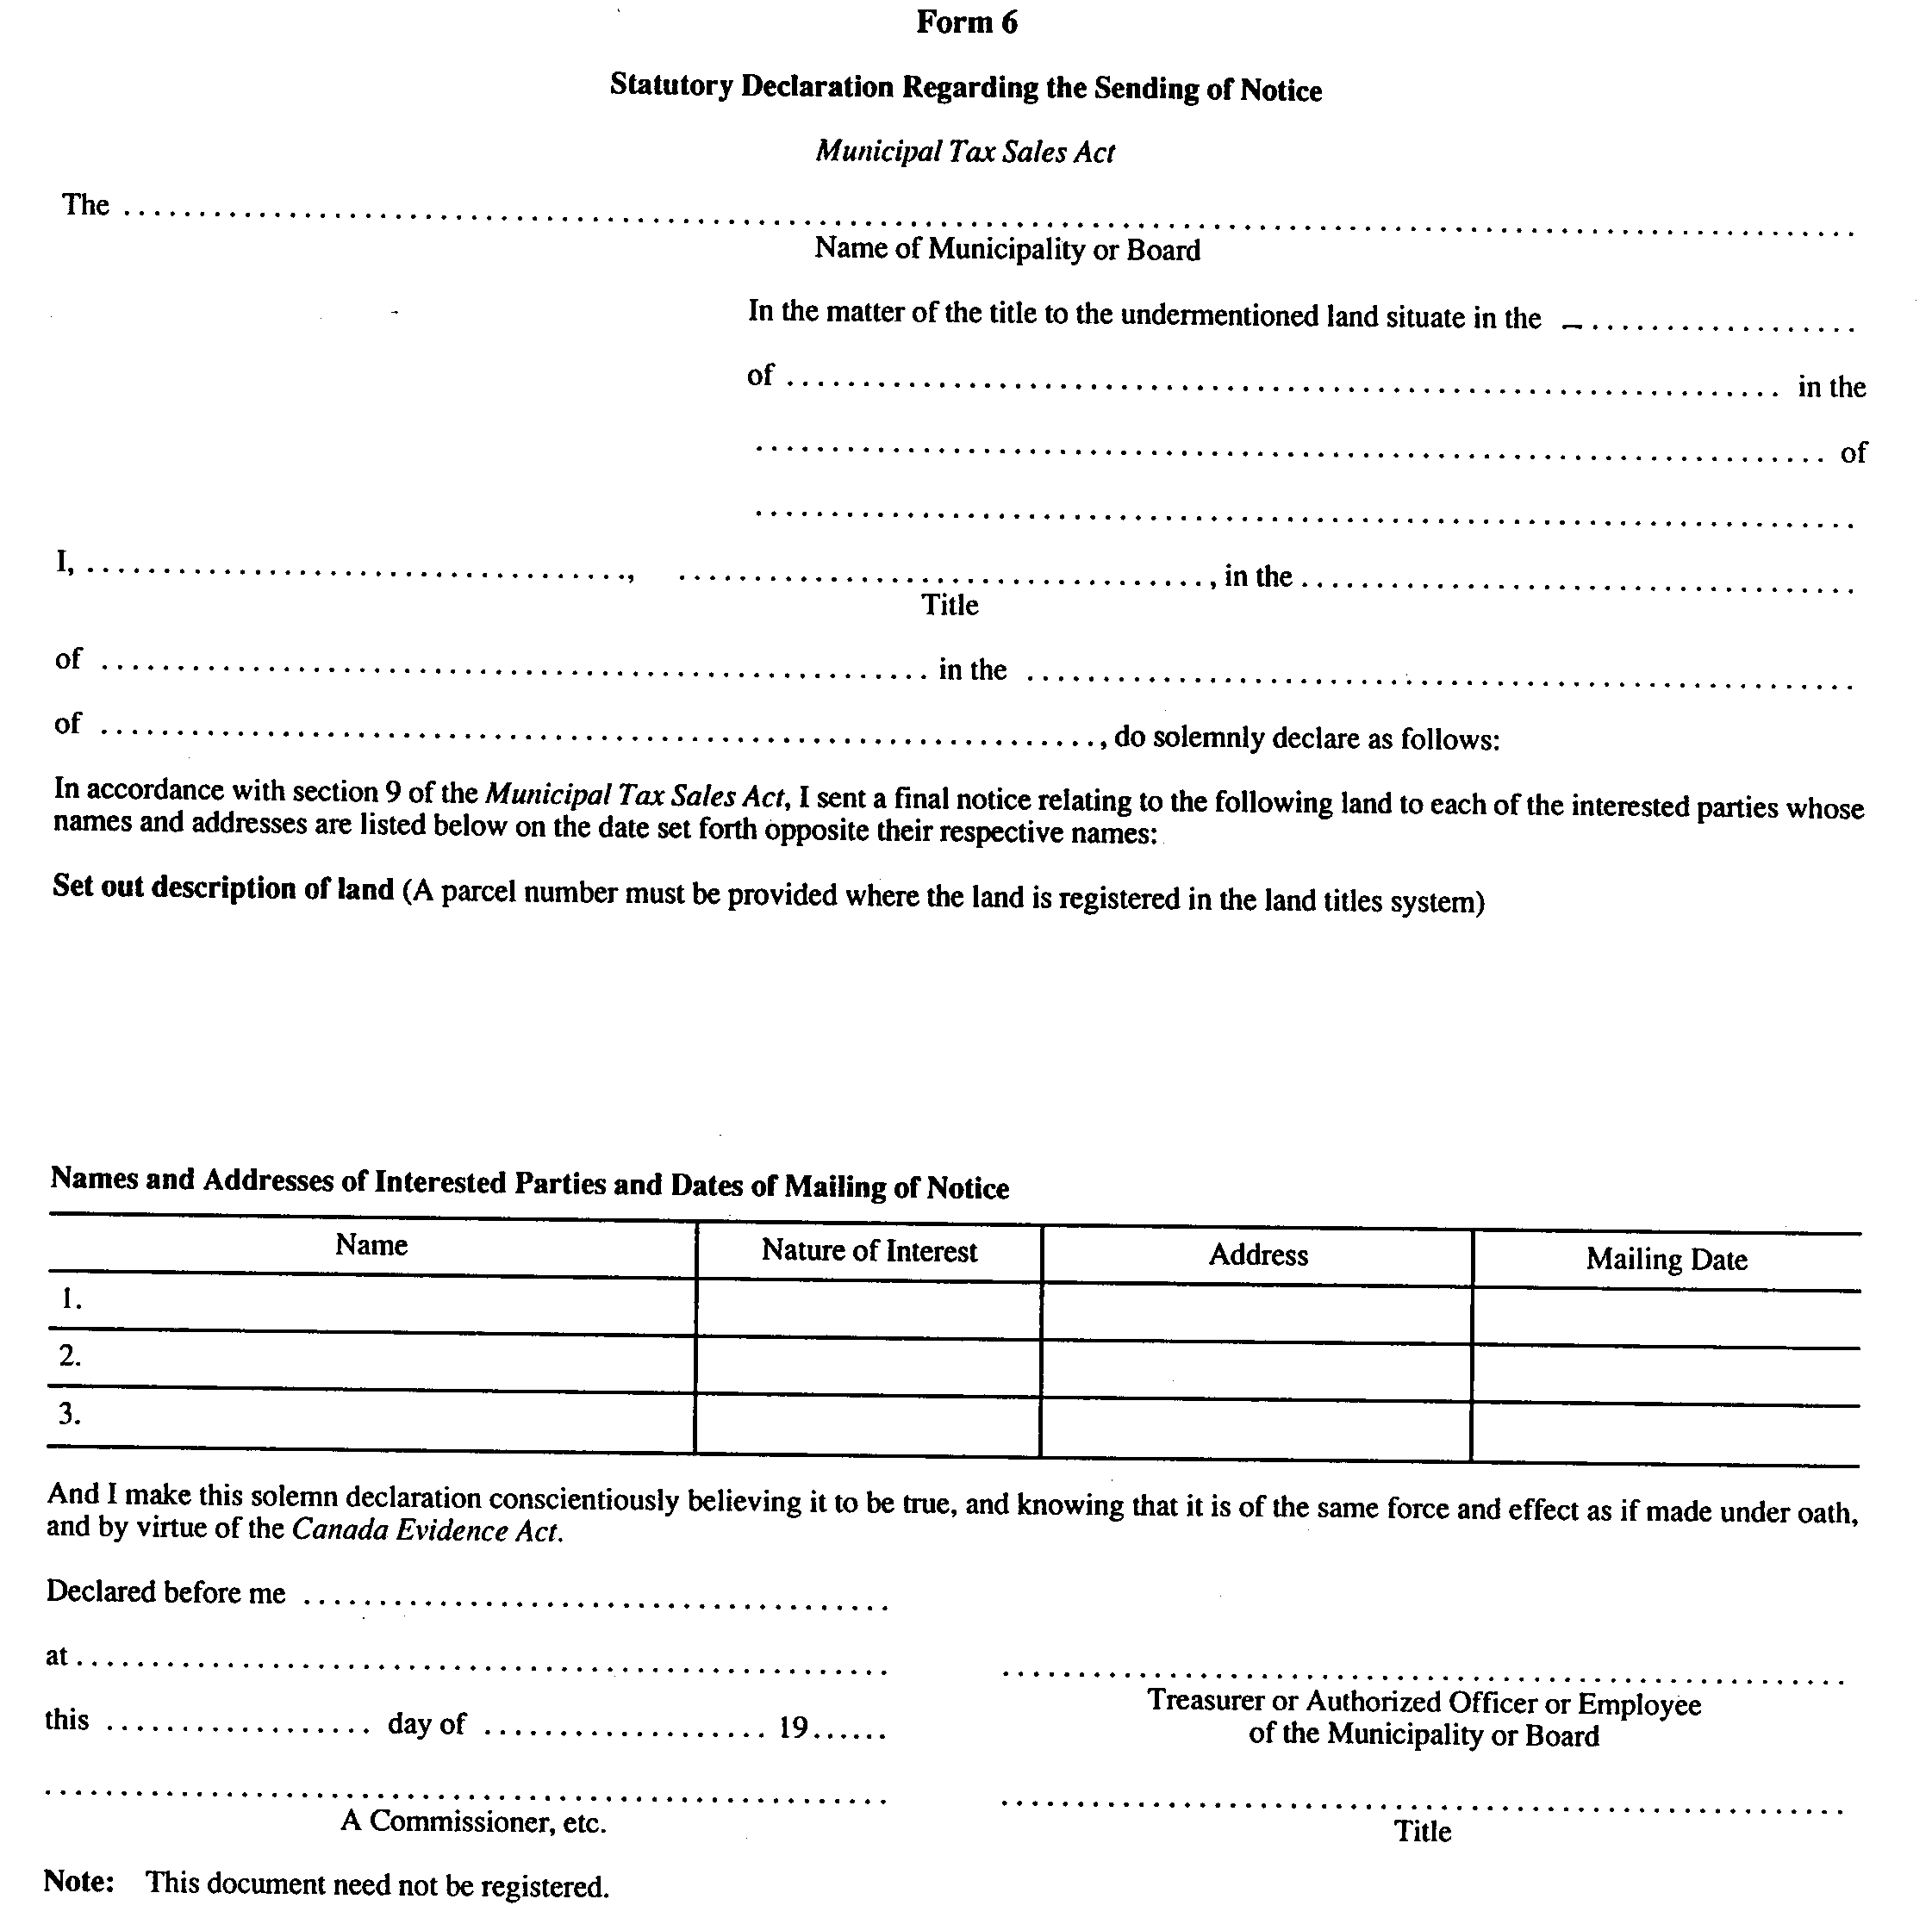
R.R.O. 1990, Reg. 824, Form 6.
Form 7
Municipal Act, 2001
SALE OF LAND BY PUBLIC TENDER
Insert regs\graphics\1990\824\824007ae.tif
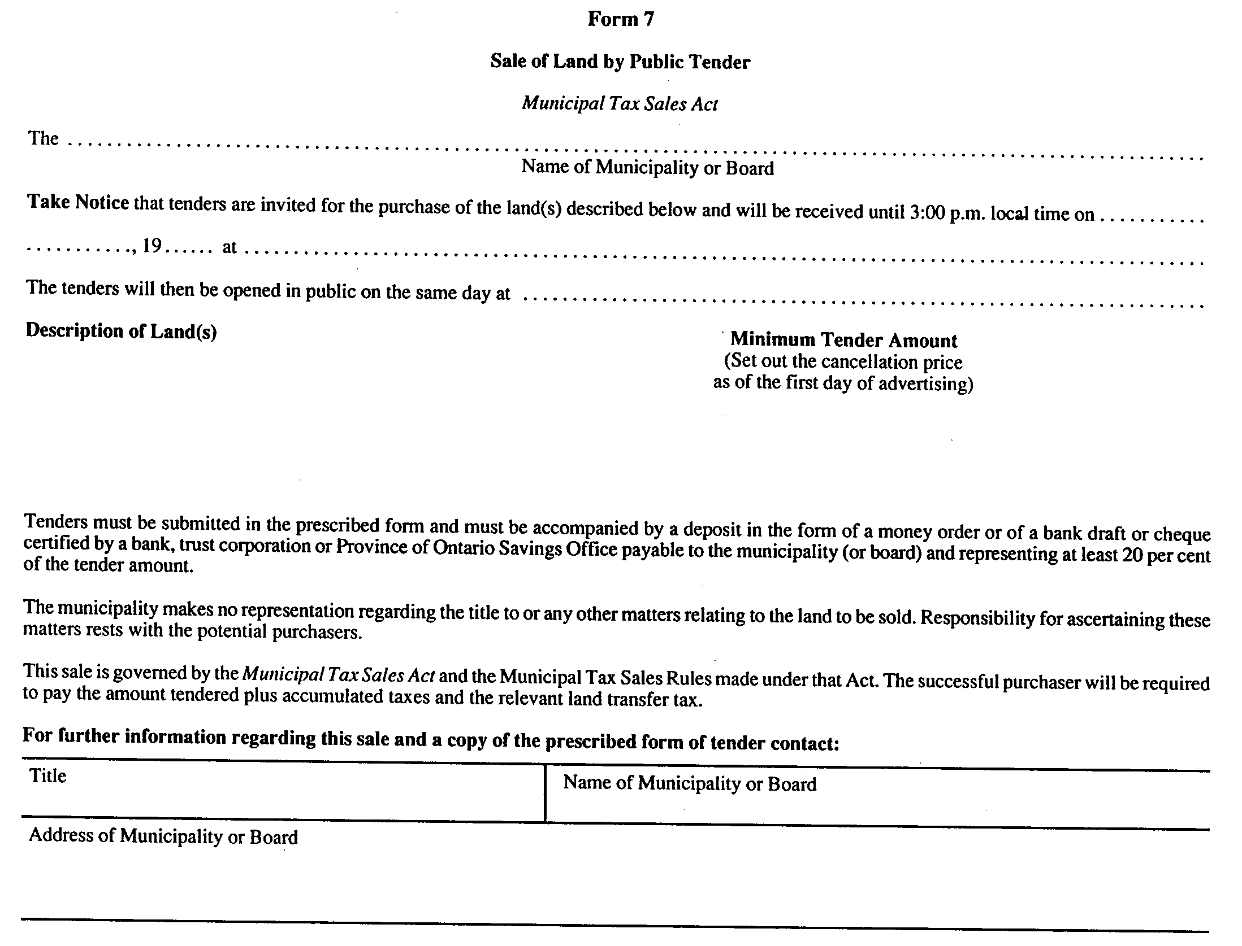
R.R.O. 1990, Reg. 824, Form 7.
Form 8
Municipal Act, 2001
TENDER TO PURCHASE
Insert regs\graphics\1990\824\824008ae.tif
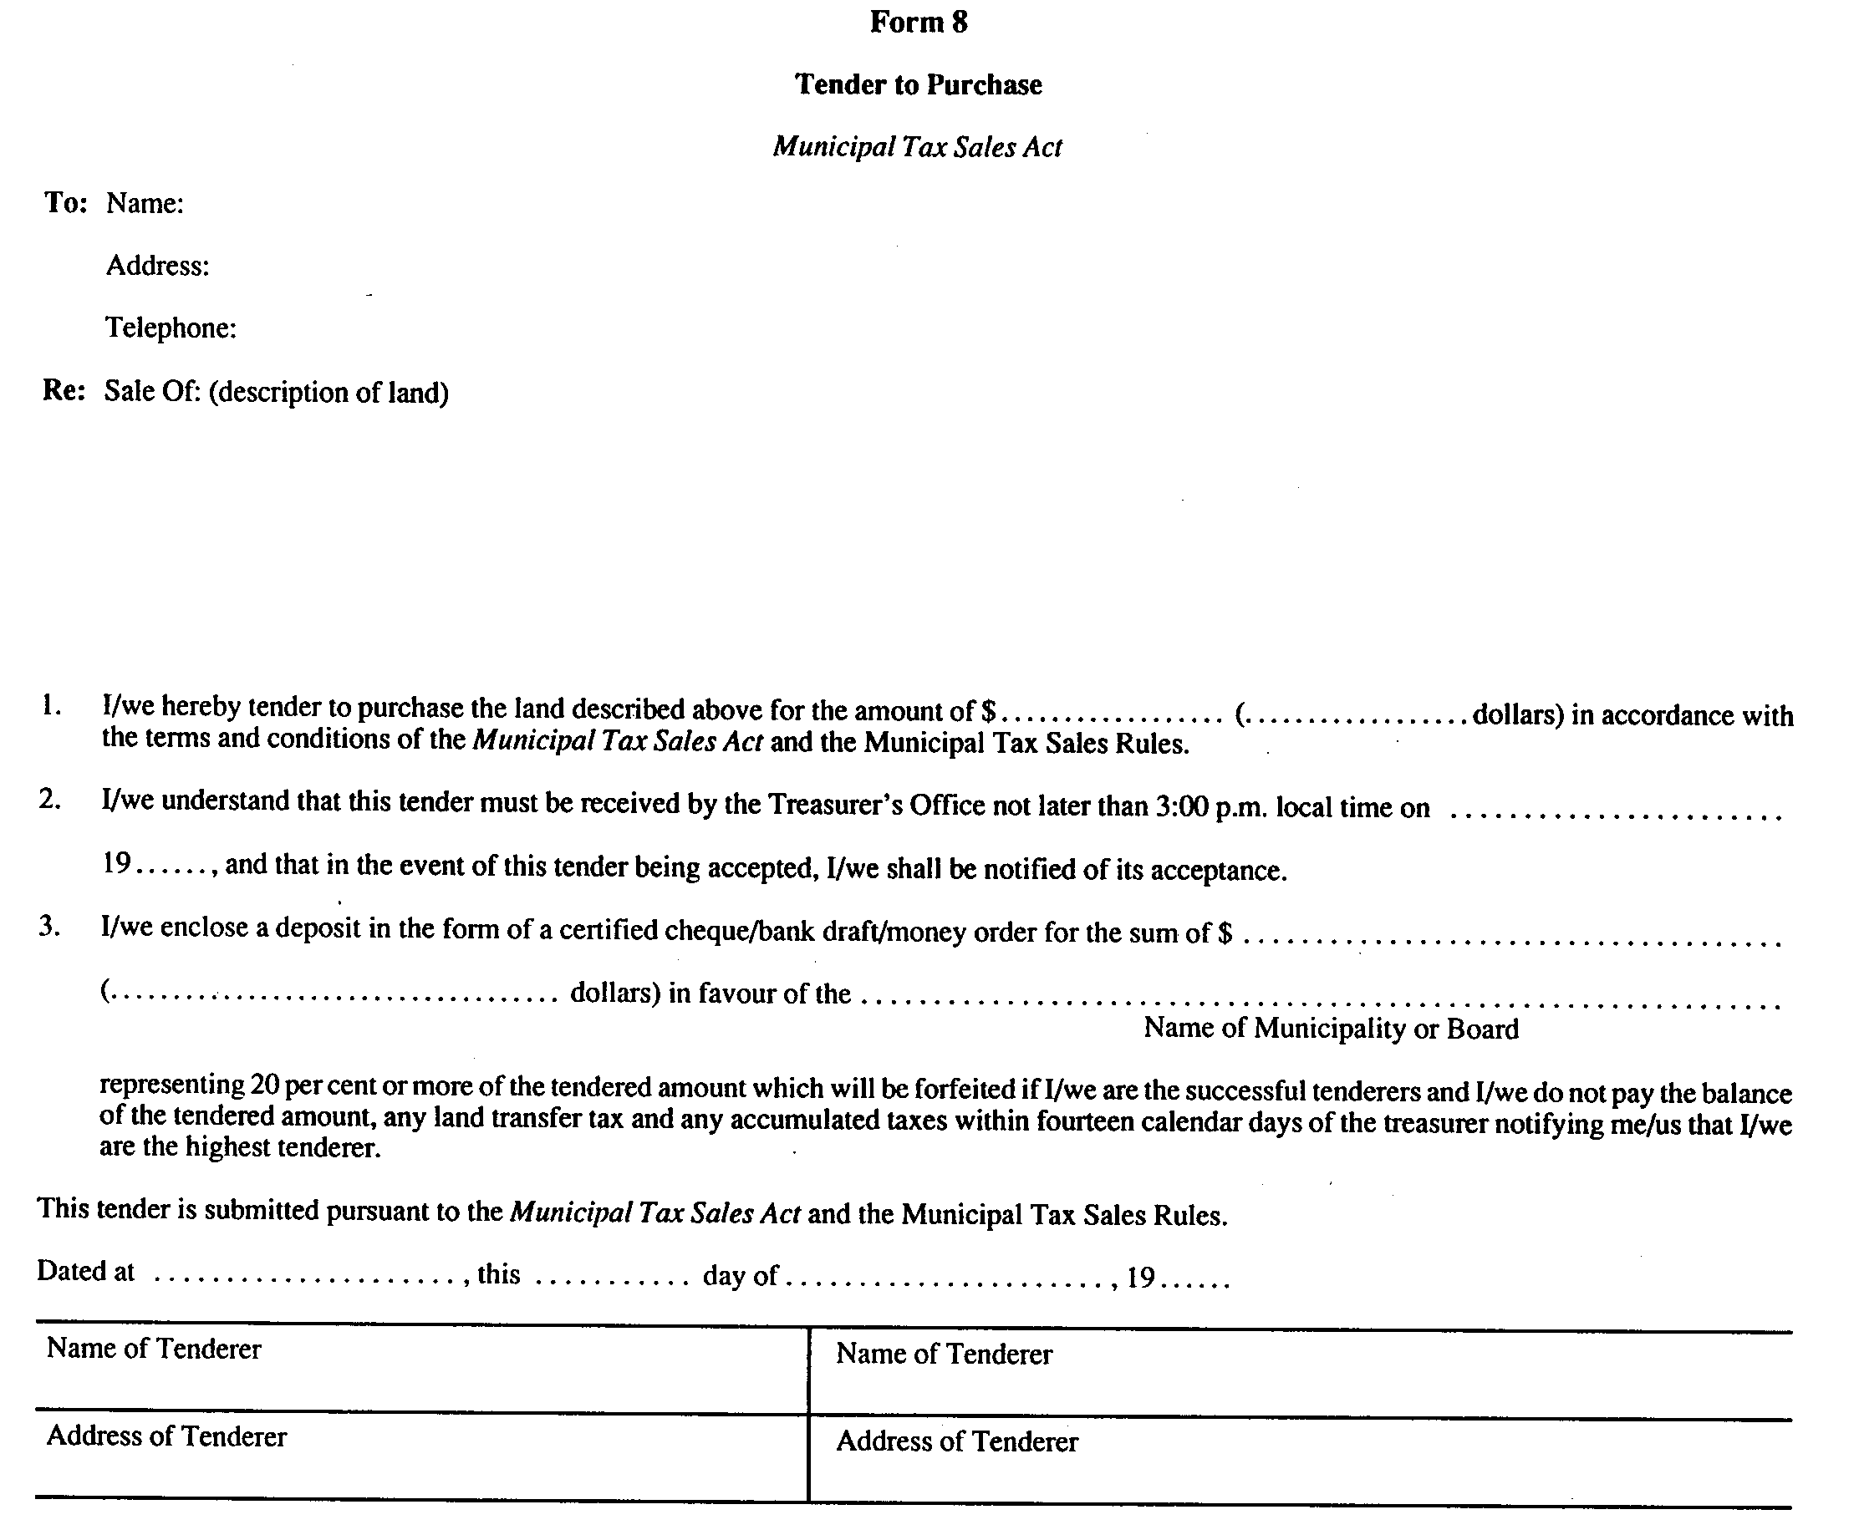
R.R.O. 1990, Reg. 824, Form 8.
Form 9
Municipal Act, 2001
SALE OF LAND BY PUBLIC AUCTION
Insert regs\graphics\1990\824\824009ae.tif
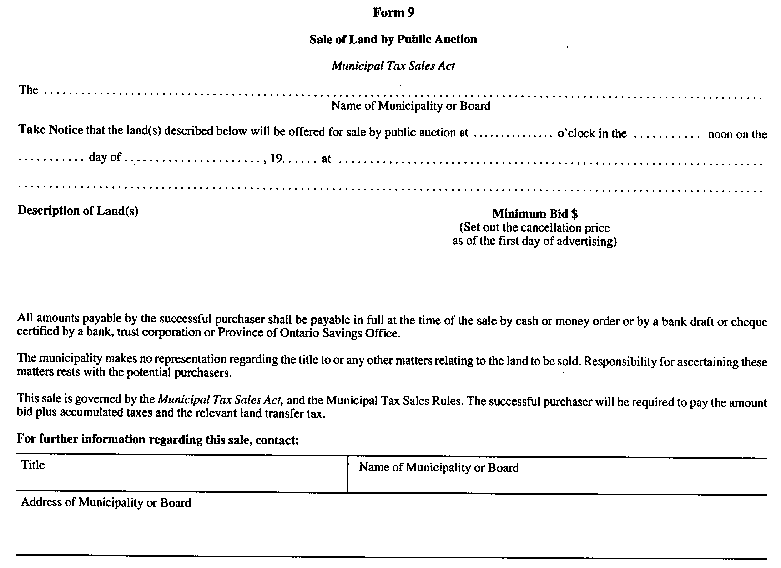
R.R.O. 1990, Reg. 824, Form 9.
Form 10
Municipal Act, 2001
TRANSFER/DEED OF LAND
Insert regs\graphics\1990\824\824010ae.tif
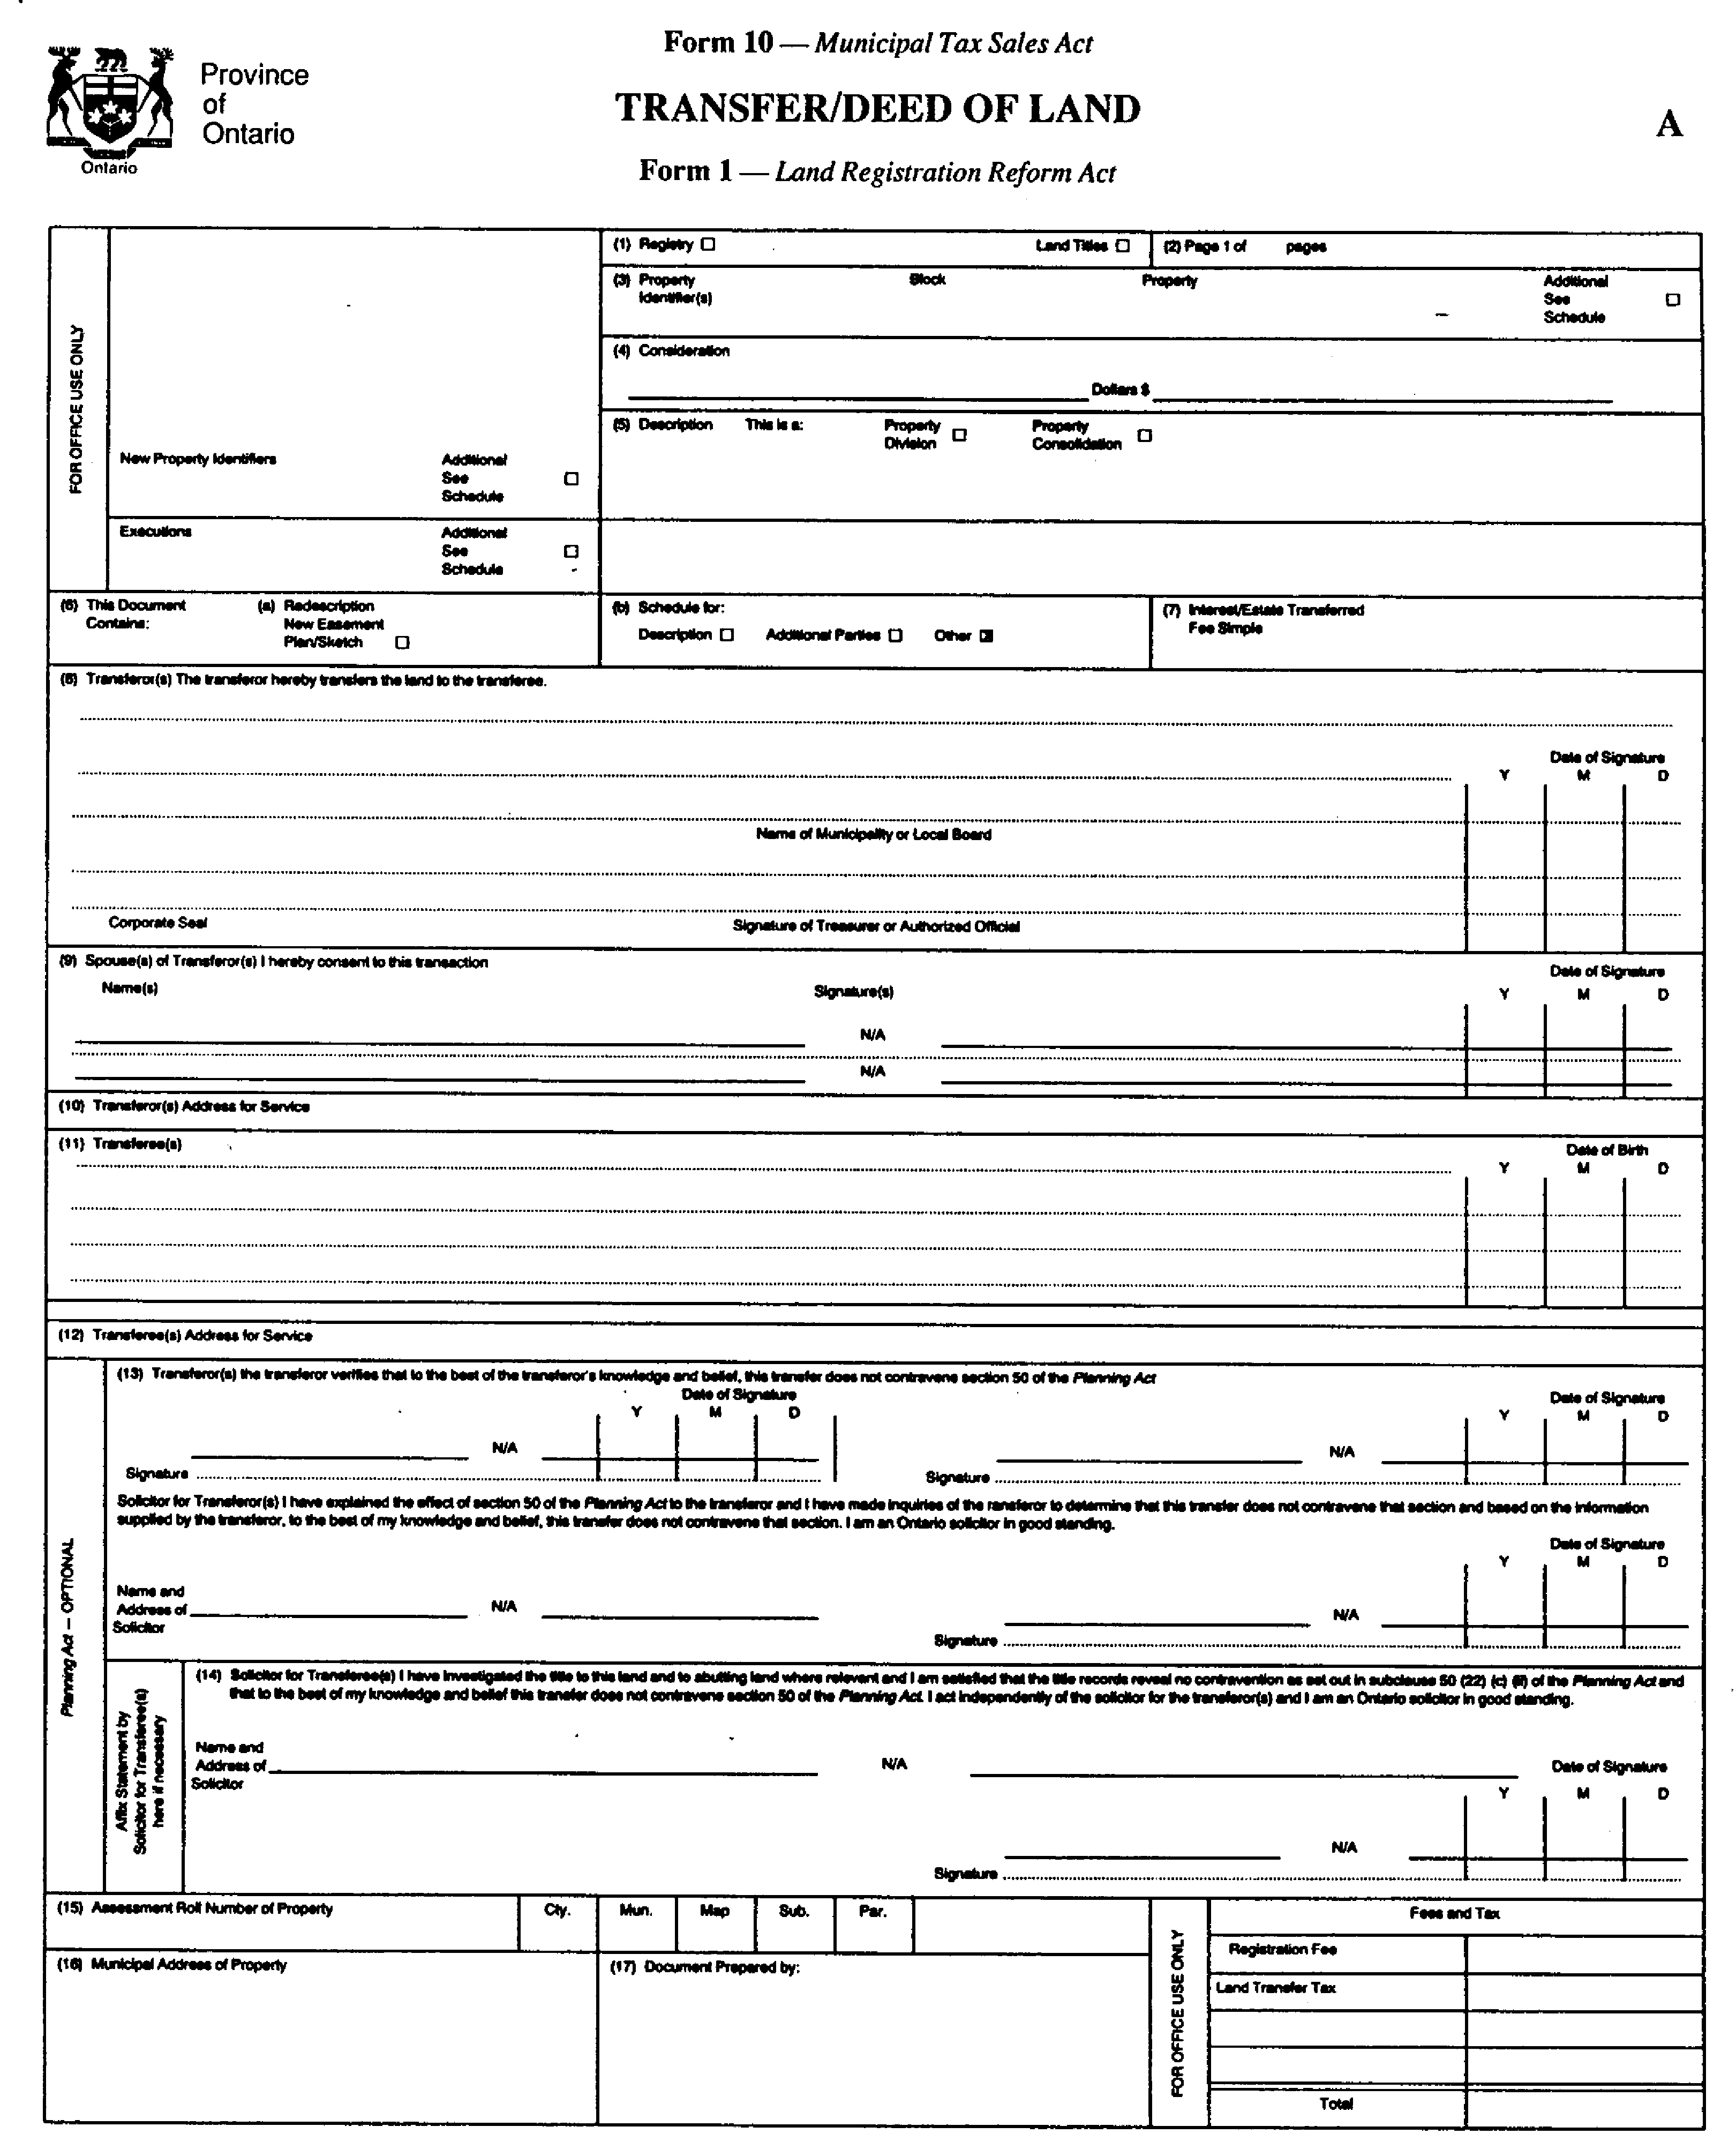
Insert regs\graphics\1990\824\824010be.tif
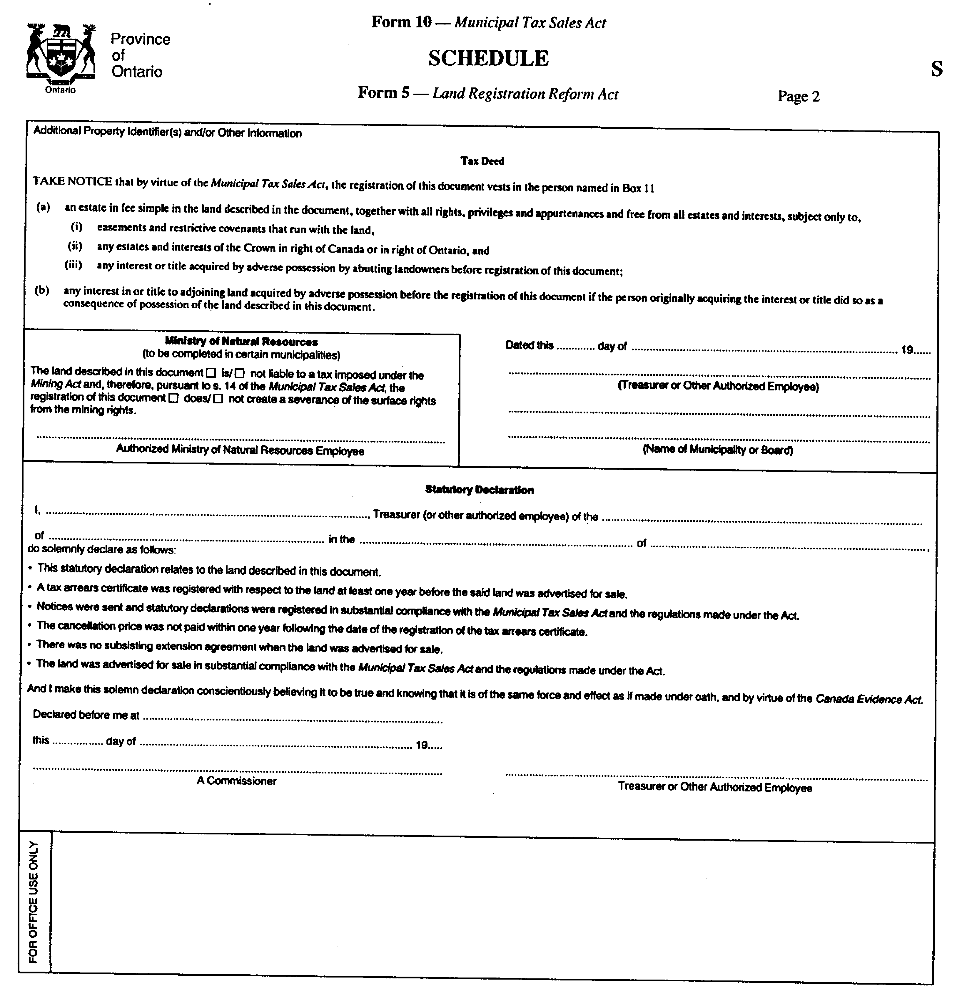
R.R.O. 1990, Reg. 824, Form 10.
Form 11
Municipal Act, 2001
DOCUMENT GENERAL
Insert regs\graphics\1990\824\824011ae.tif
Insert regs\graphics\1990\824\824011be.tif
R.R.O. 1990, Reg. 824, Form 11.
Form 12
Municipal Act, 2001
PAYMENT INTO COURT—STATEMENT OF FACTS
Insert regs\graphics\1990\824\824012ae.tif
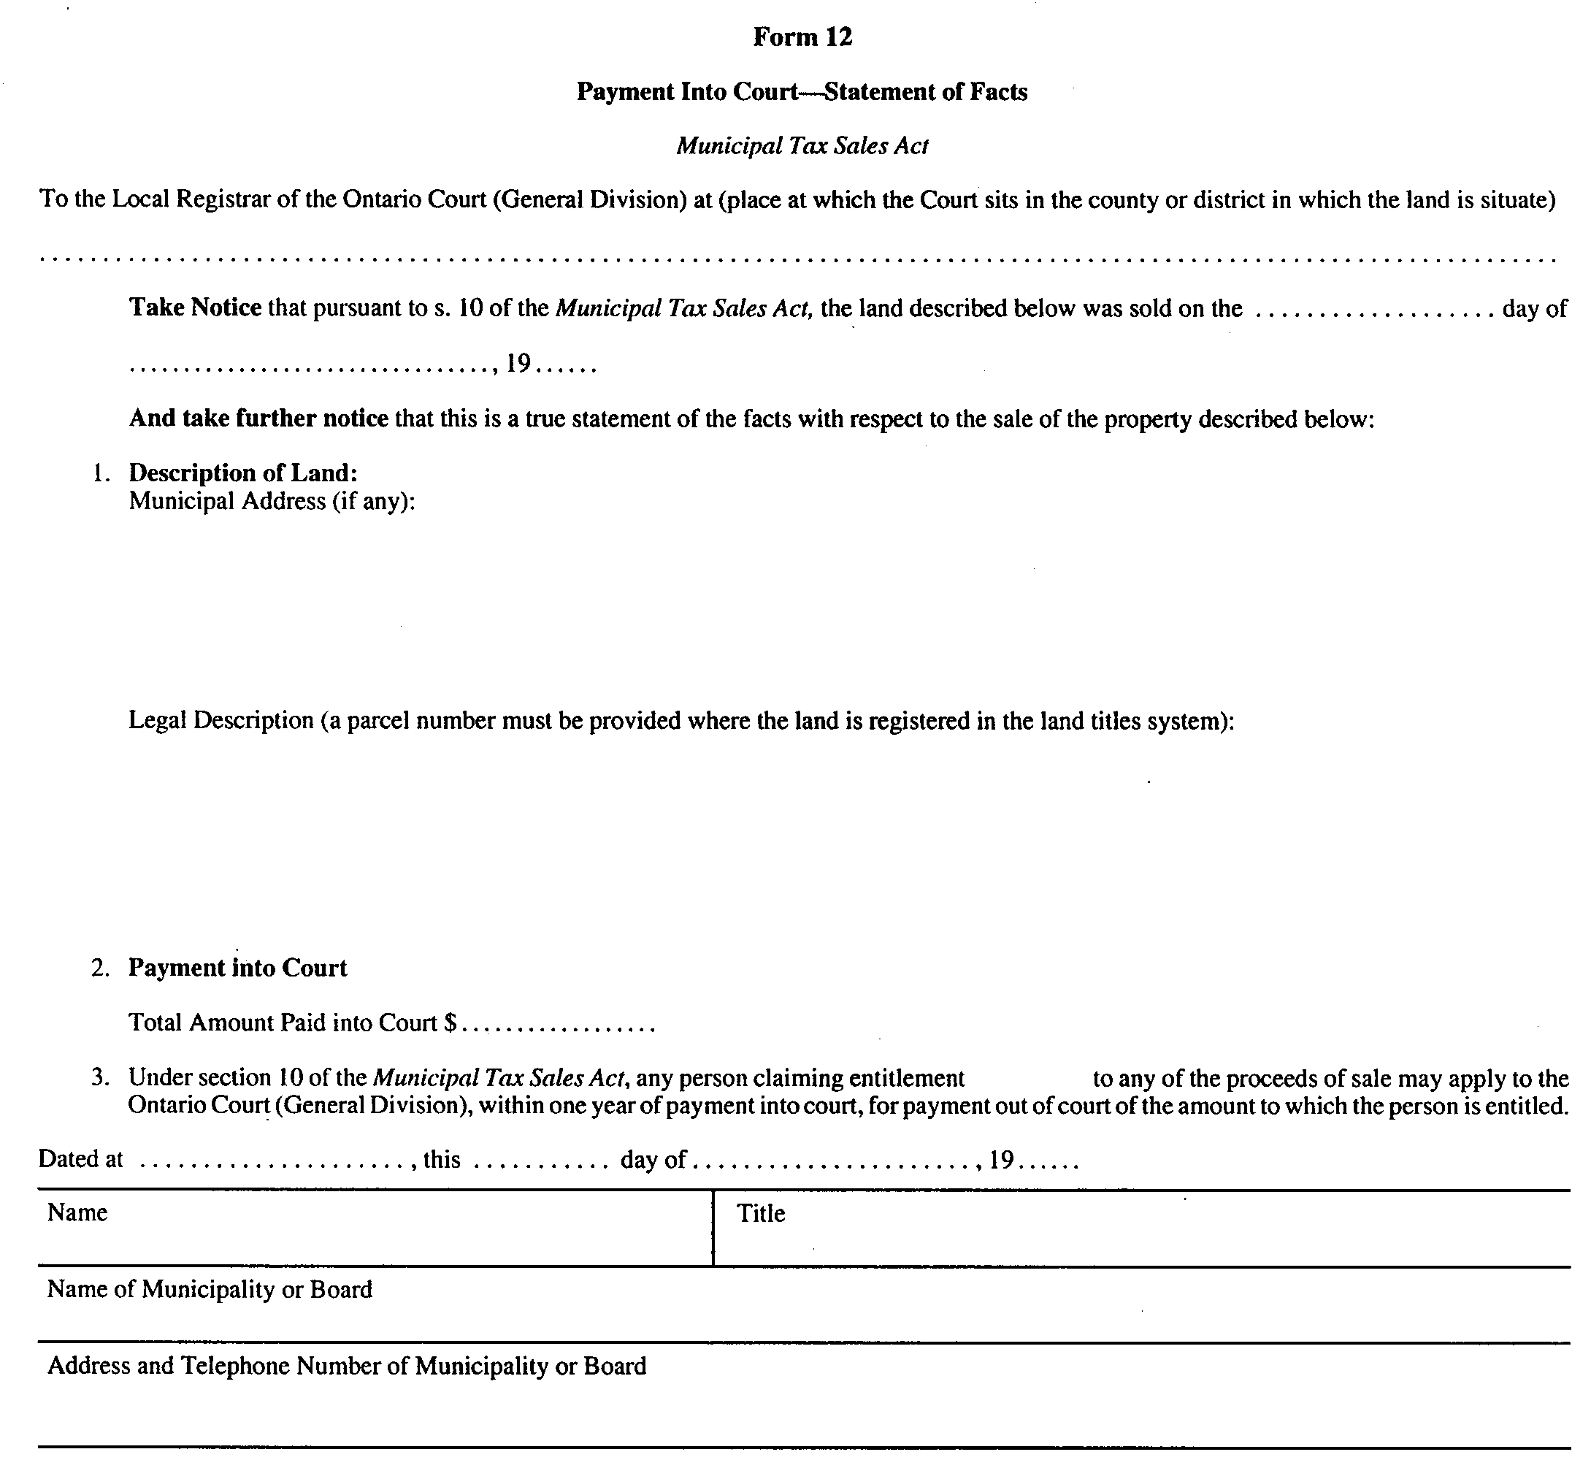
R.R.O. 1990, Reg. 824, Form 12.
Form 13
Municipal Act, 2001
DOCUMENT GENERAL
Insert regs\graphics\1990\824\824013ae.tif
R.R.O. 1990, Reg. 824, Form 13.

Français

Back to top

