Français
Personal Property Security Act
R.R.O. 1990, REGULATION 912
GENERAL
Note: This Regulation was revoked on August 1, 2007. See: O. Reg. 56/07, ss. 3, 4.
Last amendment: O. Reg. 56/07.
This is the English version of a bilingual regulation.
Definitions
1. In this Regulation,
“address” includes the postal code or the equivalent thereof, if any; (“adresse”)
“artificial body” includes a partnership, corporation, association, organization, estate of a deceased natural person, trade union, church or other religious organization, syndicate, joint venture, trust or trustee in bankruptcy; (“entité artificielle”)
“authorized signature of assignor” means the name of the assignor, typed, machine printed or stamped together with,
(a) the signature of the assignor, or
(b) the signature of a person with actual, implied or apparent authority to sign on behalf of the assignor, together with the typed, machine printed or stamped name of the person; (“signature autorisée du cédant”)
“authorized signature of the secured party” means the name of the secured party, typed, machine printed or stamped together with,
(a) the signature of the secured party, or
(b) the signature of a person with actual, implied or apparent authority to sign on behalf of the secured party, together with the typed, machine printed or stamped name of the person; (“signature autorisée du créancier garanti”)
“maturity date” or “date of maturity” means the date, excluding days of grace, on which the debt will be fully paid if every payment is made according to the original terms of the security agreement; (“date d’échéance”)
“motor vehicle” means an automobile, motorcycle, motorized snow vehicle and any other vehicle that is self-propelled but does not include,
(a) a street car or other vehicle running only upon rails,
(b) a farm tractor,
(c) an implement of husbandry,
(d) a machine acquired for use or used as a road-building machine, or
(e) a craft intended primarily for use in the air or in or upon the water; (“véhicule automobile”)
“person” means an artificial body or a natural person; (“personne”)
“principal amount” means the amount that is secured or is intended to be secured under the original terms of the security agreement and may include interest, precalculated interest, carrying charges, insurance premiums or any other cost or charge; (“montant principal”)
“registering agent” means a person who acts as an agent for a secured party or assignor when submitting a statement for registration but does not include a clerk or other employee of the secured party or assignor; (“agent d’enregistrement”)
“specific page of registration” means, in respect of a single page registration, the financing statement or financing change statement that is registered and, in respect of a multiple page registration, one of the financing statements or financing change statements that is registered and that comprises a page of the multiple page registration or a motor vehicle schedule that is attached to a statement and that comprises a page of the multiple page registration; (“page précise d’un enregistrement”)
“vehicle identification number” means the number that the person who constructed the motor vehicle affixed to it for identification purposes. (“numéro d’identification du véhicule”) R.R.O. 1990, Reg. 912, s. 1.
Form of Statement and When Required
2. If the Act requires a financing statement or a financing change statement in the prescribed form or format to be registered, the statement shall be the form or format provided or approved by the registrar. R.R.O. 1990, Reg. 912, s. 2; O. Reg. 76/92, s. 1.
Content of Financing Statement
3. (1) A financing statement shall set out in the appropriate place according to the information being entered,
(a) a “P” to indicate that a registration is being made under the Act;
(b) the number of years for the registration period;
(c) the information required under section 16 and, if the person is a natural person, the date of birth of the person;
(d) the address of the debtor;
(e) the name and address of the secured party;
(f) the classification of the collateral as consumer goods, inventory, equipment, accounts or that the classification is other than consumer goods, inventory, equipment or accounts or any combination thereof;
(g) if a motor vehicle is included in the collateral, an indication that it is included;
(h) if a motor vehicle schedule is attached, an indication that it is attached;
(i) if all the collateral is classified as consumer goods, the principal amount;
(j) if all the collateral is classified as consumer goods, the maturity date or, if there is no fixed date of maturity, an indication that there is no fixed maturity date; and
(k) the authorized signature of the secured party. R.R.O. 1990, Reg. 912, s. 3 (1).
(2) If there is more than one secured party, the name, address and authorized signature of at least one secured party shall be set out in the appropriate place on the financing statement. R.R.O. 1990, Reg. 912, s. 3 (2).
(3) If a security interest is assigned, the name, address and authorized signature of the assignor may be set out instead of the name, address and authorized signature of the secured party. R.R.O. 1990, Reg. 912, s. 3 (3).
(4) The registration period of a financing statement shall be a whole number and if the collateral,
(a) includes consumer goods, the period shall be for one year up to five years, as the case requires; or
(b) does not include consumer goods, the period shall be for one year up to twenty-five years or for a perpetual period, as the case requires. R.R.O. 1990, Reg. 912, s. 3 (4).
(5) A financing statement may set out in the appropriate place according to the information being entered,
(a) the name and address of the registering agent, if any; and
(b) the Ontario corporation number, if the debtor is a corporation incorporated in Ontario. R.R.O. 1990, Reg. 912, s. 3 (5).
(6) If a registration period of a financing statement is a perpetual period, the period shall be designated on the financing statement by the number “99”. R.R.O. 1990, Reg. 912, s. 3 (6).
(7) If the collateral includes a motor vehicle and the motor vehicle is classified as consumer goods, the motor vehicle shall be described on line 11 or 12 on the financing statement or in the appropriate place on a motor vehicle schedule. R.R.O. 1990, Reg. 912, s. 3 (7).
(8) If the collateral includes a motor vehicle and the motor vehicle is not classified as consumer goods, the motor vehicle may be described on line 11 or 12 on the financing statement or in the appropriate place on a motor vehicle schedule. R.R.O. 1990, Reg. 912, s. 3 (8).
(9) The description of the motor vehicle on line 11 or 12 or on a motor vehicle schedule shall include the vehicle identification number, the four digits of the model year, if any, the model, if any, and the make or the name of the manufacturer. O. Reg. 637/98, s. 1.
(10) If lines 11 and 12 are completed, additional motor vehicles may be described in the appropriate place on a motor vehicle schedule. R.R.O. 1990, Reg. 912, s. 3 (10).
(11) Collateral other than a motor vehicle that is consumer goods may be described on line 13, 14 or 15 of the financing statement. R.R.O. 1990, Reg. 912, s. 3 (11).
(12) The description of a motor vehicle on line 13, 14 or 15 of a financing statement shall not include the vehicle identification number. R.R.O. 1990, Reg. 912, s. 3 (12).
(13) If the collateral includes goods other than inventory that are used or acquired for use for more than one purpose, the financing statement shall set out the classification of the goods in accordance with clause (1) (f) based on their primary use and may set out an additional classification based on any secondary use. R.R.O. 1990, Reg. 912, s. 3 (13).
Collateral Brought into Ontario
4. A financing statement that is tendered for registration with respect to the following matters shall be designated as a caution filing and shall set out the information required by section 3 except that the date of birth of a natural person need not be set out:
1. Collateral that is intended to be brought into Ontario and that is subject to a security interest in another jurisdiction.
2. Collateral that is brought into Ontario and that is subject to a security interest in another jurisdiction at the time that it is brought into Ontario.
3. Goods that are brought into Ontario and that are subject to the seller’s right to revendicate or to resume possession of the goods. R.R.O. 1990, Reg. 912, s. 4.
Renewal of a Registration
5. (1) If a registration period is extended, the financing change statement referred to in subsection 52 (1) of the Act shall be designated as a renewal and shall set out,
(a) the information required under section 19; and
(b) the number of years by which the registration period is extended. R.R.O. 1990, Reg. 912, s. 5 (1).
(2) The extension of a registration period shall be a whole number and, if the collateral,
(a) includes consumer goods, subject to subsection 51 (6) of the Act, the period shall be extended for one year up to five years, as the case requires; or
(b) does not include consumer goods, the period shall be extended for one year up to twenty-five years or for a perpetual period, as the case requires. R.R.O. 1990, Reg. 912, s. 5 (2).
(3) If the registration period is extended for a perpetual period, the period shall be designated on the financing change statement by the number “99”. R.R.O. 1990, Reg. 912, s. 5 (3).
Registration of a Financing Statement under Subsection 52 (2) of the Act
6. (1) Subject to subsection (2), if a registration ceases to be effective, the financing statement referred to in subsection 52 (2) of the Act shall set out the information required under section 3. R.R.O. 1990, Reg. 912, s. 6 (1).
(2) If the secured party’s name was changed or the secured party assigned its interest in all of the collateral since the original financing statement was registered, the financing statement referred to in subsection 52 (2) of the Act shall set out the new name of the secured party or the assignee’s name, as the case requires. R.R.O. 1990, Reg. 912, s. 6 (2).
Assignment by Secured Party
7. (1) If the assignment by a secured party of the secured party’s interest in all or part of the collateral is recorded, the financing change statement referred to in subsection 47 (1) of the Act shall be designated as an assignment by the secured party or assignment of a security interest in part of the collateral by the secured party and shall set out,
(a) the information required by section 19;
(b) the name of the assignor as set out on the financing statement or a financing change statement that relates to the financing statement;
(c) the name and address of the assignee; and
(d) despite clause 19 (h), the authorized signature of the assignor or the authorized signature of the secured party. R.R.O. 1990, Reg. 912, s. 7 (1).
(2) If there is an assignment of the secured party’s interest in part of the collateral and the collateral to which the assignment relates includes a motor vehicle and the motor vehicle is,
(a) classified as consumer goods; or
(b) classified as equipment or inventory and is described on line 11 or 12 of the financing statement or a related financing change statement or on a motor vehicle schedule attached to a statement,
the motor vehicle shall be described on line 11 or 12 of the financing change statement or on a motor vehicle schedule. R.R.O. 1990, Reg. 912, s. 7 (2).
(3) If the collateral includes a motor vehicle and the motor vehicle is not classified as set out in clause (2) (a) or classified and described as set out in clause (2) (b), the motor vehicle may be described on line 11 or 12 of the financing change statement or on a motor vehicle schedule. R.R.O. 1990, Reg. 912, s. 7 (3).
(4) The description of the motor vehicle on line 11 or 12 of the financing change statement or on a motor vehicle schedule shall include the vehicle identification number, the four digits of the model year, if any, the model, if any, and the make or the name of the manufacturer. O. Reg. 637/98, s. 2.
(5) If lines 11 and 12 of the financing change statement are completed, additional motor vehicles may be described in the appropriate place on the motor vehicle schedule. R.R.O. 1990, Reg. 912, s. 7 (5).
(6) If an assignment of a security interest in part of the collateral relates to collateral that is not described as required in subsection (2), the collateral may be described on line 13, 14 or 15 of the financing change statement. R.R.O. 1990, Reg. 912, s. 7 (6).
(7) The description of a motor vehicle on line 13, 14 or 15 of a financing change statement shall not include the vehicle identification number. R.R.O. 1990, Reg. 912, s. 7 (7).
Transfer of Collateral
8. (1) If the transfer by a debtor of the debtor’s interest in all or part of the collateral is recorded, the financing change statement referred to in section 48 of the Act shall be designated as a transfer by the debtor or transfer of part of the collateral by the debtor and shall set out,
(a) the information required by section 19;
(b) despite clause 19 (d), the name of the transferor as the name is set out on the financing statement or a financing change statement that relates to the financing statement;
(c) the name of the transferee in the manner prescribed under section 16;
(d) if the transferee is a natural person, the date of birth of the person if known to the secured party; and
(e) the address of the transferee if known to the secured party. R.R.O. 1990, Reg. 912, s. 8 (1).
(2) If there is a transfer of part of the collateral by a debtor and the transferred collateral includes a motor vehicle and the motor vehicle is,
(a) classified as consumer goods; or
(b) classified as equipment or inventory and is described on line 11 or 12 of the financing statement or a related financing change statement or on a motor vehicle schedule attached to a statement,
the motor vehicle shall be described on line 11 or 12 of the financing change statement or on a motor vehicle schedule. R.R.O. 1990, Reg. 912, s. 8 (2).
(3) If a transfer of part of the collateral includes a motor vehicle and the motor vehicle is not classified as set out in clause (2) (a) or classified and described as set out in clause (2) (b), the motor vehicle may be described on line 11 or 12 of the financing change statement or on a motor vehicle schedule. R.R.O. 1990, Reg. 912, s. 8 (3).
(4) The description of the motor vehicle on line 11 or 12 of the financing change statement or on a motor vehicle schedule shall include the vehicle identification number, the four digits of the model year, if any, the model, if any, and the make or the name of the manufacturer. O. Reg. 637/98, s. 3.
(5) If lines 11 and 12 of the financing change statement are completed, additional motor vehicles may be described in the appropriate place on the motor vehicle schedule. R.R.O. 1990, Reg. 912, s. 8 (5).
(6) If a transfer of part of the collateral relates to collateral that is not described as required in subsection (2), the collateral may be described on line 13, 14 or 15 of the financing change statement. R.R.O. 1990, Reg. 912, s. 8 (6).
(7) The description of a motor vehicle on line 13, 14 or 15 of a financing change statement shall not include the vehicle identification number. R.R.O. 1990, Reg. 912, s. 8 (7).
Debtor Name Change
9. If the change of a debtor name is recorded, the financing change statement referred to in section 48 of the Act shall be designated as an amendment and shall set out the information required under clause 15 (c). R.R.O. 1990, Reg. 912, s. 9.
Registration of a Discharge
10. If the discharge of a registration is recorded, the financing change statement referred to in section 55 of the Act shall be designated as a discharge and shall set out the information required under section 19. R.R.O. 1990, Reg. 912, s. 10.
Registration of a Partial Discharge
11. (1) If the partial discharge of a registration is recorded, the financing change statement referred to in section 55 of the Act shall be designated as a partial discharge and shall set out the information required under section 19. R.R.O. 1990, Reg. 912, s. 11 (1).
(2) If the partial discharge relates to collateral that includes a motor vehicle and the motor vehicle is,
(a) classified as consumer goods; or
(b) classified as equipment or inventory and is described on line 11 or 12 of the financing statement or a related financing change statement or on a motor vehicle schedule attached to a statement,
the motor vehicle shall be described on line 11 or 12 of the financing change statement or on a motor vehicle schedule. R.R.O. 1990, Reg. 912, s. 11 (2).
(3) If the partial discharge includes a motor vehicle and the motor vehicle is not classified as set out in clause (2) (a) or classified and described as set out in clause (2) (b), the motor vehicle may be described on line 11 or 12 of the financing change statement or on a motor vehicle schedule. R.R.O. 1990, Reg. 912, s. 11 (3).
(4) The description of the motor vehicle on line 11 or 12 of the financing change statement or on a motor vehicle schedule shall include the vehicle identification number, the four digits of the model year, if any, the model, if any, and the make or the name of the manufacturer. O. Reg. 637/98, s. 4.
(5) If lines 11 and 12 of the financing change statement are completed, additional motor vehicles may be described in the appropriate place on the motor vehicle schedule. R.R.O. 1990, Reg. 912, s. 11 (5).
(6) Collateral other than collateral described as required in subsection (2) may be described on line 13, 14 or 15 of the financing change statement. R.R.O. 1990, Reg. 912, s. 11 (6).
(7) The description of a motor vehicle on line 13, 14 or 15 of a financing change statement shall not include the vehicle identification number. R.R.O. 1990, Reg. 912, s. 11 (7).
Other Change (Subordination)
12. If the subordination of the interest of a secured party of record is recorded, the financing change statement referred to in section 50 of the Act shall be designated as an other change, and shall set out,
(a) the information required under section 19; and
(b) the type of change as a subordination and the particulars of the subordination on line 25, 26, 27 or 28. R.R.O. 1990, Reg. 912, s. 12; O. Reg. 76/92, s. 2.
Other Change (Seizure)
13. If the seizure of a security interest by a sheriff is recorded, the financing change statement referred to in section 27 of the Execution Act shall be designated as an other change and shall set out,
(a) the information required under section 19;
(b) the type of change as a seizure of a security interest and the particulars of the seizure on line 25, 26, 27 or 28; and
(c) Revoked: O. Reg. 76/92, s. 3.
(d) despite clause 19 (h), the signature of the sheriff. R.R.O. 1990, Reg. 912, s. 13; O. Reg. 76/92, s. 3.
Amendments to Information
14. (1) A financing change statement referred to in section 49 of the Act shall be designated as an amendment and shall set out,
(a) if the statement being amended was registered prior to the coming into force of this Regulation or under section 82 of the Act, the registration number of the statement or the file number assigned by the registrar to the financing statement;
(b) if the statement being amended was registered under Part IV of the Act, the file number assigned by the registrar to the financing statement;
(c) if the statement relates to a registration that was entered in the central file of the registration system by the registrar under section 78 of the Act, the registration number under the Corporation Securities Registration Act, being chapter 94 of the Revised Statutes of Ontario, 1980, or the file number assigned by the registrar to the registration;
(d) if a motor vehicle schedule is attached, an indication that it is attached;
(e) the information required under section 15;
(f) the name and address of one of the secured parties or of the registering agent, if any;
(g) a brief statement of the reasons for the amendment; and
(h) the authorized signature of the secured party. R.R.O. 1990, Reg. 912, s. 14 (1).
(2) This section and section 15 apply to an amendment to a motor vehicle schedule that is a page of a financing statement or a financing change statement. R.R.O. 1990, Reg. 912, s. 14 (2).
15. The financing change statement referred to in section 14 shall set out,
(a) if the amendment indicates that the financing statement should or should not have been designated as a caution filing,
(i) the name of one of the debtors as the name is set out on the financing statement,
(ii) an indication in the reasons for amendment that the financing statement should or should not have been designated as a caution filing, and
(iii) the information required under section 14;
(b) if the amendment deletes a line of information on a financing statement or financing change statement,
(i) the name of one of the debtors as the name is set out on the statement,
(ii) an indication in the reasons for amendment what information is being deleted, and
(iii) the information required under section 14;
(c) if the amendment substitutes a line of information for a line of information on a financing statement or financing change statement,
(i) the name of one of the debtors as the name is set out on the statement,
(ii) an indication in the reasons for amendment what information is being substituted,
(iii) the line of information substituted, and
(iv) the information required under section 14;
(d) if the amendment adds a line of information to a financing statement or financing change statement,
(i) the name of one of the debtors as the name is set out on the statement,
(ii) the line of information added, and
(iii) the information required under section 14;
(e) if the amendment is of a nature other than that referred to in clause (a), (b), (c) or (d),
(i) the name of one of the debtors as the name is set out on the statement,
(ii) the information, if any, added or substituted in the appropriate place, and
(iii) the information required under section 14. O. Reg. 76/92, s. 4.
Particulars of Content of Form
16. (1) The name of a debtor who is a natural person shall be set out in the financing statement to show the first given name, followed by the initial of the second given name, if any, followed by the surname. R.R.O. 1990, Reg. 912, s. 16 (1).
(2) If the first given name of the debtor exceeds nineteen characters, including punctuation marks and spaces, the first nineteen characters shall be set out in the appropriate place for the name and the complete name, including the initial of the second given name, if any, shall be set out on line 13, 14 or 15. R.R.O. 1990, Reg. 912, s. 16 (2).
(3) If the surname of a debtor exceeds twenty-two characters, including punctuation marks and spaces, the first twenty-two characters shall be set out in the appropriate place for the name and the complete name, including the initial of the second given name, if any, shall be set out on line 13, 14 or 15. R.R.O. 1990, Reg. 912, s. 16 (3).
(4) The name of a debtor that is an artificial body shall be set out in the financing statement as follows:
1. If the artificial body is a partnership and the partnership is,
i. registered under the Business Names Act, the registered name of the partnership,
ii. a limited partnership, the name of the partnership filed under the Limited Partnerships Act, or
iii. a partnership other than a partnership described in subparagraph i or ii,
A. the name of the partnership as set out in the security agreement, and
B. whether or not the person creates a security interest, the name of at least one of the partners, and if the partner is,
1. a natural person, the name in the manner required under subsection (1), or
2. an artificial body, the name in the manner required under this subsection.
2. If the artificial body is a corporation, the incorporated name of the corporation.
3. If the artificial body is an unincorporated association, organization, syndicate, joint venture or church or other religious organization,
i. the name as set out in the constitution, charter or other document creating the association, organization, syndicate, joint venture or church or other religious organization, and
ii. whether or not the person signing creates a security interest, the name of each person signing the security agreement on behalf of the association, organization, syndicate, joint venture or church or other religious organization, and if the person signing is,
A. a natural person, the name in the manner required under subsection (1), or
B. an artificial body, the name in the manner required under this subsection.
4. If the artificial body is an estate of a deceased natural person, the first given name, followed by the initial of the second given name, if any, followed by the surname of the deceased, followed by the word “estate”.
5. If the artificial body is a trade union,
i. the name of the trade union, and
ii. whether or not the natural person creates a security interest, for each natural person signing the security agreement on behalf of the trade union, the name in the manner required under subsection (1).
6. If the artificial body is a trust and the document creating the trust,
i. designates a name for the trust, that name followed by the word “trust”, or
ii. does not designate a name for the trust, whether or not the trustee creates a security interest, the name of one of the trustees, and if the trustee is,
A. a natural person, the name in the manner required under subsection (1), or
B. an artificial body, the name in the manner required under this subsection.
7. If the artificial body is an estate of a bankrupt and the bankrupt is,
i. a natural person, the first given name of the person, followed by the initial of the second given name, if any, followed by the surname, followed by the word “bankrupt”, or
ii. an artificial body, the name of the person followed by the word “bankrupt”.
8. If the artificial body is other than an artificial body described in paragraphs 1 to 7,
i. the name of the artificial body, and
ii. whether or not the person signing creates a security interest, the name of each person signing the security agreement on behalf of the artificial body, and if the person signing is,
A. a natural person, the name in the manner required under subsection (1), or
B. an artificial body, the name in the manner required under this subsection. R.R.O. 1990, Reg. 912, s. 16 (4).
(5) If a person is identified to the public by a name or style other than the person’s own name, the name may be set out in the financing statement on the appropriate line for business debtor. R.R.O. 1990, Reg. 912, s. 16 (5).
(6) The name of a person that is required to be set out on a financing statement under subsection (1) or (4) shall be set out for,
(a) a natural person, on the appropriate line for an individual debtor; or
(b) an artificial body, on the appropriate line for a business debtor. R.R.O. 1990, Reg. 912, s. 16 (6).
17. Despite paragraph 2 of subsection 16 (4), if a corporation has an English form of name and a French form of name,
(a) the English form of the name shall be set out on the appropriate line for the name of a business debtor; and
(b) the French form of the name shall be set out on another appropriate line for the name of a business debtor. R.R.O. 1990, Reg. 912, s. 17.
18. The date of birth or date of maturity in a financing statement or financing change statement shall be set out to show,
(a) the day of the month in numerals;
(b) the name of the month in accordance with the abbreviation or word set out in Column 2 of Schedule 3; and
(c) the four digits of the number of the year. R.R.O. 1990, Reg. 912, s. 18; O. Reg. 637/98, s. 5.
19. A financing change statement other than a statement designated as an amendment shall set out,
(a) if the financing statement to which the financing change statement relates was registered prior to the coming into force of this Regulation or under section 82 of the Act, the registration number or the file number assigned by the registrar to the financing statement;
(b) if the financing statement to which the financing change statement relates was registered under Part IV of the Act, the file number assigned by the registrar to the financing statement;
(c) if the financing change statement relates to a registration which was entered in the central file of the registration system by the registrar under section 78 of the Act, the registration number under the Corporation Securities Registration Act, being chapter 94 of the Revised Statutes of Ontario, 1980, or the file number assigned by the registrar to the registration;
(d) the name of one of the debtors as the name is set out on the financing statement or a financing change statement that relates to the financing statement;
(e) if the financing change statement relates to a registration under the Corporation Securities Registration Act, being chapter 94 of the Revised Statutes of Ontario, 1980, the name of one of the debtors as the name has been entered in the central file of the registration system by the registrar under section 78 of the Act or as the name is set out on a financing change statement that relates to the entry;
(f) if a motor vehicle schedule is attached, an indication that it is attached;
(g) the name and address of one of the secured parties or of the registering agent, if any; and
(h) the authorized signature of the secured party. R.R.O. 1990, Reg. 912, s. 19.
Divided Registrations
20. The registrant shall divide a registration that exceeds ninety pages into two or more separate registrations. R.R.O. 1990, Reg. 912, s. 20.
Approved Forms
21. (1) Upon application, the registrar may approve a form or format of financing statement or financing change statement. R.R.O. 1990, Reg. 912, s. 21 (1); O. Reg. 76/92, s. 5 (1).
(2) An approval granted under subsection (1) may be for a limited time period and may be qualified and may require that the qualification or approval be indicated in the form or format. R.R.O. 1990, Reg. 912, s. 21 (2); O. Reg. 76/92, s. 5 (2).
(3) The registrar may withdraw an approval granted under subsection (1) upon written notice sent by registered mail and the approval shall be deemed to be withdrawn ten days after the mailing of the notice. R.R.O. 1990, Reg. 912, s. 21 (3).
Procedure
22. (1) A financing statement or financing change statement that is submitted to a branch registrar shall be submitted unseparated in duplicate or in triplicate, as the case requires. R.R.O. 1990, Reg. 912, s. 22 (1).
(2) Despite subsection (1), a single copy of a financing statement or a financing change statement may be submitted to a branch registrar if approved by the registrar. R.R.O. 1990, Reg. 912, s. 22 (2).
(3) The original of a financing statement or a financing change statement shall be known as the central office copy, one copy shall be known as the branch registry office copy and the remaining copy, if any, shall be known as the registrant’s copy. R.R.O. 1990, Reg. 912, s. 22 (3).
(4) If the branch registrar accepts a financing statement or a financing change statement for registration, the branch registrar shall number the statement, separate the copies and forward the central office copy to the central office. R.R.O. 1990, Reg. 912, s. 22 (4).
(5) If the registrant requests that the registrant’s copy, if any, be returned to the registrant, the branch registrar shall,
(a) give the copy to the registrant at the branch registry office; or
(b) if the registrant requests that the copy be returned by mail and the registrant provides a prepaid addressed envelope, mail the copy to the registrant. R.R.O. 1990, Reg. 912, s. 22 (5).
(6) Clause (5) (a) does not apply to the central registration branch. R.R.O. 1990, Reg. 912, s. 22 (6).
(7) Subsection (5) does not apply to a registration that is accepted at the central registration branch if the registrar sends to the registrant a verification statement that includes particulars of the registered statement referred to in subsection (1). R.R.O. 1990, Reg. 912, s. 22 (7).
(8) The verification statement may be sent in an electronic format. O. Reg. 76/92, s. 6.
Manner of Recording
23. (1) The information that is required or permitted by this Regulation to be set out on a financing statement, financing change statement or a motor vehicle schedule shall be set out in a manner suitable for filming and, without limiting the generality of the foregoing,
(a) the information shall be typewritten or machine printed in black ink with clear, neat and legible characters without erasures, interlineation or alterations;
(b) alphabetic characters shall be in upper case only; and
(c) subject to subsection 25 (1), the information shall be without punctuation marks or symbols. R.R.O. 1990, Reg. 912, s. 23 (1).
(2) An error in transcribing information onto a financing statement, a financing change statement or a motor vehicle schedule in respect of the following information may be corrected before the statement is tendered for registration by typing an “X” over the error:
1. The name or address of a person.
2. The name or address of a secured party.
3. The description of the collateral.
4. The reasons for amendment or other change description.
5. The name or address of a registering agent. R.R.O. 1990, Reg. 912, s. 23 (2).
(3) The registrar or a branch registrar may refuse to accept a statement or a motor vehicle schedule if the correction may, in the opinion of the registrar or branch registrar, create an ambiguity. R.R.O. 1990, Reg. 912, s. 23 (3).
24. A financing statement or financing change statement tendered for registration by mail shall be addressed to:
Personal Property Security Registrations
Central Registration Branch
Box 21100
Postal Station “A”
Toronto, Ontario M5W 1W6
R.R.O. 1990, Reg. 912, s. 24.
24.1 A financing statement or financing change statement in an electronic format tendered for registration by delivery as described in clause 46 (2) (a) of the Act shall be delivered to one of the following addresses:
1. Central Office
Personal Property Security Registration Branch
Registration Division
Ministry of Consumer and Commercial Relations
393 University Avenue, 3rd Floor
Toronto, Ontario
2. Computer and Telecommunication Services
Ministry of Government Services
East Building
1201 Wilson Avenue
Downsview, Ontario
O. Reg. 76/92, s. 7.
25. (1) The punctuation mark or symbol set out in Column 2 of Schedule 1 may be used in a financing statement, a financing change statement or a motor vehicle schedule in lieu of the information set out opposite thereto in Column 1 of Schedule 1. R.R.O. 1990, Reg. 912, s. 25 (1).
(2) The abbreviations or expansions set out in Column 2 of Schedule 2 may be used in lieu of the information set out opposite thereto in Column 1 of Schedule 2 with respect to,
(a) items 1 to 14, on lines 03, 06, 03/06, 08, 08/16, 16, 24 and 29 in a financing statement or a financing change statement;
(b) items 15 to 35, on lines 04, 07, 09, 04/07, 09/17 and 17 in a financing statement or a financing change statement;
(c) items 36 to 57, on lines 11 and 12 in a financing statement or a financing change statement or on lines 41 to 56 in a motor vehicle schedule; and
(d) items 58 to 62, on lines 13, 14 and 15 in a financing statement or a financing change statement. R.R.O. 1990, Reg. 912, s. 25 (2).
26. The time assigned to a registration shall correspond with the time at the central office. R.R.O. 1990, Reg. 912, s. 26.
26.1 Despite section 26, if the registration of a financing statement or financing change statement is in an electronic format, the time assigned to the registration is the time assigned by the computer used in the registration system. O. Reg. 76/92, s. 8.
Registration in an Electronic Format
26.2 (1) Sections 1 to 26.1 apply, subject to this section to financing statements and financing change statements tendered for registration in an electronic format by delivery, by mail or by direct electronic transmission. O. Reg. 76/92, s. 8.
(2) Clauses 3 (1) (k), 7 (1) (d), 13 (d), 14 (1) (h) and 19 (h), subsections 22 (1) to (6) and section 23 do not apply to information tendered for registration in an electronic format. O. Reg. 76/92, s. 8.
(3) The authorized signature of a secured party under subsection 3 (2) or of the assignor under subsection 3 (3) is not required in the case of a financing statement tendered for registration in an electronic format. O. Reg. 76/92, s. 8.
Forms
27. (1) A financing statement shall be in Form 1. R.R.O. 1990, Reg. 912, s. 27 (1).
(2) A financing change statement shall be in Form 2 or Form 3, as the case requires. R.R.O. 1990, Reg. 912, s. 27 (2).
(3) A motor vehicle schedule shall be in Form 4. R.R.O. 1990, Reg. 912, s. 27 (3).
(4) A notice of a security interest in collateral that is fixtures, goods that may become fixtures, crops, oil, gas or minerals to be extracted under subsection 54 (1) of the Act shall be in Form 5. R.R.O. 1990, Reg. 912, s. 27 (4).
(5) A notice of a security interest in a right to payment under a mortgage, charge or lease of real property under subsection 54 (1) of the Act shall be in Form 6. R.R.O. 1990, Reg. 912, s. 27 (5).
(6) A notice of a security interest under this section shall be signed by the secured party or the secured party’s solicitor or personal representative. R.R.O. 1990, Reg. 912, s. 27 (6).
(7) An extension notice under subsection 54 (3) of the Act shall be in Form 7 and shall be signed by the secured party, the secured party’s solicitor or personal representative. R.R.O. 1990, Reg. 912, s. 27 (7).
(8) A notice registered in Form 5, 6 or 7 may be discharged by registering a certificate of discharge in Form 8. R.R.O. 1990, Reg. 912, s. 27 (8).
(9) A certificate of discharge shall be signed by the secured party or the secured party’s solicitor or personal representative. R.R.O. 1990, Reg. 912, s. 27 (9).
(10) If a solicitor or personal representative signs Form 5, 6, 7 or 8, the title or capacity of the person signing shall be set out on the form. R.R.O. 1990, Reg. 912, s. 27 (10).
28. The charge for a statement referred to in subsection 18 (7) of the Act shall not exceed,
(a) for a statement in writing of the amount of the indebtedness and the terms of payment thereof, $10.00;
(b) for a statement in writing approving or correcting a statement of the collateral or a part thereof as specified in a list attached to the notice, $5.00;
(c) for a statement in writing approving or correcting a statement of the amount of the indebtedness and of the terms of payment thereof, $5.00;
(d) for a true copy of the security agreement, for each page thereof, 50 cents;
(e) for sufficient information as to the location of the security agreement or a true copy thereof so as to enable inspection of the security agreement or copy, no charge. R.R.O. 1990, Reg. 912, s. 28.
Schedule 1
Item | Column 1 | Colonne 1 | Column 2
Poste |  |  | Colonne 2
1. | Parentheses | Parenthèses | ( )
2. | Apostrophe | Apostrophe | ’
3. | Period | Point | .
4. | Plus sign | Signe plus | +
5. | Ampersand | Esperluète | &
6. | Hyphen | Trait d’union | -
7. | Virgule | Barre oblique | /
8. | Comma | Virgule | ,
9. | Percent sign | Pour cent | %
10. | Quotation mark | Guillemets | “
11. | Dollar sign | Symbole du dollar | $
12. | Number sign | Numéro | #
13. | Question mark | Point d’interrogation | ?
14. | Asterisk | Astérisque | *
15. | Colon | Deux-points | :
16. | Semicolon | Point-virgule | ;
17. | Greater than | Plus grand que | >
18. | Equal | Égal | =
19. | Less than | Plus petit que | <
20. | Square brackets | Crochets | [ ]
21. | Oblique | Trait oblique | \
22. | Exclamation mark | Point d’exclamation | !
O. Reg. 741/93, s. 2.
Schedule 2
Item | Column 1 | Column 2
Poste | Colonne 1 | Colonne 2
1. | COMPANY | CO
2. | LIMITED | LTD
3. | INCORPORATED | INC, INCORP, INCORPORATE
4. | CORPORATION | CORP
5. | BROTHERS | BROS, BRO’S, BROTHER, BRO, BROTHER’S
6. | DIVISION | DIV, DIVS, DIVISIONS, DIVISION’S
7. | CANADA | CAN
8. | INTERNATIONAL | INT, INTS, INT’S, INT’L, INT’LS, INTERN, INTERNS, INTERNATIONALS
9. | CONSTRUCTION | CONST, CONSTR
10. | COOPERATIVE | COOPERATIVES, CO-OPERATIVE, CO-OPERATIVES, COOP, COOPS, CO-OP, CO-OPS
11. | NUMBER | NO, #
12. | AND | &
13. | MISTER | MR, MR’S, MISTERS, MISTER’S
14. | ASSOCIATION | ASSOCIATIONS, ASSOC, ASSOCS, ASSOC’S, ASS’N, ASSN’S, ASS’NS
15. | ½ | ONE HALF
16. | STREET | ST
17. | AVENUE | AVE
18. | ROAD | RD
19. | BOULEVARD | BLVD
20. | CIRCLE | CIR
21. | CRESCENT | CRES
22. | DRIVE | DR
23. | COURT | CT
24. | HIGHWAY | HWY
25. | APARTMENT | APT
26. | EAST | E
27. | WEST | W
28. | NORTH | N
29. | SOUTH | S
30. | LOT | L
31. | CONCESSION | CON, C
32. | TOWNSHIP | TWSP, TWP
33. | RURAL ROUTE | RR
34. | TORONTO | TOR
35. | ONTARIO | ONT, ON
36. | INTERNATIONAL HARVESTER | IH, INTERNAT HARV
37. | MASSEY FERGUSON | MF
38. | CHEVROLET | CHEV
39. | PONTIAC | PONT
40. | OLDSMOBILE | OLDS
41. | CHRYSLER | CHRYS
42. | PLYMOUTH | PLY
43. | AMERICAN MOTORS | AM, AM MOTORS
44. | MOTORS | MTRS
45. | VOLKSWAGEN | VW
46. | RAMBLER | RAMBL
47. | ½ TON TRUCK | HLF TON TRK
48. | ½ TON PICKUP TRUCK | HALF TON PU TRK
49. | ¾ TON TRUCK | 3 QTR TON TRK
50. | STATION WAGON | STN WGN
51. | 4 DOOR HARDTOP | 4 DR HDTP
52. | CONVERTIBLE | CONV
53. | COUPE | CPE
54. | DELIVERY VAN | DEL VAN
55. | SEDAN | SDN
56. | SUPERSPORT | SS
57. | SERIAL NUMBER | SERIAL
58. | INCH | IN
59. | TELEVISION | TV
60. | ½ | HLF
61. | ¼ | QTR
62. | BEDROOM SUITE | BDRM STE
R.R.O. 1990, Reg. 912, Sched. 2; O. Reg. 741/93, s. 3.
Schedule 3
Item | Column 1 | Colonne 1 | Column 2
Poste |  |  | Colonne 2
1. | JANUARY | JANVIER | JAN
2. | FEBRUARY | FÉVRIER | FEB
3. | MARCH | MARS | MAR
4. | APRIL | AVRIL | APR
5. | MAY | MAI | MAY
6. | JUNE | JUIN | JUN, JUNE
7. | JULY | JUILLET | JUL, JULY
8. | AUGUST | AOÛT | AUG
9. | SEPTEMBER | SEPTEMBRE | SEP
10. | OCTOBER | OCTOBRE | OCT
11. | NOVEMBER | NOVEMBRE | NOV
12. | DECEMBER | DÉCEMBRE | DEC
O. Reg. 741/93, s. 4.
Form 1 Revoked: O. Reg. 637/98, s. 6.
Form 1C
Financing Statement/Claim for Lien
Personal Property Security Act
Insert regs\graphics\1990\912\91201cab.tif
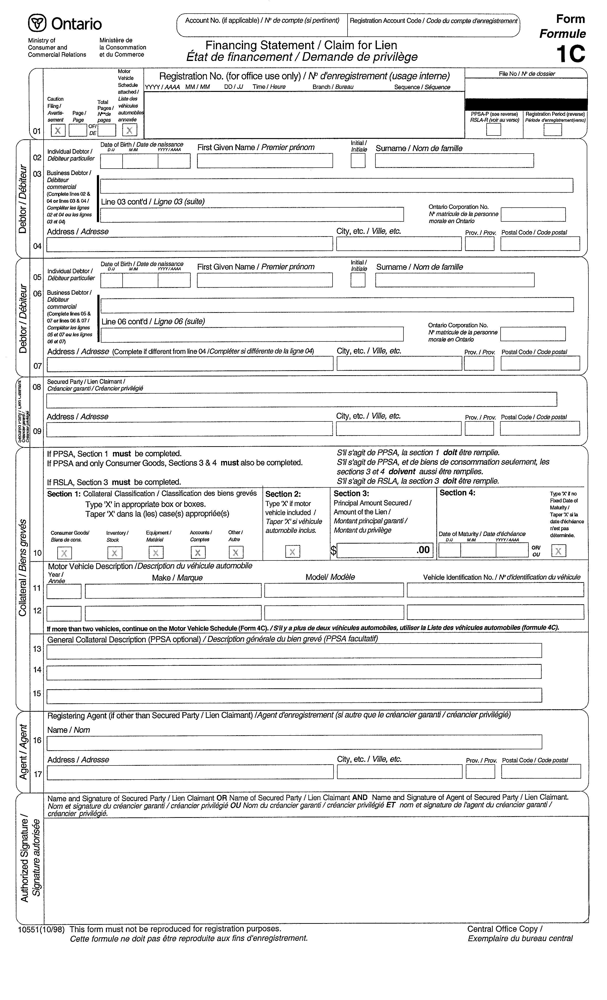
O. Reg. 637/98, s. 6.
Form 2 Revoked: O. Reg. 637/98, s. 6.
Form 2C
Financing Change Statement/Change Statement
Personal Property Security Act
Insert regs\graphics\1990\912\91202cab.tif
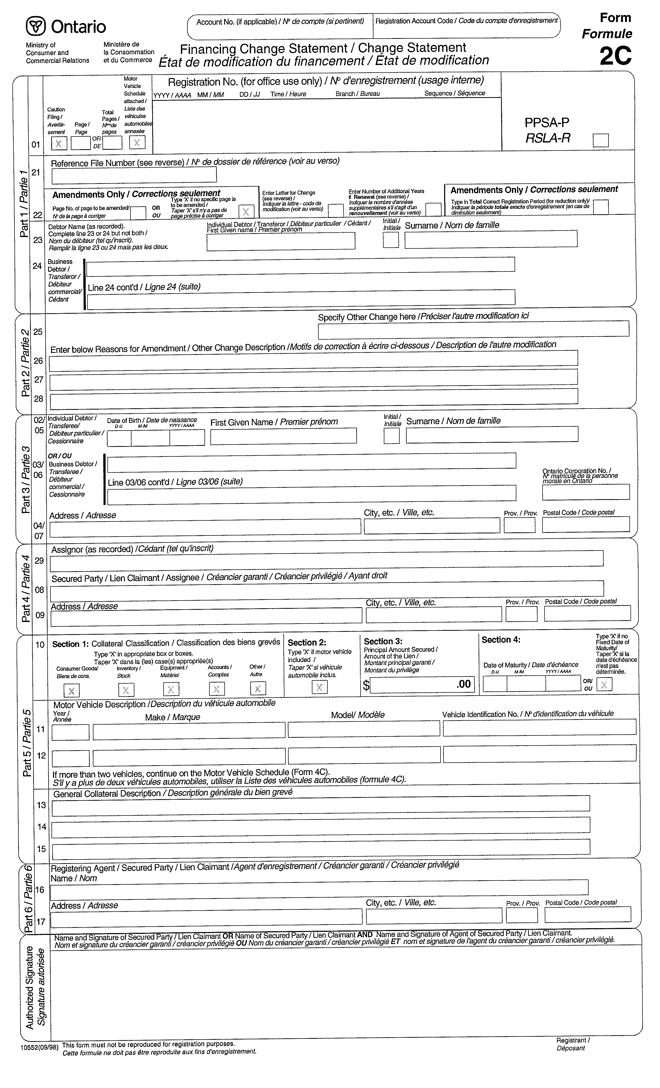
O. Reg. 637/98, s. 6.
Form 3 Revoked: O. Reg. 637/98, s. 6.
Form 3C
Financing Change Statement/Change Statement
Personal Property Security Act
Insert regs\graphics\1990\912\91203cab.tif
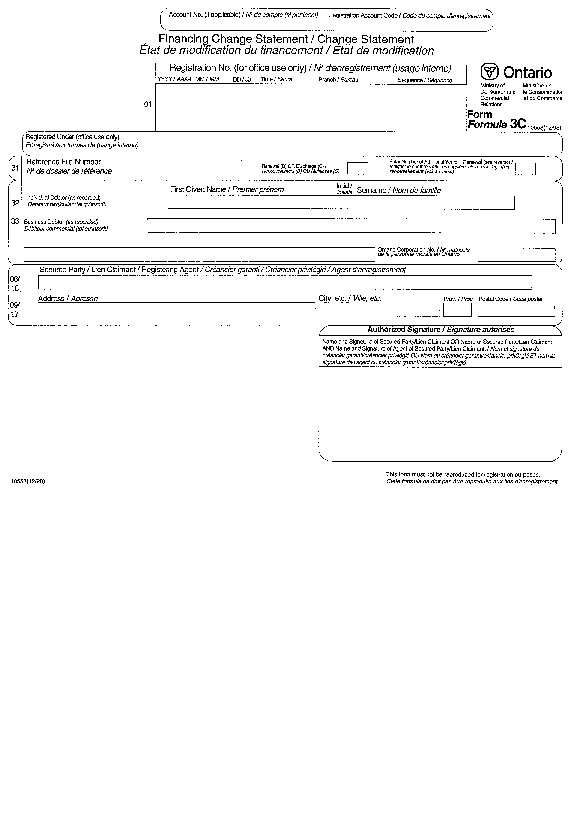
O. Reg. 637/98, s. 6.
Form 4 Revoked: O. Reg. 637/98, s. 6.
Form 4C
Motor Vehicle Schedule
Personal Property Security Act
Insert regs\graphics\1990\912\91204cab.tif
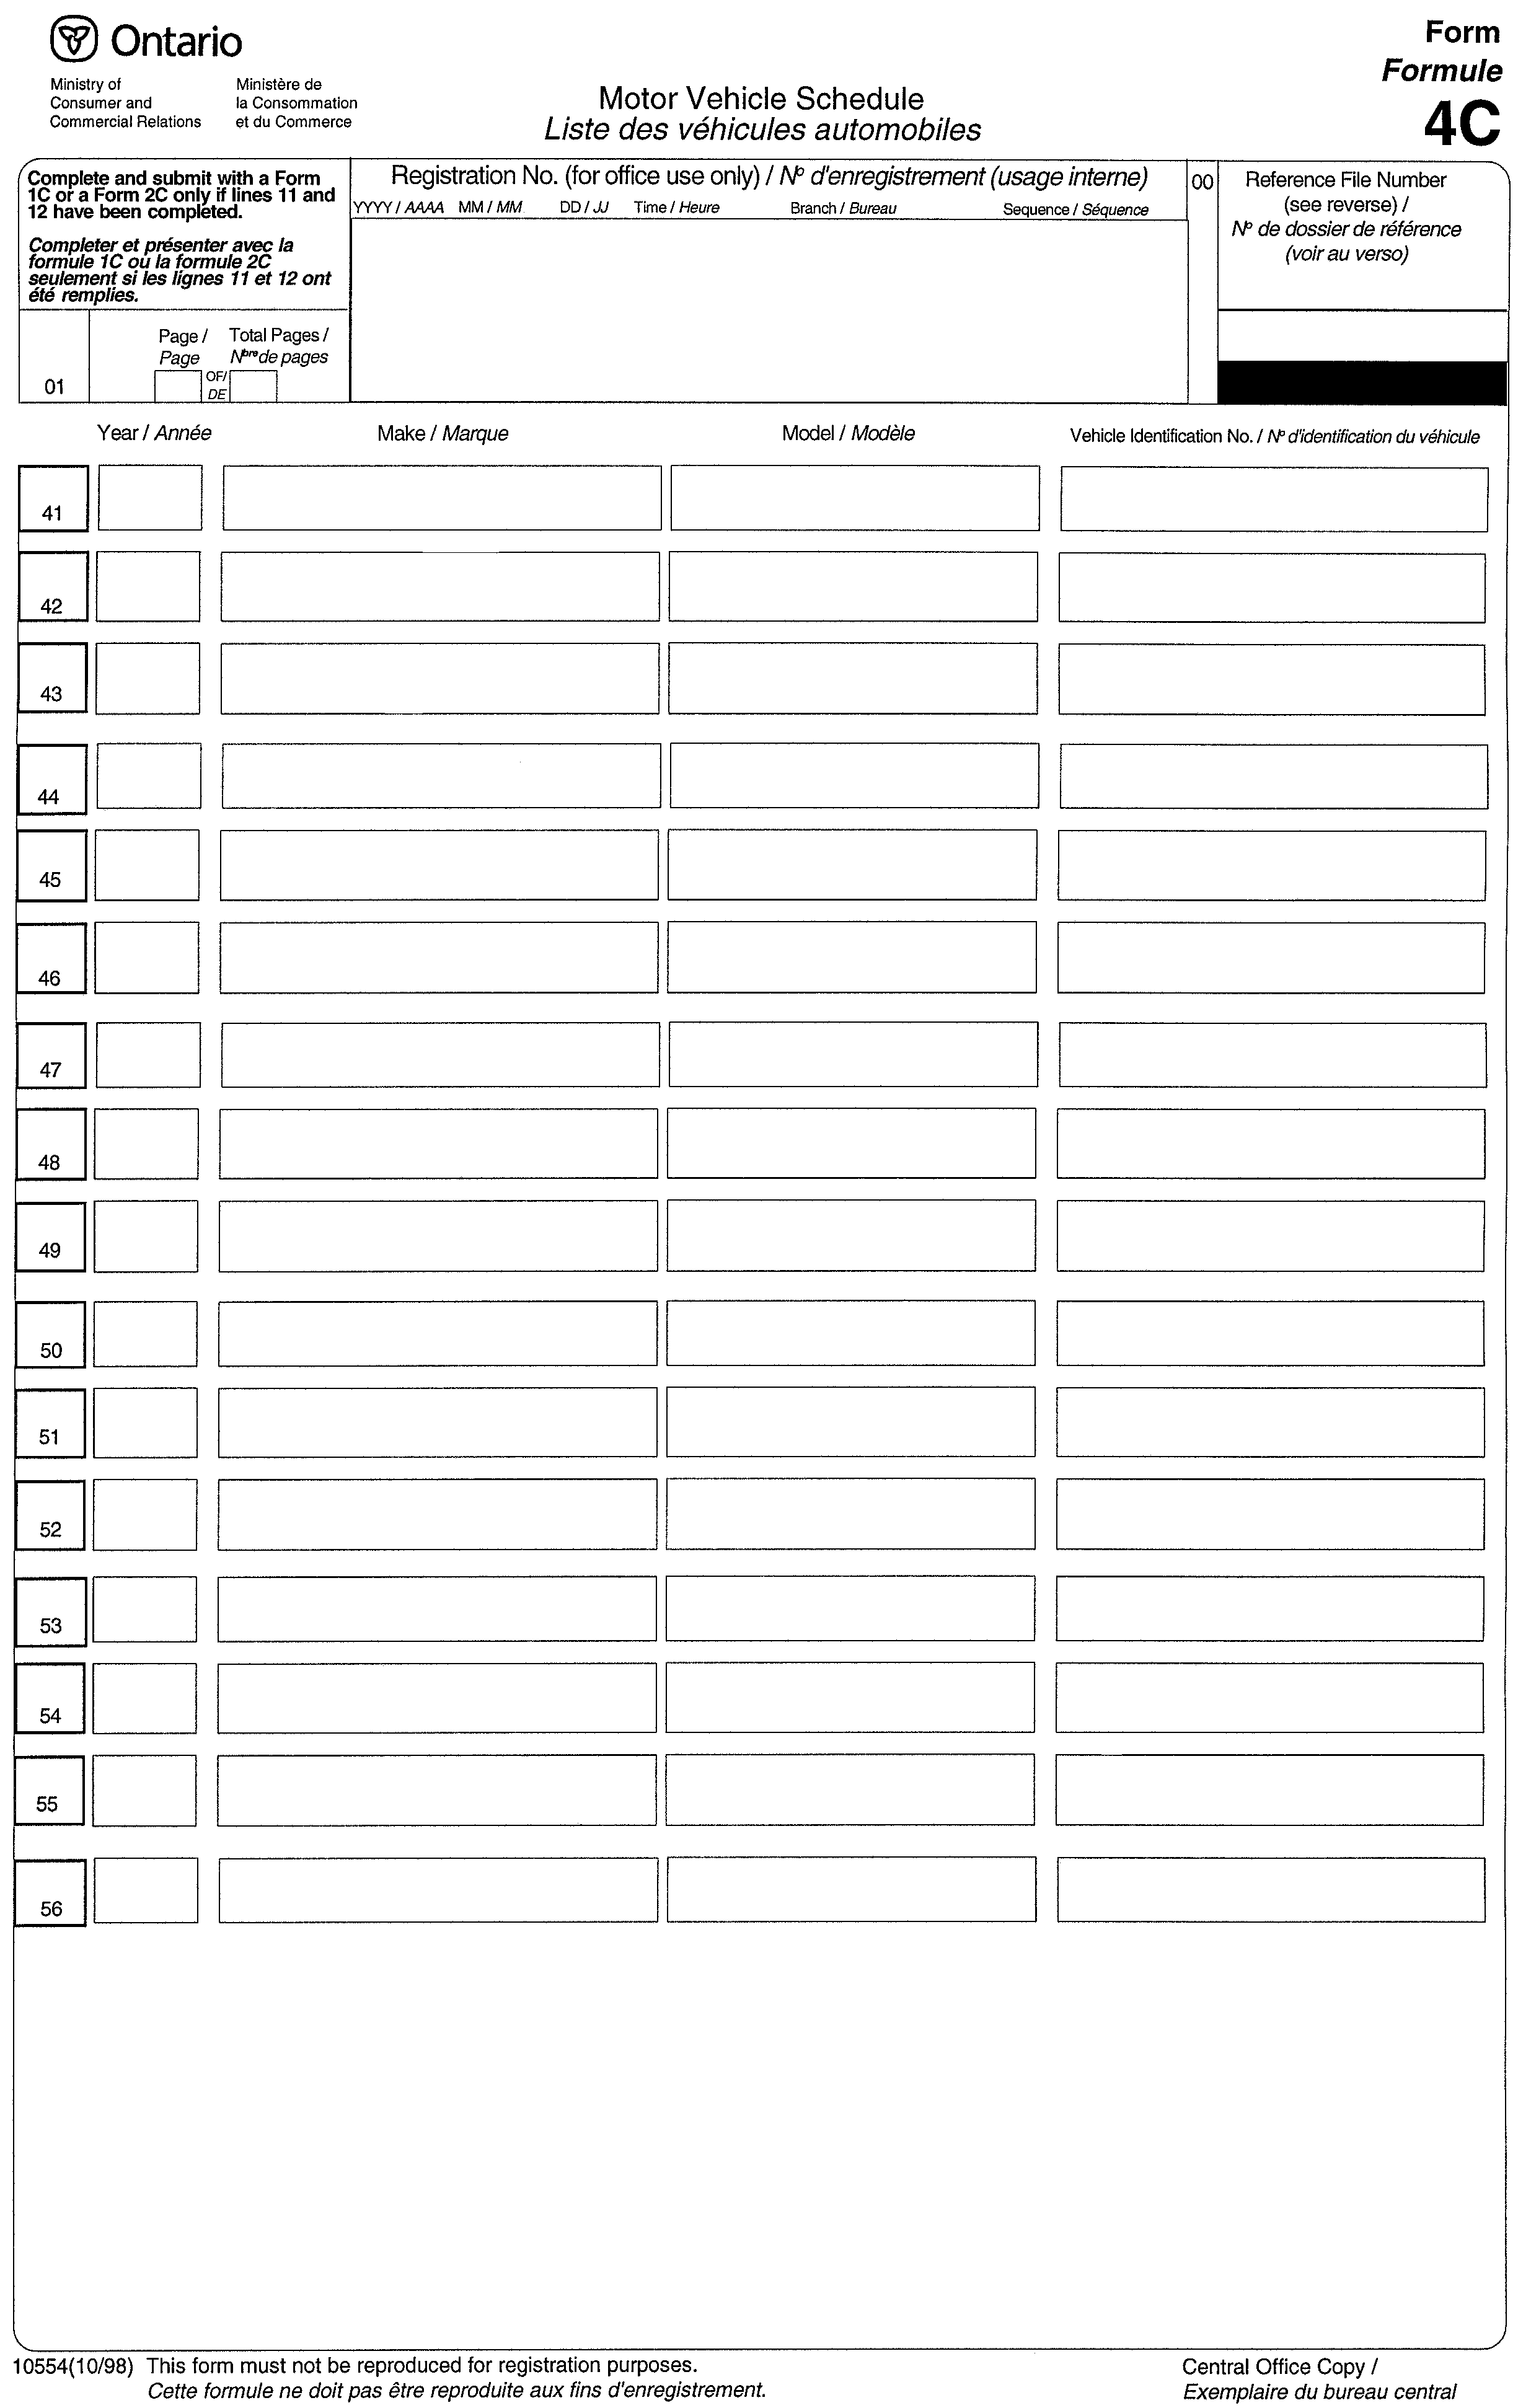
O. Reg. 637/98, s. 6.
Form 5
notice of security interest
Personal Property Security Act
Insert regs\graphics\1990\912\912005ae.tif
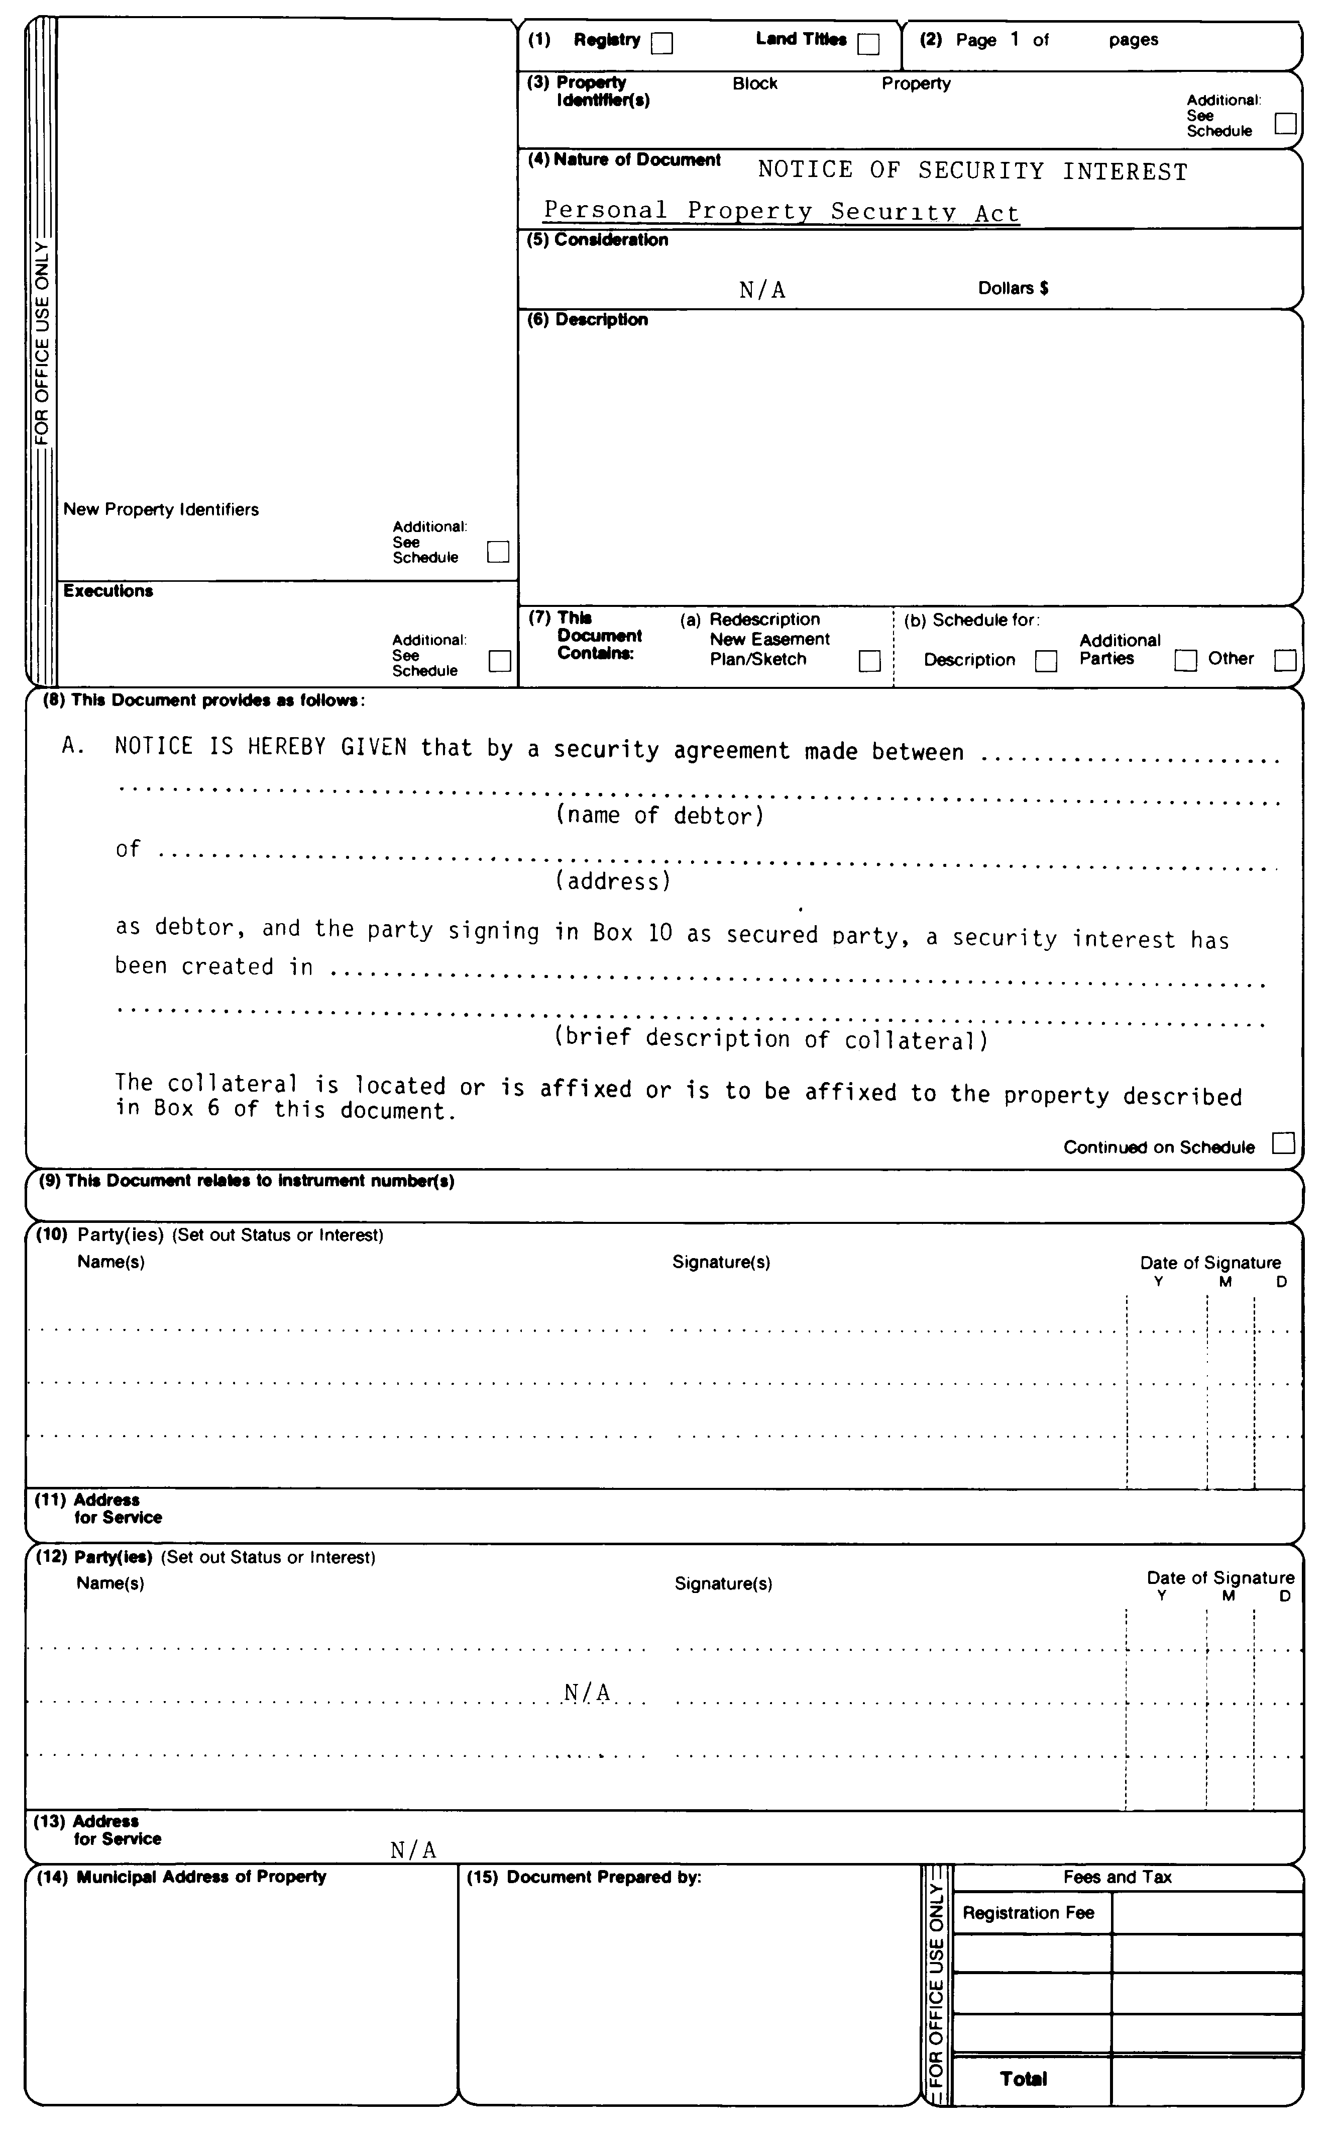
Insert regs\graphics\1990\912\912005be.tif
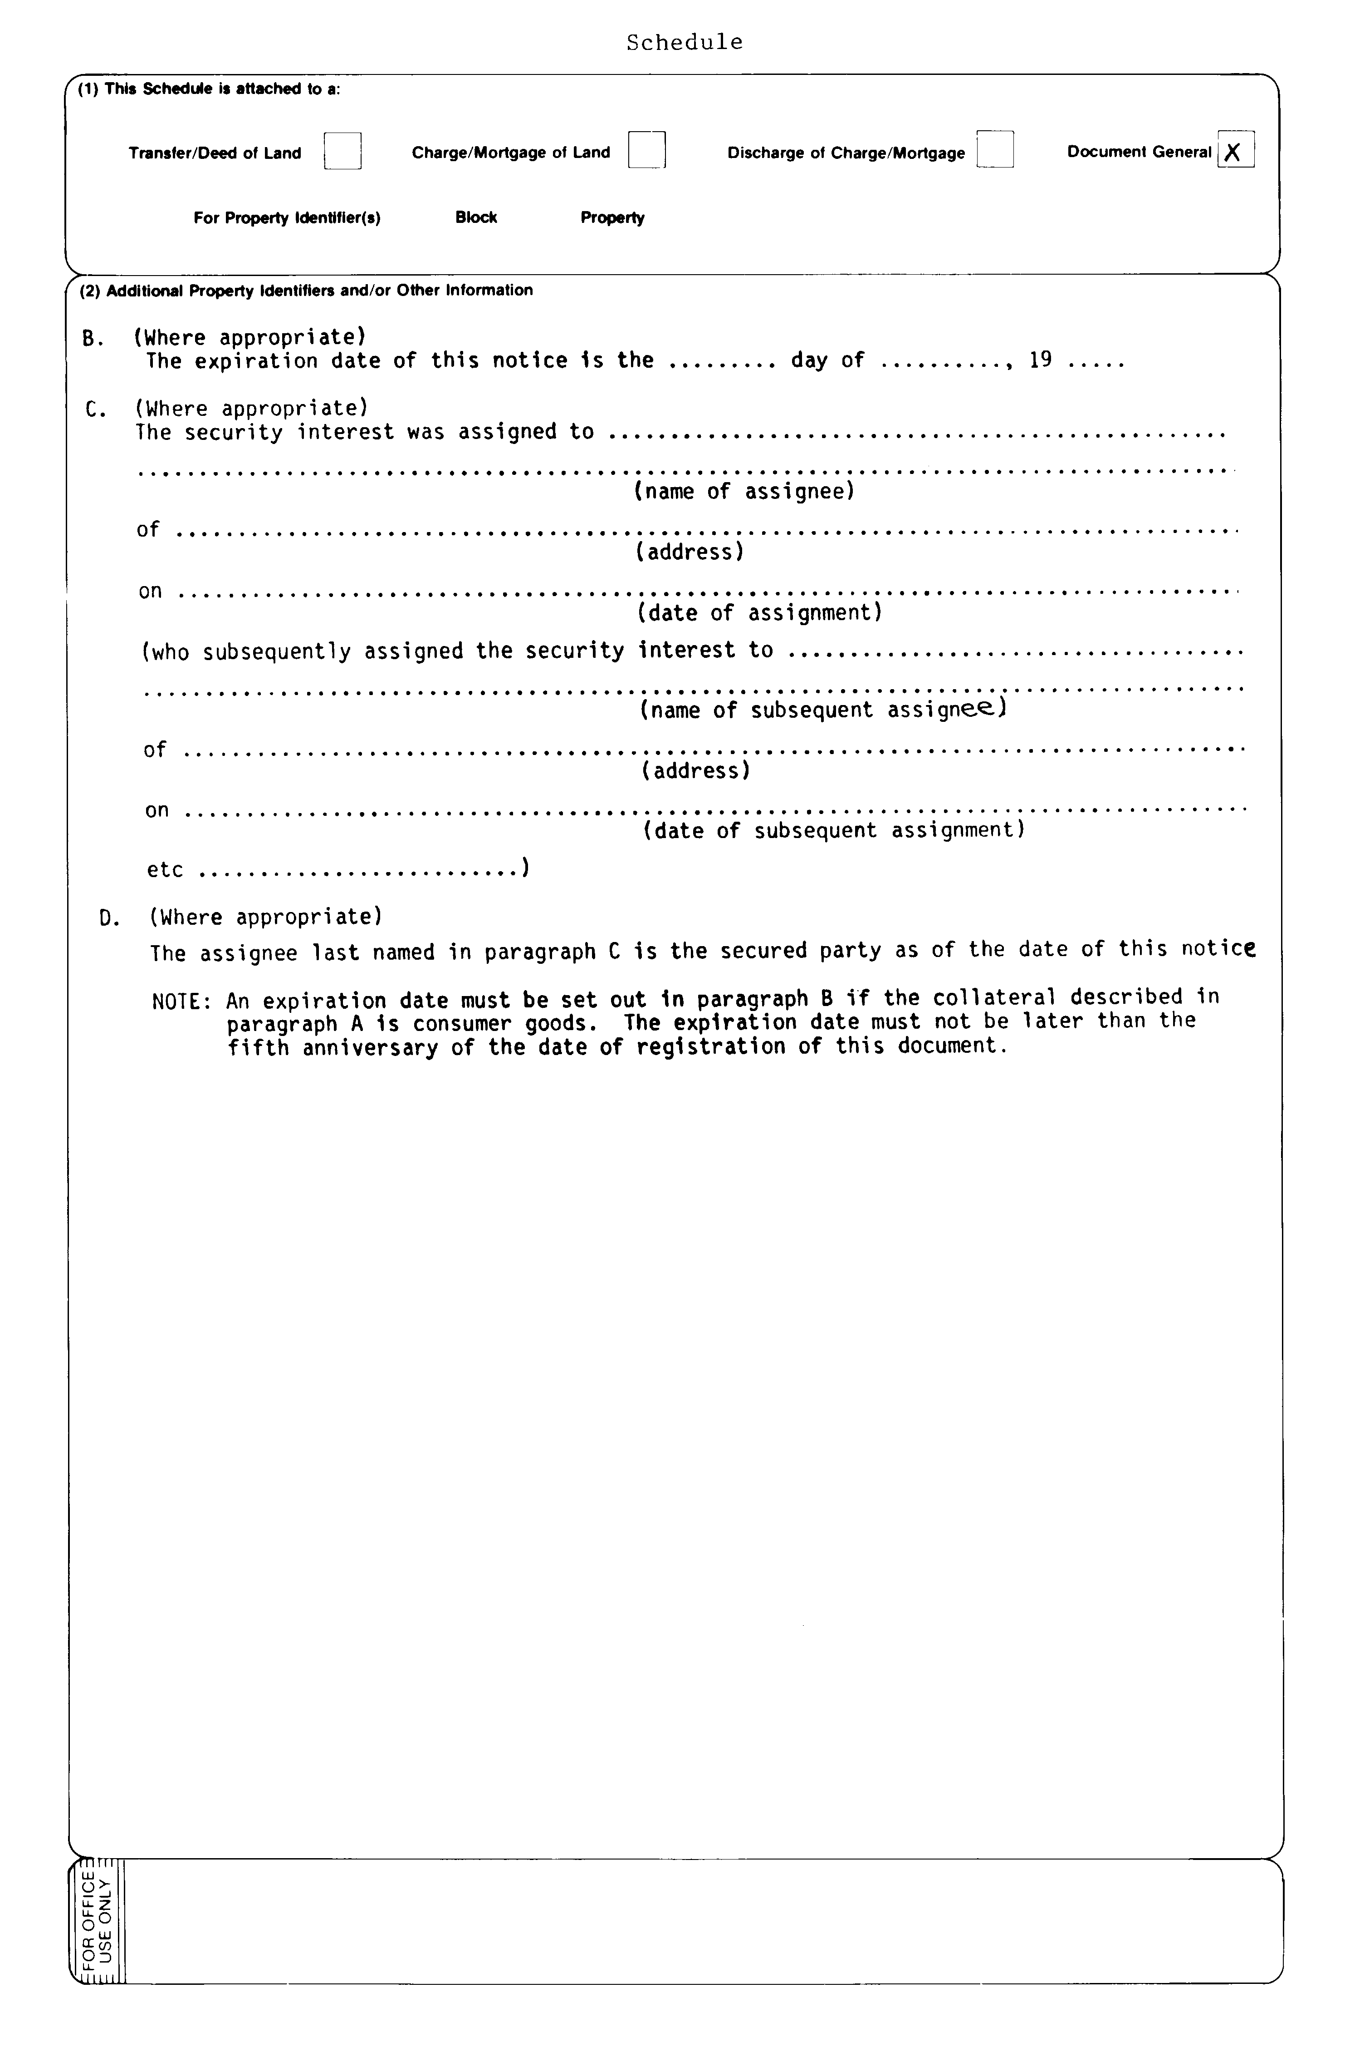
R.R.O. 1990, Reg. 912, Form 5.
Form 6
notice of security interest
Personal Property Security Act
Insert regs\graphics\1990\912\912006ae.tif
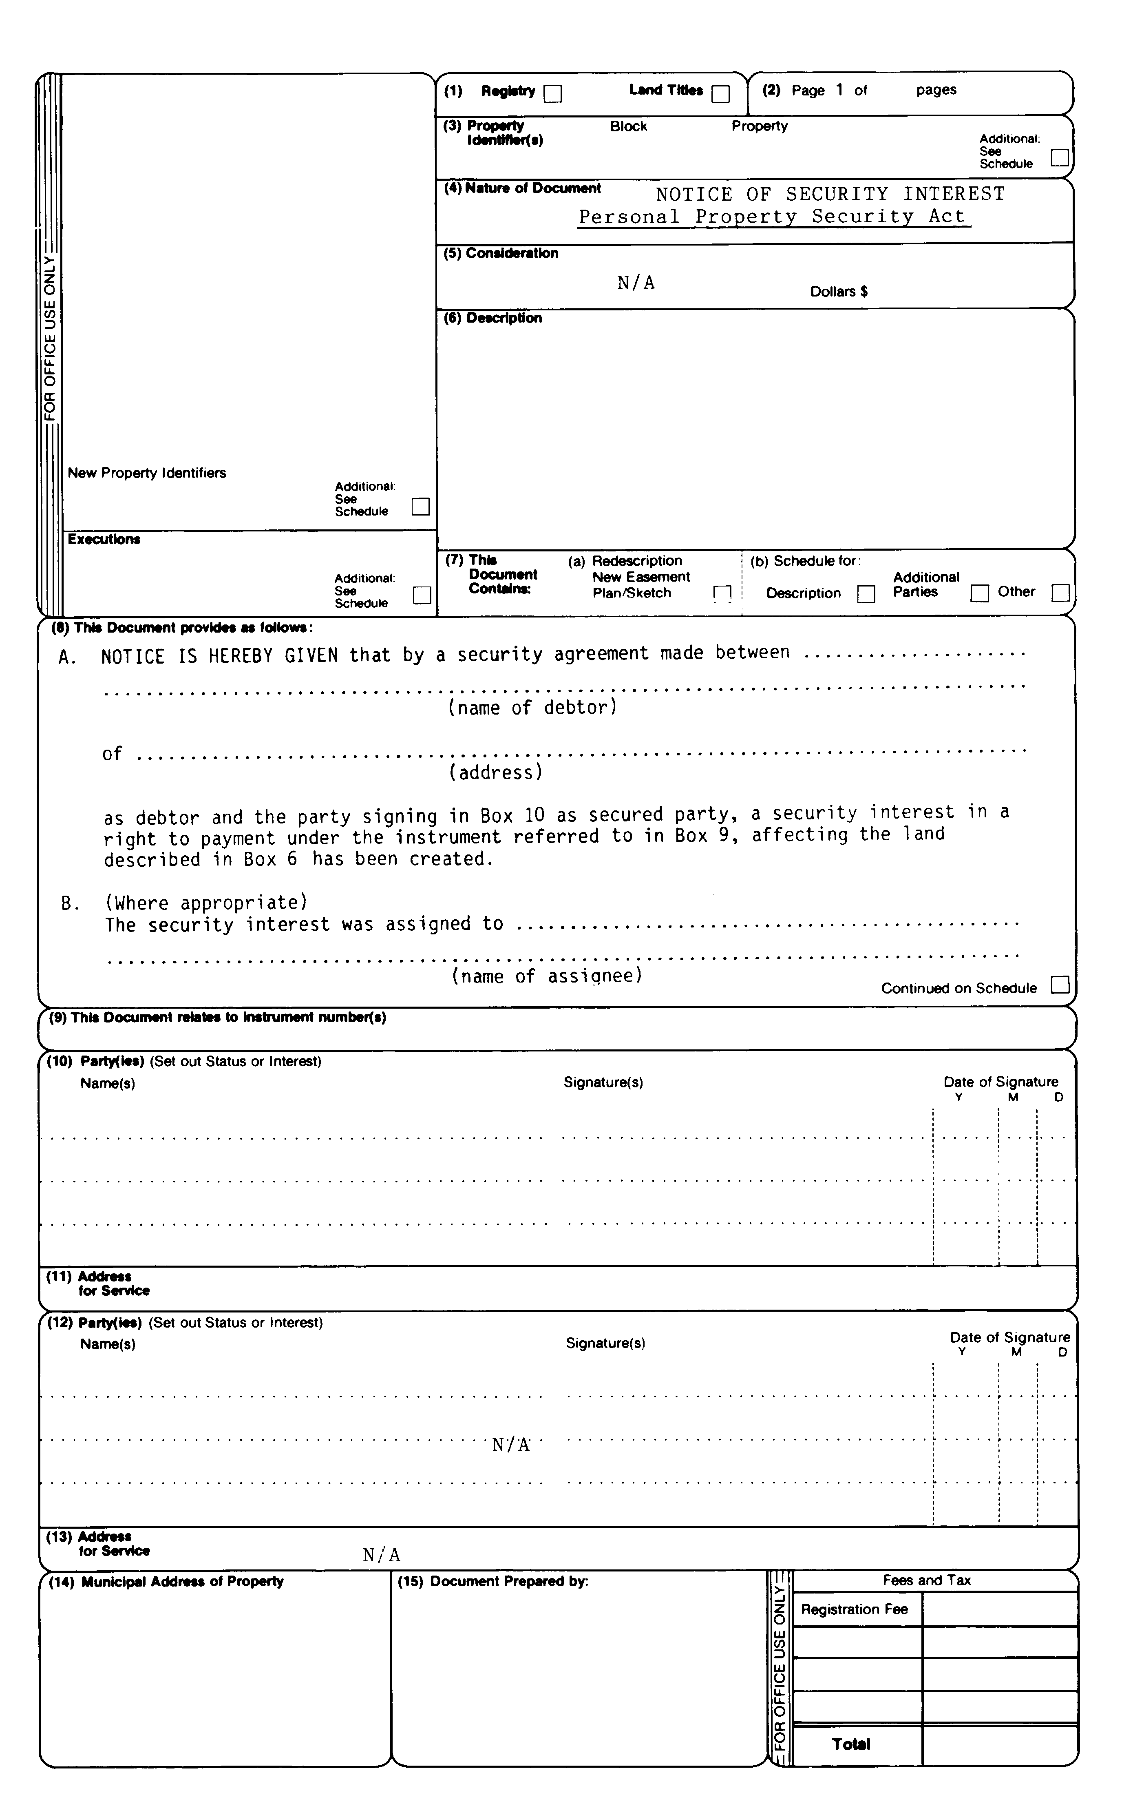
Insert regs\graphics\1990\912\912006be.tif
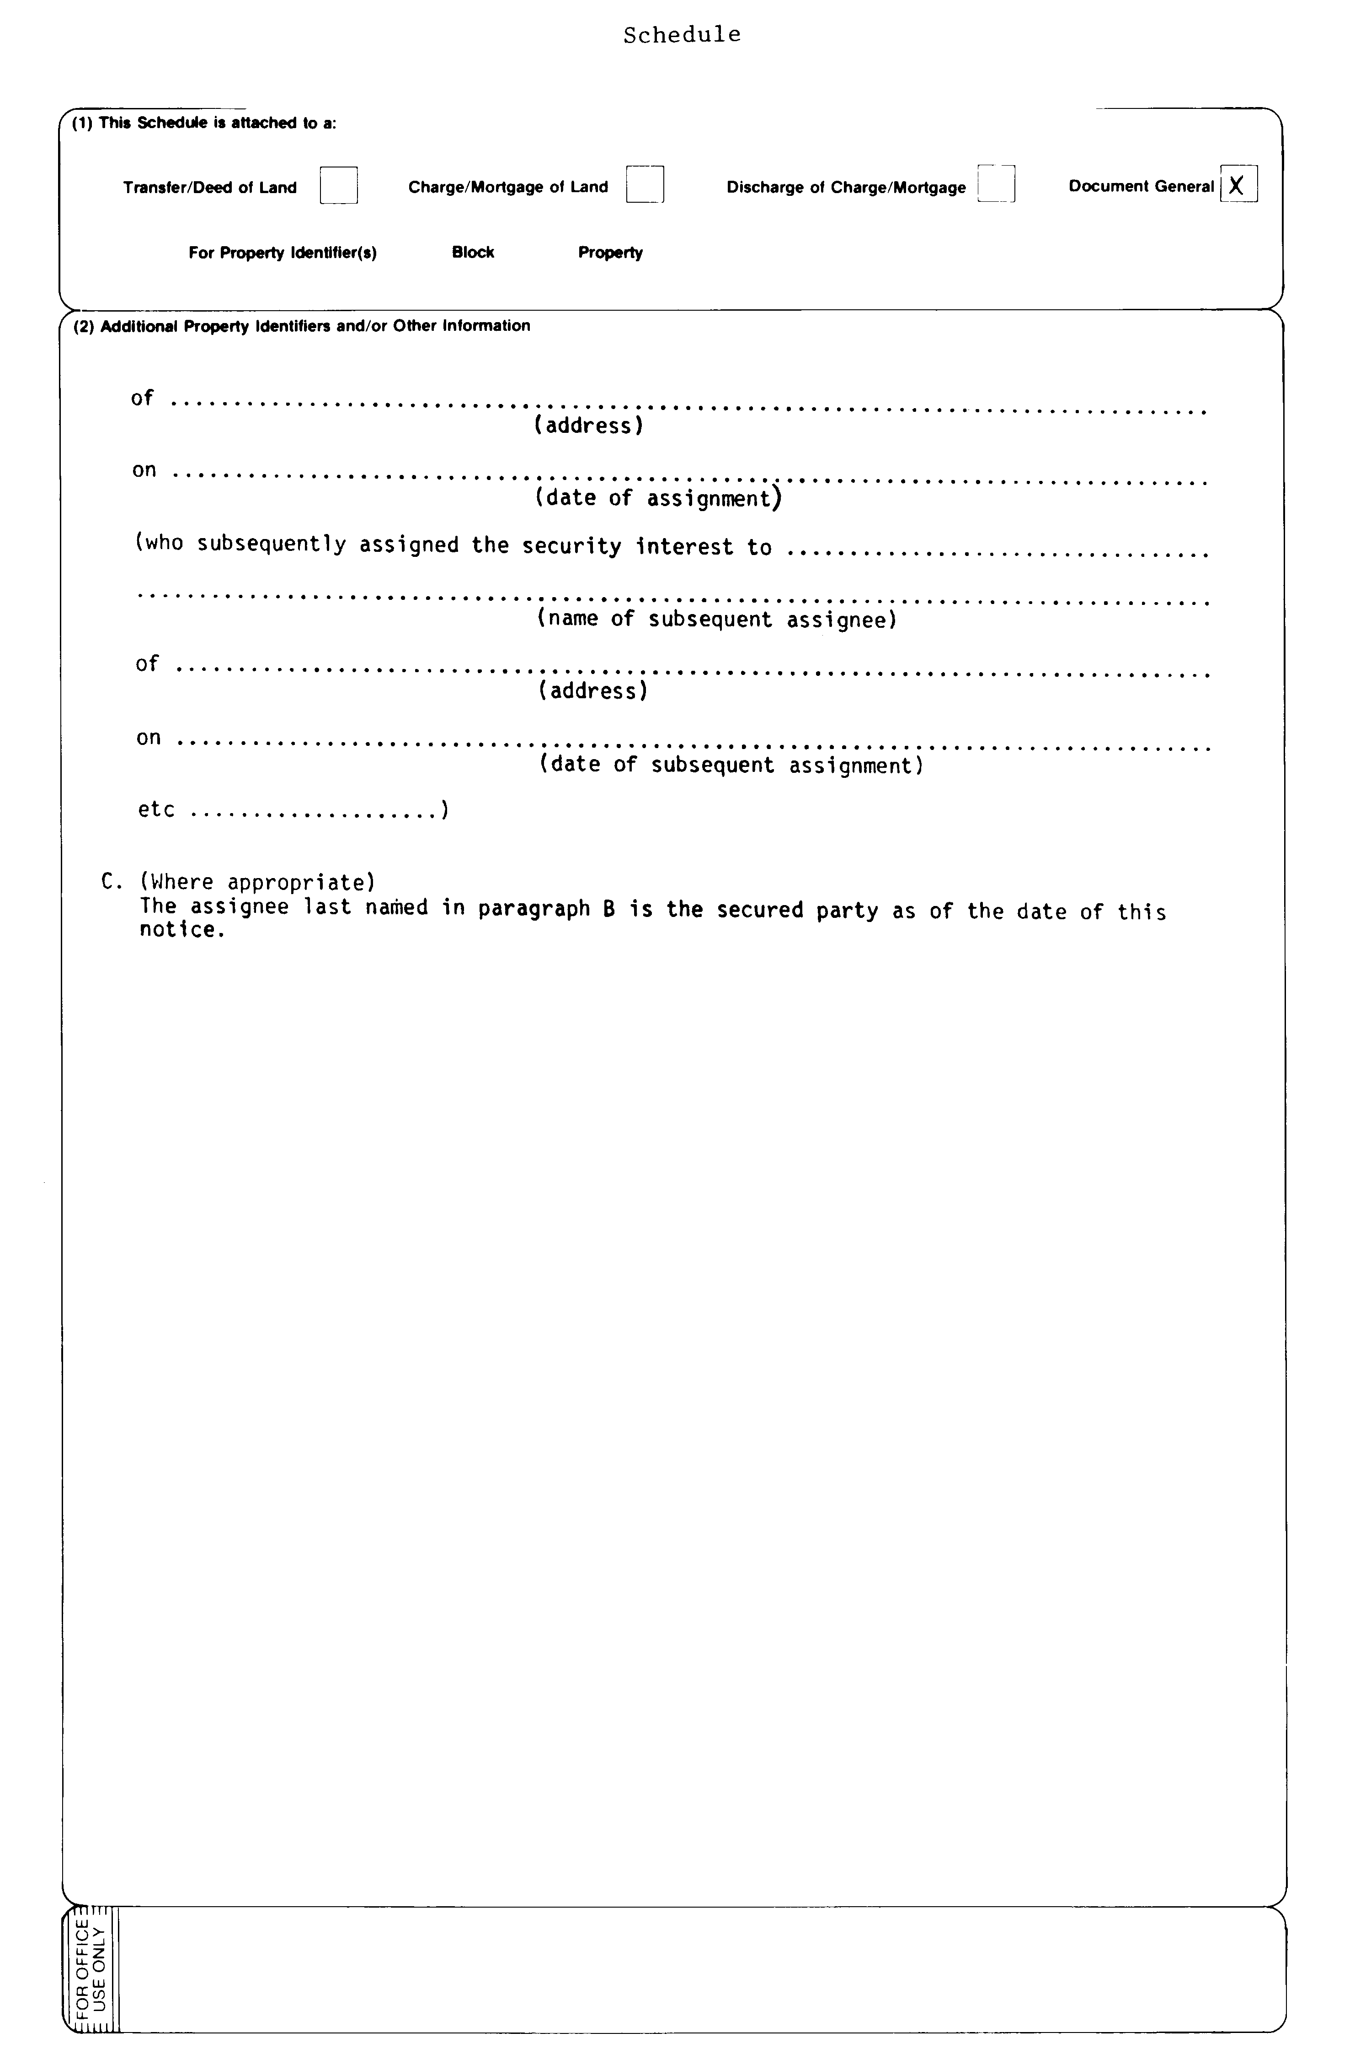
R.R.O. 1990, Reg. 912, Form 6.
Form 7
extension notice
Personal Property Security Act
Insert regs\graphics\1990\912\912007ae.tif
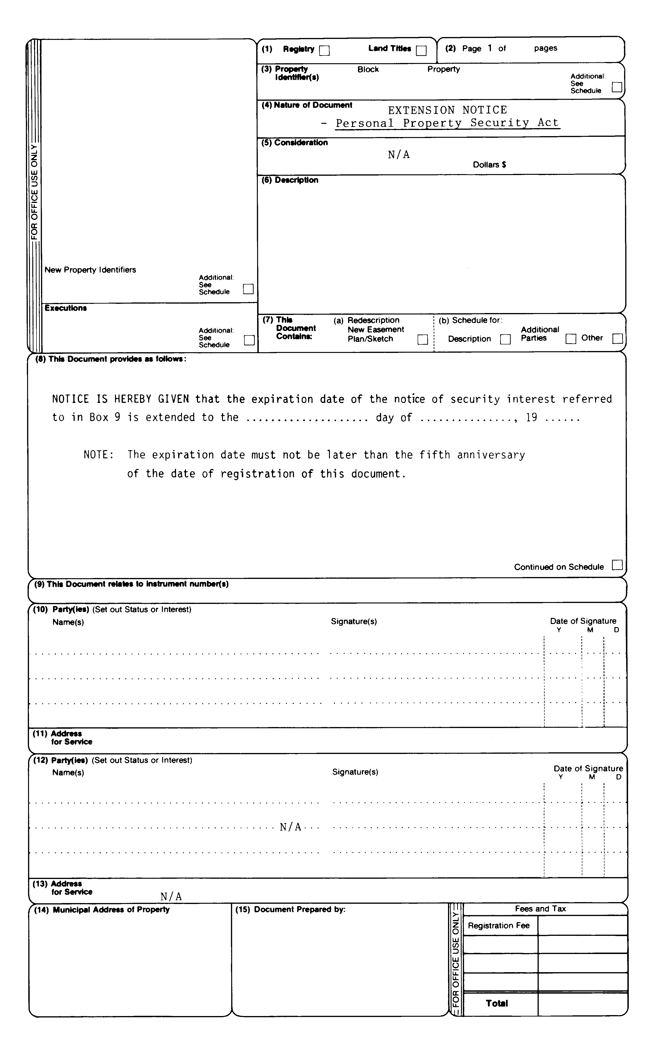
R.R.O. 1990, Reg. 912, Form 7.
Form 8
certificate of discharge
Personal Property Security Act
Insert regs\graphics\1990\912\912008ae.tif
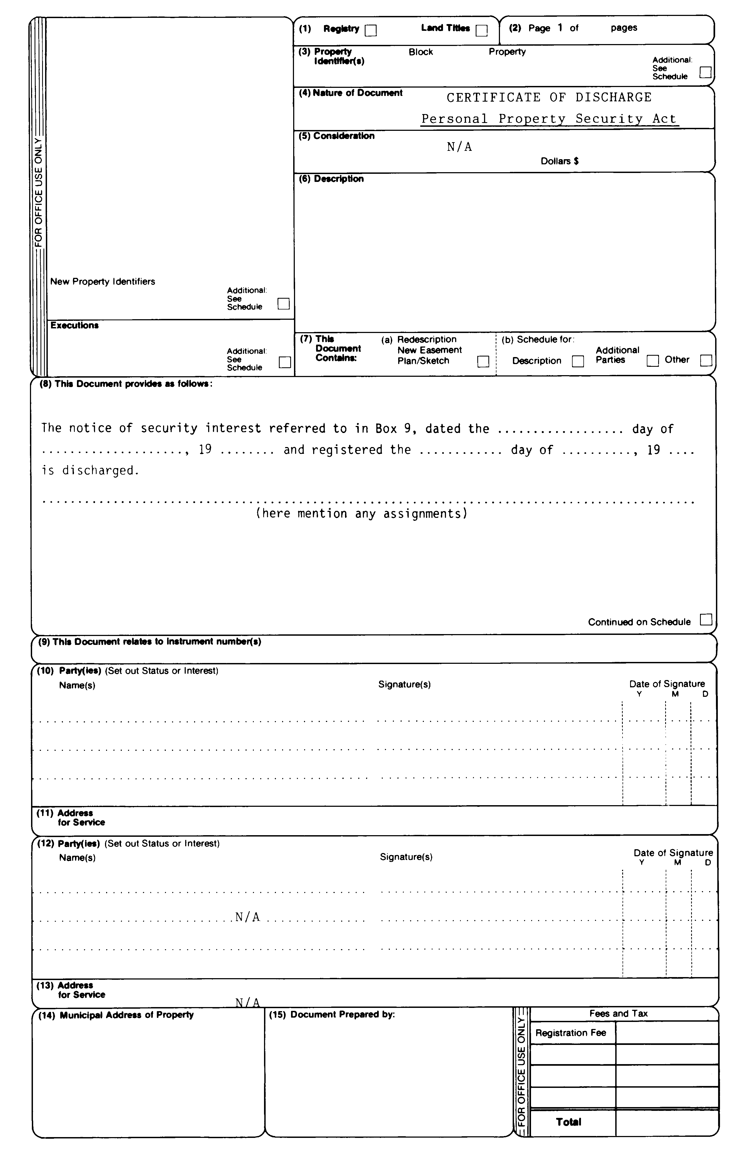
R.R.O. 1990, Reg. 912, Form 8.

Français

Back to top

