Français
Mining Act
ONTARIO REGULATION 111/91
Amended to O. Reg. 195/06
FORMS
Note: This Regulation was revoked on August 8, 2006. See: O. Reg. 195/06, ss. 4, 5.
This is the English version of a bilingual regulation.
1. Any form required to be prescribed under the Act shall be in the form approved by the Minister and provided by the Ministry, except as set out in sections 2, 3, 4, 5, 6, 7, 8, 9 and 10. O. Reg. 241/00, s. 1.
2. An application to record a staked mining claim under subsection 44 (1) of the Act shall be in Form 1. O. Reg. 503/96, s. 1.
3. A transfer of an unpatented mining claim or any interest in an unpatented mining claim shall be in Form 2. O. Reg. 503/96, s. 1.
4. (1) Assessment work referred to in subsection 65 (2) of the Act and exploration work referred to in subsection 66 (3) of the Act shall be declared in Form 3 if the work has been performed on mining lands. O. Reg. 503/96, s. 1.
(2) Prospecting and regional surveys on Crown land referred to in subsection 66 (2) of the Act shall be declared in Form 4. O. Reg. 503/96, s. 1.
5. A notice of intention to perform assessment work under section 78 of the Act shall be in Form 5. O. Reg. 503/96, s. 1.
6. A notice of project status under clause 140 (1) (a) or 141 (1) (a) or subsection 144 (1) of the Act shall be in Form 6. O. Reg. 241/00, s. 2.
7. A notice of material change under subsection 144 (2) of the Act shall be in Form 7. O. Reg. 241/00, s. 2.
8. An inspection warrant under subsection 146 (5) of the Act shall be in Form 8. O. Reg. 241/00, s. 2.
9. A search warrant under subsection 146 (6) of the Act shall be in Form 9. O. Reg. 241/00, s. 2.
10. A notice to require a hearing under Part VII of the Act shall be in Form 10. O. Reg. 241/00, s. 2.
11.-18. Revoked: O. Reg. 503/96, s. 1.
19.-21. Revoked: O. Reg. 241/00, s. 3.
21.1, 21.2 Revoked: O. Reg. 241/00, s. 3.
22, 23. Revoked: O. Reg. 241/00, s. 3.
24.-26. Revoked: O. Reg. 503/96, s. 2.
27. Omitted (revokes other Regulations). O. Reg. 111/91, s. 27.
28. Omitted (provides for coming into force of provisions of this Regulation). O. Reg. 111/91, s. 28.
Form 1
APPLICATION to record staked mining claim(s)
Mining Act
Insert regs\graphics\1991\111\111001ae.tif
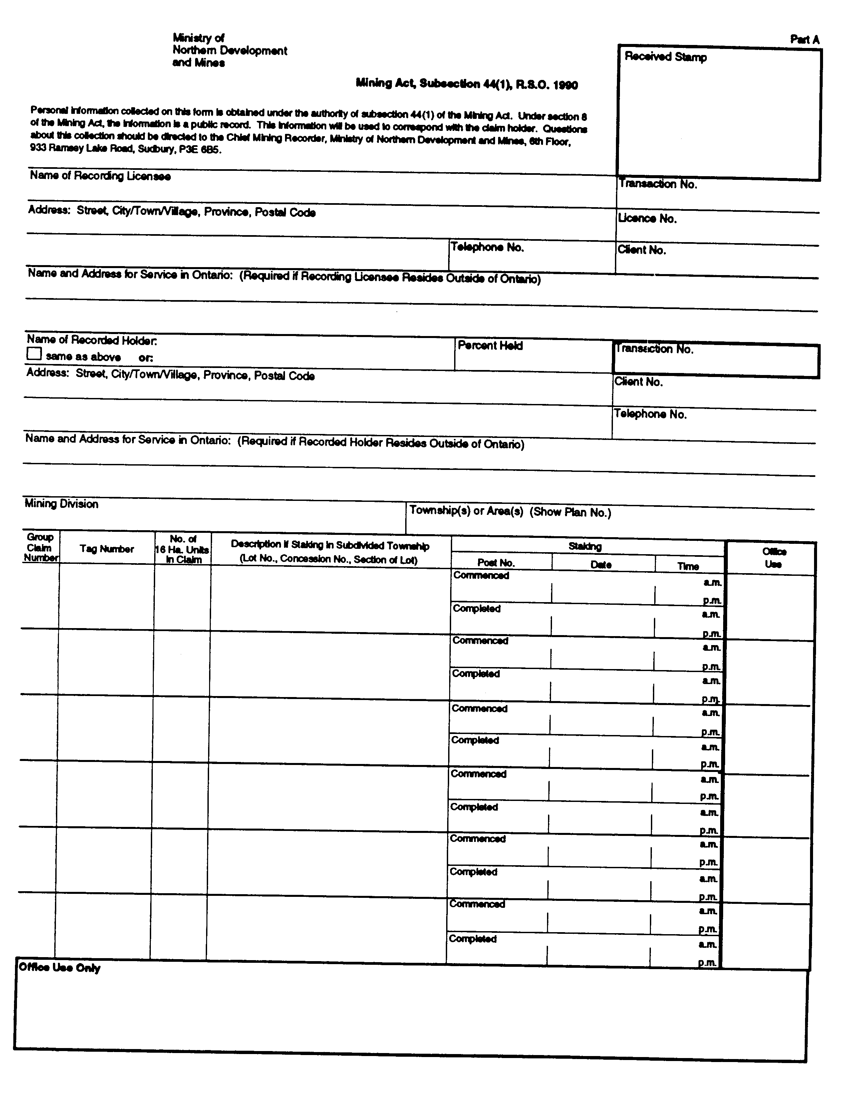
Insert regs\graphics\1991\111\111001be.tif
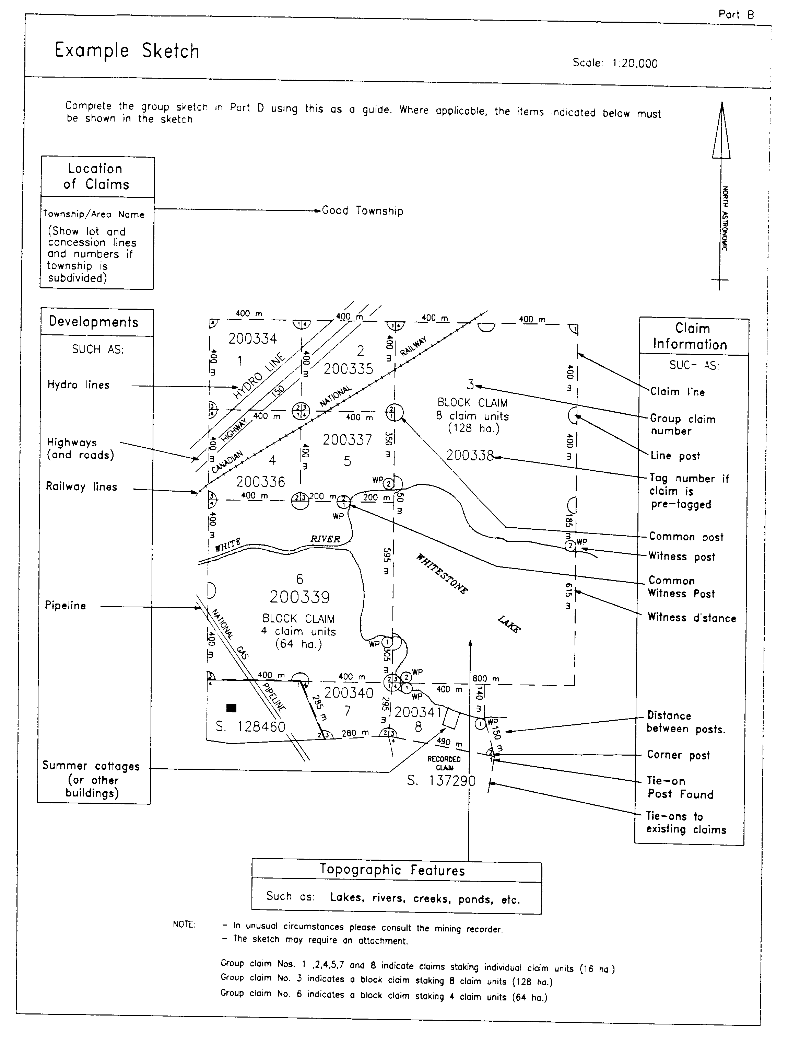
Insert regs\graphics\1991\111\111001ce.tif
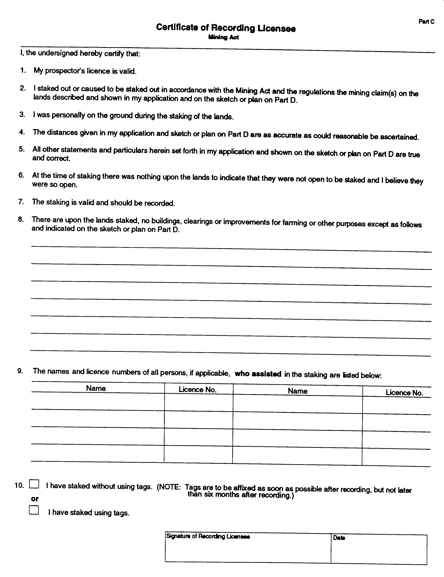
Insert regs\graphics\1991\111\111001de.tif
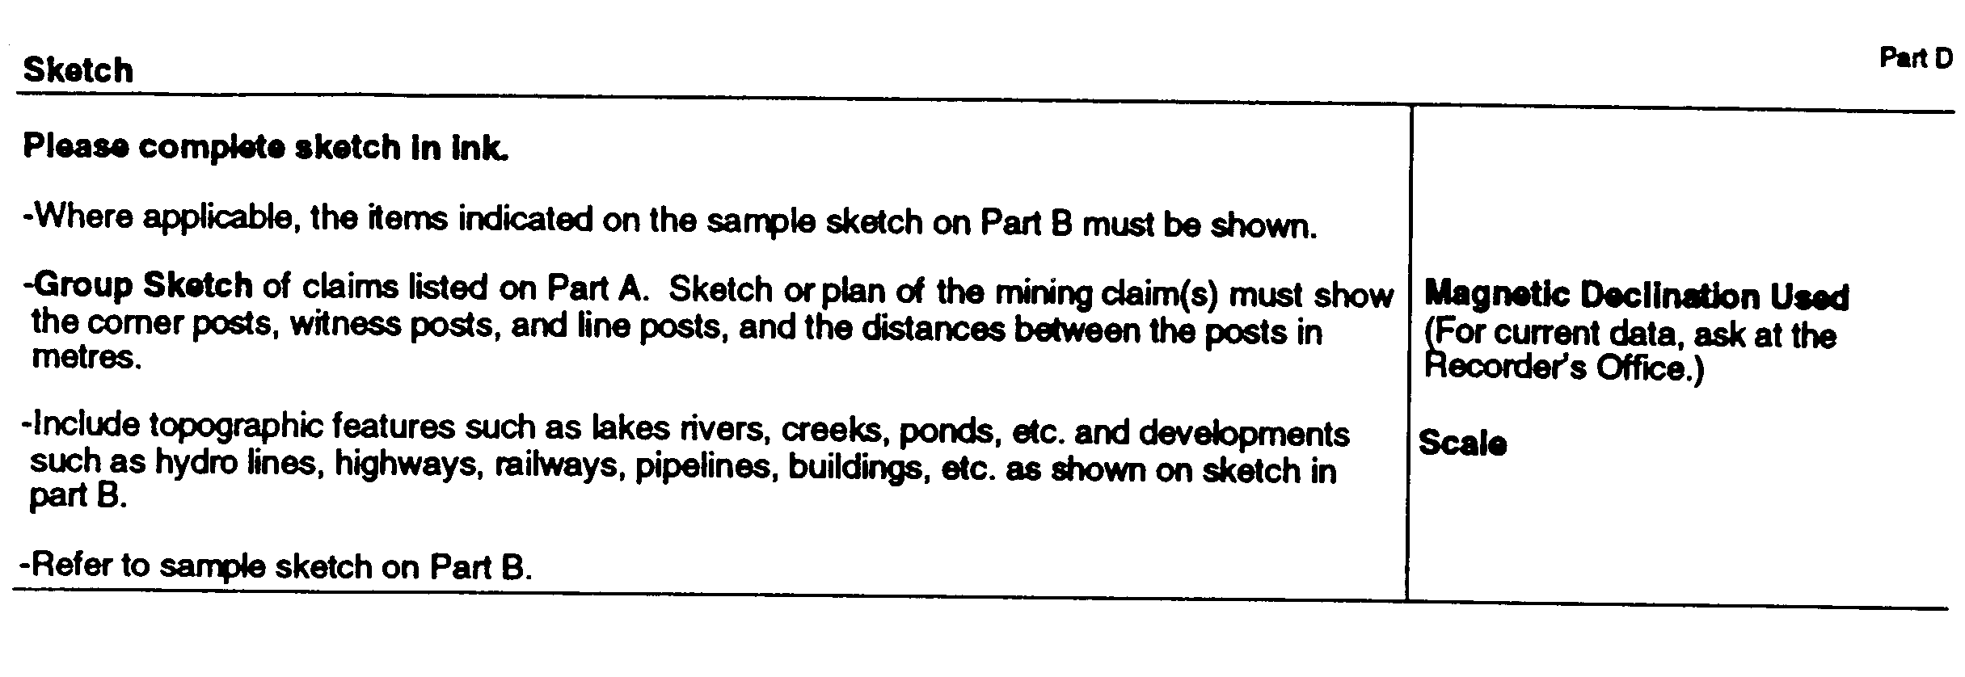
O. Reg. 503/96, s. 3.
Form 2
transfer of unpatented mining claim(s)
Mining Act
Insert regs\graphics\1991\111\111002ae.tif
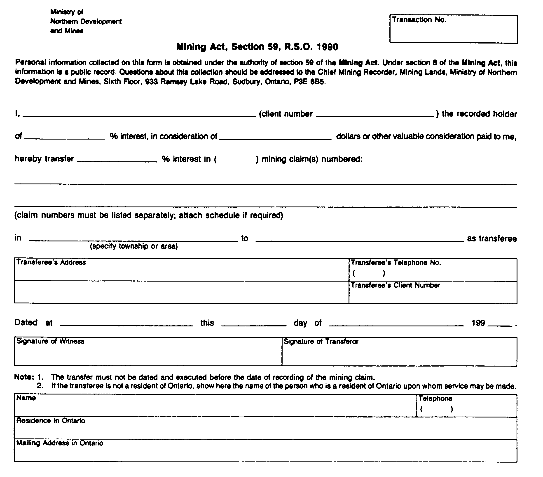
Insert regs\graphics\1991\111\111002be.tif
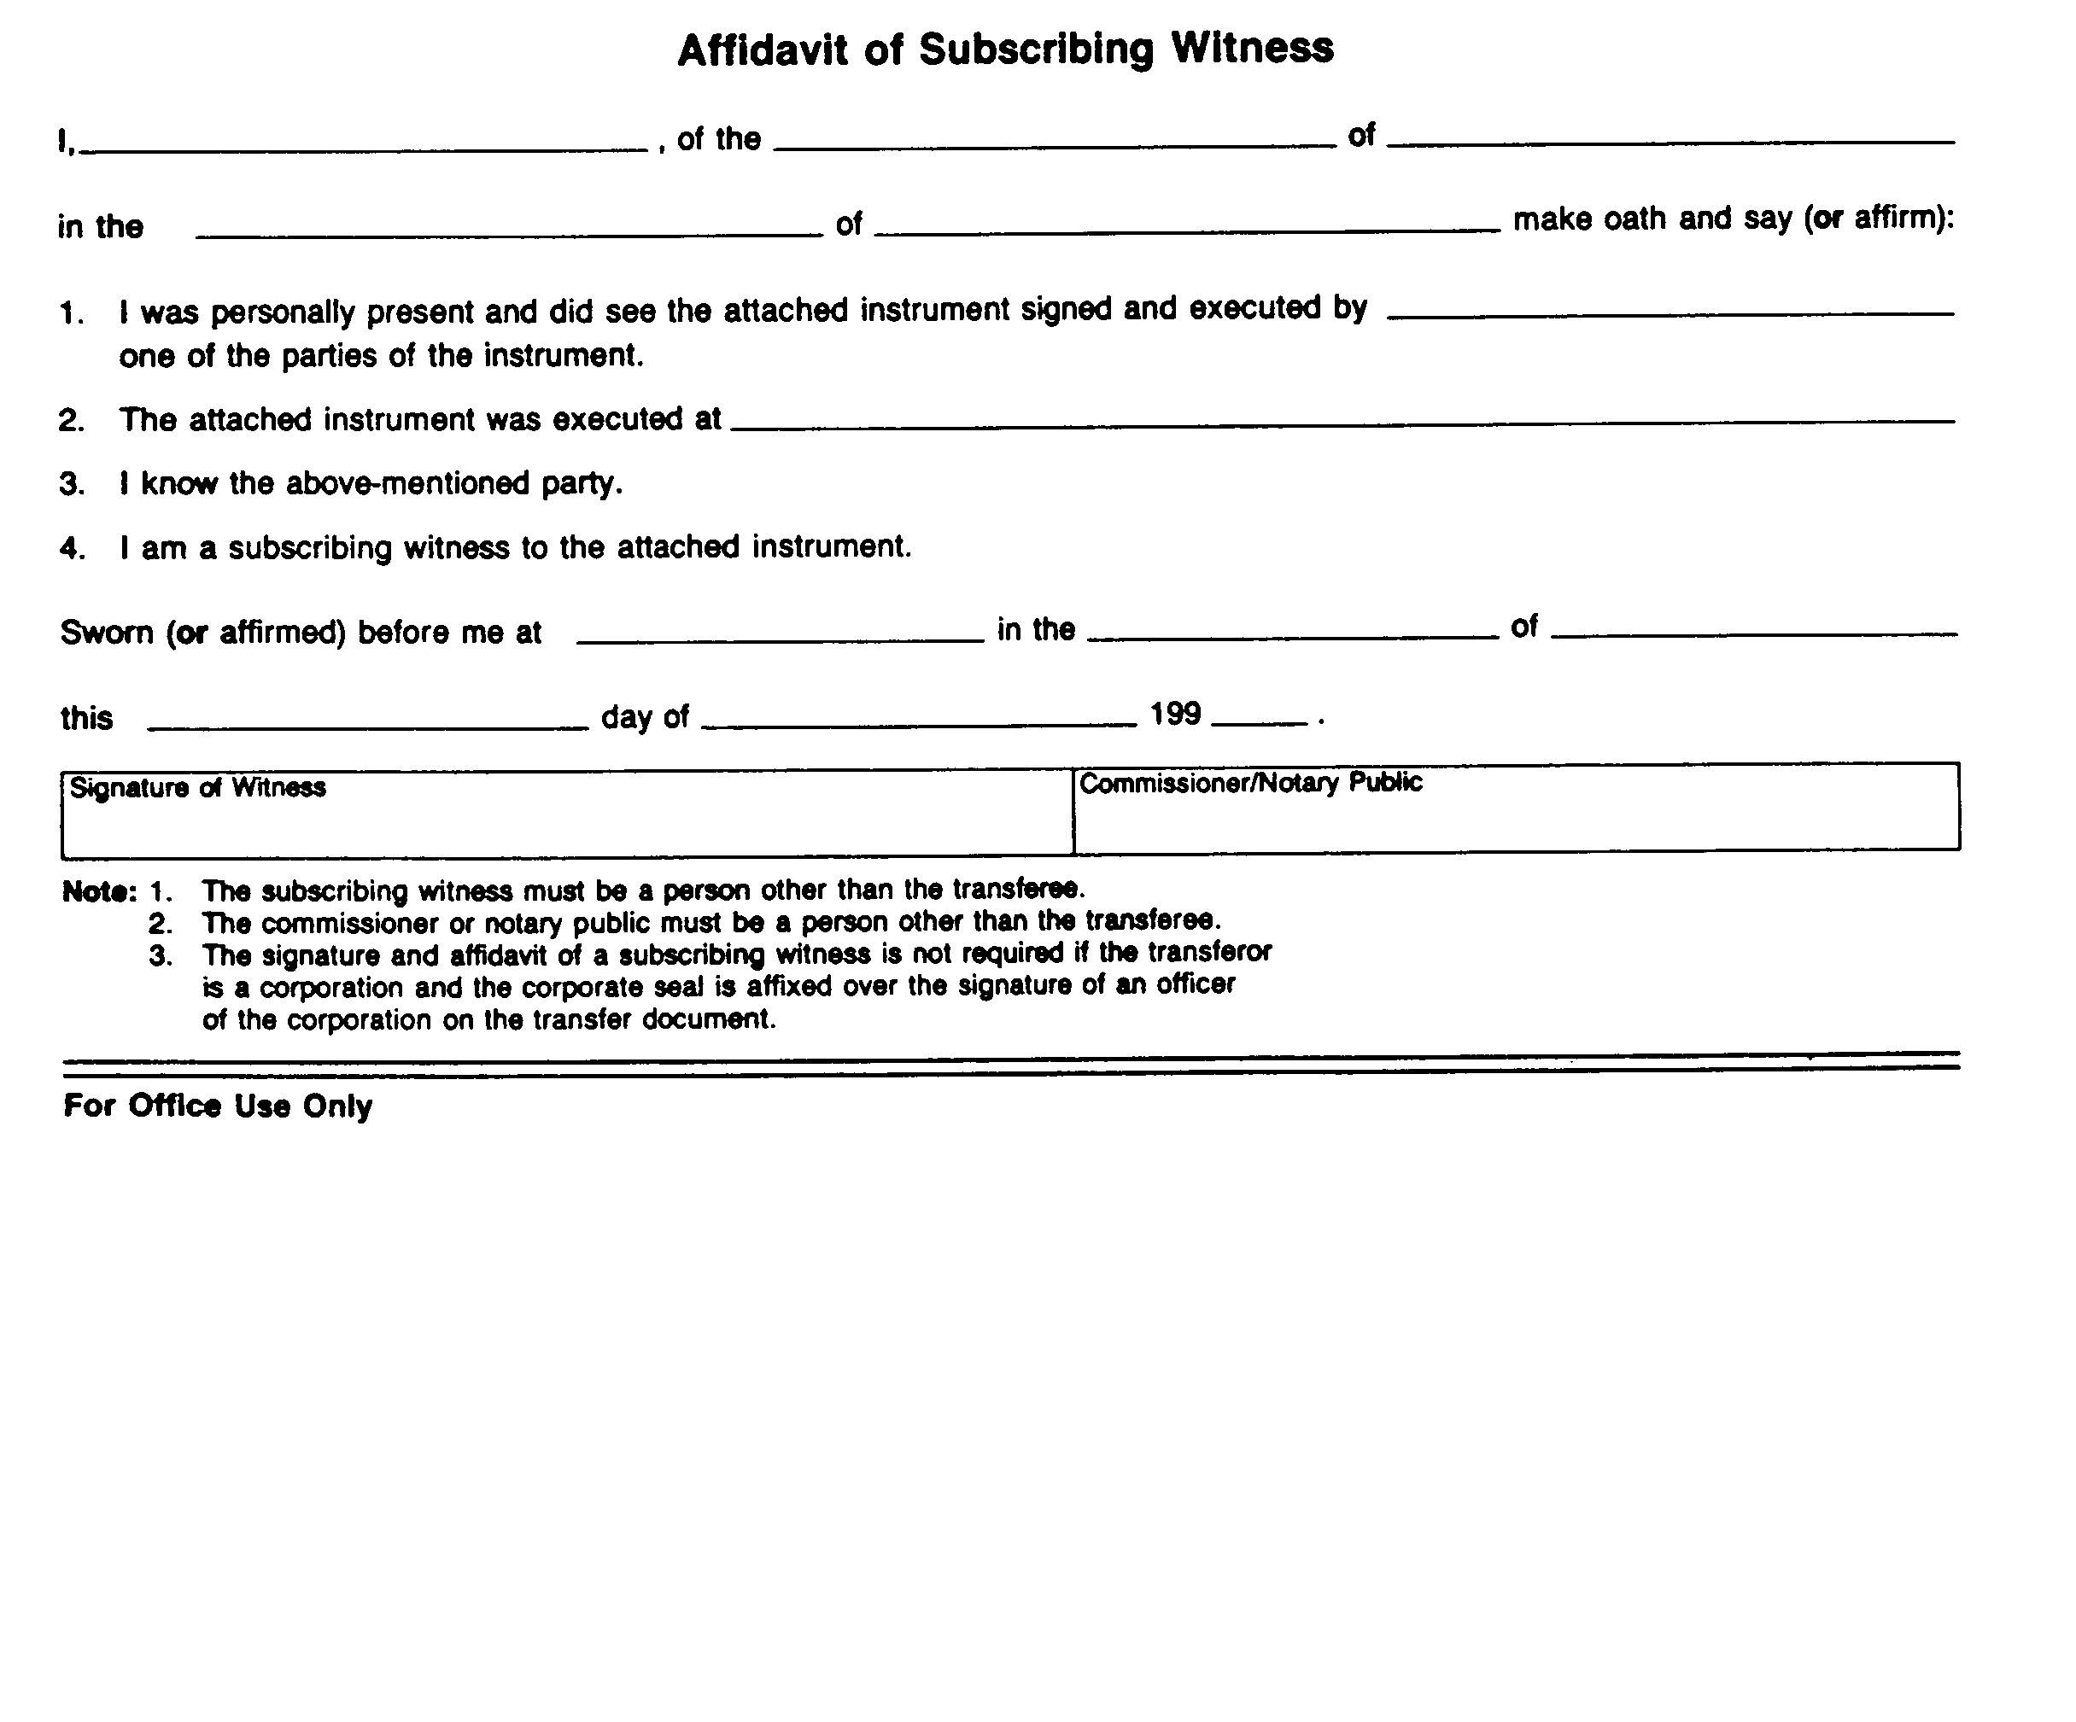
O. Reg. 503/96, s. 3.
Form 3
declaration of assessment work performed on mining land
Mining Act
Insert regs\graphics\1991\111\111003ae.tif
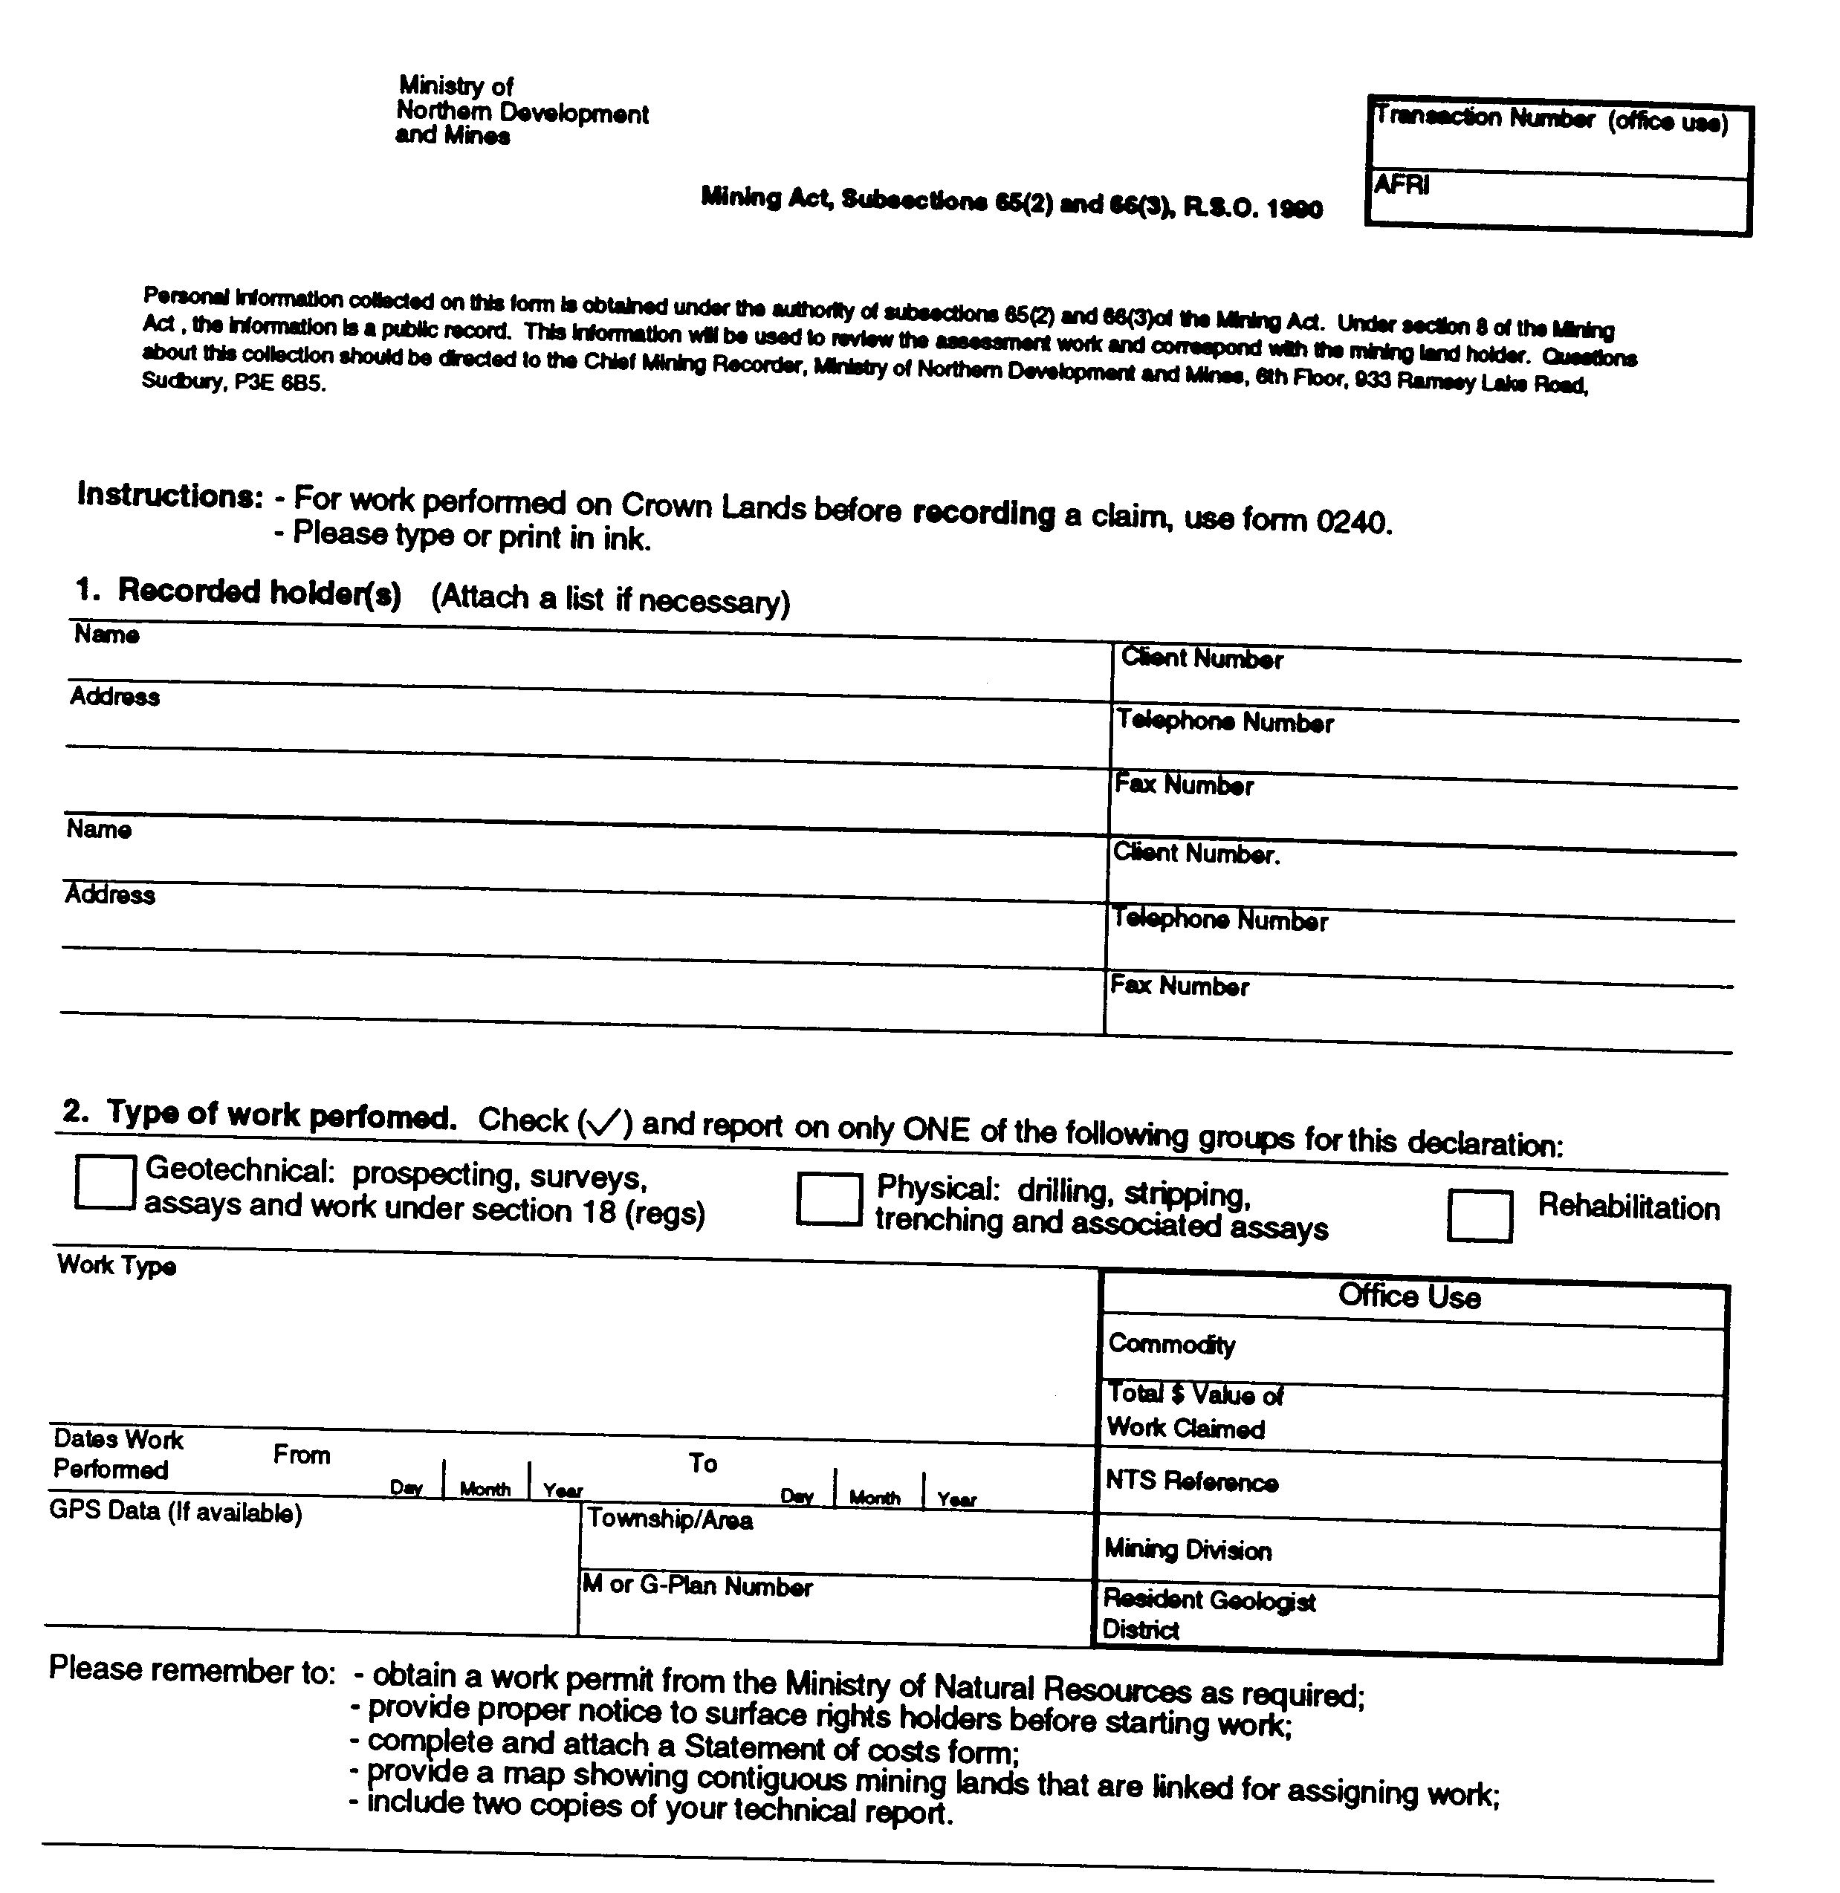
Insert regs\graphics\1991\111\111003be.tif
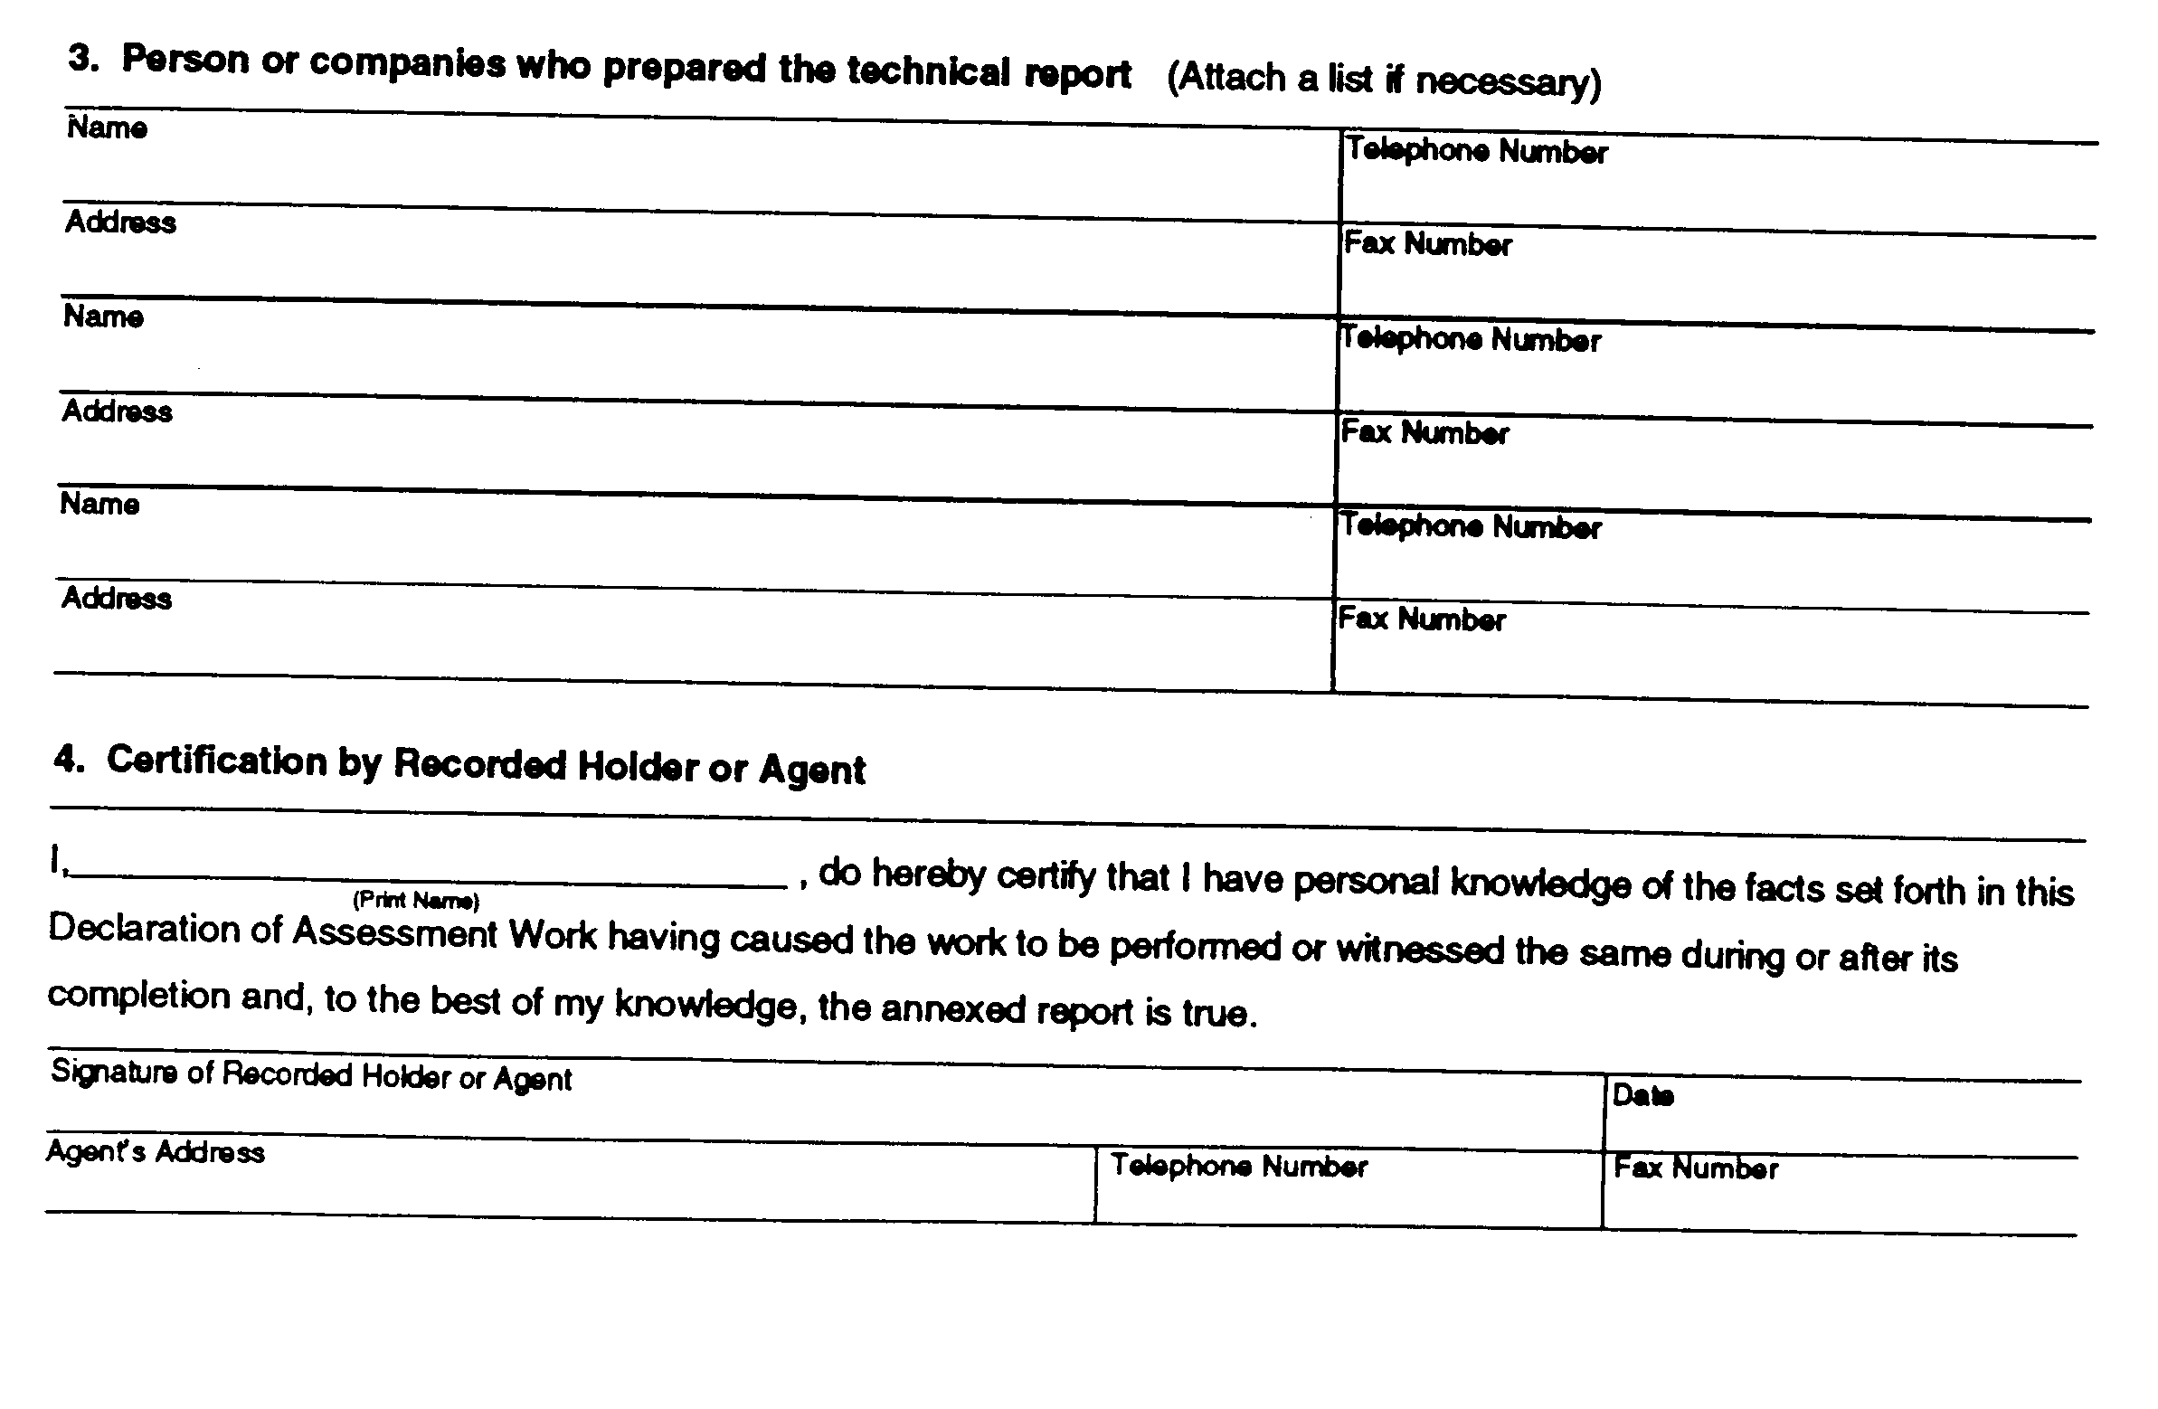
Insert regs\graphics\1991\111\111003ce.tif
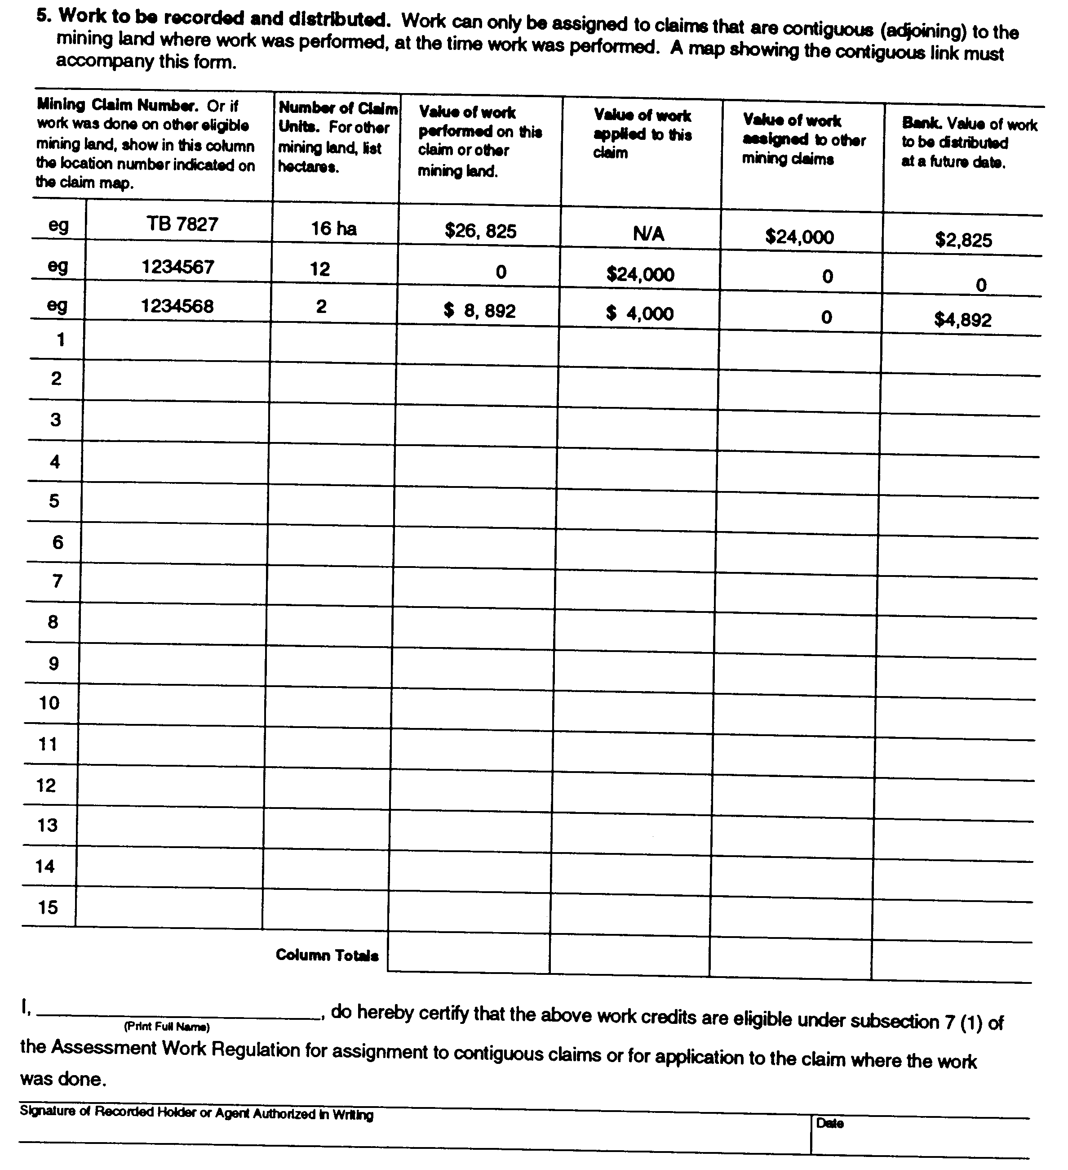
Insert regs\graphics\1991\111\111003de.tif
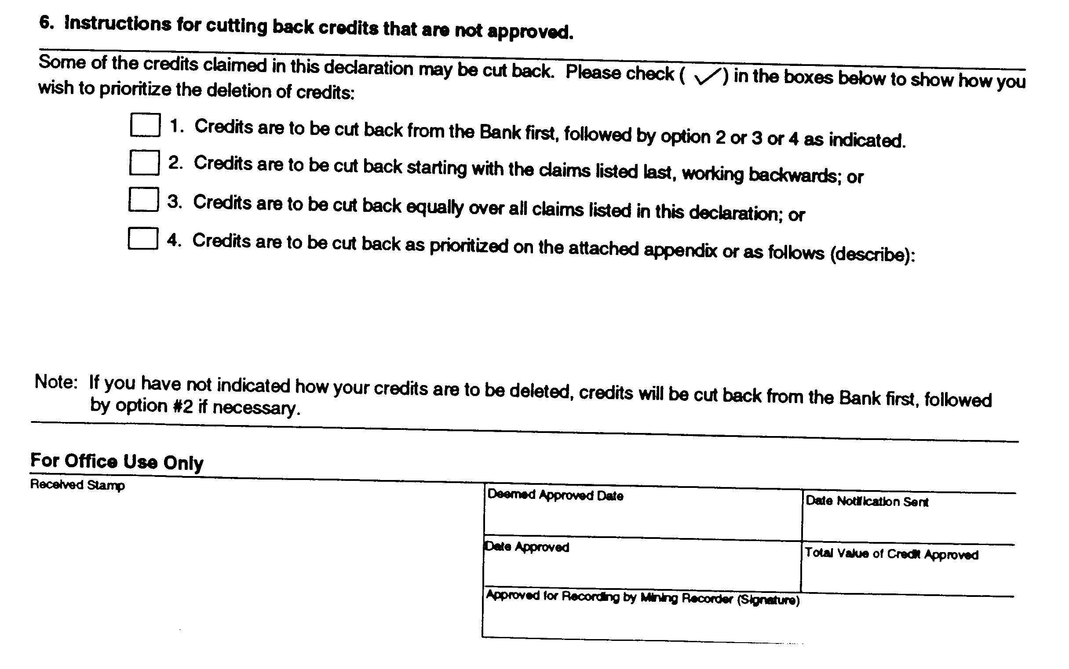
O. Reg. 503/96, s. 3.
Form 4
declaration of assessment work performed on crown lands
Mining Act
Insert regs\graphics\1991\111\111004ae.tif
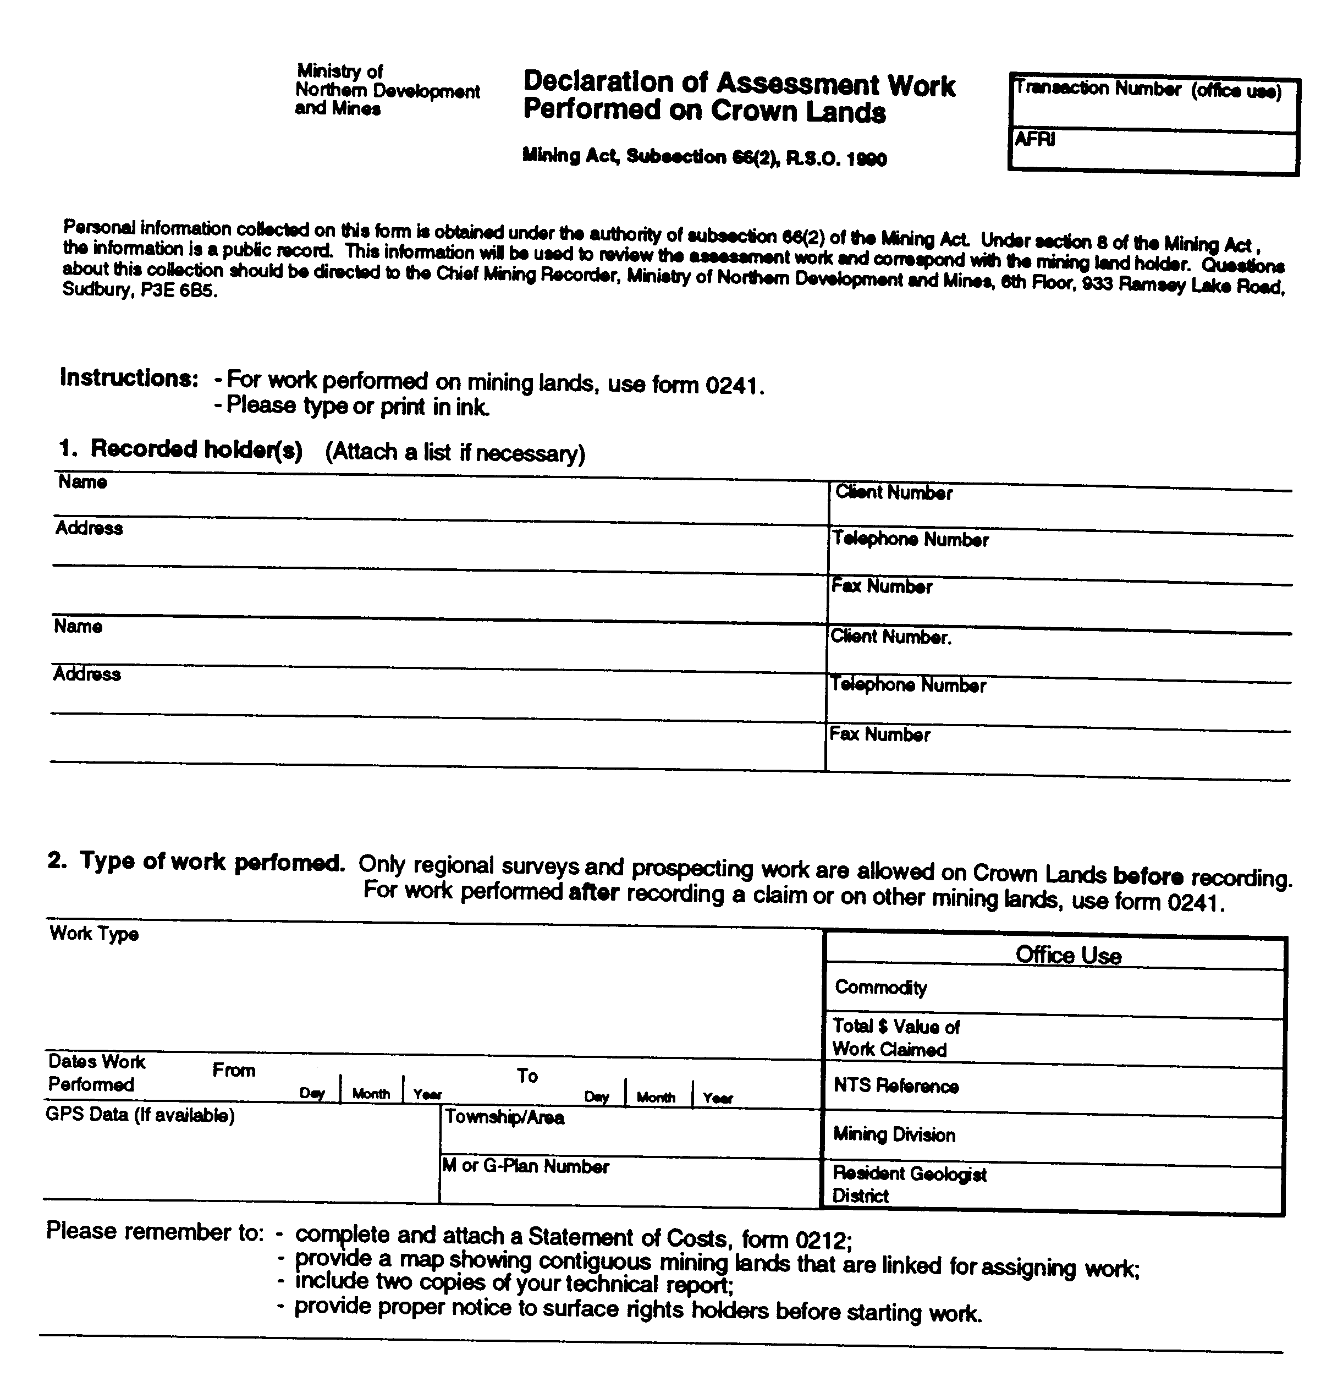
Insert regs\graphics\1991\111\111004be.tif
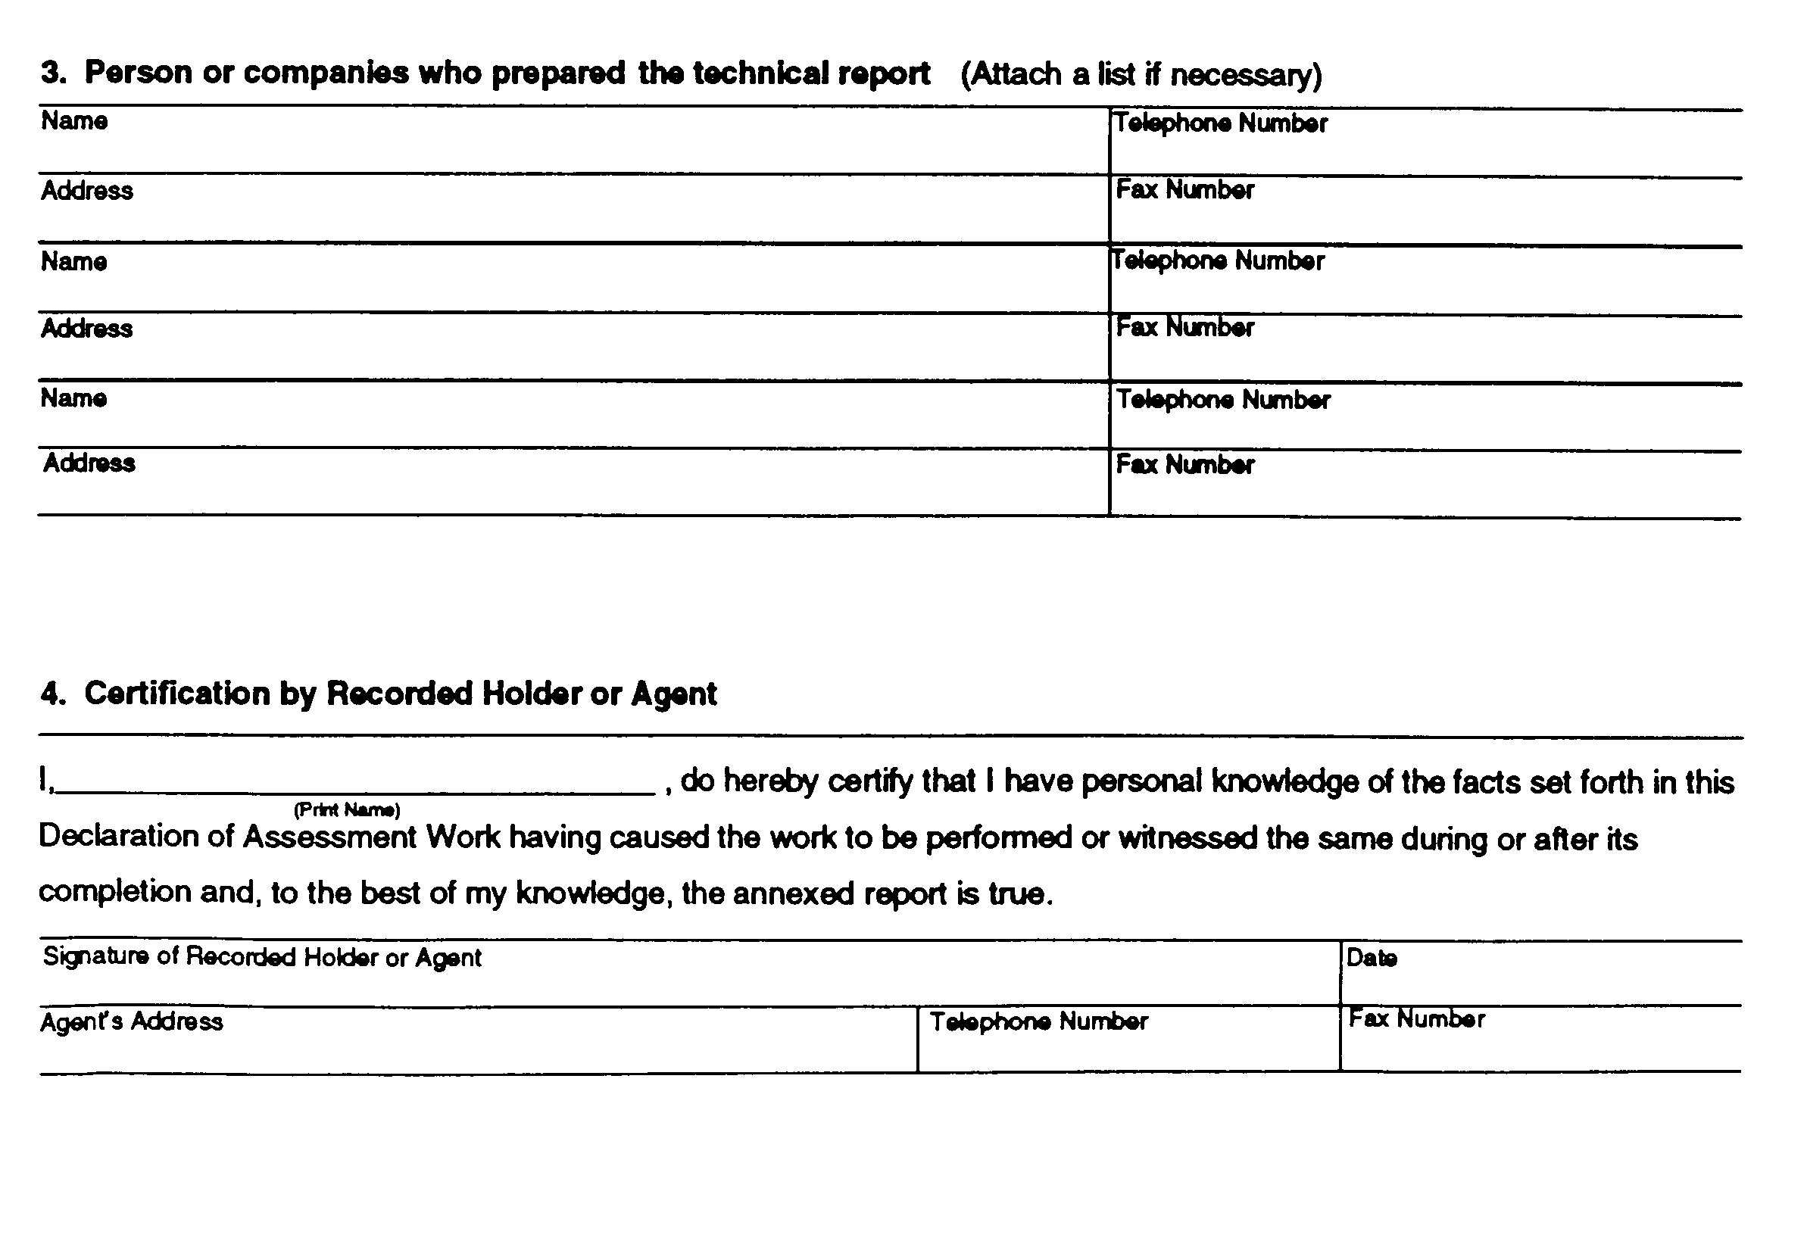
Insert regs\graphics\1991\111\111004ce.tif
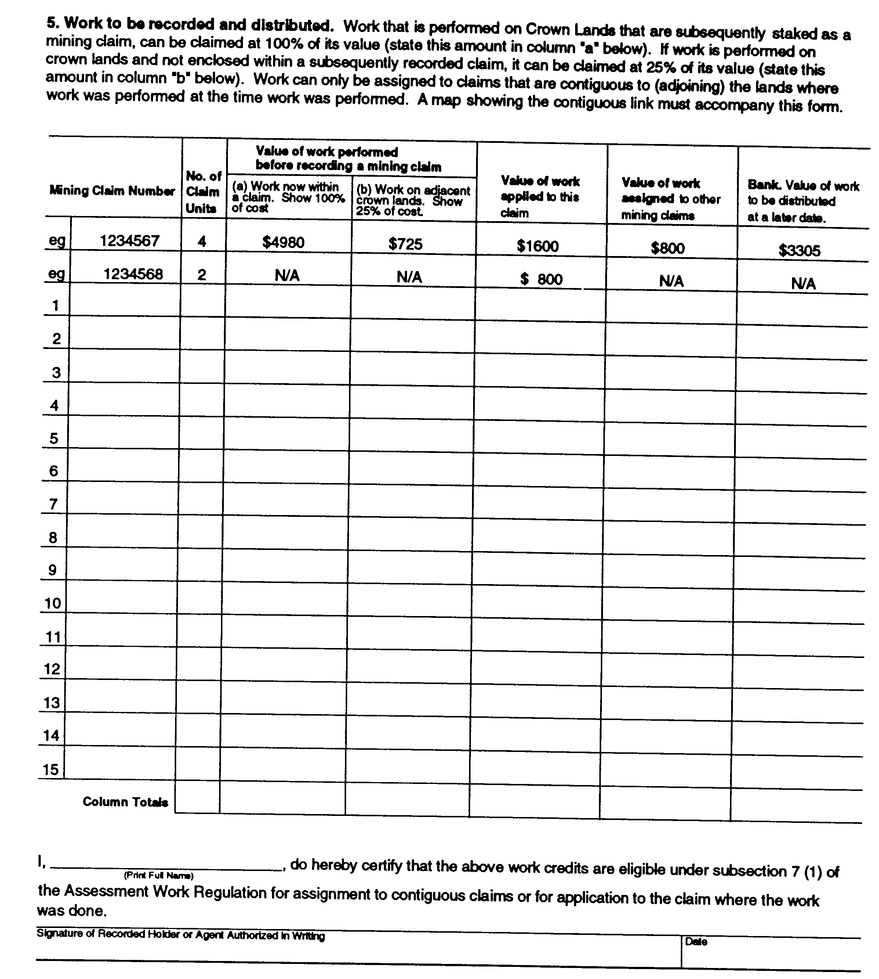
Insert regs\graphics\1991\111\111004de.tif
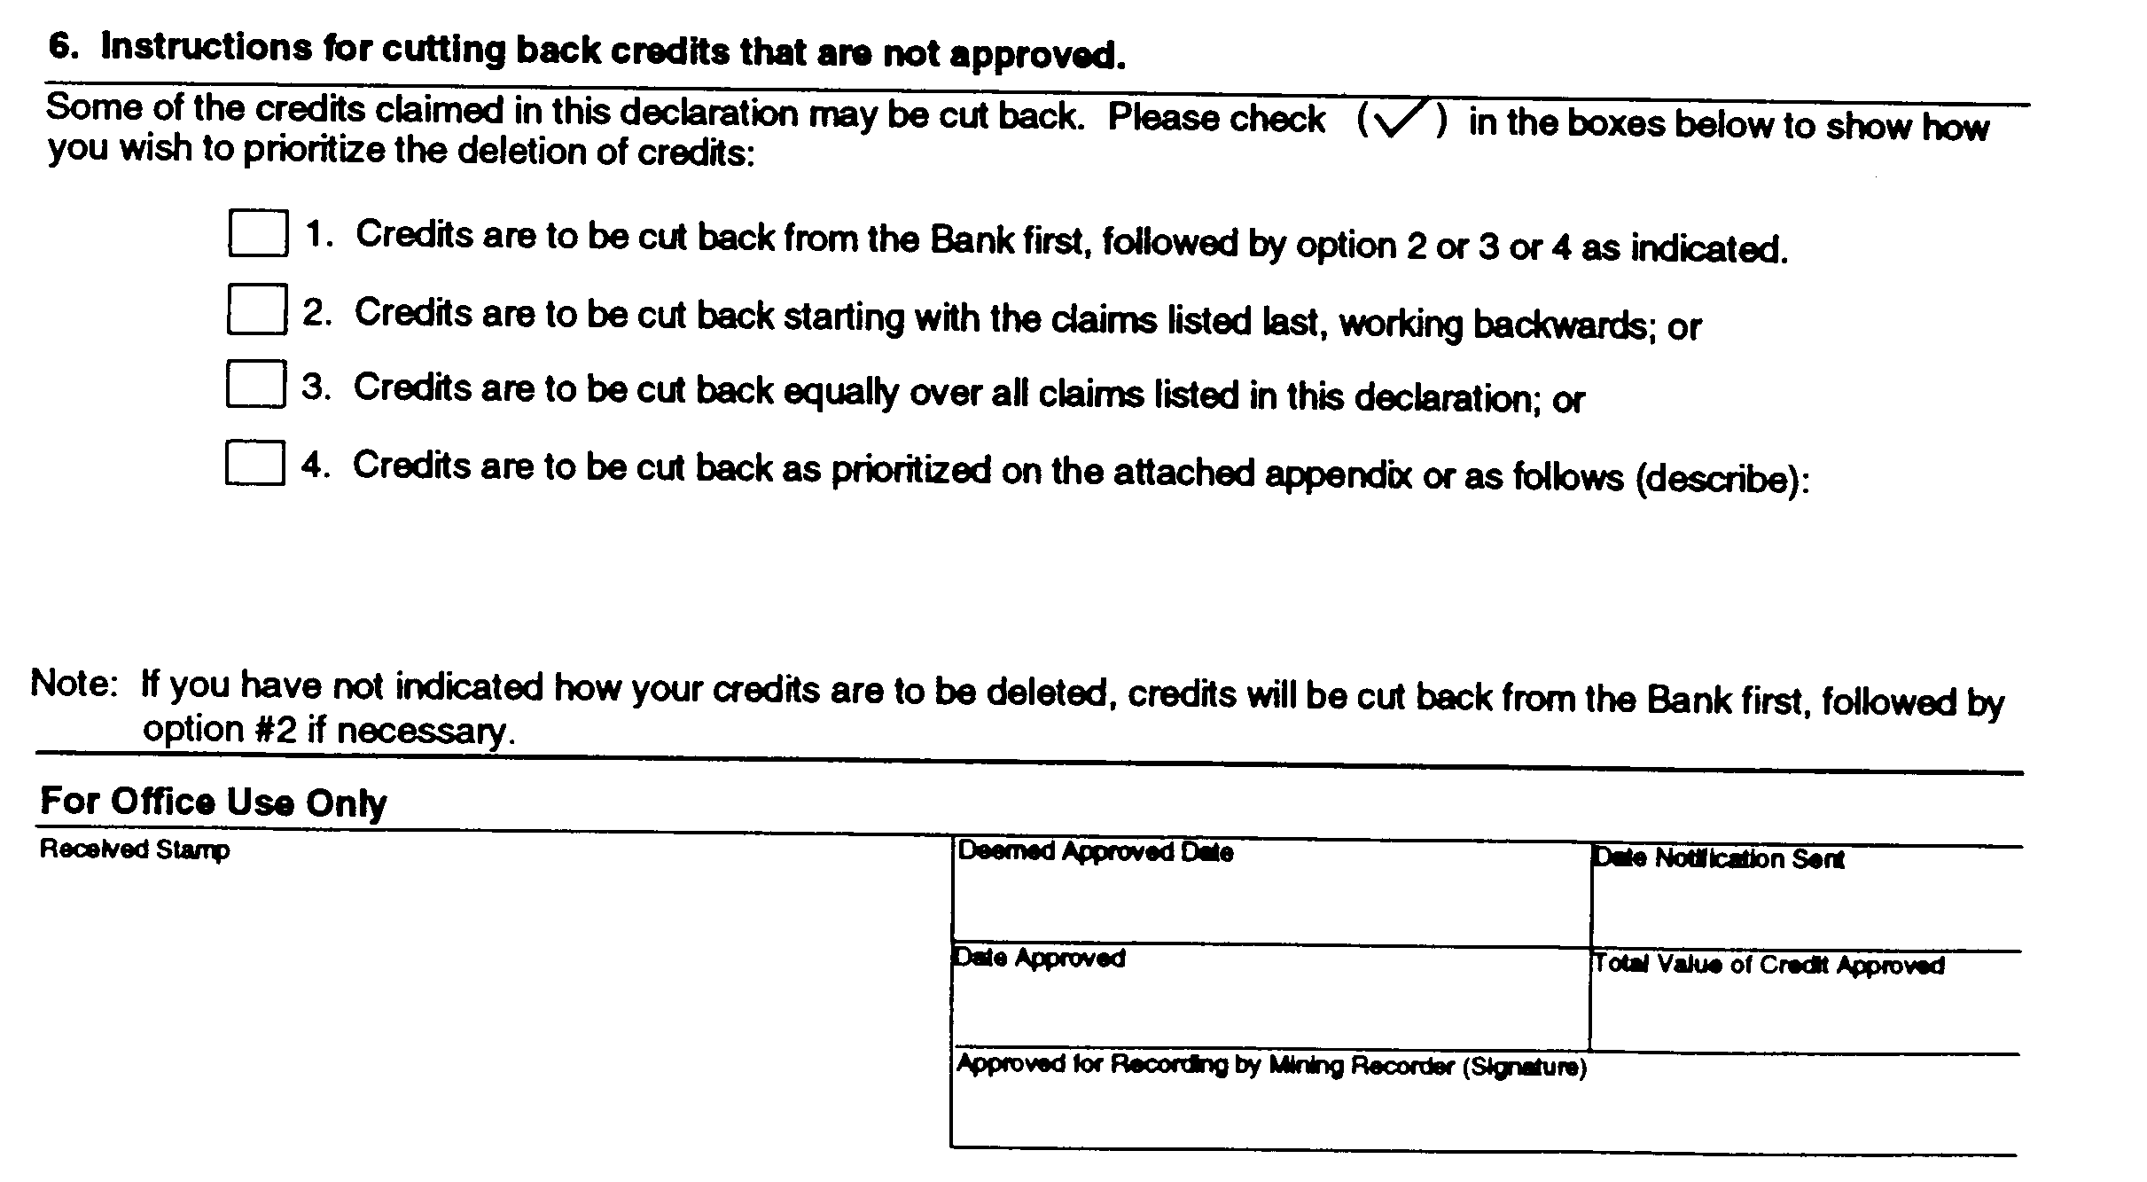
O. Reg. 503/96, s. 3.
Form 5
notice of intention to perform assessment work
Mining Act
Insert regs\graphics\1991\111\111005ae.tif
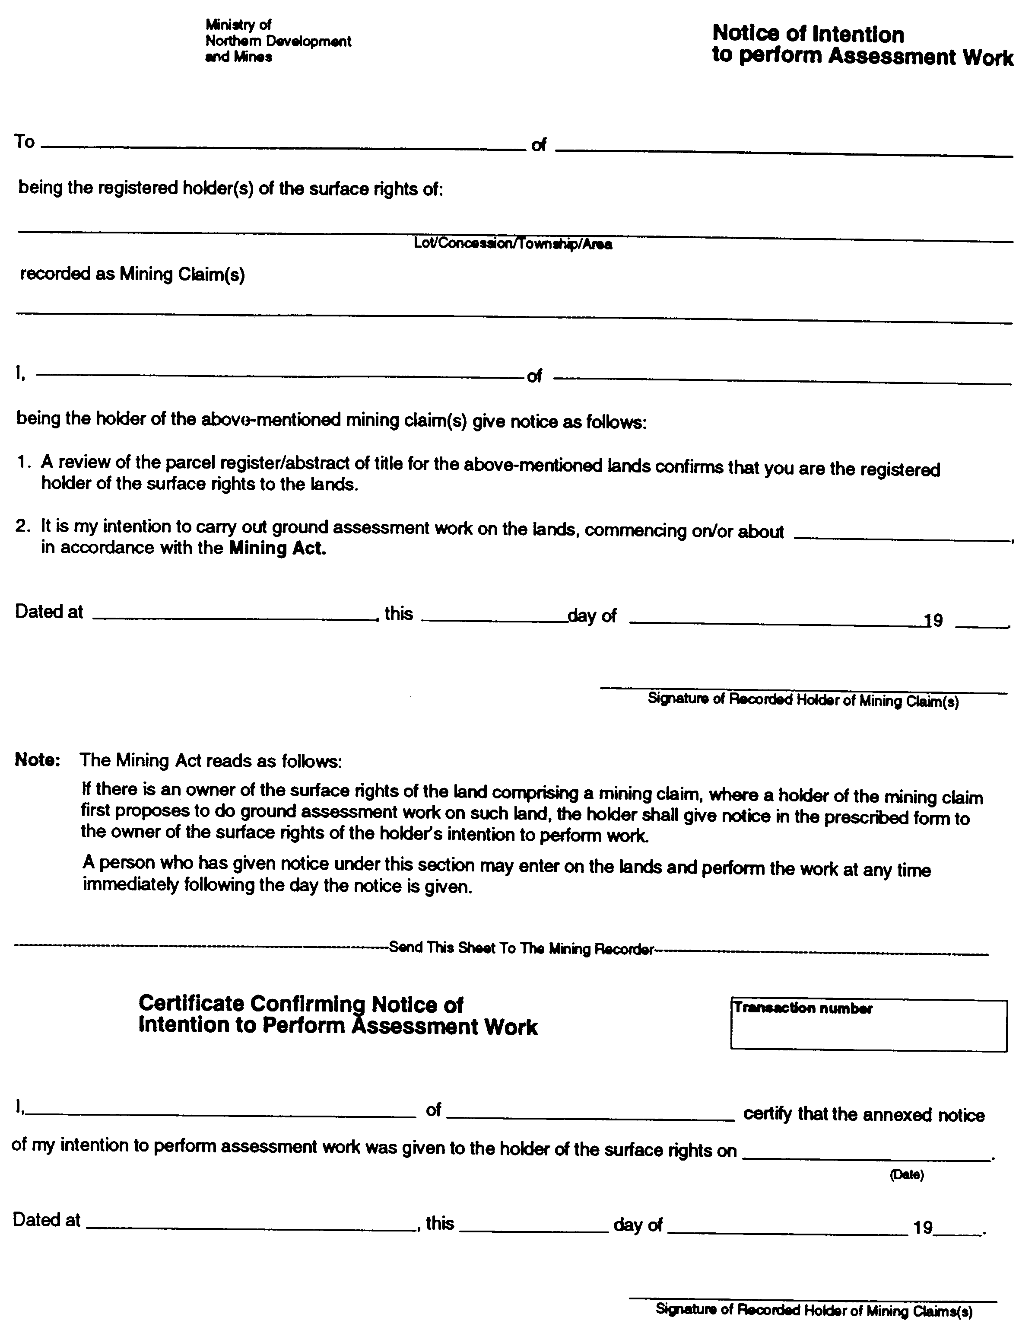
O. Reg. 503/96, s. 3.
Form 6
NOTICE OF PROJECT STATUS
Mining Act
Insert regs\graphics\1991\111\111006ae.tif
Insert regs\graphics\1991\111\111006be.tif
O. Reg. 241/00, s. 4.
Form 7
NOTICE OF MATERIAL CHANGES
Mining Act
Insert regs\graphics\1991\111\111007ae.tif
Insert regs\graphics\1991\111\111007be.tif
O. Reg. 241/00, s. 4.
Form 8
INSPECTION WARRANT (Subsection 146 (5))
Mining Act
Insert regs\graphics\1991\111\111008ae.tif
Insert regs\graphics\1991\111\111008be.tif
O. Reg. 241/00, s. 4.
Form 9
SEARCH WARRANT (Subsection 146 (6))
Mining Act
Insert regs\graphics\1991\111\111009ae.tif
O. Reg. 241/00, s. 4.
Form 10
NOTICE TO REQUIRE HEARING UNDER PART VII OF THE ACT
Mining Act
Insert regs\graphics\1991\111\111010ae.tif
O. Reg. 241/00, s. 4.
FormS 11-24 Revoked: O. Reg. 503/96, s. 3.
FormS 25-29 Revoked: O. Reg. 241/00, s. 5.
FormS 30-32 Revoked: O. Reg. 503/96, s. 4.
FormS 33, 34 Revoked: O. Reg. 241/00, s. 5.

Français

Back to top

