Français
Courts of Justice Act
ONTARIO REGULATION 704/91
Amended to O. Reg. 655/00
TORONTO FAMILY CASE MANAGEMENT RULES
Note: This Regulation was revoked on December 31, 2000. See O. Reg. 655/00, r. 6.03 (2).
This is the English version of a bilingual regulation.
RULE 1 — APPLICATION AND INTERPRETATION OF RULES
FAMILY CASE MANAGEMENT RULES
Scope
1.01 (1) These rules apply to proceedings in the Superior Court of Justice and the Ontario Court of Justice that are commenced in the part of the City of Toronto that was known as the City of Toronto before January 1, 1998 and belong to the following categories:
1. Proceedings under the Change of Name Act, Part III or VII of the Child and Family Services Act, the Children’s Law Reform Act, the Divorce Act (Canada), the Family Law Act, the Family Support Plan Act, the Marriage Act and the Reciprocal Enforcement of Support Orders Act.
2. Proceedings for the interpretation, enforcement or variation of a marriage contract, cohabitation agreement, separation agreement or paternity agreement.
3. Proceedings for relief by way of constructive or resulting trust or a monetary award as compensation for unjust enrichment between persons who have cohabited.
4. Proceedings for the enforcement of a support order. O. Reg. 483/94, s. 1 (1); O. Reg. 626/98, s. 1; O. Reg. 543/99, s. 1 (1).
(1.1) Revoked: O. Reg. 483/94, s. 1 (1).
Ordinary rules of court
(2) The Rules of Civil Procedure or the Family Law Rules, as the case may be, also apply to proceedings to which these rules apply, but these rules prevail in the event of conflict. O. Reg. 704/91, r. 1.01 (2); O. Reg. 543/99, s. 1 (2).
Time
(3) A time prescribed under these rules, the Rules of Civil Procedure or the Family Law Rules may be extended only by order of the case management judge. O. Reg. 704/91, r. 1.01 (3); O. Reg. 543/99, s. 1 (3).
(4) Revoked: O. Reg. 483/94, s. 1 (2).
Format of documents
(5) The forms prescribed in these rules and notices and orders referred to in these rules may be single spaced, may bear the short title of the proceeding and need not have a backsheet. O. Reg. 704/91, r. 1.01 (5).
Registrar’s notices
(6) Notices sent by the registrar under these rules may be printed on coloured paper. O. Reg. 704/91, r. 1.01 ( 6).
PURPOSE
1.02 The purpose of these rules is to establish a case management system that reduces unnecessary cost and delay in family litigation, facilitates early and fair settlements and brings proceedings expeditiously to a just determination while allowing sufficient time for the conduct of the proceeding. O. Reg. 704/91, r. 1.02.
DEFINITIONS
1.03 In these rules,
“applicant” includes a petitioner, a plaintiff, a respondent who makes a claim and a defendant who makes a counterclaim, crossclaim or third or subsequent party claim; (“requérant”)
“case management judge” means the judge assigned to manage a proceeding under subrule 2.02 (1) or 3.01 (2) or clause 3.01 (6) (c); (“juge responsable de la gestion de la cause”)
“defence” includes an answer; (“défense”)
“originating document” means a notice of application in the Superior Court of Justice, an application in the Ontario Court of Justice, a petition, statement of claim, notice of action, counterclaim, claim by respondent, counterpetition, crossclaim or third or subsequent party claim; (“document introductif”)
“registrar” means a registrar or clerk of the court; (“greffier”)
“respondent” includes a defendant; (“intimé”)
“rules of court” means the Rules of Civil Procedure or the Family Law Rules, as the case may be. (“règles de pratique”) O. Reg. 704/91, r. 1.03; O. Reg. 483/94, s. 1 (3); O. Reg. 543/99, s. 2.
MATTERS NOT PROVIDED FOR
1.04 If matters are not provided for in these rules, the practice shall be determined by analogy to them. O. Reg. 704/91, r. 1.04.
RULE 2 — GENERAL PROCEDURE
COMMENCEMENT OF PROCEEDING — SUPERIOR COURT OF JUSTICE
Case information statement — Superior Court of Justice
2.01 (1) In the Superior Court of Justice, on filing an originating document, the application shall file in duplicate a case information statement (Form 1). O. Reg. 483/94, s. 2 (1); O. Reg. 543/99, s. 3 (3).
Statement mandatory
(2) The registrar shall not accept an originating document without the case information statement. O. Reg. 483/94, s. 2 (1).
ASSIGNMENT OF PROCEEDINGS TO CASE MANAGEMENT
Registrar’s duty
2.02 (1) The registrar shall assign all proceedings to case management. O. Reg. 483/94, s. 2 (2).
Warning
(2) When an originating document is issued or filed, the registrar shall attach to it a warning that the proceeding will be subject to case management by the court, and shall give the applicant a copy of the warning for service on each respondent. O. Reg. 483/94, s. 2 (2).
TIMETABLE
Prepared by registrar
2.03 (1) On the commencement of a proceeding, the registrar shall give the applicant a timetable that sets maximum times for the proceeding in accordance with Schedule A. O. Reg. 483/94, s. 2 (3).
Given to client
(2) The applicant’s solicitor shall give a copy of the timetable forthwith to his or her client. O. Reg. 704/91, r. 2.03 (2).
Service
(3) The case information statement, the timetable, the warning and the originating document shall be served together. O. Reg. 704/91, r. 2.03 (3).
FAILURE TO COMPLY WITH TIMETABLE — ONTARIO COURT OF JUSTICE
Powers of case management judge
2.04 (1) In the Ontario Court of Justice, where a party fails to comply with a timetable, the case management judge may,
(a) convene a case conference;
(b) amend the timetable and order the party to comply with the amended timetable;
(c) strike out any document filed by the party;
(d) dismiss the party’s proceeding or strike out the party’s defence;
(e) order the party or his or her solicitor to pay costs, including solicitor and client costs fixed and payable forthwith; and
(f) make any other order that is just. O. Reg. 704/91, r. 2.04 (1); O. Reg. 483/94, s. 2 (5); O. Reg. 543/99, s. 4 (2).
Late filings generally not accepted
(2) In the Ontario Court of Justice, the registrar shall not accept a document for filing after the expiry of a time prescribed under these rules, except by direction of the case management judge. O. Reg. 543/99, s. 4 (3).
Late filing of proof of service
(3) Despite subrule (2), proof of service of an originating document may be filed at any time, except that where the time for filing proof of service has been extended by order, proof of service may be filed after the time prescribed in the order only by direction of the case management judge. O. Reg. 704/91, r. 2.04 (3); O. Reg. 483/94, s. 2 (7).
failure to comply with timetable — SUPERIOR COURT OF JUSTICE
Powers of registrar
2.05 (1) In the Superior Court of Justice, where a party fails to comply with a timetable, the registrar shall serve a notice on the parties that the proceeding will be dismissed without further notice unless, within 30 days after service of the notice, a party,
(a) sets the proceeding down for trial;
(b) files minutes of settlement; or
(c) requests a case conference. O. Reg. 483/94, s. 2 (8); O. Reg. 543/99, s. 5 (2).
Dismissal after 30 days
(2) If no party takes a step referred to in clause (1) (a), (b) or (c) within 30 days after service of the notice, the registrar shall dismiss the proceeding with costs. O. Reg. 483/94, s. 2 (8).
Registrar to serve dismissal order
(3) The registrar shall serve the order on the parties by mail, and the solicitor for a party shall immediately give a copy of the order to his or her client and file proof that this has been done. O. Reg. 483/94, s. 2 (8).
2.06 Revoked: O. Reg. 483/94, s. 2 (8).
2.07 Revoked: O. Reg. 483/94, s. 2 (8).
DEFENCE OF PROCEEDING — SUPERIOR COURT OF JUSTICE
Case information statement with defence
2.08 (1) In the Superior Court of Justice, the respondent shall serve and file a case information statement (Form 1) with any defence. O. Reg. 483/94, s. 2 (9); O. Reg. 543/99, s. 6 (2).
Refusal to accept defence
(2) The registrar shall not accept a defence without the case information statement. O. Reg. 483/94, s. 2 (9).
consolidation or hearing together or related proceedings
Consolidation
2.09 (1) Where the court orders, under the rules of court, that a proceeding to which these rules apply be consolidated with a proceeding to which they would not otherwise apply, these rules apply to the consolidated proceeding. O. Reg. 483/94, s. 2 (9).
Hearing together
(2) Where the court orders under the rules of court, that a proceeding to which these rules apply be heard at the same time as or immediately before or after a proceeding to which they would not otherwise apply, the case management judge may order that these rules apply to the other proceeding. O. Reg. 483/94, s. 2 (9).
Service of case management documents
(3) Where a proceeding becomes subject to these rules under subrule (1) or (2), the applicant in the proceeding originally subject to these rules shall forthwith serve the case information statements, timetable and warning on every party to the other proceeding who is not also a party to the proceeding originally subject to these rules. O. Reg. 483/94, s. 2 (9).
RULE 3 — CASE MANAGEMENT JUDGE AND CASE CONFERENCE
CASE MANAGEMENT JUDGE
Assignment — Ontario Court of Justice
3.01 (0.1) In the Ontario Court of Justice, a case management judge shall be assigned to a proceeding when it is commenced. O. Reg. 483/94, s. 3 (1); O. Reg. 543/99, s. 7 (2).
Assignment — Superior Court of Justice
(0.2) In the Superior Court of Justice, a case management judge shall be assigned to a proceeding the first time one of the following events occurs:
1. A party makes a motion on notice to another party and confirms in accordance with subrule (4.1) that the motion will be argued.
2, A party requests a case conference. O. Reg. 483/94, s. 3 (1); O. Reg. 543/99, s. 7 (4).
Duties
(1) The case management judge shall deal with all matters that arise in the proceeding before the hearing, including all motions, case conferences and settlement conferences. O. Reg. 704/91, r. 3.01 (1).
Substitution
(2) A substitute case management judge may be assigned to a proceeding at any time. O. Reg. 704/91, r. 3.01 (2).
Informal motion procedure
(3) A motion may be made to the case management judge, depending on the practical requirements of the situation,
(a) with or without supporting material or a motion record;
(b) by attendance, conference call, telephone call or telephone transmission, or in writing; and
(c) in the absence of the public, if the case management judge is of the opinion that it is impractical to have the motion heard in public. O. Reg. 704/91, r. 3.01 (3).
Motion without material
(4) Where a motion is made without supporting material or a motion record,
(a) a case management motion form (Form 2) signed by the moving party’s solicitor shall be submitted to the case management judge before the motion is heard;
(b) a case management motion form signed by the responding party’s solicitor may be submitted to the case management judge before the motion is heard;
(c) the case management judge shall record the disposition of the motion on the form;
(d) the registrar shall send a copy of the disposition of the motion to the parties unless the case management judge directs that a copy need not be sent; and
(e) no formal order need be prepared, signed or entered unless the case management judge directs it. O. Reg. 704/91, r. 3.01 (4); O. Reg. 483/94, s. 3 (2).
Confirmation of motion — Superior Court of Justice
(4.1) In the Superior Court of Justice, a party who makes a motion on notice to another party shall confirm with the registrar that the motion will be argued, by filing a confirmation (Form 3) not later than 2 p.m. two days before the hearing date. O. Reg. 483/94, s. 3 (1); O. Reg. 543/99, s. 7 (6).
Effect of failure to confirm
(4.2) If no confirmation is filed in accordance with subrule (4.1), the motion shall not be heard, except by order of a judge. O. Reg. 483/94, s. 3 (1).
Powers on own initiative
(5) The case management judge may, on his or her own initiative, require a hearing, case conference or conference call to deal with any matter arising in connection with case management, including a failure to comply with these rules or the rules of court. O. Reg. 704/91, r. 3.01 (5).
Powers generally
(6) The case management judge may,
(a) extend or abridge a time prescribed under an order, these rules or the rules of court;
(b) adjourn a case conference;
(c) delegate his or her authority to another judge;
(d) set aside an order made by the registrar under these rules;
(e) direct a reference under the rules of court; and
(f) make orders, impose terms and give directions as necessary to carry out the purpose of these rules. O. Reg. 704/91, r. 3.01 (6).
Motion for leave to appeal
(7) Despite subrule (1), a motion for leave to appeal from an order of the case management judge shall be made to another judge. O. Reg. 704/91, r. 3.01 (7).
Not to preside at hearing
(8) The case management judge shall not preside at the hearing of the proceeding. O. Reg. 704/91, r. 3.01 (8).
CASE CONFERENCE
Ontario Court of Justice — scheduled on commencement
3.02 (1) In the Ontario Court of Justice, the registrar shall schedule a case conference in accordance with Schedule A and shall include the date of the conference in the timetable for the proceeding. O. Reg. 483/94, s. 3 (3); O. Reg. 543/99, s. 8 (2).
Superior Court of Justice — scheduled on request
(2) In the Superior Court of Justice, the registrar shall schedule a case conference at a party’s request. O. Reg. 483/94, s. 3 (3); O. Reg. 543/99, s. 8 (4).
Notice and confirmation — Superior Court of Justice
(3) In the Superior Court of Justice, when a case conference is scheduled at a party’s request, the party shall,
(a) immediately serve a case conference notice (Form 4) on every other party; and
(b) confirm with the registrar that the conference is to take place, by filing, not later than 2 p.m. two days before the scheduled date, a confirmation (Form 3), failing which the registrar shall cancel the conference. O. Reg. 483/94, s. 3 (3); O. Reg. 543/99, s. 8 (6).
Case memorandum — Superior Court of Justice
(4) In the Superior Court of Justice, each party shall serve a case memorandum and file it with proof of service, not later than two days before a case conference, unless the case management judge directs that a party need not file a case memorandum. O. Reg. 483/94, s. 3 (3); O. Reg. 543/99, s. 8 (8).
Duties of judge
(4.1) At the conference, the case management judge shall,
(a) identify the issues, and note those that are contested and those that are not contested;
(b) explore methods (including alternative dispute resolution methods) to resolve the contested issues;
(c) if possible, secure the parties’ agreement to a specific schedule of events in the proceeding within the times listed in Schedule A;
(d) review and, if necessary, amend the timetable for the proceeding;
(e) set a date for the next appearance in court, unless the proceeding is disposed of at the conference; and
(f) complete a memorandum of outstanding issues. O. Reg. 483/94, s. 3 (3).
Parties to attend personally if directed
(4.2) The parties shall attend the conference personally if the case management judge so directs. O. Reg. 483/94, s. 3 (3).
Counsel
(4.3) Counsel attending the conference shall be the counsel who will appear at the hearing, shall have authority to deal with the matters referred to in subrule (4.1) and shall be fully acquainted with the facts and legal issues. O. Reg. 483/94, s. 3 (3).
Powers of judge
(5) At the conference, the case management judge may, where appropriate,
(a) make a procedural order;
(b) make an order for interim relief;
(c) on consent of the parties, refer any issue for alternative dispute resolution;
(d) convene a settlement conference;
(e) convene a hearing; and
(f) give directions. O. Reg. 704/91, r. 3.02 (5).
Subsequent conferences
(6) Subsequent conferences may be convened on the case management judge’s initiative or at the request of a party. O. Reg. 704/91, r. 3.02 (6).
Amending timetable
(7) A party seeking to amend the timetable for the proceeding at a case conference shall notify the other parties of the proposed amendment and the reason for it before requesting the conference and, where the other parties consent to the proposed amendment, the consent shall be filed. O. Reg. 704/91, r. 3.02 (7).
RULE 4 — STEPS BEFORE HEARING
PRE-TRIAL CONFERENCE — SUPERIOR COURT OF JUSTICE
Application of rule
4.01 (0.1) This rule applies only to actions in the Superior Court of Justice. O. Reg. 543/99, s. 9 (2).
Action on trial list
(1) Counsel shall, within 30 days after an action is placed on the trial list, make arrangements with the registrar for a pre-trial conference, failing which the registrar shall set a date and the conference shall take place on that date unless the case management judge orders otherwise. O. Reg. 483/94, s. 4 (2); O. Reg. 543/99, s. 9 (4).
Case memorandum
(2) The applicant, or any other party by direction of the case management judge or by agreement of the parties, shall serve and file with proof of service a case memorandum and a record for the hearing (containing all pleadings, financial statements and net family property statements and all other material the party considers necessary for the pre-trial or settlement conference), not later than 10 days before the conference. O. Reg. 483/94, s. 4 (2); O. Reg. 543/99, s. 9 (5).
Other parties to deliver memoranda
(2.1) Every other party shall serve and file with proof of service a case memorandum containing any other material the party considers necessary for the pre-trial or settlement conference, not later than five days before the conference. O. Reg. 483/94, s. 4 (2).
Expert reports
(3) A party’s case memorandum shall also contain a copy of all expert reports intended for use at the hearing and, in the case of an expert who has not yet provided a report, a summary of the evidence that the expert is expected to give at the hearing. O. Reg. 704/91, r. 4.01 (3); O. Reg. 483/94, s. 4 (3).
Expert reports not disclosed
(4) An expert report that was not served or in respect of which a summary of evidence was not provided at the pre-trial or settlement conference may be introduced at the hearing only with permission of the presiding judge, on any terms he or she considers appropriate, and the judge shall give permission to introduce the report unless prejudice will result that cannot be compensated for by costs or an adjournment. O. Reg. 704/91, r. 4.01 (4); O. Reg. 483/94, s. 4 (4).
Confirmation of conference
(4.1) The parties shall confirm with the registrar that the pre-trial conference will take place, by jointly filing a confirmation (Form 3) not later than 2 p.m. two days before the scheduled date, failing which the registrar shall cancel the conference. O. Reg. 483/94, s. 4 (5); O. Reg. 543/99, s. 9 (7).
(5) Revoked: O. Reg. 483/94, s. 4 (6).
PREPARATION FOR HEARING
Completion before pre-trial or settlement conference
4.02 (1) All forms of discovery and disclosure before a hearing required or permitted by the rules of court shall be completed before the pre-trial or settlement conference, and a party may not require further discovery or disclosure without an order. O. Reg. 483/94, s. 4 (7).
No motions after pre-trial or settlement conference
(2) No motion may be made after a pre-trial or settlement conference, except with the permission of the case management judge. O. Reg. 483/94, s. 4 (8).
(3) Revoked: O. Reg. 483/94, s. 4 (8).
(4) Revoked: O. Reg. 483/94, s. 4 (8).
(5) Revoked: O. Reg. 483/94, s. 4 (8).
RULE 5 — FAMILY CASE MANAGEMENT ADVISORY COMMITTEE
FAMILY CASE MANAGEMENT ADVISORY COMMITTEE
Establishment
5.01 (1) There shall be a Family Case Management Advisory Committee to monitor the operation of these rules and to recommend to the appropriate authorities, including the Family Rules Committee, changes in policies and procedures necessary to facilitate case management. O. Reg. 704/91, r. 5.01 (1).
Composition
(2) The committee shall consist of,
(a) two judges of the Superior Court of Justice, chosen by the court’s regional senior judge for the Toronto region;
(b) two judges of the Ontario Court of Justice, chosen by the court’s regional senior judge for the Toronto region;
(c) two persons chosen by the Advocates’ Society;
(d) two persons chosen by the Canadian Bar Association — Ontario;
(e) two persons chosen by the County of York Law Association; and
(f) two persons employed in the administration of the courts, chosen by the Regional Director of Courts Administration for the Toronto region. O. Reg. 704/91, r. 5.01 (2); O. Reg. 543/99, s. 10.
RULE 6 — CITATION
SHORT TITLE
6.01 These rules may be cited as the Toronto Family Case Management Rules. O. Reg. 704/91, r. 6.01.
Schedule A
NOTE: The time periods for steps in a proceeding are cumulative and are counted from the commencement of the proceeding.
1. Proceedings in the Ontario Court of Justice under the Children’s Law Reform Act and the Family Law Act.
Step in the proceeding | To be completed within not more than
Service and filing proof of service of originating document | 30 days
Filing of defence | 70 days
Case conference | 80 days
Settlement conference (by which time all discovery and assessments are to be completed) | 170 days
Hearing | 230 days
. . . . .
3. All other proceedings in the Ontario Court of Justice.
Step in the proceeding | To be completed within not more than
Service and filing proof of service of originating document | 45 days
Case conference | 80 days
Settlement conference | 100 days
Hearing | 120 days

4. All proceedings in the Superior Court of Justice.
Step in the proceeding | To be completed within not more than
Setting down for hearing | 230 days
O. Reg. 483/94, s. 6; O. Reg. 543/99, s. 11.
Form 1
Courts of Justice Act
Insert regs\graphics\1991\704\704001ae.tif

O. Reg. 483/94, s. 7; O. Reg. 543/99, s. 12 (1).
Form 2
Courts of Justice Act
Insert regs\graphics\1991\704\704002ae.tif
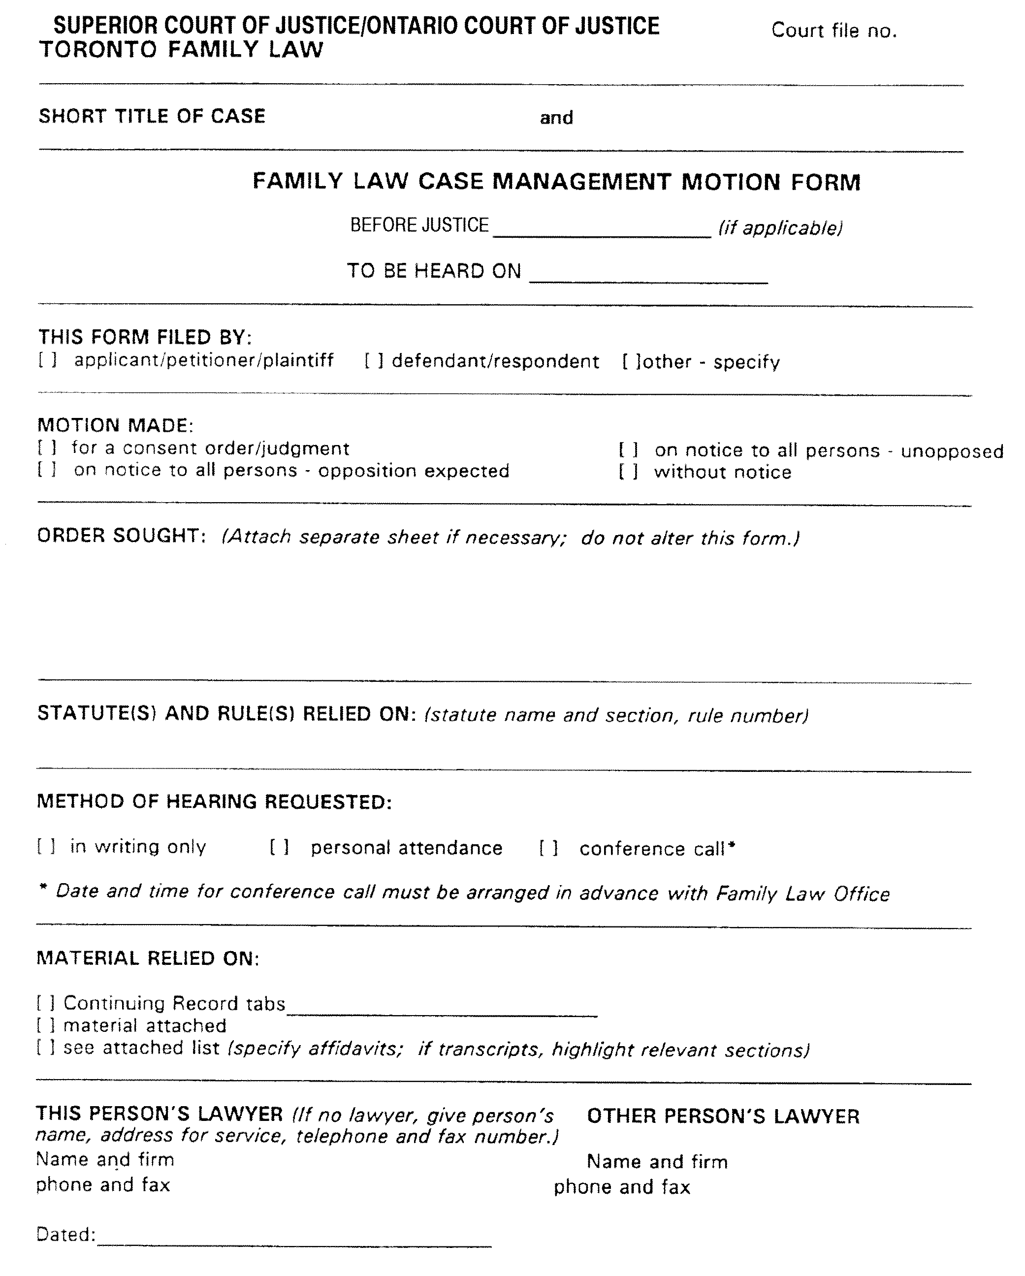

Insert regs\graphics\1991\704\704002be.tif
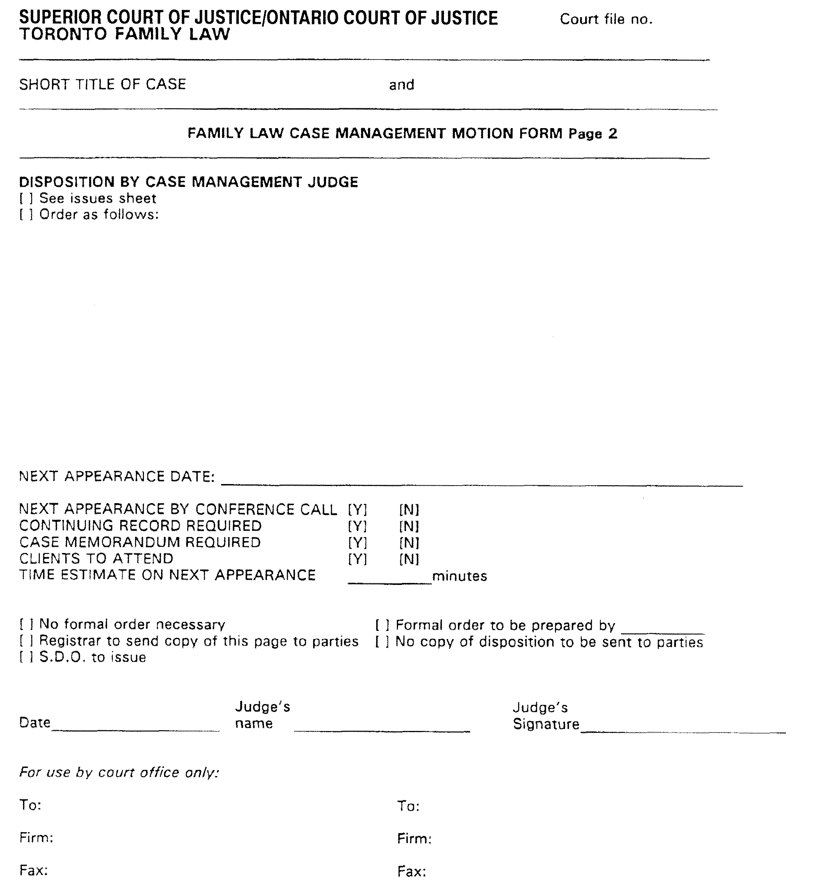
O. Reg. 483/94, s. 7; O. Reg. 543/99, s. 12 (2, 3).
Form 3
Courts of Justice Act
Insert regs\graphics\1991\704\704003ae.tif
O. Reg. 483/94, s. 7; O. Reg. 543/99, s. 12 (1).
Form 4
Courts of Justice Act
Insert regs\graphics\1991\704\704004ae.tif
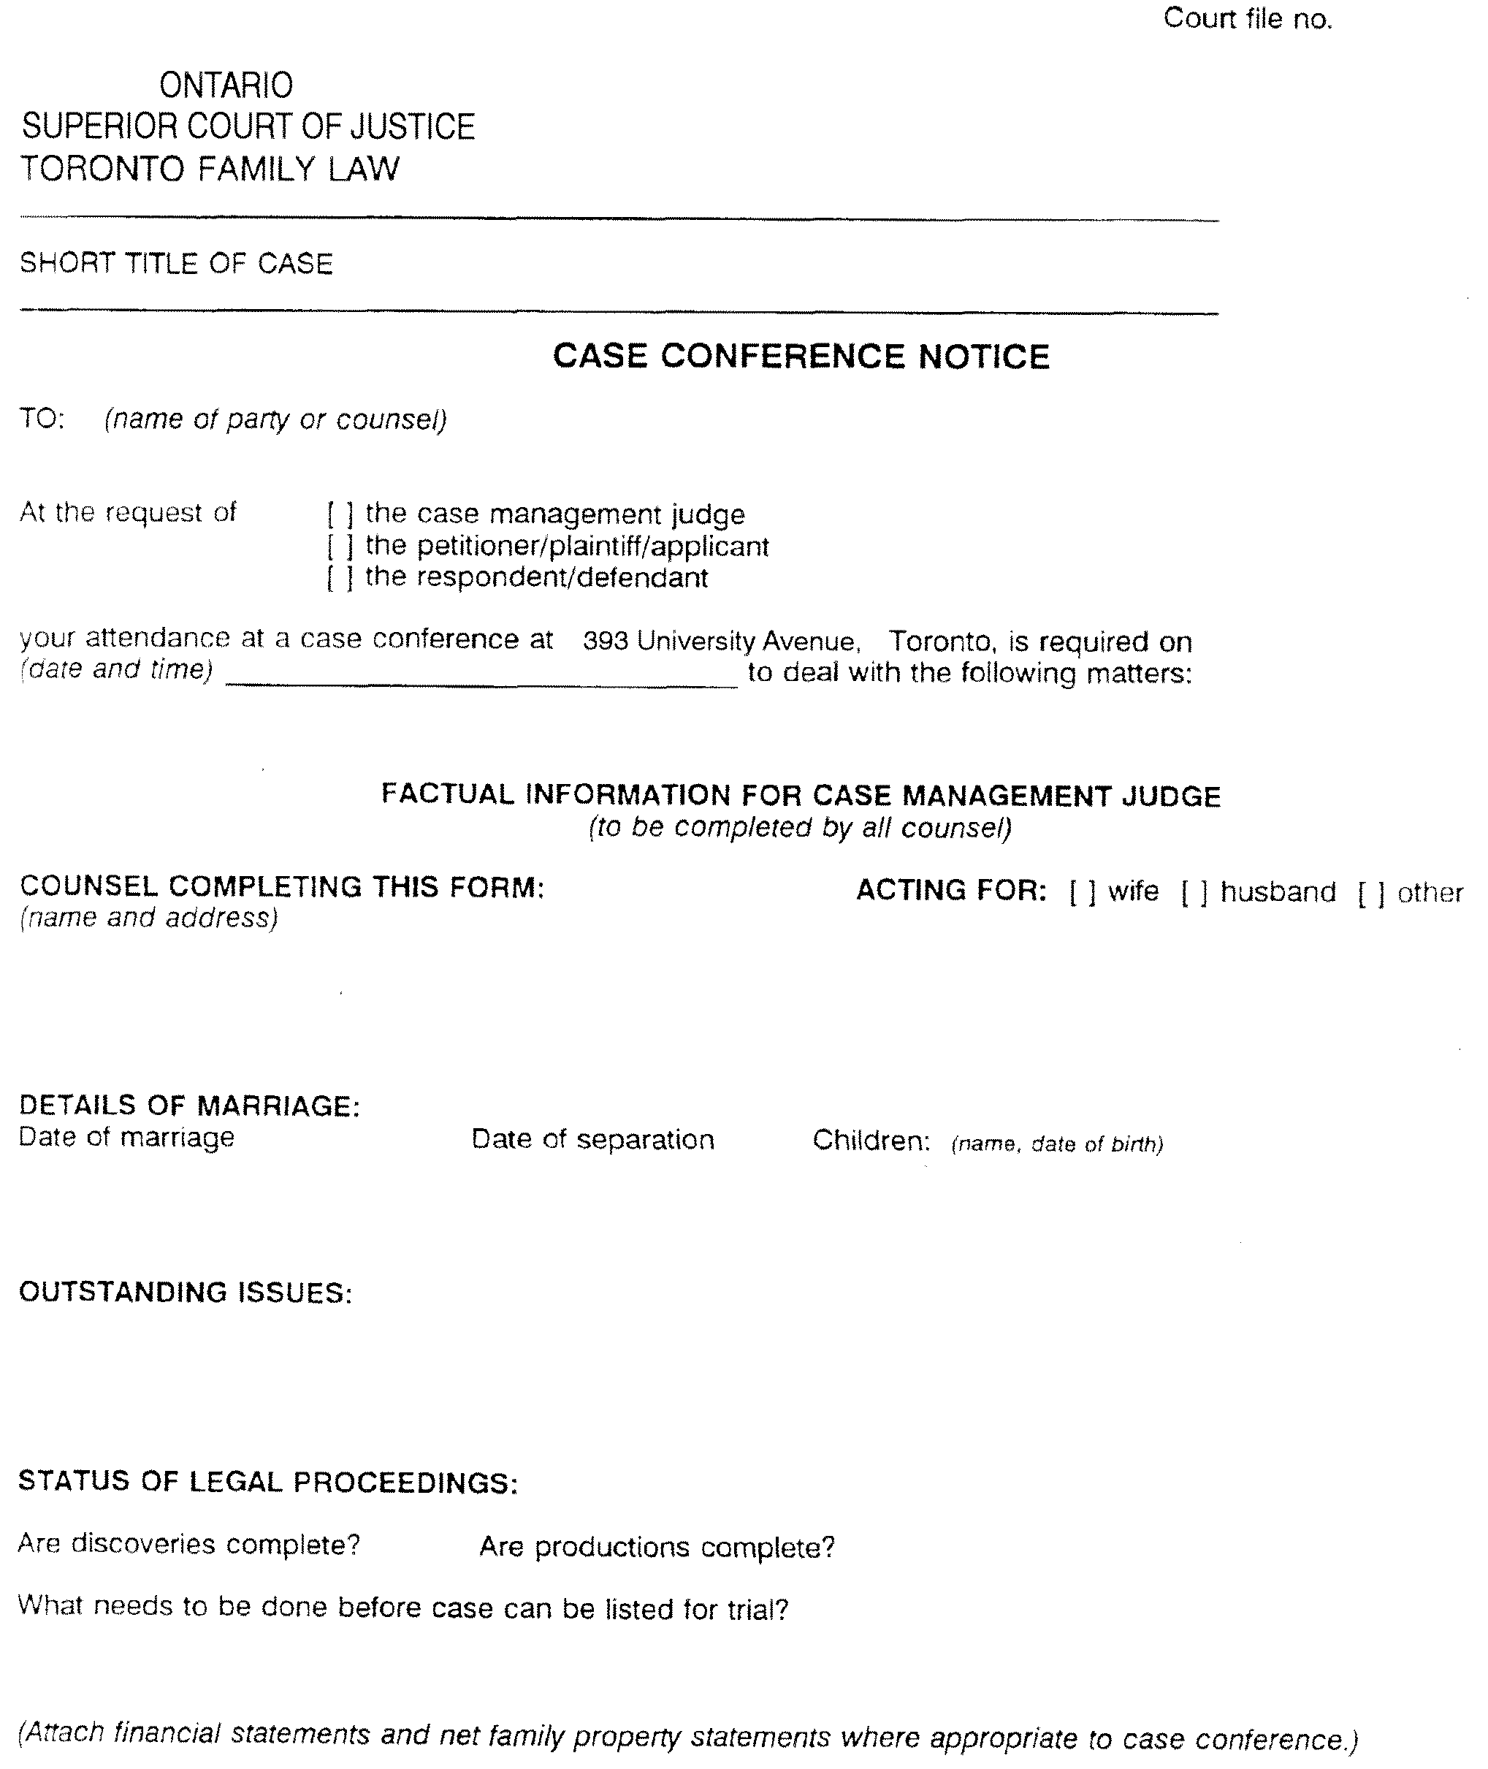

O. Reg. 483/94, s. 7; O. Reg. 543/99, s. 12 (1, 4).
Form 5 Revoked: O. Reg. 483/94, s. 7.

Français

Back to top

