Environmental Protection Act
Loi sur la protection de l’environnement
ONTARIO REGULATION 14/92
Amended to: O. Reg. 24/01
FORMS
Note: This Regulation was revoked on February 8, 2001. See: O. Reg. 24/01, s. 2.
This Regulation is made in English only.
1. A certificate of prohibition under subsection 197 (2) of the Act shall be in Form 1. O. Reg. 14/92, s. 1.
2. A certificate of withdrawal of prohibition under subsection 197 (5) of the Act shall be in Form 2. O. Reg. 14/92, s. 2.
Form 1
Formule 1
Environmental Protection Act
Loi sur la protection de l’environnement
Insert regs\graphics\1992\14\014001ab.tif
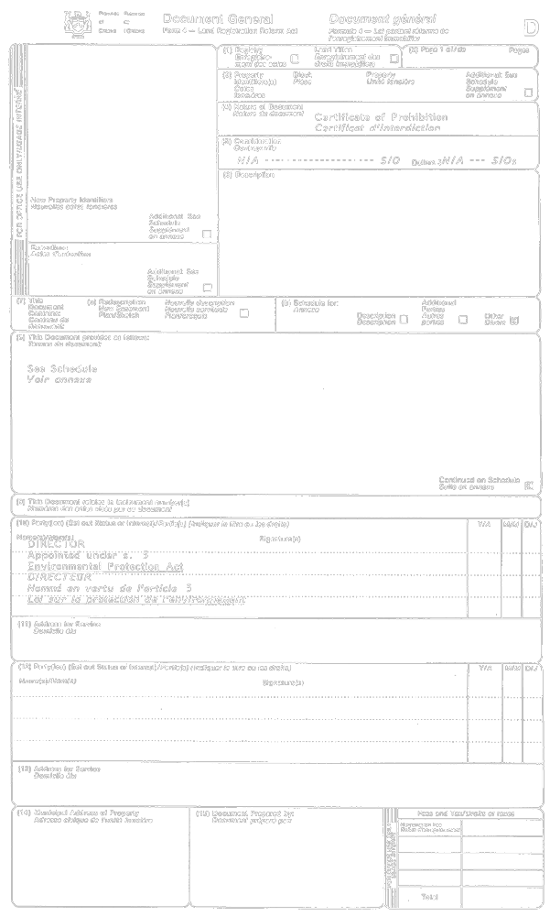
Insert regs\graphics\1992\14\014001bb.tif
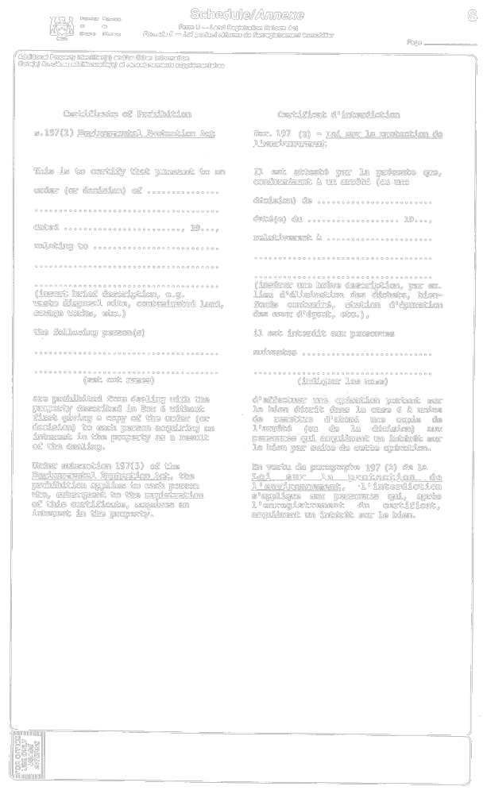
O. Reg. 14/92, Form 1.
Form 2
Formule 2
Environmental Protection Act
Loi sur la protection de l’environnement
Insert regs\graphics\1992\14\014002ab.tif
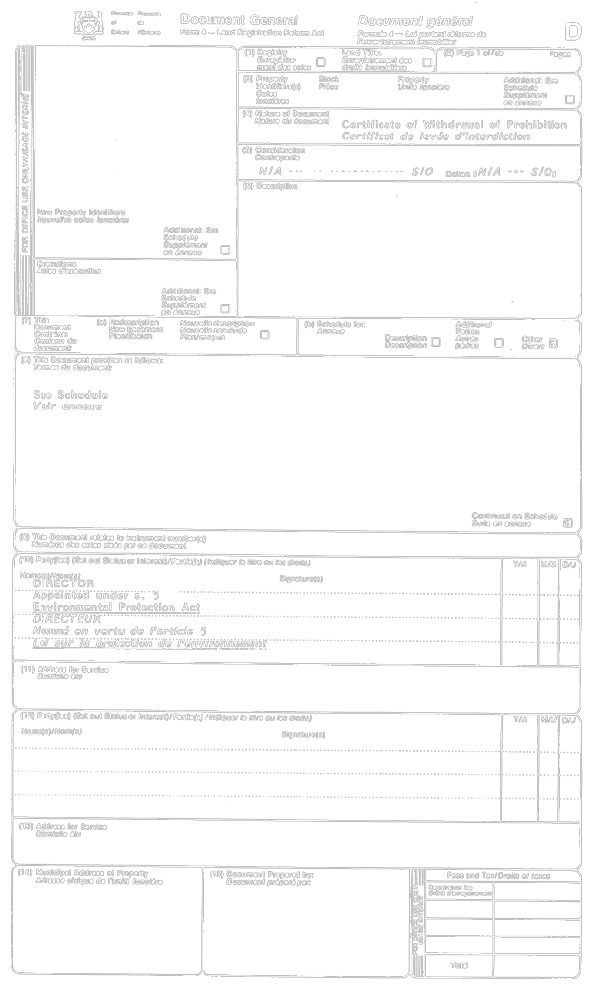
Insert regs\graphics\1992\14\014002bb.tif
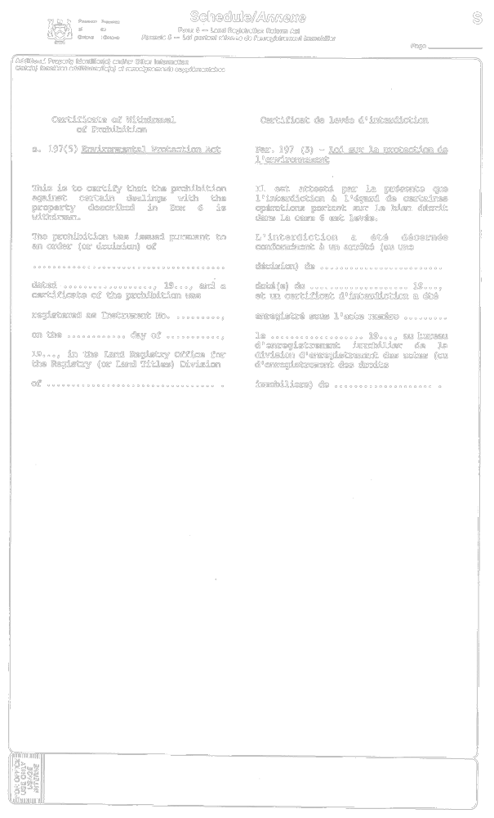
O. Reg. 14/92, Form 2.

Back to top

