Ontario Water Resources Act
Loi sur les ressources en eau de l’Ontario
ONTARIO REGULATION 15/92
Amended to: O. Reg. 25/01
FORMS
Note: This Regulation was revoked on February 8, 2001. See: O. Reg. 25/01, s. 2.
This Regulation is made in English only.
1. A certificate of prohibition under subsection 103 (2) of the Act shall be in Form 1. O. Reg. 15/92, s. 1.
2. A certificate of withdrawal of prohibition under subsection 103 (5) of the Act shall be in Form 2. O. Reg. 15/92, s. 2.
Form 1
Formule 1
Ontario Water Resources Act
Loi sur les ressources en eau de l’Ontario
Insert regs\graphics\1992\15\015001ab.tif
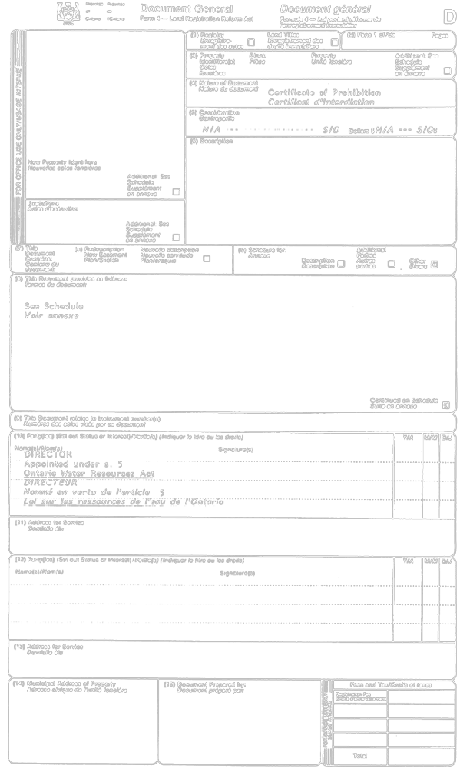

Insert regs\graphics\1992\15\015001bb.tif
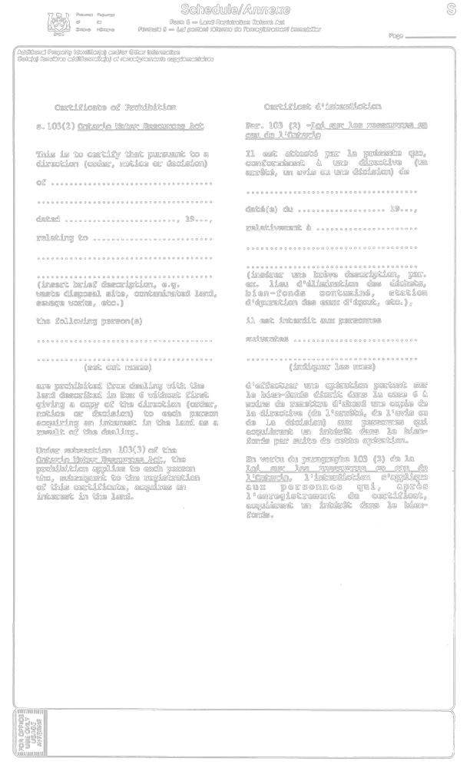

O. Reg. 15/92, Form 1.
Form 2
Formule 2
Ontario Water Resources Act
Loi sur les ressources en eau de l’Ontario
Insert regs\graphics\1992\15\015002ab.tif
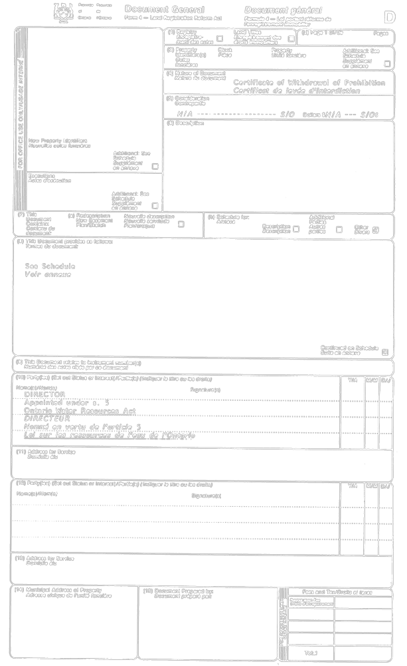

Insert regs\graphics\1992\15\015002bb.tif
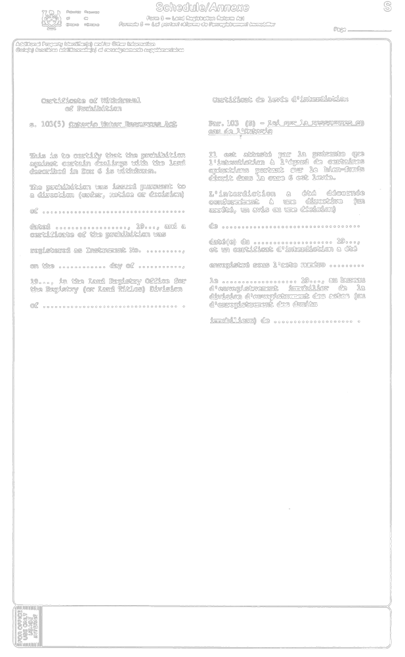

O. Reg. 15/92, Form 2.

Back to top

