Education Act
Loi sur l’éducation
ONTARIO REGULATION 123/92
Amended to O. Reg. 357/93
ASSESSMENT AND TAX ADJUSTMENTS-1992
Note: This Regulation became spent some time before January 1, 2004.
This Regulation is made in English only.
Proportions of Assessment
1. (1) For purposes of taxation in 1992, the proportions of assessment of public corporations rated and assessed in each municipality set out in Column 1 of Schedule 1 shall be adjusted as follows:
1. For public school purposes, to the percentage of the assessment set out in Column 2 opposite the municipality.
2. For separate school purposes, to the percentage of the assessment set out in Column 3 opposite the municipality.
(2) The assessment commissioner shall adjust the assessment roll returned for each municipality in 1991 for taxation in 1992 according to the calculations made under subsection (1). O. Reg. 123/92, s. 1.
Allocation of Telephone and Telegraph Levies
2. (1) For purposes of taxation in 1992, the allocation of the tax levied under subsections 159 (12) and (13) of the Municipal Act in each area municipality of The Regional Municipality of Ottawa–Carleton set out in Column 1 of Schedule 2 shall be adjusted as follows:
1. For The Ottawa Board of Education or The Carleton Board of Education, to the percentage of the tax levied set out in Column 2 opposite the area municipality.
2. For The Ottawa Roman Catholic Separate School Board or The Carleton Roman Catholic Separate School Board, to the percentage of the tax levied set out in Column 3 opposite the area municipality.
3. For the public sector of The Ottawa–Carleton French–language School Board, to the percentage of the tax levied set out in Column 4 opposite the area municipality.
4. For the Roman Catholic sector of The Ottawa–Carleton French–language School Board, to the percentage of the tax levied set out in Column 5 opposite the area municipality.
(2) The council of each area municipality of The Regional Municipality of Ottawa–Carleton shall allocate the tax levied under subsections 159 (12) and (13) of the Municipal Act according to the proportions determined under subsection (1). O. Reg. 123/92, s. 2.
3. (1) For purposes of taxation in 1992, the allocation or payment of the tax levied under subsections 159 (12) and (13) of the Municipal Act in each municipality set out in Column 1 of Schedule 3 shall be adjusted as follows:
1. For public school boards, to the percentage of the tax levied set out in Column 2 opposite the municipality.
2. For separate school boards, to the percentage of the tax levied set out in Column 3 opposite the municipality.
(2) The council of each municipality set out in Column 1 of Schedule 3 shall allocate or pay the tax levied under subsections 159 (12) and (13) of the Municipal Act according to the proportions determined under subsection (1).
(3) For purposes of taxation in 1992, the allocation or payment to the separate school board of the tax levied under subsections 159 (12) and (13) of the Municipal Act in each municipality in the united counties of Prescott and Russell shall be divided between the Conseil des écoles séparées catholiques de langue française de Prescott–Russell and The Prescott and Russell County Roman Catholic English–Language Separate School Board in the same manner as payments made by the municipality under subsection 120 (2) of the Education Act.
(4) The council of each municipality in the united counties of Prescott and Russell shall allocate or pay the tax levied under subsections 159 (12) and (13) of the Municipal Act for the separate school board to the Conseil des écoles séparées catholiques de langue française de Prescott–Russell and The Prescott and Russell County Roman Catholic English–Language Separate School Board according to the proportions determined under subsection (3). O. Reg. 123/92, s. 3.
4. A reference in this Regulation to Schedule 1, 2 or 3 is a reference to Schedule 1, 2 or 3, respectively, as set out in the original version of Ontario Regulation 123/92 published in The Ontario Gazette dated March 28, 1992. O. Reg. 123/92, s. 4.
Schedule 1
Insert regs\graphics\1992\123\12301au.tif
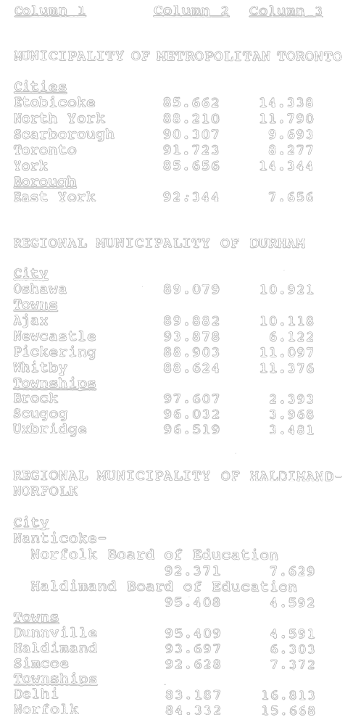
Insert regs\graphics\1992\123\12301bu.tif
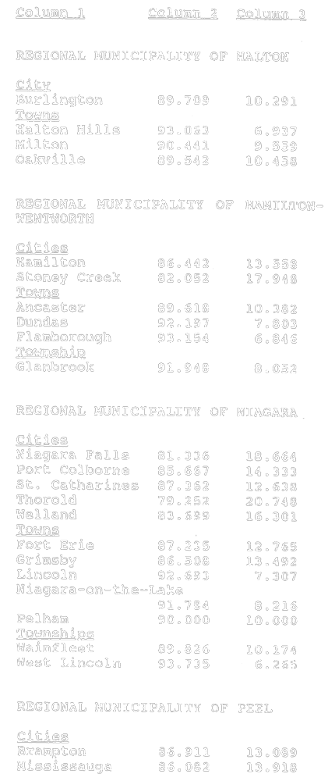
Insert regs\graphics\1992\123\12301cu.tif
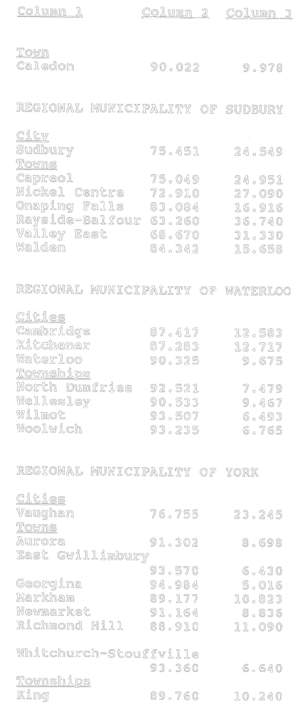
Insert regs\graphics\1992\123\12301du.tif
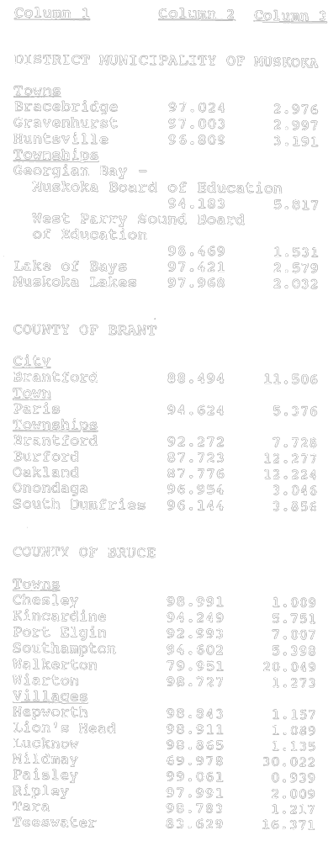
Insert regs\graphics\1992\123\12301eu.tif
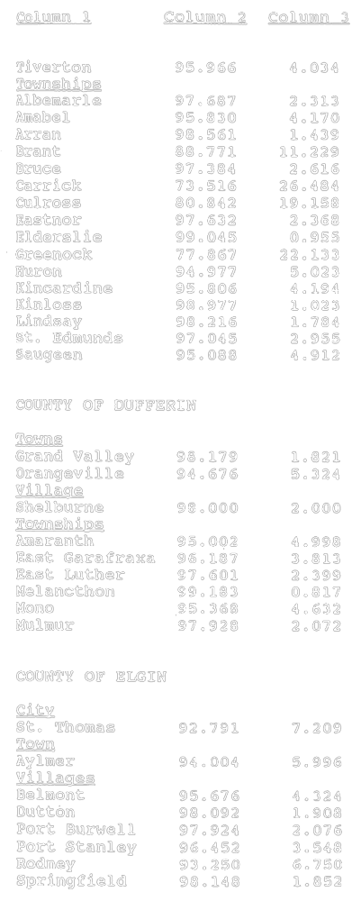
Insert regs\graphics\1992\123\12301fu.tif
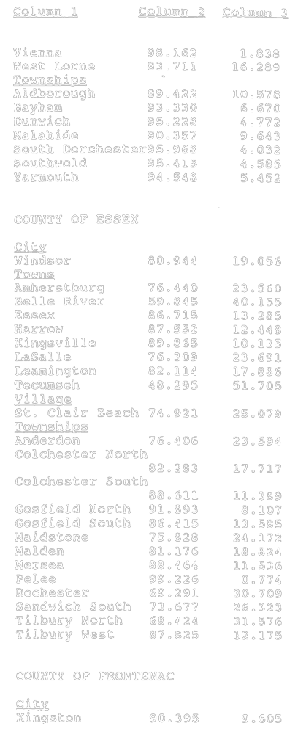
Insert regs\graphics\1992\123\12301gu.tif
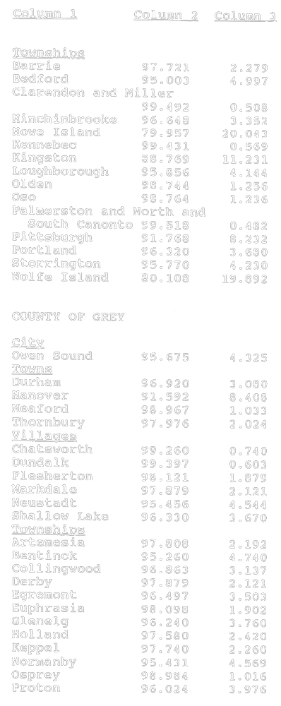
Insert regs\graphics\1992\123\12301hu.tif
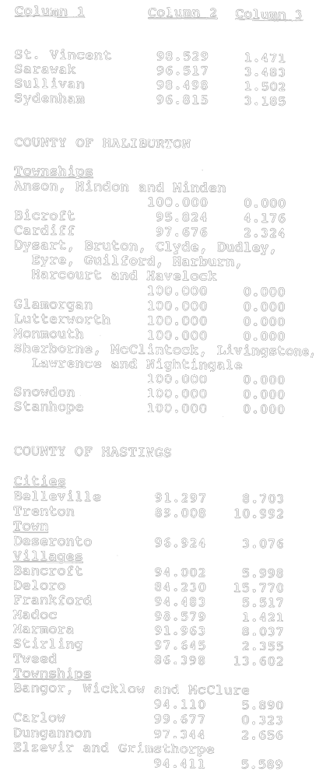
Insert regs\graphics\1992\123\12301iu.tif
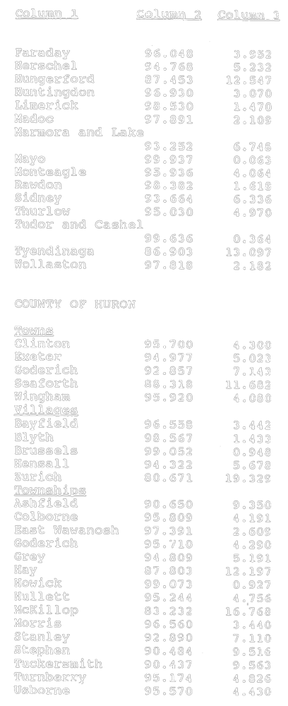
Insert regs\graphics\1992\123\12301ju.tif
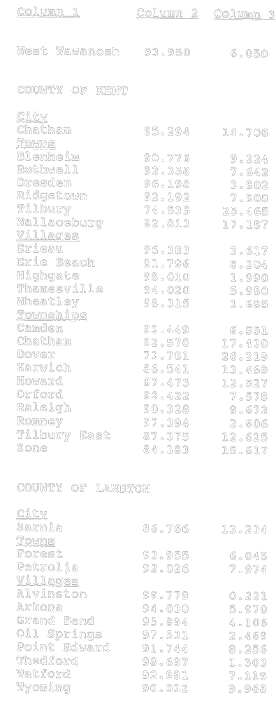
Insert regs\graphics\1992\123\12301ku.tif
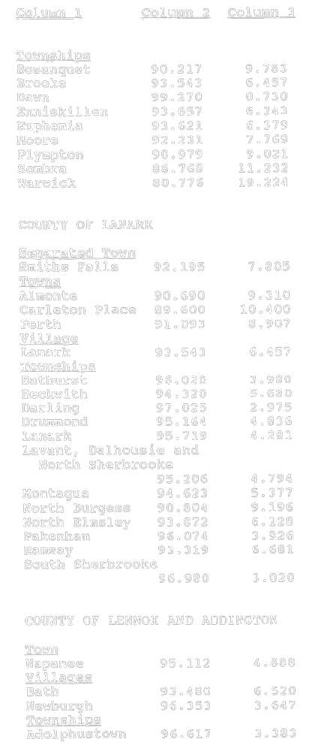
Insert regs\graphics\1992\123\12301lu.tif
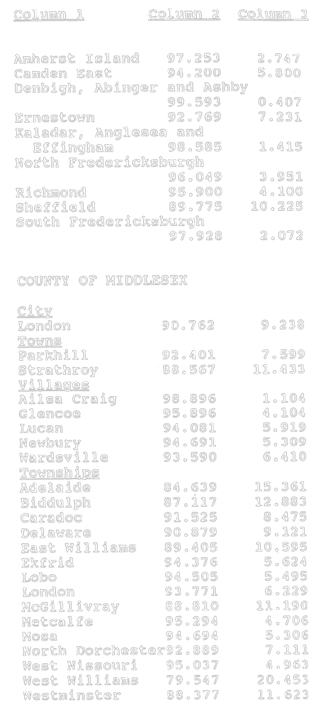
Insert regs\graphics\1992\123\12301mu.tif
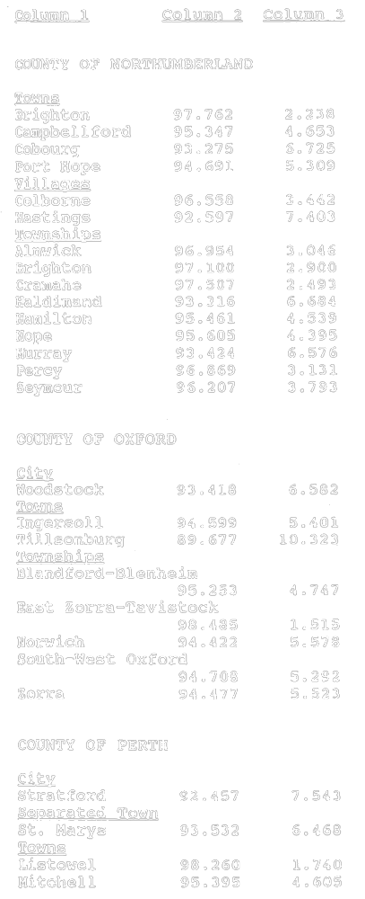
Insert regs\graphics\1992\123\12301nu.tif
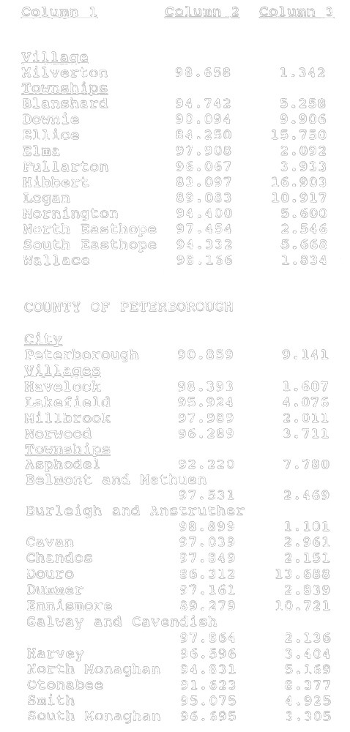
Insert regs\graphics\1992\123\12301ou.tif
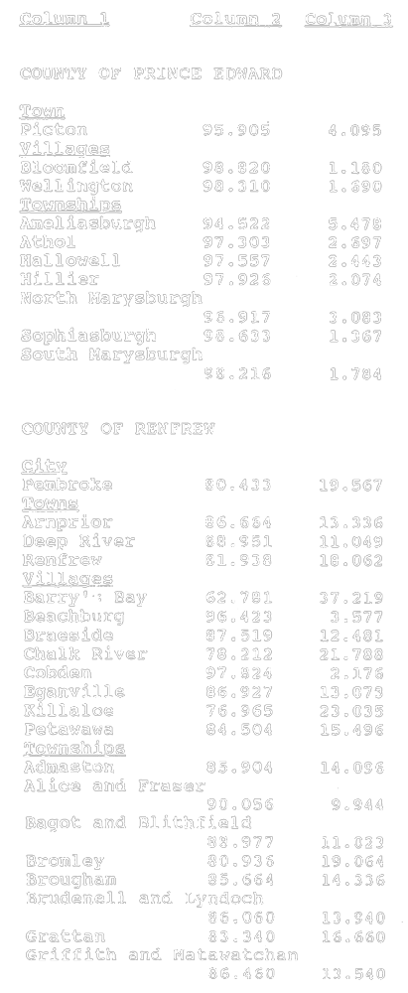
Insert regs\graphics\1992\123\12301pu.tif
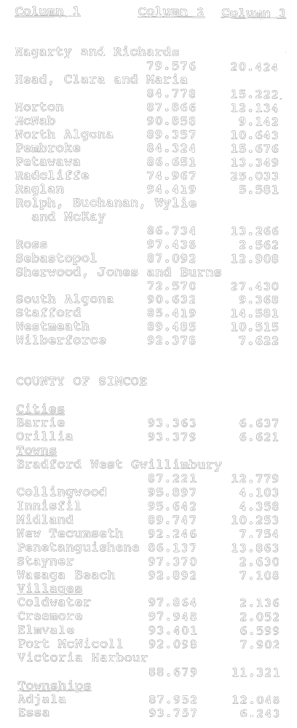
Insert regs\graphics\1992\123\12301qu.tif
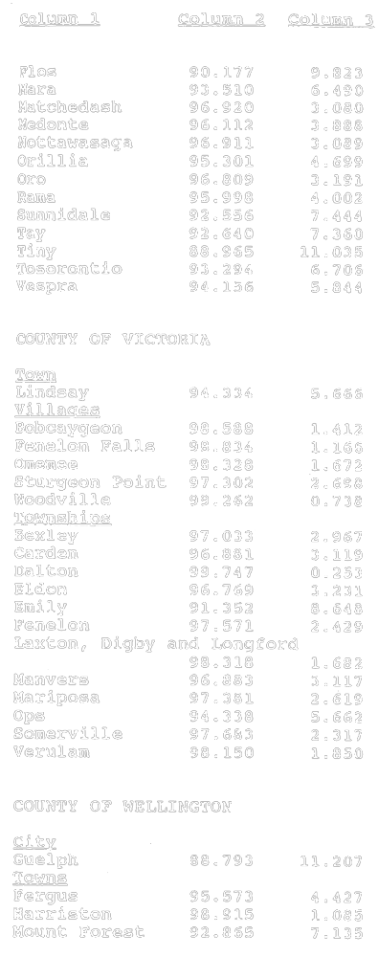
Insert regs\graphics\1992\123\12301ru.tif
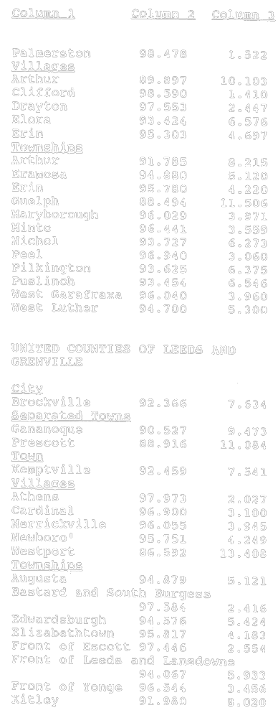
Insert regs\graphics\1992\123\12301su.tif
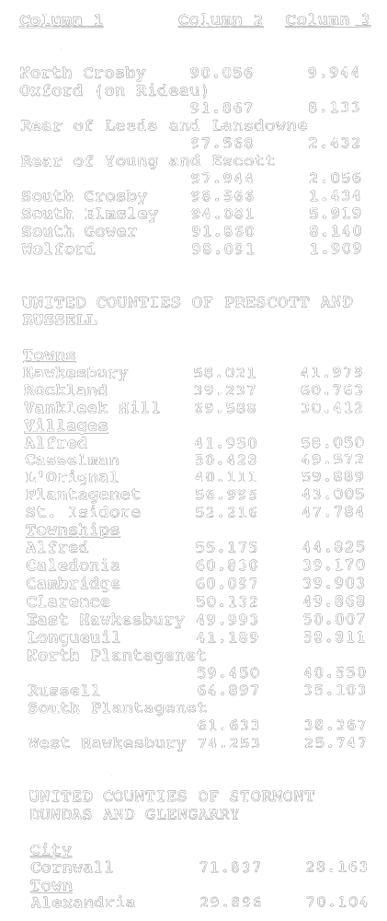
Insert regs\graphics\1992\123\12301tu.tif
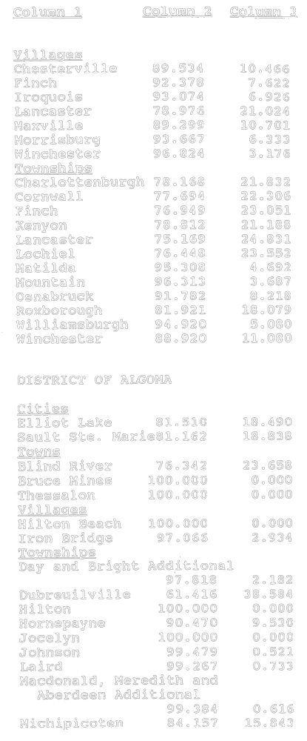
Insert regs\graphics\1992\123\12301uu.tif
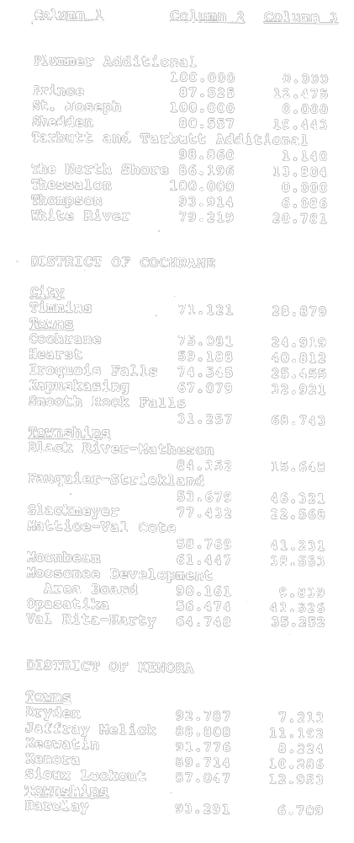
Insert regs\graphics\1992\123\12301vu.tif
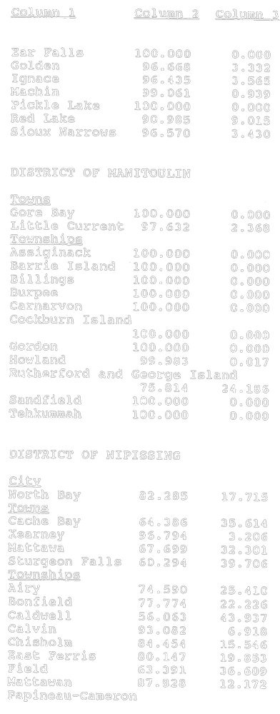
Insert regs\graphics\1992\123\12301wu.tif
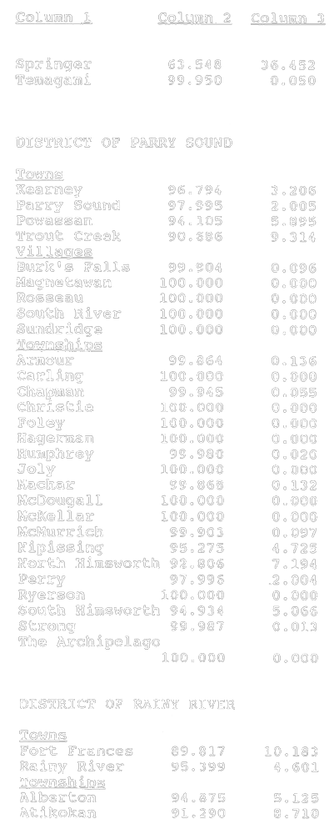
Insert regs\graphics\1992\123\12301xu.tif
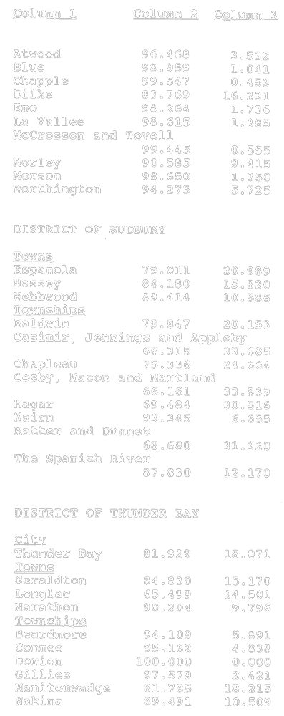
Insert regs\graphics\1992\123\12301yu.tif
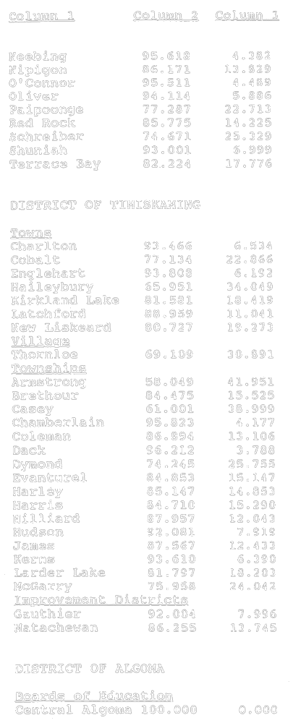
Insert regs\graphics\1992\123\12301zu.tif
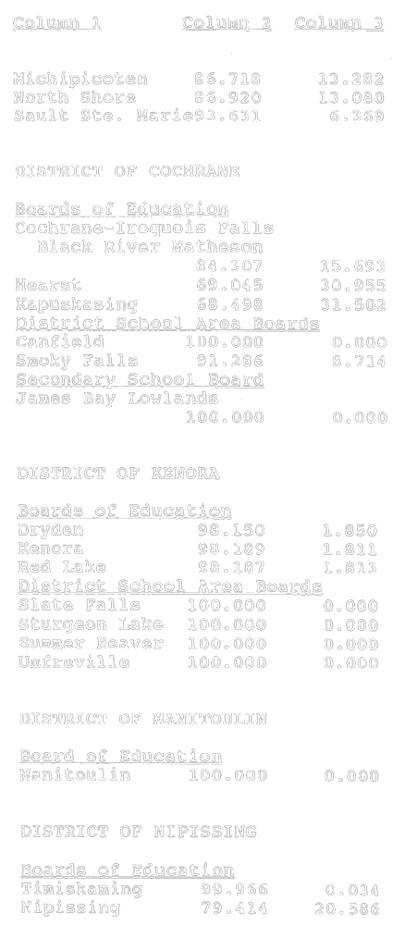
Insert regs\graphics\1992\123\12301zau.tif
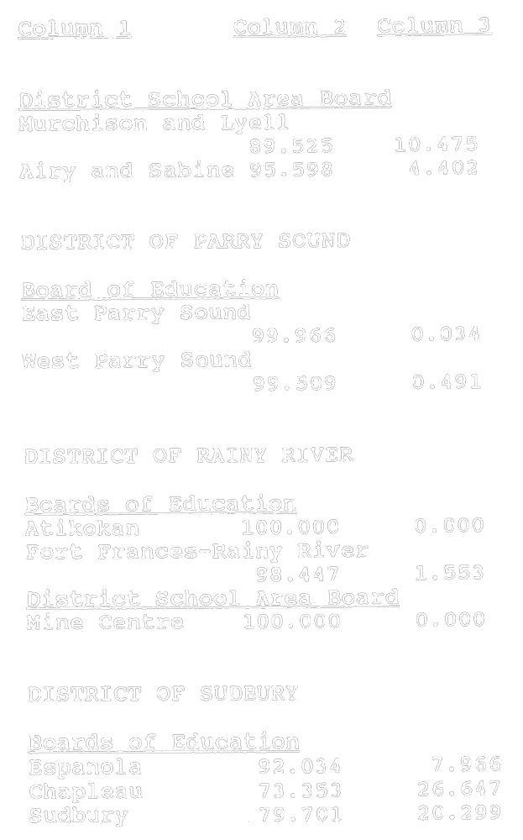
Insert regs\graphics\1992\123\12301zbu.tif
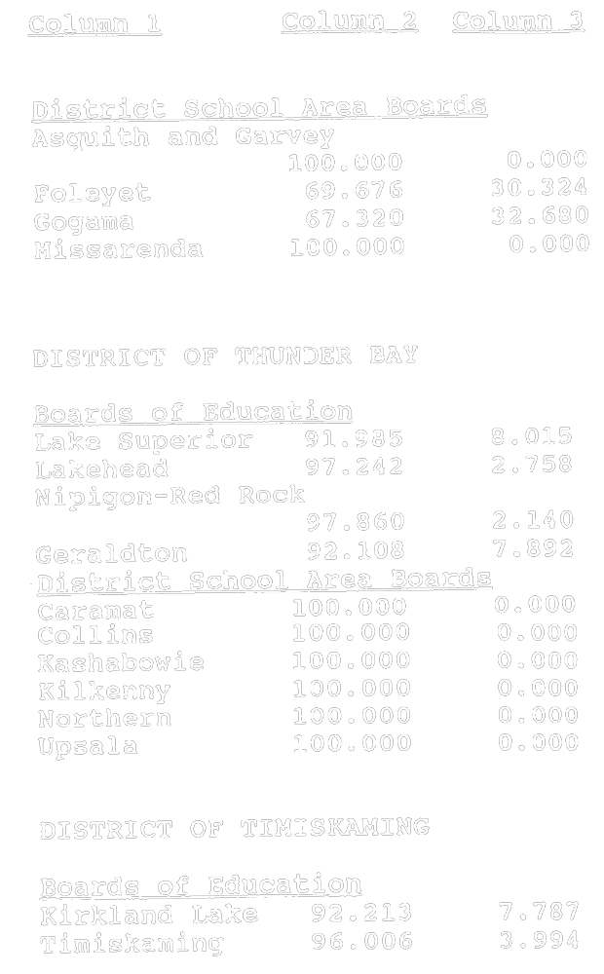
O. Reg. 123/92, Sched. 1; O. Reg. 357/93, s. 1.
Schedule 2
Insert regs\graphics\1992\123\12302au.tif
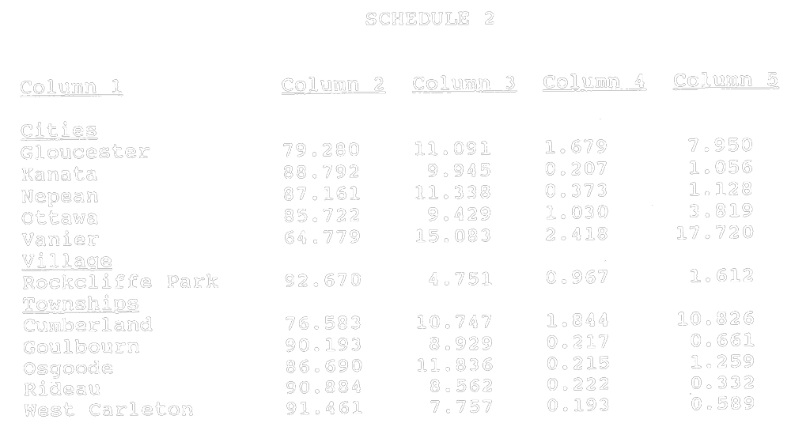
O. Reg. 123/92, Sched. 2.
Schedule 3
Insert regs\graphics\1992\123\12303au.tif
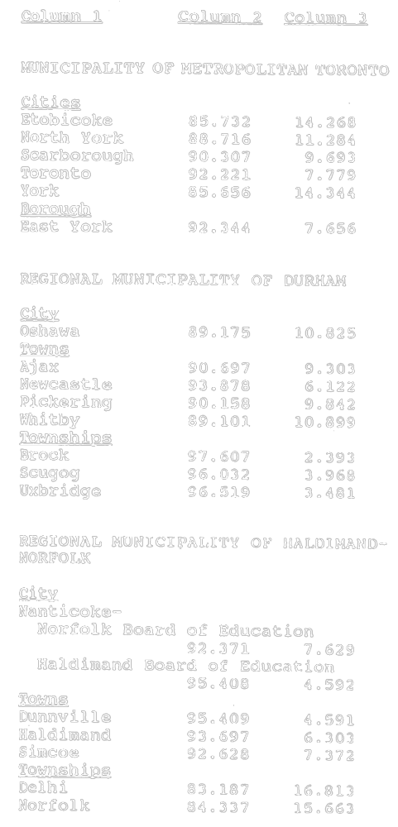
Insert regs\graphics\1992\123\12303bu.tif
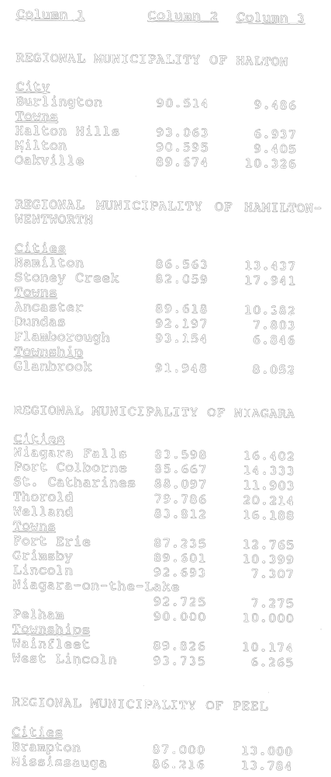
Insert regs\graphics\1992\123\12303cu.tif
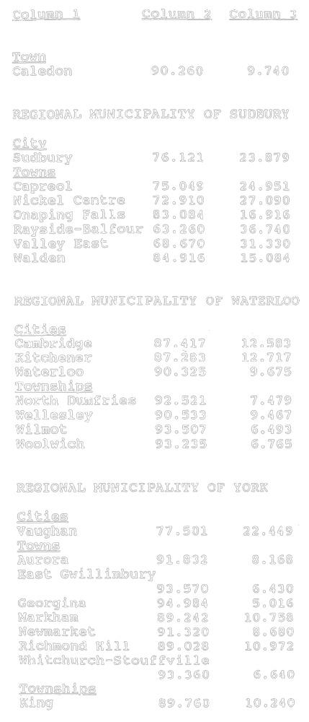
Insert regs\graphics\1992\123\12303du.tif
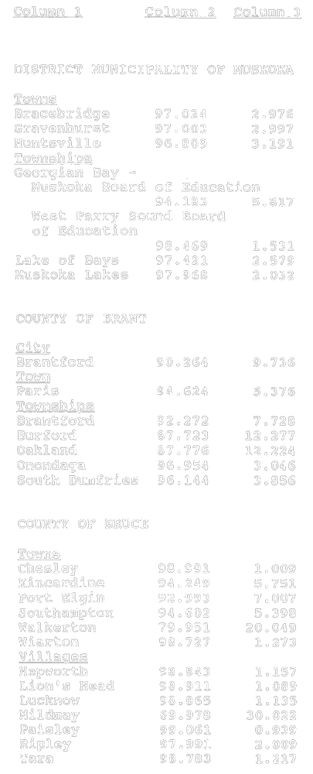
Insert regs\graphics\1992\123\12303eu.tif
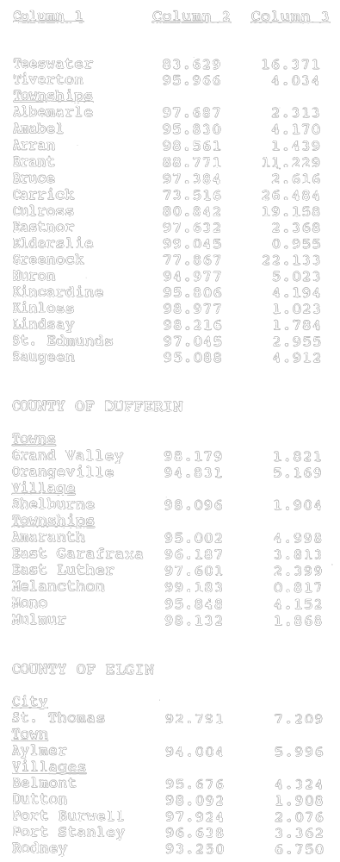
Insert regs\graphics\1992\123\12303fu.tif
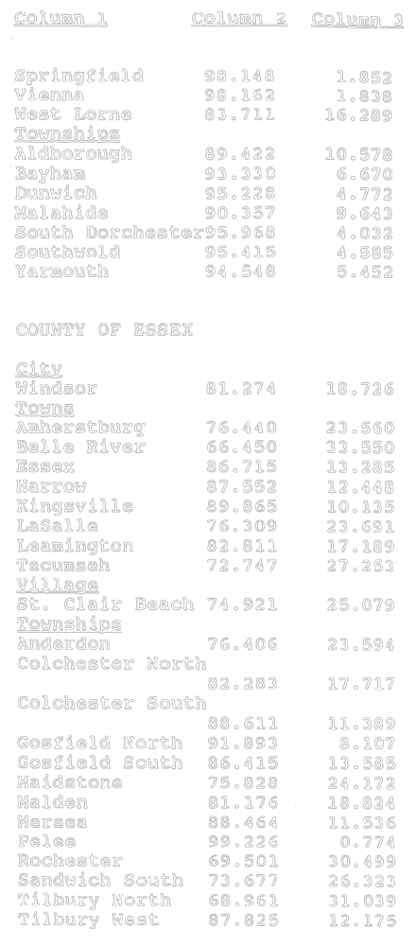
Insert regs\graphics\1992\123\12303gu.tif
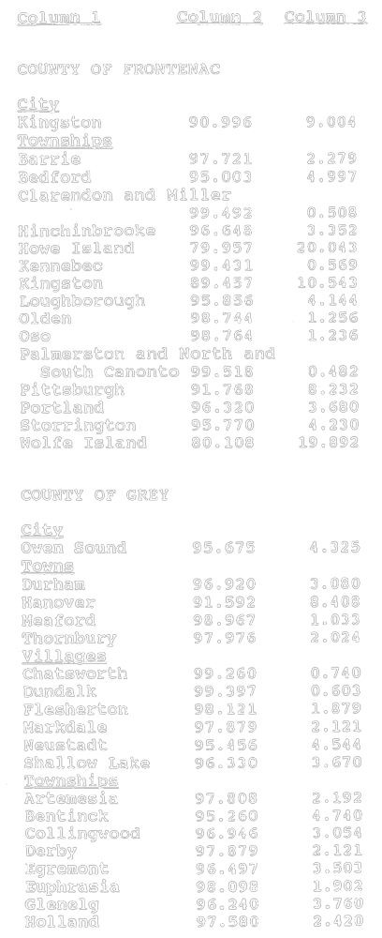
Insert regs\graphics\1992\123\12303hu.tif
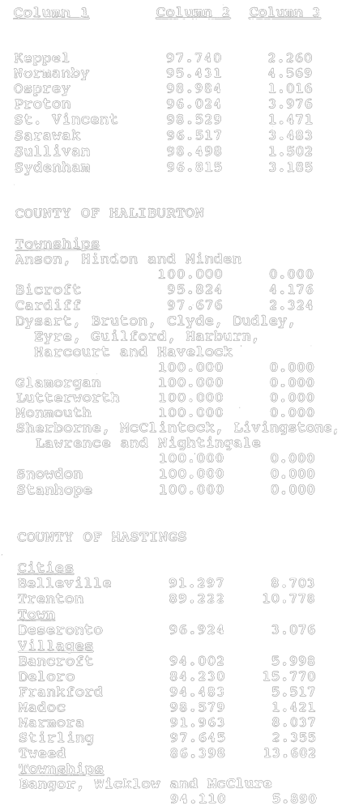
Insert regs\graphics\1992\123\12303iu.tif
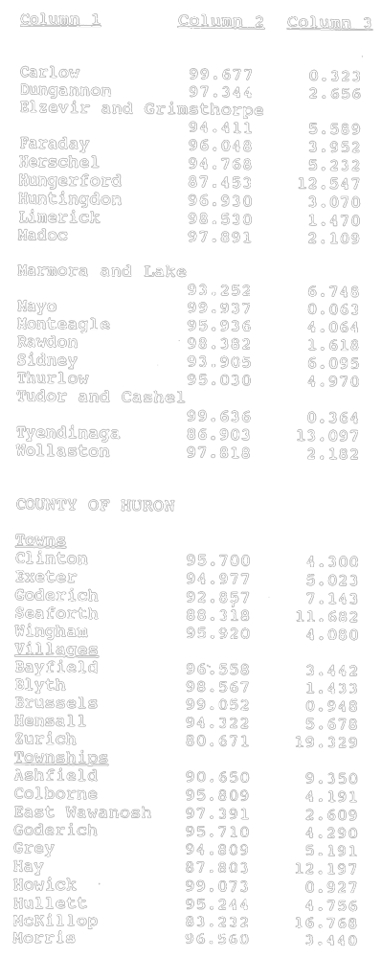
Insert regs\graphics\1992\123\12303ju.tif
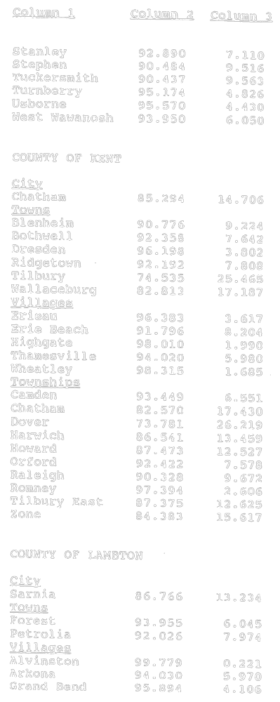
Insert regs\graphics\1992\123\12303ku.tif
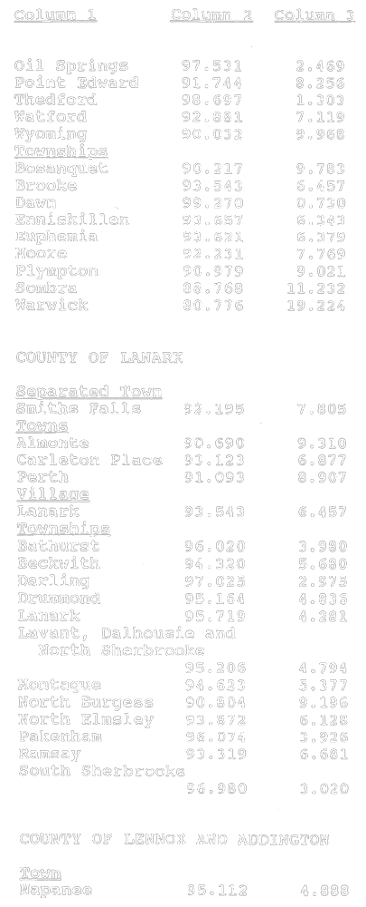
Insert regs\graphics\1992\123\12303lu.tif
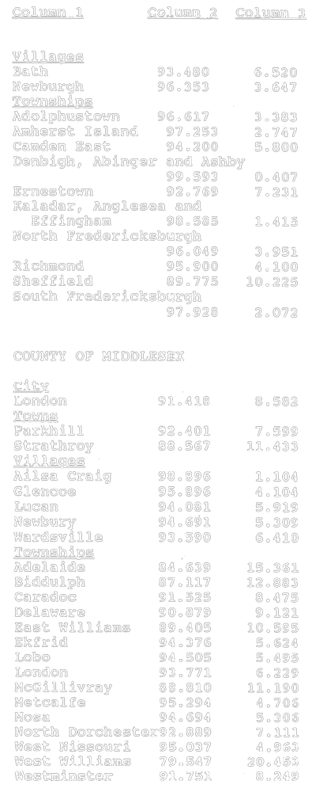
Insert regs\graphics\1992\123\12303mu.tif
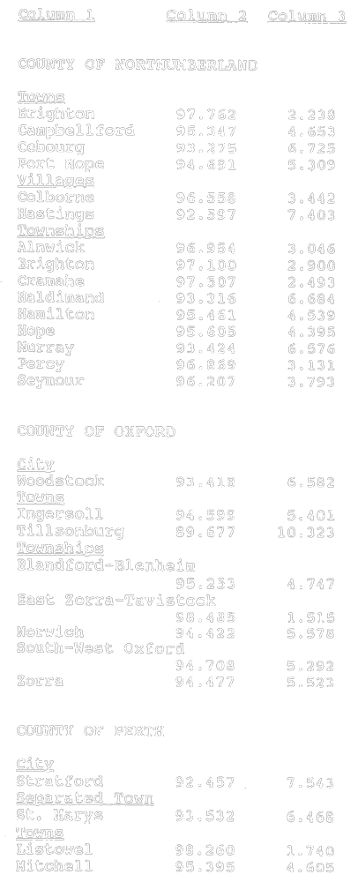
Insert regs\graphics\1992\123\12303nu.tif
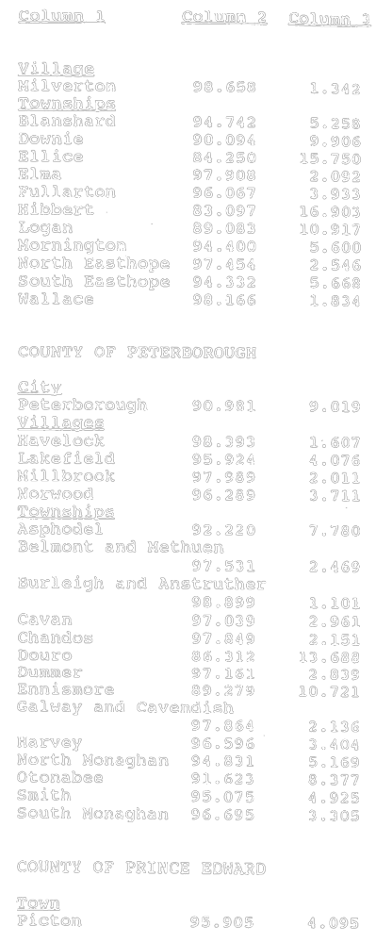
Insert regs\graphics\1992\123\12303ou.tif
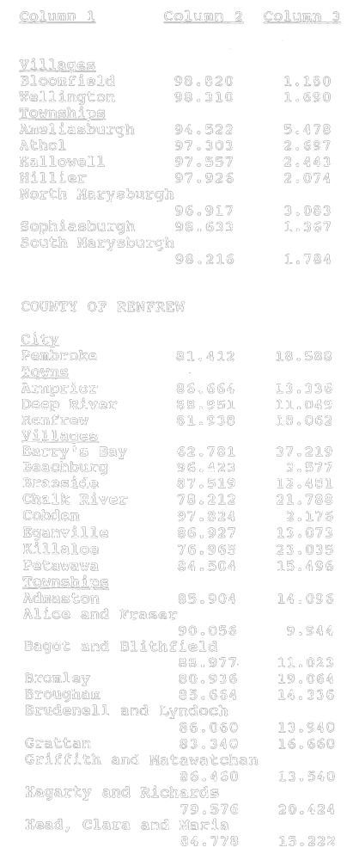
Insert regs\graphics\1992\123\12303pu.tif
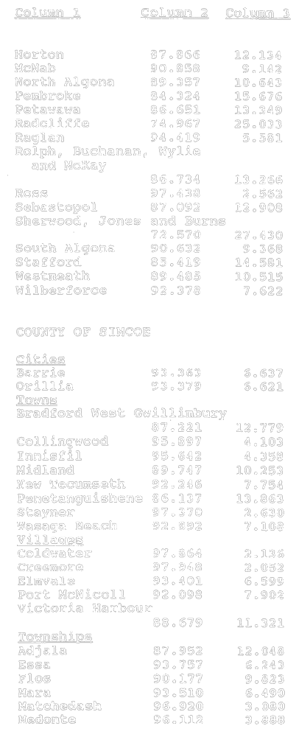
Insert regs\graphics\1992\123\12303qu.tif
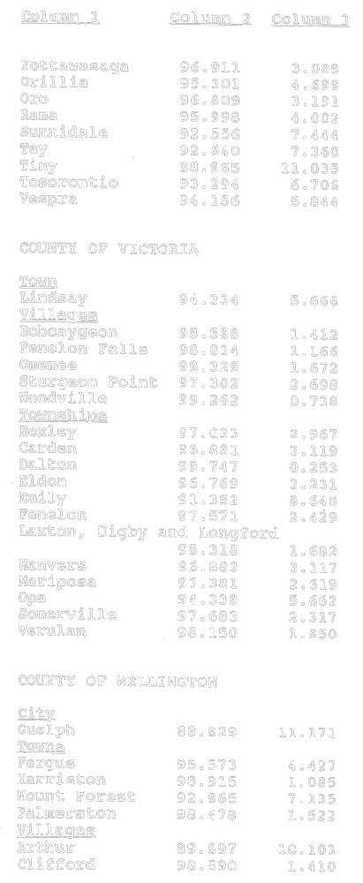
Insert regs\graphics\1992\123\12303ru.tif
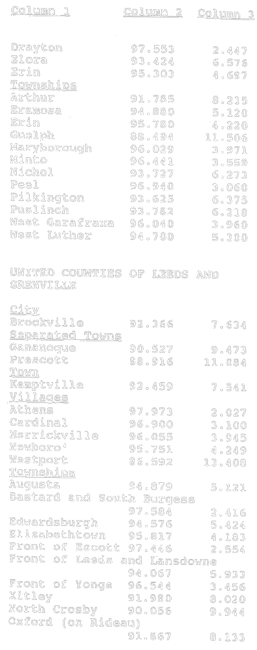
Insert regs\graphics\1992\123\12303su.tif
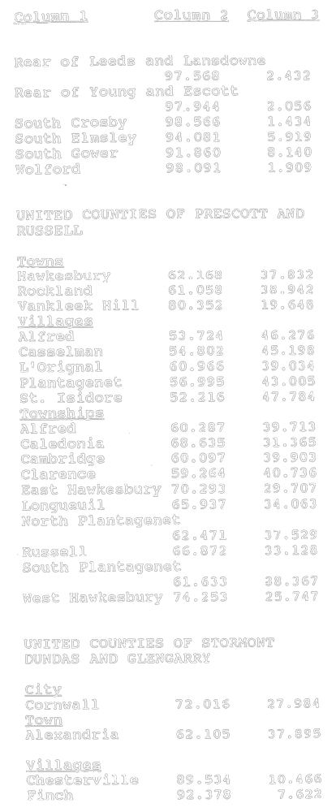
Insert regs\graphics\1992\123\12303tu.tif
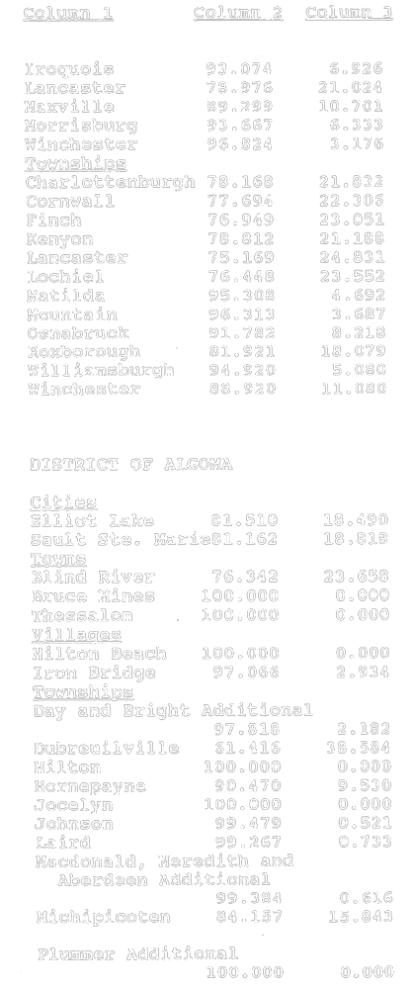
Insert regs\graphics\1992\123\12303uu.tif
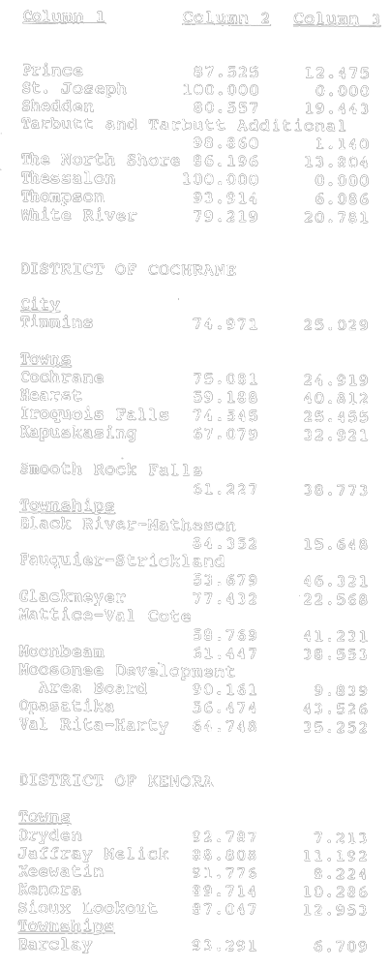
Insert regs\graphics\1992\123\12303vu.tif
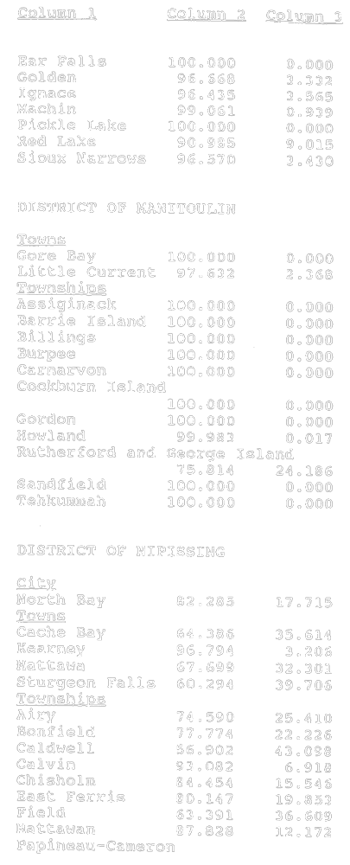
Insert regs\graphics\1992\123\12303wu.tif
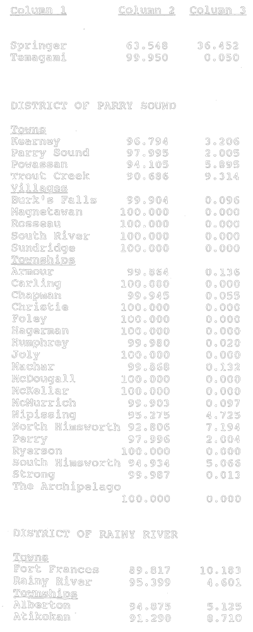
Insert regs\graphics\1992\123\12303xu.tif
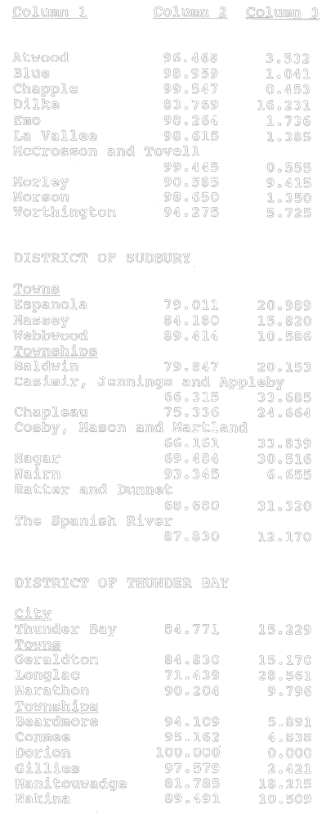
Insert regs\graphics\1992\123\12303yu.tif
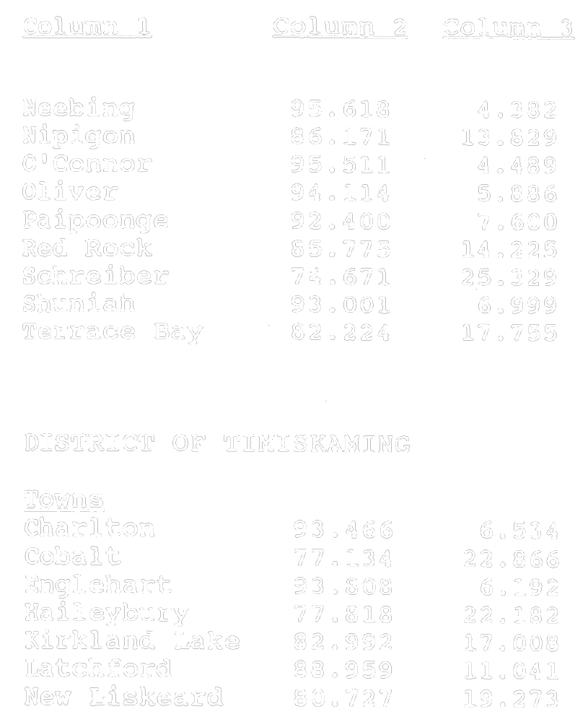
Insert regs\graphics\1992\123\12303zu.tif
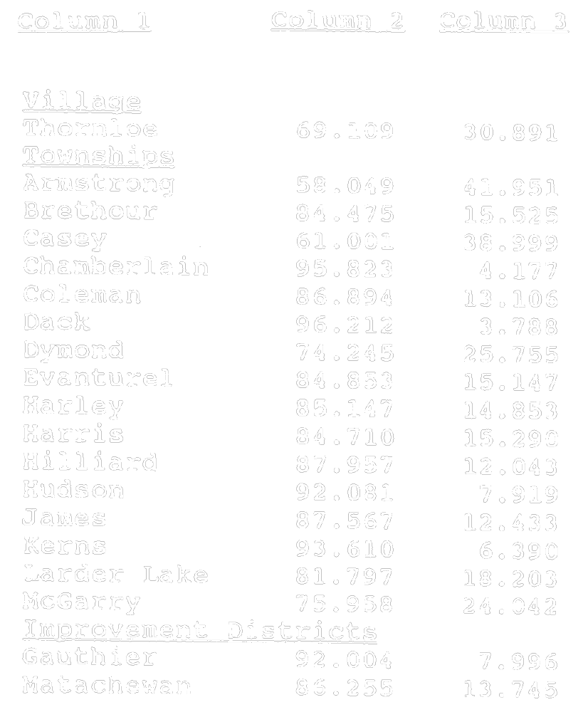
O. Reg. 123/92, Sched. 3.

Back to top

