Statute Labour Act
R.S.O. 1990, Chapter S.20
Historical version for the period December 20, 2006 to December 31, 2008.
Last amendment: 2006, c. 33, Sched. Z.3, s. 31.
Skip Table of Contents
CONTENTS
Exemptions
1. | Exemptions of persons in Canadian Forces
2. | Students
Statute Labour
3. | Liability to perform statute labour
4. | Commutation of labour
5. | Labour in township in which poll tax is not levied
6. | Abolition of labour
7. | Penalty for non-performance
8. | Commutation in case of non-resident owner of unoccupied land
9. | If resident owner, etc., makes default, commutation to be entered upon collector’s roll
Statute Labour in Unincorporated Townships
Road Commissioners
10. | Meeting for election of road commissioners
11. | Requisition for meeting
12. | Meeting in case person named fails to call it
13. | Notice of meeting
14. | Number of commissioners
15. | Chair of meeting
16. | Mode of voting
17. | Qualification of road commissioners
18. | Record of persons voting
19. | Objections to voters
20. | Declaration of office
21. | First meeting of commissioners
22. | Powers of road commissioners as to opening roads
23. | Time for performance
24. | Amount of statute labour to be performed
25. | Commissioners to oversee work
26. | Commutation
27. | Commutation of statute labour in townships
28. | Meeting for election of new commissioners
29. | Penalty for neglect to perform work or pay money
30. | Election of chair and appointment of secretary-treasurer
31. | Commutation money
32. | Statute labour book
33. | Notice to perform statute labour
34. | Return of arrears to sheriff
35. | Sale of land by sheriff for arrears
36. | Penalty for neglect to serve as commissioners
Recovery of Penalties
37. | Recovery of penalties
Form 1 | Public notice
Form 2 | Declaration of office
Form 3 | Statute labour book
Form 4 | Notice to perform statute labour
Form 5 | Notice to pay the commutation of statute labour
Form 6 | Return to sheriff

Exemptions
Exemptions of persons in Canadian Forces
1. A person who is a member of the Canadian Forces is not liable to perform statute labour or to commute therefor. R.S.O. 1990, c. S.20, s. 1.
Students
2. A student in attendance at an institution of learning in Ontario is not liable to perform statute labour or to commute therefor. R.S.O. 1990, c. S.20, s. 2.
Statute Labour
Liability to perform statute labour
Number of days of statute labour
3. (1) Every person assessed upon the assessment roll of a township that has not passed a by-law abolishing statute labour is, if his or her property is assessed at not more than $300, liable to two days statute labour; at more than $300 but not more than $500, three days; at more than $500 but not more than $700, four days; at more than $700 but not more than $900, five days; and for every $300 over $900, or any fractional part thereof over $150, one additional day; but the council may, by a by-law operating generally and rateable, reduce or increase the number of days labour to which all the persons rated on the assessment roll or otherwise, shall be respectively liable so that the number of days labour to which each person is liable shall be in proportion to the amount at which he or she is assessed, and in all cases both of residents and non-residents the statute labour shall be rated and charged against every separate lot or parcel according to its assessed value. R.S.O. 1990, c. S.20, s. 3 (1).
Case of parts of lots owned by one person
(2) Where one person is assessed for lots or parts of several lots in different parts of the township, not exceeding in the aggregate eighty-one hectares, such part or parts shall be rated and charged for statute labour as if the same were one lot, and the statute labour shall be rated and charged against any excess over eighty-one hectares as if the excess were one lot. R.S.O. 1990, c. S.20, s. 3 (2).
Where labour to be performed
(3) Every resident has the right to perform his or her whole statute labour in the statute labour division in which his or her residence is situate, unless otherwise ordered by the municipal council. R.S.O. 1990, c. S.20, s. 3 (3).
Regulations as to performance
(4) The council may pass by-laws for regulating the manner and the divisions in which statute labour or commutation money shall be performed or expended. R.S.O. 1990, c. S.20, s. 3 (4).
Definition
(5) In this section and in sections 4, 5 and 6,
“township” means a local municipality that was a township on December 31, 2002. 2002, c. 17, Sched. F, Table.
Commutation of labour
4. (1) The council of any township may by by-law direct that a sum not exceeding $3 a day shall be paid as commutation of statute labour for the whole or any part of the township, in which case the amount of the commutation shall be added in a separate column in the collector’s roll and shall be collected and accounted for like other taxes.
Idem
(2) Where no such by-law has been passed, the statute labour in respect of lands of residents and non-residents shall be commuted at the rate of $2 for each day’s labour. R.S.O. 1990, c. S.20, s. 4.
Labour in township in which poll tax is not levied
5. In a township that has not passed a by-law abolishing statute labour, every able person over the age of eighteen who,
(a) is not exempt from performing statute labour;
(b) is not otherwise assessed in the township; and
(c) has not filed with the clerk a certificate showing that the person has been assessed or performed statute labour elsewhere in Ontario,
is liable to one day of statute labour on the roads and highways in the township. R.S.O. 1990, c. S.20, s. 5.
Abolition of labour
6. The council of every township may pass by-laws to abolish statute labour. R.S.O. 1990, c. S.20, s. 6.
Penalty for non-performance
7. (1) Any person liable to perform statute labour under section 5, not commuted, shall perform it when required so to do by the pathmaster or other officer of the municipality appointed for that purpose, and, in case of wilful neglect or refusal to perform the labour after six days notice requiring him to do so, shall incur a penalty of $10.
Payment of penalties to treasurer
(2) All sums and penalties, other than costs, recovered under this section shall be paid to the treasurer of the local municipality and shall form part of the statute labour fund thereof. R.S.O. 1990, c. S.20, s. 7.
Commutation in case of non-resident owner of unoccupied land
8. A non-resident owner of unoccupied land shall not be permitted to perform statute labour in respect thereof, but the labour shall be commuted and the amount of the commutation shall be charged against every separate lot or parcel and be entered in the collector’s roll, and the council shall order all sums paid on that account to be expended in the statute labour division in which the land is situate. R.S.O. 1990, c. S.20, s. 8.
If resident owner, etc., makes default, commutation to be entered upon collector’s roll
9. (1) Where an owner or tenant makes default in performing his or her statute labour or in payment of commutation therefor, the overseer of highways in whose division the owner or tenant is placed shall return him or her as a defaulter to the clerk of the municipality before the 15th day of August, and the clerk shall in that case enter the commutation for statute labour against the land in the collector’s roll of the current or following year, and it shall be collected by the collector.
Overseer to expend the commutation money in the division
(2) In every such case the clerk shall notify the overseer of highways who may be appointed for the division in the following year, or after it has been collected, of the amount of the commutation, and the overseer shall expend that amount upon the roads in the statute labour division where the property is situate, and shall give an order upon the treasurer of the municipality to the person performing the work. R.S.O. 1990, c. S.20, s. 9.
Statute Labour in Unincorporated Townships
Road Commissioners
Meeting for election of road commissioners
10. (1) Twenty resident landholders,
(a) in any unincorporated township;
(b) in any designated part of any unincorporated township;
(c) in any two or more contiguous unincorporated townships;
(d) in any designated parts of two or more contiguous unincorporated townships; or
(e) in any locality that has not been surveyed or laid out into townships,
have the right to have a public meeting called for the purpose of electing road commissioners.
Definitions
(2) In this section and in the following sections of this Act, “landholder” means an owner, locatee, purchaser or tenant of land, and “resident” includes a person who resides in the township or locality for any part of a year. R.S.O. 1990, c. S.20, s. 10.
Requisition for meeting
11. (1) The landholders desiring the meeting to be called shall sign a requisition authorizing one of their number, who shall be named in the requisition, to call a meeting of the resident landholders of the township or townships or of the designated part or parts of the township or townships or of the locality for the purpose of electing road commissioners.
Where jurisdiction extends to parts of two or more townships
(2) Where it is proposed that the road commissioners shall have jurisdiction over two or more townships or designated parts of two or more townships, the requisition shall be signed by a least eight resident landholders in any one township or part of a township or where there are less than fifteen resident landholders in any one township or part of a township by a majority of them, but the total number of resident landholders signing the requisitions shall not be less than twenty and the requisition shall designate what parts of the townships are to be included. R.S.O. 1990, c. S.20, s. 11.
Meeting in case person named fails to call it
12. In case the person so named declines to call a meeting or neglects to do so for ten days after the requisition is presented to him or her, any three of the persons who signed the requisition may call the meeting. R.S.O. 1990, c. S.20, s. 12.
Notice of meeting
13. (1) The notice calling the meeting shall be in Form 1, and,
(a) shall be posted up in at least six conspicuous places and at each post office and public school house in the township, townships or locality, as the case may be; or
(b) shall be sent by registered mail to all landholders in the township, townships or locality addressed to their last known place of residence; or
(c) shall be published once a week for at least three weeks in a newspaper having general circulation in the township, townships or locality,
and the day named in the notice shall be at least ten days from the date of the last posting, mailing or publication, as the case may be.
Idem
(2) The notice shall be in English, and may also be in French. R.S.O. 1990, c. S.20, s. 13.
Number of commissioners
14. The election shall take place at the time named, and the number of commissioners to be elected shall be either three or five, as may be stated in the requisition, unless the meeting, before proceeding to an election, decides that a number different from that stated in the requisition shall be elected, but the number shall not be fewer than three nor more than five. R.S.O. 1990, c. S.20, s. 14.
Chair of meeting
15. In case the meeting is called by the person named in the requisition, the person is entitled to preside at the meeting as chair, but if he or she is absent, or declines to act, the landholders present may appoint another chair, and the chair shall act as returning officer and, in the event of a tie, has a casting vote, although he or she may have previously voted, and the landholders present shall also appoint a secretary, who shall record the proceedings. R.S.O. 1990, c. S.20, s. 15.
Mode of voting
16. (1) The landholders present shall decide how the voting for commissioners shall be conducted.
Qualifications of voters
(2) Every person is entitled to vote in the election of the road commissioners who is of the full age of eighteen years and a landholder in the township or townships, or part or parts thereof, or the locality, for which the election is held. R.S.O. 1990, c. S.20, s. 16.
Qualification of road commissioners
17. No person may be elected as a road commissioner unless he or she is qualified to vote in the election of road commissioners and unless he or she has performed or commuted for the statute labour to which he or she is liable. R.S.O. 1990, c. S.20, s. 17.
Record of persons voting
18. The chair shall, at the request of any two landholders present, direct the secretary to record the names of all persons voting and, unless the vote is by ballot, how each votes. R.S.O. 1990, c. S.20, s. 18.
Objections to voters
19. If an objection is made to the right of any person to vote at the meeting, the person shall name the property in respect of which he or she claims the right to vote, and the chair shall administer to the person an oath, or affirmation if he or she is by law permitted to affirm, according to the following form in English or French, whereupon the person shall be permitted to vote:
You swear (or if the voter is entitled to affirm, solemnly affirm) that you are of the age of eighteen years, and that you are the owner, tenant, purchaser or locatee of lot ....... in the ............... concession of this township and that you are entitled to vote at this election.
(So help you God. Only if the person swears an oath.)
R.S.O. 1990, c. S.20, s. 19.
Declaration of office
20. The commissioners elected shall take a declaration of office in Form 2 in English or French before a justice of the peace and shall hold office until their successors are elected at the meeting called as provided in section 28 or, where no such meeting is called, until the 31st day of May in the year following that in which they were elected. R.S.O. 1990, c. S.20, s. 20.
First meeting of commissioners
21. The commissioners shall meet within two weeks after their election, and shall then or as soon thereafter as may be, name the roads and parts of roads upon which statute labour is to be performed, and shall appoint the places and times at which the persons required to perform statute labour are to work. R.S.O. 1990, c. S.20, s. 21.
Powers of road commissioners as to opening roads
22. (1) The commissioners have power to open road allowances when they have been laid down in the original surveys, and where such road allowances are either wholly or partly impracticable, to lay out roads in lieu thereof and direct the performance of statute labour thereon, and where no road allowances are laid down in the original surveys, but any of the area is reserved for roads, the commissioners may lay out roads where necessary and direct the performance of statute labour accordingly.
Filing plan of roads in Ministry of Natural Resources
(2) In cases of deviations from road allowances and of roads laid out where there are no road allowances as above provided, the commissioners shall cause a plan thereof, so far as the same affects ungranted lands of the Crown, to be made by an Ontario land surveyor and shall file the plan in the Ministry of Natural Resources, and the commissioners may pay the cost of preparing the plan out of any money received by way of commutation of statute labour.
Compensation for land taken for deviation
(3) In the case of a deviation passing over any patented improved land, the commissioners may pay to the owner of the land taken for the purpose of making the deviation the value of it as may be agreed upon between the commissioners and the owner, and in case of disagreement, the Expropriations Act applies.
Land to be vested in Crown
(4) Where the value of the land taken has been agreed upon between the commissioners and the owner, the owner shall execute a conveyance of the land to Her Majesty in right of Ontario and such conveyance shall be registered in the proper land registry office. R.S.O. 1990, c. S.20, s. 22.
Time for performance
23. The time for the performance of statute labour shall from time to time be regulated and fixed by resolution of the commissioners. R.S.O. 1990, c. S.20, s. 23.
Amount of statute labour to be performed
24. (1) Despite subsection (3), each owner, locatee, purchaser or tenant of land may be required to perform one day’s labour for every twenty hectares and one day’s labour for the remainder of the hectarage held by him or her, where the total hectarage held by him or her divided by twenty leaves a remainder, and for the first four hectares that he or she has cleared after the first four, he or she may be required to perform one day’s additional labour, and for every eight hectares over and above the first four, one additional day’s labour, and each householder who is not an owner, locatee, purchaser or tenant of the land may be required each year to perform one day’s labour.
Idem
(2) Any owner, locatee, purchaser or tenant of land holding less than twenty hectares may be required to perform statute labour as the commissioners may direct, but not exceeding the scale provided for in subsection (1) where the land is in part cleared and not exceeding one day where no part of the land is cleared.
Statute labour in unincorporated areas
(3) Where road commissioners have been elected for any unincorporated area, the secretary-treasurer shall enter in the statute labour book the name, date of birth and place of abode of every able person over the age of eighteen who,
(a) is not exempt from performing statute labour;
(b) is not assessed for statute labour in the area under subsection (1) or (2); and
(c) has not filed with the secretary-treasurer a certificate showing that he or she has been assessed or performed statute labour elsewhere in Ontario,
and every such inhabitant is liable to one day of statute labour on the roads in the area.
Where land assessed for school purposes
(4) Where the land in an unincorporated township is assessed for school purposes under the Education Act, the commissioners may by resolution provide that the amount of statute labour to be performed shall be determined on the same basis as is prescribed in subsection 3 (1) in which case subsections 3 (1) and (2) apply with necessary modifications. R.S.O. 1990, c. S.20, s. 24.
Commissioners to oversee work
25. (1) Each commissioner shall, during the time he or she is required to perform statute labour, act as overseer, and the commissioners shall arrange among themselves for overseeing the various persons engaged in doing statute labour.
General powers
(2) The commissioners have the same powers as municipal corporations have in reference to statute labour to appoint overseers and require returns to be made to them of the statute labour performed in their districts. R.S.O. 1990, c. S.20, s. 25.
Commutation
26. (1) Any person instead of performing the statute labour required of him or her may commute therefor by payment at the rate per day fixed by resolution of the commissioners which rate shall not be greater than the rate per day paid for labour by the Ministry of Transportation, and the commissioners shall expend all commutation money upon the roads on which the labour that is commuted for should have been performed, unless in the opinion of the commissioners the money should be expended on other roads under their jurisdiction.
Unoccupied land of non-resident owner
(2) The statute labour in respect of unoccupied land of a non-resident owner shall in all cases be commuted. R.S.O. 1990, c. S.20, s. 26.
Commutation of statute labour in townships
27. (1) The commissioners may by resolution direct that a sum computed at the rate per day fixed by resolution of the commissioners under subsection 26 (1) shall be paid as commutation of statute labour for the whole of the township, but the resolution shall not take effect until it has been submitted to and sanctioned by the majority of the landholders present at the annual meeting or at a special meeting called in the manner provided for in this Act for the election of commissioners.
Record of persons liable to commutation
(2) The name of every person liable for the payment of the commutation shall be entered in the book directed to be kept by section 32, and the commissioners shall expend all commutation money received on the roads upon which the labour that is commuted for should have been performed unless in the opinion of the commissioners the money should be expended on other roads under their jurisdiction. R.S.O. 1990, c. S.20, s. 27.
Meeting for election of new commissioners
28. The majority of the commissioners may call a meeting to be held at any time between the 1st day of January and the 31st day of May for the election of their successors, but in case of their failure so to do a meeting may be called in the manner hereinbefore provided for a first election. R.S.O. 1990, c. S.20, s. 28.
Penalty for neglect to perform work or pay money
29. Any person liable to perform statute labour or to pay an amount of commutation money in lieu thereof under sections 10 to 36 who, after six days notice requiring him or her to do the labour, wilfully neglects or refuses to perform, at the time and place named by the commissioners, the number of days labour for which the person is liable or who, after six days notice requiring him or her to pay the money, fails to pay the amount of commutation money for which he or she is liable, shall incur a penalty of $5, and in addition the amount of the commutation money as fixed by the commissioners under section 26 for each day in respect of which the person makes default, the same to be paid to the secretary-treasurer and to be expended in improving the roads on which the labour should have been performed, or such other roads as, in the opinion of the commissioners, require improvement. R.S.O. 1990, c. S.20, s. 29.
Election of chair and appointment of secretary-treasurer
30. (1) The commissioners, at the first meeting after their election, shall elect one of their number as chair to preside at meetings and shall appoint some competent person who may be one of themselves other than the chair, as secretary-treasurer and the secretary-treasurer is exempt from the performance of statute labour and the commissioners may each year pay to the secretary-treasurer out of the commutation fund such amount as may be fixed by resolution of the commissioners.
Security
(2) The secretary-treasurer before entering on his or her duties shall take a declaration of office in Form 2 in English or French before a justice of the peace, and shall give security satisfactory to the commissioners which shall be lodged for safekeeping with the chair. R.S.O. 1990, c. S.20, s. 30.
Commutation money
31. The secretary-treasurer shall receive and safely keep all commutation money and shall pay out such money in accordance with this Act. R.S.O. 1990, c. S.20, s. 31.
Statute labour book
32. (1) The secretary-treasurer shall keep a statute labour book in Form 3 and shall enter therein the name of every person liable for the performance of statute labour or payment of the commutation and the lot or parcel of land in respect of which he or she is liable.
Idem
(2) The statute labour book shall be in English, and may also be in French.
Entry of payment or performance
(3) Upon the performance of statute labour or payment of the commutation the secretary-treasurer shall make entry thereof in the statute labour book in the column provided for that purpose.
Entry of default
(4) Where any person who has been served with the prescribed notice as provided in section 33 does not perform his or her statute labour or commute therefor, the secretary-treasurer shall enter the commutation thereof in the proper column of the statute labour book against the name of the person in default.
Inspection of statute labour book
(5) The statute labour book shall be available for inspection at all reasonable times by any owner or locatee of land, or householder in the area over which the commissioners have jurisdiction and by any officer or employee of the Ministry of Transportation designated by the Minister of Transportation. R.S.O. 1990, c. S.20, s. 32.
Notice to perform statute labour
33. (1) The secretary-treasurer shall serve each notice to perform statute labour in Form 4 or, where a resolution has been passed and sanctioned as provided by section 27, to pay the commutation thereof in Form 5 personally or by leaving it at the usual place of abode of the person to whom it is directed with a grown up person residing there or by sending it by registered mail addressed to the person to whom it is directed at the post office nearest to his or her last known place of residence.
Idem
(2) The notices shall be in English, and may also be in French.
Time
(3) The notices shall be served not less than six days before the date on which the person liable for statute labour is required to report or to pay exclusive of that date and the date of the service or mailing, as the case may be. R.S.O. 1990, c. S.20, s. 33.
Return of arrears to sheriff
34. (1) On or before the 1st day of June in the year following that in which default was made, the secretary-treasurer shall make a return in Form 6 to the sheriff for the district showing each lot or parcel of land in respect of which default has been made, the name of the owner or locatee, the amount chargeable at the date of the return and the year for which the amount in arrear was imposed.
Idem
(2) The return shall be in English, and may also be in French.
Sheriff to keep account of arrears
(3) The sheriff shall enter the particulars so furnished in a book to be kept by him or her for that purpose.
Payment of arrears not to be made to secretary-treasurer after two years
(4) The secretary-treasurer shall not receive any payments on account of such arrears after the expiration of two years from the date specified in the notice in Form 4 or 5, but in the case of payments made within such period the secretary-treasurer shall forthwith notify the sheriff thereof and the sheriff shall enter the payment against the proper lot or parcel in the book kept by him or her for that purpose.
After two years all arrears to be paid to sheriff
(5) Upon the expiration of the two year period all arrears are payable to the sheriff and the sheriff shall enter every payment in the book kept by him or her and shall return the amount paid to the secretary-treasurer.
Arrears to bear interest
(6) All arrears bear interest at the rate of 10 per cent per annum. R.S.O. 1990, c. S.20, s. 34.
Sale of land by sheriff for arrears
35. (1) Where it appears from the entries in the book kept by the sheriff that any amount chargeable for statute labour is in arrear for three years from the 31st day of December in the year in which the amount became payable, the sheriff shall proceed to collect the amount together with the penalties provided by section 29 and interest as provided by subsection 34 (5) and all other lawful charges and costs by the sale of the lands in respect of which the arrears are chargeable and the procedure in relation to the sale and the provisions applicable to deeds, the redemption of lands thereafter and deeds to be given to purchasers shall be the same as nearly as possible as in the case of the sale of lands by the sheriff under section 202 of The Assessment Act, being chapter 272 of the Revised Statutes of Ontario, 1937, for arrears of taxes in organized municipalities in the Territorial District of Parry Sound, but the commissioners shall not purchase such land. R.S.O. 1990, c. S.20, s. 35 (1).
Notice of adjourned sale
(2) The sheriff shall give notice in the advertisement of an adjourned sale that if no price is offered for any land or any interest therein at the adjourned sale the land or the interest therein of the owner or person liable for the statute labour in arrear may be forfeited to the Crown and if, at the adjourned sale, no price is in fact offered, the sheriff shall forthwith notify the Minister of Natural Resources accordingly giving a description of the land, the name of the owner or person liable for the statute labour in arrear and the amount of the arrears together with any penalties, interest, charges and costs that may be payable in respect thereof. R.S.O. 1990, c. S.20, s. 35 (2).
Forfeiture
(3) Upon notification by the sheriff that no price has been offered for any land or any interest therein at an adjourned sale, the Minister of Natural Resources may declare the land or the interest therein forfeited to the Crown as provided in the Provincial Land Tax Act in the case of land or the interest therein in respect of which the taxes imposed under that Act remain unpaid for a period of two years and the Provincial Land Tax Act applies with necessary modifications to the land or the interest therein so forfeited. R.S.O. 1990, c. S.20, s. 35 (3).
Note: Effective January 1, 2009, subsection (3) is amended by the Statutes of Ontario, 2006, chapter 33, Schedule Z.3, subsection 31 (1) by striking out “as provided in the Provincial Land Tax Act” and substituting “as provided in the Provincial Land Tax Act, 2006” and by striking out “and the Provincial Land Tax Act applies” and substituting “and the Provincial Land Tax Act, 2006 applies”. See: 2006, c. 33, Sched. Z.3, ss. 31 (1), 34 (2).
Where forfeiture annulled on payment of arrears
(4) Where forfeiture is annulled upon payment to the Minister of Natural Resources in addition to any amounts payable under the Provincial Land Tax Act by reason of the forfeiture, of the amount of the arrears, penalties, interest, charges and costs referred to in subsection (1), the Minister of Natural Resources shall remit to the secretary-treasurer of the commissioners the amount of such arrears, penalties and interest, and to the Minister of Transportation such charges and costs. R.S.O. 1990, c. S.20, s. 35 (4).
Note: Effective January 1, 2009, subsection (4) is amended by the Statutes of Ontario, 2006, chapter 33, Schedule Z.3, subsection 31 (2) by striking out “Where forfeiture is annulled” at the beginning and substituting “Where the forfeiture is revoked” and by striking out “the Provincial Land Tax Act” and substituting “the Provincial Land Tax Act, 2006”. See: 2006, c. 33, Sched. Z.3, ss. 31 (2), 34 (2).
Penalty for neglect to serve as commissioners
36. The commissioners, when duly elected, shall serve during the term for which they are elected or shall forfeit the sum of $5, which may be sued for, together with costs, in any court having jurisdiction by any three electors making the complaint. R.S.O. 1990, c. S.20, s. 36.
Recovery of Penalties
Recovery of penalties
37. The penalties imposed by this Act are recoverable under the Provincial Offences Act. R.S.O. 1990, c. S.20, s. 37.
Form 1
PUBLIC NOTICE
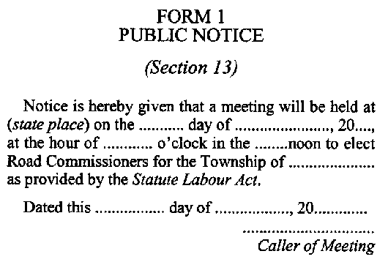
R.S.O. 1990, c. S.20, Form 1.
Form 2
DECLARATION OF OFFICE

R.S.O. 1990, c. S.20, Form 2.
Form 3
STATUTE LABOUR BOOK
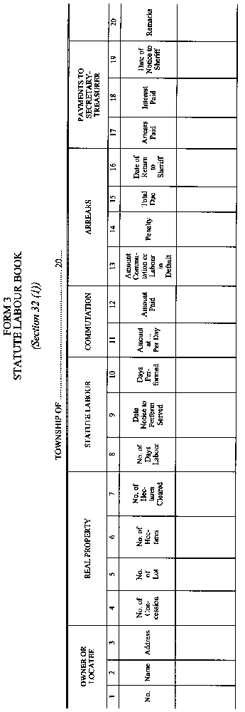
R.S.O. 1990, c. S.20, Form 3.
Form 4
NOTICE TO PERFORM STATUTE LABOUR
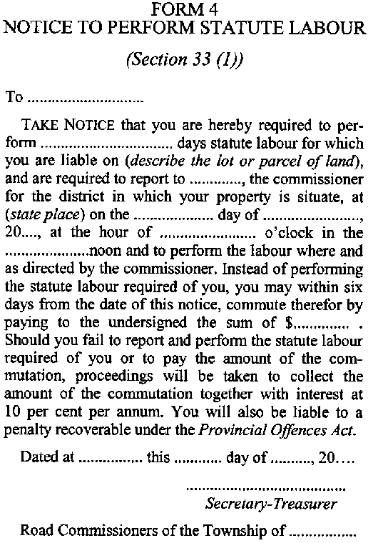
R.S.O. 1990, c. S.20, Form 4.
Form 5
NOTICE TO PAY THE COMMUTATION OF STATUTE LABOUR
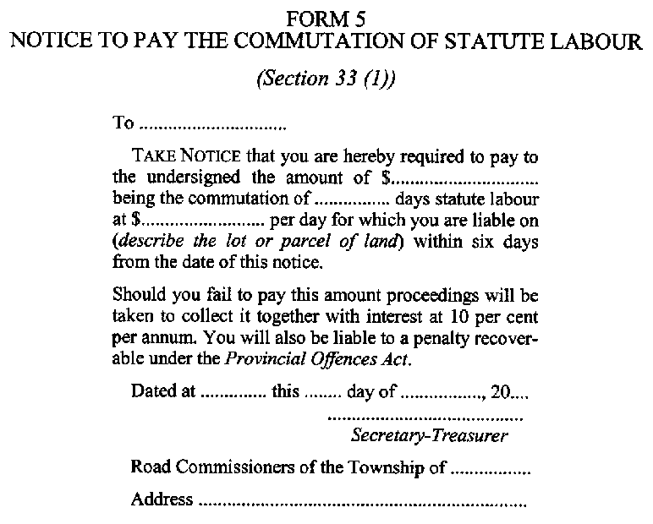
R.S.O. 1990, c. S.20, Form 5.
Form 6
RETURN TO SHERIFF
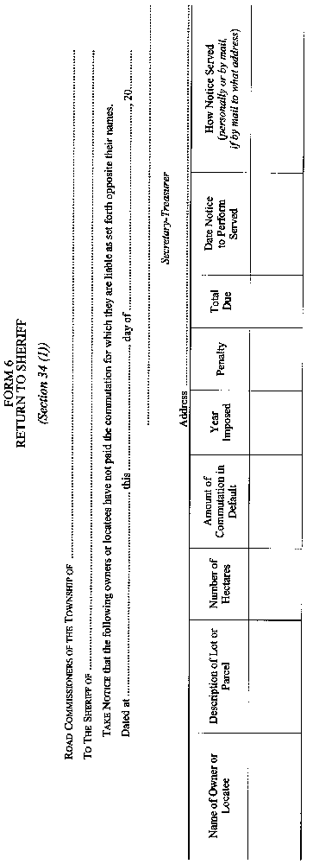
R.S.O. 1990, c. S.20, Form 6.
______________

Back to top

